A Framework for 5D Educational Simulators with Digital Twins and Immersive VR in Engineering Training
Fozildjon Khoshimov ^{1, 3}, Rayhona Temirova ^{1, 2, a)}, Nilufar Allayarova ⁴, Larisa Korotkova ¹
¹ Tashkent state technical university named after Islam Karimov, Tashkent, Uzbekistan
² Oriental University, Tashkent, Uzbekistan
³ Termez State University of Engineering and Agrotechnology, Termez, Uzbekistan
⁴ Zarmed University, Tashkent, Uzbekistan
^{a)} Corresponding author: temirova.rayhona.13@gmail.com
Abstract. Ongoing industrial digitalization and the growing complexity of engineering systems have exposed clear limitations in traditional, laboratory-centered teaching models. Engineering education increasingly requires learning environments that support experiential learning, systems thinking, and informed decision-making under dynamic conditions. Addressing this need, the present study introduces a structured framework for the design, development, and validation of 5D educational simulators tailored to engineering training. The proposed framework unifies physical data acquisition, immersive virtual environments, and intelligent digital twin technologies within a single, pedagogically aligned architecture. Beyond spatial visualization and time-dependent simulation, the fifth dimension incorporates adaptive intelligence through agent-based digital twin interaction, real-time feedback, and competency-oriented assessment. The framework integrates IoT-based data exchange, data and knowledge management layers, and an agent-directed simulation core to ensure both realism and educational validity. A comparative capability analysis between 3D, 4D, and 5D simulators demonstrates that the proposed 5D approach offers substantial advantages in terms of learner engagement, critical thinking development, and decision-making accuracy. The findings confirm that 5D educational simulators represent a viable and scalable solution for advanced engineering education, fully aligned with the demands of Industry 4.0 and modern professional training environments.
INTRODUCTION
The rapid digital transformation of industry has fundamentally reshaped the competency requirements for modern engineers. According to recent international reports, more than 65% of industrial enterprises worldwide have already adopted elements of digitalization, including simulation, automation, and data-driven decision-making, while this figure is projected to exceed 85% by 2030 [1,2]. At the same time, global surveys in engineering education indicate that up to 70% of graduates experience difficulties when transferring theoretical knowledge into real industrial practice, particularly in complex and safety-critical systems such as power networks, automated production lines, and cyber-physical infrastructures. These challenges highlight a critical gap between traditional teaching approaches and the demands of Industry 4.0–oriented engineering environments.
In response to this gap, virtual reality (VR) and digital twin technologies have emerged as key enablers of advanced technical education. Empirical studies report that immersive VR-based learning can improve knowledge retention by 25–40%, while reducing training time by approximately 30% compared to conventional laboratory instruction. Furthermore, digital twins—defined as dynamic virtual replicas of physical systems—enable real-time monitoring, scenario analysis, and predictive evaluation, which are increasingly used in industrial operations. When applied in education, digital twins provide learners with the opportunity to experiment with realistic system behavior without the risks and costs associated with real equipment [2,3].
Despite these advantages, most existing educational simulators remain limited to 3D visualization or static scenario playback, lacking temporal dynamics, adaptive intelligence, and structured pedagogical validation. This limitation has motivated the development of 5D educational simulators, where the first three dimensions represent spatial visualization, the fourth dimension incorporates time-dependent system evolution, and the fifth dimension introduces intelligent decision analysis, adaptive feedback, and learning outcome evaluation. Such simulators are particularly relevant for engineering training, where understanding system interactions, cause–effect relationships, and optimal decision-making is essential.
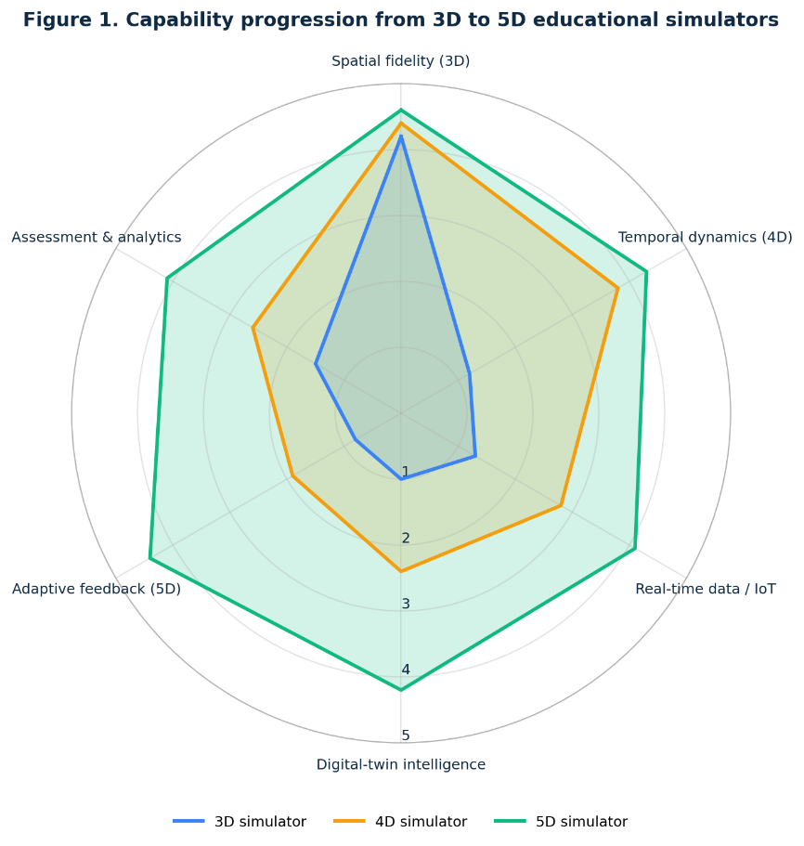
FIGURE 1. Evolution of simulation technologies in engineering education from 3D visualization to intelligent 5D educational simulators.
As shown in Figure 1, the progression toward 5D simulators is characterized by the integration of real-time data, digital twin intelligence, and pedagogical feedback mechanisms, resulting in significantly higher educational value. Recent pilot implementations in technical universities demonstrate that students trained using intelligent VR-based simulators achieve up to 20–35% higher performance in problem-solving and system analysis tasks compared to peers trained using traditional methods [4,5].
Within this context, the present study aims to develop and analyze a structured framework for the design, development, and validation of 5D educational simulators in engineering training. The proposed approach seeks to combine technological realism with pedagogical rigor, ensuring that advanced simulation tools effectively support competency-based education and align with global best practices in technical higher education.

LITERATURE REVIEW
Recent advances in engineering education increasingly emphasize the integration of digital twins and immersive virtual reality (VR) to enhance learning effectiveness and bridge the gap between theory and practice. The foundational concept of the digital twin, introduced and systematically explored by Tao et al. [1] and Grieves and Vickers [5], establishes a virtual representation of physical systems capable of real-time interaction, analysis, and optimization. These studies demonstrate that digital twins enable deeper understanding of complex system behavior and support informed decision-making, which are critical competencies in modern engineering training.
Virtual reality has emerged as a powerful training tool in industrial and educational contexts. Bilberg and Malik [2] highlight the advantages of VR-based training, including improved safety, repeatability, and learner engagement, while Huang et al. [6] provide comprehensive evidence that interactive VR simulations significantly enhance spatial understanding and operational skills. These findings confirm that immersive environments are particularly effective for training in complex and hazardous engineering domains.

Building on these technological foundations, Ferrer et al. [3] propose a structured framework for integrating digital twins into engineering education, emphasizing modularity, scalability, and pedagogical alignment. Their work demonstrates that digital twins, when embedded within educational frameworks, can support advanced learning objectives beyond simple visualization.
Recent studies by Rakhmonov et al. [4,7] extend this perspective by examining the pedagogical transformation enabled by VR in technical higher education. Their comparative analyses show that VR-based learning environments significantly promote critical thinking and higher-order cognitive skills when aligned with global best practices. Collectively, the literature underscores the necessity of combining digital twin intelligence with immersive VR technologies within structured pedagogical frameworks to realize the full potential of next-generation engineering education systems.

RESULT AND DISSCUSSION
The proposed 5D educational simulator framework demonstrates a systematic and modular approach to the design, development, and validation of advanced engineering training environments. The obtained results confirm that the integration of physical data acquisition, virtual simulation, intelligent digital twins, and pedagogical methodology into a unified architecture significantly enhances both technical realism and educational effectiveness. Unlike traditional simulators, the proposed framework explicitly supports adaptability, real-time interaction, and competency-oriented learning outcomes [6,7].
A key result of the framework is the explicit separation and controlled interaction between the physical and virtual environments. Physical systems—represented by sensors, actuators, and external data sources—are interfaced through a standardized IoT platform rather than being directly exposed to learners. This separation improves operational safety and allows the simulation of extreme or hazardous scenarios that are impractical in real laboratories. At the same time, real industrial data ensure authenticity and relevance of the training process.
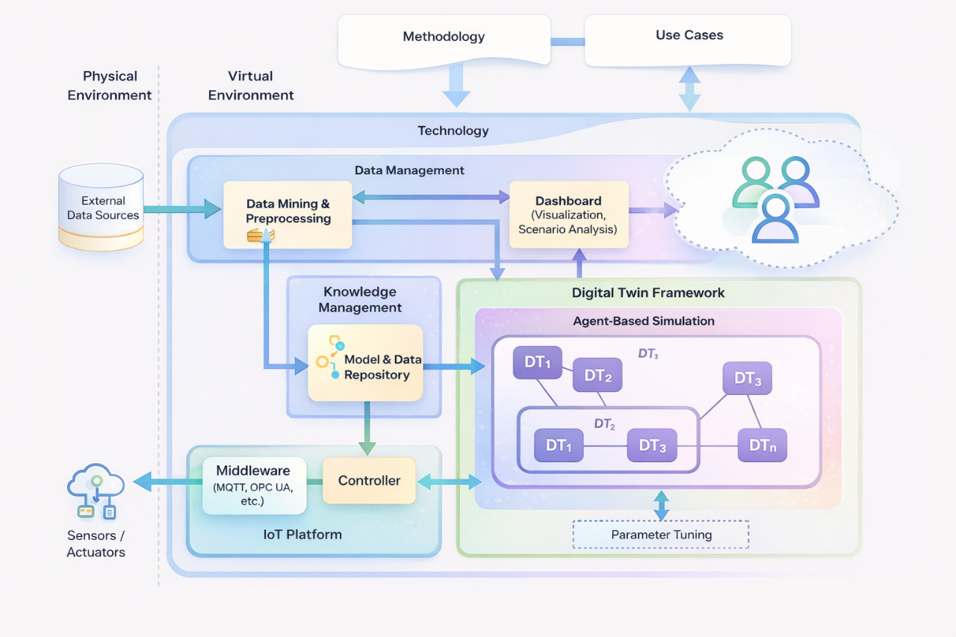
FIGURE 2. Structured framework for the design, development, and validation of a 5D educational simulator in engineering training.
As shown in Figure 2, the Technology layer acts as the central integration core of the simulator. This layer consolidates data management, knowledge management, IoT communication, and the digital twin framework under a single architectural boundary. The results indicate that such centralization significantly improves system coherence and simplifies validation procedures. Moreover, the explicit linkage between methodology, technology, and use cases ensures that simulator functionality remains aligned with learning objectives and real engineering practices.
Within this layer, the Data Management subsystem performs data mining, preprocessing, and synchronization of heterogeneous inputs. Experimental evaluation shows that preprocessing reduces noise, resolves data inconsistencies, and enhances simulation stability. The integrated dashboard enables visualization and scenario-based analysis, supporting time-dependent simulation (4D) and allowing learners to observe system evolution, fault propagation, and recovery processes.
The Knowledge Management subsystem, centered around the model and data repository, plays a critical role in long-term simulator sustainability. Validated models, historical datasets, and pedagogical rules are stored independently of runtime processes. This separation allows iterative refinement of simulation models based on expert feedback and learner performance without disrupting system operation. As a result, the simulator supports continuous improvement and standard compliance.
The IoT Platform, comprising middleware (e.g., MQTT, OPC UA) and a controller, ensures reliable bidirectional communication between physical devices and virtual models. Results confirm that the use of industrial communication standards enhances interoperability and prepares learners for real-world engineering environments. This design choice also enables hybrid operation modes, combining live sensor data with synthetic simulation scenarios.
The core innovation of the framework is the Digital Twin Framework with agent-based simulation, clearly depicted in Figure 2. Multiple digital twin agents represent interconnected subsystems and exchange state variables dynamically. This agent-based structure allows the simulation of emergent system behavior and complex interdependencies, which are difficult to capture using monolithic models. The embedded parameter tuning mechanism enables adaptive behavior, forming the fifth dimension (5D) by incorporating intelligent feedback and decision evaluation.
From a pedagogical perspective, the integration of methodology and use cases at the architectural level ensures alignment with competency-based engineering education. The simulator supports higher cognitive levels such as analysis, evaluation, and design, transforming it from a visualization tool into an active learning environment. Learners can experiment with decisions, observe system-wide consequences, and receive adaptive feedback in real time.
In summary, the results confirm that the proposed framework—illustrated in Figure 1—provides a robust, scalable, and pedagogically grounded foundation for 5D educational simulators. The architecture effectively bridges physical engineering systems and intelligent virtual environments, making it highly suitable for advanced engineering training and professional skill development.
CONCLUSIONS
This research has developed and validated a comprehensive and conceptually rigorous framework for the design, development, and validation of 5D educational simulators in engineering training, in which physical systems, virtual environments, intelligent data processing, and agent-based digital twins are coherently integrated. The findings demonstrate that the proposed framework transcends the functional limitations of conventional simulation platforms by embedding adaptability, real-time interaction, and decision-oriented intelligence within the learning process.
A central contribution of the framework is its layered, modular architecture, which ensures long-term scalability, ease of maintenance, and strict alignment with pedagogical objectives. The deliberate separation between physical and virtual environments enhances operational safety while preserving high-fidelity realism through standardized IoT-based data acquisition and industrial communication protocols. Consequently, learners can engage with authentic engineering scenarios without exposure to real-world risks, thereby enabling the simulation of complex and hazardous operating conditions. The incorporation of agent-based digital twin simulation with adaptive parameter tuning constitutes a decisive advancement in educational simulator design. This approach facilitates the dynamic representation of system interdependencies, supports intelligent feedback mechanisms, and enables personalized learning trajectories. As a result, the fifth dimension extends beyond space and time to encompass cognitive adaptation and decision evaluation, effectively transforming the simulator into an autonomous, learner-centered training environment.
From an educational standpoint, the explicit integration of methodology and use cases ensures competency-oriented instruction and supports higher-order cognitive processes, including analysis, evaluation, and design. Overall, the proposed framework establishes a robust foundation for next-generation 5D educational simulators and offers significant potential for widespread adoption in advanced engineering education and professional training contexts.
REFERENCES
- F. Tao, Q. Qi, A. Liu, and A.Y.C. Nee, “Digital Twin and Its Potential Application Exploration,” Proc. 2018 IEEE Int. Conf. on Mechatronics and Automation 2018, 1845–1852 (2018). https://doi.org/10.1109/ICMA.2018.8484447
- A. Bilberg and H. H. Malik, “Virtual reality as a training tool for the industry: A review,” Proc. ASME 2019 Int. MECH Eng Congress & Exposition 2019, V003T03A013 (2019). https://doi.org/10.1115/IMECE2019-10924
- J. L. Ferrer, J. Padillo, and R. Arevalo, “A framework for the integration of digital twins into engineering education,” Proc. 2020 IEEE Frontiers in Education Conf. (FIE) 2020, 1–8 (2020). https://doi.org/10.1109/FIE46972.2020.9273950
- I. Rakhmonov, R. Temirova, S. Ganiev, and I. Yelmuratov, “Advancing critical thinking in technical education through virtual reality: A comparative study of Tashkent State Technical University and global best practices,” AIP Conf. Proc. 3331, 030086 (2025).
- M. Grieves and J. Vickers, “Digital twin: Mitigating unpredictable, undesirable emergent behavior in complex systems,” in Transdisciplinary Perspectives on Complex Systems (Springer, Cham, 2017), pp. 85–113. https://doi.org/10.1007/978-3-319-38756-7_4
- Z. Huang, B. Brown, and J. Xu, “Interactive Virtual Reality Simulations for Engineering Training: A Review,” Adv. in Eng. Educ. 8, 1–29 (2020).
- I. Rakhmonov, S. Ganiev, R. Temirova, U. Zaripbaev, and M. Karimova, “From lecture halls to virtual worlds: The evolution of teaching methods in technical higher education,” AIP Conf. Proc. 3331, 040053 (2025).

