Analysis of Comprehensive Diagnostic Methods for Asynchronous Motors in Pumping Stations
Olimjon Toirov¹, Fozil Sharopov²^{,a)}, Firdavs Qobilov¹, Jasurbek Nizamov³ Shokhrukh Azimov¹
¹Tashkent State Technical University named after Islam Karimov, Tashkent, Uzbekistan
² Academy of Sciences of the Republic of Uzbekistan, Tashkent, Uzbekistan
³Andijan state technical institute, Andijan, Uzbekistan
^{a)} Corresponding author: sharopovfozilqobilovich@gmail.com
Abstract. This article analyzes systems for determining the technical condition and diagnosing pump units in pumping stations in order to ensure their reliability and energy efficiency. At present, the following existing methods aimed at improving the reliability and energy efficiency of pump units and reducing operating costs are considered: vibration diagnostics and noise sensors, temperature regimes (housing, bearings, rotor, pump), inlet and outlet pressure sensors, thermal imaging diagnostics, assessment of insulation condition, analysis of electrical parameters, and measurement of insulation resistance. The capabilities and limitations of these methods are examined.
INTRODUCTION
It is well known that electric motors used in pumping stations occupy a special place among the main and largest consumers of electrical energy produced in the Republic. Approximately 60 percent of the generated electrical energy is consumed by electric motors in various sectors. In this regard, the reliability and efficiency of pumping units, particularly asynchronous motors installed in pumping stations, are of decisive importance in ensuring the stability of the entire power system [1].
These motors mainly operate as driving forces in pump units, fans, compressors, conveyors, and various technological equipment. At the same time, timely diagnosis of the technical condition is crucial to ensure the uninterrupted operation and extended service life of asynchronous motors in pumping stations. The main purpose of diagnostics is to detect defects and malfunctions in asynchronous motors installed in pumping units at an early stage, prevent their development, ensure continuous operation, and reduce unplanned shutdowns [2].
Today, diagnostic systems for pump units not only identify faults but also provide the possibility of predicting the future condition of motors based on their operating parameters.
Although scientific research on comprehensive diagnostics of pumping units is actively conducted worldwide, the development of integrated diagnostic and monitoring systems adapted to the operating modes of pumping stations has not yet been sufficiently addressed [3]. Therefore, this study analyzes the scientific foundations for assessing the technical condition of pumping units in pumping stations and diagnosing them using automated methods. At present, the majority of the electrical energy produced in the country is consumed by economic sectors, industrial enterprises, public utilities, and infrastructure facilities. Among them, pumping stations are considered some of the largest consumers of electrical energy.
Asynchronous motors in pumping stations often operate under severe conditions – high temperature, humidity, vibration, and continuous operating modes – which negatively affect their reliability. According to observed data, 20–25 percent of asynchronous motors installed in pumping stations fail annually. The main reasons include, untimely maintenance and preventive repair, insulation system degradation, vibration and mechanical wear of bearings, non-compliance with operating modes and load parameters [4].
Failure of asynchronous motors leads not only to equipment breakdown but also to stoppage of the entire technological process at pumping stations, reduced energy efficiency, and economic losses. Therefore, accurate and prompt diagnosis of the technical condition of asynchronous motors is a pressing requirement today.
Existing problems in diagnosing asynchronous motors used in pumping stations can be grouped as follows:
- unreliability and insufficiency of available data on the technical condition of electrical equipment;
- absence of a unified standardized method for accurately assessing the risk of motor failure;
- lack of objective criteria for evaluating maximum service life and maintenance priorities.
The main faults in asynchronous motors are divided into two categories [5]. Electrical faults include short circuits in stator windings, insulation breakdown, abnormal current increase, and dielectric losses. Mechanical faults include bearing wear, rotor imbalance, uneven air gap, and increased vibration. Studies show that most failures of asynchronous motors are caused by short circuits in stator windings (40–45%), mechanical faults in bearings (25–30%), and insulation breakdown (around 20%).

EXPERIMENTAL RESEARCH
Pump units in pumping stations constantly operate in aggressive environments. The most common types of failures in pump units and their motors, the condition of motors after failure, and their percentage distribution are presented in Table 1. Overheating of the stator in asynchronous motors at pumping stations due to increased load accounts for 31%. The possible reasons are as follows:
- Excessive load on the pump unit. Increased hydraulic resistance in the pump. Incorrect pump selection. Lowering of water levels in deep wells and operation of the pump in an “extended mode.”
- Imbalances in the power supply. Uneven voltage distribution among phases. Low voltage (U < 90–95% of nominal) leading to increased current. Excessive voltage also increases magnetic flux, causing overheating.
- Increased mechanical resistance. Increased friction of the pump shaft (bearing failure, lack of lubrication). Improper shaft alignment.
- Technical faults in the motor itself. Short circuits in stator windings. Cracks or moisture in insulation. Increased resistance due to aging of windings.
- Insufficient ventilation. Contamination of cooling channels or fan blades. High ambient temperature. Motor housing covered with dirt and dust.
- Incorrect pump operating mode. Improper adjustment of the frequency controller. Pump operating frequency exceeding the normal range.
Overheating of the stator of asynchronous motors in pumping stations due to load conditions mainly occurs as a result of increased current, mechanical resistance, and faults in the power supply system. Inter-turn short circuits in the stator windings of the motor account for approximately 15% of failures [6].
To eliminate the existing problem, it is necessary to normalize the load, perform diagnostics of the pump and motor condition, restore ventilation, and check electrical parameters. Inter-turn short circuits in the stator windings of asynchronous motors installed at pumping stations represent one of the most dangerous motor faults and arise due to the following main reasons:
- Aging and degradation of insulation. When a motor operates for a long time at elevated temperatures, the insulation layer ages, becomes brittle, and its thermal regime is violated.
- Operation under overload conditions. Current exceeding the nominal value causes intensive heating of the windings. Burnout or melting of overheated insulation leads to inter-turn short circuits.
- Increased vibration. This may result from bearing defects or misalignment of the shaft.
- Influence of moisture and dust. In humid environments, insulation absorbs moisture and its dielectric strength decreases.
- Electrical shocks. Voltage surges in the network, increased harmonics due to improper filtering in frequency converters (VFDs), and short-term current surges can puncture insulation.
- Improper winding manufacturing. Errors during factory assembly of windings, poor-quality insulation during stator rewinding, and insufficient spacing between turns.
- Mechanical damage. Damage to windings during installation or dismantling, or contact between the rotor and stator due to bearing failure.
Inter-turn short circuits primarily occur as a result of insulation failure, which in turn is a direct consequence of overheating, vibration, moisture, electrical surges, and mechanical damage. Bearing damage accounts for approximately 12% of failures [7].

TABLE 1. Tabular representation of common fault types in asynchronous motors
#№ | Faults in Asynchronous Motors | Condition of Motors After Failure | Motor Failure Rate (%)
11. | Overheating of the asynchronous motor stator due to increased load |  | 31%
22. | Inter-turn short circuit in the stator windings of the motor |  | 15%
33.. | Damage to bearings |  | 12%
44. | Damage (burning) of stator winding insulation |  | 11%
55. | Uneven air gap between the stator and rotor of the motor  (Stator slots / Air gap / Rotor slots) | Stator slot  Air gap  Rotor slot | 9%
66. | Two-phase operation of the electric motor (loss of one phase) |  | 8%
77. | Damage to the rotor of the asynchronous motor |  | 5%
88. | Loosening at the fastening points of the stator windings |  | 4%
99. | Imbalance of the motor rotor |  | 3%
110. | Improper alignment of the motor shaft | 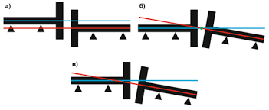 | 2%

The primary and most common cause of bearing damage is improper lubrication [8]. This includes:
- Insufficient lubrication. Metal-to-metal friction occurs in the bearing, leading to overheating, burn marks, and deformation of balls or rollers.
- Excessive lubrication. Excess grease heats up during rotation and loses its properties. Too much grease increases aerodynamic resistance inside the bearing and intensifies friction.
- Use of inappropriate lubricant type. Lubricants with low temperature resistance harden or melt quickly and fail to withstand bearing loads.
- Contaminated lubricant. Metal particles, dust, water, or chemicals accelerate bearing surface wear. Contaminated grease significantly reduces bearing service life.
- Incorrect shaft alignment. Additional loads and forces arise in the bearing.
- High vibration levels. Caused by imbalance of the motor, pump, or gearbox.
- Excessive load. Torque exceeding the nominal value prevents the bearing assembly from carrying the design load.
- Installation errors. Inclined installation of bearings, hammering during mounting (causing deformation of balls or rollers), and improper installation of bearing covers.
- Corrosion. Exposure to moisture, acids, or alkalis causes corrosion, leading to rapid damage of bearing raceways.
Misalignment of gearboxes, shafts, pumps, and motor shafts in pumping station units occurs when the axes of the motor and the connected mechanism (pump, gearbox, generator) are not collinear. This condition is considered one of the most harmful mechanical faults for electric motors. Shaft misalignment leads to several serious consequences: increased vibration, rapid bearing failure, uneven air gap between stator and rotor, damage to couplings and shafts, motor overheating and reduced efficiency, and a shortened overall service life of the unit [9]. Failures of asynchronous motors in pumping stations can generally be divided into two categories: electrical and mechanical (fig. 1). According to industrial operation statistics, faults are classified into 10 groups (as shown in Table 1), among which the most common type is short circuit in the stator windings.
One of the most widespread faults in asynchronous motors is mechanical damage, which represents a serious problem [10]. A typical sign of winding wear is increased noise. During motor operation, the occurrence of vibration causes additional heating of the asynchronous motor (fig. 2). Electrical motor damage during short circuits includes insulation breakdown of stator windings, reduction in resistance, damage to insulation, and deterioration of electrical contacts and connections.
At present, the following main methods are used for diagnosing asynchronous motors in pumping stations. Vibration diagnostics – sensors designed to monitor and analyze vibration in mechanical components of pumps (rotor, bearings, balancing elements, etc.). This method monitors pump operating quality, detects component damage in advance (bearing defects, imbalance), and identifies preventive maintenance needs during servicing [11].

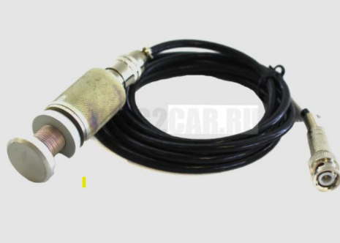
FIGURE 1. DiSco vibration sensor

The operating principle of a vibration sensor can be explained as follows:
- It measures vibration in the form of velocity, acceleration, or angular position.
- It transmits data and signals to an electronic monitoring system.
- When predefined threshold values are exceeded, it enables automatic alarms or shutdown of the pump.
- Thermal imaging diagnostics – this method identifies an infrared sensor and camera system used for non-contact, rapid, and accurate measurement of temperature distribution in a pump or pumping system (fig. 3). It is mainly applied to detect overheating zones in pumping units [12].
It serves to predict faults in bearings, rotors, and electrical components in advance, identify mechanical and electrical operating problems, and detect power losses and safety deficiencies (fig. 4).
The operating principle of a thermal imager can be explained as follows:
- It measures infrared radiation, which propagates depending on temperature and is displayed in the form of a color-coded image.
- The thermal imaging camera quickly scans any part of the pump.
- Temperature differences are used to identify defects and overheating zones.
- The collected data are transmitted to a computer or mobile applications.
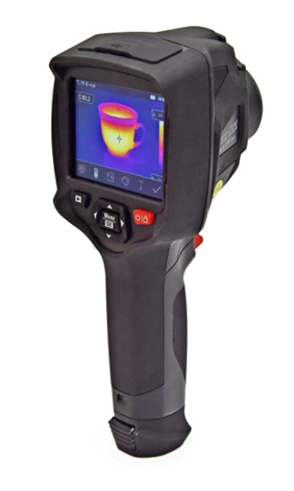
FIGURE 2. Thermal imagers registered in the state register

The main functions of a thermal imager include: detecting bearing overheating, monitoring the temperature of electric motor components and cables, identifying non-uniform heating of the pump casing (indicating imbalance), and detecting power losses and insulation problems [13].
The main advantages of a thermal imager are as follows:
- Non-contact and rapid measurement.
- Enhanced safety (inspection without opening electrical components or equipment).
- Early fault detection and the ability to perform preventive maintenance.
- Storage of data in both visual and digital formats.
Areas of application include pump maintenance, monitoring of electric pump motors, and preventive inspections at industrial facilities.
Analysis of insulation condition – insulation resistance and dielectric losses are measured. Motors in pumping stations are exposed to high humidity, vibration, dust, and temperature fluctuations. Therefore, continuous monitoring of insulation condition is extremely important. The objective is to verify the insulation’s ability to withstand maximum voltage (fig. 5). A sharp increase in current indicates insulation deterioration. Insulation failure is also closely related to vibration and overheating [14].
Pressure sensor – this sensor mainly measures the pressure of liquid inside pipelines or reservoirs at pumping stations and transmits this information to the control system (fig. 6). Its main functions include automatic start/stop of the pump, prevention of excessive or insufficient pressure in the system, protection of pumps and pipelines from аварий conditions, and ensuring stable pressure in water supply systems [15].
Main types:
- Mechanical pressure relay – has a simple design and is used in small pumping stations.
- Electronic (analog/digital) pressure sensor – operates in conjunction with automated control systems.
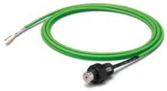
FIGURE 3. Vibration sensor

Main technical parameters:
- Measurement range (e.g., 0–6 bar, 0–10 bar),
- Accuracy class,
- Output signal (4–20 mA, 0–10 V, etc.),
- Supply voltage,
- Protection class (IP65, IP67).
Advantages:
- Extends the service life of the pump,
- Saves electrical energy,
- Reduces the number of emergency situations.
Manometer (pressure gauge) – a device used in pumping stations to accurately and visually measure water pressure. It is very important for monitoring pump operating pressure [16]. The main operating principle of a manometer is based on measuring the pressure of a liquid or gas and displaying it in units such as millimeters of water column, bar, or psi. The operator monitors the pump pressure through the manometer and, if necessary, controls the system accordingly.
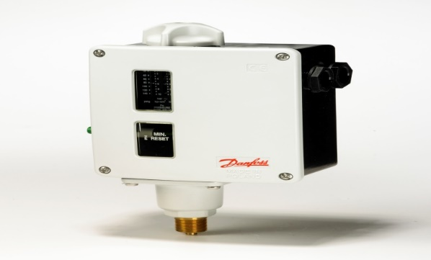
FIGURE 4. Pressure switch

The main types of manometers include: a) Mechanical manometers (spring-type, capillary-type),
b) Electronic (digital) manometers – intended for use in automated systems [17].
In schematic diagrams, a manometer is also referred to as a pressure relay (pressure switch) – a device that sends a signal to automatically start or stop the pump when the pressure in the pumping station reaches or falls below a predefined limit. The manometer is installed at the pump outlet. Thus, the manometer indicates the pump discharge pressure and monitors pressure for automatic pump control.
Noise sensor – a sensor used to detect abnormal, excessive, or improper acoustic signals generated during the operation of a pump or pumping system [18].
It enables early detection of pump faults such as bearing, rotor, and valve problems and provides monitoring of the machine’s technical condition [19-20].
The main operating principle of a noise sensor can be explained as follows:
- The noise sensor listens to acoustic signals in the surrounding environment.
- The signals are analyzed through specialized electronic systems.
- When abnormal or non-standard sounds are detected, an alarm is triggered or an automatic corrective system is activated.
Main types of noise sensors:
- Microphone-based acoustic sensors – operate using high-sensitivity microphones; suitable for open environments and industrial pumps.
- Ultrasonic sensors – detect high-frequency sounds; mainly used for bearings and motors.
- Analytical and intelligent sensors – automatically recognize different types of noise and identify faults.
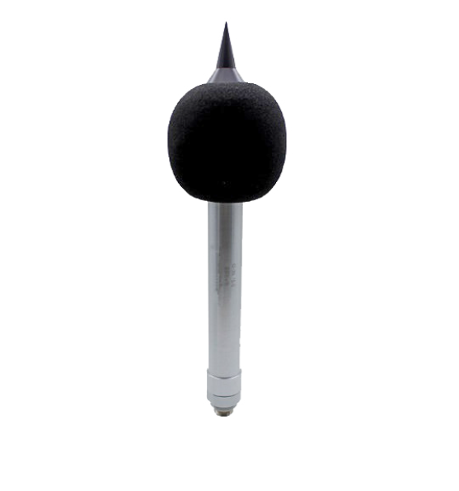
FIGURE 5. ICB300-06 noise sensor (indoor type)

Installation method of a noise sensor in pumps, mounted on the pump housing, connected to the electronic control system, enables real-time monitoring and analysis [21]. Main advantages of noise sensors, allow rapid detection of mechanical faults, improve overall pump operating quality, reduce preventive maintenance and repair costs.
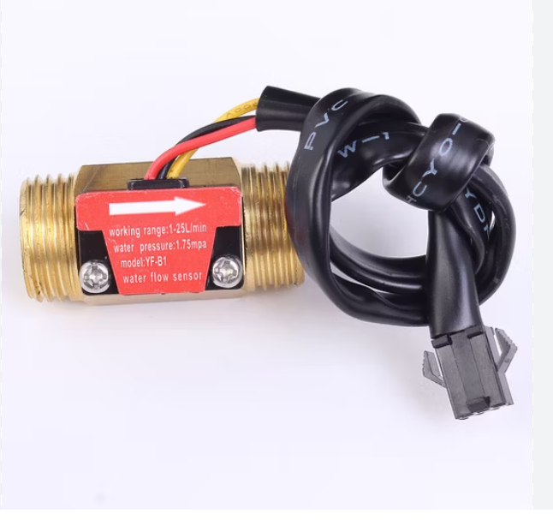
FIGURE 6. Water mass flow sensor (SEO) Yf-B1, standard air mass flow sensor G1/2, 1–25 L/min

In pump protection systems, when flow conditions deteriorate (for example, due to blockage or insufficient water supply), the control system introduces corrective actions or shuts down the pump. In automated control, PLC/SCADA systems use the flowmeter signal (e.g., 4–20 mA) to regulate pump speed, valves, and other system components [22].
Flowmeters operate based on different technologies:
- Electromagnetic (magnetic) flowmeters – when a liquid passes through a magnetic field, an induced electrical signal is generated.
- Turbine flowmeters – the flow rotates an internal turbine, and the rotational speed is proportional to the flow rate.
- Ultrasonic flowmeters – fluid velocity is determined using ultrasonic waves.
- Vortex (turbulent) flowmeters – generate signals based on the frequency of vortices formed downstream of an obstruction when flow passes through the meter.
- Mass / thermal or correlation-type meters – measure flow based on thermal or mass principles, mainly for gases (remote or in-line types).
In pump assemblies (for example, a flow metering skid – pump + measurement + control package), the flowmeter acts as the primary sensor, providing flow data to the instrument system. This data is used for automatic control of pump operating speed, energy consumption, and water delivery quality [23-27].
Through flowmeters, the following parameters are obtained:
- Flow rate – amount of liquid or gas passing through,
- Total flow – cumulative consumption,
- Flow trends – changes over time,
- Control signals – inputs for automated systems.
If a flowmeter is installed on a pump:
- Direct installation – the flow passes through the meter inside the pipe,
- Clamp-on type – mounted externally on the pipe, enabling non-contact measurement.
Although these methods provide a certain level of effectiveness, each has specific limitations. For example, vibration diagnostics is effective in detecting mechanical defects but cannot assess insulation conditions. Acoustic analysis is effective for identifying mechanical faults but requires specialized equipment and significant time. Thermal imaging diagnostics is useful for evaluating insulation conditions by observing temperature distribution, but it is relatively expensive. Electrical parameter analysis enables accurate assessment of operating conditions by monitoring current, voltage, and power harmonics.
In addition, each method requires costly equipment, and the practical implementation of their integrated use has not yet been sufficiently studied. At present, there is a strong need for an integrated approach to assessing the technical condition of asynchronous motors in pumping stations.
In a comprehensive diagnostic device for pumping station pump units, dynamic parameters such as vibration and noise, hydraulic parameters including water flow rate, pressure, and efficiency, as well as the temperature and condition of bearings installed in the pump, are determined.
According to research results, scientific issues related to increasing equipment reliability through comprehensive diagnostics of pumping stations, developing monitoring systems, and integrating remote control functionalities have not yet been sufficiently investigated.
Based on this, the development of a real-time comprehensive diagnostic device for pumping stations is considered one of the most pressing challenges. The creation of a system capable of simultaneously monitoring the energy, operational, and technological parameters of pump units, performing comprehensive diagnostics, and enabling remote control would undoubtedly allow effective and complete resolution of any problems occurring in asynchronous motors.
CONCLUSION
Comprehensive diagnostic methods for pump units in pumping stations were analyzed, focusing on fault types and their percentage distribution, including insulation failure, bearing wear, rotor imbalance, and short circuits in stator windings, as well as their operational characteristics. Timely detection and elimination of these faults play a decisive role in improving the overall reliability of electromechanical systems. In addition, methods for analyzing external magnetic fields of asynchronous motors are still insufficiently applied, indicating the need for further in-depth research in this area. Comprehensive diagnostic approaches were proposed. Although these methods demonstrate a certain level of effectiveness, an analysis of their capabilities and shortcomings clearly shows that each method has specific limitations.
To implement comprehensive diagnostics, it is first necessary to develop a methodological approach, followed by the design of a functional scheme, fabrication of the device, development of operating algorithms, and creation of appropriate software. The obtained results indicate that introducing an integrated approach to diagnosing asynchronous motors in pumping stations – namely, the simultaneous analysis of vibration, temperature, insulation condition, electrical parameters, and magnetic fields – represents the most effective solution. Such a comprehensive diagnostic system enables scientifically grounded prediction of motor faults, extension of service life, and assurance of reliable operation.
Moreover, research findings show that the implementation of modern diagnostic systems for asynchronous motors in pumping stations can increase maintenance efficiency by 24–25%, reduce the number of emergency failures by 30%, decrease spare parts shortages by 27%, and save 20–25% in excess operating time and energy consumption.
REFERENCES
- A. Sinelnikov. Technical maintenance and efficiency of diagnosing induction motors / A.M. Sinelnikov, V.V. Bonnet // Bulletin of Irkutsk State Agricultural Academy. – 2009. – No. 37. – pp. 60–65.
- O. Toirov, M. Taniev, M. Hamdamov, A. Sotiboldiev, Power Losses Of Asynchronous Generators Based On Renewable Energy Sources E3S Web of Conferences, 434, 01020, (2023) https://doi.org/10.1051/e3sconf/202343401020
- D. Jumaeva, O. Toirov, B. Numonov, N. Raxmatullaeva, M. Shamuratova. Obtaining of highly energy-efficient activated carbons based on wood, // E3S Web of Conferences 410, 01018, (2023). https://doi.org/10.1051/e3sconf/202341001018
- O. Toirov, Sh. Azimov, Z. Najmitdinov, M. Sharipov, Z. Toirov. Improvement of the cooling system of reactive power compensating devices used in railway power supply // E3S Web of Conferences, 497, 01015, (2024). https://doi.org/10.1051/e3sconf/202449701015
- D. Jumaeva, U. Raximov, O. Ergashev, A. Abdyrakhimov. Basic thermodynamic description of adsorption of polar and nonpolar molecules on AOGW, // E3S Web of Conferences 425, 04003 (2023) https://doi.org/10.1051/e3sconf/202343401020
- A. Zrelov Analysis of methods for detecting defects in the squirrel-cage windings of a high-power induction motor // Modern Materials, Engineering and Technology: Proceedings of the 4th International Scientific and Practical Conference, December 25–26, 2014.
- O. Toirov, S. Khalikov, Sodikjon Khalikov, F. Sharopov, Studies of reliability indicators of pumping units of machine irrigation on the example of the “Namangan” pumping station, // E3S Web of Conferences 410, 05015, (2023). https://doi.org/10.1051/e3sconf/202341005015
- D. Bystrov, S. Giyasov, M. Taniev, S. Urokov. Role of Reengineering in Training of Specialists // ACM International Conference Proceeding Series (2020) https://doi.org/10.1145/3386723.3387868
- A.Vakalchuk. Diagnostics of electrical machine faults / A.A. Vakalchuk, S.V. Sukyasov // Bulletin of Irkutsk State Agricultural Academy. – 2009. – No. 37. – pp. 60–65.
- L. Sidelnikov. Review of methods for monitoring the technical condition of induction motors during operation / L.G. Sidelnikov, D.O. Afanasyev // Bulletin of Perm National Research Polytechnic University. Geology. Oil and Gas Engineering and Mining. – 2013. – No. 7. – pp. 127–137.
- O. Toirov, V. Ivanova, V. Tsypkina, D. Jumaeva, D. Abdullaeva, Improvement of the multifilament wire lager for cable production, // E3S Web of Conferences 411, 01041 (2023), https://doi.org/10.1051/e3sconf/202341101041
- T. Kamalov, U. Mirkhonov, S. Urokov, D. Jumaeva, The mathematical model and a block diagram of a synchronous motor compressor unit with a system of automatic control of the excitation // E3S Web of Conferences, 288, 01083, (2021), https://doi.org/10.1051/e3sconf/202128801083
- O. Toirov, S. Urokov, U. Mirkhonov, H. Afrisal, D. Jumaeva, Experimental study of the control of operating modes of a plate feeder based on a frequency-controlled electric drive, // E3S Web of Conferences, SUSE-2021, 288, 01086 (2021). https://doi.org/10.1051/e3sconf/202128801086
- S. Khalikov, Diagnostics of pumping units of pumping station of machine water lifting, // E3S Web of Conferences 365, 04013, (2023). https://doi.org/10.1051/e3sconf/202336504013
- A. Korobeynikov. Analysis of existing methods for diagnosing electric motors and prospects for their development / A.B. Korobeynikov, A.S. Sarvarov // Electrical Engineering Systems and Complexes. – 2015. – No. 1 (26). – pp. 4–9.
- O. Toirov, A. Khalbutaeva, Z. Toirov. Calculation of the magnetic flux with considering nonlinearities of saturation of the magnetic circuit of synchronous motors, // 3rd International Scientific and Technical Conference on Actual Issues of Power Supply Systems, ICAIPSS 040022, (2023). https://doi.org/10.1063/5.0218821
- S. Khalikov. Research and Evaluation of the Reliability Indicators of Pumping Units for Mechanical Irrigation of the Pumping Station “Kyzyl-Tepa”, // Power Technology and Engineering, 57 (5), (2024). https://doi.org/10.1007/s10749-024-01720-2
- O. Toirov, M. Taniev, B. Safarov, Z. Toirov. Simulation model of an asynchronous generator integrated with a power supply system at different wind speeds, // AIP Conference Proceedings, 3331 (1), 060025, (2025). https://doi.org/10.1063/5.0305672
- O. Filina, A. Khusnutdinov, O. Toirov, Kh. Vakhitov, A. Abdyllina, Investigation the conditions of existence and disturbances of brush-collector contact // E3S Web Conf. 563, 01009, (2024). https://doi.org/10.1051/e3sconf/202456301009
- O. Toirov, Sh. Azimov, Z. Toirov. Improving the cooling system of reactive power compensation devices used in railway power supply // AIP Conference Proceedings, 3331, 1, 050030, (2025). https://doi.org/10.1063/5.0305670
- A. Gerasimuk. Study of heating in a high-power high-voltage synchronous motor during sudden shutdown of the cooling system / A.V. Gerasimuk, M.V. Kipervasser, E.N. Topilskaya // Bulletin of the Siberian State Industrial University. – 2016. – No. 2 (16). – pp. 32–34.
- O. Toirov, W. Yu. Non-Intrusive Load Monitoring Based on Image Load Signatures and Continual Learning // Proceedings of 2025 2nd International Conference on Digital Society and Artificial Intelligence, (2025) https://doi.org/10.10.1145/3748825.3748963
- Fedorov M.M. Method for diagnosing open circuits and inter-turn short circuits in induction motor stator windings / M.M. Fedorov, A.A. Tkachenko // Explosion-Proof Electrical Equipment. – 2011. – No. 1. – pp. 168–174.
- O. Toirov, V. Tsypkina, V. Ivanova, D. Isamukhamedov, M. Kozlitin, Z. Toirov. Overview of Modern Materials Used for the Production of Optical Fiber for Fiber Optic Cables AIP Conference Proceedings, 3331 (1), 050029 (2025). https://doi.org/10.1063/5.0305669
- T. Sadullaev, U. Hoshimov, S. Urokov, A. Naimov, J. Khudoyorov, Z. Toirov. Development of an integrated method for rating electrical energy consumption during the drilling process, // AIP Conference Proceedings, 3331 (1), 050028, (2025). https://doi.org/10.1063/5.0305668
- N. Avezova, A. Usmanov. Review of Modern Approaches in the Development of Hybrid Biogas Systems // Applied Solar Energy, 60 (6), (2024) https://doi.org/10.3103/S0003701X25600845
- Sh. Atoev, T. Sadullayev, D. Jumaeva, Energy-saving operating modes and functional diagrams of a cotton-cleaning device based on frequency-controlled electric drives. // AIP Conference Proceedings, 3152 (1), 030016, https://doi.org/10.1063/5.0218797

