Justification of the energy efficiency of using an algorithm that eliminates accidental overloads of the electric drive of mobile electric machines used in greenhouses
Sergey Bakirov^{1, а)}, Lyazat Sadykova², Sergey Bakhteev¹, Anton Ishchenko¹, Anvar Saidkhodjaev ³
¹ Vavilov University, Saratov, Russia
² West Kazakhstan Innovation and Technology University, Uralsk, Kazakhstan
³ Tashkent state technical university named after Islam Karimov, Tashkent, Uzbekistan
^{a)} Corresponding author: s.m.bakirov@mail.ru
Abstract. Theoretical studies of the impact of the roller flange on the electric drive power consumption confirm the hypothesis of a sudden, random increase in load during operation, exceeding the rated electric motor power several times due to lateral friction. Equipping mobile vehicles with more powerful electric motors to cover the random overload is economically impractical due to the reduced battery power reserve and the frequent power consumption for charging. The use of various electric drive control algorithms is not suitable for the occurrence of random, sharp overloads during operation due to lateral flange friction. This paper substantiates the energy efficiency of using several configuration options for electric vehicles. It is justified that double overload must be avoided when combined with an algorithm that eliminates overload, which increases energy efficiency by 1.5 to 3.4 times.
INTRODUCTION
Flanges on the rollers of mobile electric tube-rail vehicles act as limiters and prevent them from derailing during movement. Flanges improve driving safety and also create additional load on the electric drive due to lateral friction. It is impossible to completely eliminate lateral friction even with ideal thermal register positions [1-3].
The algorithm proposed in the authors' works [4-5], which eliminates the influence of additional load on the drive electric motor, eliminates the effect of double loading by automatically regulating the voltage at the terminals, thereby temporarily affecting the movement process. It turns out that during the movement of a mobile electric vehicle, random lateral friction occurs, for example, diagonal, leading to additional load (Figure 1).
Simulating this case can have several possible outcomes. First, if the mobile electric machine is moving only the operator, i.e., without additional load, the lateral friction may be short-lived—1–2 seconds. After this time (1–2 seconds), the lateral friction disappears (passes) and the load equalizes. The actual value of the electric motor current increases proportionally to the shaft load. During the short period of increased current, the winding temperature does not have time to rise sharply due to thermodynamic laws, but it will lead to excessive consumption of electrical energy from the power source. A prolonged load of 2 seconds or more also leads to an increase in winding temperature, which then leads to interturn short circuits in the winding, stalling of the rotor (armature) of the electric motor, etc. Secondly, if a mobile electric machine is equipped with an electric motor with a triple power reserve.
P_{motor} = 3 Pnom, (1)
Then the additional overloads that arise during travel do not affect the reliability of the electric drive, but lead to increased energy consumption throughout the entire service life of the mobile electric machine. Thirdly, if the machine is equipped with an electric motor with a power equal to the rated mechanical power.
P_{motor} = Pnom, (2)
whose control algorithm eliminates 200% (double) overloads on the shaft, then the question arises as to whether the electric drive can overcome the lateral friction of the flange that occurs during travel.
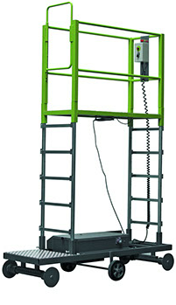  а) | 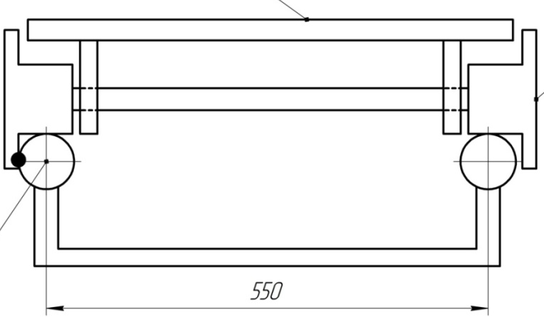  b) | 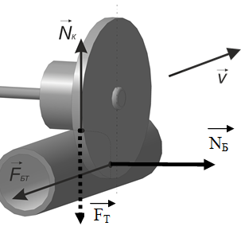  c)
FIGURE 1. Effect of lateral friction on the formation of load on the electric drive: a) External appearance; b) Lateral friction of the flange; c) 3D model of flange friction forces; N_{k} is the vertical support reaction force due to gravity, N; N_{B} is the horizontal lateral friction force of the roller flange, N.

We will verify this hypothesis during production tests, taking into account that the mobile electric machine continues to move by inertia; the torque generated on the shaft does not decrease; and the voltage control algorithm at the electric motor terminals eliminates the effect of excessive current in the winding. In this theoretical study, we will substantiate the energy efficiency of all variants of electric drives for a mobile electrified machine, namely: operation with an electric motor of rated power without an algorithm (variant 2); equipping the machine with an electric motor of three times the rated power (variant 1) and equipping the machine with an electric motor of rated power with an algorithm that excludes the effect of an overload of 200% under the condition (variant 3) that all variants of electric drives overcome the additional load due to lateral friction [6-9].

EXPERIMENTAL RESEARCH
We will evaluate the efficiency of the options using the energy consumption indicator for the same service life of the considered options. If the nominal voltage of the electric motors of all options is the same, then during the service life t, the duration of an overload of 200% of the nominal value will be tп. The energy consumption W of the considered options can be found using the expressions:
(3)

where W₁, W₂, W₃ are the energy consumption of the electric drive of the machine configuration options, respectively, at triple the nominal power, nominal power without the algorithm, and nominal power with the algorithm, eliminating electric motor overload, in W*s; U_{nom} is the nominal voltage at the electric motor terminals, in V; I₁ and I_{nom} are the currents in the electric motor windings, respectively, at triple the nominal power and nominal power of the electric motor, in A; x, y, e, f, j are the degrees of change in the parameter value depending on the overload arising due to the lateral friction of the machine roller flange; t_{н0}-t_{н} is the duration of electric drive operation in nominal mode, s; t_{п0}-t_{п} is the duration of electric drive operation in overload mode, s.
Let us represent the energy consumption of the electric drive options as the sum of the integrals of instantaneous power over time tн and tп. The interpretation of energy consumption is shown in Figure 2.
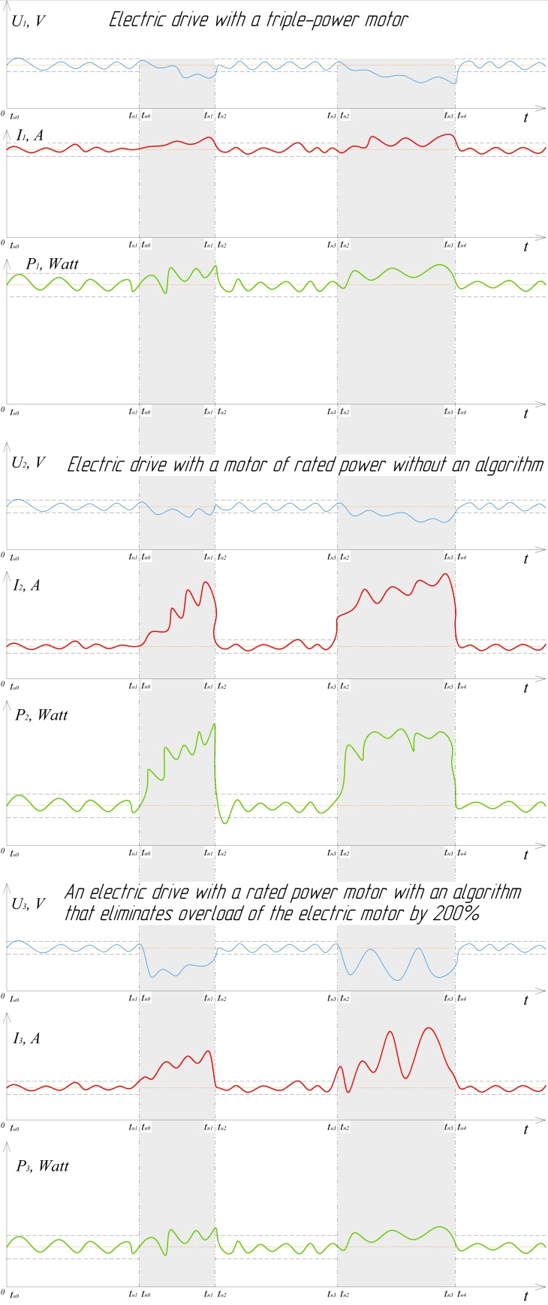
FIGURE 2. Theoretical timing diagram of the parameters of the PES electric drive by variants (U1, U2, U3 – respectively, the change in the nominal voltage by variants, V; I1, I2, I3 – respectively, the change in the current in the winding of the electric motor of the PES electric drive variants, A; P1, P2, P3 – respectively, the change in the consumed power of the PES electric drive variants, W)

An analysis of the timing diagram shows that energy consumption is significantly affected by the frequency and duration of overloads occurring during travel. We will show the energy consumption of the variants in a combined graph (Figure 3).
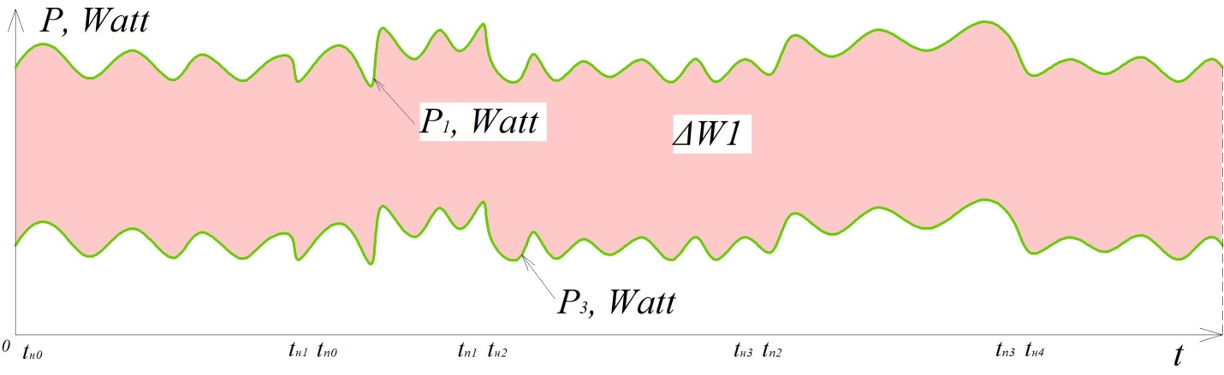
a)
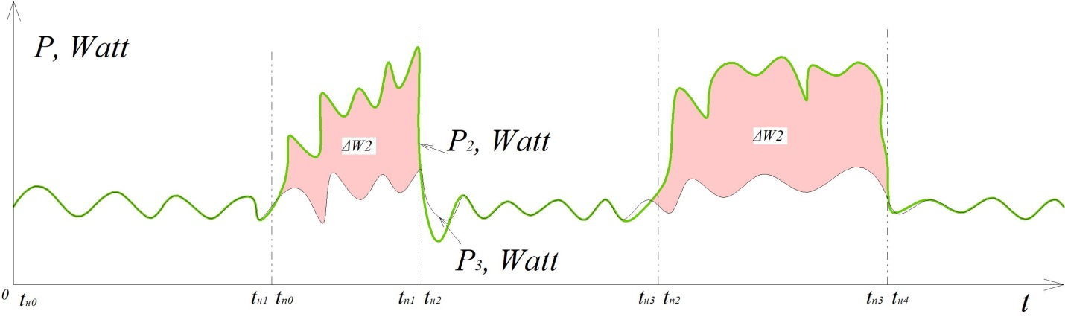
b)
FIGURE 3. Dependence of instantaneous power (energy consumption) for three PES electric drive variants (a – ΔW1 – the proportion of excess energy consumption for the variant equipped with a triple-power electric motor; b – ΔW2 – the proportion of excess energy consumption for the variant equipped with a nominal-power electric motor without an algorithm, relative to the variant equipped with a nominal-power electric motor with an algorithm that eliminates a 200% overload).

The frequency of a random event (the occurrence of lateral friction) is characterized by a normal distribution. To theoretically assess the impact of this parameter, we use the relative overload effect value θ, taking into account the number and duration of overload conditions.
(4)
where n is the number of overload conditions occurring during the operating time t of the mobile electric vehicle.
Let us evaluate the influence of the relative overload effect on the energy efficiency of the electric drive variants of a mobile electric machine, making a number of assumptions:
- the degrees of change in the current and voltage parameters x, y, e, f, j when changing the operating mode (from nominal to overload mode) are assumed to be equal to 1, assuming that the power of the battery power source is significantly greater than the power of the electrical receiver;
- the rated current of an electric drive with an electric motor of triple the power (variant 1) is 3 times higher than the rated current of the other variants;
- when overload mode occurs, the current of an electric motor of nominal power without the algorithm (variant 2) increases 3 times;
- in overload mode, the current of an electric motor with the algorithm that excludes 200% overload (variant 3) does not exceed 1.4 I_{nom} according to [10];
- the action of the algorithm that excludes 200% overload of the electric motor reduces the rated voltage by one step, according to [10]. Taking these assumptions into account, over the service life of
t = t_{п} + t_{nom}, (5)
the energy consumption of the electric drive variants of a mobile electric machine will be:
$\left.\begin{aligned}&W_{1}=3U_{nom}I_{nom}(t_{н}+t_{п}), \\ &W_{2}=U_{nom}I_{nom}(t_{н}+3t_{п}), \\ &W_{3}=U_{nom}I_{nom}(t_{н}+\frac{1,4}{2,0}t_{п}).\end{aligned}\right\}.$ (6)
If
t_{п} = θ t,
t_{н} = (1 – θ) t,
А = U_{nom} I_{nom},
Then expression (5) will take the form
(7)
Based on expression (6), we find ΔW1 and ΔW2, which are shown in Figure 3, using the expressions:
(8)
RESEARCH RESULTS
We will show the change in the share of excess energy consumption of options 1 and 2 electric drives relative to the option of equipping with an electric motor of rated power with an algorithm that excludes an overload of 200%, in Figure 4.
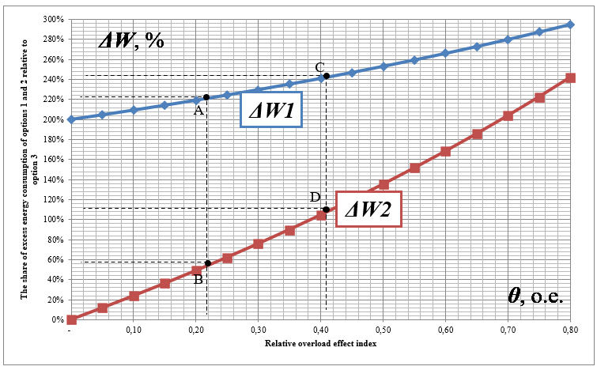
FIGURE 4. Dependence of the proportions of excess energy consumption of options 1 and 2 electric drives relative to option 3 of an electric motor with rated power and an algorithm that eliminates 200% overload, relative to the change in the relative overload effect indicator (frequency and duration of the overload mode)

Considering the above assumptions, Figure 4 shows that, with a relative overload effect indicator θ = 20%, the reduction in energy consumption between options 1 and 3 (1 is three times the electric motor power; 3 is the rated power of the electric motor with an algorithm that eliminates 200% overload by reducing the terminal voltage by a factor of 2) will be 3.2 times (point A in Figure 4), compared to options 2 and 3, it will be 1.5 times (point B in Figure 4). If the frequency and duration of the overload mode increases to 0.4 (40%), then it is possible to achieve a reduction in energy consumption using an electric motor with a rated power and algorithm relative to option 1 ΔW1 by 3.4 times and, accordingly, in comparison with option 2 ΔW2 by 2.1 times.
CONCLUSIONS
From an energy conservation perspective, a battery-powered power source for a mobile electric vehicle is economically impractical. Autonomous power sources are equipped with additional devices (capacitors, current limiters) to reduce the negative impact of sudden, random overloads and maintain reliability within the required range. At the same time, using an AC power source expands the flexibility of using various control schemes with frequency converters and other known devices, thereby eliminating additional operating costs associated with a battery power source.
Therefore, using an algorithm that prevents overloading of the electric motor in the electric drive of a mobile electric vehicle with a rated power required to support a lifting capacity of 100-150 kg increases energy efficiency by 1.5-3.4 times compared to traditionally established solutions, namely, using three times the electric motor's capacity or the rapid failure of both the electric motor and the battery power source under random overload conditions. The established theoretical dependence of energy consumption reduction depending on the relative effect of overload during the service life should be tested in practice.
REFERENCES
1. Oskin S. V., Bogatyrev N. I. Electric drive. Krasnodar: OOO KRON, 2016. 490 p.
2. Pavlovich S. N. Automated electric drive: lecture course for students majoring in "Technological equipment for mechanical engineering production". Minsk: BNTU, 2008. 128 p.
3. Handbook of electric machines: in 2 volumes / edited by I. P. Kopylov, B. K. Klokov. Vol. 1. Moscow: Energoatomizdat, 1988. 456 p.
4. Anosov V. N., Kaveshnikov V. M. Improving the efficiency of traction electric drive systems of autonomous vehicles: monograph. Novosibirsk: Publishing house of NSTU, 2014. 218 p.
5. Bakirov S. M., Ishchenko A. P. Evaluation of the influence of the flange on the power of the electric drive of a rail electrified machine // Bulletin of the Kurgan State Agricultural Academy. – 2019. – No. 4 (32). – P. 61-65.
6. Zaky M. S. A self-tuning PI controller for the speed control of electrical motor drives //Electric Power Systems Research. – 2015. – Т. 119. – С. 293-303.
7. Vanchinathan K. et al. Design methodology and experimental verification of intelligent speed controllers for sensorless permanent magnet brushless DC motor: intelligent speed controllers for electric motor //International Transactions on Electrical Energy Systems. – 2021. – Т. 31. – №. 9. – С. e12991.
8. Pavlenko V., Ginzburg M. Justification of the range of speed control of drives based on valve electric motors // Technologies of the fuel and energy complex. - 2006. - No. 5. - P. 43-48.
9. Boljanović S., Maksimović S. Computational mixed mode failure analysis under fatigue loadings with constant amplitude and overload //Engineering Fracture Mechanics. – 2017. – Т. 174. – С. 168-179.
10. Urazbakhtin R. R. Critical operating modes of an integrated starter-generator // The journal presents scientific reviews, articles of a problematic and scientific-practical nature. - 2022. - P. 31.

