Predictive Modeling of Diesel Engine Oil Health Considering Contamination Dynamics and System-Level Fault Scenarios
Abzal Biniyazov¹, ᵃ⁾, Lyazat Sadykova¹, Bibigul Sarguzhiyeva¹, Akylbek Omarov¹, Anvar Saidkhodjaev ², Alibi Bijanov³
¹ West Kazakhstan Innovative Technological University, Uralsk, Republic of Kazakhstan
² Tashkent state technical university named after Islam Karimov, Tashkent, Uzbekistan
³ Karakalpak State University named after Berdakh, Nukus, Uzbekistan
^{a)} Corresponding author: abiniyazov@mail.ru
Abstract. The reliable operation of modern diesel engines operating under high thermal and mechanical loads critically depends on the condition of the lubricating oil. During real exploitation, engine oil is continuously exposed to contamination by fuel dilution, coolant leakage, and wear debris, which leads to progressive degradation of its physicochemical properties and accelerates component wear. Conventional oil condition monitoring methods are largely based on laboratory analysis and do not provide continuous insight into oil degradation dynamics under varying fault scenarios. This study proposes a system-oriented dynamic mathematical model for assessing diesel engine lubricating oil degradation under the influence of contaminant intrusion and operational faults. The lubrication system is represented using a control-volume approach, allowing mass balance equations to describe oil circulation, consumption, replenishment, and contaminant accumulation. A multicomponent mixture model is developed to quantify the evolution of kinematic viscosity as a function of temperature and the mass fractions of oil, fuel, coolant, and solid impurities. In addition, a kinetic model based on chemical reaction principles is formulated to capture the temporal variation of the oil’s alkaline reserve under normal and faulty operating conditions. Numerical simulations demonstrate that fuel and coolant ingress significantly accelerate oil degradation, while periodic oil replenishment partially compensates for the loss of functional properties. The results indicate that monitoring oil level alone is insufficient to distinguish the nature of contamination, whereas the temporal behavior of kinematic viscosity and alkaline number provides a reliable diagnostic indicator of underlying system faults. The proposed modeling framework offers a practical foundation for condition-based maintenance strategies and can be integrated into onboard monitoring systems to enhance early fault detection and improve diesel engine reliability.
INTRODUCTION
The continuous growth in power density, efficiency requirements, and environmental regulations has significantly increased the operational stress imposed on modern diesel engines. Under such conditions, the lubrication system becomes a critical factor governing engine reliability, thermal stability, and wear resistance. Engine oil performs several essential functions, including friction reduction, heat dissipation, contaminant suspension, and corrosion protection. Any degradation in oil properties directly affects the tribological behavior of engine components and may lead to premature failures.
During real-world operation, diesel engine oil is exposed to multiple contamination mechanisms. Fuel dilution caused by incomplete combustion or injector malfunction, coolant ingress resulting from sealing defects, and solid wear particles generated by frictional interactions progressively alter the oil’s physicochemical properties. These contaminants influence key diagnostic parameters such as kinematic viscosity and alkaline reserve, reducing the oil’s lubricating effectiveness and accelerating component degradation. Importantly, these processes often evolve gradually and remain undetected until severe damage occurs.
Conventional oil condition monitoring approaches are primarily based on periodic laboratory analysis, which, although accurate, are costly and unsuitable for continuous diagnostics. In practical operation, oil level monitoring alone is insufficient, as an apparent increase in oil volume may result from contaminant ingress rather than replenishment. Consequently, there is a strong need for advanced diagnostic methods capable of capturing the dynamic evolution of oil properties under varying operating and fault conditions, without reliance on frequent laboratory testing.
The temperature dependence of kinematic viscosity represents one of the most informative indicators of oil condition, as viscosity directly governs hydrodynamic lubrication regimes and oil film stability. Each fluid present in the lubrication system exhibits a unique viscosity–temperature relationship, and even small amounts of fuel or coolant contamination can cause measurable deviations from the expected oil behavior.
Mathematical modeling offers a powerful framework for describing these processes in a quantitative and physically consistent manner. Physics-based models allow the integration of mass balance principles, fluid flow dynamics, and chemical kinetics to simulate oil circulation, consumption, replenishment, and contaminant accumulation. Such models are particularly valuable for diesel engines, where lubrication system behavior is strongly coupled with combustion processes, thermal loading, and mechanical wear mechanisms.
In this study, a system-oriented dynamic mathematical model of the diesel engine lubrication system is developed using a control-volume approach. The model accounts for oil flow distribution, evaporation losses, periodic replenishment, and contaminant ingress from fuel and cooling systems. Temperature-dependent viscosity models and kinetic equations describing alkaline additive depletion are integrated into a unified framework, enabling continuous assessment of oil condition under normal and faulty operating scenarios.
The proposed modeling approach provides a robust foundation for condition-based maintenance and early fault diagnosis. By enabling real-time evaluation of oil degradation trends, it offers a practical alternative to traditional laboratory-based methods and supports improved reliability, reduced maintenance costs, and extended service life of diesel engines operating under demanding conditions.

RESULT AND DISSCUSSION
The developed dynamic mathematical model was numerically implemented to investigate the evolution of lubricating oil properties in a diesel engine under various operational and fault conditions. The simulation framework integrates mass balance equations, temperature-dependent viscosity models, and kinetic descriptions of additive depletion, enabling a comprehensive assessment of oil degradation dynamics during real engine operation.
One of the key results concerns the temperature dependence of kinematic viscosity for individual fluids involved in the lubrication system. Regression-based models were used to approximate the viscosity–temperature relationships for motor oil, diesel fuel, and coolant. These relationships serve as the basis for evaluating the viscosity of the multicomponent oil mixture. The results clearly demonstrate that each fluid exhibits a distinct nonlinear viscosity response to temperature variation, which makes viscosity a sensitive indicator of contamination. learning environments.
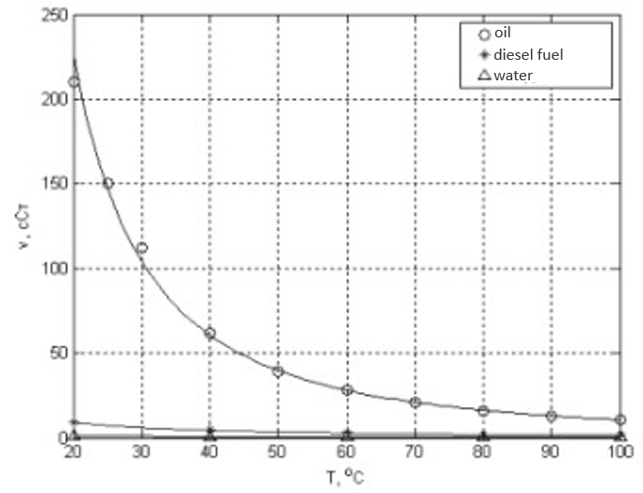
FIGURE 2. Functional dependences of kinematic viscosity on temperature for engine oil, diesel fuel, and coolant.

As shown in Figure 1, the viscosity of motor oil decreases monotonically with increasing temperature, following a characteristic nonlinear trend. In contrast, diesel fuel exhibits significantly lower viscosity values across the entire temperature range, while the coolant demonstrates a different slope and curvature. These differences enable the identification of contamination effects, as even small amounts of fuel or coolant cause measurable deviations from the nominal oil viscosity curve. The accuracy of the regression approximations was validated using the relative error criterion:

$ε=\frac{1}{n}\sum_{i=1}^{n}{∣\frac{ν_{i}^{\text{calc}}-ν_{i}^{\text{exp}}}{ν_{i}^{\text{exp}}}∣}$ (1)
which confirmed an acceptable level of agreement between experimental and calculated values.
The temporal evolution of the oil mixture mass in the crankcase was analyzed by solving the mass balance equation:
$\frac{dM_{\text{mix}}}{dt}=G_{\text{in}}-G_{\text{out}},$ (2)
where $M_{\text{mix}}$is the total mass of oil with contaminants, $G_{\text{in}}$represents oil replenishment and contaminant ingress, and $G_{\text{out}}$accounts for oil consumption due to evaporation, leakage, and combustion. Simulation results reveal that oil replenishment masks the accumulation of contaminants by maintaining the total mass within acceptable limits, thereby complicating fault detection based solely on oil level measurements.
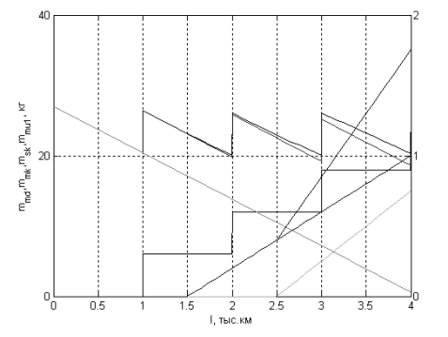
FIGURE 2. Variation of the mass of engine oil, diesel fuel, and coolant in the diesel engine crankcase considering oil replenishment, oil consumption, and system faults.

Figure 2 illustrates the dynamic interaction between oil replenishment, oil consumption, and contaminant accumulation. The results show that fuel and coolant ingress lead to a progressive increase in total mixture mass, while simultaneously reducing the effective fraction of pure motor oil. Notably, after the onset of coolant leakage, the required oil replenishment volume decreases due to the artificial increase in crankcase level caused by contaminant inflow. This finding confirms that oil level monitoring alone cannot distinguish between healthy operation and contamination-induced volume growth. To further analyze this effect, the percentage of contaminants in the oil mixture was calculated as:
$C_{\text{imp}}(t)=\frac{M_{\text{imp}}(t)}{M_{\text{mix}}(t)}×100\%.$ (3)
The simulations indicate a sharp increase in contaminant concentration following the activation of fault scenarios, particularly coolant leakage, which leads to rapid deterioration of lubricating properties.
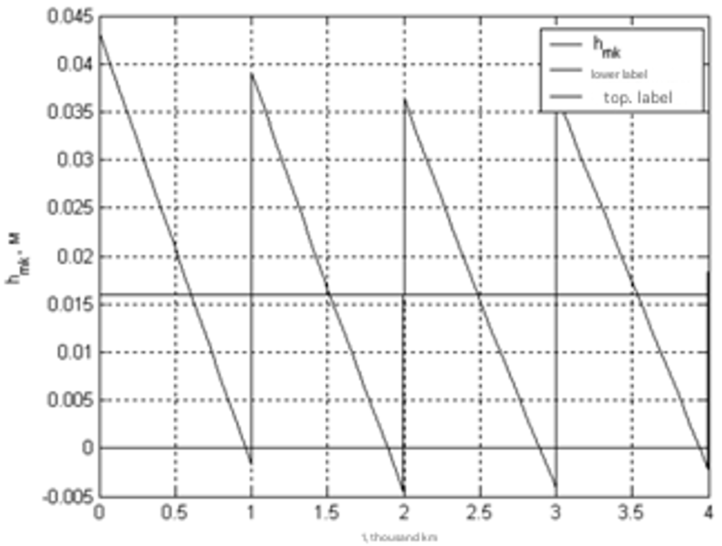
FIGURE 3. Dynamics of the working mixture volume in the diesel engine crankcase indicating the minimum and maximum permissible levels.

Figure 3 demonstrates the evolution of the oil mixture level relative to the permissible operating range. The results reveal that contaminant ingress shifts the mixture volume toward the upper threshold, delaying oil replenishment triggers and increasing the risk of operating with degraded oil. This behavior highlights a critical diagnostic limitation of level-based maintenance strategies and underscores the importance of monitoring oil quality parameters rather than volume alone.
A key diagnostic outcome of the study is associated with the temporal evolution of the alkaline number (BN), which reflects the oil’s ability to neutralize acidic byproducts of combustion. The degradation of alkaline additives was modeled using a kinetic equation of the form:
$\frac{dC_{\text{BN}}}{dt}=-kC_{\text{BN}}$ (4)
where $C_{\text{BN}}$is the concentration of alkaline additives and $k$is the reaction rate constant. The model accounts for replenishment events, which introduce fresh additives and partially restore the alkaline reserve.
Figure 4 shows that, under normal operating conditions with periodic oil replenishment, the alkaline number exhibits stepwise increases followed by gradual decay. In contrast, fuel contamination significantly accelerates the depletion of the alkaline reserve, leading to a pronounced downward trend. At an operating distance of approximately 4000 km, the alkaline number in the replenishment scenario exceeds the non-replenished case by more than one unit, demonstrating the compensatory effect of oil addition. However, this compensation is insufficient to fully offset the negative impact of persistent contamination.

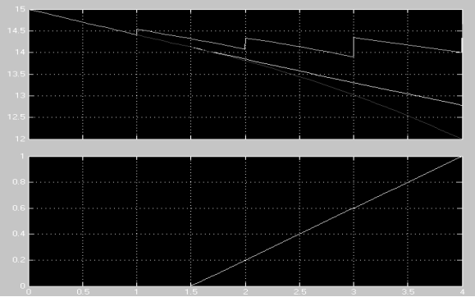
FIGURE 4. Temporal variation of the alkaline number of engine oil considering oil replenishment and fuel system faults.

Overall, the results confirm that kinematic viscosity and alkaline number are highly sensitive indicators of oil degradation and fault development. The integrated modeling approach provides quantitative insight into the coupled effects of temperature, contamination, and maintenance actions. These findings support the use of dynamic oil property monitoring as a reliable basis for condition-based maintenance and early fault diagnosis in diesel engines.
CONCLUSIONS
This study presented a comprehensive system-oriented dynamic mathematical model for assessing the degradation of lubricating oil in diesel engines operating under real эксплуатация conditions. By integrating mass balance principles, temperature-dependent viscosity modeling, and chemical kinetics of alkaline additive depletion, the proposed framework enables a quantitative description of oil condition evolution in the presence of operational faults and contaminant ingress.
The results demonstrate that fuel and coolant contamination significantly accelerate oil degradation, leading to pronounced changes in kinematic viscosity and alkaline reserve. While periodic oil replenishment partially compensates for additive depletion and viscosity loss, it also masks contaminant accumulation when oil level is used as the sole diagnostic indicator. This finding confirms that oil level monitoring alone is insufficient for reliable fault detection and emphasizes the necessity of monitoring physicochemical oil properties.
The simulation outcomes highlight kinematic viscosity and alkaline number as sensitive and robust diagnostic parameters capable of indicating early-stage faults in fuel and cooling systems. The proposed modeling approach provides a practical foundation for condition-based maintenance strategies and supports the development of onboard oil condition monitoring systems. By enabling early fault detection and optimized maintenance scheduling, the model contributes to improved diesel engine reliability, reduced operational risks, and extended service life under demanding operating conditions.

REFERENCES
- E. S. Sankovich and A. B. Sukhotsky, Hydraulics, Hydraulic Machines, and Hydraulic Drives (Belarusian State Technological University, Minsk, 2011), 141 p.
- A. M. Biniyazov and A. S. Denisov, “Analysis of quantitative and qualitative changes in the lubrication system parameters during diesel engine operation,” Bulletin of Toraighyrov University, No. 2, 119–129 (2023).
- A. S. Denisov and A. R. Asoyan, “Theoretical prerequisites for changes in detergency-dispersancy and viscosity properties of engine oil during operation of high-performance diesel engines,” Bulletin of Saratov State Technical University, No. 2(71), 129–134 (2013).
- A. I. Petrov, Technical Thermodynamics and Heat Transfer (Lan Publishing House, Saint Petersburg, 2024), 428 p.
- V. V. Bykov and V. P. Bykov, Research and Development in Mechanical Engineering (Mashynostroenie, Moscow, 2011). Available at: http://e.lanbook.com/books/element.php?pl1_cid=25&pl1_id=3312
- V. L. Konyukh, Design of Automated Production Systems (KURS Publishing House, Moscow, 2014), 312 p. Available at: http://znanium.com/go.php?id=449810
- A. M. Sychev and A. D. Shchitov, “Modeling the dynamics of an electro-hydraulic valve drive of an internal combustion engine gas distribution mechanism in the SIMULINK environment,” in Proceedings of the II International Scientific Conference ‘Problems of Control, Processing, and Information Transmission (ATM–2011)’ (Scientific Book, Saratov, 2011), pp. 348–350.
- M. G. Shatrov, K. A. Morozov, I. V. Alekseev, et al., Automotive Engines (Academy Publishing Center, Moscow, 2010), 464 p.
- A. N. Bayakhov, A. M. Biniyazov, A. Yu. Bektilevov, R. S. Sadykov, V. P. Zakharov, and L. Kh. Sarsenbaeva, “Operation maintenance of forced automobile diesel engines ensuring the functional condition of the lubrication system,” Int. J. Mech. Prod. Eng. Res. Dev. 9(3), 1761–1768 (2019).
- A. M. Biniyazov, V. Zakharov, L. Sadykova, Y. Yerbayev, and K. Turlybayev, “Improving the performance of forced automotive diesel engines by optimizing oil volume control in the lubrication system,” J. Chin. Inst. Eng. 48, 1–10 (2025). https://doi.org/10.1080/02533839.2025.2474687
- A. M. Biniyazov, A. Omarov, V. Zakharov, L. Sadykova, and A. Kazhiyakhmetova, “Character of changes in quantitative and qualitative parameters of the lubrication system during diesel engine operation,” Int. J. Eng. Trends Technol. 73(6), 466–475 (2025). https://ijettjournal.org/archive/ijett-v73i6p138
- D. K. Kushaliyev, Y. T. Yerbayev, A. M. Balgynova, R. F. Kalimullin, and A. M. Biniyazov, “Increasing the durability of car suspension shock absorbers using an innovative silent block repair kit,” ARPN J. Eng. Appl. Sci. 17(13), 1375–1381 (2022).

