Cognitive System Analysis with Psychofactor-Based Feedback for Enhancing the Didactic Efficiency of AI-Driven Training Systems in Power Engineering Education
Nikolai Tsybov¹, Zhalalidin Galbae¹, Bubuaisha Bekzhanova¹, Askarbek Karmyshakov¹, Samat Umetaliev¹, Tadjinisa Mamarasulova ^{2, a)}
¹ Kyrgyz State Technical University N. A. I. Razzakov, Bishkek, Kyrgyz Republic
²Tashkent state technical university named after Islam Karimov, Tashkent, Uzbekistan
^{a)} Corresponding author: husanovbaxtiyor7@gmail.com
Abstract. Although artificial intelligence-based training systems are widely applied in technical education, their didactic efficiency remains limited due to the dominance of purely technical design approaches that neglect cognitive and personality-related learning factors. This study proposes a methodology for enhancing the didactic efficiency of AI-driven training systems through the integration of cognitive system analysis with psychofactor-based feedback. The training system is modeled as a multi-level cognitive structure incorporating automated system-cognitive analysis, psychodiagnostics, and adaptive task regulation. Key psychofactors influencing learning performance were identified using Spearman rank correlation analysis, while their relative weights were determined using the Fishburn method. These psychofactors were embedded into the training algorithm as cognitive feedback elements that dynamically adjust task complexity and instructional support. The classical expert model of educational quality assessment was further extended by introducing psychofactor-dependent and feedback-driven coefficients. The results demonstrate that psychofactor-aware cognitive feedback reduces error intensity, improves learning efficiency, and supports the formation of advanced engineering competencies, enabling students to actively engage in complex design tasks within power engineering education.
INTRODUCTION
In power engineering education, AI-driven information training systems are increasingly used to support knowledge acquisition, laboratory simulations, and engineering design training. These systems offer substantial advantages in terms of scalability, automation, and access to complex virtual environments. However, despite their technological maturity, many AI-based training platforms demonstrate limited didactic efficiency, particularly in disciplines that require the development of high-level cognitive and design competencies.
A fundamental reason for this limitation lies in the prevailing design philosophy of information training systems, which predominantly treats such systems as purely technical artifacts. In this approach, the primary emphasis is placed on computational performance, algorithmic optimization, and interface functionality, while the cognitive characteristics, psychological states, and individual learning trajectories of students remain insufficiently addressed. As a result, the core pedagogical objective of effective knowledge transfer and competency formation is often not fully achieved. This issue is especially critical in power engineering education, where students must simultaneously master theoretical foundations, analytical reasoning, and complex circuit and system design skills.
Recent research in educational technologies highlights the growing importance of cognitive and personality-oriented approaches to learning. Cognitive system analysis provides a theoretical framework in which an educational information system is viewed as a multi-level hierarchical cognitive structure responsible for perception, processing, and feedback of information. Within this framework, learning outcomes are influenced not only by instructional content but also by cognitive and psychological factors that determine how learners perceive, process, and apply new knowledge. However, existing AI-based training systems rarely integrate cognitive system analysis directly into their operational algorithms, and even fewer incorporate formalized psychodiagnostic feedback mechanisms.
Another critical challenge in technical education is the nonlinearity and unpredictability of the learning process. Traditional evaluation models often fail to capture dynamic changes in student performance caused by psychological barriers, motivational fluctuations, and individual differences in cognitive readiness. Psychofactors such as fear, self-esteem imbalance, and responsibility perception can significantly affect students’ ability to engage in creative engineering tasks. Ignoring these factors leads to increased error intensity, reduced learning efficiency, and delayed professional skill development.
In this context, the integration of psychofactor-based feedback into AI-driven training systems represents a promising direction for improving didactic efficiency. By embedding psychodiagnostic results into cognitive system analysis, training systems can dynamically adapt task complexity, feedback intensity, and learning trajectories to individual learners. This approach enables a transition from a passive, instructor-centered model to a personality-oriented, adaptive learning paradigm in which students actively participate in the design and control of their educational process.
The purpose of this study is to develop and validate a cognitive system analysis methodology with psychofactor-based feedback for enhancing the didactic efficiency of AI-driven training systems in power engineering education. The proposed approach extends classical expert models of educational quality assessment by incorporating cognitive and psychological parameters, thereby providing a scientifically grounded framework for adaptive engineering training systems.

LITERATURE REVIEW
Researchers associate the origins of automated information training systems with the pioneering works of B.F. Skinner, who introduced the concept of linear programmed instruction in 1954, and N.A. Crowder, who later proposed branched programming in 1960 [1,2]. These foundational studies established the methodological basis for algorithmic control of the learning process. In the early 1990s, the emergence of adaptive information systems marked a new stage in educational technology development, creating the prerequisites for implementing a personality-oriented approach in technical education [3].
However, effective realization of a personality-oriented approach requires systematic consideration of students’ personal characteristics obtained through psychodiagnostics. Despite decades of progress in instructional technologies, psychodiagnostic data have rarely been embedded into the operational algorithms of automated training systems. Existing exceptions are limited to systems that account only for learners’ psycho-emotional states, without addressing deeper cognitive and personality-related factors [4].
Enhancing the didactic efficiency of technical training tools necessitates formalized results from comprehensive system analysis. A broad methodological framework for analyzing pedagogical systems was proposed by N.V. Sofronova, who combined cognitive system, structural, expert, retrospective, factor, statistical, correlation, situational, PEST, and SWOT analyses [5]. V.G. Minenko emphasized the importance of qualimetric analysis methods supported by experimental validation as a basis for evaluating pedagogical technologies [6]. To analyze the dynamic behavior of information systems, T.A. Tkalich suggested applying cognitive analysis using functional graphs [7].
Within educational research, cognitive system approaches are widely employed to identify cause–effect relationships and predict pedagogical outcomes, often through cognitive maps and functional models. However, the diagnostic accuracy of such models is constrained by the incompleteness of initial knowledge, which limits their adequacy.
Of particular significance to this study are the works of E.V. Lutsenko on automated system-cognitive analysis (ASC-analysis), which conceptualizes scientific knowledge acquisition through the construction and investigation of adequate object models [8,9]. Unlike stage-based analyses, ASC-analysis is structured around fundamental cognitive operations—perception, synthesis, abstraction, forecasting, comparison, classification, and decision-making—allowing flexible and purpose-oriented system modeling [8–10].

RESULT AND DISSCUSSION
At present, systemic cognitive analysis is primarily applied in education to monitor learning outcomes, control instructional quality, forecast educational performance, and support decision-making under conditions of nonlinearity and uncertainty. In particular, automated system-cognitive analysis (ASC-analysis), developed by E.V. Lutsenko, has demonstrated high effectiveness in modeling complex educational systems and analyzing their dynamic behavior [8–10]. However, existing applications of cognitive analysis are mainly limited to assessment and monitoring tasks rather than being embedded directly into the operational algorithms of information training systems.
In this study, the scope of cognitive system analysis is extended to the design and functioning of AI-driven information training systems for technical universities. In accordance with ASC-analysis procedures, the initial stage involves the formation of a formalized cognitive concept, subject-area modeling, synthesis of system models, and verification of the object under study. Unlike traditional approaches, the proposed methodology integrates enhanced cognitive system analysis with feedback directly into the training system’s algorithm.
The feedback mechanism incorporates two key components:
(i) adaptive models of virtual electronic devices with increasing levels of complexity;
(ii) cognitive qualities of the learner, formed through psychodiagnostics and psychocorrection.
The development of new cognitive qualities is achieved through psychocorrectional interventions based on the methodology of A.V. Krutikov [11]. Psychodiagnostics identifies psychofactors that negatively affect learning outcomes, particularly irrational attitudes associated with the influence of the superego. Such attitudes significantly reduce creative cognitive capacity and provoke maladaptive behavioral responses. Systematic elimination of these factors enhances students’ readiness for complex engineering tasks.
Importantly, psychodiagnostic results are used not only for correctional purposes but also as new cognitive elements within system analysis. This integration expands the functionality of cognitive system analysis and enables the training system to adapt dynamically to both academic performance and personal characteristics.
To implement this approach, a conceptual method for designing electronic devices using cognitive system analysis is proposed. In traditional engineering education, high-level specialists are trained through prolonged participation in design processes, typically lasting three to seven years. The proposed concept replaces this passive accumulation model with an active, feedback-driven design paradigm.

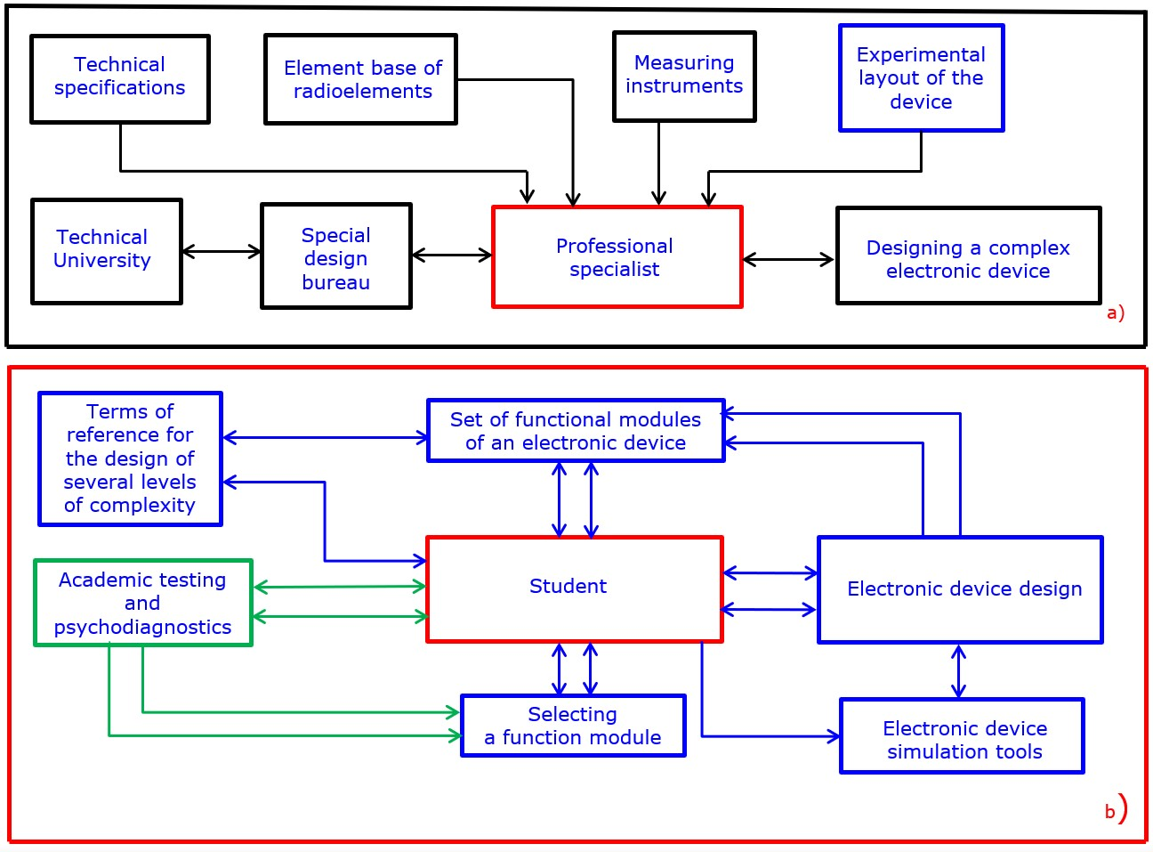
FIGURE 1. Traditional (a) and proposed (b) concepts of methods for designing electronic devices, using elements of cognitive systems analysis.

Figure 1 illustrates the traditional and proposed concepts of electronic device design training. In contrast to conventional models, the proposed approach does not require high initial qualifications. Students and young engineers are actively involved in system-level design from early stages. Cognitive feedback—incorporating psychofactors and learning outcomes—guides both the evolution of the technical solution and the professional development of the learner. Consequently, the learner transitions from a passive object to an active subject of the design process.
The training system consists of a core control unit and a variable module set comprising ten functionally equivalent electronic units of increasing complexity. The most advanced module corresponds to patent-level technical solutions. Psychodiagnostic assessment assigns each student to one of ten readiness levels, determining the complexity of the design task offered.
Initially, students are assigned a basic electronic unit. They calculate component parameters and model the unit in one of several simulation environments. Each completed design is evaluated automatically, and the system progressively offers more complex tasks with enhanced technical requirements. The final outcome is the independent design of a complex electronic unit with scientific novelty.

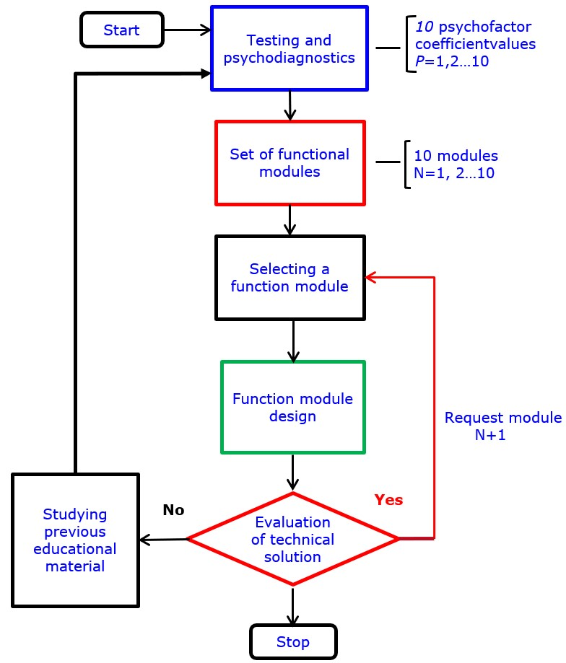
FIGURE 2. Algorithm for the functioning of the training device
From an initial set of seventy-seven psychofactors, five primary and fourteen secondary psychofactors were identified using Spearman rank correlation analysis. The correlation coefficient is calculated as:
$\begin{matrix} & ρ=1-\frac{6∑d^{2}}{n\left(n^{2}-1\right)} & & \end{matrix}$ (1)
where $d$is the rank difference and $n$is the number of criteria.
Statistically significant correlations ($p<0.05$) were observed only for the first five psychofactors, confirming their dominant influence on academic performance. According to Krutikov’s theory, the first psychofactor acts as a generative cause for the others, which was confirmed by inter-factor correlation analysis.
To integrate psychofactors into the training algorithm, a generalized criterion was formed using the Fishburn weighting method. The weighting coefficient is defined as:
$\begin{matrix} & w_{i}=\frac{n-i+1}{\sum_{k=1}^{n}{k}} & & \end{matrix}$ (2)
The generalized psychofactor criterion is calculated as:
$\begin{matrix} & k_{Ps}=\sum_{i=1}^{n}{w_{i}}P_{i} & & \end{matrix}$ (3)
where $P_{i}$denotes the normalized value of the $i$-th psychofactor.
Monitoring educational quality is challenging due to the nonlinear nature of learning processes. Therefore, the expert quality model proposed by S.A. Gordienko was extended by introducing psychofactor-dependent and feedback-dependent coefficients.
The generalized efficiency coefficient of the learning process is expressed as:
$\begin{matrix} & P_{omo}=\int_{0}^{T}{f(}v_{j},ΔΘ_{j}) dt & & \end{matrix}$ (4)
The relative preparation coefficient after the $j$-th lesson is:
$\begin{matrix} & v_{j}=δ_{j}(1-q_{j}Δt_{j}) & & \end{matrix}$ (5)
To incorporate psychofactors and adaptive feedback, new coefficients were introduced:
$\begin{matrix} & δ_{j}=δ_{j-1}⋅P_{j} & & \end{matrix}$ (6)
$\begin{matrix} & q_{j}=B_{0}⋅F_{j} & & \end{matrix}$ (7)
where $P_{j}$reflects psychofactor readiness and $F_{j}$represents task complexity feedback.
The resulting expressions become:
$\begin{matrix} & P_{omo}^{*}=P_{omo}\left(P_{j},F_{j}\right) & & \end{matrix}$ (8)
$\begin{matrix} & v_{j}^{*}=v_{j}(P_{j},F_{j},R_{zn}) & & \end{matrix}$ (9)
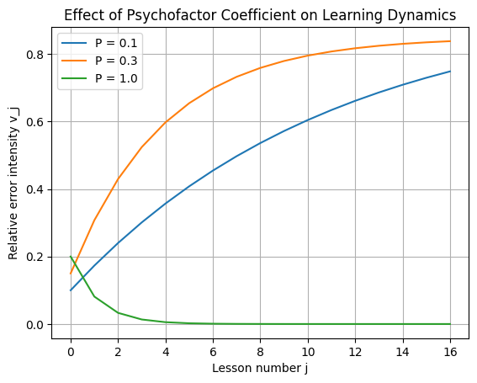
FIGURE 4. Effect of Psychofactor Coefficient on Learning Dynamics
The figure 4 illustrates the simulated dependence of the relative error intensity $v_{j}$on the lesson number $j$for three different values of the psychofactor coefficient $P$. The curves were generated using the proposed cognitive–psychofactor model and reflect the dynamics of learning efficiency under varying levels of psychofactor readiness. As shown in the figure, the psychofactor coefficient has a decisive influence on the learning trajectory. For a low psychofactor level (P = 0.1), the relative error intensity decreases slowly, indicating weak cognitive readiness and insufficient internal resources for stable knowledge acquisition. In this case, learning remains inefficient even after a large number of lessons, reflecting the negative impact of unresolved psychofactors on perception and feedback assimilation.
At a moderate psychofactor level (P = 0.3), the reduction in error intensity becomes more pronounced, demonstrating improved adaptation to the training process. However, the curve still asymptotically approaches a relatively high error level, suggesting partial but incomplete compensation of cognitive and psychological limitations.
In contrast, for a high psychofactor level (P = 1.0), the error intensity rapidly converges toward zero within the first few lessons. This behavior confirms that the elimination of dominant negative psychofactors and the formation of new cognitive qualities significantly enhance feedback efficiency, accelerate learning stabilization, and enable effective mastery of complex engineering tasks.
Overall, the results quantitatively confirm that psychofactor-aware cognitive feedback is a key determinant of didactic efficiency, enabling a transition from slow, error-prone learning to stable, high-performance educational outcomes in AI-driven training systems.
CONCLUSIONS
This study demonstrated that the didactic efficiency of AI-driven information training systems in power engineering education can be significantly enhanced through the integration of cognitive system analysis with psychofactor-based feedback. Unlike conventional training platforms that primarily emphasize technical functionality, the proposed approach treats the training system as a multi-level cognitive structure that dynamically adapts to both academic performance and personal characteristics of learners.The results confirm that psychofactors exert a decisive influence on learning dynamics, error intensity, and the development of advanced engineering competencies. By incorporating psychodiagnostic data into the operational algorithms of training systems, it becomes possible to regulate task complexity, feedback intensity, and learning trajectories in a scientifically grounded manner. The use of correlation analysis and Fishburn-based weighting enabled the identification and formalization of dominant psychofactors, while the extension of the expert quality assessment model allowed these factors to be embedded into quantitative performance indicators.
Simulation results obtained using the proposed mathematical model demonstrate that higher psychofactor readiness leads to faster stabilization of learning outcomes, a substantial reduction in error intensity, and improved efficiency of knowledge acquisition. Moreover, the adaptive design methodology supports the transformation of students from passive recipients of information into active subjects of engineering design, capable of generating technically novel solutions.
Overall, the proposed cognitive–psychofactor framework provides a robust methodological foundation for the development of next-generation AI-based training systems. Its application can contribute to the accelerated preparation of highly qualified specialists in power engineering and other technical disciplines, while ensuring a personality-oriented, adaptive, and cognitively effective learning process.
REFERENCES
1. Skinner, B. F. The science of learning and art of teaching [Text] / B. F. Skinner // Harward Education Rev. – 1954. – Vol. 24. – P. 86–97.
2. Karpova, I. P. History and Prospects of Development of Automated Learning Systems [Electronic resource] / I. P. Karpova. - Access mode:
https://publications.hse.ru/mirror/pubs/share/folder/fy9jvqbotk/direct/83795635. -Title from the screen.
3. Tumbinskaia, M. V. Automated information systems in education as a tool for human-machine interaction: history and prospects [Text] / M. V. Tumbinskaia // Proceedings of the Third International Conf. "Development of computing technology and its software in Russia and the former USSR: history and prospects" (SoRuCom-2014). - M., 2014. - P. 369-376.
4. Mishina, V. E. Analysis and study of methods for automatic determination and control of the user's emotional state [Electronic resource] / V. E. Mishina // Sovrem scientific research and innovation. – 2017. – No. 4. – Access mode: URL: http://web.snauka.ru/issues/2017/04/80863. – Title from the screen.
5. Sofronova N.V. Methods of analysis of pedagogical systems. Fundamental research. 2013. No. 11-3. P. 578-583.
6. Minenko V.G., Khoroshun K.V., Romanova M.L., Bus T.V. Qualimetric methods of analysis of pedagogical technologies. Scientific notes of P.F. Lesgaft University. 2023. No. 2 (216). P. 292-296.
7. Tkalich T.A. Cognitive analysis of performance indicators of information systems. Economics and Management (Minsk). 2012. No. 3 (31). P. 93-99.
8. Lutsenko E.V. UNIVERSAL COGNITIVE ANALYTICAL SYSTEM "EIDOS". Krasnodar, 2014.
9. Lutsenko E.V., Loiko V.I., Baranovskaya T.P. Automated system-cognitive analysis - a promising tool for solving the problems of the digital society. In the collection: New quality of education and science: possibilities and prospects. Collection of articles from the international scientific and practical conference. Research Institute of History, Economics and Law. 2017. Pp. 113-117.
10. Lutsenko E.V. Problems and prospects of the theory and methodology of scientific knowledge and automated system-cognitive analysis as an automated method of scientific knowledge providing meaningful phenomenological modeling. Polythematic online electronic scientific journal of the Kuban State Agrarian University. 2017. No. 127. P. 1-60.
11. Krutikov, A. V. Personal psychologist. Synharmonic psychotraining [Electronic resource] / A. V. Krutikov. - 2nd ed., revised and enlarged - 2012. - 244 p. - Access mode: livemusik-nuernberg1.jimdo.com/russian/книги/ WV Weltall Verlag e.K. - Title from the screen.
12. Potashnik, M. M. Quality management of education [Text]: practical orientation monograph and method. manual / M. M. Potashnik. - M .: Pedagogical Society of Russia, 2000. - 448 p.
13. Tsybov, N. N. Analysis and formalization of the components of the quality of the educational process [Text] / N. N. Tsybov // Vestn. Voronezh. in-ta high technologies. - 2019. - No. 1 (28). - P. 147-152.
14. Gordienko, S. A. Using an expert system to calculate the indicator of theoretical training of a student / S. A. Gordienko, I. V. Trubachev, V. A. Yarmysh // Innovative technologies in the educational process: materials of the XIX All-Russian scientific and practical. conf. - M., 2017. - P. 55-60.

