Prospects and Operational Reliability of Dry Gas Dynamic Seals in Centrifugal Compressors: An Industrial Case Study from a Refinery Hydrogen System
Lyazat Sadykova ¹, S. V. Oleynikov¹, A. B. Kairanbayeva¹, Yusup Hamidov²
¹ West Kazakhstan Innovative Technological University, Uralsk, Republic of Kazakhstan
²Termez State University of Engineering and Agrotechnology, Termez, Uzbekistan
^{a)} Corresponding author: lazatsadykova022@gmail.com
Abstract. Dry gas dynamic seals (DGDS) have become a critical technology for improving the reliability, efficiency, and environmental safety of centrifugal compressors operating under high-pressure and high-speed conditions in the oil and gas industry. This paper pressents an industrial case study and engineering analysis of replacing conventional oil-based mechanical seals with double dry gas dynamic seals on a centrifugal compressor unit (CK-1) operating in a hydrogen-containing gas system at the Atyrau Oil Refinery. The limitations of traditional oil seals—including excessive thermal loading, oil leakage, catalyst contamination, and high lifecycle costs—are systematically analyzed. The operating principle of gas-dynamic sealing stages, including spiral-groove pressure generation and non-contact operation, is described in detail. Special attention is given to the design and implementation of buffer and separation gas supply subsystems, as well as to the automation architecture for real-time monitoring, alarm generation, and emergency shutdown. The results demonstrate a significant reduction in leakage rates, elimination of oil ingress into the process gas, extended seal service life (up to 100,000 h), and a substantial decrease in energy consumption and maintenance costs. The proposed control and protection system ensures safe compressor operation under variable process conditions and complies with API 617 requirements. The findings confirm the technical and economic feasibility of DGDS deployment in refinery hydrogen compression systems.
INTRODUCTION
Centrifugal compressors of various designs and purposes are extensively employed in the oil and gas sector for the transportation and compression of gaseous hydrocarbon streams. Within such machinery, one of the most critical and persistently challenging technical issues is ensuring high reliability of the rotor shaft sealing system [1].
Until 2004, the majority of centrifugal compressors were equipped with oil-lubricated mechanical face seals (Fig. 1). In these arrangements, sealing of the friction pair—comprising a stationary cartridge (1) and a rotating cartridge (2)—was achieved by supplying barrier oil at a pressure approximately 1.5–2.0% higher than that of the compressed gas. Despite widespread adoption, conventional “oil” seals exhibit a fundamental vulnerability: at high circumferential velocities, particularly under elevated process pressures, the seal cartridges are prone to thermal overload and overheating. For example, sealing natural gas at about 70 kgf/cm² with a shaft speed of 6500 rpm is technically demanding for a standard oil seal. Under such extreme operating conditions, the mechanical face seal must maintain a relatively high, regulated leakage rate between cavities A and B (Fig. 1) to remove heat and prevent catastrophic degradation of the cartridges and, consequently, seal failure.
In typical operation, most “oil–gas” leakage is collected and returned to the oil reservoir, while the separated gas is routed to a flare header or vent stack. However, a second, equally consequential drawback arises: a portion of the barrier fluid inevitably migrates into the process gas. For some operators, this primarily manifests as direct oil consumption—often on the order of 1–3 barrels per day, as reported for the oil seal systems of Cooper-Bessemer RF 2BB-30 compressors operating within the Uralsk gas compression units. For other refinery processes, the implications are far more severe and can translate into substantial financial losses [2, p. 121]. A notable example is catalytic reforming, where oil carryover into hydrogen-containing gas streams leads to contamination of high-value catalysts. In practice, oil leakage during hydrogen-rich gas compression can reduce the service life of rhenium–platinum catalysts by approximately a factor of three, thereby increasing the cost of reformate production and, ultimately, affecting the economic performance of the Atyrau Oil Refinery.
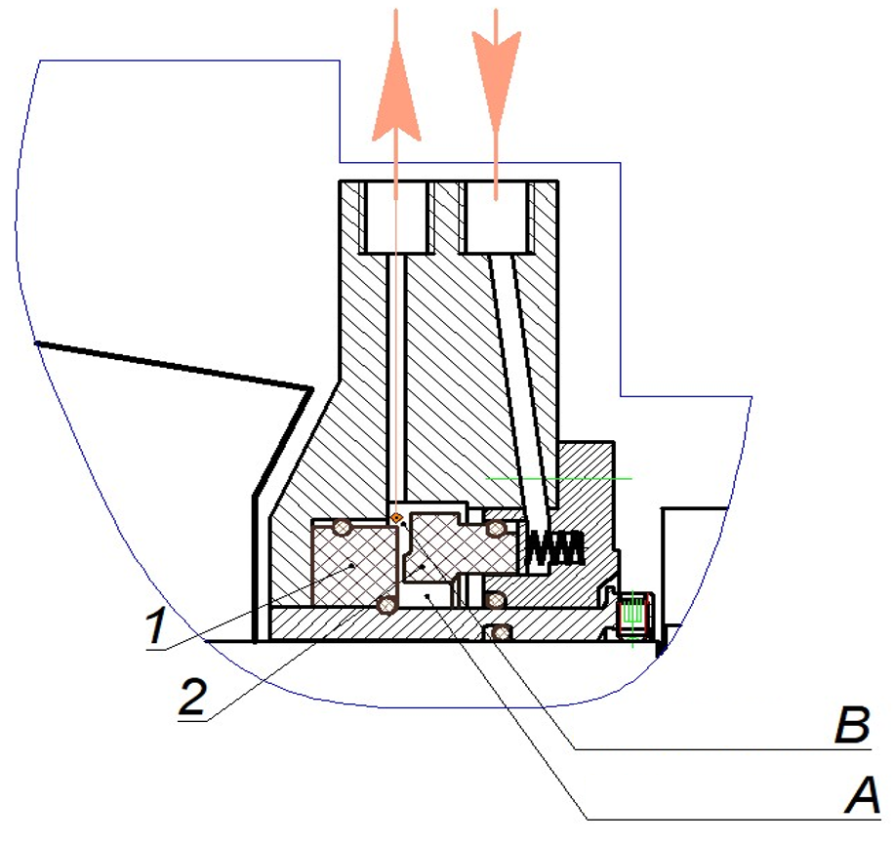
FIGURE 1. Schematic diagram of an oil-lubricated mechanical seal
By contrast, dry gas seals eliminate direct contact between sealing rings during steady-state operation; as a result, frictional heating is inherently minimized, enabling safer operation under demanding speed and pressure regimes.
In summary, the increasing complexity of power supply systems, combined with the limitations of traditional teaching methods, necessitates the development of advanced educational tools. A 5D educational simulation framework represents a promising solution by integrating technical realism, temporal dynamics, learner cognition, and outcome-based assessment into a coherent learning environment. The following sections of this article present the conceptual architecture, design methodology, and implementation principles of the proposed framework, along with an analysis of its potential impact on power supply engineering education.

METHODOLOGY
The operating principle of a dry gas dynamic seal is based on the formation of a stable, non-contact gas film between sealing surfaces. As shown in Figure 2, an axially movable ring (2) and a rotating ring (1) form a face-type sealing gap. The high-pressure gas region $P_{0}$is separated from the low-pressure region $P_{2}$by elastomeric sealing rings (3) and (4), where ring (4) allows axial displacement of the movable ring. Spiral grooves with a depth of 5–10 μm are laser-machined on the rotating ring surface, oriented at angles $φ_{1}$and $φ_{2}$relative to the outer radius.
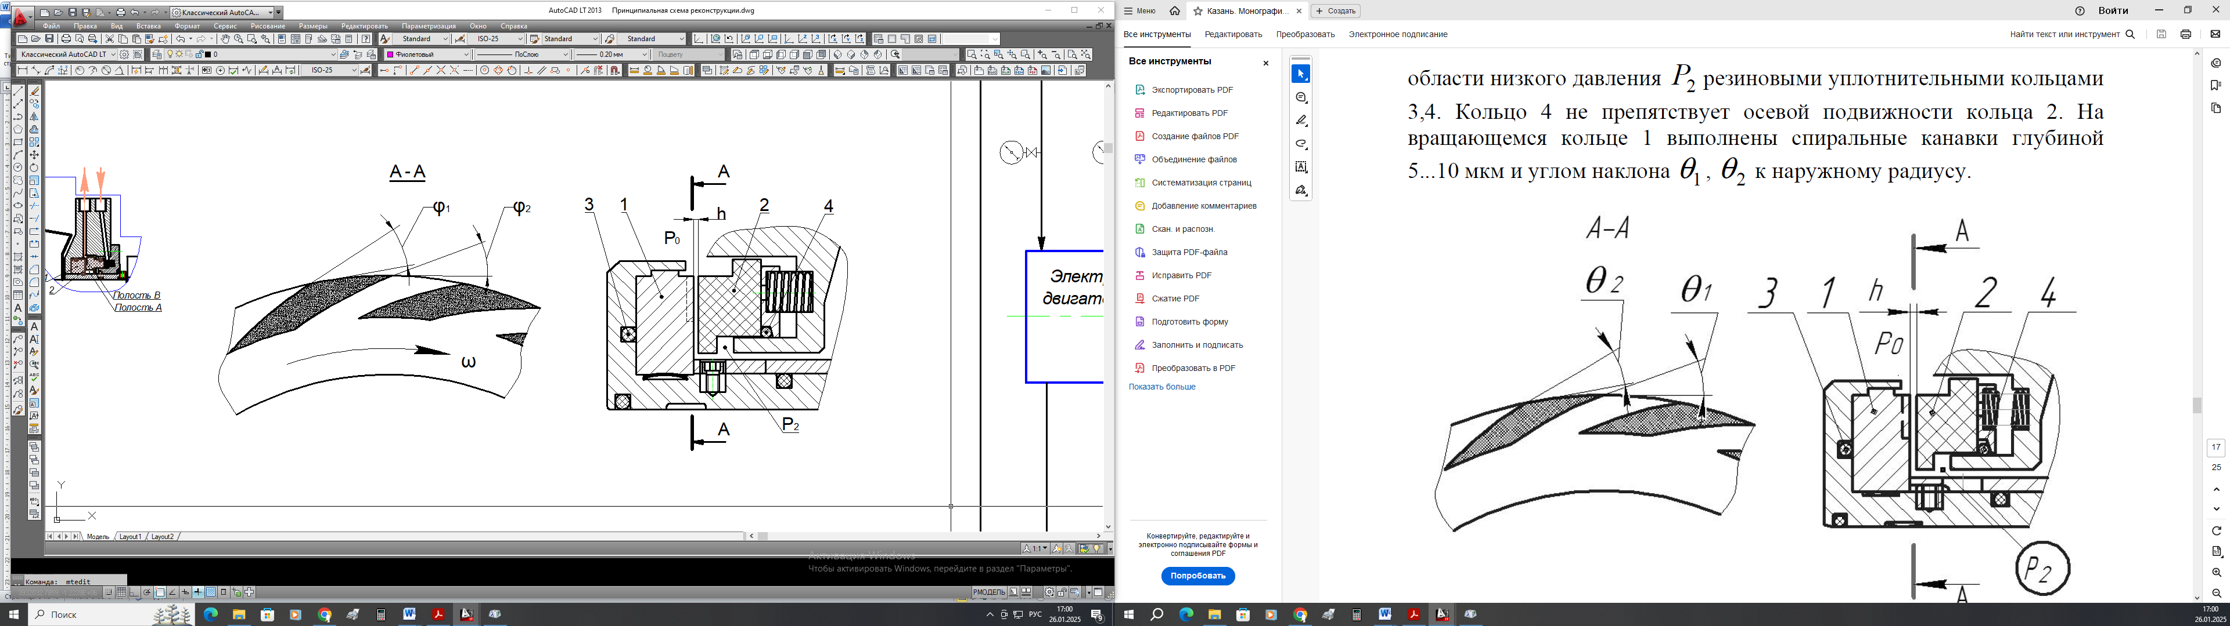
FIGURE 2. Schematic diagram of a single-stage dry gas dynamic seal
It should be noted that groove geometry varies depending on compressor characteristics, including rotational speed, pressure level, and whether the compressor operates in reversible or non-reversible modes. The unidirectional spiral groove configuration illustrated in Figure 2 is the most widely used design and has been adopted by leading DGDS manufacturers such as John Crane, EagleBurgmann, and TREM Engineering.
During rotation of the shaft with angular velocity $ω$, aerodynamic forces arise on the rear surfaces of the grooves. These forces entrain gas from the high-pressure cavity $P_{0}$and transport it radially inward along the groove axes. As a result, gas-dynamic pressure increases to a peak value $P_{k}>P_{0}$within the grooves and then gradually decreases toward the seal outlet, reaching $P_{2}$. Under the action of these forces, the axially movable ring lifts away from the rotating ring, forming a controlled sealing gap $h$. The compressed gas passing through this gap constitutes a small, regulated leakage flow $Q$.
Seal durability is ensured by maintaining a stable operating clearance of $h=2\text{–}4$μm, which provides dry gas-lubricated friction without direct contact during normal operation. When the compressor is stopped, tight sealing is achieved by direct contact of the mating seal faces.
At the Atyrau Oil Refinery, the CK-1 centrifugal compressor of the catalytic reforming unit was modernized by replacing conventional oil-lubricated seals with double dry gas dynamic seals manufactured by TREM Engineering. The implemented configuration significantly improved operational reliability without requiring major modifications to the compressor casing or shaft.
The DGDS system employed on the CK-1 compressor consists of two sealing stages, as shown in Figure 3. The primary (working) stage separates cavities A and B and ensures normal sealing performance, while the secondary (backup) stage isolates cavities B and C and provides sealing in emergency conditions. Each stage includes a rotating disk mounted on the shaft and an axially movable stationary ring installed in the compressor housing.
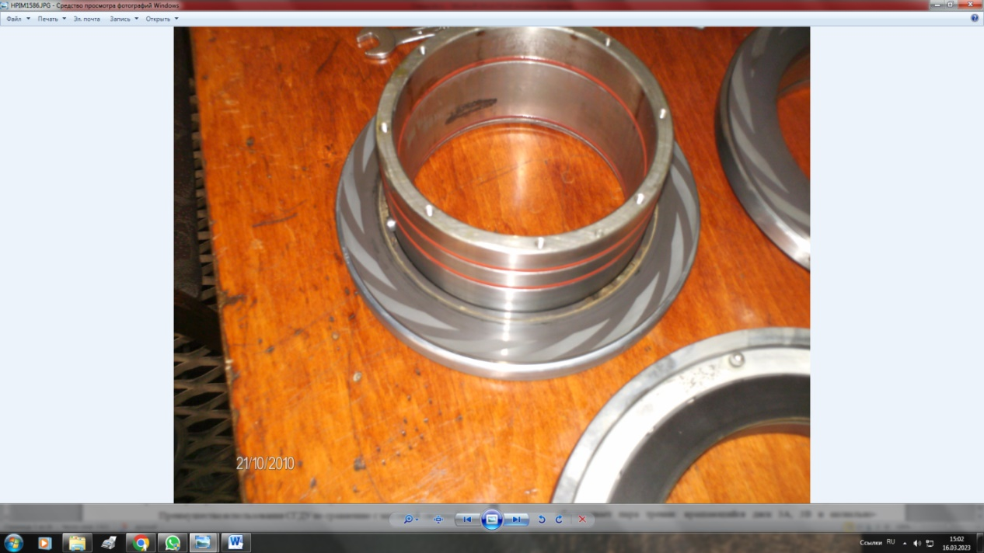
FIGURE 3. Functional layout of the double-stage dry gas dynamic sealing system
A hydrogen-containing process gas is used as buffer gas and is supplied to cavity A at a pressure slightly exceeding the process gas pressure near the rotor hub. Leakage from cavity B through the primary seal is directed to the flare system. The secondary seal is protected by an inert separation gas—nitrogen—supplied to cavity D, which prevents gas release into the bearing housing and compressor hall.
Dry gas dynamic seals are designed in accordance with API 617 requirements for axial and centrifugal compressors, with additional sealing-related provisions referenced from API 682. Over the past two decades, DGDS technology has gained widespread adoption due to its superior reliability, reduced leakage rates, extended service life, lower frictional losses, and complete elimination of oil contamination of process gases.

RESULT AND DISSCUSSION
The control system integrated into the dry gas dynamic seal (DGDS) assembly is designed to perform three essential functions:
- remote monitoring and stabilization of DGDS operating parameters within specified limits;
- transmission of standardized warning signals to the compressor control system;
- automatic emergency shutdowns and interlocks in response to hazardous operating conditions.
In general, the DGDS control architecture consists of three functional subsystems: buffer gas supply, separation gas supply, and leakage removal from internal sealing stages. The buffer gas supply subsystem is of primary importance, as it directly affects seal integrity and operational safety.
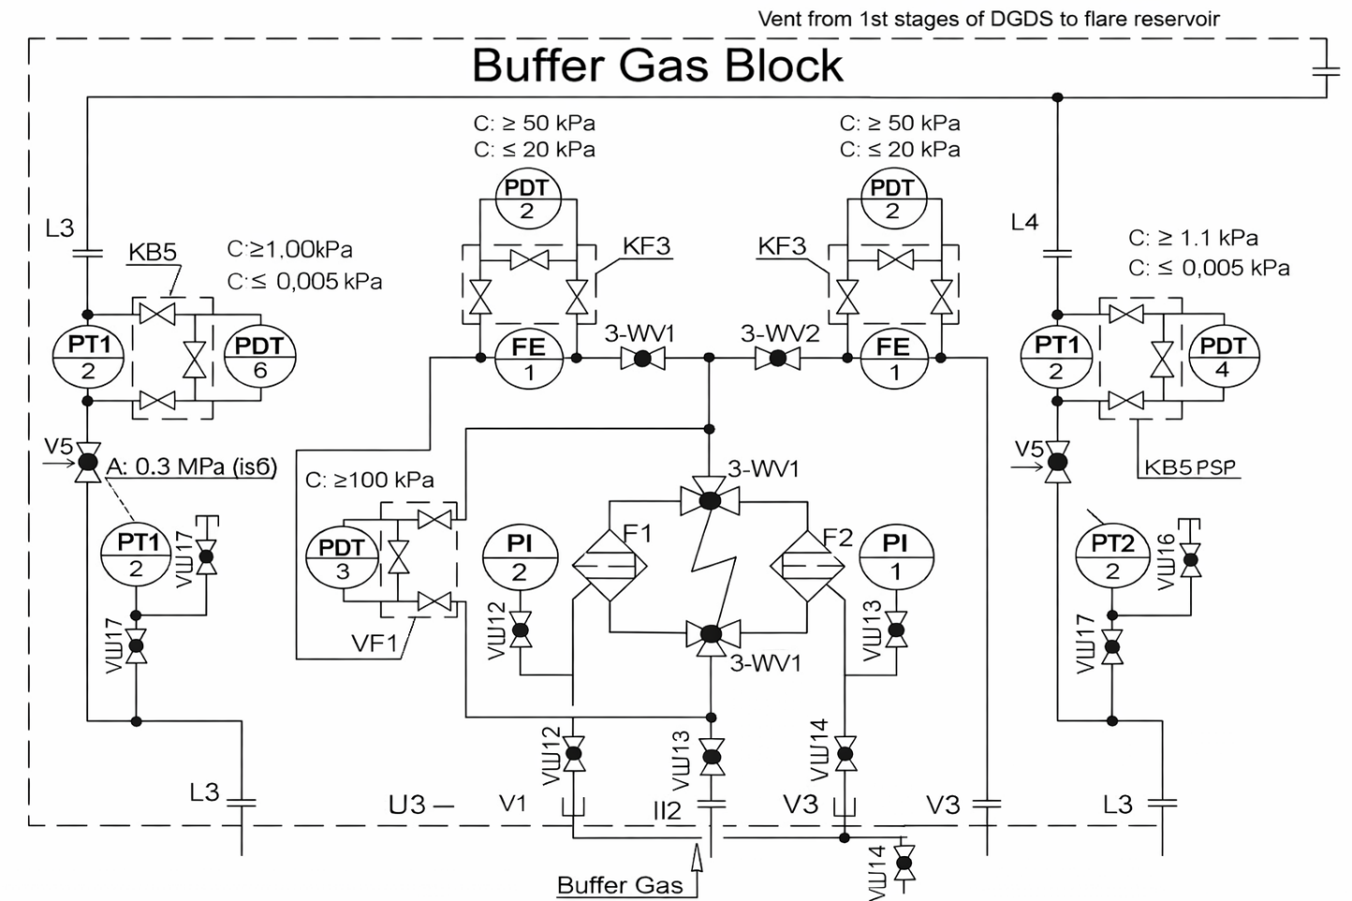
FIGURE 4. Functional diagram of the buffer gas supply unit
The buffer gas subsystem includes dual coalescing filters operating in duty–standby mode to ensure continuous operation. Filter condition is monitored in real time using a differential pressure transmitter; when the pressure drop exceeds a preset threshold (≥100 kPa), a warning signal is issued and the system switches to the standby filter. Pressure gauges provide visual confirmation of residual pressure before maintenance (Figure 4). After filtration, the buffer gas—derived from the compressor discharge hydrogen-containing gas—is divided into suction-side and discharge-side flows. Orifice plates and differential pressure sensors monitor gas flow rates, issuing alarms in case of insufficient pressure (risk of dry friction and overheating) or excessive flow (indicating seal wear).
Leakage from the primary sealing stage is monitored on the low-pressure side of the system. Pressure sensors initiate automatic compressor shutdown if pressure between the primary and secondary seals exceeds 0.3 MPa, indicating failure of the main seal (Figure 5).
The separation gas subsystem provides final isolation of the secondary seal from the bearing housing and compressor hall.
Nitrogen is used as an inert separation gas and is supplied through a pressure-regulating filter assembly. Pressure monitoring ensures immediate alarm and shutdown in case of abnormal deviations, preventing hazardous gas release into the machine hall.
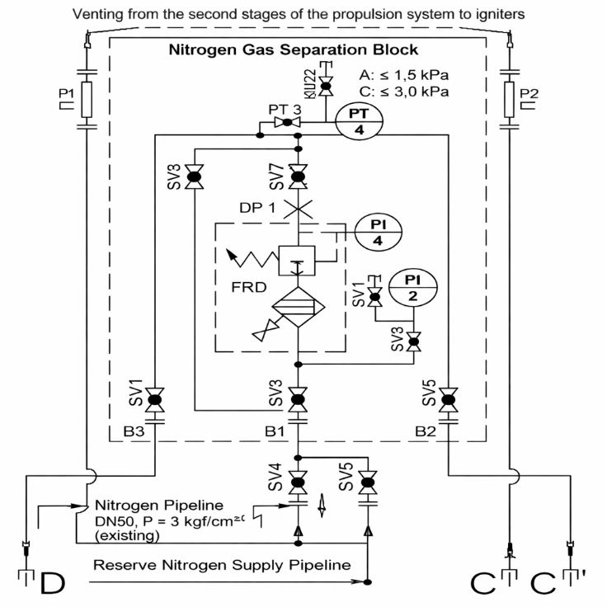
FIGURE 5. Functional diagram of the separation gas supply unit
Overall, the DGDS control system is primarily dedicated to industrial safety rather than process regulation. Automation of hydrogen-containing gas compression parameters remains unchanged and is outside the scope of this study. The implemented monitoring and protection architecture provides sufficient real-time diagnostics to ensure safe and reliable compressor operation following DGDS modernization.
CONCLUSIONS
The conducted study demonstrates that the implementation of dry gas dynamic seals (DGDS) in centrifugal compressors represents a technically sound and economically justified solution for modern oil refinery applications. The replacement of conventional oil-based sealing systems with DGDS eliminates direct mechanical contact between sealing elements during operation, thereby significantly reducing thermal loading, friction losses, and the risk of seal failure under high-pressure and high-speed conditions. The developed buffer gas and separation gas supply systems, combined with a dedicated monitoring and protection architecture, ensure stable formation of the gas-dynamic sealing gap and reliable isolation of process gas from the atmosphere.
The proposed control system provides continuous diagnostics of critical parameters, timely warning signals, and automatic emergency shutdowns, which are essential for maintaining industrial safety in hydrogen-containing gas compression units. Industrial implementation at the Atyrau Oil Refinery confirmed a substantial reduction in leakage rates, complete elimination of oil contamination of the process gas, extended seal service life, and decreased energy consumption due to the removal of high-pressure oil supply systems. Overall, the results confirm that DGDS technology, when integrated with properly designed control and protection subsystems, significantly enhances compressor reliability, operational safety, and lifecycle efficiency in accordance with API 617 requirements.
REFERENCES
- S. V. Falaleev and D. K. Novikov, “Dry gas seal for the 370-18-1 compressor,” Gas Industry, No. 4, 55–57 (1998).
- V. V. Sedov and S. V. Falaleev, “Reduction of the life-cycle cost of mechanical gas-dynamic seals for gas pumping units,” Gas Turbine Technologies, No. 7, 8–12 (2008).
- A. I. Golubev and L. A. Kondakov, Seals and Sealing Technology: A Reference Book (Mashinostroenie, Moscow, 1986), 464 pp.
- S. V. Oleynikov and A. B. Nuralina, “Dry gas dynamic seals of centrifugal compressors and control principles,” in Proceedings of the Graduate Student Research Collection of West Kazakhstan State University, Issue 1 (WKSU Publishing House, Uralsk, 2009), pp. 125–128.
- S. V. Oleynikov and A. B. Nuralina, “Basic principles of dry gas dynamic seal control,” in Proceedings of the Scientific and Practical Conference ‘Scientific and Technological Progress: Engineering, Technologies, and Education’ (K. Zhubanov Aktobe Regional University Publishing House, Aktobe, 2010), pp. 269–272.
- V. De Brasi, “Gas turbine developments,” Gas Turbine World, June, 175 (2001).
- P. I. Plastinin, Reciprocating Compressors, Vol. 1: Theory and Design (Kolos, Moscow, 2000), 456 pp.
- R. Chellini, “High-speed power turbine for the LM2500+ gas generator,” Compressor Technology, No. 6, 280 (1997).
- N. W. Korner, W. H. Day, and D. P. Smith, “Development of a water-cooled gas turbine,” ASME Publications, Paper No. GT-72, 156 (1978).
- H. Noda, “35 MW gas turbine power plant with the world’s highest thermal efficiency,” VGB Review, International Edition, No. 3, 2–10 (1980).
- V. Heder, The Sick Pump and the Sick Compressor (Gostekhizdat, Moscow, 1932), 196 pp.

