Phase Reactive Power Control Device for Voltage Balancing in Three-Phase Networks
Ikromjon Rakhmonov^{1,4}, Bakhriddin Kholikhmatov ^{1, a)}, Allayar Kosnazarov ³, Khasan Murodov²
¹ Tashkent state technical university named after Islam Karimov, Tashkent, Uzbekistan
² Navoi State University of Mining and Technologies, Navoiy, Uzbekistan
³ Karakalpak State University named after Berdakh, Nukus, Uzbekistan
⁴ Termez State University of Engineering and Agrotechnology, Termez, Uzbekistan
^{a)} Corresponding author: xolixmatov.b22@mail.ru
Abstract. Electric arc furnaces (EAFs) are among the most powerful and non-stationary industrial consumers of electrical energy. Their operation is characterized by severe phase current unevenness, rapid reactive power fluctuations, and significant voltage asymmetry in the power grid. This article discusses a voltage balancing device designed for use in EAF power supply systems and based on phase-independent control of reactive power flows. Control is achieved using controlled magnetic chokes, the inductance of which is varied by magnetizing the core via a thyristor bridge.
INTRODUCTION
Electric arc furnaces (EAFs) are widely used in modern metallurgical production due to their high productivity, technological versatility, and ability to efficiently process various types of raw materials. Their flexibility in controlling the melting process makes EAFs indispensable in steelmaking and special alloy production. However, despite these advantages, EAFs represent one of the most problematic types of electrical loads from the standpoint of power quality and power system stability.
The electric arc combustion process is inherently stochastic and highly nonlinear. During furnace operation, the arc length, arc resistance, and arc position continuously change, which leads to abrupt and irregular fluctuations of current and voltage in each phase. As a result, the power supply system experiences significant voltage asymmetry, rapid variations of reactive power consumption, voltage flicker, and increased harmonic distortion. These effects substantially degrade the electromagnetic compatibility of electrical equipment and complicate the stable operation of both the furnace itself and other consumers connected to the same network.
Voltage asymmetry in networks supplying EAFs leads to the appearance of negative-sequence components of currents and voltages. These components cause additional thermal losses in transformers, cables, and overhead lines, accelerate insulation aging, and reduce the service life of electrical equipment. Electric motors connected to such networks may operate with increased slip and overheating, while protection and automation devices may experience malfunctions or false triggering. Moreover, voltage unbalance adversely affects neighboring industrial and commercial consumers, resulting in reduced reliability and overall efficiency of the power system.
Traditional methods of reactive power compensation, such as fixed capacitor banks or stepwise-controlled capacitor installations, are generally designed for relatively stable and symmetric load conditions. In the case of EAFs, these methods prove to be ineffective due to their limited dynamic response, inertia, and inability to independently regulate reactive power in each phase. As a result, they cannot adequately compensate fast-changing and phase-dependent disturbances caused by arc furnace operation [1, 4, 7].
Therefore, the development of advanced compensation devices capable of real-time redistribution of reactive power among network phases is of critical importance. Such devices must take into account the asymmetric, dynamic, and rapidly varying nature of EAF loads and provide phase-independent control to ensure voltage symmetry, reduced losses, and improved power quality. Implementing these solutions is essential for enhancing the stability, efficiency, and reliability of power supply systems feeding electric arc furnaces.

EXPERIMENTAL RESEARCH
The electrical load of an EAFs is characterized by the following features:
- significant unevenness of phase currents;
- rapid and chaotic changes in reactive power;
- the presence of higher harmonics and voltage fluctuations;
- pronounced phase asymmetry in medium-voltage networks (35 kV).
During the melting process, arc parameters continuously change, resulting in different levels of reactive power consumption across phases. As a result, the voltage unbalance factor can exceed permissible standard values, especially in the initial stages of melting and during unstable arc combustion [2].
These features make the use of conventional compensating devices ineffective and require phase-independent and high-speed reactive power control.
The proposed device is designed for operation in the electric power supply system of an electric arc furnace and is oriented toward operation under conditions of highly transient and asymmetric loads [6]. Depending on the power supply configuration of the metallurgical unit, the device can be installed on the medium-voltage side of the power grid (35 kV) or on the secondary voltage side of the furnace transformer. The choice of connection point is determined by the requirements for compensation depth, current level, and electromagnetic compatibility conditions.
The device is designed using a phase-modular principle and consists of three identical phase modules, each of which is connected to the corresponding phase of the electric arc furnace power grid. This architecture ensures complete independence of reactive power regulation across phases, which is crucial for compensating for the asymmetrical conditions typical of electric arc operation.
FIGURE 1. Electrical schematic of the phase module of a voltage balancing device based on a controlled magnetic reactor

Each phase module of the proposed system is designed as an autonomous functional unit and includes a controlled magnetic reactor implemented on a ferromagnetic core, a power winding, a bias (magnetizing) winding, a thyristor control bridge, and a capacitor bank. The power winding of the magnetic reactor is directly connected into the corresponding phase of the power circuit and determines the magnitude of the reactive current flowing through that phase. By interacting with the network voltage, this winding forms the inductive component of reactive power, which can be continuously adjusted depending on operating conditions. The capacitor bank is connected in parallel with the reactor and generates a capacitive component of reactive power, thereby expanding the overall control range and enabling bidirectional regulation of reactive power within a wide interval.
Regulation of the reactor inductive reactance is achieved by controlled variation of the magnetic state of its ferromagnetic core. This function is realized through the bias winding, which is supplied from a controlled thyristor bridge connected to an auxiliary voltage source. By varying the thyristor firing angle, the magnitude and waveform of the bias current are adjusted, leading to changes in the magnetization level of the core. As the magnetic permeability of the core varies, the inductance of the power winding changes smoothly and continuously. This approach enables precise and stepless regulation of the phase reactive current without the need for mechanical switching devices, contactors, or tap-changing mechanisms.
The use of thyristor-based magnetic control provides high dynamic performance and fast response of the device, which is particularly important under conditions of rapidly changing and highly nonlinear loads characteristic of electric arc furnace operation. Abrupt variations in arc current and reactive power demand can be effectively compensated in real time, ensuring stable operating conditions of the power supply system. Since each phase module operates independently, the device can selectively compensate phase-specific reactive power imbalances that arise during the melting process, thereby contributing to improved voltage symmetry across the three-phase network.
An additional advantage of the proposed solution is its structural simplicity and robustness. The absence of complex inverter-based power electronic converters and the use of a minimal number of power semiconductor elements significantly enhance the reliability of the device and reduce maintenance requirements. Furthermore, the modular architecture and compatibility with conventional power equipment simplify integration into existing power supply systems of metallurgical enterprises, making the device suitable for both new installations and retrofitting of operating electric arc furnace facilities.
RESEARCH RESULTS
The operation of the proposed voltage balancing device when supplying an electric arc steelmaking furnace is based on the controlled variation of the magnetic state of the reactor core connected in each phase of the supply network. The fundamental regulating element of the system is a controlled magnetic reactor whose inductance can be smoothly adjusted by magnetizing the ferromagnetic core. This principle enables continuous control of reactive power without interrupting the power circuit or introducing mechanical switching operations. Each phase module incorporates a power winding of the magnetic reactor that is directly connected into the corresponding phase circuit, as well as a bias (magnetizing) winding designed to control the magnetic flux within the core. The bias winding is supplied from a thyristor bridge connected to an auxiliary voltage source, allowing precise electronic control of the magnetizing process. The operating mode of the thyristor bridge is defined by the thyristor firing angle, which determines both the magnitude and the waveform of the bias current applied to the magnetizing winding.
As the thyristor firing angle increases, the bias current correspondingly rises, leading to an increase in the magnetic flux density within the reactor core. When the magnetic flux approaches the saturation region of the ferromagnetic material, the magnetic permeability of the core decreases. This reduction in permeability causes a decrease in the inductance of the reactor power winding and, consequently, a reduction in its inductive reactance. Under these conditions, the reactive current flowing through the reactor increases, which corresponds to a higher consumption of inductive reactive power by the given phase of the network. Conversely, when the thyristor firing angle is reduced, the bias current decreases, allowing the reactor core to exit the saturation region. As a result, the magnetic permeability of the core increases, leading to an increase in the inductance of the power winding. This increase in inductance causes a rise in the inductive reactance of the reactor and a corresponding reduction in the reactive current flowing through the phase. In this manner, controlled variation of the magnetic state of the core provides smooth, continuous, and reversible regulation of reactive power in each phase of the supply network.
A key feature of the proposed device is the phase-independent nature of its control strategy. Each phase of the power supply network feeding the electric arc steelmaking furnace is equipped with its own controlled magnetic reactor and an independent thyristor control channel. This structural arrangement enables selective and asymmetric regulation of reactive power, making it possible to compensate for the uneven distribution of reactive power among phases that is inherent to the electric arc burning process. As a result, the voltage unbalance factor can be effectively reduced even under highly dynamic and stochastic operating conditions. It should be emphasized that, in the proposed device, the thyristor firing angle is not an optimization objective by itself but rather serves as a control variable through which the magnetic state of the reactor core is influenced. The primary physical mechanism responsible for voltage balancing is the redistribution of reactive power flows among the phases by means of controlled variation of the inductive reactances of the individual phase branches. This approach ensures that voltage symmetry is restored through fundamental electromagnetic processes rather than direct electronic intervention in the power circuit.
Due to the absence of mechanical switching elements and the reliance on magnetic regulation processes, the device exhibits high dynamic performance, rapid response, and strong resistance to abrupt load changes typical of electric arc steelmaking furnace operation. These characteristics allow the device to effectively reduce voltage unbalance and improve overall power quality in the supply network without the need for complex inverter-based systems, thereby enhancing reliability, reducing maintenance requirements, and simplifying practical implementation in industrial power supply systems.
Relationship between the thyristor firing angle and the sinusoidal voltage
To explain the principle of magnetic reactor control, Fig. 2 presents oscillograms obtained in the MATLAB/Simulink environment, illustrating the relationship between the sinusoidal network voltage and the thyristor firing instants in the magnetizing circuit [3]. Thyristor control is performed synchronously with the network sinusoid, while the firing instant is defined by the control angle α [5].

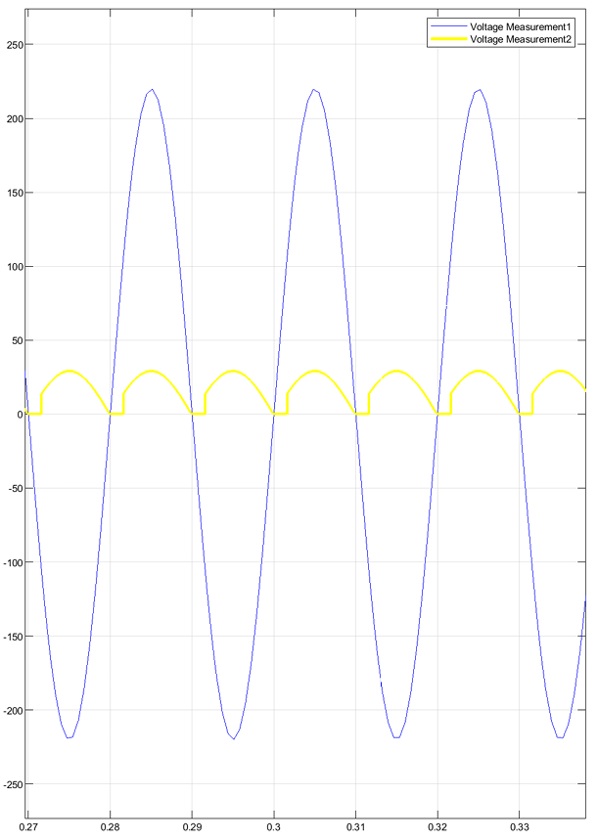 | 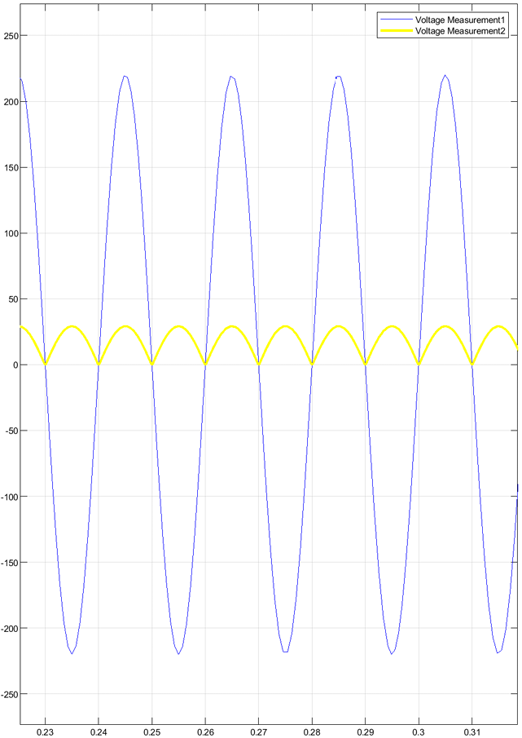
a) | b)
FIGURE 2. Oscillograms of the sinusoidal voltage and the magnetizing current of the magnetic reactor:
a) full thyristor conduction (α = 0–180°);
b) partial thyristor conduction (α = 30–210°).

Variation of the thyristor firing angle leads to a change in the waveform and average value of the bias current flowing through the control winding of the reactor. This causes a change in the magnetic state of the core and, consequently, in the inductance of the power winding. Thus, phase-pulse control of the thyristor bridge provides smooth regulation of the reactive current in the network phase without direct impact on the power circuit of the load.
The obtained oscillograms confirm that reactive power control is carried out by varying the magnetic parameters of the reactor, while the thyristor firing angle acts as a control parameter that determines the magnetization mode. This approach ensures stable and high-speed phase regulation of reactive power when supplying an electric arc steelmaking furnace.
CONCLUSIONS
The paper considers a voltage balancing device intended for application in power supply systems of electric arc steelmaking furnaces, which are characterized by sharply nonstationary and phase-unbalanced loads. The proposed solution is based on phase-independent control of reactive power flows using controlled magnetic reactors, whose inductive parameters are varied by thyristor-controlled magnetization of the core.
In contrast to conventional compensating devices designed for symmetrical operating conditions, the considered structure provides individual regulation of reactive current in each phase, which makes it possible to effectively compensate unbalances arising during the electric arc burning process. In this case, the thyristor firing angle is used as a control parameter for shaping the magnetizing current and is not an independent control objective.
REFERENCES
- Olczykowski, Z. Electric Arc Furnaces as a Cause of Current and Voltage Asymmetry. Energies 2021, 14, 5058. https://doi.org/10.3390/en14165058
- Czarnecki L.S. Reactive power under nonsinusoidal conditions // IEEE Transactions on Power Delivery, Vol. 20, No. 1, 2005, pp. 423–430.
- Gyugyi L. Application characteristics of thyristor-controlled reactors // IEEE Transactions on Industry Applications, Vol. IA-20, No. 2, 1984, pp. 262–269.
- Naqash M.Y., Rashid Z. PI controller based automatic power factor correction using capacitor bank // ECCE, 2023, Vol. 19, No. 1, pp. 40–48.
- Rakhmonov I.U., Kholikhmatov B.B., Ilyasov A.P. GENETIC ALGORITHMS AS A METHOD OF GLOBAL OPTIMIZATION: POSSIBILITIES AND LIMITATIONS // Universum: Technical Sciences: Electronic Scientific Journal. 2024. 11(128).
- Rakhmonov I.U., Kholikhmatov B.B., Saidkhodzhaev A.G. Device for reducing asymmetry // E3S Web of Conferences, 2023, Vol. 461, 01052.
- Usmanov Eldor, Kholikhmatov Bakhriddin, Rikhsitillaev Bakhodir, Nimatov, Kamoliddin. Device for reducing asymmetry // E3S Web of Conferences 461. 2023, PP, 01052, 1-5. https://doi.org/10.1051/e3sconf/202346101052

