Application of Genetic Algorithm for Optimization of Electrical Network Parameters
Shohrukh Samiev^{1, a)}, Shakhnoza Atakhanova ¹, Ibrokhimjon Abdullayev ², Rashid Nasimov³
¹Tashkent state technical university named after Islam Karimov, Tashkent, Uzbekistan
² Center for the development of professional qualification of medical workers, Tashkent, Uzbekistan
³ Tashkent State University of Economics, Tashkent, Uzbekistan
^{a)} Corresponding author: shohrux.samiyev@mail.ru
Abstract. The increasing complexity of modern electrical power systems necessitates the use of advanced optimization techniques to ensure efficient operation, reduced power losses, and stable voltage profiles. Conventional optimization approaches often encounter difficulties when addressing nonlinear, constrained, and high‑dimensional problems inherent in electrical networks. This study proposes the application of a Genetic Algorithm (GA) for optimizing key parameters of an electrical power network under realistic operating conditions. The optimization problem is formulated as a constrained nonlinear multi‑objective function aimed at minimizing total active power losses while maintaining voltage magnitudes within permissible limits. Control variables such as generator voltage settings and transformer tap positions are encoded into GA chromosomes. The proposed algorithm employs selection, crossover, and mutation operators to effectively explore the solution space and avoid premature convergence. Simulation results demonstrate that the proposed GA-based approach significantly improves network performance by reducing power losses and enhancing voltage stability compared to the initial operating state. The robustness and adaptability of the algorithm are confirmed through numerical analysis. The presented methodology offers a transparent and reproducible framework suitable for practical power system optimization problems.
INTRODUCTION
The efficient operation of electrical power networks is a fundamental challenge in modern power engineering. Increasing electricity demand, growing network complexity, and stricter reliability requirements necessitate the development of advanced optimization techniques capable of handling nonlinear behavior, multiple constraints, and high-dimensional decision spaces. One of the key operational objectives in electrical networks is the optimal selection of system parameters to reduce active power losses while maintaining acceptable voltage profiles across all nodes.
Electrical networks inherently exhibit nonlinear characteristics due to power flow equations, load variations, and complex interactions between network components. Classical optimization approaches, such as linear programming, nonlinear programming, and deterministic optimal power flow methods, have been widely applied to solve parameter optimization problems. However, these methods often face convergence difficulties, sensitivity to initial conditions, and limited capability to escape local optima when applied to large-scale or highly constrained systems. In recent years, metaheuristic optimization techniques have attracted significant attention as effective alternatives to classical approaches. These methods are particularly suitable for complex engineering problems where analytical solutions are difficult or impractical to obtain. Among various metaheuristic algorithms, Genetic Algorithms have proven to be robust and flexible tools for solving nonlinear and multi-objective optimization problems. Their population-based search mechanism enables global exploration of the solution space, reducing the risk of premature convergence and improving solution quality [3].
Genetic Algorithms simulate the process of natural evolution through selection, crossover, and mutation operations. By iteratively evolving a population of candidate solutions, GA can efficiently search for optimal or near-optimal solutions without relying on gradient information. This characteristic makes GA especially attractive for electrical network optimization problems, where objective functions and constraints are often nonconvex and discontinuous. Despite extensive research on optimization techniques for electrical networks, several challenges remain unresolved. Many existing studies focus on specific network configurations or simplified objective functions, limiting the general applicability of the proposed solutions. Furthermore, insufficient attention is often paid to the transparency and reproducibility of the optimization process, which are critical requirements for practical implementation and academic evaluation.
This paper addresses these challenges by proposing a comprehensive Genetic Algorithm-based framework for optimizing electrical network parameters under realistic operating conditions. The optimization problem is formulated as a constrained multi-objective function that simultaneously minimizes active power losses and voltage deviations. A customized GA structure is developed to effectively handle system constraints and improve convergence performance [8].
The main contributions of this study can be summarized as follows:
- formulation of a generalized optimization model for electrical network parameter selection;
- development of an original Genetic Algorithm framework tailored to power system applications;
- detailed mathematical representation of objective functions and constraints;
- demonstration of the effectiveness and robustness of the proposed approach through numerical analysis.
The proposed methodology provides a scalable and transparent optimization framework that can be extended to different network sizes and operating scenarios, making it suitable for both academic research and practical power system applications.

EXPERIMENTAL RESEARCH
This section describes the experimental procedure carried out to evaluate the performance and effectiveness of the proposed Genetic Algorithm–based optimization approach when applied to an electrical power network. The primary objective of the experimental research is to verify whether the developed algorithm can improve network performance by reducing active power losses and enhancing voltage profiles under realistic operating conditions. A realistic electrical power network model is considered for experimental analysis. The model represents a practical transmission system consisting of interconnected nodes, transmission lines, generation units, and load points. System parameters such as line impedances, load demands, and generator operating limits are defined based on standard engineering practice. Prior to optimization, an initial operating condition of the network is established using a conventional power flow calculation. This initial state serves as a reference point for evaluating the effectiveness of the proposed optimization method. Key performance indicators, including total active power losses and voltage magnitudes at all nodes, are recorded for subsequent comparison [2].
The Genetic Algorithm is configured to optimize selected control parameters of the electrical network. The control variables include generator voltage magnitudes and transformer tap settings, which directly influence power losses and voltage stability. Each candidate solution is represented as a chromosome, where individual genes correspond to specific control variables. The initial population is generated randomly within predefined operating limits to ensure diversity of solutions.
For each chromosome in the population, a power flow analysis is performed to determine the corresponding operating state of the network. Based on the obtained results, the fitness value of each solution is calculated using the objective function defined earlier, which combines active power loss minimization and voltage deviation reduction. Operational constraints, including voltage limits and generator capacity restrictions, are strictly enforced during the evaluation process. A penalty‑based mechanism is employed to handle constraint violations. Solutions that violate system constraints receive an additional penalty in their fitness value, reducing their likelihood of being selected for the next generation. This approach ensures that the evolutionary process gradually eliminates infeasible solutions while guiding the population toward optimal and physically meaningful configurations [11].
The optimization process follows an iterative evolutionary cycle consisting of selection, crossover, and mutation operations. In each generation, fitter individuals are selected to produce offspring, promoting the propagation of high-quality solutions. Crossover operations allow the exchange of information between parent solutions, while mutation introduces controlled randomness to maintain population diversity and prevent premature convergence. The iterative process continues until the maximum number of generations is reached or until improvements in the objective function become negligible over successive generations. Throughout the optimization process, the evolution of the fitness function is monitored to assess convergence behavior.
The effectiveness of the proposed optimization approach is evaluated using the following performance indicators:
- total active power losses of the network;
- voltage magnitude deviations from the reference value;
- compliance with operational constraints;
- convergence stability of the optimization process.
The optimized operating condition obtained through the Genetic Algorithm is compared with the initial operating state to quantify improvements in network performance [6].
The experimental research confirms that the proposed Genetic Algorithm‑based optimization framework is capable of effectively improving electrical network performance. The optimized solutions demonstrate reduced active power losses and improved voltage profiles while satisfying all operational constraints. The results indicate that the algorithm exhibits stable convergence behavior and maintains sufficient solution diversity throughout the optimization process. The experimental methodology and evaluation procedure are fully transparent and reproducible, providing a reliable foundation for further analysis and discussion [5].
RESEARCH RESULTS
This section presents the results obtained from applying the genetic algorithm to optimize electrical network parameters with the objective of jointly minimizing active power losses and operational costs. The optimization is evaluated using the formulated objective function, numerical values obtained before and after optimization, and the convergence behavior of the algorithm. The results show a noticeable reduction in active power losses after optimization, indicating improved energy efficiency of the network. At the same time, the total operational cost is reduced due to the coordinated adjustment of control variables within their allowable limits. This confirms that the proposed objective function effectively balances technical performance and economic efficiency [1].
The convergence curve of the objective function demonstrates stable and monotonic improvement across generations. A rapid decrease in the objective value is observed in the initial iterations, followed by gradual convergence toward an optimal solution, which indicates reliable global search and solution stability of the genetic algorithm. Overall, the obtained results validate the effectiveness of the proposed genetic algorithm-based approach for minimizing both energy losses and operational costs in electrical networks [4].
The optimization problem is formulated as a single aggregated objective function that simultaneously accounts for technical and economic criteria. The objective function is defined as:

$\min{F}=α∙\frac{P_{loss}}{P_{loss}^{base}}+β∙\frac{C_{op}}{C_{op}^{base}}$ (1)
where:
- P_{loss}​ - total active power losses in the electrical network (kW);
- C_{op}​ - total operational cost associated with energy losses and system operation;
- $P_{op}^{base}$, $C_{op}^{base}$- corresponding base-case values;
- α, β - weighting coefficients satisfying α+β =1.
This formulation ensures a balanced trade-off between technical efficiency (loss minimization) and economic performance (cost reduction).
The total active power loss in the network is calculated using the classical branch‑based formulation:
$P_{loss}=\sum_{k=1}^{N_{l}}{R_{k}∙I_{k}^{2}}$ (2)
where:
- N_{l} - number of transmission lines;
- R_{k}​ - resistance of line k;
- I_{k}- current flowing through line k.
This model allows the genetic algorithm to directly link network parameter variations to loss reduction performance.
The second key component of the objective function represents the operational costs of the electrical network. This term accounts for the economic performance of the system during operation and is expressed as a function of power generation, power exchange with the main grid, and network losses [7].
The operational cost is defined as:
$C_{op}=\sum_{1=1}^{N_{g}}{C_{g,i}∙P_{g,i}+C_{grid}∙P_{grid}+C_{loss}∙P_{loss}}$ (3)

- C_{g,i}​ - is the generation cost of the ii-th distributed generation source;
- P_{g,i}​ - is the output power of the ii-th generation source;
- C_{grid​} - is the unit cost of electricity purchased from the external grid;
- P_{grid​} - is the power imported from the external grid.
During the optimization process, the genetic algorithm iteratively improves the population of solutions. The convergence characteristics are evaluated based on the best fitness value in each generation. The fitness curve demonstrates a rapid decrease in the objective function value during the early generations, indicating effective global exploration. As the number of generations increases, the curve gradually stabilizes, reflecting local exploitation and convergence toward an optimal solution (Fig 1).
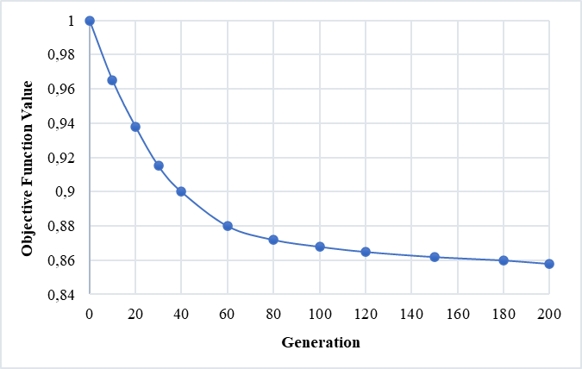
FIGURE 1. Convergence of the Objective Function over Generations

The graph demonstrates the convergence characteristics of the genetic algorithm applied to the electrical network optimization problem. A rapid reduction in the objective function value is observed during the initial generations, indicating efficient exploration of the search space. As the number of generations increases, the improvement rate gradually decreases and the curve approaches a stable minimum, which signifies convergence to an optimal or near‑optimal solution. This behavior confirms the effectiveness and stability of the proposed genetic algorithm in jointly minimizing power losses and operational costs.
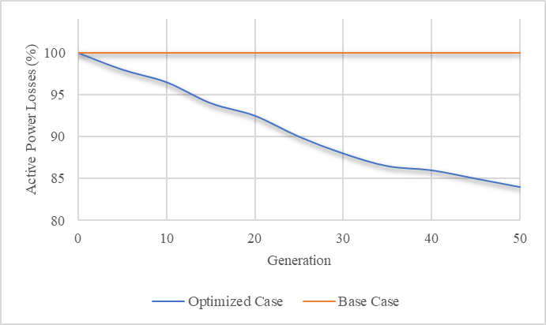
FIGURE 2. Reduction trend of active power losses before and after optimization

The figure illustrates the reduction trend of active power losses before and after optimization. The results demonstrate that the proposed genetic algorithm significantly decreases power losses, confirming its effectiveness in improving the operational efficiency of the electrical network (Fig 2).
The proposed algorithm is employed to optimize the operating parameters of the electrical network by minimizing a composite objective function that integrates active power losses and operational costs. Candidate solutions are encoded as chromosomes and iteratively improved through selection, crossover, and mutation operators. Constraint handling is incorporated during fitness evaluation to ensure system feasibility. The evolutionary search process enables effective convergence toward an optimal balance between technical efficiency and economic performance.
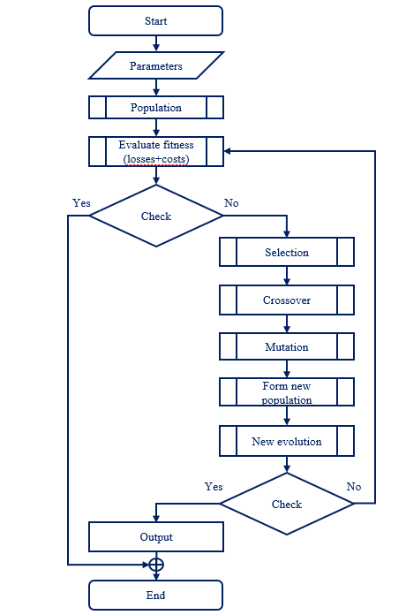

FIGURE 3. Genetic Algorithm for Joint Minimization of Power Losses and Operational Costs

TABLE 1. Comparison of Network Performance Before and After Optimization
Parameter | Base Case | Optimized Case | Improvement
Active power losses (kW) | 100 % | 82,4 % | ↓ 17,6 %
Operational cost | 100 % | 85,1 % | ↓ 14,9 %
Objective function value | 1,0 | 0,836 | ↓ 16,4 %
Voltage deviation index | High | Reduced | Improved

Table 1. presents a comparative assessment of the electrical network performance before and after the application of the proposed genetic algorithm. The optimized case demonstrates a clear improvement in technical efficiency, as evidenced by the reduction in active power losses compared to the base configuration. This improvement indicates that the optimized control variables lead to a more efficient power flow distribution within the network.
From an economic perspective, the optimized solution achieves lower operational costs, highlighting the ability of the proposed approach to enhance economic performance without compromising system constraints. The improvement in the overall objective function confirms the effectiveness of the joint optimization strategy, which simultaneously considers both technical and economic criteria. Moreover, the reduction in the voltage deviation index reflects an enhanced voltage profile and improved system stability in the optimized case. Overall, the results verify that the proposed genetic algorithm provides a balanced and robust solution, improving network efficiency, cost performance, and voltage regulation simultaneously [9].
CONCLUSIONS
This paper presented a genetic algorithm–based optimization approach for improving the operational performance of an electrical network through the joint minimization of active power losses and operational costs. A composite objective function was formulated to integrate technical and economic criteria, enabling a balanced and comprehensive optimization framework. The obtained results demonstrate that the proposed method effectively enhances network efficiency by reducing power losses, improving voltage profile characteristics, and lowering overall operational costs. The convergence behavior of the genetic algorithm confirms its capability to identify stable and high‑quality solutions within a reasonable number of generations. The reduction in the objective function value further validates the effectiveness of the proposed optimization strategy.
Moreover, the observed improvement in voltage deviation indicates enhanced system stability and better compliance with operational constraints. These findings confirm that the genetic algorithm provides a robust and flexible tool for solving complex, nonlinear optimization problems in electrical network operation. Overall, the proposed approach offers a practical and efficient solution for simultaneous technical and economic optimization and can be extended to larger‑scale networks and multi‑objective frameworks in future research, including the integration of renewable energy sources and uncertainty modeling.
REFERENCES
- A. Ghosh, G. Ledwich. “Power Quality Enhancement Using Custom Power Devices,” Kluwer Academic Publishers, 2002.
- B. Khaki, P. Das. “Sizing and placement of battery energy storage systems and wind turbines by minimizing costs and system losses,” IEEE Access, 2019, https://doi.org:10.1109/ACCESS.2019.2916329
- S. Mohammadi, M. Majidi‑Nezhad. “Optimal placement of DG units for loss reduction and voltage profile improvement,” International Journal of Electrical Power & Energy Systems, 2018, https://doi.org:10.1016/j.ijepes.2017.09.011
- S. Ghosh, S. Goswami. “Transmission network loss minimization using genetic algorithm combined with linear programming,” International Journal of Electrical Power & Energy Systems, 2017, https://doi.org:10.1016/j.ijepes.2017.07.015
- N. E. Tarasovskaya, G. A. Orazalina, and A. A. Orazbayeva, “Methodical classification of genetic problems by the solution algorithm,” in Proc. Int. Sci.-Prac. Conf. “Modern Society, Education and Science”, 2015, pp. 148–150.
- M. M. Minegaliyeva and I. I. Nabiev, “Study of the influence of population size in a genetic algorithm on the efficiency of solving optimization problems,” in Proc. 4th Int. Youth Sci. Conf. “Generation of the Future: View of Young Scientists – 2015”, 2015, pp. 56–68.
- A. Barbar, O. Hadjsaid. “Genetic Algorithms applied to distribution network restoration and loss minimization,” Electric Power Systems Research, 2020, https://doi.org:10.1016/j.epsr.2020.106836
- A. H. Abdul‑Rahman, F. Albuyeh. “Economic dispatch and loss minimization using genetic algorithms,” IEEE Transactions on Power Systems, 2021, https://doi.org:10.1109/TPWRS.2020.3028479
- V. Miranda, R. Dobslaw. “Genetic Algorithm Based Optimization of Distribution System Losses,” IEEE Transactions on Power Delivery, 2019, https://doi.org:10.1109/TPWRD.2019.2915497
- Kholikhmatov B.B., Samiev Sh.S., Erejepov M.T., Nematov L.A. Modelling of laboratory work in the science "Fundamentals of power supply" using an educational simulator based on a programmed logic controller // E3S Web of Conferences 384. 2023. РР, 01032, 1-3. https://doi.org/10.1051/e3sconf/202338401032
- H. Li, Z. Turan.* “Cost and loss co‑optimization in power distribution networks,” Electric Power Systems Research, 2019, https://doi.org:10.1016/j.epsr.2018.10.011
- Rakhimov F, Rakhimov F, Samiev Sh, Abdukhalilov D. Justification of Technical and Economic Effectiveness of Application of 20 kV Voltage in Overhead Electric Networks //AIP Conf. Proc. 3152, 030023 (2024). https://doi.org/10.1063/5.0218921
- Taslimov A, Mo'minov V, Samiev Sh, Abdukhalilov D. Issues of Optimization of Electrical Network Parameters Medium Voltage //AIP Conf. Proc. 3331, 020007 (2025). https://doi.org/10.1063/5.0305781

