The importance of water reservos in Uzbekistan's hydropower potential
Guzal Sherko'zieva ^{a)}, Feruza Azizova, Feruza Salomova, Sajida Sharipova, Akida Imamova
Tashkent State Medical University, Tashkent, Uzbekistan
^{a)} Corresponding author: guzal.sherquzieva@gmail.com
Abstract. In this article The results of the analysis of the ecological and hygienic state of water bodies and water quality indicators, which are the main sources of pollution in the hydropower industry, are presented. The results of the annual dynamics of the sanitary and chemical indicators of water bodies were as follows: in 2023, the total number of samples was 755, of which 134 (17.7%) did not meet hygienic requirements, and in 2024, the total number of samples was 895, of which 176 (19.6%) did not meet hygienic requirements. If we analyze the results obtained, it can be seen that during the observation years, the number of samples that did not meet hygienic requirements for sanitary and chemical indicators of water was greater than for samples for sanitary and microbiological indicators.
INTRODUCTION
Currently, the economically justified hydropower potential of the countries is estimated at 173 billion kWh/year, of which 84% falls on the countries of Central Asia. The development of hydropower potential is especially promising for these countries. In the article “Central Asia on the Threshold of a New Era” by the President of the Republic of Uzbekistan Sh.M. Mirziyoyev in the socio-political newspaper “Yangi Uzbekistan” dated November 13, 2025, No. 234 (1560), the following is stated: Fundamental positive changes are taking place in the field of hydropower, which previously caused sharp disagreements and contradictions [5]. The agreement between Uzbekistan, Kazakhstan and Kyrgyzstan on the joint implementation of the Kambarata HPP-1 project has opened a new page in the practice of joint use of the region's water and energy resources is a vivid proof of fraternal cooperation. Cooperation between Uzbekistan and Tajikistan on the construction of the Yavon and Fondarya hydroelectric power plants on the Zarafshan River is progressing . An agreement was reached with Turkmenistan on the rational use of Amu Darya water resources as part of an intergovernmental agreement. This will improve joint management of water resources and reduce the risk of environmental problems. On June 25, 2025, the World Bank approved a $150 million concessional loan for Uzbekistan for a new project aimed at developing the small hydropower sector and increasing the reliability of electricity supply throughout the country. By 2030, Uzbekistan's electricity demand is expected to double to more than 120 billion kilowatt-hours. Despite the country's growing electricity production, about 10% of demand is not being met, which has led to power outages, especially in areas that do not need energy and in rural areas. Small hydroelectric power plants (SHPs) with capacities ranging from 100 kW to 5 MW, using the existing irrigation canal network, can increase electricity generation in energy-starved regions.
The government of Uzbekistan plans to invest in the construction of about 3,000 small hydropower plants by 2026, bringing their installed capacity to 160 MW. The project will finance the construction of small hydropower plants with a total installed capacity of up to 150 MW by 2030. They are expected to generate more than 520 gigawatt-hours of clean electricity per year. In addition, the project will help reduce carbon dioxide emissions by up to 430,000 tons per year.
In accordance with the development strategy of Uzbekistan for 2022-2026, 15 new hydroelectric power plants (HPPs) with a total capacity of 868 MW will be built in the country. In addition, five existing HPPs will be modernized. As a result, starting from 2026, an additional 868 MW of generating capacity will be generated annually, including 7 additional hydroelectric power plants with a total capacity of 173 MW, which will be built in Samarkand, Surkhandarya and Tashkent regions by 2022.
Uzbekistan 's water resources consist mainly of glaciers, rivers, lakes , reservoirs, transboundary rivers and groundwater. The total theoretical hydroelectric potential of the country's rivers is 88.5 billion kWh per year, of which the technical hydroelectric potential is 27.4 billion kWh per year. The Piskent River has the largest potential (1324 MW) among the studied watercourses in the republic, which is 45.3% of the existing hydropower resources in Uzbekistan. In 2022, hydroelectric power stations in Uzbekistan produced almost 9% of all electricity, and 13% of the current capacity was used. In 2023, the country's energy balance will require 84,653.4 million kWh of electricity, with the share of hydropower accounting for 8% (6.8 billion kWh). The republic's energy sector gross domestic product to the unity correct coming capacity of 11.9 billion soums in 2022 organization did​ So , hydropower​ in gross domestic product share is 77147.7 billion soums or 8.7 percent organization It does. at the time Hydroelectric power plants in 9 regions located to be , to work to release volume according to Tashkent province first in place stands. Next six 13 percent of the population of the republic growth , industry number of enterprises from 45 thousand to 100 thousand increased . As a result electricity to the energy demand 35 percent exceeded [2].

Hydropower in 2023-2025​​ 559.4 million US dollars per sector equivalent , including $165.9 million in investments. In 2023, two new automated hydroelectric power plants with a capacity of 13.6 MW will be commissioned in the USA and one hydroelectric power plant will be modernized[6]. The Resolution of the President of the Republic of Uzbekistan dated March 30, 2023 No. 104 “On measures to further reform the hydropower sector” approved proposals to increase the total capacity of hydroelectric power plants to 5,507.8 MW by the end of 2028, including the creation of an additional 3,279.8 MW of capacity through the implementation of projects to build hydroelectric power plants with a total capacity of 1,600 MW. In 2022, the republic's energy sector to gross domestic product relatively capacity is 11.9 billion. So , hydropower​ work of release in gross domestic product share is 77,147.7 billion soums or 8.7 percent organization is enough In 2023, the rest everyone thing if the same, hydroelectric power plants by created additional value gross domestic product volume for about 3.8 trillion soums increases.

TABLE 1.Hydropower rating of Uzbekistan's regions (2022)
No. | Regions | index | Rating
1 | Tashkent region | 0.68 | 1
2 | Andijan region | 0.12 | 2
3 | Syrdarya region | 0.07 | 3
4 | Surkhandarya region | 0.04 | 4
5 | Khorezm region | 0.03 | 5
6 | Tashkent city | 0.02 | 6
7 | Namangan region | 0.02 | 7
8 | Kashkadarya region | 0.01 | 8
9 | Samarkand region | 0.01 | 9

As can be seen from the above, Tashkent, Andijan, and Syrdarya regions occupy the highest positions in this ranking. Namangan, Kashkadarya, and Samarkand regions occupy the lowest positions [ 6.7 ] .

EXPERIMENTAL RESEARCH
Conducting sanitary microbiological examination of open water bodies, developing preventive measures based on the data obtained. As a result of the conducted examinations, the following main tasks were achieved: assessing the ecological, hygienic, microbiological state of water, determining the suitability of water for a specific type of consumption, the degree and nature of its pollution.
In the process of scientific research, sanitary-hygienic, laboratory instrumental and statistical methods were used. During the sanitary-bacteriological examination, samples taken from the water body were subjected to microbiological examination and analyzed. The results obtained were evaluated in accordance with the following legal and regulatory documents. Law of the Republic of Uzbekistan “On Water and Water Use”. Tashkent, May 6, 1993, No. 837-XII. Sanitary rules and norms (SanR and N No. 0318-15 “Hygienic and anti-epidemic requirements for water protection in water bodies on the territory of the Republic of Uzbekistan” [1.2.3]

RESEARCH RESULTS
It is set before us Based on the goal, we studied the state of pollution of open water bodies over the years and obtained the following results. The state of microbiological pollution of water in water bodies of the 1st category over the years 2023-2024 was: in 2023, the total number of samples was 105, of which 3 (2.8%) did not meet hygienic requirements, and in 2024, the total number of samples was 56, of which 4 (7.1%) did not meet hygienic requirements (Fig. 1).
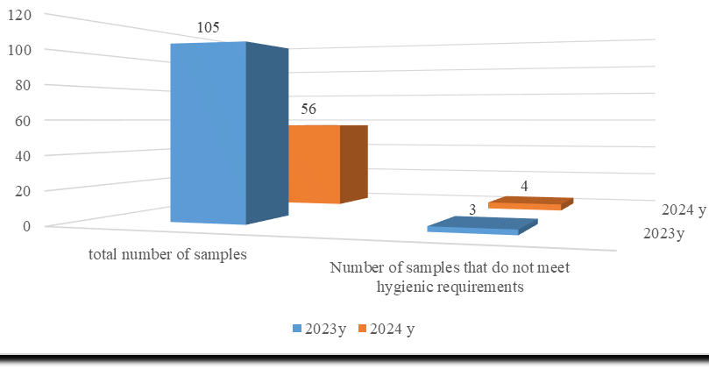
FIGURE 1. Microbiological indicators of water bodies of the 1st category

Today, global problems associated with the inefficient use of open water bodies and natural water resources require attention to sustainable development, protection of open water bodies from pollution, as well as the introduction of innovative approaches to solving problems. Based on this, it is advisable to monitor the state of pollution of water bodies. The state of microbiological pollution of water bodies of the 2nd category in the dynamics of 2023-2024 In 2023, the total number of samples was 5339, of which 15 (0.28%) did not meet hygienic requirements, and in 2024, the total number of samples was 5107, of which 225 (4.4%) did not meet hygienic requirements (Fig. 2).

FIGURE 2. Microbiological indicators of water bodies of the 2nd category
The microbiological contamination of open water sources increases from 5% in winter to 26.3% in summer. In the warm season, the number of intestinal diseases increases sharply, for example, the number of people with bacterial dysentery increases by 3 times. In the summer months, the incidence of acute intestinal infections (AII) increases: AII - 130-264 cases per 100,000 people, about 90% of all AII cases are recorded among children under 2 years of age, due to the transmission of infections through water and food. According to WHO data: up to 1.2 billion cases of diarrhea are recorded in the world annually. About 2.2 million people die from diarrhea every year. Diarrhea is the cause of 88% of annual deaths among children. About 5 million children die from intestinal infections and their complications every year. Therefore, when we examined the state of microbiological contamination of water reservoirs, we also detected pathogens in 1 md ^{3 of water.} In 2023, the total number of samples was 5339, of which 15 (0.28%), and in 2024, the total number of samples was 5107, of which 225 (4.4%) were identified as pathogens (Fig. 3).

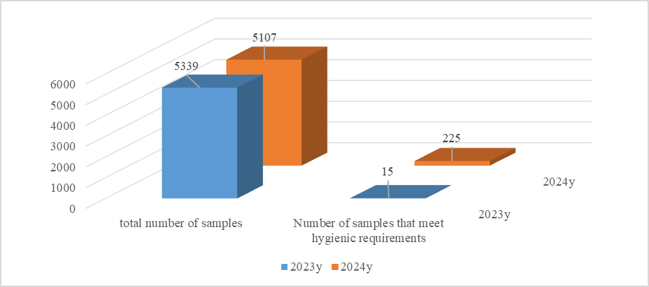
FIGURE 3. Triggers detected in ^{1m3 of water over the years}

According to scientists' calculations, environmental pollution causes every sixth death in the world every year. In addition, due to environmental pollution, the world economy lost 4.6 trillion dollars in 2015 (6.2% of the world's GDP). Chad, Central African Republic and In Niger majority people water and soil from pollution death will be .
As you know , Central Uzbekistan in Asia territory from the beginning irrigated fields many , but water resources territories according to same not distributed and shortage with from others separated standing region . At the same time, water is widely used in agriculture in our country, and its pollution with various chemicals, in particular pesticides, is increasing day by day. Therefore, we also examined the sanitary chemical indicators of water bodies over the years and obtained the following results: in 2023, the total number of samples was 755, of which 134 (17.7%) did not meet hygienic requirements, and in 2024, the total number of samples was 895, of which 176 (19.6%) did not meet hygienic requirements (Figure 4).
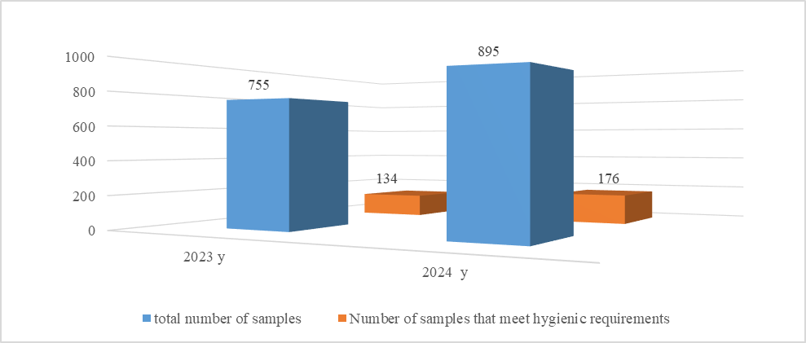
FIGURE 4. Years in dynamics water objects sanitary chemical of water indicators
Assessing the level of pollution of open water bodies , monitoring them, predicting the level of pollution , and monitoring the state of polluting sources and their impact on open water bodies remain one of the most pressing problems of the present day. Analyzing the results obtained, during the years of monitoring, the number of samples that did not meet hygienic requirements for sanitary-chemical indicators of water was greater than for samples for sanitary-microbiological indicators.
CONCLUSIONS
1. The level of water pollution in open water bodies in the Republic of Uzbekistan, which have unique climatic conditions, was studied over the years.
2. Sharp increase in water consumption in all sectors of the economy, especially in hydropower, water use is increasing year by year.
3. The waste water discharged into the open water basin is not discharged into the open water basins without using full treatment methods.
4. Samples taken during the monitoring years were identified that did not meet hygienic requirements in terms of sanitary and chemical indicators.
REFERENCES
- Cabinet of Ministers of the Republic of Uzbekistan, Resolution No. 343 of June 3, 2021, “On further improving the system for assessing the level of environmental pollution” (2021). https://lex.uz/docs/7387235
- Law of the Republic of Uzbekistan, “On Water and Water Use,” No. 837-XII, May 6, 1993 (Tashkent, Uzbekistan, 1993).
- Sanitary Rules and Norms of the Republic of Uzbekistan (SanR and N), No. 0318-15, “Hygienic and anti-epidemic requirements for the protection of water bodies in the territory of the Republic of Uzbekistan” (2015). https://lex.uz/docs/12328
- Sh. M. Mirziyoyev, “Central Asia on the threshold of a new era,” Yangi Uzbekistan Newspaper, No. 234 (1560), November 13 (2025). https://www.gazeta.uz/uz/2025/11/13/central-asia-security/
- M. Ibragimov, “Uzbekistan to boost hydroelectric power generation with World Bank support,” World Bank Press Release No. 2025/ECA/109 (2025). https://www.vsemirnyjbank.org/ru/news/press-release/2025/06/25/uzbekistan-to-enhance-energy-production-through-hydropower-with-world-bank-support
- R. Zhumamatov, “The role of hydropower in the national economy of Uzbekistan,” Institute of Macroeconomic and Regional Studies (IMRS), January 26 (2023). https://imrs.uz/publications/articles-and-abstracts/role_hydropower
- President of the Republic of Uzbekistan, Presidential Resolution No. PP-104 of March 30, 2023, “On measures to further reform the hydropower sector,” Norma.uz Information and Legal Portal (2023). https://www.norma.uz/novoe_v_zakonodatelstve/sferu_gidroenergetiki_reformiruyut
- G. F. Sherqo‘ziyeva, F. I. Salomova, F. L. Azizova, S. A. Sharipova, and A. O. Imamova, “Ecological status of water resources in hydroenergy,” AIP Conf. Proc. 3331(1), 030063 (2025). https://doi.org/10.1063/5.0306482
- G. Z. Sherqo‘ziyeva, F. Salomova, M. Bahriddinova, and B. Toshpo‘latov, “Ichimlik suvi sifati muammolari va yechimlari,” University Research Base, 463–466 (2024). https://scholar.kokanduni.uz/index.php/rb/article/view/550
- D. Berdiyeva, I. Otajonov, S. Kiryigitova, M. Sobirova, and G. Sherqo‘ziyeva, “Impact of heavy metals (copper, cadmium, mercury, and lead) on the fertility, microbiological activity, and crop productivity of irrigated meadow soils: A literature review from an ecological and food security perspective,” J. Carcinog. 24(8s), 352–359 (2025). https://doi.org/10.64149/J.Carcinog.24.8s.352-359

