The problem and solutions of pollution of open water bodies
Guzal Sherko'zieva ^{a)}, Feruza Salomova, Akida Imamova, Nozim Jalolov, Nargiza Ikramova
Tashkent State Medical University, Tashkent, Uzbekistan
^{a)} Corresponding author: guzal.sherquzieva@gmail.com
Abstract. In the article The results of the analysis of the ecological and hygienic state of pollution of open water bodies and water quality indicators, which are the main sources of pollution in the hydropower sector, are presented. More than 100 large and small rivers and canals flow through the territory of Tashkent city. The Boz-suv canal is a category 1 water source, from which the Boz-suv and Qodriya water supply facilities receive water. During the monitoring years, the number of facilities discharging wastewater into water bodies was 4. The following results were obtained from laboratory analysis of chemical indicators of open water bodies belonging to the second category in the dynamics of 2023-2024: in 2023 , a total of 754 samples were taken (100%), of which 126 (16.7%) did not meet hygienic requirements, and in 2024, a total of 895 samples were taken (100%), of which 176 (19.6%) did not meet hygienic requirements.
INTRODUCTION
The hydropower sector, like other rapidly developing sectors, has begun a new era in its activities as a separate sector in a single system. Today, due to the decreasing amount of natural resources used as the main raw material for the production of electricity and environmental problems, the production of electricity using non-traditional methods remains one of the important issues. It should be emphasized that the further development of the hydropower sector plays an important role in ensuring the guaranteed provision of the growing demand for electricity by industrial and municipal enterprises, agriculture and the population in the regions , the rational use and conservation of organic fuel reserves in our country, as well as the reduction of emissions of harmful waste into the environment . Water resources play a very important role in ensuring the economic development of our country. Water resources occupy a special place among natural resources and are incomparable in their importance. Water is used in all sectors of the national economy and in the life of the population. 70-80% of the water resources of the Central Asian countries are located in the countries of Tajikistan, Kyrgyzstan and Kazakhstan. Water resources are an important component of nature and are of particular importance in human life and activity. With the growth of the population and the increase in production, the importance of water is increasing further. Currently, the total water demand of the Republic of Uzbekistan is 5660 billion m ^{3 per year} . 92% of it is spent on agriculture, 5.5% on household and economic needs and 1.5% on industrial needs, 0.8% on fisheries and 0.2% for energy purposes. Central Asia is one of the few regions in the world where water security is inextricably linked to energy, food, and the environment. Water resources are of strategic importance here. Water and energy resources are a unifying factor among the Central Asian countries. The mountainous countries located in the river basins (Kyrgyzstan and Tajikistan) have very large freshwater reserves and huge hydropower potential. The countries in the middle and lower reaches of the rivers (Uzbekistan, Kazakhstan, and especially Turkmenistan) have large reserves of fossil fuels. While the waters of open basins are characterized by a high content of bacteria, turbidity, color, and low salinity, groundwater is characterized by colorlessness, clarity, the absence of bacteria, a high content of salts, and in addition, the presence of iron, fluorine, and dissolved gases. The implementation of the Resolutions of the President of the Republic of Uzbekistan No. PP-2947 dated May 2, 2017 "On the Program of Measures for the Further Development of Hydropower in 2017-2021", No. PP-4067 dated December 19, 2018 "On Measures for the Implementation of the Comprehensive Investment Program of the Republic of Uzbekistan for 2019" and No. PP-4563 dated January 9, 2020 "On Measures for the Implementation of the Investment Program of the Republic of Uzbekistan for 2020-2022", as well as the consistent increase in the use of renewable energy sources, fully ensuring the demand for electricity by sectors of the economy and the population of the republic, is one of the pressing problems of the present day.

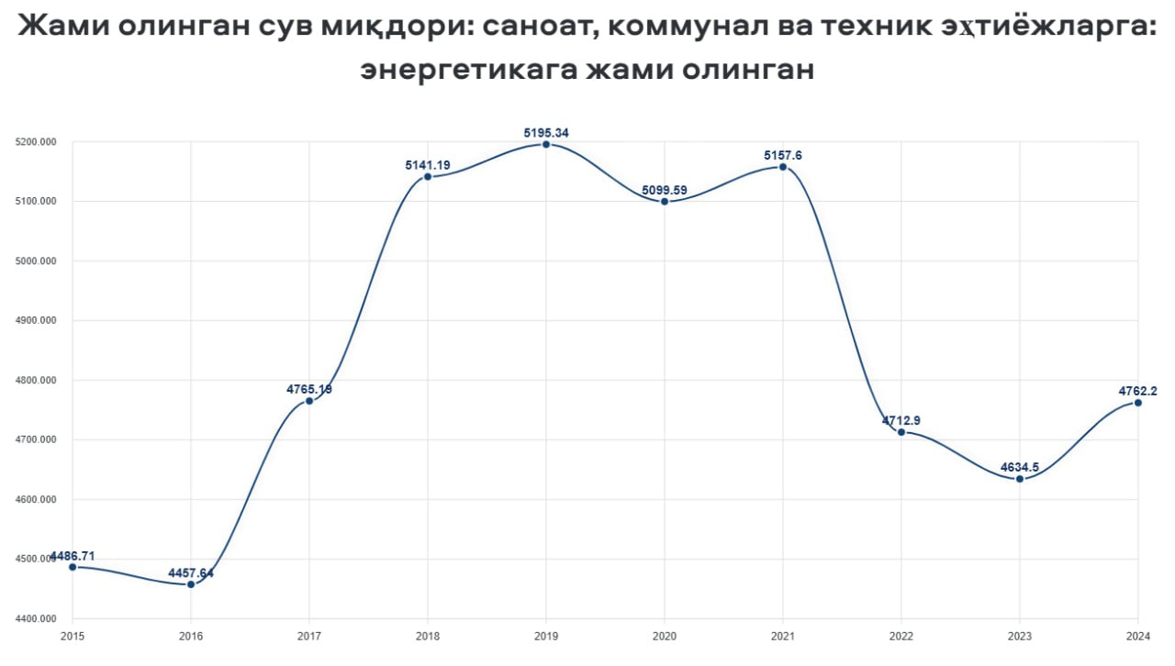
FIGURE 1. Total amount of water withdrawn over the years.

This diagram shows that in the dynamics of 2017-2021, the amount of water withdrawn across the republic for industrial, municipal and technical needs, as well as energy, was the largest in comparison with other years. If we analyze the state of hydropower in the world, hydropower provides up to 88% of the world's renewable energy and up to 20% of all electricity, with a hydropower capacity of 777 GW. Iceland is the absolute leader in hydroelectric power generation per capita. Other countries with the highest per capita hydroelectric power generation are Norway (hydropower accounts for 98% of total production), Canada and Sweden. In Paraguay, 100% of the energy produced is produced by hydroelectric power plants. In the early 2000s, China was considered the most active country in the construction of hydroelectric power plants. As of 2008, the largest producers of hydropower (including processing in pumped storage power plants) in absolute terms were the following countries:

Table 1. Leading countries by hydropower electricity consumption
№ | Country | Hydro power consumption (T W-s)
1 | China | 585
2 | Canada | 369
3 | Brazil | 364
4 | USA | 251
5 | Russia | 167
6 | Norway | 140
7 | India | 116
8 | Venezuela | 87
9 | Japan | 69
10 | Sweden | 66
11 | France | 63

The advantages of hydropower are: the use of renewable energy, very cheap electricity, and the absence of harmful emissions into the atmosphere. However, it also has disadvantages, especially flooding of agricultural lands, construction is carried out in areas with large reserves of hydropower, it is dangerous due to the high seismicity of the regions on mountain rivers, and the reduction and unregulated release of water from reservoirs leads to the restructuring of the ecosystem.

EXPERIMENTAL RESEARCH
To conduct a yearly dynamic analysis of the sanitary condition of open water bodies used in hydropower , analyze the data obtained and develop preventive measures based on them. As a result of the conducted research, the following main tasks were achieved: to assess the ecological and hygienic condition of water, to determine the degree and nature of its pollution.
In the process of scientific research, sanitary-hygienic, laboratory instrumental and statistical methods were used. During the sanitary-bacteriological examination, samples taken from the water body were subjected to microbiological examination and analyzed. The results obtained were evaluated in accordance with the following legal and regulatory documents. Law of the Republic of Uzbekistan “On Water and Water Use”. Tashkent, May 6, 1993, No. 837-XII. Sanitary rules and norms (SanR and N No. 0318-15) “Hygienic and anti-epidemic requirements for water protection in water bodies on the territory of the Republic of Uzbekistan” [1.2.3]
RESEARCH RESULTS
It is set before us Based on this goal, we studied the pollution status of open water bodies over the years and obtained the following results. More than 100 large and small rivers and canals flow through the territory of Tashkent. Laboratory tests are regularly conducted to monitor the composition and quality of the water in these rivers and canals. The Boz-Su canal is a category 1 water source, from which the Boz-Su and Qodriya waterworks receive water. During the monitoring years, the number of facilities discharging wastewater into water bodies was 4. The facilities discharging wastewater into water bodies are the Bektemir wastewater treatment plant, the Salar wastewater treatment plant, the automobile plant No. 4, the Boz-suv wastewater treatment plant, 6 of which are household and 1 is industrial wastewater. The number of water bodies of the 1st category in Tashkent is 1, from which the Boz-suv and Qodriya waterworks receive water, and the remaining open water bodies belong to the 2nd category (Figure 2).

FIGURE 2. Categories of watersheds flowing through Tashkent city

If we analyze the open water basins flowing through Tashkent city by districts, we get the following: the largest number of open water basins flows through Yangihayot district (Salar, Jun, Chirchik River, Naiman, Karasuv), Almazar district (Kalkauz, Kichkirik, Damashi, Kara-kamish) and Yashanaabad district (Barathoja, Kara-suv, Tol-arik, Salar). The fewest open water basins flow through Mirabad and Uchtepa districts, each with one open water basin (Figure 3).

FIGURE 3. Open water bodies in urban districts

According to data, every sixth death in the world is caused by environmental pollution. At the same time, due to this pollution, the world economy suffered a loss of 4.6 trillion dollars in 2015. Therefore, we examined the state of pollution of open water bodies by chemical indicators in 2023 and obtained the following results: A total of 45 samples (100%) were taken from Mirzo Ulugbek district, of which 21 (46.6%) were found to be non-hygienic, 18 samples (100%) were taken from Shaykhantokhur district, of which 3 (16.6%) were found to be non-hygienic, 57 samples (100%) were taken from Sergali district, of which 12 (21.0%) were found to be non-hygienic, 75 samples (100%) were taken from Almazar district, of which 8 (10.6%) were found to be non-hygienic, and 92 samples (100%) were taken from Yangi Hayot district, of which 35 (38.0%) were found to be non-hygienic. in the observation year, all the samples taken from Uchtepa, Bektemir, Mirabad and Yakkasaray districts met the hygienic requirements. (Figure 4).

Figure 4. Pollution status of open water bodies according to chemical indicators (2023)

In 2024, we examined the state of pollution of open water bodies by chemical indicators and obtained the following results: A total of 56 samples (100%) were taken from Mirzo Ulugbek district, of which 29 (51.7%) were positive, a total of 30 samples (100%) were taken from Shaikhontokhur district, of which 3 (10.0%), a total of 65 samples (100%) were taken from Sergali district, of which 14 (21.5%), a total of 108 samples (100%) were taken from Almazar district, of which 36 (33.3%) were positive, and a total of 80 samples (100%) were taken from Yangi Hayot district, of which 24 (30.0%), a total of 27 samples (100%) were taken from Uchtepa district, of which 4 (14.8%), Chilonzor A total of 54 samples (100%) were taken from the district, 9 of which (16.6%) did not meet hygienic requirements, while all samples taken from Bektemir, Mirabad and Yashnabad districts in the same monitoring year met hygienic requirements (Figure 5).

FIGURE 5. Pollution status of open water bodies according to chemical indicators (2024)

One of the current pressing problems is to improve the mechanisms for assessing the level of pollution of open water bodies, their monitoring, forecasting the level of pollution , monitoring the state of polluting sources and their impact on open water bodies. Open water bodies are divided into two categories depending on the purpose for which they are used. Therefore, we conducted laboratory analysis of chemical indicators of open water bodies belonging to the second category in 2023-2024 and obtained the following results: in 2023 , a total of 754 samples were taken (100%), of which 126 (16.7%), and in 2024, a total of 895 (100%) samples were taken, of which 176 (19.6%) did not meet hygienic requirements (Figure 6).

FIGURE 6. Results on chemical indicators of water bodies of the 2nd category.

If we analyze the results obtained, we can see that during the observation years, the number of samples that did not meet hygienic requirements for sanitary and chemical indicators of water was 16.7% in 2023, while in 2024, 19.6% of the total samples taken did not meet hygienic requirements.
CONCLUSIONS
1. The level of water pollution in open water bodies in Tashkent city was studied over the years.
2. More than 100 large and small rivers and canals flow through the territory of Tashkent.
3. Boz-suv canal is a water source of the 1st type, from which "Boz-suv" and "Qadriya" waterworks receive water.
4. During the monitoring years, the number of facilities discharging wastewater into water bodies was 4. The following results were obtained from laboratory analysis of chemical indicators of open water bodies belonging to the second category in the dynamics of 2023-2024: in 2023 , a total of 754 samples were taken (100%), of which 126 (16.7%), and in 2024 , a total of 895 samples were taken (100%), of which 176 (19.6%) did not meet hygienic requirements.
REFERENCES
- Cabinet of Ministers of the Republic of Uzbekistan, Resolution No. 343 of June 3, 2021, “On further improving the system for assessing the level of environmental pollution” (2021). https://lex.uz/docs/7387235
- Law of the Republic of Uzbekistan, “On Water and Water Use,” No. 837-XII, May 6 (Tashkent, Uzbekistan, 1993).
- Sanitary Rules and Norms of the Republic of Uzbekistan (SanR and N), No. 0318-15, “Hygienic and anti-epidemic requirements for the protection of water bodies in the territory of the Republic of Uzbekistan” (2015). https://lex.uz/docs/12328
- Sh. M. Mirziyoyev, “Central Asia on the threshold of a new era,” Yangi Uzbekistan Newspaper, No. 234 (1560), November 13 (2025). https://www.gazeta.uz/uz/2025/11/13/central-asia-security/
- M. Ibragimov, “Uzbekistan to boost hydroelectric power generation with World Bank support,” World Bank Press Release No. 2025/ECA/109 (2025). https://www.vsemirnyjbank.org/ru/news/press-release/2025/06/25/uzbekistan-to-enhance-energy-production-through-hydropower-with-world-bank-support
- R. Zhumamatov, “The role of hydropower in the national economy of Uzbekistan,” Institute of Macroeconomic and Regional Studies, January 26 (2023). https://imrs.uz/publications/articles-and-abstracts/role_hydropower
- President of the Republic of Uzbekistan, Presidential Resolution No. PP-104 of March 30, 2023, “On measures to further reform the hydropower sector,” Norma.uz Information and Legal Portal (2023). https://www.norma.uz/novoe_v_zakonodatelstve/sferu_gidroenergetiki_reformiruyut
- G. F. Sherqo‘ziyeva, F. I. Salomova, F. L. Azizova, S. A. Sharipova, and A. O. Imamova, “Ecological status of water resources in hydroenergy,” AIP Conf. Proc. 3331(1), 030063 (2025). https://doi.org/10.1063/5.0306482
- G. Z. Sherqo‘ziyeva, F. Salomova, M. Bahriddinova, and B. Toshpo‘latov, “Ichimlik suvi sifati muammolari va yechimlari,” University Research Base, 463–466 (2024). https://scholar.kokanduni.uz/index.php/rb/article/view/550
- D. Berdiyeva, I. Otajonov, S. Kiryigitova, M. Sobirova, and G. Sherqo‘ziyeva, “Impact of heavy metals (copper, cadmium, mercury, and lead) on the fertility, microbiological activity, and crop productivity of irrigated meadow soils: A literature review from an ecological and food security perspective,” J. Carcinog. 24(8s), 352–359 (2025). https://doi.org/10.64149/J.Carcinog.24.8s.352-359

