Constructive solutions for increasing core recovery during well drilling
Narimov Ravshanbek¹, Komilov Tolib^{1,2, a)}, Umedov Sherali¹, Rakhimov Anvarkhodzha¹, Rakhimov Komilkhodzha¹, Ashurov Bobirjon¹, Sindarov Javohir¹, Kazakov Umirzak¹
¹ Tashkent state technical university named after Islam Karimov, Tashkent, Uzbekistan
² Termez State University of Engineering and Agrotechnology, Termez, Uzbekistan
^{a)} Corresponding author: komilovtolib87@yandex.ru
Abstract. An analysis of the developed and used modifications of core-taking drills and component parts during well drilling has been conducted. Based on the study and analysis of existing core sampling equipment and component parts, innovative solutions and developments were used in the research. For the purpose of testing these developments and core sampling, experimental samples of core-taking drills, drill bits, and spring core holders with varying spring lobe thicknesses of 0.4-0.2 mm, depending on the hardness categories of the passing rocks, were manufactured, ensuring maximum core recovery and preservation, which increases the level of obtaining high-quality geological information for the studied interval of the well, as well as a core-taking drilling technology was created, which contributes to the complete recovery of core material, and its significant importance for accurate study of the productive formation and obtaining effective results of exploration work and reliable geological information was revealed. This design ensures increased core extraction efficiency in various geological conditions. The proposed solution allows for adaptation to the physical and mechanical properties of the formation during the drilling process. As a result of theoretical analysis, it was shown that the use of the structure ensures an increase in the core yield coefficient, a reduction in dynamic loads, and a decrease in operating costs.
INTRODUCTION
In the world, special attention is paid to the targeted study of the issues of well drilling with core extraction, its high-quality extraction, and the solution of problems related to the development of measures and technologies for the extraction of core material, as well as methods for the development of core drilling apparatus and component parts. In this regard, special attention is paid to the development of various methods and developments for extracting kernel from equipment and various types of drill bits, as well as to solving problems in this area.
The saturation of reservoirs with oil and gas is determined and refined by drilling wells. For this purpose, when drilling prospecting and exploration wells, core sampling is carried out in certain intervals.
Core sampling is carried out during the search and exploration of oil and gas deposits to calculate reserves and assess the suitability of these deposits for industrial development, the study of their geological structure.
The purpose of drilling with core sampling is the formation and removal of samples to the surface of rocks with dimensions that ensure the conduct of the entire necessary complex of their research.
The physical characteristics of the formations are refined on the basis of the study and analysis of the properties of cores taken directly from the formation with the help of coring projectiles.
Research conducted by scientists, research work on the creation of innovative developments, on the creation of effective core sampling devices.
At present, several modifications of core-picking projectiles of the “Nedra”, “Silur”, “Cambrian” and others types have been developed and are used in well drilling. On all coring projectiles, the core is formed by a drill head or bit equipped with hard alloy teeth. Previously, coring tools and cone drill heads were purchased from Russia, China and the USA.
The development of a more advanced projectile design requires a fundamentally new solution in the design of core-receiving devices for core extraction during the drilling of cracked, layered, and crushed sedimentary rocks.
Many companies in foreign countries - USA, PRC, RF are also engaged in the creation of core-withdrawing apparatus and drill bits for core extraction during the drilling of oil and gas exploration wells [1, 2]. “Nedra” and “Silur” core-withdrawing devices can be used in single and multi-section assembly with lengths of 8, 16, 24 m and more. Other modifications of core-receiving devices are also manufactured, which are analogous to the “Nedra” series device, including the “KIM” type "modernized isolating core separators." The presented types of core drill bit layouts and their modifications are successfully used with core-taking drills when drilling with diamond and ball bits.
In the “IGIRNIGM” State Enterprise, the design of the core-selecting projectile 164/80 has been developed, which allows for the elimination of all noted structural shortcomings and the preservation of all the achieved positive advantages of the ZKS-112 projectile [3-5].
Burservice JSC is one of the successful organizations engaged in the creation of UKR-185/100, UKR-127/80, UKR122/62 core sampling tools, which are the most effective and allow for the extraction of 100 mm diameter cores.
The length of the core receiving pipe is 27 m. The UKR-185/100 type core-withdrawing projectile was used in core-withdrawing drilling at well No. 1VU of the Yurubchen-Tokhom deposit (RF). Core extraction was carried out in carbonate deposits with salt deposits. Drilling with core extraction was 500 m, with an average core recovery rate of 99.7 m/h and a drilling rate of 1.2 m/h. The core extraction drilling process at Burservice JSC was 27 m.
The BS-295/100 type drill head ensures the sectional extraction of core from the new design of elongated fiberglass core receiving pipes, which fix the core (PFK-121/100) [6].
“Radius-Service” LLC produces core-selecting projectiles, which are distinguished by the fact that the core receiver is made in the form of one or more core-receiving pipes connected by a coupling. The core-receiving pipe is equipped with a sealant, in the lower part in the form of a diaphragm, covering the core-receiver cavity from the bottomhole. The core suction pipe supports are isolated from the cavity between the housing and the core receiver. This cavity is filled with insulating fluid. The specified projectile can be used with a screw bottom engine and rotor rotation [7-9].
The disadvantage of this core-drawing projectile design is the preservation of reservoir pressure in the core-drawing pipe, which poses a danger during the dismantling of the projectile [10].
The SK-172/100 type core-extracting apparatus housing, in which the extracted core is isolated, is equipped with spiral-shaped centers of the “Radius-Service” LLC [11].
Over the past years, a good result in the oil and gas industry has been a core recovery of 40-60%, but now for geologists a result below 70-100% is considered unacceptable [12-14].
When drilling wells until 2016, Russian-made three-cone drilling heads of type 6 VK were used, which are designed for core sampling in rocks of medium hardness. Drilling heads type 6VK-SZ consist of a body and three cutters, which are mounted on the trunnions of the body. The cutters are armed with hard-alloy teeth with a wedge-shaped rock-cutting surface. The destruction of the rock occurs in the cutting-crushing mode with the predominance of the cutting process. During core sampling with a 6 VK-SZ drill head, not only the annular surface, but also the central part of the core is crushed in rocks of III and V categories.
Based on the study of the above drill heads, the authors of the article, in order to preserve and ensure the maximum removal of the core from weakly cemented rocks, developed a six-bladed cone drill bit type 6 LBK-MSZ Ø187.3/80 (Fig.1) of cutting-abrasive action. It is designed for core sampling in soft, medium-soft, medium-hard rocks of category III and V with Russian-made core sampling devices such as “Nedra” and “Silur”, as well as a core sampling projectile (COS), developed at the State Institution “IGIRNIGM”.
EXPERIMENTAL RESEARCH
Taper bit type 6 LBK-MSZ Ø187.3/80 is a one-piece body with six blades, which are equipped with cylindrical carbide teeth made of VK-8 grade alloy. The body has a connecting thread Z-150.
Drilling cone bit 6 LBK-MSZ Ø187.3/80 differs from other types of bits in that the core holder is located 30 mm from the main end surface and is equipped with prismatic carbide teeth. Bottomhole washing is carried out through six holes with a diameter of 16 mm, located between the blades.
Until 2018, prototypes of a drill bit type 6 LBK-MSZ Ø187.3 / 80 were used and experimental work and tests were carried out at well No. 1 P of the Koncha area of the Zarafshan region. The test results are given in table. one.
As can be seen from Table. 1, core recovery has improved and reached an average of 77%, which allows geologists to more realistically assess the properties of productive deposits in practice.
An increase in the axial load on the drill heads of types 6 VK-SZ and 6 LBK-MSZ more than 2 tons leads to a worsening of the core recovery. With loads on the drill heads of 2-2.5 tons, the core yield was 60-100%, and with a higher load, the core yield was 30-40%. Therefore, the optimal load on the drill heads should be within 2 tons.
At rotor speeds of 30-50 rpm, core removal with a drilling cone bit type 6 LBK-MSZ increases to 100%, when using a drilling head type 6 VK-SZ, core removal decreases to 30%. Therefore, in rocks of medium hardness, it is better to use drilling cone bits of type 6 LBK-MSZ.
The dependence of the effect of fluid flow per unit of time on the percentage of core recovery by drilling heads of types 6 VK-SZ and 6 LBK-MSZ shows that with an increase in fluid flow to 8 l/s, core recovery using a drilling cone bit of type 6 LBK-MSZ increases dozens of times, with drill heads of type 6 VK-SZ decreases. Based on the foregoing, it is recommended to use drilling cone bits of type 6 LBK-MSZ.

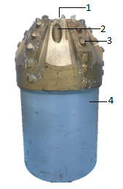 | 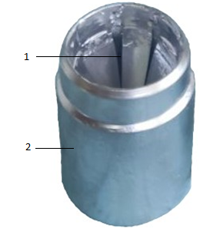 | 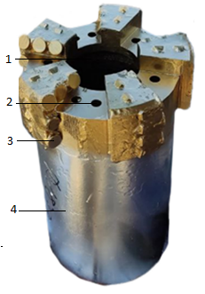
Figure 1. Blade 6LBK-MSZ conical drilling head: 1-hole for core, 2-liquid channel, 3 - cutter,  4 - body | Figure 2. Advanced spring core holder:  1-spring core holder, 2-housing | Figure 3. Drilling head type “PDC” 1-hole for core,  2 - liquid channel, 3 - cutter,  4 - housing

One of the reasons for the insufficient removal of the core is the imperfection of the coring tool and component parts. In order to meet all modern requirements, continuous development and improvement of core sampling shells is necessary.
The authors of the article studied and analyzed the actual field data on coring in various mining and geological conditions, which made it possible to develop a new innovative design and technology for drilling with core sampling by the rotary method.
The authors of the article in the mechanical workshop of the Research Center GU "IGIRNIGM" made a prototype of a new innovative design of the core sampler, where the components were improved: - a springy core holder (see Fig. 2), which was tested in well No. “Kasanskaya NGRE” and a PDC type drill head equipped with polycrystalline diamond teeth (see Fig. 3) were tested at well No. 11R of the Andakli field of Alatskaya NGRE LLC. The test results are shown in Table 2 and in Figures 4, 5 and 6.
RESEARCH RESULTS
The improved core sampling tool and the technology of its use in core sampling in various areas and intervals make it possible to bring the percentage of core recovery up to 80-100%.
It should be emphasized that this development is an import-substituting product and allows you to save foreign currency.

Table 1. Results of core sampling using drill heads
№  п/п | Drill head |  | Drilling interval |  | Parameters Ch. solution |  |  | Core reco-very, % | Drilling mode |  |  | Note
№  п/п | Type | Diameter, mm | from | to | Condi-tional  visco- sity, T | Density, ρ, g/cm³ | Water return,  cm³/30 min |  | Load-load, t | Rotor revolu-tion, rpm | Produc-tivity of the pump, l/s | Average core recovery as a percentage 56%
1. | 6 VK tricone | 187,3/80 С3 | 670 | 671 | 55 sec | 1,10 | 5 | 30 | 3 | 50 | 11 | Average core recovery as a percentage 56%
2. | 6 VK tricone | 187,3/80 С3 | 906 | 907 | 70 sec | 1,11 | 5 | 30 | 3 | 35 | 10 | Average core recovery as a percentage 56%
3. | 6 VK tricone | 187,3/80 С3 | 950 | 951 | 60 sec | 1,11 | 5 | 60 | 2,5 | 30 | 7 | Average core recovery as a percentage 56%
4. | 6 VK tricone | 187,3/80 С3 | 996 | 997 | 60 sec | 1,11 | 5 | 100 | 2 | 30 | 6 | Average core recovery as a percentage 56%
5. | 6 VK tricone | 187,3/80 С3 | 1031 | 1033 | 60 sec | 1,11 | 5 | 60 | 2,5 | 35 | 7 | Average core recovery as a percentage 56%
6. | 6 VK tricone | 187,3/80МС3 | 1065 | 1066 | 60 sec | 1,11 | 5 | 100 | 2 | 35 | 7 | Average core recovery percentage 77%
7. | 6 VK tricone | 187,3/80МС3 | 1098 | 1100 | 60 sec | 1,11 | 5 | 65 | 2,5 | 30 | 6 | Average core recovery percentage 77%
8. | 6 VK tricone | 187,3/80МС3 | 1165 | 1166 | 55 sec | 1,10 | 5 | 100 | 3 | 50 | 10 | Average core recovery percentage 77%
9. | 6 VK tricone | 187,3/80МС3 | 1250 | 1251 | 60 sec | 1,11 | 5 | 60 | 2,5 | 35 | 7 | Average core recovery percentage 77%
10. | 6 VK tricone | 187,3/80МС3 | 1350 | 1351 | 85 sec | 1,11 | 5 | 60 | 2,5 | 35 | 6 | Average core recovery percentage 77%

Table 2. Core sampling using a spring core holder and a cylindrical PDC drill head
No  n/p | Coring interval, m | Drill head diameter,  mm | Mud parameters |  |  |  |  | Core sampling mode |  |  |  | Core removal, %
No  n/p | Coring interval, m | Drill head diameter,  mm | Density,  g/cm³ | Conditional viscosity, sek | Water loss,  cm³/30min | Crust, mm | RN | Rotor turns,  rpm | Stand pressure,  atm. | Weight on  bit, t | Performance  pump, l/s | Core removal, %
Well No. 1, Temirkazgan area
1 | 2264 – 2268 | 158,7 | 1,12 | 45 | 6 | 1 | 9 | 30 | 20 | 2,5 | 10 | 60
2 | 2485 – 2489 | 158,7 | 1,08 | 55 | 5 | 1 | 9 | 45 | 22 | 4,5 | 14 | 100
3 | 2580 – 2584 | 158,7 | 1,08 | 55 | 5 | 1 | 9 | 50 | 22 | 5 | 16 | 100
Well No. 11P, Andakli fields
1 | 2192 – 2197 | 187,3 | 1,12 | 55 | 6 | 1 | 9 | 40 | 20 | 2,5 | 7 | 80
2 | 2367 – 2371 | 187,3 | 1,10 | 55 | 6 | 1 | 9 | 50 | 20 | 3 | 8 | 100
3 | 2453 – 2458 | 187,3 | 1,12 | 55 | 6 | 1 | 9 | 60 | 20 | 4 | 10 | 100

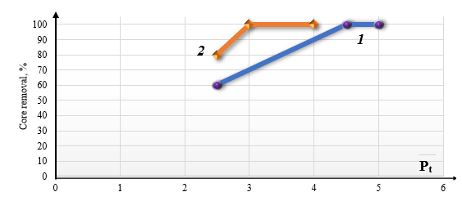
Fig. 5. Dependence of the core recovery percentage on the axial load
1- Well No. 11P, Andakli fields 2- Well No. 1, Temirkazgan area

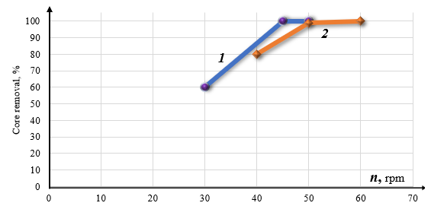
Fig. 6. Dependence of the percentage of core recovery on the rotor speed
1- Well No. 11P, Andakli fields, 2- Well No. 1, Temirkazgan area

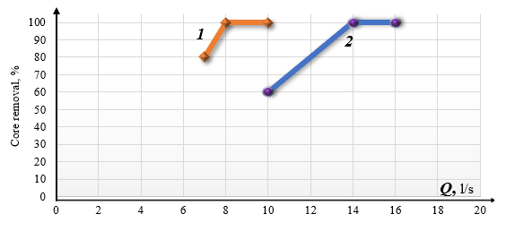
Fig. 7. Dependence of the percentage of core recovery on the performance of the mud pump
1- Well No. 11P, Andakli fields 2- Well No. 1, Temirkazgan area

CONCLUSION
Thus, the planned ways of research to improve the removal of the core during their selection allows us to study and identify the features of the operation of various types of drilling heads. This makes it possible to develop reasonable recommendations for improving the design of cone, vane drill bits that will work effectively both when drilling soft, medium and hard rocks. Despite the fact that it has been proven by world practice that a reliable core sampling tool diamond or polycrystalline diamond drill heads, rather than roller cone ones. The study presented by us and tested on borehole wells showed the correctness of our developments. It is worth noting that the use of a six-bladed cone drill bit of the 6LBK type is a confirmation of this, where the economic efficiency in terms of the cost of the core bit itself and high core removal in comparison with cone bits is higher than 1.2-1.4 times, compared to RDS type core bits purchased abroad twice. The cutters are full cutters and can be placed on the bit without additional standard PDC cutters. An increase in the resource of a rock cutting tool while maintaining the values of mechanical speed makes the drill head the most advanced technology for breaking rocks in hard and fractured rocks.
REFERENCES
- Vozdvizhensky B.I., S.A. Volkov, A.S. Volkov. Column Drilling Moscow “Nedra” 1982, 438 p.1.
- Egamberdiev M.E. Oil and gas facies of the Mesozoic and Paleogene. Uzbek SSR “Fan” Publishing House 1981. 139 p [98-133 p].
- Davlatova N.F. Obtaining Micellar Solutions from Secondary Products of Oil and Fat Production // Collection of Theses of the Oil and Gas Production Complex of the Russian State University of Oil and Gas named after I.M. Gubkin. -Moscow, 2014.
- Kurbanov M., Narimoa R.A. et al. Report of JSC “IGIRNIGM” Provision of scientific and methodological assistance in the selection of core from the productive horizons of the drilling company “Karaulbazar NGRE” under contract NoPD 425-14B Tashkent 2016 52 p.
- Pazilov M.M., Kadyrov N.A. Lubricating reagent based on the cubic residue of the fatty acid distillation process // Mejdn. NPK “Environmental Problems of the South of Russia. 2007.
- Barshay G.S. Biyanovskiy N.I. Theory and Practice of Turbine Drilling. Gostoptekhizdat theory Moscow 1961, 409 p.
- Kurbanov M. Report of “IGIRNIGM” LLC, Providing scientific and methodological assistance in the selection of core from productive
- Chuev D.E. World market of oil service services in modern crisis conditions journal Drilling and oil. January 2016, 63 p.
- Bulatov A.I., Dolgov S.V. “The satellite of the driller”. Nedra Publishing House. Moscow. 2014.
- Mishevicha V.I., Sidorova N.A. “Handbook of drilling engineer”. Nedra Publishing House. Moscow. 1973.
- Kurbanov M. Handwritten report of JSC “IGIRNIGM” Provision of scientific and methodological assistance in the selection of core from the productive horizons of drilling wells DP “Karaulbazarskaya NGRE”. Tashkent. 2016.
- Narimov R.A., Rakhmedov T.F. and others. The report of the IGIRNIGM State Enterprise “Development of the design and technology of production of core-collecting shells used in the selection of core samples at promising oil and gas-bearing sites”. Tashkent. 2022.
- Narimov R.A. et al. Author's work No. EC-01-002339: Author's design of a three-dimensional model and a core selection projectile “KOS”.
- Komilov T.O., Makhamatkhodzhaev D.R. Improved composition of a drilling fluid to prevent the absorption of promovable liquids // Oil Industry. Issue. 1167. - M., 2021. Pp. 68-74. https://doi.org/10.24887/0028-2448-2021-2-68-72

