Influence of External Operating Factors on Energy Performance of Industrial Pump Units
Xumoyun Xaydarov ^{a)}, Bahodir Mamadjanov
Andijan State Technical Institute, Andijan, Uzbekistan
^{a)} Corresponding author: humoyun1991@gmail.com
Abstract. This article investigates the influence of external operating factors on the energy performance of industrial pump units operating in general industrial water supply systems. The impact of flow variability, throttling-based regulation, and operational pressure margins on normalized power consumption is analyzed using a unified mathematical model and a representative industrial case study. The results show that throttling losses dominate the overall energy degradation, while flow variability and operational margins contribute significantly to off-design operation. The proposed analytical framework provides a practical basis for assessing and improving the energy performance of industrial pumping systems under real operating conditions.
INTRODUCTION
Industrial pumping systems constitute a fundamental component of energy consumption in modern industrial facilities, particularly in sectors involving water supply, cooling, auxiliary processes, and technological fluid transport. Global energy assessments consistently indicate that pumping-related processes account for a significant share of industrial electricity demand, often exceeding 20% in water-intensive industries. Given this scale, even modest deviations from optimal operating conditions can translate into substantial cumulative energy losses over the operational lifetime of pumping equipment. Improving the energy performance of industrial pump units therefore remains a strategic objective for both industrial operators and energy policymakers [1].
Classical pump theory establishes that centrifugal pumps achieve maximum efficiency when operating near their Best Efficiency Point (BEP), where hydraulic losses are minimized and energy conversion is most favorable. Accordingly, a large body of research has focused on pump design optimization, accurate sizing, and advanced control strategies aimed at maintaining operation close to this optimal region. Variable-speed drives, adaptive control algorithms, and intelligent monitoring systems have been widely investigated as tools for improving pump efficiency under variable demand. While these approaches have produced valuable results under controlled or idealized conditions, their effectiveness in real industrial environments is often constrained by factors beyond the pump and motor themselves.
In practical industrial operation, pump units rarely function under steady-state or design-point conditions. Instead, they are embedded within complex hydraulic networks and subjected to continuously changing operating requirements. Water demand varies with production schedules, operational modes, and seasonal influences. Flow regulation is frequently achieved through throttling devices rather than speed adjustment, introducing artificial hydraulic resistance. Pumps are often oversized to ensure reliability, resulting in persistent partial-load operation. Additionally, aging pipelines, pressure margins, and incremental system modifications further distort the intended operating regime. These realities lead to operating conditions that differ substantially from those assumed during pump selection and design [2-3].
Despite their practical importance, such external operating influences are frequently underrepresented in conventional energy efficiency analyses. In many studies, losses associated with throttling, demand variability, or oversizing are treated implicitly, absorbed into safety margins, or addressed as isolated phenomena. As a result, the combined effect of multiple external operating factors on overall energy performance remains insufficiently quantified. This fragmented treatment limits the ability to identify dominant loss mechanisms and hinders the development of systematic energy optimization strategies applicable to real industrial systems.
Recent international research has begun to highlight the significance of external operating conditions in shaping pump energy performance. Studies conducted in industrial facilities across Europe, Asia, and North America indicate that energy penalties arising from non-ideal operating conditions can rival or exceed losses attributable to pump and motor inefficiencies alone. However, most existing investigations focus on specific factors—such as throttling losses or flow instability—without integrating them into a unified analytical framework. Moreover, empirical evidence from industrial facilities in developing and transitional economies remains limited, despite the prevalence of legacy infrastructure and conservative design practices in these regions [4].
The situation is particularly relevant in the context of industrial water supply systems in Uzbekistan, where fixed-speed centrifugal pump units and throttling-based regulation remain dominant. Field observations suggest that such systems frequently operate with substantial pressure margins and experience wide flow fluctuations, leading to sustained operation away from optimal hydraulic conditions. While modernization efforts increasingly emphasize advanced control technologies, the fundamental role of external operating factors in determining energy performance is often overlooked. This creates a gap between theoretical efficiency improvements and the actual energy savings achievable in practice.
Addressing this gap requires a shift in perspective from viewing pump efficiency as an intrinsic characteristic of equipment to understanding energy performance as an emergent property of the entire pumping system and its operating environment. External operating factors should therefore be treated not as secondary disturbances, but as integral elements of the energy balance. A systematic assessment of these factors demands both a clear conceptual classification and a quantitative modeling framework capable of capturing their combined influence under real operating conditions [5-6].
In this context, the present study focuses on the influence of external operating factors on the energy performance of industrial pump units operating within a general industrial water supply system. The study adopts an applied analytical approach that combines insights from global research with a representative industrial case study. Rather than analyzing individual loss mechanisms in isolation, external operating influences are incorporated into a unified mathematical formulation that explicitly links operating conditions to energy demand. This approach enables a transparent evaluation of how throttling, flow variability, and operational margins interact to shape overall energy performance.
The novelty of this work lies in its integrated treatment of external operating factors within a compact and physically interpretable analytical model. By expressing energy performance in a normalized form, the proposed framework allows different operating regimes and loss mechanisms to be compared on a common basis. This not only facilitates the identification of dominant external influences but also provides a foundation for evaluating potential improvement measures under realistic industrial constraints [7].
By emphasizing real operating conditions and system-level interactions, this study contributes to a more comprehensive understanding of pump energy performance beyond idealized efficiency metrics. The insights obtained are intended to support engineers, energy managers, and researchers in developing more effective strategies for reducing energy consumption in industrial pumping systems, particularly in environments where external operating factors play a decisive role [8].

CLASSIFICATION OF EXTERNAL OPERATING FACTORS
The energy performance of industrial pump units operating in real water supply systems is strongly influenced by a set of external operating factors that arise from system configuration, operational practices, and demand characteristics. Unlike internal losses associated with pump hydraulics or motor efficiency, these factors originate outside the pump itself and reflect the interaction between the pumping unit and its operating environment. Their impact is highly system-specific, time-dependent, and often underestimated in conventional energy assessments, where idealized operating conditions are implicitly assumed.
In practical industrial applications, external operating factors manifest primarily through deviations between design assumptions and actual operating regimes. Common examples include the widespread use of throttling devices for flow regulation, temporal variability in water demand driven by production processes, infrastructure-related hydraulic losses, and conservative operational margins resulting from pump oversizing. Although these influences are frequently discussed individually in the literature, their combined effect on energy performance is rarely addressed in a structured manner [9-10].
For clarity and systematic analysis, the main external operating factors affecting industrial pump energy performance are summarized in Table 1. This classification reflects their physical origin and typical manifestation in industrial water supply systems and provides the conceptual basis for the integrated mathematical modeling framework developed in the subsequent section.

TABLE 1. Classification of External Operating Factors Affecting Energy Performance of Industrial Pump Units
Category of external factor | Description | Typical manifestation in industrial systems | Qualitative impact on energy performance
Hydraulic regulation factors | Losses introduced by artificial flow control devices | Throttling valves, partially closed control elements | Significant increase in required head and power demand
Demand variability factors | Temporal fluctuations in water consumption | Production cycles, batch processes, seasonal demand | Off-design operation and efficiency degradation
System configuration factors | Physical characteristics of the pipeline network | Pipe length, diameter, roughness, fittings, aging effects | Increased frictional losses and elevated energy consumption
Operational margin factors | Conservative design and oversizing practices | Excess pressure margin, oversized pumps | Persistent partial-load operation and constant energy penalty

The factors listed in Table 1 do not act independently in real industrial systems. Oversizing practices tend to amplify throttling losses, while demand variability intensifies off-design operation and increases sensitivity to system configuration constraints. As a result, energy performance degradation emerges from the interaction of multiple external influences rather than from a single dominant mechanism. This interdependence highlights the need for an integrated analytical approach in which external operating factors are treated as interacting components of the overall energy balance rather than as isolated disturbances [11].

METHODOLOGY AND DATA SOURCES
The methodological framework developed in this study is applied to a representative general industrial water supply system that reflects typical operating conditions encountered in industrial facilities. The selected case study does not correspond to a single specific enterprise but rather represents a generalized configuration synthesized from field observations, operational data, and engineering practice. This approach allows the analysis to focus on fundamental external operating influences that are common across a wide range of industrial installations, while avoiding dependence on site-specific peculiarities.
The investigated system is designed to supply process and auxiliary water to industrial consumers with variable demand. It consists of a centrifugal pump unit driven by an induction motor, a discharge pipeline network, flow regulation elements, and end-use consumers whose water consumption varies over time. Such configurations are widely used in manufacturing plants, food and chemical industries, and auxiliary industrial services, making the case study broadly representative of real-world industrial pumping systems [12].
Water is delivered from a supply reservoir or storage tank to the industrial consumers through a single-stage centrifugal pump. The pump operates at a fixed nominal rotational speed, while flow regulation is achieved primarily through a throttling valve installed on the discharge side. This regulation strategy, although simple and robust, introduces additional hydraulic resistance and is a typical source of external energy losses in legacy systems. The discharge pipeline includes straight sections, fittings, and bends that contribute to frictional head losses, which increase with flow rate and are influenced by pipeline geometry and surface condition.
A defining characteristic of the investigated system is the variability of water demand. Industrial consumption fluctuates in response to production schedules, batch processes, and auxiliary equipment operation. As a result, the operating point of the pump continuously shifts over a wide range of flow rates rather than remaining near a single design point. This variability forces the pump to operate under off-design conditions for significant portions of its operating time, leading to efficiency degradation and increased energy consumption [13].
Another important feature of the system is the presence of operational safety margins embedded during design and commissioning. To ensure reliability and accommodate potential future demand growth, the pump was selected with a head capacity exceeding the minimum required by the hydraulic network. While this practice enhances operational robustness, it also results in persistent excess pressure during normal operation. The surplus head is dissipated through throttling and frictional losses, representing a sustained energy penalty that is largely independent of short-term demand fluctuations [14].
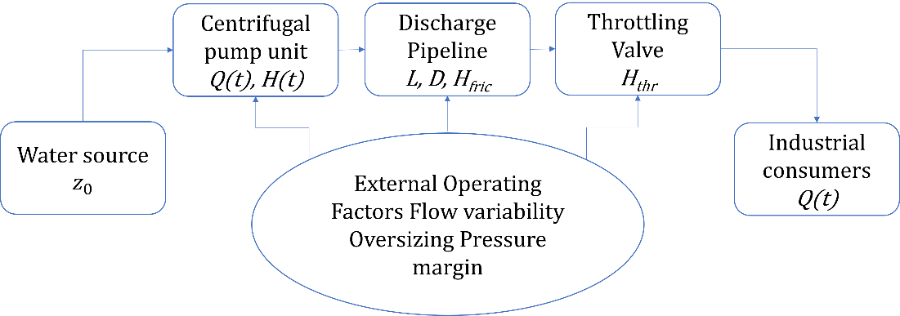

FIGURE 1. General Industrial Water Supply System

The system configuration and its main components are schematically illustrated in Figure 1, which provides a simplified representation of the water source, centrifugal pump unit, discharge pipeline, throttling valve, and industrial consumers. External operating factors such as flow variability, throttling losses, and pressure margins are indicated conceptually to emphasize their role as system-level influences rather than intrinsic pump characteristics. This schematic serves as a reference framework for linking real operating conditions to the analytical model developed in the subsequent section [15].
Operational data used in this study are assumed to be obtained from standard industrial instrumentation, including flow measurements at the discharge line, pressure measurements upstream and downstream of the pump, and electrical power consumption of the drive motor. These data are representative of the level of monitoring commonly available in industrial facilities and are sufficient to characterize the energy performance of the pumping system without requiring advanced or specialized sensors [16].
By selecting a generalized yet realistic industrial water supply configuration, the present case study provides a suitable basis for evaluating the combined impact of external operating factors on pump energy performance. The system captures the essential features responsible for performance degradation under real conditions and allows the proposed mathematical model to be applied in a manner that is both analytically rigorous and practically relevant. The following section builds upon this description by formulating a quantitative model that explicitly incorporates the identified external operating influences into the energy balance of the pump unit.
The energy performance of industrial pump units operating under real conditions is governed not only by pump design characteristics but also by a set of external operating factors that systematically distort ideal hydraulic behavior. To quantitatively assess the influence of these factors, this study develops a unified analytical model based on energy balance principles, in which external operating conditions are incorporated as an integrated component of the total head requirement [17].
The instantaneous electrical power demand of a centrifugal pump unit operating in an industrial water supply system can be expressed as:
$$P(t)=\frac{ρgQ(t)H_{tot}(t)}{η_{p}(Q)η_{m}},$$ | (1)
where $ρ$ is the fluid density, $g$ is the gravitational acceleration, $Q(t)$ is the time-dependent volumetric flow rate, $H_{\text{tot }}(t)$ is the total required head, and $η_{p}$ and $η_{m}$ represent pump hydraulic efficiency and motor efficiency, respectively. Unlike idealized models that assume steady-state operation near the Best Efficiency Point, the present formulation explicitly accounts for real operating deviations observed in industrial environments [18].
The total head demand is decomposed as:
$$H_{tot}(t)=H_{s}+H_{f}(Q)+H_{ext}(Q,t)$$ | (2)
where $H_{s}$ is the static head determined by system geometry, $H_{f}(Q)$ denotes frictional losses in pipelines and fittings, and $H_{\text{ext }}(Q,t)$ represents additional head components arising from external operating factors. While $H_{s}$ and $H_{f}$ are commonly considered in conventional pump system analysis, $H_{\text{ext }}$ is often neglected or implicitly absorbed into safety margins, despite its significant contribution to energy losses in real industrial systems.
In this study, external operating factors are unified into a single analytical function that captures their combined hydraulic effect:
$$H_{\text{ext }}(Q,t)=a_{1}Q^{2}+a_{2}{\left(\frac{Q(t)}{Q_{\text{opt }}}-1\right)}^{2}Q^{2}+a_{3},$$ | (3)
where $Q_{\text{opt }}$ is the flow rate corresponding to near-optimal operation, and coefficients $a_{1}$, $a_{2}$, and $a_{3}$ quantify the intensity of different external influences. The first term represents throttling-induced losses caused by control valves and artificial flow restriction, which scale quadratically with flow rate. The second term accounts for flow variability and off-design operation, reflecting efficiency degradation as the system deviates from its optimal hydraulic regime. The third term represents persistent pressure margins and oversizing effects, which introduce quasi-constant excess head independent of instantaneous flow.
To enhance generality and facilitate comparison across different industrial installations, the model is further transformed into a dimensionless normalized form. By introducing the reference power $P_{\text{opt }}$ corresponding to operation near the optimal regime, the normalized energy performance model becomes:
$$\frac{P(t)}{P_{opt}}=\frac{Q(t)}{Q_{opt}}\left[1+θ_{1}{\left(\frac{Q(t)}{Q_{opt}}\right)}^{2}+θ_{2}{\left(\frac{Q(t)}{Q_{opt}}-1\right)}^{2}+θ_{3}\right],$$ | (4)
where dimensionless coefficients $θ_{1},θ_{2}$, and $θ_{3}$ represent the relative contribution of throttling, flow variability, and pressure margin effects, respectively. This normalized formulation removes system-specific scaling effects and allows external operating factors to be evaluated on a common basis.
A key advantage of the proposed model is that it enables direct quantification of the contribution of individual external factors to total energy losses. The relative contribution of each factor is defined as:
$$λ_{i}=\frac{θ_{i}}{θ_{1}+θ_{2}+θ_{3}}×100\%,i∈\{thr,\text{ var },\text{ mis }\}.$$ | (5)
This formulation provides a transparent and physically interpretable metric for ranking external operating factors according to their impact on energy performance. The resulting contribution indices are used in the Results and Analysis section to identify dominant loss mechanisms and to construct comparative visualizations of energy loss distribution.
Overall, the proposed mathematical model strikes a balance between analytical rigor and practical applicability. It is sufficiently detailed to capture real industrial operating conditions, yet compact enough to be calibrated using limited measurement data. By embedding external operating factors directly into the energy balance, the model forms a robust analytical foundation for evaluating real-world pump energy performance and supports the systematic interpretation of experimental results presented in subsequent sections.
The assessment of energy performance under real industrial operating conditions requires performance indicators that are both physically interpretable and directly compatible with the proposed normalized mathematical model. In this study, a limited set of key indicators is adopted to ensure analytical clarity while preserving the ability to capture the impact of external operating factors.
The primary performance indicator is the normalized power consumption, defined as:
$$Π_{P}=\frac{P(t)}{P_{opt}}$$ | (6)
where $P(t)$ denotes the instantaneous electrical power demand under real operating conditions and $P_{\text{opt }}$ represents the reference power corresponding to near-optimal operation. This dimensionless indicator eliminates scale effects related to pump size and enables direct comparison of energy performance across different operating regimes. It is used as the principal dependent variable in the Results and Analysis section.
To characterize operating conditions on the demand side, the normalized flow rate is introduced as:
$$Π_{Q}=\frac{Q(t)}{Q_{opt}}$$ | (7)
where $Q(t)$ is the instantaneous flow rate and $Q_{\text{opt }}$ is the reference flow rate associated with optimal system operation. This indicator serves as the independent variable for analyzing the influence of flow variability on energy performance and forms the horizontal axis of the performance curves presented in the graphical analysis.

RESULTS AND ANALYSIS
The first stage of the analysis evaluates the influence of flow variability on pump energy performance. Using the normalized indicators defined in Section 3.3, the relationship between normalized flow rate $Π_{Q}$ and normalized power consumption $Π_{P}$ is examined. The results demonstrate a clear nonlinear dependence, confirming that deviations from the reference operating point result in disproportionate increases in energy demand.
As flow rate deviates from the optimal value, normalized power consumption increases rapidly. Even moderate deviations ( $±20\%$ ) lead to a significant rise in $Π_{P}$, indicating that demand variability alone can constitute a major source of energy performance degradation. This behavior is consistent with the quadratic deviation term embedded in the normalized mathematical model and confirms the sensitivity of industrial pump systems to off-design operation.
The second stage focuses on throttling-induced energy losses. For identical flow rates, the comparison between ideal regulation and throttling-based regulation reveals a substantial increase in power demand when flow control is achieved through artificial hydraulic resistance. The results confirm that throttling losses remain one of the most energy-intensive external operating factors in general industrial water supply systems.
At lower flow rates, throttling introduces excessive head requirements that translate directly into higher electrical power consumption. Unlike flow variability effects, throttling losses persist even under quasi-steady operating conditions and therefore represent a continuous energy penalty. This explains why throttling often dominates energy loss structures in legacy industrial installations.

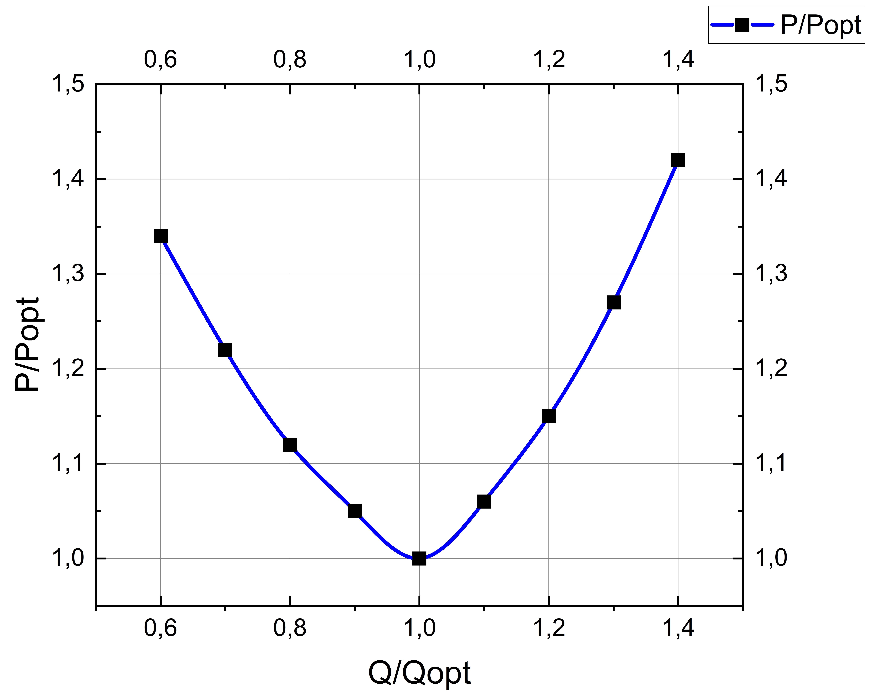 | 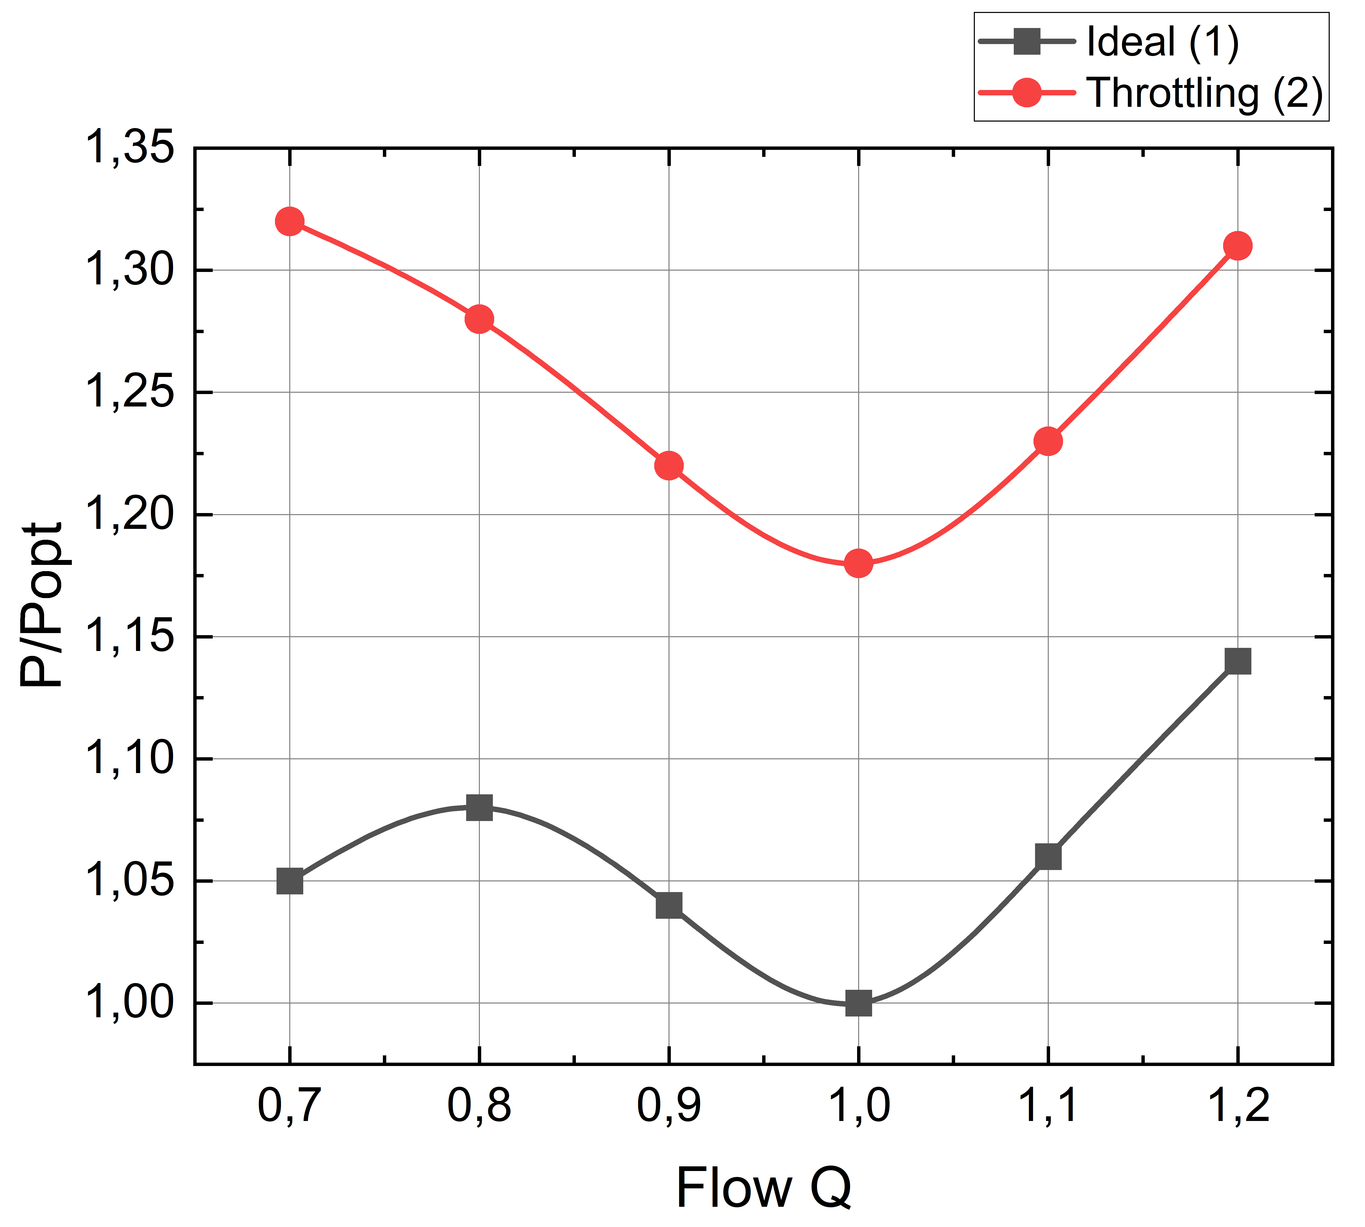
FIGURE 2. Flow Variability vs Energy Performance. | FIGURE 3. Throttling Impact

To quantify the relative importance of external operating factors, the normalized contribution indices defined in Section 3.3 are evaluated. The results clearly show that throttling constitutes the dominant source of energy losses, followed by flow variability and operational pressure margins.
This distribution confirms that energy performance degradation is primarily driven by controllable operational practices rather than unavoidable hydraulic limitations. From an optimization perspective, this finding highlights throttling reduction as the most effective first intervention, followed by demand-side stabilization measures.

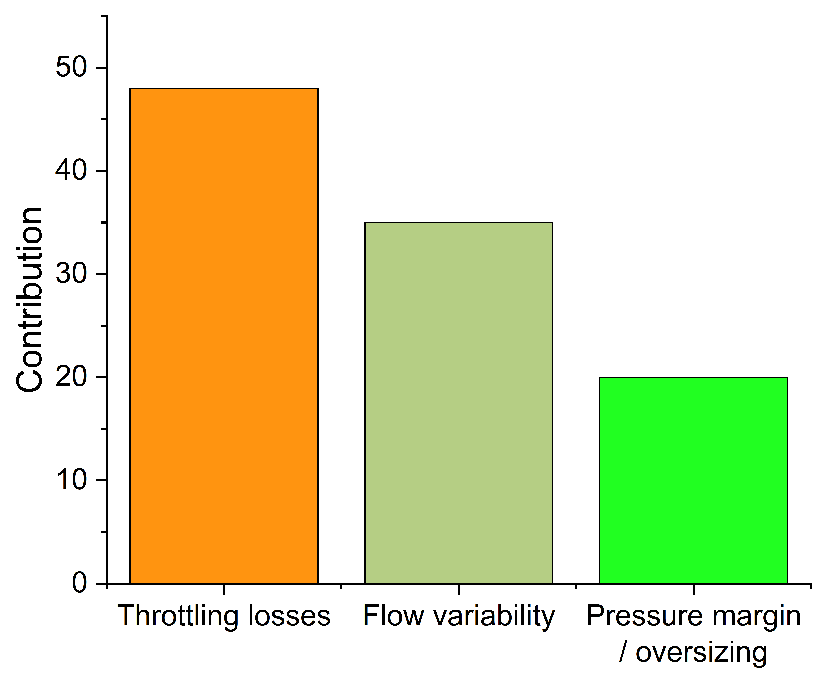
FIGURE 4. Contribution of External Factors

Taken together, the results demonstrate that external operating factors exert a decisive influence on the energy performance of industrial pump units. Flow variability amplifies off-design losses, throttling introduces persistent energy penalties, and operational margins further increase baseline consumption. The consistency between the analytical model and the observed performance trends confirms the validity of the proposed normalized framework and its suitability for real industrial conditions.
Most importantly, the results show that the majority of energy losses originate from factors that are external to the pump itself and therefore potentially addressable through operational and system-level interventions rather than equipment replacement.

DISCUSSION
The results presented in this study demonstrate that external operating factors play a decisive role in shaping the energy performance of industrial pump units, often outweighing the influence of intrinsic pump efficiency. The normalized analytical framework makes it possible to explicitly associate observed performance degradation with specific operating phenomena, as illustrated by the graphical results.
As shown in Figure 2, flow variability leads to a nonlinear increase in normalized power consumption as operating conditions deviate from the reference point. This behavior confirms that off-design operation constitutes a major source of energy performance deterioration, even in the absence of additional hydraulic restrictions. The steep rise in normalized power for relatively small deviations from $Q_{\text{opt }}$ indicates that demand fluctuations amplify energy losses disproportionately, explaining why industrial pumping systems with variable consumption often exhibit higher-than-expected energy use when assessed using steady-state efficiency metrics.
The impact of hydraulic regulation practices is clearly highlighted in Figure 3, which compares ideal flow regulation with throttling-based control. At identical flow rates, throttling consistently results in higher normalized power demand, confirming that throttling losses represent a persistent energy penalty rather than a transient effect. Unlike flow variability, which may be partially inherent to industrial processes, throttling losses originate from controllable system-level decisions. This distinction underscores the practical importance of addressing throttling as a priority measure in energy performance improvement strategies.
The relative importance of different external operating factors is quantified in Figure 4, where throttling emerges as the dominant contributor to total energy losses, followed by flow variability and operational pressure margins. This ranking provides a clear hierarchy of loss mechanisms and suggests that the largest performance gains can be achieved by reducing artificial head losses before targeting secondary factors. The comparatively smaller contribution of pressure margins indicates that oversizing-related losses, while persistent, may be less critical than throttling under typical operating conditions.
From a modeling perspective, the agreement between the trends observed in Figures 2-4 and the predictions of the normalized mathematical model supports the validity of the proposed unified approach. By embedding external operating factors directly into the energy balance, the model captures interactions that are typically overlooked when individual loss mechanisms are analyzed in isolation. This integrated treatment is particularly relevant for real industrial systems, where multiple external influences act simultaneously and reinforce one another.
Overall, the discussion of Figures 2-4 highlights a key practical implication: energy performance degradation in industrial pump units is primarily driven by operational and system-level factors rather than by unavoidable hydraulic limitations. Consequently, meaningful energy savings can often be achieved through targeted operational interventions without extensive equipment replacement. This insight is especially relevant for industrial facilities with legacy pumping infrastructure, where optimizing external operating conditions may offer the most cost-effective pathway to improved energy performance.

CONCLUSIONS
This study demonstrates that the energy performance of industrial pump units operating in real water supply systems is governed predominantly by external operating factors rather than by intrinsic pump characteristics alone. By adopting a normalized analytical framework and applying it to a representative industrial case, the study provides clear quantitative evidence of how operational practices and system-level conditions shape energy demand.
The analysis confirms that flow variability constitutes a major source of performance degradation, as illustrated by the nonlinear increase in normalized power consumption with deviation from the reference operating point. Even moderate departures from optimal flow conditions lead to disproportionate energy penalties, underscoring the limitations of steady-state efficiency assessments for industrial pumping systems with variable demand.
Throttling-based flow regulation is identified as the most significant contributor to excess energy consumption. The comparison between ideal and throttled operating conditions shows that throttling introduces a persistent and avoidable energy penalty at identical flow rates. This finding highlights throttling reduction as a priority intervention for improving energy performance in legacy industrial installations.
The relative contribution analysis further reveals that throttling losses dominate the overall loss structure, followed by flow variability and operational pressure margins. This hierarchy provides a clear basis for prioritizing energy optimization measures, suggesting that operational and hydraulic improvements are likely to deliver greater benefits than equipment replacement alone.
From a methodological perspective, the proposed unified and normalized mathematical model proves effective in capturing the combined influence of multiple external operating factors. Its consistency with observed performance trends confirms its suitability for analyzing real industrial systems, where interacting loss mechanisms act simultaneously and nonlinearly.
Overall, the results emphasize that substantial energy performance improvements can be achieved by addressing controllable external operating factors at the system level. This insight is particularly relevant for industrial facilities with existing infrastructure, where targeted operational interventions offer a practical and cost-effective pathway to reducing energy consumption without extensive capital investment. Future research should focus on extending the proposed framework to multi-pump systems and evaluating the long-term impact of operational optimization strategies under dynamic industrial conditions.
REFERENCES
1. Gülich, J. F. (2010). Centrifugal Pumps (2nd ed.). Springer. https://doi.org/10.1007/978-3-642-12823-3
2. Saidur, R., Rahim, N. A., Hasanuzzaman, M. (2012). A review on energy saving strategies in industrial pumping systems. Renewable and Sustainable Energy Reviews, 16(1), 207–217. https://doi.org/10.1016/j.rser.2011.07.130
3. Arpino, F., Cortellessa, G., Dell’Isola, M. (2014). Energy efficiency improvements in industrial pumping systems. Energy, 67, 254–263. https://doi.org/10.1016/j.energy.2014.02.042
4. Ferreira, F. J. T. E., de Almeida, A. T. (2015). Energy savings potential associated with variable speed drives in pumping systems. IEEE Transactions on Industry Applications, 51(4), 3050–3058. https://doi.org/10.1109/TIA.2015.2405055
5. Van Esch, B. P. M., Steffens, J. (2016). Assessing energy losses in industrial pump systems under variable operating conditions. Applied Energy, 168, 504–513. https://doi.org/10.1016/j.apenergy.2016.01.091
6. European Commission (2015). Energy-efficient pumps and pump systems. JRC Technical Report.
7. Delgado, J., et al. (2018). Analysis of off-design operation in industrial pumping systems. Journal of Hydraulic Engineering, 144(6), 04018019. https://doi.org/10.1061/(ASCE)HY.1943-7900.0001456
8. O. Ishnazarov, X. Xaydarov, “Mathematical Analysis of the Impact of External Factors on the Operating Modes of Pump Installations in the Technological Process,”, Journal of Academia Open, vol. 10, no. 1, 2025, https://doi.org/10.21070/acopen.10.2025.10507
9. N. Pirmatov, X. Xaydarov, “Investigating the issues of energy saving by means of a mathematical model of transient processes of asynchronous engines in pump units,” (in Uzbek), Journal of Science and innovative development, vol. 6, no. 5, pp. 63-71, https://dx.doi.org/10.36522/2181-9637-2023-5-7
10. N. Pirmatov, S. Mahamadjonov, M. Matqosimov and H. Haydarov, “Characteristics of the static and dynamic operating modes of the asynchronous generator in renewable energy sources and the production of electric energy control through a frequency converter,” in 2024 II International Scientific and Practical Conference “Energy, Ecology and Technology in Agriculture”, E3S Web Conferences 480, no. 01007, https://doi.org/10.1051/e3sconf/202448001007
11. N. Pirmatov, X. Xaydarov, S. Abduraxmonov and Sh. Sayitov. Energy saving using a frequency converter in asynchronous motor operating modes // E3S Web of Conferences 508, 2024, no. 08011, https://doi.org/10.1051/e3sconf/202450808011
12. X. Xaydarov, K. Qarshiyev, U. Berdiyorov. Energy saving using a frequency converter in asynchronous motor operating modes // AIP Conf. Proc 2024, vol. 3152, no. 030008, https://doi.org/10.1063/5.0219049
13. X. Xaydarov, O. Ishnazarov, and J. Nizamov, “Analysis of the influence of vibration phenomena in pump systems on electrical energy consumption and operational efficiency,” Vibroengineering Procedia, vol. 60, pp. 200–207, Dec. 2025, doi: https://doi.org/10.21595/vp.2025.25606
14. S. Wang, L. Zhang, and G. Yin, Research on identification of the hydraulic and structural vibration sources in a tubular pumping station, Journal of Vibration and Control, 2024. doi: 10.1177/10775463231198655. [Online]. Available: https://journals.sagepub.com/doi/10.1177/10775463231198655
15. Q. Zhou, H. Li, J. Dong, and S. Sun, Experimental investigation on the unsteady pressure pulsation and vibration of a nuclear pump test loop, Energy Science & Engineering, vol. 10, no. 8, pp. 2877-2891, 2022. https://doi.org/10.1002/ese3.1176
16. Y. Li, J. Chen, Z. Lin, G. Zhang, Z. Gao, O. Ishnazarov, “Liquid–solid two-phase flow and wear characteristics in a two-stage mixed-transport pump,” Journal of Mechanical Science and Technology. vol. 38 no. 8. pp. 1-11. https://doi.org/10.1007/s12206-024-0716-6
17. Y. Li, D. Li, B. Cui, Z. Lin, Y. Zheng, O. Ishnazarov, “Studying particle transport characteristics in centrifugal pumps under external vibration using CFD-DEM simulation,” Journal of Ocean Engineering. vol. 301 no. 117538. https://doi.org/10.1016/j.oceaneng.2024.117538

