Analysis of heat exchange processes of locomotive traction electric motors
Shukhrat Jamilov ^{a)}, Julenev Nikolay, Shaxboz Samatov, Nusratillo Abdullayev
Tashkent State Transport University, Tashkent, Uzbekistan
^{a)} Corresponding author: shuxratjamilov@mail.ru
Abstract. This article analyzes the heat exchange processes occurring in traction electric machines. The study considers the main factors influencing the temperature regime of electrical machine elements, including such parameters as the thermal conductivity coefficient, cooling conditions, and load changes. Based on the classical theory of heating, the processes of heating and cooling of the machine are mathematically modeled using heat balance equations. Based on the model, the exponential change in temperature over time, the concept of the time constant, and the rate of temperature increase under adiabatic conditions were determined. Graphs and formulas show how the machine temperature changes over time. The research results are of practical importance in assessing the thermal state of electrical machines, assessing their reliability, and designing cooling systems.
INTRODUCTION
The stability of the temperature regime of modern traction electric machines when operating under various load conditions is of great importance. The reliable and efficient operation of electrical machines directly depends on their thermal state. Increasing the temperature can lead to the wear and tear of insulation materials, overheating, and even the failure of the electric car. Therefore, an in-depth study of heat exchange processes in electrical machines, their mathematical modeling, and the determination of optimal cooling methods is one of the important scientific and practical tasks.
Currently, it is possible to determine the temperature change of electrical machines using models based on classical thermal theory. Such models take into account the geometric and thermal properties of the machine elements, cooling conditions, and heat transfer coefficients. Through them, it is possible to analyze the heating and cooling processes of the machine based on an exponential law [1-4].
The article theoretically examines the heat exchange processes of a traction electric machine based on this approach. The purpose of the research is to obtain the basic mathematical equations describing the thermal state of electrical machines, to determine the physical meaning of the time constant, and to conduct a graphical analysis of heating and cooling processes [5].
As for non-stationary processes in electrical machines, they should be classified as very typical operational phenomena, and therefore their analysis is very relevant. Therefore, in the development of the theory of electrical machines, an attempt was made to obtain calculation formulas based on them, according to which the schematization of the process gives more realistic results [7-9].

EXPERIMENTAL RESEARCH
Theoretical foundations of heat exchange. As for non-stationary processes in electrical machines, they should be classified as very typical operational phenomena, and therefore their analysis is very relevant. Therefore, in the development of the theory of electrical machines, an attempt was made to obtain calculation formulas based on them, according to which the schematization of the process gives more realistic results.
The assumptions, called classical heating theory, are as follows.
1. The entire electric machine (or its analyzed element) is the only body with infinite thermal conductivity, which leads to the absence of a temperature gradient in any direction in the volume of the machine [10] – [12].
2. The ambient temperature $ϑ_{c}$ is constant, meaning the environment has infinite heat capacity.
3. The heat transfer coefficient а between the machine surface and the environment does not depend on the location and duration of the process.
Now let's write the equation of thermal conductivity for a unit volume of a surface-cooled object:
$сρ-\frac{∂ϑ}{∂t}=λ∇^{2}ϑ+ρ_{0}-α\frac{F}{V}\left(ϑ-ϑ_{c}\right)$ $(1)$
$∇ϑ=0, ϑ_{c}=0$ we will take
$$Pdt=cGdϑ+αFϑdt (2)$$
where $G=ρV$ - mass of the body; $P=p_{0}V$ - separated losses.
Equation (1) can be easily interpreted as the heat balance equation, according to which the released heat is partially used to increase the enthalpy of the body and partially released into the environment. Thus, equation (1) can be obtained directly from reasoning.

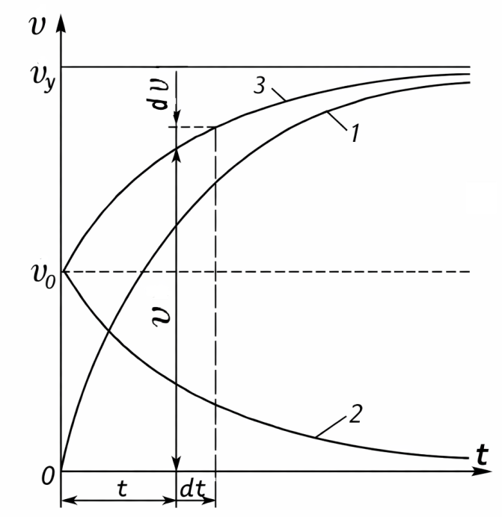  FIGURE 1. Temperature curve change | 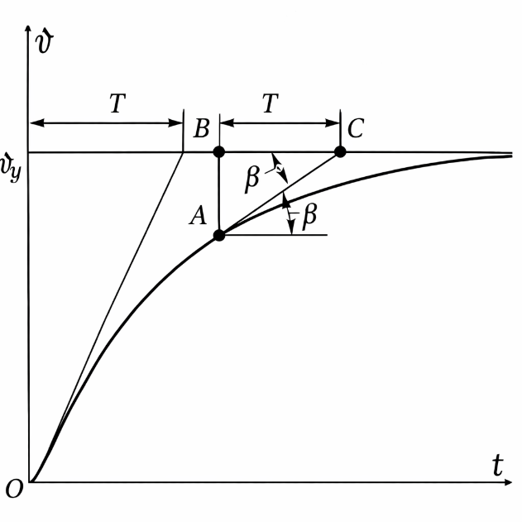FIGURE 2. The geometric meaning of the constancy of time.

Based on equation (1), we first analyze the process of heating the body. If the losses P are finite, the temperature of the body tends to a stable value, as the duration of the process tends to infinity: $ϑ=ϑ_{у}$ at $t→∞$. But in a steady state, the enthalpy does not change, and for any time interval ∆t, all the released heat is transferred to the environment: $P∆t=αFϑ_{y}∆t$. Therefore, $ϑ_{y}=P/(αF)$. Equation (1) can now be rewritten
$αFϑ_{y}dt=cGdϑ+αFϑdt$ (3)
In the last equation, the mixed ones are separated:
$\frac{αF}{cG}dt=\frac{dϑ}{ϑ_{y}-ϑ}$ (4)
We introduce the notation $сG/(αF)=T$. Subsequently,
$\frac{t}{T}=-\ln\left(ϑ_{y}-ϑ\right)+const$ (5)
At the beginning of the process, the permissible temperature in the machine is $ϑ_{0}$, i.e., at $t=0,$ $ϑ=ϑ_{0}$, from which $С=\ln\left(ϑ_{y}-ϑ_{9}\right).$ Thus, $\frac{t}{T}=ln\frac{ϑ_{y}-ϑ_{0}}{ϑ_{y}-ϑ};$
$ϑ=ϑ_{y}\left(1-e^{-\frac{t}{T}}\right)+ϑ_{0}e^{-\frac{t}{T}}$ (6)
The obtained heating equation describes the exponential law of temperature increase over time (curve 1 of Fig. 3.5). Remember,
$ϑ_{0}=0$ $ϑ=ϑ_{y}\left(1-e^{-\frac{t}{T}}\right)$ (7)
Now let's consider the cooling process from the temperature $ϑ_{0}$ when the load is applied (Fig. 1.1, curve 2). For this, we substitute the above equation P = 0. Then
$\frac{dϑ}{ϑ}=-\frac{αF}{cG}dt=-\frac{dt}{T}$ (8)
from where $\frac{t}{T}=-\ln{ϑ}+const$. Considering that $ϑ=ϑ_{9}$ at $t=0,$ we get
$С=lnϑ_{0}$ and $ϑ=ϑ_{0}e^{-\frac{t}{T}}$ (9)
As you can see (Fig. 1.1), the heating curve 3 at $ϑ≠0$ is the sum of the heating curve 1 at $ϑ_{0}=0$ and the cooling curve 2 from the temperature $ϑ_{0}$.
It is very convenient for analyzing transient loads and other transient modes, which characterize the intensity of transient heat transfer and depend on the heat capacity of the body, the mass of its cooling surface, and the heat transfer coefficient. It is called the time constant and has a simple geometric meaning (Fig. 1.2).
from the above equation it follows that $ϑ_{0}=0\frac{dϑ}{dt}\frac{1}{T}\left(ϑ_{y}-ϑ\right)$ when but
$\frac{dϑ}{dt}=tgβ=\frac{AB}{BC}=\frac{1}{BC}\left(ϑ_{y}-ϑ\right)$ (10)
where BC is the heating subcurve. Therefore, for any point on the curve
$\frac{1}{T}\left(ϑ_{y}-ϑ\right)=\frac{1}{BC}\left(ϑ_{y}-ϑ\right)$and $T=BC$ (11)
Thus, T is the lower curve at any point of the heating (or cooling) curve.
RESEARCH RESULTS
The analysis of an adiabatic non-stationary process, i.e., a process without heat exchange with the environment, is of interest. (1) We obtain the equation $α=0$, then $\frac{dϑ}{dt}=\frac{P}{cG}=const$. For copper coils, for example, c = 0.39 kJ • kg/K; γ = 8.9 g/sm³ and ρ = 0.0175 Ohm • mm²/m. From here, the rate of increase of the winding temperature is determined by the increase in the constant current density (in kelvins per second)
$\frac{P}{cG}=\frac{j^{2}ρlS}{cγlS}=\frac{j^{2}}{cγ/ρ}=\frac{j^{2}}{200}$ (12)
Formula (1.5) is accurate in the absence of temperature differences in the body and the cooling medium, i.e., at first glance, it is only suitable for calculating the heating of highly heat-conducting parts washed by a strong stream of cooling water.
$ϑ_{y}=∆ϑ_{α}=\frac{P}{αF}$ (13)
$T=\frac{∆ϑ_{α}}{P/(cG)}=\frac{cG}{αF}$ (14)
It should be noted that the above analysis can be applied to many objects far from satisfying the classical conditions, if under the value $ϑ_{y}$ we take the steady average or maximum increase in the temperature of the heated body from the lowest level. under the value of the temperature of the cooling medium and the time constant T - this is the ratio of the excess body temperature to the rate of adiabatic increase:
$T=\frac{ϑ_{y}}{∆_{ад}}=\frac{ϑ_{y}}{P/(cG)}$ (15)
For the most general case, when temperature drops occur in the active $\left(∆ϑ_{λ_{α}}\right)$ and insulating $(∆ϑ_{λ_{из}})$ layers, the surface is heated by convective cooling$(∆ϑ_{α})$ and a cooling medium $(∆ϑ_{с})$ . $ϑ_{y}$and T can be represented as follows:
$ϑ_{у}=∆ϑ_{с}+∆ϑ_{α}+∆ϑ_{λ_{из}}+∆ϑ_{λ_{α}}$ (16)
$T=ϑ_{у}{\left(\frac{P}{c_{α}G_{α}+c_{из}G_{из}+c_{с}G_{с}}\right)}^{-1}==\frac{c_{α}G_{α}}{αF}\left(1+\frac{∆ϑ_{λ_{из}}}{∆ϑ_{α}}+\frac{∆ϑ_{λ_{α}}}{∆ϑ_{α}}+\frac{∆ϑ_{с}}{∆ϑ_{α}}\right)∙\left(1+\frac{c_{из}G_{из}}{c_{α}G_{α}}+\frac{c_{с}G_{с}}{c_{α}G_{α}}\right)$ (17)
The applied formal technique ensures the qualitative accuracy of the conclusions: formula (17) shows the slowing down of a non-stationary process under conditions of a correct decrease in internal and external temperature. Physically, this deceleration depends, in particular, on the final thermal conductivity of the attached heated masses.
Based on expressions (16) and (17), an important characteristic of a non-stationary process is the ratio of temperature drops inside the body and on the surface of the body in a stable state in a cooling medium. In different parts of electrical machines, these ratios vary greatly: for example, the internal drop is only a few percent of the convective drop in an air-cooled uninsulated copper tire and can be several times greater than the convective drop with an air-cooled stator core [13] – [14].
During forced air cooling of the coil poles, the heating (temperature increase) of the medium is 5-8 times less than the convective difference from the channel surface, but with water cooling of the stator core, it is tens of times greater than this difference. Under these conditions, the universality of the accurate interpretation of the time constant for (16) must be verified.
Comparison of approximate solutions according to (15) and (17) with exact solutions of heat conduction problems for characteristic active parts of electrical machines provides a very convenient situation. It turned out that the exponential form of the heating curve, which is a time constant acting as a measure of thermal inertia, is characteristic of active steel packets of the stator core in the main and end zones of the magnetic circuit, as well as direct and indirect gas cooling of induction machines with a large part of the armature winding operating on direct and alternating current [15].
With a sharp change in load, the process of temperature increase in the initial period can be considered adiabatic:
$\frac{dϑ}{dt}=\frac{∆P}{cG}=\frac{j_{2}^{2}+j_{1}^{2}}{cγ/ρ}=\frac{j_{1}^{2}(k_{j}^{2}-1)}{cγ/ρ}$ (18)
where k_{j} — j₂/j₁ - current overload.
It is characteristic that with exponential temperature increase, its stable state value is practically achieved after a time interval equal to 4T. This can be seen from the following values $\frac{ϑ}{ϑ_{y}}=1-e^{-t/T}$:
The usual loading mode of some electrical machines, for example, round motors, is the interval loading mode. If the operating time with load t in each cycle (Fig. 1.2) is equal to $τ_{н}$, and the idle time $τ_{0}$ then the ratio $\frac{τ_{н}}{τ}=τ_{н}/(τ_{н}+τ_{0})$ gives a relative operating cycle (usually it is measured in percentages and is equal to 15; 25 or 40%. Curve 1 indicates the interval mode, curve 2 indicates the long-term mode.

TABLE 1. Exponential Growth of Temperature
Process duration | T | 2T | 3T | 4T | 5T
Temperature at partially preset levels | 0,632 | 0,865 | 0,950 | 0,982 | 0,993

After some time, the mode is established, i.e., the temperature decrease during cooling $τ_{0}$ is equal to the temperature increase during $τ_{н}$.
In mode up to specified interval
$ϑ_{max}=\frac{1-e^{-τ_{н}/T}}{1-e^{-τ_{н}/T}}ϑ_{y. п};$ (19)

$ϑ_{min}=\frac{e^{-τ_{0}/T}-e^{-τ/T}}{1-e^{-τ/T}}ϑ_{y. п};$ (20)

where $ϑ_{y. п}$ is the value of the stable state of temperature in the long-term regime.
CONCLUSIONS
In this study, the heat exchange processes of traction electric machines were analyzed theoretically and mathematically. Based on the classical thermal model, the main equations describing temperature changes were developed, and the possibility of obtaining exponential temperature curves for the heating and cooling processes of the machine was shown.
Also, the concept of the time constant was defined as an important indicator of thermal inertia, which made it possible to assess at what rate the temperature reaches a stable state. Based on the heating and cooling formulas, it was possible to explain, based on graphs and tables, how the machine temperature occurs in variable load modes.
Based on the adiabatic model, it was determined that the temperature increases linearly at the initial stage and, in a steady state, is cooled by the temperature differential. The obtained results are of practical importance in ensuring the reliable operation of electrical machines, predicting the thermal limit, and correctly designing cooling systems.
REFERENCES
- Khamidov, O. R., Kamalov, I. S., & Kasimov, O. T. (2023, March). Diagnosis of traction electric motors of modern rolling staff using artificial intelligence. In AIP Conference Proceedings (Vol. 2612, No. 1, p. 060018). AIP Publishing LLC. https://doi.org/10.1063/5.0125345
- Khamidov, O., Kudratov, S., Nuriddin, Z., Kasimov, O., & Abduvakhobov, M. (2025, July). Assessment of the condition of bearing assembly traction motors of electric locators of the “Uzbekistan” series using utilisation of modern technologies. In AIP Conference Proceedings (Vol. 3256, No. 1, p. 060014). AIP Publishing LLC. https://doi.org/10.1063/5.0266928
- Grishchenko, A. В., Yusufov, A. M., & Kurilkin, D. N. (2023). Forecasting the residual service life of the main frame and extending the service life of shunting locomotives JSC “UTY”. In E3S Web of Conferences (Vol. 460, p. 06032). EDP Sciences. https://doi.org/10.1051/e3sconf/202346006032
- Ergashev, O., Kasimov, O., Djamilov, S., Azimov, S., & Keldibekov, Z. (2024, March). Improvement of diagnostics of traction electrical motors of railway rolling stock. In AIP Conference Proceedings (Vol. 3045, No. 1, p. 050041). AIP Publishing LLC. https://doi.org/10.1063/5.0197378
- Abdurasulov, S., Zayniddinov, N., Khamidov, O., Yusufov, A., & Jamilov, S. (2025, July). Stress-strain state analysis of cross beam of main frame of industrial electric locomotives PE2M and PE2U. In AIP Conference Proceedings (Vol. 3256, No. 1, p. 060011). AIP Publishing LLC. https://doi.org/10.1063/5.0266927
- Jamilov, S., Safarov, U., Julenev, N., & Qosimov, K. (2024, June). Analysis of Experimental Studies of Transient Processes during the Start-up of the Protection of the Diesel Generator Set. In ICTEA: International Conference on Thermal Engineering (Vol. 1, No. 1). https://journals.library.torontomu.ca/index.php/ictea/article/view/2234
- Jamilov, S., Yusufov, A., Samatov, S., Kudratov, S., & Abdurasulov, S. (2024, June). Research of Factors Affecting the Heating and Cooling of Locomotive Traction Electric Machines. In ICTEA: International Conference on Thermal Engineering (Vol. 1, No. 1). https://journals.library.torontomu.ca/index.php/ictea/article/view/2212
- Khamidov, O., Zayniddinov, N., Kudratov, S., & Erkinov, B. (2024). RETRACTED: Analysis of malfunctions that occur in the crankshaft of locomotive thermal power plants during operation. In E3S Web of Conferences (Vol. 538, p. 01027). EDP Sciences. https://doi.org/10.1051/e3sconf/202453801027
- Kulmanov, B., Khamidov, O., Abdulatipov, U., Erkinov, B., & Keldibekov, Z. (2025, July). Assessment of efficiency of diesel locomotive engines using controlled drives of gas distribution mechanisms. In AIP Conference Proceedings (Vol. 3256, No. 1, p. 060003). AIP Publishing LLC. https://doi.org/10.1063/5.0266933
- Jamilov, S., Ergashev, O., Abduvaxobov, M., Azimov, S., & Abdurasulov, S. (2023). Improving the temperature resistance of traction electric motors using a microprocessor control system for modern locomotives. In E3S Web of Conferences (Vol. 401, p. 03030). EDP Sciences. https://doi.org/10.1051/e3sconf/202340103030
- Oleg Ablyalimov. Efficiency of locomotives of electric tractions on hilly section of railway. Aip Conference Proceedings, 2025, 3256, 060004. DOI: https://doi.org/10.1063/5.0266948
- Ablyalimov, O., Bakyt, G., Tursunov, N., Safarov, U., Baubekov, Y. Research of heat transfer processes in motor-axial bearings of traction electric motors of diesel locomotives. Vibroengineering Procedia, 2025, 58, страницы 264–270. DOI: https://doi.org/10.21595/vp.2025.24955
- Ablyalimov, O. To the efficiency of locomotives of electric tractions on a hilly section of the railway. E3S Web of Conferences, 2023, 458, 03026. DOI: https://doi.org/10.1051/e3sconf/202345803026
- Jamilov Sh.F. Modern temperature sensors for the assessment of the permissible thermal state of electric traction machines of a locomotive tractor / Sh.F. Jamilov // Acta of Turin Polytechnic University in Tashkent. – 2023. - P. 41 – 44. (05.00.00; № 25). https://acta.polito.uz/index.php/journal/article/view/184
- Jamilov Sh.F. Studying factors determining the service life of electric machines / Sh.F. Jamilov // Acta of Turin Polytechnic University in Tashkent. – 2023. - P. 25 – 29. (05.00.00; № 25). https://acta.polito.uz/index.php/journal/article/view/205

