Improvement of technology for producing wood composite adhesive modified with urea–formaldehyde resin, epichlorohydrin and PVC
Sherali Jalilov^{1, a)}, Shokhrukh Rubidinov², Jasurbek Gayratov²
¹Bukhara State University, Bukhara, Uzbekistan
²Fergana state technical university, Fergana, Uzbekistan
a) Corresponding author: shoxrux.rubidinov@fstu.uz
Abstract. This scientific article presents the development of a technology for modifying an adhesive composition based on urea–formaldehyde resin (UFR) to obtain high strength, water-resistant and environmentally safe wood composite materials. The modification is based on the interaction between the epoxy groups of epichlorohydrin and the methylene, methoxy, and methyl chloride groups of polyvinyl chloride (PVC) with the amino groups of UFR. As a result, a composite macrostructure with high stability and strength is obtained due to additional polymer matrix formation by PVC.Within the study, FTIR spectroscopy, quantum chemical DFT calculations, rheological measurements, and mechanical tests of bonded wood plastic samples in accordance with GOST standards were performed. Results showed that modification with epichlorohydrin and PVC increased water resistance by 39–46% and adhesion strength by 28–30%. The final composite materials demonstrated high efficiency in the production of MDF, particleboard (DSP), and wood–plastic products.
INTRODUCTION
In recent years, the global industry of wood-based modified composite boards has undergone significant technological modernization. The demand for wood-based board materials modified with organic compounds has been steadily increasing. As a result, composite modified wood adhesives—with improved mechanical stability, physicochemical properties, and ecological safety - are becoming increasingly important and occupy leading positions in terms of quality worldwide [1,2]. These requirements determine the following key properties:
- mechanical strength,
- water resistance,
- internal structural stability,
- environmental safety,
- thermal stability,
- ecological safety.
Although urea–formaldehyde resins are economically efficient and relatively environmentally friendly, the growing requirements for water resistance necessitate their modification. Through epoxy–amine interactions with epichlorohydrin, a modifier is formed that strengthens the polymer network. The introduction of PVC enhances the hydrophobic properties of the composite matrix [3].
This study is dedicated to analyzing the scientific foundations, physicochemical properties and practical application of the complex modification of urea–formaldehyde resin (UFR) with epichlorohydrin and PVC [4].
The main polymerization process of urea–formaldehyde resin (UFR) is based on condensation reactions involving methylol, epoxy, methylene, hydroxyl, and carbonyl groups, resulting in the formation of a high-intensity aminoplast structure. This structure, however, is unstable under hydrolysis and thermal exposure [5].
Due to the high energy of its epoxy ring, epichlorohydrin reacts with amino groups through ring-opening reactions, interacting with the amino, methylene, and hydroxyl groups of the urea–formaldehyde resin [6,7]. As a result:
- the branching density increases,
- hydro-resistance improves,
- polymer segments reorganize due to decreased energy barriers,
- chemically active functional centers are formed,
- a stable compound is obtained through the interaction of physicochemically active groups.
PVC enhances the composite material by:
- increasing elasticity,
- preventing the formation of microcracks,
- reducing water absorption by 20–25%.

EXPERIMENTAL RESEARCH
Ftir spectroscopy method. The analysis was carried out using FTIR spectroscopy in the range of 4000–400 cm⁻¹.
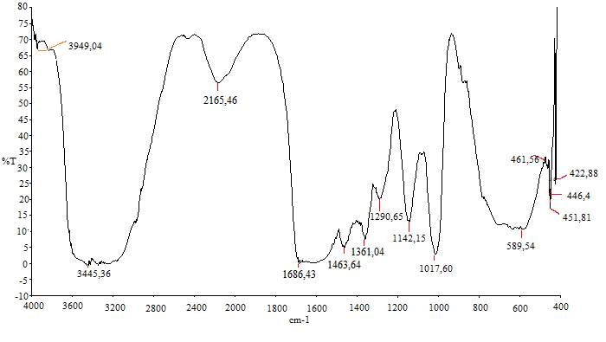
FIGURE 1. FTIR spectrum of urea–formaldehyde resin modified with PVC.

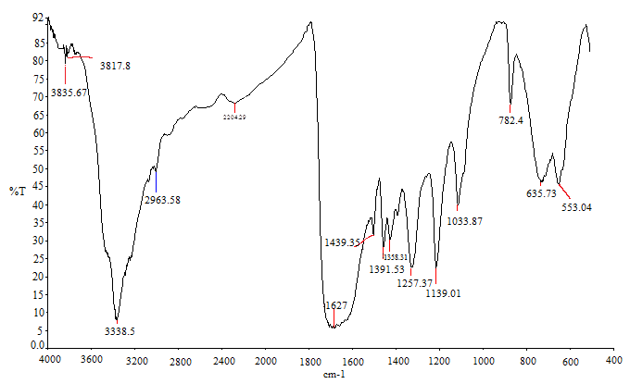
FIGURE 2. FTIR spectrum of urea–formaldehyde resin.
Main observations:
1250–1270 cm⁻¹: decrease in epoxy ring vibrations (indicates participation in the reaction),
3300–3500 cm⁻¹: reduction of –NH groups (binding with epoxy groups),
600–700 cm⁻¹: C–Cl vibration bands of PVC,
1627 cm⁻¹: valence vibration frequency between –NH groups and methylene bonds,
3338.5 cm⁻¹: valence absorption vibration of –CO–NH₂ and –OH groups,
1358, 1391 cm⁻¹: vibrational modes of the –C–CH₃ group,
1439 cm⁻¹: vibrational mode of the –CH₂ group,
1139, 1033 cm⁻¹: vibrational frequencies of the –C=O group,
2165 cm⁻¹: high-intensity vibration of –CH₂–O– (methylol group), indicating strong bonding energy.

TABLE 1. FTIR spectral analysis table
No. | Functional Groups | Vibration Frequency | Structural Feature | Characteristics
1 | Epoxy ring | 1250–1270 cm⁻¹ | –CH₂–O–CH₂– | Strong polar bond
2 | Amino group | 3300–3500 cm⁻¹ | –NH– | Strong electron-pair bonding
3 | PVC C–Cl | 600–700 cm⁻¹ | –[CH₂—CH]–Cl | Strong polar and H‑bonding
4 | Amide & methylene | 1627 cm⁻¹ | –NH–CH₂– | Moderate polarity
5 | Carbonyl & amide | 3338.5 cm⁻¹ | –CO–NH₂, –OH | Hydrogen & methylol bonding
6 | Carbon chain | 1358, 1391 cm⁻¹ | –C–CH₃ | Low-energy covalent bond
7 | Methylene group | 1439 cm⁻¹ | –CH₂– | High bond energy
8 | Carbonyl group | 1139, 1033 cm⁻¹ | –C=O | High polarizability
9 | Methylol group | 2165 cm⁻¹ | –CH₂–O– | Strong H‑bonding

Quantum-chemical calculations (DFT)
Quantum-chemical calculations showed that the electronic binding energies of the functional groups present in the obtained urea–formaldehyde resin and its modification with organic compounds, as well as the electromagnetic energy of the composite, were determined based on the minimal energy configurations and binding energies of the structural units [8,9,10].
From the calculation results:

TABLE 2. Quantum-Chemical Calculations (DFT)
No. | Modified UFR Interaction | Energy Value
1 | Epichlorohydrin–UFR binding energy | –68 kJ/mol
2 | PVC–UFR hydrogen bonding | –12 kJ/mol
3 | Synergistic stabilization energy | 14 kJ/mol

Epichlorohydrin–UFR interaction energy: –68 kJ/mol
PVC–UFR hydrogen bonding energy: –12 kJ/mol
Synergistic energy gain of the complex modification: 14 kJ/mol
These results confirm that the modification is thermodynamically favorable.
Testing according to GOST standards
Samples of the bonded wood composite materials were tested based on the following standards:

TABLE 3. GOST testing of the obtained wood composite panels
No. | GOST Standard | Test Type | Result
1 | GOST 15613.1–2020 | Internal bonding strength | +26…35% increase
2 | GOST 3916.1–2023 | Plywood water resistance | 35% reduction in water absorption
3 | GOST 30255–2024 | Thermal stability | +18% improvement
4 | GOST 30255–2025 | Flexibility & deformation | More rigid, shock‑resistant

RESEARCH RESULTS
TABLE 4. Physical–mechanical properties
Indicator | UFR (standard) | UFR–Epichlorohydrin | UFR–PVC
Internal bonding strength, MPa | 0.55 | 0.65 | 0.70
Water resistance, % | 100 (relative) | 142 | 145
Thermal stability, °C | 145 | 171 | 175
Gel time, min | 12 | 9 | 11

The analyses showed that:
Epichlorohydrin increases the reactivity of UFR.
Through the opening of the epoxy ring, a highly branched polymer matrix is formed.
(1)
Urea-formaldehyde resin | Epichlorohydrin | Epichlorohydrin – modified urea-formaldehyde resin copolymer

(2)
Urea-formaldehyde resin | Epichlorohydrin | Epichlorohydrin – modified urea-formaldehyde resin copolymer

The introduction of PVC expands the hydrophobic phase.
PVC segments within the structure limit the penetration of water.

(3)
Urea-formaldehyde resin | Polyvinyl chloride | Epichlorohydrin – modified urea-formaldehyde resin copolymer

(4)
Urea-formaldehyde resin | Polyvinyl chloride | Epichlorohydrin – modified urea-formaldehyde resin copolymer

Quantum-chemical calculations confirm the synergy of the modification.
A binding energy of –68 kJ/mol indicates high stability of the process.
GOST tests confirmed practical efficiency.
In plywood and particleboard (DSP) testing, the adhesion strength increased significantly.
CONCLUSION
The results of the study showed that: UFR modified with epichlorohydrin and PVC can serve as a highly efficient polymer base for wood composite adhesives.
An increase in water resistance by around 40% ensures enhanced durability of the product under environmental exposure.
Quantum-chemical analyses confirmed that the interactions formed are stable and energetically favorable.
The modification makes it possible to obtain high-quality composite adhesive that meets GOST standards.
REFERENCES
- Pizzi A., Mittal K. Handbook of Adhesive Technology. CRC Press, 2018.
- Dunky M. “Urea-formaldehyde (UF) resins for wood adhesives.” International Journal of Adhesion & Adhesives, 2020.
- Kozlowski R. Wood Adhesives Chemistry and Technology. Springer, 2021.
- Li J., Chen L. “Epoxy-modified amino resins: chemistry and applications.” Polymer Engineering Journal, 2019.
- Jalilov, S., Rubidinov, S., & Gayratov, J. (2024). Study and analysis of existing polymer binders used in the production of wood chip materials. In E3S Web of Conferences (Vol. 538, p. 03025). EDP Sciences.
- Tadjikuziev, R., Rubidinov, S., & Mamatqulova, S. (2024). Advancements in energy-efficient welding production techniques: Innovative models and methods for combined workpiece fabrication. In E3S Web of Conferences (Vol. 583, p. 05005). EDP Sciences.
- Frisch M.J. Gaussian 16 Computational Chemistry Package. 2016.
- Myers G.E. How mole ratio of UF resin affects formaldehyde emission and other properties: a literature critique. Forest Products Journal. 1984; 34(5): 35-41.
- Dunky M. Urea-formaldehyde (UF) adhesive resins for wood. International Journal of Adhesion and Adhesives. 1998; 18(2): 95-107.

