Ensemble of ring structures and their prospects

Otabek Zokirov¹^{,a)}, Eleonora Seitmuratova², Nargiza Tulyaganova³, G‘olib Ochilov³, Nilufar Khamidova³, Mukaddas Djabbarova³

¹ Tashkent state transport university, Tashkent, Uzbekistan
² Academy of Sciences of the Republic of Kazakhstan, Almaty, Kazakhstan
³Tashkent state technical university named after Islam Karimov, Tashkent, Uzbekistan
^{a)} Corresponding author: zokirov-otabek@mail.ru
Abstract. The article discusses the cosmic-structural objects of the Ziaetdin Mountains and their size, radius, genesis, and relationships with other geological formations. The study examines the prospects of these cosmic-structural objects and their role in the formation and localization of mineral occurrences.
INTRODUCTION
The association between concentric geological structures and ore deposits—particularly those of endogenous origin—is well established. This relationship is supported by numerous studies conducted by O.M. Borisov, A.K. Glukh, F.A. Usmanov, Sh.E. Ergashev, and many other researchers working under diverse landscape-climatic and geological-tectonic conditions across Uzbekistan.
Research by V.T. Jukov, G.E. Lazarev, and Yu.I. Fivensky indicates that the formation of ring structures reflects the influence of a previously unrecognized source of energy that plays an active role in the transformation of the Earth’s crust. Since this energy has likely existed throughout geological history, ring structures formed not only on the modern Earth surface but also during earlier stages of tectogenesis. Consequently, they may occur at various depths within the crust. This provides grounds for distinguishing both near-surface and buried ring structures, offering new perspectives on several geological processes and phenomena, including: pronounced differentiation of engineering-geological and other properties over relatively small areas; the development of compaction and decompaction zones within geological strata; the formation of oil, gas, and other mineral deposits; and the occurrence of hazardous processes such as karst, among others.
According to S.V. Poroshin, regional ring structures represent one of the forms that reflect the ascent and breakthrough of material from deeper layers of the Earth into the overlying crust. In this context, mantle convection and potential movements of sub-crustal material are of significant importance. S.V. Poroshin attributes the appearance of oval structures to the subsequent compression of primary ring structures—compression that is most intense in the crust and gradually diminishes with depth.
A.I. Baikov considers ring structures to be distinctive “plate nails” that anchor lithospheric plates to the mantle. This interpretation suggests new opportunities for developing criteria for the exploration of large mantle-derived ore deposits.

EXPERIMENTAL RESEARCH
The application of high-resolution satellite imagery in geological research enables the precise delineation of geological formations, the characterization of the structural features of tectono-structural deformations, and the refinement of geoinformation content on existing maps. These improvements are achieved through the identification of ring-shaped structures, photo-anomalies, and other morphological features that were previously overlooked or difficult to detect during earlier comprehensive geological surveys [5-6].
During the interpretation of satellite imagery, modern stereoscopes and interpretoscopes were employed. Both direct indicators—such as clearly defined boundaries, distinctive image characteristics, color, size, geometric shape or configuration, tone, shadow, texture, and structure—and indirect indicators, including soil and vegetation patterns, were taken into account.
Experimental results reveal that earlier geological and structural data on ring-shaped structures—specifically their contours, dimensions, and spatial distribution—show substantial discrepancies when compared with analytical information derived from modern digital satellite imagery. These findings underscore the importance and effectiveness of broader implementation of advanced remote-sensing techniques in both scientific and applied geological research.
RESEARCH RESULTS
Ring structures (RS) or central-type structures (CTS) have been known for a long time, but with the advent of satellite imagery, they have attracted particular attention from geologists. The high interest in these structures is due not only to the fact that satellite images have made it possible to identify them widely, but primarily because more than 70% of them are associated with various types of mineral resources [1-8].
To assess the potential of ring structures for different mineral resources within the Ziaetdin Mountains, numerous concentric structures have been identified, varying in size, composition, and genesis. Of particular interest are well-defined structures that surround all known ore fields or control the deposits and ore occurrences within the Ziaetdin Mountains.
It should be noted that all known gold deposits and occurrences (Karakutan, Beshkuduk, Kapkakly, Yangidavan, Kyzbybi, Tillyatag, Akmazar, Bichanchi) are spatially associated with the external, internal, contour, or peripheral zones of central-type structures. They are located in zones of junction between different structures. In this regard, CTS-19, 22, 23, 24, and 26 are of particular interest, as they control gold ore deposits (Karakutan, Kapkakly, Yangidavan, Kyzbybi, Akmazar) and also encompass zones of gold mineralization along the entire perimeter of the structures.

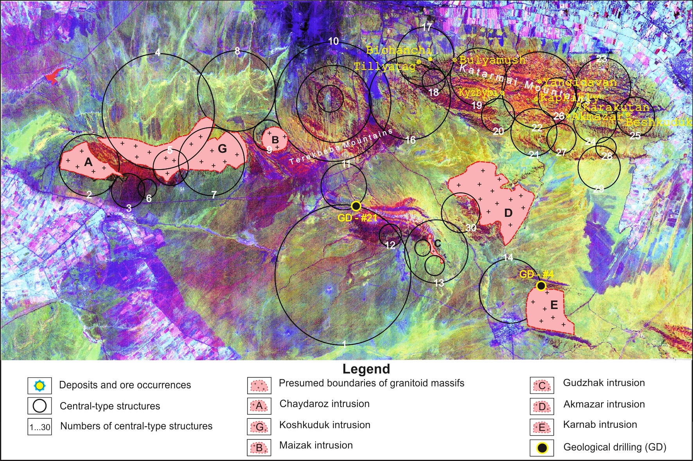
FIGURE 1. Panorama and locations of the identified ring structures in the Ziaetdin area.

In this context, it can be considered that the contours of all ring structures are of exploration interest, particularly the nodes where they intersect with other concentric structures as well as with northeast-trending faults. CTS-17 is also highly promising, as it is complicated by the contour elements of structures 16, 18, and 19, within the internal and external zones of which deposits and ore occurrences (Tillyatag, Bulyamush, Bichanchi) have been identified. Most of these are associated with structural contours and the nodes of their intersections with faults. Of exploration interest are also the three-zonal, framework components of CTS-10, which intersect the western terminations of the Ziaetdin Mountains, as well as CTS-20, 21, 25, 27, and 28, which cross the southern, eastern, and central parts of the Ziaetdin range. These structures intersect not only with adjacent ring structures but also with major faults such as the Belkuduk, Southern, and Karakutan faults, creating favorable conditions for the localization of ore-bearing fluids. Attention should also be given to areas where Lower Silurian, Lower Devonian, and Lower Carboniferous strata outcrop, as well as to the zones of exo- and endocontacts of granitoid massifs, where the aforementioned CTS have been recorded.
Below are some of the interpreted data from digital remote-sensing satellite imagery of the Ziaetdin Mountains, specifically regarding the identified central-type ring structures that spatially control gold ore occurrences in the Ziaetdin range [5-6]:
CTS-21, 27, 28. These structures are located in the southern part of the Katarmay Mountains, most of which are covered by Cretaceous deposits. The overall background of these structures on satellite images is red-burgundy to yellow-green. In places, they intersect formations of the Katarmay suite, which are associated with gold mineralization in the Ziaetdin Mountains. These ring structures may have special metallogenic significance. From the north, they are intersected by a newly identified southern fault, and from the south by the major Belkuduk fault. Additionally, these structural objects complicate adjacent ring structures, where rock fragmentation and fracturing create favorable conditions for the penetration of ore-bearing fluids and the localization of mineralization. CTS-21 intersects with structures 20, 22, 26, and 27; CTS-27 intersects with structures 21 and 26; CTS-28 intersects with structures 24 and 29. Zones of intersection of central-type structures represent the most favorable positions for the manifestation of various geological processes, including ore formation. Evidence of this is the localization of gold deposits and occurrences (Karakutan, Bulyamush) within the intersection zones of ring structures.
The presented remote-sensing structural data provide sufficient confidence to consider the aforementioned CTS as prospective zones for ore mineralization, and exploration works should be conducted at their intersections.
CTS-1. This structure is located in the southern part of the Ziaetdin Mountains and has a diameter of approximately 12 km. Most of it is covered by Mesozoic–Cenozoic deposits. The overall phototone is variegated, ranging from green-yellow to red-burgundy and violet, with small black spots in the northeastern part of the structure. CTS-1 is complicated by CTS-11, CTS-13, and the subsidiary CTS-12, as well as numerous northeast-, northwest-, and meridional-trending faults. On the east, the structure is in contact with Lower Devonian carbonate deposits, Lower–Upper Silurian and Carboniferous deposits, as well as with CTS-13, which consists of two small structures associated with the Upper Carboniferous Gudjak granitoid intrusive.
Analysis of the spatial position of CTS-1 in relation to lineaments, other ring structures, and its contacts with rocks of varying ages confidently indicates its ore-concentrating role, which is confirmed by newly obtained geological data. In the Turytau Mountains, at the intersections of ring and linear structures, black bitumen was recorded in Lower Devonian limestones in drilled core wells of the Central Uzbekistan State Geological Exploration Enterprise.
These examples of remote geological characteristics of concentric structures in the Ziaetdin Mountains clearly demonstrate their significant role in the geological framework of the area. However, confidently recognizing the mineralogenic “signature” of a particular structure is not always straightforward, since ring structures often mutually complicate one another, developing throughout the geological history of the region, during which younger structures of the same or different genesis may form in the location of older ones. Nevertheless, certain relationships can be identified between specific genetic types of ring structures and their characteristic mineralization.
In the presence of numerous, variably oriented lineaments, the spatial association of ore deposits or occurrences with these cosmic structures can be confidently established: areas of ore mineralization are typically associated with a particular lineament. Known deposits and significant occurrences of endogenous mineralization in Western Uzbekistan are located along these lineaments. Of particular interest are the framework nodes and contacts of lineaments with concentric structures.
In the Ziaetdin Mountains, known gold deposits (Beshkuduk, Karakutan, Kapkakly, etc.) are strictly associated with major sublatitudinal and northeast-trending lineaments occurring within the intersections of several central-type concentric structures.
Between 2007 and 2012, research results obtained by O.T. Zokirov within the study area were applied and integrated, and results were confirmed by qualified specialists of the “Central Uzbekistan GSPÉ” state enterprise, the leading organization in the region.
According to I.B. Turamuratov, Kh.A. Omonov, R.S. Khan, and others, cores from boreholes No. 4 and No. 21, drilled into Lower Silurian and Lower Devonian strata, showed black bitumen-like spots. Upon heating, these released a combustion odor typical of petroleum products. Laboratory analyses of drill cuttings also detected gold concentrations of 0.2–1.4 g/t, zinc 0.01–0.05%, and trace amounts (0.1%) of chromium, nickel, lead, bismuth, cobalt, and antimony.
Analyses conducted by O.T. Zokirov in collaboration with qualified expedition specialists (I.S. Sultonov, A.D. Ravshanov) indicate that drilling was performed in the junction zones of several ring structures (CTS-1, CTS-11), as well as across the northern part of the Karnab intrusive and the intersection zone with CTS-14.
CONCLUSION

Based on the results presented above, the patterns of distribution and localization of endogenous gold mineralization in the Ziaetdin Mountains can be specified [5-6]:
- Known deposits and ore occurrences are clearly associated with the intersections of the central-type structures listed above, as well as with their internal and external zones;
- The most favorable positions for ore localization are areas where the contours of different structures, including subsidiary structures, intersect, as well as intersections with sublatitudinal, northeast-trending, and, less frequently, meridional lineaments;
- Areas of ore occurrences are marked by zones of quartzification, fragmentation, and other alterations.
These results from digital remote-sensing data indicate the significant role of cosmic structures in the formation and localization of gold mineralization in the Ziaetdin Mountains. In this regard, central-type structures are of primary importance, seemingly linked to deep-seated energy sources. Their contours—arc-shaped and linear, framework-like—served as ore-conducting channels and zones for the discharge of ore-bearing material. Such structures are reliably identifiable in processed data using linear combination methods such as “ACР” and
“Index-E.”
REFERENCES
- Ergashev, Sh.E., & Zokirov, O.T. Modern Methods for Prospecting Ore Mineralization in Low-Mountain Conditions. Tashkent: State Enterprise “Research Institute of Mineral Resources (NIIMR)”, 2009. 115 p.
- Goipov, A.B., Akhmadov, Sh.I., Tevelev, A.V., Musakhonov, Z.M., & Mirsayapov, R.I. Application of Innovative Methods of Spectral and Structural Interpretation to Solving Geological Problems and Searching for Deposits (Based on the Example of the Auminzatau–Beltau Ore District of the Republic of Uzbekistan). Moscow University Geology Bulletin, 2024, Vol. 79, No. 6, pp. 798–809. ISSN 0145-8752.
- Khamidova, N., Dadasheva, A., & Ashurova, Sh. Workforce Reskilling and Economic Shifts in Automation with Eco-Skills Monitoring. International Conference on Civil, Environmental, and Applied Sciences (ICCEAS 2025), pp. 85–91.
- Urinov, U., Hamidova, N., & Mirzakulov, I. Chemical Technology of Oligomers Production from Homopolymer Based on Epichlorohydrin and Morpholine. E3S Web of Conferences, 497, 03030 (ICECAE 2024), pp. 1–6.
- Zokirov, O.T. Cosmo-Structural Model of the Ziaetdin Mountains and Its Significance in Studying the Patterns of Gold Mineralization Distribution (Based on Digital Space Remote Sensing Data), PhD Dissertation. Tashkent, 2012. 118 p.
- Zokirov, O.T. Cosmo-Structural Objects of Central Asia and Their Importance in the Localization of Mineral Deposits, DSc Dissertation. Tashkent, 2019. 198 p.
- Raximov Z, Zokirov O. Digital space imagery, space infrastructure and metasomatic changes/4th International Conference Series on Science, Engineering, and Technology (ICSSET) 2024, Indonesian, pp.171-178
- Zokirov O.T. Raximov Z.Z. Methods of interpreting digital space images/4th International Conference Series on Science, Engineering, and Technology (ICSSET) 2024, Indonesian, pp.103-109

