Improvement of the design of shaking and cleaning equipment based on efficient energy use
Urozov Mustafokul ^{1,a)}, Davron Jurayev², Kamola Rustamova³, Xumoyiddin Abdurashidov⁴, Bakhtiyor Karshiev¹
¹ Cotton industry scientific center joint-stock company, Tashkent, Uzbekistan
²Termez state university of engineering and agrotechnologies, Termez, Uzbekistan
³Termiz state university, Termez, Uzbekistan
^{a)} Corresponding author: urazov.mustafo.81@mail.ru
Abstract. The supply mechanism of the shaking-cleaning equipment used in wool enterprises, as well as the elimination of fiber clogging, the prevention of fiber winding around the supply roller, and the improvement of fiber transfer efficiency, face several design issues. Specifically, certain parts of the equipment between the shaking-cleaning drum with pins and the slatted grid are inconveniently designed, which negatively affects the operational efficiency of the equipment and the quality of the fiber. These shortcomings have been found to cause a significant decrease in economic efficiency. Furthermore, fiber processing in the shaking-cleaning equipment increases energy consumption due to the added complexity of the process.
INTRODUCTION
The increasing global demand for natural textile fibers requires the study of wool processing techniques and technologies. Therefore, many researchers worldwide have conducted and continue to conduct scientific studies aimed at improving the wool shaking-cleaning process.
The quality of wool fiber and the products derived from it largely depends on the cleaning process. Effective cleaning methods are necessary to ensure the high quality of locally produced coarse wool. The process of removing impurities from wool fiber plays a crucial role in its subsequent processing and preparation for consumption. The characteristics of local coarse wool are significant during processing, as its high crimp, softness, and durability provide additional quality benefits.
Wool has a complex histological structure, consisting of branching and non-uniform cells due to its epidermal origin. Wool fibers have a porous structure that provides high thermal insulation for woolen garments. The fibers are composed of overlapping scales, which create friction between fibers and contribute to the strength and coarseness of the wool.
Factors determining wool fiber quality include its degree of cleanliness, elasticity, and coefficient of friction. When fibers are cleaned from impurities, a significant improvement in their quality is observed.
The following methods are used for cleaning local wool fiber:
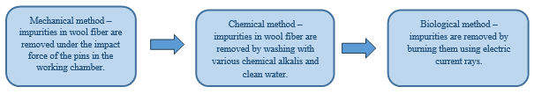
FIGURE 1. abbbbbbbbbbbbbbb

In the mechanical cleaning of wool, vibrational systems in the drum enable the separation of impurities through oscillations. The intensity and frequency of vibrations in the pinned drum play a crucial role in improving cleaning efficiency. Such systems help reduce energy consumption while increasing the speed of the process. The design and operating principle of the pinned drum determine its effectiveness. Inside the drum, the pins mechanically act on the wool fibers, removing impurities. Variations in the drum’s size, shape, materials, and internal structure can enhance and accelerate the cleaning process.
Numerous studies have been conducted to improve the design and operating principles of the pinned drum in wool shaking-cleaning equipment. These include proposals for additional cleaning and fractional dust removal in the shaking machine. Furthermore, paired pins have been installed side by side on the shaking drum to increase cleaning efficiency.
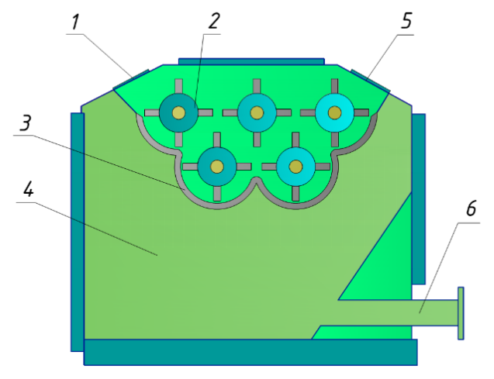
FIGURE 2. Five-drum shaking machine proposed by S.A. Noskova
1 – raw material feed section; 2 – slatted drums; 3 – grate grid; 4 – chamber for foreign impurities; 5 – outlet for cleaned wool; 6 – dust exhaust pipe.

In scientific research, a new machine for wool shaking was proposed (Figure 1). The machine utilized five slatted drums arranged in two rows. It was suggested to place two additional drums with horizontal slats under three horizontal slatted drums to carry out the shaking process. However, due to the absence of a supply mechanism in this machine, achieving effective cleaning was not possible. The supply mechanism plays a critical role in the shaking process.
In the machine, six shaking drums were installed at an incline, and the wool was lifted from bottom to top with the help of pins on the drum, producing the shaking effect. Condensers separating fiber from dust and air were installed between the cleaning devices. The drawbacks of this machine include fiber damage due to the large number of shaking drums, high energy consumption, and occasional fiber loss in the condensers.
For local coarse wool, mechanical cleaning efficiency was improved by increasing the number of pins on the drum from 44 to 66 and the number of rows from 8 to 12, which eliminated the dead zones in the working chamber. Additionally, the pins were refined to a smooth cylindrical shape; however, this modification did not achieve the expected results

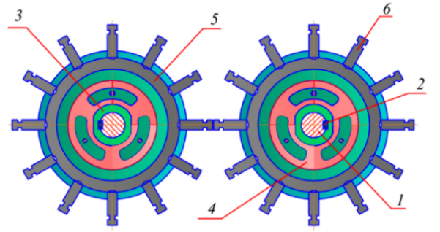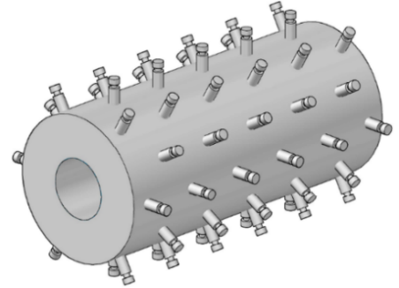
FIGURE 3. Appearance of the pinned drum and pins in the wool shaking-cleaning equipment;
1 – shaft; 2 – key; 3 – fastening part to the housing; 4 – bushing; 5 – drum; 6 – pins

At present, it is necessary to determine the mechanical resistance, quality level, and the amount of impurities in local wool fibers under different climatic conditions, and to design new equipment and constructions based on these indicators. A thorough study and scientific research of the wool shaking-cleaning process is an urgent task.
The improved inclined pinned-drum wool cleaner reduces the resistance forces acting on the pins during the cleaning process by gently penetrating the fiber clusters. By tilting the pins at an angle of 25 degrees relative to the radial axis, occurrences of pin breakage and backward bending during the shaking-cleaning process are minimized (Figure 3).
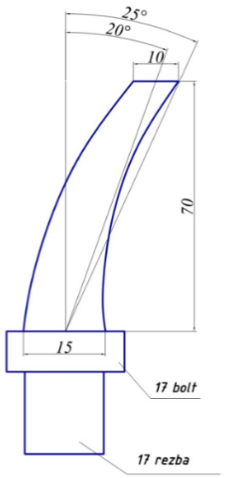  . | 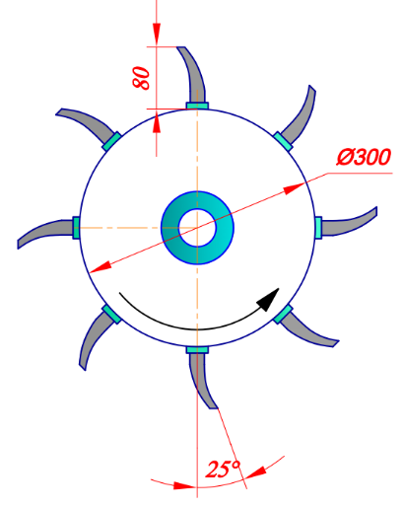 | 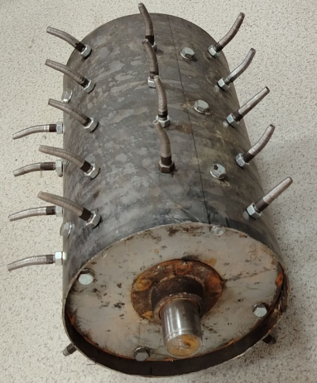

FIGURE 4. Kinematic diagram of the improved inclined pin system.

This, in turn, reduces the load on the pinned drum and increases cleaning efficiency.
We determine the force exerted by the fibers along the surface of the pins (Figure 4).
$dR=q⋅dL$ (1)
Here, $dL$ - Arc length of the pin surface (of the inclined pin); $dR$ - force acting on the pin surface, $q$ - Distributed force exerted by the wool fiber flow on the arcuate pin surface.

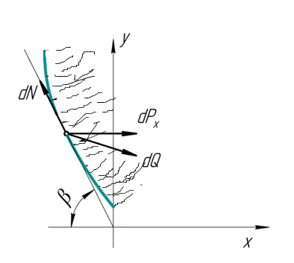
FIGURE 5. Diagram of forces acting on fibers along the surface of the inclined pin.

We determine the projections of the force exerted by the fibers on the arcuate pin surface along the OX and OY axes. Here, - Component of the pressure force of the fibers on the arcuate surface along the OY axis, $β$ - Component of the inclined pin along the OX axis [19-38].
$\left\{\begin{aligned}&dP_{x}=q⋅Sinα⋅dL \\ &dP_{y}=q⋅Cosα⋅dL\end{aligned}\right.$ (2)
The pressure force in the waste, separated along the arcuate surface of the wool fibers, is expressed as follows.
$\left\{\begin{aligned}&dN=dP_{x}⋅Cosβ \\ &dQ=dP_{x}⋅Sinβ\end{aligned}\right.$ (3)
(2) We express the action of the fibers on the surface of the inclined-pointed pin along the OX axis in the equation (3).
$\left\{\begin{aligned}&dN=q⋅Sinα⋅Cosβ⋅dL \\ &dQ=q⋅Sinα⋅Cosβ⋅dL\end{aligned}\right.$ (4)
(4) In equation $dN$ va $dQ$ Forces at the point of separation from the surface of the inclined pin, respectively , $dP_{x}$ Force contributing to the pressure force.
In the same manner, we express the equation for the separation of the fibers along the OY axis for the pressure force.
$\left\{\begin{aligned}&dN=dP_{u}⋅Sinβ \\ &dQ=dP_{u}⋅Cosβ\end{aligned}\right.$ (5)
In equation (5), we substitute the force from equation (2) and perform the calculation.
$\left\{\begin{aligned}&dN=q⋅Cosα⋅Sinβ⋅dL \\ &dQ=q⋅Cosα⋅Cosβ⋅dL\end{aligned}\right.$ (6)
By summing equations (4) and (6), we express the total effect of the forces acting on the fibers during impurity separation as well as the forces on the surface of the inclined pin.
$$\left\{\begin{aligned}&2⋅dN=q⋅Sinα⋅CosβdS+q⋅Cosα⋅Sinβ⋅dL \\ &2⋅dQ=q⋅Sinα⋅Sinβ⋅dS+q⋅Cosα⋅Cosβ⋅dL\end{aligned}\right.$$
Here:
$$N=\frac{1}{2}⋅q⋅Sin(α+β)⋅\int_{0}^{L}{dL}$$
$Q=\frac{1}{2}⋅q⋅Cos(α-β)⋅\int_{0}^{L}{dL}$ (7)
(7) $dL$ -We integrate equation (7) along the arc length of the inclined pin surface.
$\left\{\begin{aligned}&N=\frac{1}{2}⋅q⋅L⋅Sin(α+β) \\ &Q=\frac{1}{2}⋅q⋅L⋅Cos(α-β)\end{aligned}\right.$ (8)
Equations (8) describe the separation of impurities from fibers along the surface of the inclined pins during their movement. The components of the pressure force have been analyzed graphically using the Maple software.

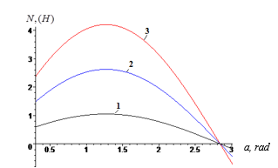
FIGURE 6. $β_{1}=15^{0}β_{2}=20^{0}β_{3}=25^{0}$ Graph of the time-dependent variation of the arcuate tooth’s inclination angle at different values during the movement of fibers on the surface of the inclined pins and the separation of impurities.

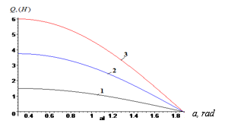

FIGURE 6. $β_{1}=15^{0}β_{2}=20^{0}β_{3}=25^{0}$ Graph of the time-dependent changes in the inclination angle of the arcuate tooth at various values during the movement of fibers on the surface of the inclined pins and the separation of impurities

Obstacles arising in the movement of wool fibers during cleaning from impurities under the action of inclined pins require additional time and increase energy consumption. Theoretically, in the separation of impurities from fibers, the pinned drum plays an important role in directing the impurities along the surface under the influence of the inclined pins. Specifically, the pinned drum ensures that the separated impurities are removed rather than rejoining the fiber flow being cleaned, thereby preventing contamination and increasing cleaning efficiency (Figure 7).
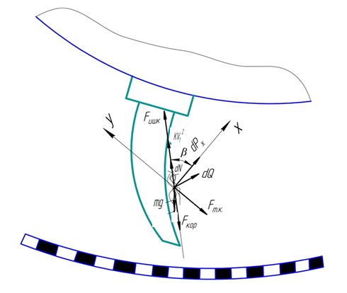
FIGURE 7. Scheme of the movement of the fiber flow on the surface of the improved inclined pins under the action of external forces

Here:
- Weight force of the fiber bundle;
$F_{kor}=2⋅m⋅ω⋅\dot{x}$- Coriolis force;
$F_{mq}==m⋅ω^{2}⋅L$ - Centrifugal force;
$N$ -normal pressure;
$F_{ish}=μ⋅N$ - frictional force;
$Kϑ_{1}^{2}$- Air resistance force;
In the presented scheme, the normal pressure is equal to $N=\frac{1}{2}⋅q⋅L⋅Sin(α+β)$.
CONCLUSIONS
The supply mechanisms are among the most important and complex components of wool shaking-cleaning equipment. These mechanisms are crucial for ensuring a continuous and uniform supply of fibers to the machine, as well as for the proper distribution of energy and time during operation. In the shaking-cleaning equipment currently used in enterprises, the supply mechanism lacks adequate support for the working parts, which negatively affects the operational efficiency of the equipment, the quality of the fibers, and leads to a significant decrease in economic efficiency.
Research has examined the advantages and disadvantages of different methods for installing supply mechanisms, leading to the selection of the inclined and bunker-type systems. By installing the supply rollers at a 70° angle relative to the equipment, energy efficiency is improved. Additionally, doubling the diameter of the equipment accelerates fiber flow and enhances economic efficiency.
REFERENCES
- Gorbunova L.S., Rogachev N.V., Vasiliev L.G., Koldoev V.M. Primary Processing of Wool. Moscow: Legkaya i pishchevaya promyshlennost, 1981. – 352 p.
- Kuprashevich V.I. General Technology of Wool Production. Moscow: Legkaya i pishchevaya promyshlennost, 1981. – 136 p.
- Radovitsky V.P., Streltsov B.N. Electrodynamics of Textile Fibers. Moscow: Legkaya industriya, 1967. – 289 p.
- Mercz T.I., Cord-Ruwish R. Treatment of Wool Scouring Effluent Using Anaerobic Biological and Chemical Flocculation. Water Research Journal, 1997, Vol. 31, No. 1, pp. 170–178.
- Jóźwiak N.D., Fantilli A.P. Wool-Reinforced Cement-Based Composites. Materials, 2020, Vol. 13, No. 16, p. 3590.
- Novorodovskaya T.S., Sadova S.F. Chemistry and Chemical Technology of Wool. Moscow: Legpromizdat, 1986, pp. 148–200.
- GOST 7939-79. Unwashed Coarse Sheep Wool. Technical Specifications.
- Fraser R.D.B., Rogers G.E., Parry D.A.D. Nucleation and Growth of Microfibrils in Trichocyte (Haed-a) Keratins. Journal of Structural Biology, 2003, Vol. 143, p. 85–93.
- Yusupov S. State of Wool Production and Processing in Ikarda. UzNIIChemp, Uzbekistan, 2012, pp. 1–10.
- Tsys A.P., Sokolov G.A., Revunov V.M., Tsyganov A.S. Central Design and Technological Bureau of Spare Parts for Light Engineering. Wool Carding Machine. Patent No. SU 1298267 A1.
- Pechnikova A.G. Improvement of Technology and Equipment for Processing Wool Production Waste. PhD Dissertation in Technical Sciences. Ivanovo: IGTA, 2004. – 178 p.
- Russian Federation Patent RU 2147325. Device for Mechanical Wool Processing. Koldaev V.M., 10.04.2000.
- Noskova S.A. Development of Fiber Loosening and Cleaning Processes on Two-Row Loosening-Cleaning Machines. PhD Dissertation in Technical Sciences. Moscow: MGTU, 2005. – 194 p.
- Russian Federation Patent RU 2011105570. Device for Fractionating Down Raw Material in Liquid Medium. Galatov K.S., Chertov Yu.E., 20.08.2012.
- Russian Federation Patent RU 94028452. Loosening-Carding Aggregate. Sheludyakov N.I., 10.05.1996.
- Urozov M., Rustamova K. Development of Technology for Obtaining Reclaimed Fibers through Processing Wool Fiber Waste. Scientific Journal of Construction and Education, 2024, ISSN 2181-3779, UDK 677.052.48.3/5.
- Jo‘rayev D.A., Urozov M.K. Cleaning the Wool Fiber from Foreign Impurities by Installing a Brush Drum in the Unwashed Wool Cleaning Equipment. Journal of Textile and Fashion Technology (JTFT), 2023, Vol. 13, Issue 2, pp. 5–8.
- Abdirashidov X.A., Urozov M.K., Jurayev D.A. Improving the Pinned Drum Design of Local Sheep Wool Shaking-Cleaning Equipment to Increase Operational Efficiency. Mechanics and Technology Scientific Journal, 2025, No. 1(12) (Special Issue), NamDTU, pp. 74–77.
- Mahmutkhonov S., Baizhonova L., Mustayev R., Tashmatova S. Dynamic analysis of voltage-ampere characteristics and harmonic distortions in electric arc furnaces. // AIP Conference Proceedings. 3331(1), 2025. pp. 070023, 1–5. https://doi.org/10.1063/5.0305745.
- Bobojanov M., Mahmutkhonov S. Influence of the consumer to power quality at the point of connection // E3S Web of Conferences 384. 2023. РР, 01041, 1-5. https://doi.org/10.1051/e3sconf/202338401041.
- Bobojanov M.K., Karimov R.Ch., Popkova O.S., Tuychiev F.N., Makhmutkhanov S.K. Analysis of the results of experimental studies of the arc furnace DSP-30. // Power Engineering Research & Technology. 27(2), 2025. pp. 126–137. https://doi.org/10.30724/1998-9903-2025-27-2-126-137
- Reymov K.M., Makhmuthonov S.K., Turmanova G., Uzaqbaev Q. Optimization of electric networks modes under conditions of partial uncertainty of initial information // E3S Web of Conferences 289, 07023 (2021). -2021, pp: 1-4, https://doi.org/10.1051/e3sconf/202128907023.
- R. K. Kurbaniyazov, A. M. Reimov, A.T. Dadakhodzhaev, Sh. S. Namazov, B. M. Beglov. Nitrogen-phosphoric fertilizers produced by introduction of Central Kyzylkum phosphate raw material into ammonium nitrate melt. Russian Journal of Applied Chemistry. Russ J Appl Chem (2007) 80(11): 1984-88. https://doi.org/10.1134/S1070427207110456
- Namazov, Sh.S., Kurbaniyazov, R.K., Reimov, A.M., Beglov, B.M. Hardness of the granules of ammonium nitrate doped with the Central Kyzylkum Phosphorite. Russian Journal of Applied Chemistry. Russ J Appl Chem (2007) 81(6): 1103–1106. http://dx.doi.org/10.1134/s1070427208060402.
- Kurbaniiazov, R.K., Reimov, A.M., Namazov, Sh.S., Beglov, B.M. Nitrogen-phosphoric fertilizers obtained by interaction of the concentrated solutions of ammonium nitrate with the mineralized mass of the phosphorites of Central Kyzylkum. Russian Journal of Applied Chemistry. Russ J Appl Chem (2009) 82: 1123. https://link.springer.com/journal/11167
- Alimov, U.K., Reimov, A.M., Namazov, Sh.S., Beglov, B.M. The insoluble part of phosphorus fertilizers, obtained by processing of phosphorites of central kyzylkum with partially ammoniated extraction phosphoric acid. Russian Journal of Applied Chemistry. Russ J Appl Chem (2010) 83(3): 545–552. https://doi.org/10.1134/S107042721030328
- Reymov, A.M., Namazov, S.S., Beglov, B.M. Effect of phosphate additives on physical-chemical properties of ammonium nitrate. Journal of Chemical Technology and Metallurgy 2013 48(4), 391-395. http://dl.uctm.edu/journal/
- Urishev, B., Fakhriddin Nosirov, and N. Ruzikulova. 2023. “Hydraulic Energy Storage of Wind Power Plants.” E3S Web of Conferences, 383. https://doi.org/10.1051/e3sconf/202338304052
- Urishev, B., S. Eshev, Fakhriddin Nosirov, and U. Kuvatov. 2024. “A Device for Reducing the Siltation of the Front Chamber of the Pumping Station in Irrigation Systems.” E3S Web of Conferences, 274. https://doi.org/10.1051/e3sconf/202127403001
- Turabdjanov, S., Sh. Dungboyev, Fakhriddin Nosirov, A. Juraev, and I. Karabaev. 2021. “Application of a Two-Axle Synchronous Generator Excitations in Small Hydropower Engineering and Wind Power Plants.” AIP Conference Proceedings. https://doi.org/10.1063/5.0130649
- Melikuziev M.V. Determination of the service area and location of transformer substations in the city power supply system. E3S Web of Conferences 384, 01033 (2023) RSES 2022. https://doi.org/10.1051/e3sconf/202338401033
- Melikuziev M.V., Usmonaliev S., Khudoyberdiev N., Sodikov J., Imomaliev Z. Issues of the design procedure for the power supply system. AIP Conference Proceedings 3152, 040031 (2024). https://doi.org/10.1063/5.0218873
- Melikuziev M.V., Fayzrakhmanova Z., Akhmedov A., Kasimova G. Development of an Educational Simulator's Working Logic for the Course 'Fundamentals of Power Supply'. AIP Conference Proceedings 3152, 050025 (2024). https://doi.org/10.1063/5.0218875
- Melikuziev M.V., Nematov L.A., Novikov A.N., Baymuratov K.K. Technical and economic analysis of parameters of city distribution electric network up to 1000 V. E3S Web of Conferences 289, 07016 (2021) Energy Systems Research. https://doi.org/10.1051/e3sconf/202128907016
- L.Jing, J.Guo, T.Feng, L.Han, Z.Zhou and M.Melikuziev, "Research on Energy Optimization Scheduling Methods for Systems with Multiple Microgrids in Urban Areas," 2024 IEEE 4th International Conference on Digital Twins and Parallel Intelligence (DTPI), Wuhan, China, 2024, pp. 706-711, https://ieeexplore.ieee.org/abstract/document/10778839
- Shukhrat Umarov, Murot Tulyaganov. Peculiarities of simulation of steady modes of valve converters with periodic power circuit structure. III International Scientific and Technical Conference “Actual Issues of Power Supply Systems” (ICAIPSS2023). AIP Conf. Proc. 3152, 050004-1–050004-7; https://doi.org/10.1063/5.0218869
- Murot Tulyaganov, Shukhrat Umarov. Improving the energy and operational efficiency of an asynchronous electric drive. III International Scientific and Technical Conference “Actual Issues of Power Supply Systems” (ICAIPSS2023); https://doi.org/10.1063/5.0218876
- Shukhrat Umarov, Khushnud Sapaev, Islambek Abdullabekov. The Implicit Formulas of Numerical Integration Digital Models of Nonlinear Transformers. AIP Conf. Proc. 3331, 030105 (2025); https://doi.org/10.1063/5.0305793

