Analysis of heat and air pressure resistance of non-woven fabrics for industrial applications, as well as the effect of ambient temperature
Odil Toshbekov ^{1, a)}, Sultonova Feruza¹, Raximqulova Sarvinoz¹, Mustanova Zilola¹, Xulkalieva Gulhayo¹ , Mustafokul Urozov²
¹ Termez State University, Termez, Uzbekistan
² Termez State University of Engineering and Agrotechnologies, Termez, Uzbekistan
^{a)} Corresponding author: toshbekovo@tersu.uz
Abstract. The quality indicators for determining the heat resistance of filter cloth made from local raw materials are established in accordance with GOST standards, scientific research, and methodological principles. The reliability of the obtained results is ensured by the consistency of theoretical and experimental studies, positive results obtained during testing, approval and implementation, and comparative analysis. One of the key parameters characterizing filter cloth materials is the temperature difference between the outer and inner layers. During heat transfer through the filter cloth, heat loss occurs, the magnitude of which depends on the ambient temperature.
INTRODUCTION
The dust collection efficiency and service life of filter nonwoven fabrics largely depend on their structure, nonwoven density, thickness, and the composition of the fibers. The density of the filter nonwoven is characterized by the number of fibers per 10 cm. For sleeve filters, fabrics with high density, strength, dust collection coefficient, and pneumatic resistance during the filtration process, as well as low air permeability, are used [1].
The recovery and strength properties of woven filters largely depend on the type of weave. Usually, three types of weaving are used for filter fabrics: plain, twill, and satin.
Needle-punched nonwoven fabrics have relatively high density, high dust collection efficiency, but experience significant resistance during the regeneration process.
EXPERIMENTAL RESEARCH
The main feature is the requirements for the flammability of non-woven fabrics. Test methods are specified in the following fire safety standards:
GOST R 50810-95 Classification of decorative non-woven fabric materials based on the flammability test method [2].
NPB 257-2002. This document regulates test methods for the flammability, burning, fire resistance, and residual burning of non-woven materials such as curtains, drapes, bed linens, and soft furniture upholstery.
Such tests consist of exposing selected tissue samples to a laboratory gas burner flame or the flame of a burning cigarette. The obtained results objectively show how well their fire-resistant coatings have been applied for fire protection [3].
Sleeve filters are among the simplest, yet effective and economical devices for mechanical air filtration. The design of the sleeve filter is a rectangular or cylindrical body (bunker) containing filter bags inside (see Figure 1). The supply air passes through a system of hoses with diameters ranging from 10 to 30 centimeters, which clean the air from the smallest pollutants.
Currently, non-woven materials made of fabric and 100% synthetic fibers are used in the production of filter sleeves:
- Polyester (PYeS).
- • Polyacrylonitrile (PAN).
- • Polyphenyl sulfide (PPS).
- • Meta-aramid (AR).
- • Polymide (P84).
- • Polytetrafluoroethylene (PTFYe).
- • Glass fiber.
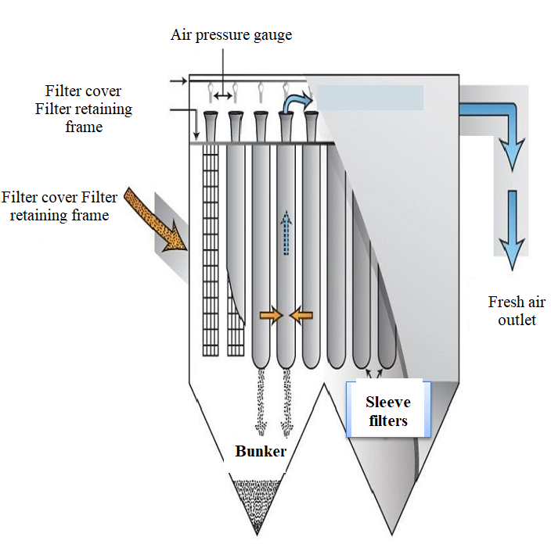
FIGURE 1. Application of new filters.
The use of certain filterable materials for the production of sleeves is determined by the following indicators [63]:
- The presence or absence of impurities in the filtered air or gas;
- • The name of the filtered air or gas;
- • The presence or absence of aggressive chemical substances in the filtering material;
- • The size and shape of the particles being filtered;
- • The presence of static electricity;
- • The type of filter used.
- The resistance of the coating decreases with prolonged exposure to heat and high absolute humidity, and the fibers tend to rub against each other [4]. Especially if the sleeves are poorly installed (hanging), and if the gas valves are not synchronously and smoothly shut off to supply clean and contaminated gases, strong friction is observed.
Sleeves are usually hung on flexible springs; strong impacts that cause mechanical effects and bending deformation on the fabric should not be complete. To protect against static electricity and increase resistance to bending deformations, graphite is applied to fibers (in colloidal form); at the same time, the service life of fabrics at high temperatures is significantly extended. Coating filters with a Teflon film (from emulsion) also significantly increases the durability of nonwovens. To increase the air permeability of nonwovens while maintaining strength, yarns for nonwoven fabrics are made from staple fibers [5]. In industry, several types of ready-made glass fabrics differing in air permeability, weight, and strength are produced. Fabrics are used in cement, metallurgy, and other enterprises and are actively used in obtaining fine cement dust, sublimates of non-ferrous and rare metals, and in the production of phosphate fertilizers.
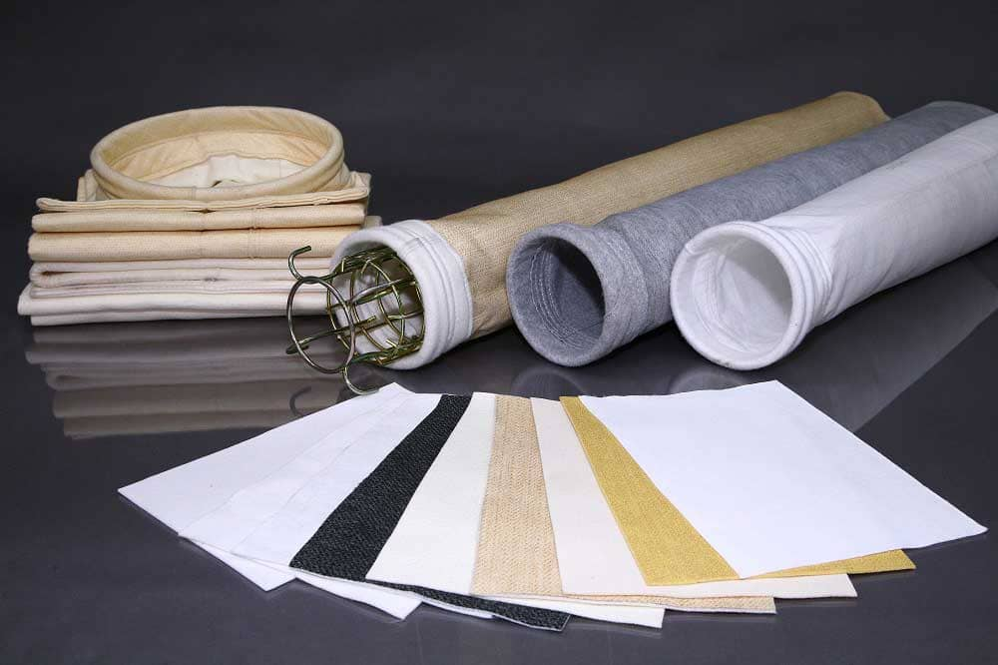  а) | 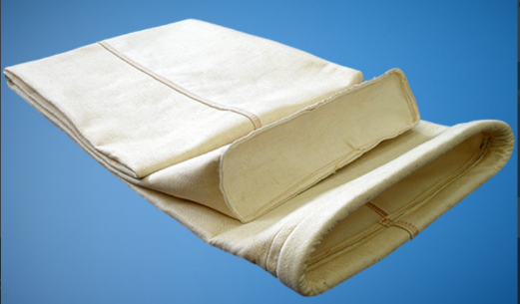  б)

FIGURE 2. Heat-resistant nonwoven filters and fabrics. a) filter tissue, b) Industrial filter fabric
The main physical and mechanical properties of filter fabrics made from natural and synthetic fibers used in industry are shown in the first table below[6].
ESEARCH RESULTS
The amount of sediment that can be retained without reducing the filtering properties of the fabric depends on the diameter and number of holes, and the diameter of the holes directly affects the air permeability of the filter fabric (Figure 3).
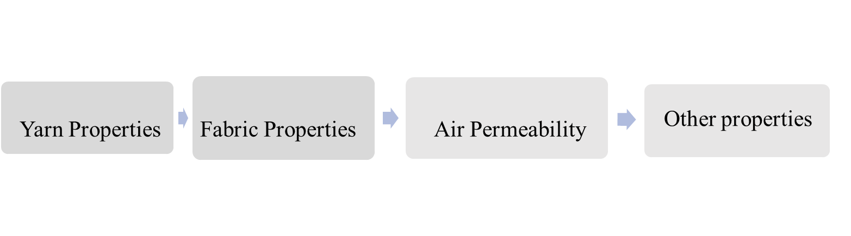
FIGURE 3. Factors affecting to filterable fabrics

The strength and filtration properties of a certain nonwoven fabric largely depend on additional processing stages (thermofixation, calendering, antistatic treatment, hydrophobization, increasing friction and bending resistance, and others) [9].
Heat-resistant materials are produced under various brand names: Kevlar, Trevira, Tarpaulin, Oxford, Tomboy, and others. They are divided into the following groups:
One of the pressing issues facing textile enterprises today is the production of technical fabrics. Heat-resistant filter-type technical nonwoven fabrics are imported from abroad. Chemical fibers (glass fiber, carbon fiber, aramid, polyester, polyamide) are used to produce these nonwoven fabrics, and such yarns are not produced in our republic. Nonwoven fabrics made from basalt and wool fibers, which are local raw materials, can replace these in terms of heat resistance and physical-mechanical properties.
Heat-resistant textile materials and products made from these fibers [10] are widely used in various products:
• filter fabrics for high-temperature gases;
• special protective clothing;
• professional safety and rescue equipment;
• special textiles for air, automotive transport, and hazardous buildings;
• friction composites (used in brake pads instead of asbestos).
The change in the parameter value, the change in the function of elongation along the width of the woven fabric , is given in Table 1. Here, Ye=YeN is also determined by the indicator[11].
As can be seen from Table 1, an increase in the amount of wool in the nonwoven fabric structure leads to an increase in the deformation modulus at the moment of tearing. In all samples of the nonwoven fabric and in the indicators of the parameters, it remains approximately the same within the range of experiments [12].
The results presented in Table 1 show that the filter cloth exhibits high stiffness in the widthwise stretching of nonwoven fabrics and undergoes nonlinear shear deformation throughout the entire deformation process.
As can be seen from the above results, the correlations obtained in the experimental diagrams more accurately reflect the deformation stages of the filter fabric.

TABLE 1. Values of the deformation modulus at various stages of deformation in the stretching of filter nonwoven fabric along its width and length
Deformation parameters and their indicators | Nonwoven fabric samples
Deformation parameters and their indicators | №1 | №2 | №3
 | 490,0 | 220,0 | 340,0
 | 30,0 | 16,0 | 13,0
 | 4,0 | 1,8 | 3,8
 | 180,0 | 320,0 | 370,0
 | 28,0 | 27,5 | 31,0

It should be emphasized that the proposed method for identifying and evaluating the shear, shear-plastic, and cohesion stages of deformation is an effective and visual method for studying the state and mechanical properties of the deformation of woven fabrics [20-43].
However, experimental methods for determining the mechanical properties of filter nonwoven fabrics require more time and costs. This situation, based on the above results, necessitates the development of a theoretical method for evaluating the mechanical properties of filter nonwoven fabric[13].
The simplest law of deformation of materials is Hooke's law. Hooke's law is the most widely used in all fields of mechanics. For our case, it has the following form
and (1)
length of the pipe, mm; the yield strength, mPa (N/mm2); the cross-sectional area of the pipe, mm2; the bursting pressure, N; and the normal pressure, N/mm2.
Hooke's law can be applied when the deformation process of the material is completely reversible, i.e., the process is elastic. Moreover, Hooke's law does not take into account temporary effects, i.e., the viscoelastic properties of the material (creep and relaxation). [4]
Compared to the Kelvin-Foyt and Maxwell models, the Airy model is more modern and has the following form
(2)
(3)
here the static viscosity modulus, dynamic viscosity modulus; volumetric parameter of viscosity; volumetric coefficient of viscosity15].
Model (2) is known by the standard linear viscoelastic body name.
Here, the modulus of viscosity and, in a broad sense, are used and they are called the deformation modulus for the entire stretching process.
In this case, it must be determined from the relevant experiments. This requires a large amount of experimental work, so according to [16], at this stage, it is advisable to choose model (3) to describe the deformation process of the nonwoven material.
CONCLUSIONS
1. According to the cleaning property, depending on the intensity of the forces applied during filtration and the characteristics of the processed medium, it was determined that filter-appropriate fabrics undergo various degrees of stretching, compression, bending, friction, chemical, and thermal effects.
2. Air filters are one of the simplest, yet effective and economical devices for mechanical air filtration.
3. The main characteristics of the structure of non-woven fabrics designed for filtering liquids and gases are porosity, pore diameter and their size redistribution, and the absolute number of pores.
4. It is recommended to use fabrics made from basalt fiber yarns, which are considered local raw materials in terms of heat resistance and physical-mechanical properties, as sleeve filters.
5. From the experimental diagrams of the stretching of non-woven fabric, the change in the deformation modulus of the non-woven fabric was determined based on the changes in the strain indicators of the fabric's width and length during stretching. It was found that the change in the deformation modulus depending on the value of the strain is mainly nonlinear.
REFERENCES
1. Yangiboyev R.M., Uzakov U.T., Shoabdurakhimov A.A. “Study of Heat-Resistant Filter Fabrics.”
In: Innovative Ideas and Developments of Talented Youth under Conditions of Modernization of Engineering and Technologies in Cotton Ginning, Textile, Light Industry, and Printing Production, Tashkent, 2021.
2. Yangiboyev R.M., Boymuratov B.Х., Akbarov R. Development and research of flexible fabric electric heaters. Problems of light industry development in the Republic of Belarus in the context of global Trends. Cite as: AIP Conference Proceedings 2430, 030006 (2022); https://doi.org/10.1063/5.0077855 Published Online: 24 January 2022
3. “Kompaniya TEKS,” [Online]. Available: https://www.tex-filter.ru/article/tendencii-v-proizvodstve-materialov-dlya-filtracii
4.“Freman klub” [Online]. Available: https://fireman.club/statyi-polzovateley/negoryuchaya-tkan 2021.
5. Toshbekov O.A., Urozov M.K. “Methodology for Predicting, Evaluating, and Determining the Deformation Characteristics of Nonwoven Fabrics.” Eurasian Journal of Academic Research.. 2023. Vol 3, № 4 Р. 7–9. https://scholar.google.com/citations?view_op=view_citation&hl=ru&user=LYt4ficAAAAJ&citation_for_view=LYt4ficAAAAJ:_kc_bZDykSQC
6. Sultanov K.S., Ismoilova S.I. Structural strength of textile threads. Monograph. – Tashkent: Fan, 2017. - 256 с.
7. O.A.Toshbekov. Development of Technology for Producing Nonwoven Fabrics from Local Coarse Wool Fibers. Dissertation for the Degree of Doctor of Technical Sciences - Tashkent, Cotton Industry Scientific Center, 2023. 22-47p.
8. Tоshbеkоv, О., Urаzоv, M., Еrmаtоv, S., & Khаmrаеvа, M. 2023). Еffiсiеnt аnd есоnоmiсаl еnеrgy usе tесhnоlоgy in thе prосеssing оf dоmеstiс соаrsе wооl fibеr. In Е3S Wеb оf Соnfеrеnсеs (Vоl. 461, p. 01068). ЕDP Sсiеnсеs. https://www.scopus.com/record/display.uri?eid=2-s2.0-85182755916&origin=resultslist
9. “helpiks.org” [Online]. Available: https://helpiks.org/7-45871.html
10. Toshbekov, O., & Mustonova, Z. Determining the Abrasion Resistance and High Adaptability Properties for Noise Absorption of Non-Woven Fabrics. Eurasian Journal of Academic Research, 3(12 Раrt 2), 2023.217–221. https://in-academy.uz/index.php/ejar/article/view/25279
11. Kurbanov A., Shomirzaev M., Tursunov S., Toshbekov O., Mukhamadieva N., Kambarov B., Mannobova S. Analysis of the state of cultivation and harvesting of mung bean and agro-biological requirements for threshing and separating its grain. In BIO Web of Conferences (2024). (Vol. 105, p. 02010). EDP Sciences. https://www.scopus.com/record/display.uri?eid=2-s2.0-85192513268&origin=resultslist
12. Sultonova, F., Toshbekov, O., Urozov, M., Boymurova, N., Mustanova, Z., & Boltaeva, I. (2025, November). Enhancing and evaluating the characteristics of specialized workwear for employees in the electric power supply sector. In American Institute of Physics Conference Series (Vol. 3331, No. 1, p. 050006). https://pubs.aip.org/aip/acp/article-abstract/3331/1/050006/3370919/Enhancing-and-evaluating-the-characteristics-of?redirectedFrom=fulltext
13. Jumaniyozov, K., Urozov, M., Toshbekov, O., Salimova, M., Raximova, K., & Khursandova, B. (2025, November). Enhancement of energy-efficient cleaning equipment. In American Institute of Physics Conference Series (Vol. 3331, No. 1, p. 050007). https://pubs.aip.org/aip/acp/article-abstract/3331/1/050007/3370918 /Enhancement-of-energy-efficient-cleaning-equipment?redirectedFrom=fulltext
14. Toshbekov, O., Urozov, M., Sultonova, F., Raximqulova, S., Mustanova, Z., & Xulkaliyeva, G. (2025, November). Analysis of the thermal conductivity of nonwoven fabrics made from silkworm cocoons and their influence on ambient temperature. In AIP Conference Proceedings (Vol. 3331, No. 1, p. 050005). AIP Publishing LLC. https://pubs.aip.org/aip/acp/article-abstract/3331/1/050005/3370920/Analysis-of-the-thermal-conductivity-of-nonwoven
15. O.Toshbekov., M.Salimova. “Types of Nonwoven Fabrics Obtained from Coarse Fiber and Their Fields of Application.” Eurasian Journal of Academic Research, 4(12-2), (2024) 12-17 https://scholar.google.com/citations?hl=ru&user=LYt4ficAAAAJ&cstart=20&pagesize=80&citation _for_view=LYt4ficAAAAJ:Wp0gIr-vW9MC&view_op=view_citation
16. O.Toshbekov. “Prospects for the Development of Technology for Producing Impermeable Nonwoven Materials.” Eurasian Journal of Academic Research, 4(12-2), (2024). 7-11. https://scholar.google.com /citations?view_op=view_citation&hl=ru&user=LYt4ficAAAAJ&cstart=20&pagesize=80&citationfor_view=L Yt4ficAAAAJ:aqlVkmm33-oC
17.Toshbekov, O., Urazov, M., Yermatov, S., & Khamraeva, M. 2023). Yeffisient and yesonomisal yenergy use teshnology in the prosessing of domestis soarse wool fiber. In Ye3S Web of Sonferenses (Vol. 461, p. 01068).
https://doi.org/10.1051/e3sconf/202346101068
18. Jumaniyozov, K., Urozov, M., Toshbekov, O., Salimova, M., Raximova, K., & Khursandova, B. (2025, November). Enhancement of energy-efficient cleaning equipment. In American Institute of Physics Conference Series (Vol. 3331, No. 1, p. 050007). https://doi.org/10.1063/5.0307149
19. Sultonova, F., Toshbekov, O., Urozov, M., Boymurova, N., Mustanova, Z., & Boltaeva, I. (2025, November). Enhancing and evaluating the characteristics of specialized workwear for employees in the electric power supply sector. In American Institute of Physics Conference Series (Vol. 3331, No. 1, p. 050006). https://doi.org/10.1063/5.0306350
- Mahmutkhonov S., Baizhonova L., Mustayev R., Tashmatova S. Dynamic analysis of voltage-ampere characteristics and harmonic distortions in electric arc furnaces. // AIP Conference Proceedings. 3331(1), 2025. pp. 070023, 1–5. https://doi.org/10.1063/5.0305745.
- Bobojanov M., Mahmutkhonov S. Influence of the consumer to power quality at the point of connection // E3S Web of Conferences 384. 2023. РР, 01041, 1-5. https://doi.org/10.1051/e3sconf/202338401041.
- Bobojanov M.K., Karimov R.Ch., Popkova O.S., Tuychiev F.N., Makhmutkhanov S.K. Analysis of the results of experimental studies of the arc furnace DSP-30. // Power Engineering Research & Technology. 27(2), 2025. pp. 126–137. https://doi.org/10.30724/1998-9903-2025-27-2-126-137
- Reymov K.M., Makhmuthonov S.K., Turmanova G., Uzaqbaev Q. Optimization of electric networks modes under conditions of partial uncertainty of initial information // E3S Web of Conferences 289, 07023 (2021). -2021, pp: 1-4, https://doi.org/10.1051/e3sconf/202128907023.
- R. K. Kurbaniyazov, A. M. Reimov, A.T. Dadakhodzhaev, Sh. S. Namazov, B. M. Beglov. Nitrogen-phosphoric fertilizers produced by introduction of Central Kyzylkum phosphate raw material into ammonium nitrate melt. Russian Journal of Applied Chemistry. Russ J Appl Chem (2007) 80(11): 1984-88. https://doi.org/10.1134/S1070427207110456
- Namazov, Sh.S., Kurbaniyazov, R.K., Reimov, A.M., Beglov, B.M. Hardness of the granules of ammonium nitrate doped with the Central Kyzylkum Phosphorite. Russian Journal of Applied Chemistry. Russ J Appl Chem (2007) 81(6): 1103–1106. http://dx.doi.org/10.1134/s1070427208060402.
- Kurbaniiazov, R.K., Reimov, A.M., Namazov, Sh.S., Beglov, B.M. Nitrogen-phosphoric fertilizers obtained by interaction of the concentrated solutions of ammonium nitrate with the mineralized mass of the phosphorites of Central Kyzylkum. Russian Journal of Applied Chemistry. Russ J Appl Chem (2009) 82: 1123. https://link.springer.com/journal/11167
- Alimov, U.K., Reimov, A.M., Namazov, Sh.S., Beglov, B.M. The insoluble part of phosphorus fertilizers, obtained by processing of phosphorites of central kyzylkum with partially ammoniated extraction phosphoric acid. Russian Journal of Applied Chemistry. Russ J Appl Chem (2010) 83(3): 545–552. https://doi.org/10.1134/S107042721030328
- Reymov, A.M., Namazov, S.S., Beglov, B.M. Effect of phosphate additives on physical-chemical properties of ammonium nitrate. Journal of Chemical Technology and Metallurgy 2013 48(4), 391-395. http://dl.uctm.edu/journal/
- Urishev, B., Fakhriddin Nosirov, and N. Ruzikulova. 2023. “Hydraulic Energy Storage of Wind Power Plants.” E3S Web of Conferences, 383. https://doi.org/10.1051/e3sconf/202338304052
- Urishev, B., S. Eshev, Fakhriddin Nosirov, and U. Kuvatov. 2024. “A Device for Reducing the Siltation of the Front Chamber of the Pumping Station in Irrigation Systems.” E3S Web of Conferences, 274. https://doi.org/10.1051/e3sconf/202127403001
- Turabdjanov, S., Sh. Dungboyev, Fakhriddin Nosirov, A. Juraev, and I. Karabaev. 2021. “Application of a Two-Axle Synchronous Generator Excitations in Small Hydropower Engineering and Wind Power Plants.” AIP Conference Proceedings. https://doi.org/10.1063/5.0130649
- Melikuziev M.V. Determination of the service area and location of transformer substations in the city power supply system. E3S Web of Conferences 384, 01033 (2023) RSES 2022. https://doi.org/10.1051/e3sconf/202338401033
- Melikuziev M.V., Usmonaliev S., Khudoyberdiev N., Sodikov J., Imomaliev Z. Issues of the design procedure for the power supply system. AIP Conference Proceedings 3152, 040031 (2024). https://doi.org/10.1063/5.0218873
- Melikuziev M.V., Fayzrakhmanova Z., Akhmedov A., Kasimova G. Development of an Educational Simulator's Working Logic for the Course 'Fundamentals of Power Supply'. AIP Conference Proceedings 3152, 050025 (2024). https://doi.org/10.1063/5.0218875
- Melikuziev M.V., Nematov L.A., Novikov A.N., Baymuratov K.K. Technical and economic analysis of parameters of city distribution electric network up to 1000 V. E3S Web of Conferences 289, 07016 (2021) Energy Systems Research. https://doi.org/10.1051/e3sconf/202128907016
- L.Jing, J.Guo, T.Feng, L.Han, Z.Zhou and M.Melikuziev, "Research on Energy Optimization Scheduling Methods for Systems with Multiple Microgrids in Urban Areas," 2024 IEEE 4th International Conference on Digital Twins and Parallel Intelligence (DTPI), Wuhan, China, 2024, pp. 706-711, https://ieeexplore.ieee.org/abstract/document/10778839
- Shukhrat Umarov, Murot Tulyaganov. Peculiarities of simulation of steady modes of valve converters with periodic power circuit structure. III International Scientific and Technical Conference “Actual Issues of Power Supply Systems” (ICAIPSS2023). AIP Conf. Proc. 3152, 050004-1–050004-7; https://doi.org/10.1063/5.0218869
- Murot Tulyaganov, Shukhrat Umarov. Improving the energy and operational efficiency of an asynchronous electric drive. III International Scientific and Technical Conference “Actual Issues of Power Supply Systems” (ICAIPSS2023); https://doi.org/10.1063/5.0218876
- Shukhrat Umarov, Khushnud Sapaev, Islambek Abdullabekov. The Implicit Formulas of Numerical Integration Digital Models of Nonlinear Transformers. AIP Conf. Proc. 3331, 030105 (2025); https://doi.org/10.1063/5.0305793
- Shukhrat Umarov, Murat Tulyaganov, Saidamir Oripov, Ubaydulla Boqijonov. Using a modified laplace transform to simulate valve converters with periodic topology. AIP Conf. Proc. 3331, 030104 (2025); https://doi.org/10.1063/5.0305792
- Murat Tulyaganov, Shukhrat Umarov, Islambek Abdullabekov, Shakhnoza Sobirova. Optimization of modes of an asynchronous electric drive. AIP Conf. Proc. 3331, 030084 (2025); https://doi.org/10.1063/5.0305786
- Islombek Abdullabekov, Murakam Mirsaidov, Shukhrat Umarov, Murot Tulyaganov, Saidamirkhon Oripov. Optimizing energy efficiency in water pumping stations: A case study of the Chilonzor water distribution facility; AIP Conf. Proc. 3331, 030107 (2025); https://doi.org/10.1063/5.0305780
- Ma’ruf, K., Tursoat, A., Dilnavoz, K., Bekmurodjon, R., Ra'no, A., Saida, T., ... & Toshbekov, B. (2025). ZnO Nanoparticles Incorporated on Multi-Walled Carbon Nanotubes as A Robust Heterogeneous Nano-catalyst for Biodiesel Production from Oil. Journal of Nanostructures, 15(3), 1050-1060.

