Description of the tension characteristics of warp and weft yarns for filter nonwoven fabrics used in energy-efficient cement plants
Odil Toshbekov ^{1,a)}, Sarvinoz Raximqulova ¹, Dilafruz Radjapova ¹, Zarina Berdimurodova¹, Feruza Sultonova¹ , Mustafokul Urozov²
¹Termez State University, Termez, Uzbekistan
²Termiz state university of engineering and agrotechnologies Uzbekistan
a) Сorresponding author: toshbekovo@tersu.uz
Abstract. This study investigated the method of incorporating warp and weft yarns into the structure to improve the mechanical and heat-resistant properties of filter nonwoven fabrics made from basalt and wool fibers. The results show that the introduction of reinforcing yarns significantly increases the tensile strength, thermal stability, and operational durability of the nonwoven fabric. - According to GOST requirements for the production of filter nonwoven fabrics, our single-layer nonwoven fabric weighs 550 g per 1 m². - Our two-layer nonwoven fabric weighs 750 g per 1 m². - Our nonwoven fabric resistant to high temperature and pressure has been found to withstand small filters up to 80-280°C and large filters up to 280-600°C.
INTRODUCTION
Since filter nonwoven fabrics are used in high-temperature and aggressive environments, they require high mechanical strength and thermal stability. Traditional nonwoven structures deform quickly under mechanical loads. Therefore, it is important to create a composite reinforcement mechanism by placing warp and weft threads inside the structure [1].
Basalt fibers provide high thermal stability, while wool fibers ensure elasticity and a porous filtration environment. Combining them with yarn reinforcement is considered a scientifically sound solution.
- In cement plants, the filter cloth used is produced by a non-woven fabric manufacturing method, and the processes of product separation, spraying, and separating clean air from dusty air are carried out.
“Filter nonwoven fabrics are manufactured in accordance with GOST standards; the basis weight of the single-layer nonwoven fabric is 550 g/m²” [2].
The double-layer nonwoven fabric has a basis weight of 750 g/m²
The heat- and pressure-resistant nonwoven fabrics were determined to be capable of operating at temperatures ranging from 80–280 °C for small filters and 280–600 °C for large filters [3].
High resistance to air pressure was determined, withstanding pressures of 4–7 atmospheres.
The dust removal capacity corresponds to 10 g of dust from dust-laden air.
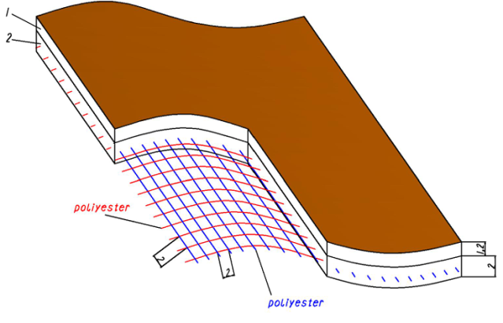 | 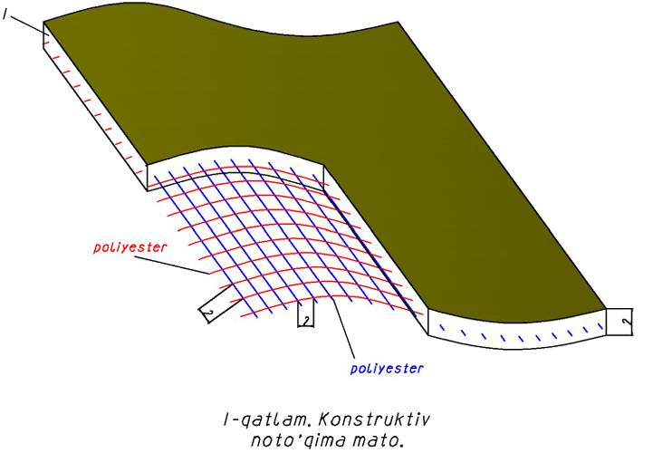
FIGURE 1: 1.5-layer nonwoven fabric | FIGURE 2: 1-layer nonwoven fabric

The tensile strength of the nonwoven fabric in total elongation is expressed as follows:
$σ_{com}=σ_{nt }=V_{nt}=σ_{yarn}=V_{yarn}$ (1)
Load distribution in rope-reinforced structures: [4].
$F∙g=F_{warp }=F∙weft+F∙fibers$ (2)
The presence of threads here reduces deformation by 30–45%.
Deformation under the influence of heat is evaluated by the following expression:
$εT=a∙∆T$ (3)
The inclusion of warp and weft yarns reduces the total thermal deformation by 20–25%
The stability of yarn tension during the reinforcement process of filter-like nonwoven fabrics made from basalt and flax fibers with warp and weft yarns is one of the important factors ensuring the mechanical strength and operational reliability of the material [5]. Therefore, before studying the tension of warp and weft yarns during the incorporation process into the nonwoven fabric structure, it is mandatory to calibrate the measuring instruments [6].
Devices based on mechanical-optical or electrical working principles used to measure tension allow recording the real-time tension of a single thread or a group of threads. However, since the threads in filter-like woven fabrics are not densely packed as in classic woven fabrics and interact with the fibrous layer, it is necessary to calibrate the device specifically for these technological conditions to ensure measurement accuracy [7].
The calibration process is usually carried out by sequentially attaching standard weights with precisely known masses to the yarn path. In this case, the yarn path is positioned in a configuration as close as possible to the working state of the filter-like woven fabric. Standard weights are applied stepwise (for example, 5, 10, 15, and 20 N), and the values indicated by the measuring device are compared with the theoretical tension values to determine the correction coefficient [8].
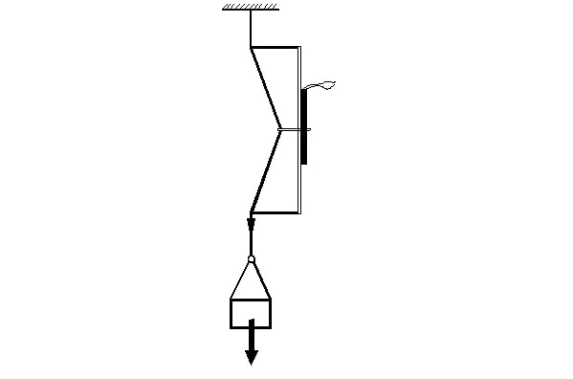  F  G  a) | 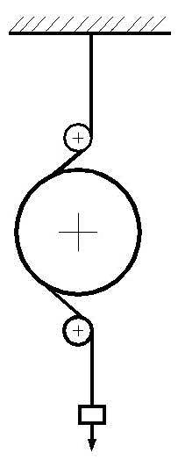  b)
FIGURE 3. Strain gauge calibration. a) for warp yarn; b) for weft yarn.
The calibration graph provides the foundation for analyzing the tension oscillograms [9] of both warp and weft yarns, and of the yarns integrated into the structure of the filter nonwoven fabric (Fig. 4).
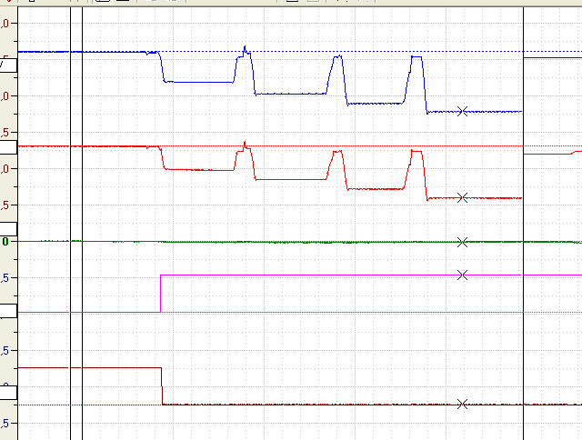
Tension of the warp yarn
Tension of 69 cN per yarn.
Weft yarn tension
Unstressed state
Tensioned state
Tension of 75 cN per yarn

FIGURE 4. Calibration graph of the warp yarn tension gauge
It should be emphasized that during the calibration of tensometers measuring the tension of warp and weft threads, the readings on the sensor's display change due to the tension of the thread (Figure 4). The data obtained from the changes in the sensor readings are recorded, and then the actual values (the calibration conversion coefficient) are determined [10].
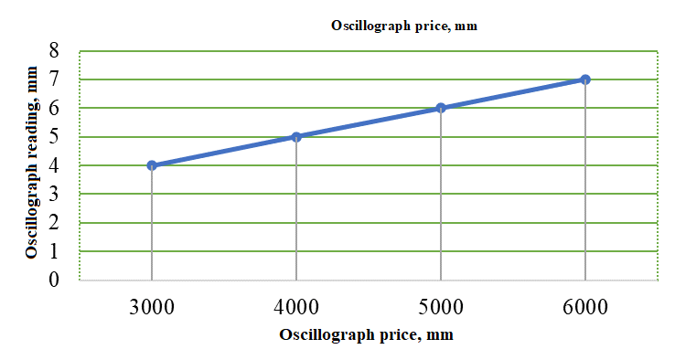
FIGURE 5. Calibration graph
By analyzing the calibration graphs, [11] it can be concluded that the average division per coordinate is 22 cN. Based on the obtained calibration data, a calibration table is created (Table 1).

TABLE 1. Calibration table
Applied load, g | 3000 | 4000 | 5000 | 6000
Oscillograph value, mm | 4 | 5 | 6 | 7
Single yarn tension, cN | 75 | 100 | 125 | 150

Calibration factor of the warp yarn tension sensor $k=tgα=0,02$.
EXPERIMENTAL RESEARCH
The primary factor affecting fabric formation on a weaving machine is the tension of the warp yarns. This tension depends on the machine’s structural parameters, shedding mechanism, and the fabric architecture. Warp yarn tension and deformation largely define the operating conditions of the weaving process and are the main cause of yarn breakage.
Changes in warp tension influence not only yarn rupture but also the final fabric structure. Therefore, analyzing the relationship between warp yarn tension, deformation, fabric architecture, and machine shedding parameters is of practical importance, allowing prediction of fabric formation under specific processing conditions [13].
For heat-resistant fabrics, high-strength yarns such as aramid, carbon, basalt, or glass are commonly used. Their high tensile strength and minimal filament elongation or breakage during weaving require robust mechanisms to control tension [12].
Monitoring warp yarn tension and deformation enables pre-assessment of fabric formation conditions. Figure 3.19 presents a single rotation of the main shaft with warp and weft tension curves, highlighting three characteristic stages: (1) average warp tension, (2) tension during shed formation, and (3) tension at beat-up.

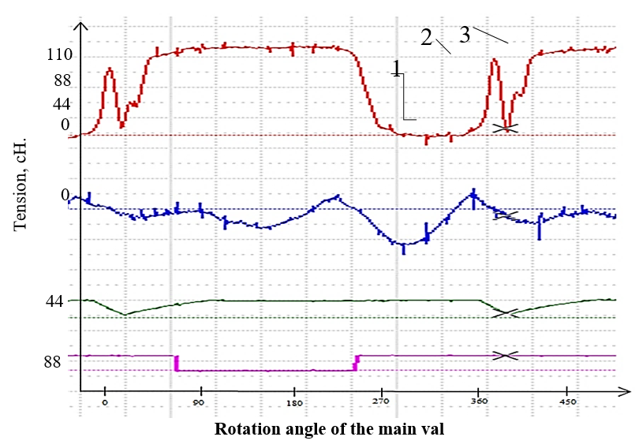
FIGURE 6. Warp and Weft Yarn Tension Curves of the Nonwoven Weaving Machine
Rotation angle of the main val
During one rotation of the main shaft of the nonwoven weaving machine, the warp yarns (basalt) experience three distinct tension stages (Figure 6). Prior to machine start-up, the warp yarns are at the shedding tension (1). When the machine begins operation and the beat-up occurs, the tension increases to a maximum (3). After the weft insertion and fabric formation, the tension adjusts during the shedding process (2), which also influences the warp tension [14].
Figure 7 presents the tension diagram (tensiogram) of warp yarns during the production of half-layer additional weft basalt nonwoven fabrics on the same weaving machine. These measurements allow evaluation of the dynamic behavior of warp yarns under operational conditions and provide a basis for optimizing machine settings and ensuring fabric uniformity.
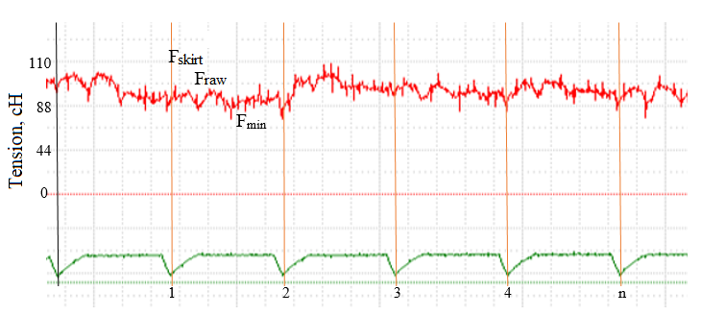
FIGURE 7. Warp yarn tension tensogram in the manufacturing of 1.5-layer nonwoven fabric
In the production of natural twisted yarns on a weaving machine, the tension of the warp threads varies. Mainly, the tension of the warp threads changes in three states: in the normal state $F_{ave}$ $F_{ўрт}$, during the formation of the shed $F_{raw}$and during beating-up $F_{gyp}$. The tension of the warp threads cyclically repeats in these three states $F_{ave}<F_{raw}≤F_{gyp}$. Thus, the greatest tension occurs during beating-up [15].
RESEARCH RESULTS
The tension of the weft threads on the shuttleless weaving machine also depends on the type of weaving, and in the production of fabrics based on plain weave $F_{ave}<F_{raw}<F_{gyp}$, in sample 1 fabrics, due to the constant openness of the shed, it remains in that state $F_{ave}<F_{raw}≤F_{gyp}$.
We analyze the results obtained based on installed devices for the dynamic tension of the warp threads in the nonwoven weaving machine (Table 2).

TABLE 2. Warp yarn tension during the nonwoven machine weaving process.
№ | Samples | In the average state, cN | During the passage of warp and weft yarns into the nonwoven fabric, cN | During twisting, cN
One-layer nonwoven fabrics
1 | Sample 1 | 67,48 | 122,32 | 99,44
2 | Sample 2 | 61,22 | 123,42 | 101,20
3 | Sample 3 | 78,98 | 126,72 | 97,68
One-and-a-half-layer nonwoven fabrics
1 | Sample 1 | 75,46 | 119,68 | 97,90
2 | Sample 2 | 72,36 | 118,14 | 94,38
3 | Sample 3 | 78,40 | 120,56 | 98,78

Naturally, the maximum tension of warp yarns is observed in high-linear-density yarns [16]. During twisting, the tension of the yarns is greater than that of the yarns during web formation. However, the elongation property of basalt yarns is only 1%.

CONCLUSIONS
Calculations have shown that for filter nonwoven fabrics based on basalt and wool fibers used in cement plants, when the relative tension of warp and weft yarns is chosen as k ≈ 1.6, the mechanical deformation is minimized, and the service life of the filter material under impulse loads and high-temperature conditions is maximized. A mechanism for controlling the tension of warp yarns has been developed. In the production of heat-resistant filter nonwoven fabric from basalt yarns on a nonwoven weaving machine, it was determined that under dynamic conditions, the tensions of warp and weft yarns vary depending on the nonwoven winding.
REFERENCES
- O. Toshbekov and M. Urozov, “Methodology for predicting, evaluating, and determining the deformation characteristics of nonwoven fabrics,” Eurasian Journal of Academic Research 3(4), 7–9 (2023).
- K. S. Sultanov and S. I. Ismoilova, Structural Strength of Textile Threads (Fan, Tashkent, 2017), 256 p. (in Russian).
- O. A. Toshbekov, Development of Technology for Producing Nonwoven Fabrics from Local Coarse Wool Fibers, Doctor of Technical Sciences Dissertation (Cotton Industry Scientific Center, Tashkent, 2023), pp. 22–47.
- O. Toshbekov, M. Urozov, S. Yermatov, and M. Khamraeva, “Efficient and economical energy use technology in the processing of domestic coarse wool fiber,” E3S Web of Conferences 461, 01068 (2023). https://doi.org/10.1051/e3sconf/202346101068
- O. Toshbekov and Z. Mustanova, “Determining the abrasion resistance and high adaptability properties for noise absorption of non-woven fabrics,” Eurasian Journal of Academic Research 3(12–2), 217–221 (2023).
- A. Kurbanov, M. Shomirzaev, S. Tursunov, O. Toshbekov, N. Mukhamadieva, B. Kambarov, and S. Mannobova, “Analysis of the state of cultivation and harvesting of mung bean and agro-biological requirements for threshing and separating its grain,” BIO Web of Conferences 105, 02010 (2024).
- F. Sultonova, O. Toshbekov, M. Urozov, N. Boymurova, Z. Mustanova, and I. Boltaeva, “Enhancing and evaluating the characteristics of specialized workwear for employees in the electric power supply sector,” AIP Conference Proceedings 3331, 050006 (2025).
- K. Jumaniyozov, M. Urozov, O. Toshbekov, M. Salimova, K. Raximova, and B. Khursandova, “Enhancement of energy-efficient cleaning equipment,” AIP Conference Proceedings 3331, 050007 (2025).
- O. Toshbekov, M. Urozov, F. Sultonova, S. Raximqulova, Z. Mustanova, and G. Xulkaliyeva, “Analysis of the thermal conductivity of nonwoven fabrics made from silkworm cocoons and their influence on ambient temperature,” AIP Conference Proceedings 3331, 050005 (2025).
- O. Toshbekov and M. Salimova, “Types of nonwoven fabrics obtained from coarse fiber and their fields of application,” Eurasian Journal of Academic Research 4(12–2), 12–17 (2024).
- O. Toshbekov, “Prospects for the development of technology for producing impermeable nonwoven materials,” Eurasian Journal of Academic Research 4(12–2), 7–11 (2024).
- V. G. Shlyakhtina, “Study of the stress–strain state,” in Creative Youth of the Lower Volga Region (2012), pp. 65–67.
- R. M. Yangiboev, B. Kh. Boymuratov, and U. T. Uzakov, “Investigation of warp yarn tension in the fabric production process,” in Proceedings of the Republican Scientific and Practical Conference “Current Issues of Innovative Technologies in Cotton Ginning, Textile, Light Industry, and Printing Production and Their Solutions under Conditions of Science–Education–Industry Integration” (April 21–22, 2021), pp. 194–197.
- M. K. Urozov, O. A. Toshbekov, and K. Rakhimova, “Methods for testing fabric thickness,” Eurasian Journal of Academic Research 2(13), 784–788 (2022).
- H. Yu. Rasulov, Optimization of Warp and Weft Yarn Tension on the STB Weaving Loom, Ph.D. Dissertation (2015).
- R. M. Yangiboev, B. Kh. Boymuratov, and U. T. Uzakov, “Development and research of flexible woven electric heaters,” in Proceedings of the Republican Scientific and Technical Conference “Innovative Technologies Based on Local Raw Materials and Secondary Resources” (Urgench State University, Urgench, April 19–20, 2021).
- Safarov J., Khujakulov A., Sultanova Sh., Khujakulov U., Sunil Verma. Research on energy efficient kinetics of drying raw material. // E3S Web of Conferences: Rudenko International Conference “Methodological problems in reliability study of large energy systems” (RSES 2020). Vol. 216, 2020. P.1-5. doi.org/10.1051/e3sconf/202021601093
- Safarov J., Sultanova Sh., Dadayev G.T., Zulponov Sh.U. Influence of the structure of coolant flows on the temperature profile by phases in a water heating dryer. // IOP Conf. Series: Materials Science and Engineering. Dynamics of Technical Systems (DTS 2020). Vol.1029, 2021. №012019. P.1-11. doi:10.1088/1757-899X/1029/1/012019
- Sultanova Sh.A., Artikov A.A., Masharipova Z.A., Abhijit Tarawade, Safarov J.E. Results of experiments conducted in a helio water heating convective drying plant. // International conference AEGIS-2021 «Agricultural Engineering and Green Infrastructure Solutions». IOP Conf. Series: Earth and Environmental Science 868 (2021) 012045. P.1-6. doi:10.1088/1755-1315/868/1/012045
- Sultanova Sh., Safarov J., Usenov A., Samandarov D., Azimov T. Ultrasonic extraction and determination of flavonoids. XVII International scientific-technical conference “Dynamics of technical systems” (DTS-2021). AIP Conference Proceedings 2507, 050005. 2023. P.1-5. doi.org/10.1063/5.0110524
- Sultanova Sh., Safarov J., Usenov A., Raxmanova T. Definitions of useful energy and temperature at the outlet of solar collectors. // E3S Web of Conferences: Rudenko International Conference “Methodological problems in reliability study of large energy systems” (RSES 2020). Vol. 216, 2020. P.1-5. doi.org/10.1051/e3sconf/202021601094
- Usenov A.B., Sultanova Sh.A., Safarov J.E., Azimov A.T. Experimental-statistic modelling of temperature dependence of solubility in the extraction of ocimum basilicum plants. // International conference AEGIS-2021 «Agricultural Engineering and Green Infrastructure Solutions». IOP Conf. Series: Earth and Environmental Science 868 (2021) 012047. P.1-5. doi:10.1088/1755-1315/868/1/012047
- Baratov, B.N., Umarov, F.Y., Toshov, Z.H. Tricone drill bit performance evaluation. Gornyi Zhurnal, Moscow, 2021. - № 12. - PP. 60-63. DOI:10.17580/gzh.2021.12.11.
- Toshov, J.B., Toshov, B.R., Baratov, B.N., Haqberdiyev, A.L. Designing new generation drill bits with optimal axial eccentricity | Вопросы проектирования буровых долот нового поколения с оптимальным межосевым эксцентриситетом // Mining Informational and Analytical Bulletin, 2022, (9). - PP. 133–142. DOI: 10.25018/0236_1493_2022_9_0_133
- Toshov J., Makhmudov A., Kurbonov O., Arzikulov G., Makhmudova G. Development and Substantiation of Energy-Saving Methods for Controlling the Modes of Operation of Centrifugal Pumping Units in Complicated Operating Conditions. Proceedings of the 11th International Conference on Applied Innovations in IT, (ICAIIT), November 2023, Koethen, Germany. – РР. 161-165.
- J.B. Toshov, K.T. Sherov, B.N. Absadykov, R.U. Djuraev, M.R. Sikhimbayev, Efficiency of drilling wells with air purge based on the use of a vortex tube. NEWS of the National Academy of Sciences of the Republic of Kazakhstan “Series of geology and technical sciences”. – Almaty, Volume 4, Number 460 (2023), 225–235. https://doi.org/10.32014/2023.2518-170X.331
Toshov J., Toshov B., Bainazov U., Elemonov M. Application of Cycle-Flow Technology in Coal Mines. Proceedings of the 11th International Conference on Applied Innovations in IT, (ICAIIT), March 2023, Koethen, Germany. – РР. 279-284.
- Usmanov, E., Kholikhmatov, B., Rikhsitillaev, B., Nimatov, K. Device for reducing asymmetry // E3s Web of Conferences 461. 2023. PP, 01052, 1-5. https://doi.org/10.1051/e3sconf/202346101052
- Toshov B., Toshov J., Akhmedova L., Baratov B. The new design scheme of drilling rock cutting tools, working in rotation mode pairs. E3S Web of Conferences 383, 04069 (2023) TT21C-2023 https://doi.org/10.1051/e3sconf/202338304069
- J.B. Toshev, M.B. Norkulov, A.A. Urazimbetova and L.G. Toshniyozov. Optimization of scheme of placing cutting structures on the cone drill bit. E3S Web of Conf., Volume 402, 10039 (2023), International Scientific Siberian Transport Forum - TransSiberia 2023, https://doi.org/10.1051/e3sconf/202340210039
- Toshov J., Baratov B., Sherov K., Mussayev M., Baymirzaev B., Esirkepov A., Ismailov G., Abdugaliyeva G., Burieva J. Ways to Optimize the Kinetic Parameters of Tricone Drill Bits. Material and Mechanical Engineering Technology, №1, 2024, 35-45. https://doi.org/10.52209/2706-977X_2024_1_35
- K.T. Sherov, N.Zh. Karsakova, B.N. Absadykov, J.B. Toshov, M.R. Sikhimbayev, Studying the effect of the boring bar amplitude-frequency characteristics on the accuracy of machining a large-sized part. NEWS of the National Academy of Sciences of the Republic of Kazakhstan “SERIES OF GEOLOGY AND TECHNICAL SCIENCES”. – Almaty, Volume 2, Number 464 (2024), 217–227. https://doi.org/10.32014/2024.2518-170X.405
- Akbar, K., Javokhir, T., Lazizjon, A., Umidjon, K., Muhammad, I., Improvement of soft-start method for high-voltage and high-power asynchronous electric drives of pumping plants. AIP Conf. Proc. 3152, 040006 (2024) / III International Scientific and Technical Conference “Actual issues of Power supply systems” (ICAIPSS2023), 7–8 September 2023, Tashkent, Uzbekistan. https://doi.org/10.1063/5.0218899
- J. Toshov, L. Atakulov, G. Arzikulov, U. Baynazov, Modeling of optimal operating conditions of cyclic-flow technologies with a belt conveyor at coal mine under the "ANSYS" program. AIP Conf. Proc. 3152, 020006 (2024) / III International Scientific and Technical Conference “Actual issues of Power supply systems” (ICAIPSS2023), 7–8 September 2023, Tashkent, Uzbekistan. https://doi.org/10.1063/5.0218904
- Kholikhmatov B.B., Samiev Sh.S., Erejepov M.T., Nematov L.A. Modelling of laboratory work in the science "Fundamentals of power supply" using an educational simulator based on a programmed logic controller // E3S Web of Conferences 384. 2023. РР, 01032, 1-3. https://doi.org/10.1051/e3sconf/202338401032
- Rakhimov F, Rakhimov F, Samiev Sh, Abdukhalilov D. Justification of Technical and Economic Effectiveness of Application of 20 kV Voltage in Overhead Electric Networks //AIP Conf. Proc. 3152, 030023 (2024). https://doi.org/10.1063/5.0218921
- Taslimov A, Mo'minov V, Samiev Sh, Abdukhalilov D. Issues of Optimization of Electrical Network Parameters Medium Voltage //AIP Conf. Proc. 3331, 020007 (2025). https://doi.org/10.1063/5.0305781
- Toshbekov, O., Urazov, M., Yermatov, S., & Khamraeva, M. 2023). Yeffisient and yesonomisal yenergy use teshnology in the prosessing of domestis soarse wool fiber. In Ye3S Web of Sonferenses (Vol. 461, p. 01068). https://doi.org/10.1051/e3sconf/202346101068
- Jumaniyozov, K., Urozov, M., Toshbekov, O., Salimova, M., Raximova, K., & Khursandova, B. (2025, November). Enhancement of energy-efficient cleaning equipment. In American Institute of Physics Conference Series (Vol. 3331, No. 1, p. 050007). https://doi.org/10.1063/5.0307149
- Sultonova, F., Toshbekov, O., Urozov, M., Boymurova, N., Mustanova, Z., & Boltaeva, I. (2025, November). Enhancing and evaluating the characteristics of specialized workwear for employees in the electric power supply sector. In American Institute of Physics Conference Series (Vol. 3331, No. 1, p. 050006). https://doi.org/10.1063/5.0306350

