Modern renium reduction methods and hydrometallurgical approaches and advanced plasma technologies
Kamol Khakimov^{a)}, Dostonbek Yormatov, Shokhrukh Chorshanbiyev, Mustafo Eshnazarov
Termez State University of Engineering and Agricultural Technology, Termez, Uzbekistan.
^{a)} Corresponding author: xakimovkamol718@gmail.com
Abstract. The article provides a detailed analysis of modern methods for reducing rhenium, including traditional hydrometallurgical approaches and advanced plasma technologies. The thermodynamic and kinetic aspects of reduction processes, which determine the efficiency of obtaining highly pure rhenium, were considered. Experimental data confirming the plasma effect on the morphological and structural characteristics of the obtained metallic rhenium are presented. Particular attention is paid to the analysis of impurity composition, process energy parameters, and the prospects for the industrial implementation of plasma technologies in the metallurgy of rare metals.
INTRODUCTION
Reduction of ammonium perrenate with hydrogen using plasma. Since there is no data in open sources on the hydrogen reduction of rhenium from ammonium perrhenate using plasma, let's consider the closest processes - the reduction of metals from oxides. Most metals, such as iron, aluminum, silicon, manganese, chromium, nickel, titanium, vanadium, etc., are extracted from oxide minerals by reduction.
Charged particles in plasma play a significant role. Reduction processes occur at the plasma-substrate (tablet) powder interface where the reducing gas is in a plasma state. [2] Plasma, which conducts electricity, is in contact with the processed material, which is in a solid or liquid state. Obviously, then the polarity of the charge must play an important role in attracting the necessary particles from the plasma volume to the interface where the desired reactions occur.For example, for reduction from iron oxide, the positive polarity of the reacting surface reduces the thermodynamic potential of the reduction reaction compared to the case with a neutral reacting surface. Conversely, in the case of a surface with negative polarity, the reaction proceeds much faster, i.e., ΔG is more negative [8
For a chemical reaction to occur, the reacting particles with sufficient kinetic energy must first collide to overcome the activation barrier. In the context of plasma interaction with metal oxides, the role of vibration-excited hydrogen molecules is emphasized in the literature. Molecules in a state of vibrational vibration can have internal energy up to 4.5 eV, which is obtained during rotation and vibration. They transfer their internal energy to other molecules and atoms in the gas phase during inelastic collisions and chemical reactions. As a result, the internal energy of the reacting particles increases, and the activation barrier decreases, facilitating the reaction. [12]
Hydrogen plasma not only provides improved reduction conditions but also provides high plasma temperatures for intensifying reduction processes, thereby enabling processes to be carried out in a single stage, which, in turn, makes metallurgical equipment smaller in size compared to traditional equipment.
EXPERIMENTAL RESEARCH
When reducing ammonium or potassium perrenates with hydrogen, rhenium powder is obtained. Electrolytic isolation yields rhenium powder or flakes (spongy rhenium precipitates). Rhenium coatings are produced through thermal dissociation. [1]
Reduction of potassium and ammonium perrenate with hydrogen under pressure (in solutions and solid state). It has been established that potassium and ammonium perrenates, both in solution and in solid form, are reduced by hydrogen at relatively low temperatures (200-300°C) under 20-100 atm pressure. [11] When water-free potassium or ammonium perrenates are reduced with hydrogen under a pressure of 50 atm, metallic rhenium is obtained in just 1-2 hours. [6]
When reduced by hydrogen under the pressure of potassium or ammonium perrenate solutions in the presence of hydrochloric acid, a number of low-valence intermediate rhenium compounds can be obtained, for example, (NH4) 2ReCl6 and (NH4) 2ReCl4, which can be used to obtain high-purity, oxygen-free metallic rhenium. [9] Reduction proceeds according to the following reactions:
2NH₄ReO₄ + 3H₂ + 12 HCl = (NH₄)₂ReCl₆ + H₂ReCl₆ + 8H₂O (at 270°С); (1)
H₂ReCl₆ + 2NH₄Cl = (NH₄)₂ReCl₆ + 2HCl; (2)
(NH₄)₂ReCl₆ + H₂ = (NH₄)₂ReCl₄ + 2HCl (at 300 – 325°С in solution HCl); [4]
The creation of an experimental installation designed to carry out reduction processes for obtaining high-purity rhenium on hydrogen plasma was preceded by the study of the results of our own experimental studies, which allowed us to form a list of the main technical requirements for the installation. Physical processes in plasma strongly depend on the geometric parameters of the reactor, such as the distance between the electrodes and the size of the electrodes, which has a huge influence on the field strengths between the electrodes. In general, the plasma-chemical reactor was a quartz tube placed in a muffle furnace with open ends and an electrode system (Fig.2).
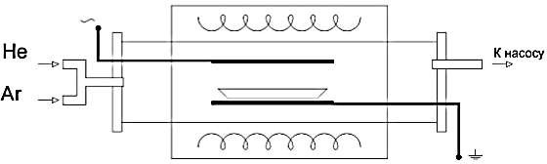
to the pump
FIGURE 1. Principal diagram of a plasma chemical reactor

The reactor's vacuum system is equipped with a mechanical pump and a cooling trap. The specific vacuum obtained in the chamber is 10-2 torr. Vacuum is measured by vacuum gauges in the chamber and the vacuum line. The gas system has two nodes for supplying hydrogen and inert gas.
The samples were studied more thoroughly using Raman spectroscopy. Below, Figures 3-6 show the Raman spectra of ammonium perrenate (for comparison) and samples that show the disappearance of characteristic peaks of ammonium perrenate, confirming the complete reduction of metallic rhenium from ammonium perrenate [3-40]. Some "noise" peaks in the spectra are characterized by the post-process oxidation of the surfaces of fine rhenium metal powders. The absence of such noise in the X-ray diffraction spectra confirms this fact.

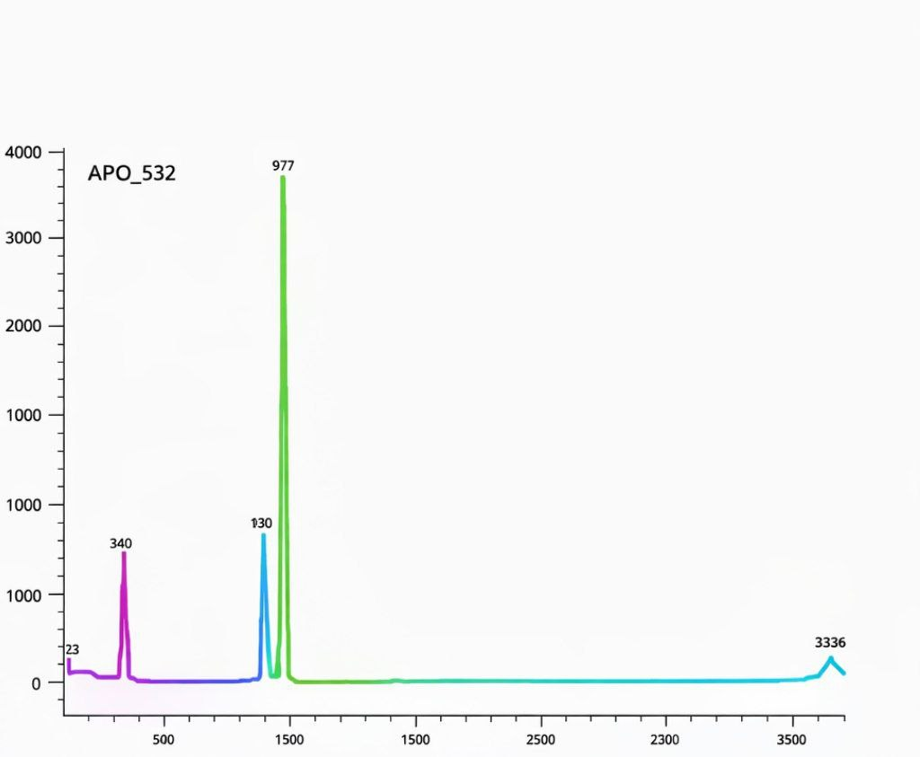
FIGURE 2. Ammonium perrenate Raman spectrum
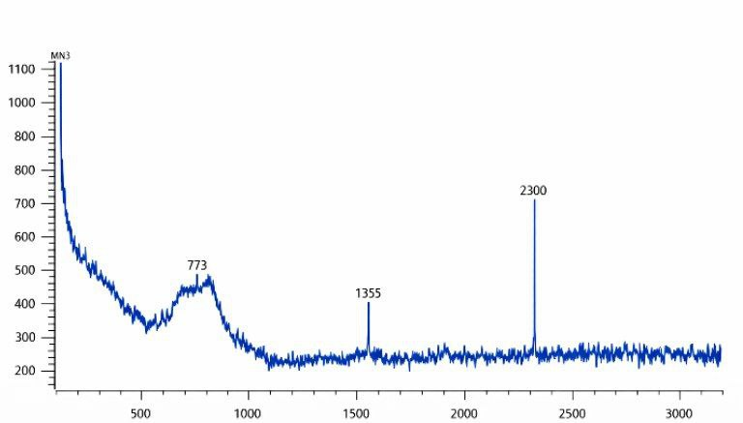
FIGURE 3. Rhenium metal sample Raman spectrum
FIGURE 4. Rhenium metal sample Raman spectrum
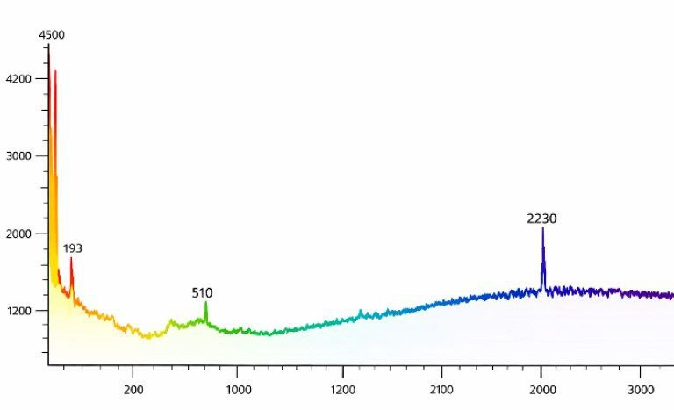
FIGURE 5. Rhenium metal sample Raman spectrum
RESEARCH RESULTS
The "chlorine" method also includes the method of chlorinating technical rhenium at a temperature of 600-700°C. The resulting rhenium pentachloride, ReCl5, is purified by vacuum distillation. Chloride is decomposed with water. In this case, 65-70% of rhenium precipitates as hydrated dioxide. Complete decomposition of chloride is achieved at pH=2.5-3.0. The filtered and washed precipitate is dried in a vacuum and reduced with hydrogen in two stages: first at 400-600°C, then at 800°C. The solution is oxidized with hydrogen peroxide, neutralized with ammonia, and ammonium perrhenate is extracted from it, which is returned for reduction. The method provides good cleaning from impurities of alkaline and alkaline-earth metals. At the same time, iron, silicon, and a number of other impurities are not separated.
Data on the content of impurities in the powder of rhenium obtained by various methods of reduction are presented in Table 1.

TABLE 1. Content of impurities in rhenium powder obtained by various methods
Impurities | Content of impurities in the obtained rhenium (%)
Impurities | from KReO₄ | from NH₄ReO₄ | chloride method
Silicon | 0,005 | 0,028 | 0,015
Iron | 0,050 | 0,024 | 0,012
Aluminum | 0,009 | 0,094 | 0,008
Manganese | 0,007 | 0,002 | 0.007
Magnesium | 0,002 | 0,038 | 0.005
Calcium | 0,008 | 0,017 | 0,002
Copper | 0,001 | 0,002 | 0,0002
Molybdenum | 0,150 | No | No
Potassium | 0,410 | No | No
Sodium | 0,150 | No | No
Nickel | 0,003 | No | No
Chromium | 0,004 | No | No
Total impurities: | 0,799 | 0,205 | 0,049

Thus, the obtained results show that plasma contributes to a more efficient process of reducing rhenium from ammonium perrenate. This leads to a noticeable increase in process productivity, a decrease in energy consumption, and a reduction in hydrogen consumption. A detailed analysis of the thermal and plasma reduction processes for rhenium shows that the use of plasma allows for a two-fold reduction in the cost per unit of electrical energy product and a three-fold reduction in the cost per unit of hydrogen product. The total productivity of the units can also be increased by 60- 100% by increasing the thickness of the ammonium perrhenate loading layer. At the same time, no noticeable changes in the granulometric composition of the rhenium metal are observed; apparently, the granulometric composition is largely determined by the characteristics of the initial ammonium perrenate powder.[5]
Regarding the samples in Figures 4-6 reduced by superpure hydrogen in the presence of plasma, impurities such as Rb - 168.2 ppm, Sb - 54.8 ppm, P - 23.3 ppm, Te - 9.5 ppm, Au - 18.1 ppm, Pt - 13.7 ppm, S - 6.4 ppm are noticeable. [10] The rhenium content in these samples is determined from 99.94% to 99.96%, which is also closer to the Re-1 grade. However, relatively high sulfur content from 0.0003 to 0.005% is found in the samples. This circumstance requires the development of additional measures to remove sulfur from the product composition.
CONCLUSIONS
Analysis of the presented methods for reducing rhenium shows that the use of plasma technology allows for a higher degree of metal extraction (95-98%) while reducing energy costs and minimizing losses. Compared to traditional methods, plasma reduction contributes to the improvement of the physicochemical characteristics of rhenium, including its purity and granulometric composition. Further development of this technology requires in-depth study of the mechanisms of rhenium-plasma interaction, improvement of impurity removal processes, and optimization of conditions for large-scale industrial applications.
REFERENCES
- Kokusheva A.A., Dairabayeva G.A., Usabekova A.Sh., Perfelyev N. A. Extraction of rhenium from sulfuric acid sludge of the Zhezkazgan copper smelting plant // Non-ferrous metals. - 1992. - No. - P. 14 - 15.
- Palant A.A., Troshkina I.D., Chekmarev A.M. Rhenium Metallurgy. - M.: Science, 2007. 298 p.
- Savitsky E.M., Tylkina M.A., Povarova K.B. Rhenium Alloys. - M.: Nauka, 1965.
- Sanaqulov K.S., Muhiddinov B.F., Hasanov A.S. Chemical Elements properties, obtaining, application. Tashkent "Turon zamin ziyo" 2016. 493p.
- Khakimov K.Zh., Rajabov Sh.Kh. Methods of extraction, processing and enrichment of rhenium // Digital technologies in industry - Karshi, 2024 - No1 P. 54-59.
- Khasanov, A. S., Akhmedov U. Ch., Khakimov K.Zh. Burning of sulfide rhenium-containing concentrates // Composite Materials - Tashkent, 2025, No1, pp. 192-195
- Khasanov, A. S., Akhmedov U. Ch., Khakimov K.Zh. Technology of obtaining, processing and application of rhenium in high-tech industries // Digital technologies in industry - Karshi, 2025 - No3 (1) P. 63-69.
- Hasanov, A. S., Hakimov, K. J., Shodiev, A. N., & Eshonkulov, U. H. (2018). Uranium and Gold. Muhofaza+ Ijtimoiy-siyosiy, ilmiy-amaliy va badiiy jurnal, (01 (157)), 13.
- Hasanov, A. S., Hakimov, K. J., Shodiev, A. N., & Eshonkulov, U. H. (2018). Uranium and Gold. Muhofaza+ Ijtimoiy-siyosiy, ilmiy-amaliy va badiiy jurnal, (01 (157)), 13.
- Hakimov, K. J., Eshonqulov, U. H., & Umirzoqov, A. (2020). Complex Processing of Lead-Containing Technogenic Waste from Mining and Metallurgical Industries in the Urals. The American journal of engineering and technology (TAJET) SJIF-5.32 DOI-10.37547/tajet, 2 (9), 2689-0984.
- Habashi F.Handbook of Extractive Metallurgy. Volume IV: Hydrometallurgy. – Weinheim: Wiley-VCH, 1997. – 1336 p.
- Fridman A., Kennedy L.A.Plasma Physics and Engineering. – New York: Taylor & Francis, 2004. – 704 p.
- Jumaniyozov, K., Urozov, M., Toshbekov, O., Salimova, M., Raximova, K., & Khursandova, B. (2025, November). Enhancement of energy-efficient cleaning equipment. In American Institute of Physics Conference Series (Vol. 3331, No. 1, p. 050007). https://doi.org/10.1063/5.0307149
- Sultonova, F., Toshbekov, O., Urozov, M., Boymurova, N., Mustanova, Z., & Boltaeva, I. (2025, November). Enhancing and evaluating the characteristics of specialized workwear for employees in the electric power supply sector. In American Institute of Physics Conference Series (Vol. 3331, No. 1, p. 050006). https://doi.org/10.1063/5.0306350
- Toshbekov, O., Urozov, M., Sultonova, F., Raximqulova, S., Mustanova, Z., & Xulkaliyeva, G. (2025, November). Analysis of the thermal conductivity of nonwoven fabrics made from silkworm cocoons and their influence on ambient temperature. In AIP Conference Proceedings (Vol. 3331, No. 1, p. 050005). AIP Publishing https://doi.org/10.1063/5.0306845
- Mahmutkhonov S., Baizhonova L., Mustayev R., Tashmatova S. Dynamic analysis of voltage-ampere characteristics and harmonic distortions in electric arc furnaces. // AIP Conference Proceedings. 3331(1), 2025. pp. 070023, 1–5. https://doi.org/10.1063/5.0305745.
- Bobojanov M., Mahmutkhonov S. Influence of the consumer to power quality at the point of connection // E3S Web of Conferences 384. 2023. РР, 01041, 1-5. https://doi.org/10.1051/e3sconf/202338401041.
- Reymov K.M., Makhmuthonov S.K., Turmanova G., Uzaqbaev Q. Optimization of electric networks modes under conditions of partial uncertainty of initial information // E3S Web of Conferences 289, 07023 (2021). -2021, pp: 1-4, https://doi.org/10.1051/e3sconf/202128907023.
- Alimov, U.K., Reimov, A.M., Namazov, Sh.S., Beglov, B.M. The insoluble part of phosphorus fertilizers, obtained by processing of phosphorites of central kyzylkum with partially ammoniated extraction phosphoric acid. Russian Journal of Applied Chemistry. Russ J Appl Chem (2010) 83(3): 545–552. https://doi.org/10.1134/S107042721030328
- Reymov, A.M., Namazov, S.S., Beglov, B.M. Effect of phosphate additives on physical-chemical properties of ammonium nitrate. Journal of Chemical Technology and Metallurgy 2013 48(4), 391-395. http://dl.uctm.edu/journal/
- Urishev, B., Fakhriddin Nosirov, and N. Ruzikulova. 2023. “Hydraulic Energy Storage of Wind Power Plants.” E3S Web of Conferences, 383. https://doi.org/10.1051/e3sconf/202338304052
- Urishev, B., S. Eshev, Fakhriddin Nosirov, and U. Kuvatov. 2024. “A Device for Reducing the Siltation of the Front Chamber of the Pumping Station in Irrigation Systems.” E3S Web of Conferences, 274. https://doi.org/10.1051/e3sconf/202127403001
- Turabdjanov, S., Sh. Dungboyev, Fakhriddin Nosirov, A. Juraev, and I. Karabaev. 2021. “Application of a Two-Axle Synchronous Generator Excitations in Small Hydropower Engineering and Wind Power Plants.” AIP Conference Proceedings. https://doi.org/10.1063/5.0130649
- L.Jing, J.Guo, T.Feng, L.Han, Z.Zhou and M.Melikuziev, "Research on Energy Optimization Scheduling Methods for Systems with Multiple Microgrids in Urban Areas," 2024 IEEE 4th International Conference on Digital Twins and Parallel Intelligence (DTPI), Wuhan, China, 2024, pp. 706-711, https://ieeexplore.ieee.org/abstract/document/10778839
- Baratov, B.N., Umarov, F.Y., Toshov, Z.H. Tricone drill bit performance evaluation. Gornyi Zhurnal, Moscow, 2021. - № 12. - PP. 60-63. DOI:10.17580/gzh.2021.12.11.
- Toshov, J.B., Toshov, B.R., Baratov, B.N., Haqberdiyev, A.L. Designing new generation drill bits with optimal axial eccentricity | Вопросы проектирования буровых долот нового поколения с оптимальным межосевым эксцентриситетом // Mining Informational and Analytical Bulletin, 2022, (9). - PP. 133–142. DOI: 10.25018/0236_1493_2022_9_0_133
- Toshov J., Makhmudov A., Kurbonov O., Arzikulov G., Makhmudova G. Development and Substantiation of Energy-Saving Methods for Controlling the Modes of Operation of Centrifugal Pumping Units in Complicated Operating Conditions. Proceedings of the 11th International Conference on Applied Innovations in IT, (ICAIIT), November 2023, Koethen, Germany. – РР. 161-165.
- J.B. Toshov, K.T. Sherov, B.N. Absadykov, R.U. Djuraev, M.R. Sikhimbayev, Efficiency of drilling wells with air purge based on the use of a vortex tube. NEWS of the National Academy of Sciences of the Republic of Kazakhstan “Series of geology and technical sciences”. – Almaty, Volume 4, Number 460 (2023), 225–235. https://doi.org/10.32014/2023.2518-170X.331
Toshov J., Toshov B., Bainazov U., Elemonov M. Application of Cycle-Flow Technology in Coal Mines. Proceedings of the 11th International Conference on Applied Innovations in IT, (ICAIIT), March 2023, Koethen, Germany. – РР. 279-284.
- Usmanov, E., Kholikhmatov, B., Rikhsitillaev, B., Nimatov, K. Device for reducing asymmetry // E3s Web of Conferences 461. 2023. PP, 01052, 1-5. https://doi.org/10.1051/e3sconf/202346101052
- Toshov B., Toshov J., Akhmedova L., Baratov B. The new design scheme of drilling rock cutting tools, working in rotation mode pairs. E3S Web of Conferences 383, 04069 (2023) TT21C-2023 https://doi.org/10.1051/e3sconf/202338304069
- J.B. Toshev, M.B. Norkulov, A.A. Urazimbetova and L.G. Toshniyozov. Optimization of scheme of placing cutting structures on the cone drill bit. E3S Web of Conf., Volume 402, 10039 (2023), International Scientific Siberian Transport Forum - TransSiberia 2023, https://doi.org/10.1051/e3sconf/202340210039
- Toshov J., Baratov B., Sherov K., Mussayev M., Baymirzaev B., Esirkepov A., Ismailov G., Abdugaliyeva G., Burieva J. Ways to Optimize the Kinetic Parameters of Tricone Drill Bits. Material and Mechanical Engineering Technology, №1, 2024, 35-45. https://doi.org/10.52209/2706-977X_2024_1_35
- K.T. Sherov, N.Zh. Karsakova, B.N. Absadykov, J.B. Toshov, M.R. Sikhimbayev, Studying the effect of the boring bar amplitude-frequency characteristics on the accuracy of machining a large-sized part. NEWS of the National Academy of Sciences of the Republic of Kazakhstan “SERIES OF GEOLOGY AND TECHNICAL SCIENCES”. – Almaty, Volume 2, Number 464 (2024), 217–227. https://doi.org/10.32014/2024.2518-170X.405
- J. Toshov, L. Atakulov, G. Arzikulov, U. Baynazov, Modeling of optimal operating conditions of cyclic-flow technologies with a belt conveyor at coal mine under the "ANSYS" program. AIP Conf. Proc. 3152, 020006 (2024) / III International Scientific and Technical Conference “Actual issues of Power supply systems” (ICAIPSS2023), 7–8 September 2023, Tashkent, Uzbekistan. https://doi.org/10.1063/5.0218904
- Kholikhmatov B.B., Samiev Sh.S., Erejepov M.T., Nematov L.A. Modelling of laboratory work in the science "Fundamentals of power supply" using an educational simulator based on a programmed logic controller // E3S Web of Conferences 384. 2023. РР, 01032, 1-3. https://doi.org/10.1051/e3sconf/202338401032
- Rakhimov F, Rakhimov F, Samiev Sh, Abdukhalilov D. Justification of Technical and Economic Effectiveness of Application of 20 kV Voltage in Overhead Electric Networks //AIP Conf. Proc. 3152, 030023 (2024). https://doi.org/10.1063/5.0218921
- Taslimov A, Mo'minov V, Samiev Sh, Abdukhalilov D. Issues of Optimization of Electrical Network Parameters Medium Voltage //AIP Conf. Proc. 3331, 020007 (2025). https://doi.org/10.1063/5.0305781
- Toshbekov, O., Urazov, M., Yermatov, S., & Khamraeva, M. 2023). Yeffisient and yesonomisal yenergy use teshnology in the prosessing of domestis soarse wool fiber. In Ye3S Web of Sonferenses (Vol. 461, p. 01068). https://doi.org/10.1051/e3sconf/202346101068
- Jumaniyozov, K., Urozov, M., Toshbekov, O., Salimova, M., Raximova, K., & Khursandova, B. (2025, November). Enhancement of energy-efficient cleaning equipment. In American Institute of Physics Conference Series (Vol. 3331, No. 1, p. 050007). https://doi.org/10.1063/5.0307149
- Sultonova, F., Toshbekov, O., Urozov, M., Boymurova, N., Mustanova, Z., & Boltaeva, I. (2025, November). Enhancing and evaluating the characteristics of specialized workwear for employees in the electric power supply sector. In American Institute of Physics Conference Series (Vol. 3331, No. 1, p. 050006). https://doi.org/10.1063/5.0306350

