Development of an energy-efficient design for a wool washing vat
Kurbonali Juraev ^{1,a)}, Urozov Mustafokul¹, Juraev Davron¹, Khusanov Ural¹, Khurramov Ruziboy¹ Khadam Jumaniyozov², Begdavlat Aliyev³
¹ Termez State University of Engineering and Agrotechnologies, Termez, Uzbekistan
² Research Institute of Fiber Crops, Tashkent, Uzbekistan
³Tashkent State University of Economics, Tashkent, Uzbekistan
^{a)} Corresponding author: qurbonalijurayev2@gmail.com
Abstract. This article examines the issue of simplifying the movement of the spiked mechanism in wool washing baths and developing an energy-efficient design. In existing washing equipment, there are various designs that ensure the elliptical movement of the spiked mechanism. While some of these designs offer high productivity, they also tend to have relatively high energy consumption. The study proposed eliminating this problem by slightly modifying the mechanism's movement trajectory and reducing the number of moving parts. In the new design, the pegs move smoothly (forming a straight-line trajectory) while shifting the wool along the washing bath. This not only prevents the wool from tangling but also saves energy spent on the process. A geometric model of the mechanism was developed using modern design software, and the motion paths were analyzed. Results showed that the new design reduces the degree of wool tangling by 10-15% and energy consumption by up to 22%. The proposed mechanism design allows for improving the quality of the washing process and reducing energy consumption.
INTRODUCTION
The wool processing process begins in its initial stage - washing, which is necessary for removing impurities from raw wool. The amount of contamination ranges from 40% to 70% and depends on the age, sex and breed of the sheep, soil and climatic conditions, the regime and conditions of their feeding[2]. Dust and plant debris are disposed of by cleaning machines. Fat (lanolin) and sweat skin waste are cleaned in washing machine containers using liquid filled with hot water and soda.[3]
The first washing mechanisms were invented by English inventors John McNaught and William McNaught. Their harrowing-style wool washing machines were patented in 1881-1882 by Great Britain, France, and Belgium. A complete, accurate, and developed version of this invention was patented in the USA in 1888[4]. Since then, this device has been improved over the years.
Later, in 1908[5] and 1909[6], F. G. Sargent proposed advanced versions of large transport mechanisms. Currently, washing machines developed on the basis of these and their inventions are widely used in many wool processing plants.
In a harrowing machine (Fig. 1), container 1 or tank, which forms the body or frame of the machine and contains the washing liquid (2). Fatty or raw wool is fed into the container through a feeding conveyor (3), which is usually driven by belt or gear transmissions. When oily wool falls from the feeding conveyor into the container, all spikes (p) installed in the longitudinal brackets (h) during harrowing (H) grasp the wool, submerge it in the washing liquid, and move it forward, towards the outlet conveyor (7). [7].
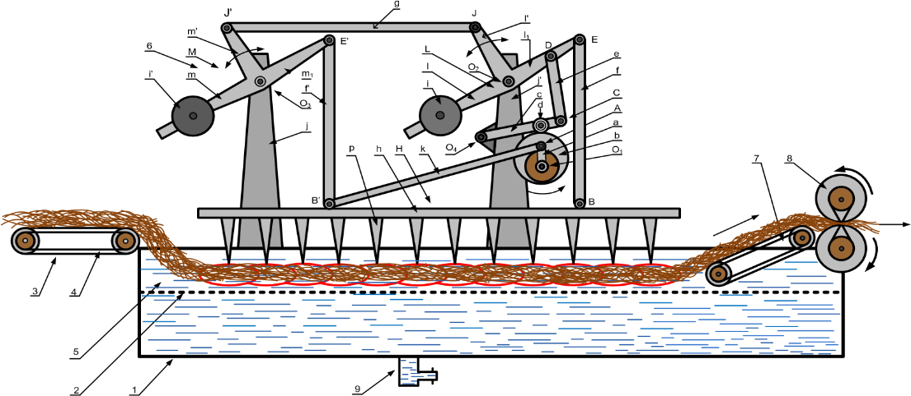
FIGURE 1. Wool washing device of the scraping type.

As can be seen from the above device, its main disadvantage is the large number and complexity of the parts used to ensure elliptical motion. J.A. Kayumov, who conducted many scientific studies in this area, created a somewhat simpler version in his scientific works. The device he created is aimed at designing a new wool transport mechanism in order to reduce fiber tangling and damage, which is carried out on the basis of the development of the topological structure of the mechanism by improving the movement. To reduce the mechanical impact of toothed supports on the fibers, it was established that the trajectory of the supports during the rotation of the mechanism should be approximately straight along a certain length. in figure 2, it can be seen that at a distance from point b to point c, the trajectory of the support is approximately a straight line [7].
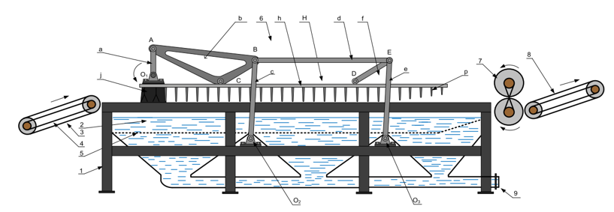
FIGURE 2. Wool washing device created by J.A. Kayumov. 1- Bowl or tank, 2- Scouring liquor, 3- Feeding conveyor, 4- Belt, 5- Perforated false bottom, 6- Harrow mechanism: a- crank, b- coupler, c and e-levers, d -connecting rod, H-harrow platform: h-longitudinal girth, p-prongs, 7-Squeeze rollers, 8- Feeding conveyor, 9- Sediment outlet

As we can observe, the number of components in Kayumov's device is significantly reduced compared to Sargent's device discussed above, and its energy efficiency has also decreased. However, in Kayumov's device, the movement trajectory of the comb (Fig. 3) is somewhat more complex, with curved lines present in the trajectory path. Due to this complexity, it is natural that a portion of the energy is lost.
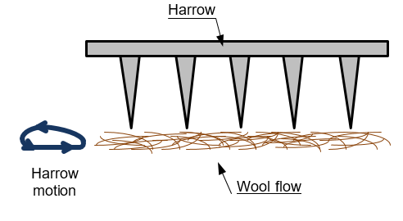
FIGURE 3. Trajectory of comb movement.
Therefore, scientific research was conducted to address this problem, and this article presents some ideas as potential solutions, along with the obtained research results.
EXPERIMENTAL RESEARCH
A technological scheme for a new type of inventive device was created as a result of observations and a literature review[8]. The object of research selected was a wool washing bath with dimensions of 2500 mm in length, 600 mm in width, and 900 mm in height. A spiked mechanism installed inside the device moves the fibers along the water flow during the wool washing process, thereby maintaining a steady mixing process throughout the entire volume of the washing medium. The main function of this mechanism is to advance the fibers forward during washing, distribute them evenly, and ensure effective interaction with water and chemical solution [9]. (Figure 4)
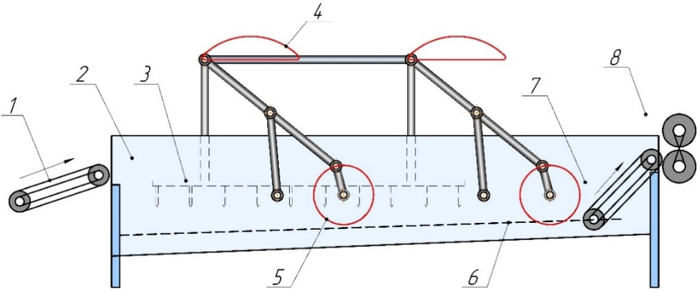
FIGURE 4. Proposed wool washing device. 1-feeding mechanism, 2-washing bath, 3-spikes, 4-trajectory of movement, 5-movement of the electric motor shaft, 6-slit, 7-discharge mechanism, 8-clamping shafts.

In this device (shown in Figure 4), there are two vessels or baths that form the body or frame of the apparatus and contain the washing liquid. Unwashed wool is fed into the container through the feed conveyor (1), which is typically driven by belt or gear transmissions. As the wool falls from the feeding conveyor into the container, a frame equipped with pegs catches the wool, submerges it into the washing liquid, and moves it forward towards the outlet conveyor (7).
The electric motor, mounted on the side of the bathtub, transmits motion through the shaft to the pulley and then sequentially through interconnected levers to one another [10-38].
In the improved design, the pegs move through a two-joint lever (Figure 4). By changing the lengths of the levers, it is possible to alter the trajectory of the pegs and obtain the desired path. When selecting the trajectory of the pegs, the work "Atlas of Trajectories of Four-Bar Linkages" created by Hrones and Nelson [10] was used. In this mechanism, only 2 rods are used to ensure the translational movement of the pegs, which helps to reduce the energy consumption of the mechanism. As the pegs move along the wool washing bath, their tips travel along a straight-line path. As a result, the intertwining of fibers is also reduced...

RESEARCH RESULTS
The research results revealed significant differences in energy efficiency and fiber integrity preservation among the three types of washing systems. Energy consumption measured during an 8-hour operation period helped determine the loading levels of the mechanisms. Distribution diagrams of incoming and outgoing fiber lengths allowed for the assessment of fiber entanglement in each design. Based on these indicators, the effectiveness of the new method was accurately evaluated.
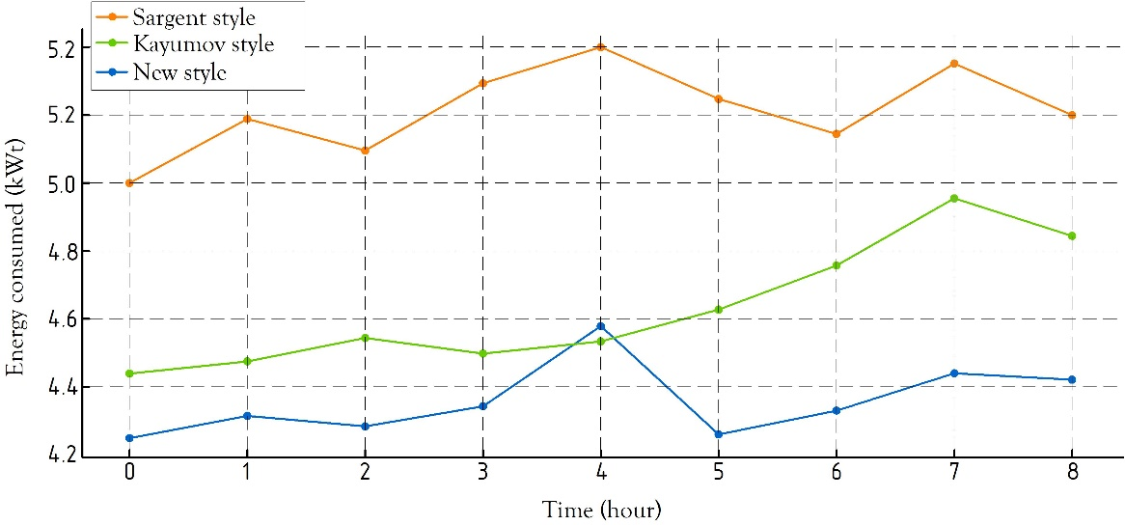
FIGURE 5. Time graph of energy expenditure

The diagram compares energy consumption values over an 8-hour period using the Sargent method (dark yellow line), the Kayumov method (green line), and the proposed new method (blue line). The results show that the Sargent method consistently demonstrates the highest energy consumption: starting at around 5.0 kW and oscillating within the range of 5.3-5.25 kW. This is attributed to the large number of moving parts in the construction and high mechanical losses.
The Kayumov method demonstrates an average level of energy consumption. Its values start at 4.45 kW and increase to 4.9 kW over time. Although energy consumption in this method is lower than in the Sargent method, a steady upward trend is still observed throughout the work process.
The improved new method demonstrates the lowest energy consumption. The line remains nearly stable in the range of 4.25-4.35 kW, only increasing to 4.55 kW during the 4th hour. Overall, the new method consumes on average 0.75-0.9 kW less energy than the Sargent method and 0.25-0.45 kW less than the Kayumov method. This is attributed to the reduction in the number of moving parts in the design, decreased friction losses, and optimization of hydrodynamic processes.
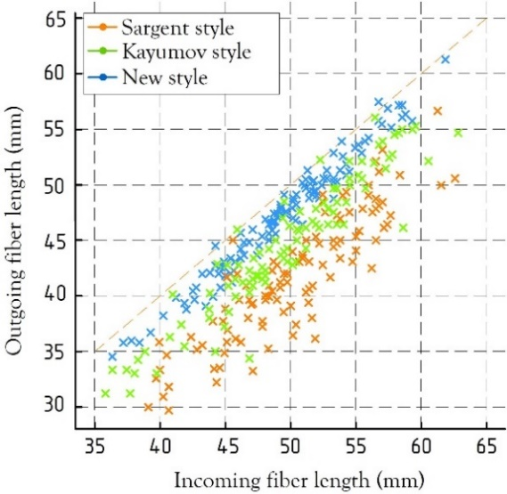
FIGURE 6. Interconnected graph of fiber entrance and exit confusion
The diagram illustrates the relationship between the input (x-axis) and output (y-axis) lengths of fibers using a scatter plot for three different washing methods. The ideal condition of "fiber shape preservation" is represented by the diagonal line (y=x) on the graph. The proximity of points to this diagonal indicates that the fibers are less tangled, while points farther from the diagonal suggest that the fibers have significantly shortened or broken.
Points in the Sargent style (dark yellow dots) are most widely distributed along the diagonal. In this style, the fiber length at the output is often positioned much lower than the length at the input, which indicates significant entanglement, stretching, and breaking of the fibers. Due to high mechanical vibrations and friction forces, the fibers cannot maintain their proper condition well.
The Kayumov style (green dots) appears more orderly compared to the Sargent style. Although the points are below the diagonal, their degree of dispersion is relatively small. This indicates a moderate level of entanglement in the fibers, but the mechanical impact is not excessively strong.
The points of the proposed new method (blue dots) are positioned closest to the diagonal. They exhibit the lowest degree of dispersion, with points concentrated around the diagonal line. This situation indicates that the fibers have almost retained their original length, and entanglement is minimal. In the new design, due to the gentle formation of hydrodynamic flows, reduction of sharp impacts, as well as decreased friction forces, the deterioration of the fiber structure has been significantly reduced.
In general, the diagram clearly shows that the new style is the most stable and least confusing construction in terms of the ability to maintain the shape of the fibers. The Sargent method has the most confusion and reduction, the Kayumov method is moderate, and the new method gives the most optimal result. According to the analysis results, the improved spiked mechanism further stabilizes the washing process, evenly distributes fiber movement, and reduces their mutual friction. As a result, an improvement in washing quality and an increase in the ease of processing wool at subsequent technological stages are ensured. At the same time, the decrease in the number of parts leads to its energy saving.
CONCLUSIONS
In this study, the influence of three different washing devices - Sargent, Kayumov, and an improved new method - on energy efficiency and fiber was experimentally compared. The analysis showed that due to the high mechanical losses in the Sargent method, energy consumption was the highest, and fiber twisting was also observed at the highest level. Despite the relative improvement of these indicators in the Kayumov method, it was found that stable effectiveness is still insufficient.
The proposed new method was distinguished by the lowest energy consumption and minimal fiber twisting. The decrease in energy by an average of 0.75-0.9 kWt and the almost preservation of fiber length is explained by the optimization of the mechanical elements of the device and the softening of hydrodynamic processes. The accumulation of fibers around the diagonal in the point diagram confirms that the degree of fiber breakage in the new method is minimal.
In general, it was established that the newly developed washing mechanism surpasses traditional systems in energy efficiency, fiber integrity preservation, and structural simplicity. These results show the practical significance of the new method in modernizing the technological process, reducing production costs, and obtaining high-quality products.
REFERENCES
- Werner Von Bergen. Wool handbook. Volume two. Third enlarged edition. Part 1: Spinning, Weaving, Knitting. “Inter Science Publishers”. A division of John Wiley & Sons, 1969. USA. https://www.researchgate.net/publication/343140251_A_study_on_wool_scouring_machines
- K.I.Kholmirzaev. Primary processing of fibrous materials. Textbook for vocational colleges. - T.: "ILM ZIYO," 2007.
- Rogachev, N.V, Fedorov V.A. Primary treatment of wool. “Light Industry”, Moscow, 1967 (in Russian).
- McNaught J. and McNaught W. ''Machinery for scouring and washing wool''. U.S. Patent No. 385,761. July 10, 1888. https://patents.google.com/patent/US33408A/en
- Sargent, Frederick G. "Wool washing machine". U.S. Patent No. 889,157. May 26, 1908. https://patents.google.com/patent/US879196
- Frederick G. Sargent and C. Allan, "Wool washing machine". U.S. Patent No. 889,157. Apr. 20, 1909. https://patents.google.com/patent/US354245A/en
- J.A. Kayumov. Design of a new harrow type wool transport mechanism to reduce fibre entanglement. Dissertatsiya - Esame finale anno 2015
- G Fozilov, A Akhmedov, Sh Yuldashev, U Akilova and K Juraev 2024 IOP Conference Series: Earth and Environmental Science 1420 012031. https://iopscience.iop.org/article/10.1088/1755-1315/1420/1/012031/meta
- R.B. Tuguzbaeva. "Improvement of the working parts of the wool washing machine." Dissertation - 2024
- J.A.Hrones and G.L.Nelson, Analysis of four bar linkage: Its application to the synthesys of the mechanisms, The Technology Press of the Massachusettes Institute of Technology, 1951. https://openlibrary.org/books/OL10237065M/Analysis_of_the_Four-Bar_Linkage
- Toshbekov, O., Urozov, M., Sultonova, F., Raximqulova, S., Mustanova, Z., & Xulkaliyeva, G. (2025, November). Analysis of the thermal conductivity of nonwoven fabrics made from silkworm cocoons and their influence on ambient temperature. In AIP Conference Proceedings (Vol. 3331, No. 1, p. 050005). AIP Publishing https://doi.org/10.1063/5.0306845
- Jumaniyozov, K., Urozov, M., Toshbekov, O., Salimova, M., Raximova, K., & Khursandova, B. (2025, November). Enhancement of energy-efficient cleaning equipment. In American Institute of Physics Conference Series (Vol. 3331, No. 1, p. 050007). https://doi.org/10.1063/5.0307149
- Sultonova, F., Toshbekov, O., Urozov, M., Boymurova, N., Mustanova, Z., & Boltaeva, I. (2025, November). Enhancing and evaluating the characteristics of specialized workwear for employees in the electric power supply sector. In American Institute of Physics Conference Series (Vol. 3331, No. 1, p. 050006). https://doi.org/10.1063/5.0306350
- Mahmutkhonov S., Baizhonova L., Mustayev R., Tashmatova S. Dynamic analysis of voltage-ampere characteristics and harmonic distortions in electric arc furnaces. // AIP Conference Proceedings. 3331(1), 2025. pp. 070023, 1–5. https://doi.org/10.1063/5.0305745.
- Bobojanov M., Mahmutkhonov S. Influence of the consumer to power quality at the point of connection // E3S Web of Conferences 384. 2023. РР, 01041, 1-5. https://doi.org/10.1051/e3sconf/202338401041.
- Reymov K.M., Makhmuthonov S.K., Turmanova G., Uzaqbaev Q. Optimization of electric networks modes under conditions of partial uncertainty of initial information // E3S Web of Conferences 289, 07023 (2021). -2021, pp: 1-4, https://doi.org/10.1051/e3sconf/202128907023.
- Alimov, U.K., Reimov, A.M., Namazov, Sh.S., Beglov, B.M. The insoluble part of phosphorus fertilizers, obtained by processing of phosphorites of central kyzylkum with partially ammoniated extraction phosphoric acid. Russian Journal of Applied Chemistry. Russ J Appl Chem (2010) 83(3): 545–552. https://doi.org/10.1134/S107042721030328
- Reymov, A.M., Namazov, S.S., Beglov, B.M. Effect of phosphate additives on physical-chemical properties of ammonium nitrate. Journal of Chemical Technology and Metallurgy 2013 48(4), 391-395. http://dl.uctm.edu/journal/
- Urishev, B., Fakhriddin Nosirov, and N. Ruzikulova. 2023. “Hydraulic Energy Storage of Wind Power Plants.” E3S Web of Conferences, 383. https://doi.org/10.1051/e3sconf/202338304052
- Urishev, B., S. Eshev, Fakhriddin Nosirov, and U. Kuvatov. 2024. “A Device for Reducing the Siltation of the Front Chamber of the Pumping Station in Irrigation Systems.” E3S Web of Conferences, 274. https://doi.org/10.1051/e3sconf/202127403001
- Turabdjanov, S., Sh. Dungboyev, Fakhriddin Nosirov, A. Juraev, and I. Karabaev. 2021. “Application of a Two-Axle Synchronous Generator Excitations in Small Hydropower Engineering and Wind Power Plants.” AIP Conference Proceedings. https://doi.org/10.1063/5.0130649
- L.Jing, J.Guo, T.Feng, L.Han, Z.Zhou and M.Melikuziev, "Research on Energy Optimization Scheduling Methods for Systems with Multiple Microgrids in Urban Areas," 2024 IEEE 4th International Conference on Digital Twins and Parallel Intelligence (DTPI), Wuhan, China, 2024, pp. 706-711, https://ieeexplore.ieee.org/abstract/document/10778839
- Baratov, B.N., Umarov, F.Y., Toshov, Z.H. Tricone drill bit performance evaluation. Gornyi Zhurnal, Moscow, 2021. - № 12. - PP. 60-63. DOI:10.17580/gzh.2021.12.11.
- Toshov, J.B., Toshov, B.R., Baratov, B.N., Haqberdiyev, A.L. Designing new generation drill bits with optimal axial eccentricity | Вопросы проектирования буровых долот нового поколения с оптимальным межосевым эксцентриситетом // Mining Informational and Analytical Bulletin, 2022, (9). - PP. 133–142. DOI: 10.25018/0236_1493_2022_9_0_133
- Toshov J., Makhmudov A., Kurbonov O., Arzikulov G., Makhmudova G. Development and Substantiation of Energy-Saving Methods for Controlling the Modes of Operation of Centrifugal Pumping Units in Complicated Operating Conditions. Proceedings of the 11th International Conference on Applied Innovations in IT, (ICAIIT), November 2023, Koethen, Germany. – РР. 161-165.
- J.B. Toshov, K.T. Sherov, B.N. Absadykov, R.U. Djuraev, M.R. Sikhimbayev, Efficiency of drilling wells with air purge based on the use of a vortex tube. NEWS of the National Academy of Sciences of the Republic of Kazakhstan “Series of geology and technical sciences”. – Almaty, Volume 4, Number 460 (2023), 225–235. https://doi.org/10.32014/2023.2518-170X.331
Toshov J., Toshov B., Bainazov U., Elemonov M. Application of Cycle-Flow Technology in Coal Mines. Proceedings of the 11th International Conference on Applied Innovations in IT, (ICAIIT), March 2023, Koethen, Germany. – РР. 279-284.
- Usmanov, E., Kholikhmatov, B., Rikhsitillaev, B., Nimatov, K. Device for reducing asymmetry // E3s Web of Conferences 461. 2023. PP, 01052, 1-5. https://doi.org/10.1051/e3sconf/202346101052
- Toshov B., Toshov J., Akhmedova L., Baratov B. The new design scheme of drilling rock cutting tools, working in rotation mode pairs. E3S Web of Conferences 383, 04069 (2023) TT21C-2023 https://doi.org/10.1051/e3sconf/202338304069
- J.B. Toshev, M.B. Norkulov, A.A. Urazimbetova and L.G. Toshniyozov. Optimization of scheme of placing cutting structures on the cone drill bit. E3S Web of Conf., Volume 402, 10039 (2023), International Scientific Siberian Transport Forum - TransSiberia 2023, https://doi.org/10.1051/e3sconf/202340210039
- Toshov J., Baratov B., Sherov K., Mussayev M., Baymirzaev B., Esirkepov A., Ismailov G., Abdugaliyeva G., Burieva J. Ways to Optimize the Kinetic Parameters of Tricone Drill Bits. Material and Mechanical Engineering Technology, №1, 2024, 35-45. https://doi.org/10.52209/2706-977X_2024_1_35
- K.T. Sherov, N.Zh. Karsakova, B.N. Absadykov, J.B. Toshov, M.R. Sikhimbayev, Studying the effect of the boring bar amplitude-frequency characteristics on the accuracy of machining a large-sized part. NEWS of the National Academy of Sciences of the Republic of Kazakhstan “SERIES OF GEOLOGY AND TECHNICAL SCIENCES”. – Almaty, Volume 2, Number 464 (2024), 217–227. https://doi.org/10.32014/2024.2518-170X.405
- J. Toshov, L. Atakulov, G. Arzikulov, U. Baynazov, Modeling of optimal operating conditions of cyclic-flow technologies with a belt conveyor at coal mine under the "ANSYS" program. AIP Conf. Proc. 3152, 020006 (2024) / III International Scientific and Technical Conference “Actual issues of Power supply systems” (ICAIPSS2023), 7–8 September 2023, Tashkent, Uzbekistan. https://doi.org/10.1063/5.0218904
- Kholikhmatov B.B., Samiev Sh.S., Erejepov M.T., Nematov L.A. Modelling of laboratory work in the science "Fundamentals of power supply" using an educational simulator based on a programmed logic controller // E3S Web of Conferences 384. 2023. РР, 01032, 1-3. https://doi.org/10.1051/e3sconf/202338401032
- Rakhimov F, Rakhimov F, Samiev Sh, Abdukhalilov D. Justification of Technical and Economic Effectiveness of Application of 20 kV Voltage in Overhead Electric Networks //AIP Conf. Proc. 3152, 030023 (2024). https://doi.org/10.1063/5.0218921
- Taslimov A, Mo'minov V, Samiev Sh, Abdukhalilov D. Issues of Optimization of Electrical Network Parameters Medium Voltage //AIP Conf. Proc. 3331, 020007 (2025). https://doi.org/10.1063/5.0305781
- Toshbekov, O., Urazov, M., Yermatov, S., & Khamraeva, M. 2023). Yeffisient and yesonomisal yenergy use teshnology in the prosessing of domestis soarse wool fiber. In Ye3S Web of Sonferenses (Vol. 461, p. 01068). https://doi.org/10.1051/e3sconf/202346101068
- Jumaniyozov, K., Urozov, M., Toshbekov, O., Salimova, M., Raximova, K., & Khursandova, B. (2025, November). Enhancement of energy-efficient cleaning equipment. In American Institute of Physics Conference Series (Vol. 3331, No. 1, p. 050007). https://doi.org/10.1063/5.0307149
- Sultonova, F., Toshbekov, O., Urozov, M., Boymurova, N., Mustanova, Z., & Boltaeva, I. (2025, November). Enhancing and evaluating the characteristics of specialized workwear for employees in the electric power supply sector. In American Institute of Physics Conference Series (Vol. 3331, No. 1, p. 050006). https://doi.org/10.1063/5.0306350

