Determining the number of rotations of the supply roller of safflower seed cleaning machine
Makhmud Karimov ^{a)}, Umarali Muxammadiyev
Termez State University of Engineering and Agrotechnologies, Termez, Uzbekistan
^{a)} Corresponding author: maxmudraxmatovich@gmail.com
Abstract. Farmers engaged in farming on arable lands are interested in growing safflower, which is harvested with grain combines in Uzbekistan. However, farmers face difficulties as they do not have a suitable machine to use when cleaning seeds. For this reason, a small-sized machine was created for farmers based on the amount of safflower they could grow. Number of rotations of the machine to transfer the sucking tube and the oscillating machine during operation is studied, according to theoretical calculations, it was found that the number of rotations of the supplying roller for the transfer of seed mixture corresponding to the working output of the machine 620 kg/h should be in the range of 140-230 rpm, while in experiments it was found that the number of rotations of the supplying roller should be equal to 210 rpm. If the end of the suction pipe is set at distances $у=0,06$ m and $х=0,07$m relative to the beginning of the coordinates, the mixture coming out of the supply pipe will completely fall into the pipe.
INTRODUCTION
Safflower is one of the valuable oilseed crops grown on arable land, from which oil is extracted, and stalks and seeds of processed oil are important nutrient for livestock. Safflower is more resistant, and if the seeds germinate 3-4 times in the spring after germination, then it is possible to harvest it 1.0-1.2 t/ha [1,2].
Safflower is harvested with grain combines, such as Keys-2366, Dominator-130, New Holland TS-5060, Vector-410 are used in Uzbekistan. Because, safflower is grown on arable lands, there are a lot of weeds (alhagi graecorum, atriplex pratovii sukhor, ferula, carduus coloratus, carthamus dianius, etc.) among crops. As a result, the content of foreign as mixtures in the seeds harvested in the combine reaches 8-13 per cent [3-6].
This indicates that the harvested seeds must be cleaned. According to the basic standards of storage or processing seed, the moisture content of the seed should not exceed 13 per cent, the amount offoreign admixtures should not exceed 2 percent.
If the seeds are stored without cleaning, the admixtures in the seeds occupy a large portion of the useful volume of the warehouses, which makes the storage of the seeds more expensive. Due to mineral admixtures, fungal and mold microorganisms spread in the seeds, which heat up on their own. When uncleaned seeds are transferred to oil extraction devices during processing, a lot of dust is released and working conditions deteriorate. When seeds are heated before oil is extracted, foreign admixtures (weeds, leaves, etc.) can burn and cause a fire. When the seeds contain foreign admixtures, the quality of the oil obtained from them deteriorates the taste of the oil is spoiled. As a result of the absorption of some of the oil extracted from the seeds by foreign admixtures, the amount of oil obtained reduces. Mineral admixtures accelerate the digestion of oil extraction equipment; reduce the amount of protein in a proportion of the hull remains [10-48].
Therefore, one of the main tasks after harvesting safflower seeds is to clean it from other admixtures. Grain combines are used for harvesting in Uzbekistan, but due to the lack of graincleaning machines suitable for farmers to clean their seeds and this work is carried out by hand in the natural wind. This leads to the increase in heavy labor costs. Taking into considerations, research has been conducted to develop a machine that can be used to clean safflower seeds for farmers.
Initially, the available grain cleaning methods and machines were analyzed to create the most optimal design of the machine. The analysis of data on available grain cleaning methods has shown that grains can be cleaned in air streams, sieves, water, electric field, color, and other methods [7,8].
Air flow, sieve, air-sieve, electric drum and optical type grain cleaning machines used in the implementation of these grain cleaning methods have been developed and their construction has been studied. It was found out that the machines of grain cleaning machines are divided into flat-surface and cylindrical machines [9-15].
From these grain cleaning machines, it was found that air-pulverized grain leaning machines are the most optimal design in terms of universality and high productivity. With the above in mind, an airblown machine was developed for farmers to use in cleaning the safflower seeds.
EXPERIMENTAL RESEARCH
Design of the safflower seed cleaning machine and selection of the types of working parts were based on the analysis of design and technological work process of existing grain cleaning machines. Size and capacity of the machine were determined based on the amount of safflower to be cleaned on the farms (5-20 t).
Number of rotations of the machine supplying roller has been theoretically and empirically studied in relation to the work efficiency. Higher mathematical rules, mathematical analysis methods, and substitution methods were use in theoretical research. Experiments to study the performance of the supplying roller were carried out on Milyutin-114 one of the sorts of safflower.
Standards were used in the experiments such as GoST 33735-2016 “Agricultural machinery. Grain cleaning machines. Test Methods” and State standard of Uzbekistan 880: 2004. “Wheat. Preparation and delivery requirements”. Before the experiments, moisture and size-mass classifications of other admixtures in the seed mixture were determined based on GoST 20915-2011 “Agricultural machinery. On basis of
Methods of determination of conditional testing. Given that amount of safflower of the farmers to be cleaned was not very large, around 5-20 tons, its working capacity was set at 600 kg/h, and the machine was designed to be small in size.
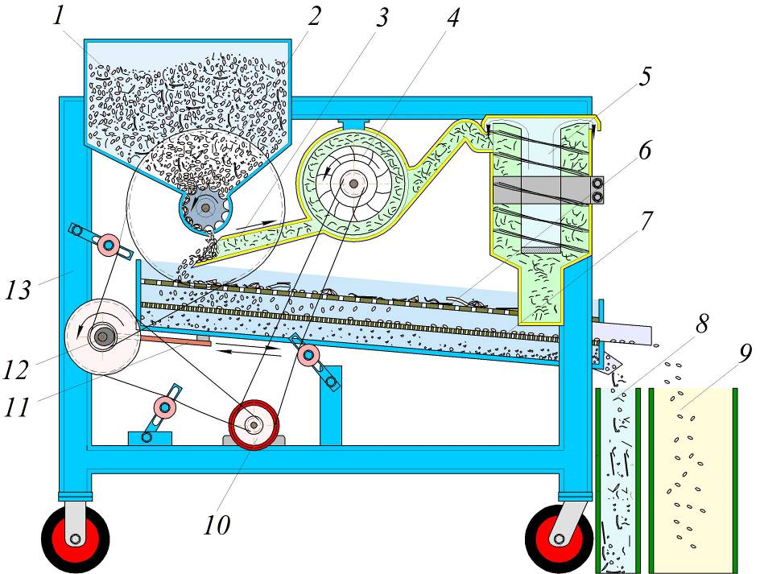
FIGURE 1. Technological scheme of safflower seed cleaning machine. 1–bunker; 2–supply roller; 3– suction pipe; 4–fan; 5–dust sinking device; 6–upper sieve;7–lower sieve; 8–container with foreign admixtures; 9–clean seed container; 10–electric motor; 11–a connecting rod that moves the sieve; 12–oscillating device; 13–machine framework.
The working process of the seed cleaning machine is as follows (figure 1). The cleaned seed mixture is passed through the bunker 1, and it is supplied by measuring through the supplying roller 2 to suction pipe 3 of the air aspiration part. Using the air stream generated by the fan 4 in the sucking tube, light admixtures (dust, leaves, sawdust, etc.) contained in the seed mixture are separated and transferred to the dust sinking device 5. Extinguished light admixtures fall into a bag mounted on the bottom of the extinguisher. This avoids from the dust smokes around when machine is being operated. Large and small heavy admixtures move along the sloping bottom of the sucking tube and fall to the upper sieve 6. Large admixtures in the seed mixture are retained in this sieve. The seeds pass through the holes of the sieve and fall into the lower sieve 7, where the foreign mixtures is separated, while the cleaned seeds move along the surface of the sieve 7 and fall into clean seed container 9. The foreign admixtures separated by the upper and lower sieves fall into a separate container 8. The moving parts of the machine are driven by belt drives using an electric motor 10. The rollers are actuated by means of an oscillating device 12 and its connecting rod that moves the sieve 11. It can be seen from the technological process of the machine that the foreign admixtures in the mass are separated in a combined way, i.e. first light mixtures in the air stream, then large and small admixtures in the sieves.
RESEARCH RESULTS
In order to study the process of separation of light impurities in the seed in this machine with the help of air flow, we study their movement in the zone 3 of the suction pipe.
In the process of technological work, the seed mixture moves freely after leaving the feeder and falls into the mouth of the suction pipe. Therefore, the mouth of the pipe should be placed in relation to the feeder in such a way that the upper edge of the mouth ensures that the seeds falling from the feeder do not remain outside without falling into the suction pipe, and the lower part ensures that the seeds are thrown into the head of the hopper. The action process of the seed mixture takes place in two stages. In the first stage, the seed mixture leaves the feeder with a linear speed v_{o} and moves freely to the mouth of the suction pipe (to the zone of influence of the air flow). In the second stage, the mixture enters the zone affected by the suction air flow and moves under the influence of the air flow. Let's consider the behavior of the seed mixture in both stages (figure 2).
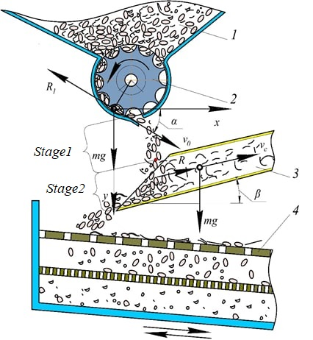
FIGURE 2. Working process of seed cleaning machine. 1–bunker; 2–supply roller; 3– suction pipe; 4–upper sieve.

Stage 1. From the hole of the supplier v_{o} A mixture of mass m ejected with a velocity m is acted upon by the force of gravity mg and ${\bar{v}}_{0}$ the force of air resistance in the direction opposite to the vector ${\bar{R}}_{1}$. This is the modulus of the force $R_{1}=mK_{w}v_{0}^{2}$ ( K_{w} - coefficient of windage of the mixture, 1/m ) of the forces acting on the mixture on the x and y axes:
$$m\ddot{x}=-R_{1x}=-mK_{w}{\dot{x}}^{2}, \\ m\ddot{y}=mg-R_{1y}=mg-mK_{w}{\dot{y}}^{2}$$
the differential equation of the motion of the mixture relative to the coordinate system x:
$$\ddot{x}=-K_{n}{\dot{x}}^{2},$$
$\ddot{y}=g-K_{n}{\dot{y}}^{2},$ (1)
where $\dot{x}=v_{x},\dot{y}=v_{y}$- projections of mixture speed on x and y axes, m/s; the angle between the $α-{\bar{v}}_{0}$vector and the x -axis , degrees ; g - acceleration of free fall , m/s²;
(1) $z=\dot{x}$entering the first equation of the system, $\dot{z}=-K_{w}z^{2}$ we arrive at the equation. $z(0)=\dot{x}(0)=v_{0}⋅\cos{α}$ taking into account the initial condition, its solution is as follows:
$\dot{x}=z=\frac{1}{K_{w}t+\frac{1}{v_{0}\cos{α}}}.$ (2)
equation (2) $x\left(o\right)=o$ with initial condition [17]:
$x=\frac{1}{K_{w}}\ln\left(K_{w}v_{0}t\cos{α}+1\right).$ (3)
by entering the designation into the $z=\dot{у}$second equation of the system, $\dot{z}=g-K_{w}z^{2}$we look for the solution of the equation.
Since gravity is greater than air resistance, the $\frac{g}{K_{w}}>{\dot{z}}^{2}$inequality holds. The general solution of the equation [17]:
(4)
$z\left(o\right)=\dot{y}\left(o\right)=v_{0y}=v_{0}\sin{α}$in the initial condition, C is equal to:
$$С=\ln{\frac{\sqrt{\frac{g}{K_{w}}}+v_{0}\sin{α}}{\sqrt{\frac{g}{K_{w}}}-v_{0}\sin{α}}}.$$
we put this expression of C into equation (4) and solve it with respect to z,
$\dot{y}=z=\sqrt{\frac{g}{K_{w}}}⋅\frac{Be^{2\sqrt{gK_{w}}t}-1}{Be^{2\sqrt{gK_{w}}t}+1}$, (5)
in this $В=\left(\sqrt{\frac{g}{K_{w}}}+v_{0}\sin{α}\right):\left(\sqrt{\frac{g}{K_{w}}}-v_{0}\sin{α}\right).$
Integrating the expression (5) and solving for the $y\left(o\right)=o$ initial condition, we get the following final result:
907352508 $у=\frac{1}{K_{w}}\ln{\frac{Be^{2\sqrt{gK_{w}}t}+1}{B+1}}-\sqrt{\frac{g}{K_{w}}}t.$ (6)
(3) and (6) are the equations of motion of the seed mixture between the nozzle and the suction pipe.
the equation (6) , it is possible to determine the time spent by the seed mixtures to pass through the gap between the supply pipe and the suction pipe. $t_{\text{thb}}$ to do this, we write (6) as follows:
$\frac{1}{K_{w}}\ln{\frac{Be^{2\sqrt{gK_{w}}t_{thb}}+1}{B+1}}-\sqrt{\frac{g}{K_{w}}}⋅t_{\text{thb}}=h_{ths}$, (7)
where $h_{ths}$is the vertical distance from the supply pipe to the suction pipe.
Equation (7) is solved using numerical methods with respect to time t_{thb .}
2nd stage . At the end of the first stage, i.e. $t=t_{\text{thb}}$from the time, the light impurities in the seeds are moved by the air flow in the suction pipe and go out, and the seeds fall into the hopper.
Equations of motion of the particle along the x and u axes:
$$m\ddot{x}=mK_{w}{\left(\dot{x}-v_{ths}\cos{β}\right)}^{2},m\ddot{y}=mg-mK_{w}{\left(\dot{y}+v_{ths}\sin{β}\right)}^{2}$$
or
$\left\{\begin{aligned}&\ddot{x}=K_{w}{\left(\dot{x}-v_{\text{ths}}\cos{β}\right)}^{2} \\ &\ddot{y}=-K_{w}{\left(\dot{y}+v_{\text{ths}}\text{sin}β\right)}^{2}+g\end{aligned}\right.$ ( 8)
where $v_{ths}$- speed of air in the suction pipe, m/s;
$β$– the angle of installation of the suction pipe relative to the horizon, degrees.
(8) to the first equation of the system$z=\dot{x}-v_{ths}\cos{β}$ $\dot{z}=\ddot{x}$ if we introduce the notations, $\dot{z}=K_{w}z^{2}$the solution is [16]:
$z=\frac{1}{С-K_{w}t}.$ (9)
C , the last condition of step 1 (2) is the initial condition of step 2, i.e. t=t_{thb} (time from mixing time to seed release time) at
$z\left(t_{\text{thb}}\right)=\dot{x}\left(t_{\text{thb}}\right)-v_{c}\cos{β}=\frac{1}{K_{w}t_{\text{thb}}+\frac{1}{v_{0}\cos{α}}}+v_{c}\cos{β}$ putting this condition in (9), we determine the integral constant C:
$С=\frac{K_{w}t_{\text{thb}}v_{0}\cos{α}+1}{v_{0}\cos{α}-\left(K_{w}t_{\text{thb}}v_{0}\cos{α}+1\right)v_{ths}\cos{β}}+K_{w}t_{\text{thb}}.$ (10)
$\dot{x}=z+v_{ths}\cos{β}$Since (9) is taken into account,
$\dot{x}=\frac{1}{\text{С}\text{-}K_{w}t}-v_{ths}\cos{β}$ (11)
The solution of this equation [16] :
$x=-\frac{1}{K_{w}}\ln\left|\text{С}\text{-}K_{w}t\right|+v_{ths}\cos{β}⋅t+C_{1}.$ (12)

From (12):
$C_{1}=x+\frac{1}{K_{w}}\ln\left|C-K_{w}t\right|+v_{ths}\cos{β}⋅t$. $x=x(t_{\text{thb}})$ at
$С_{1}=x(t_{\text{thb}})+\frac{1}{K_{w}}\ln\left|C-K_{w}t_{\text{thb}}\right|+v_{ths}\cos{β}⋅t_{\text{thb}}.$ (13)
according to (3) $x\left(t_{\text{thb}}\right)=\frac{1}{K_{w}}\ln\left(K_{w}v_{0}t_{\text{thb}}\cos{α}+1\right)$, we get after certain operations:
$С_{1}=\frac{1}{K_{w}}\ln{\frac{{\left(K_{w}t_{\text{thb}}v_{0}\cos{α}+1\right)}^{2}}{\left|v_{0}\cos{α}-\left(K_{w}t_{\text{thb}}v_{0}\cos{α}+1\right)v_{ths}\cos{β}\right|}}-v_{ths}t_{\text{thb}}\cos{β}$ (14)
C and C₁ according to (10) and (12), the equation of motion of the particle of the mixture along the x axis is derived:
$$x=\frac{1}{K_{w}}\ln{\frac{{\left(K_{w}t_{\text{thb}}v_{0}\cos{α}+1\right)}^{2}}{\left|\left(K_{w}t_{\text{thb}}v_{0}\cos{α}+1\right)-K_{w}\left(t-t_{\text{thb}}\right)\left[v_{0}\cos{α}-\left(K_{w}t_{\text{thb}}v_{0}\cos{α}+1\right)v_{c}\cos{β}\right]\right|}}+$$$+v_{ths}\left(t-t_{\text{thb}}\right)\cos{β}.$ (15)
(8) we enter the designation in the second equation of the system $z=\dot{y}+v_{c}\sin{β}$. In this $\dot{z}=\ddot{y}$. So, $\dot{z}=g-K_{w}z^{2}.$ the general solution of this equation is [16]:
$\ln{\frac{\sqrt{\frac{g}{K_{w}}}+z}{\sqrt{\frac{g}{K_{w}}}-z}}=2t\sqrt{gK_{w}}+C.$
$z\left(t_{\text{thb}}\right)=\dot{y}\left(t_{\text{thb}}\right)+v_{ths}\sin{β}$we find the integral constant C using the initial condition:
$С=\ln{\frac{\sqrt{\frac{g}{K_{w}}}+z\left(t_{\text{thb}}\right)}{\sqrt{\frac{g}{K_{w}}}-z\left(t_{\text{thb}}\right)}}-2t_{thb}\sqrt{gK_{w}}.$ (16)
$z\left(t_{\text{thb}}\right)=\dot{y}\left(t_{\text{thb}}\right)+v_{c}\sin{β}$we put the expression according to (5) into the equation:$\dot{y}\left(t_{ч}\right)$
$z\left(t_{\text{thb}}\right)=\sqrt{\frac{g}{K_{w}}}⋅\frac{Be^{2t_{\text{thb}}\sqrt{gK_{w}}}-1}{Be^{2t_{\text{thb}}\sqrt{gK_{w}}}+1}+v_{ths}\sin{β}.$ (17)
$z\left(t_{\text{thb}}\right)$putting this expression of in (16) we write:
$$С=\ln{\frac{\left(2\sqrt{\frac{g}{K_{w}}}Be^{2t_{\text{thb}}\sqrt{gK_{w}}}\right):\left(Be^{2t_{\text{thb}}\sqrt{gK_{w}}}+1\right)+v_{ths}\sin{β}}{2\sqrt{\frac{g}{K_{w}}}:\left(Be^{2t_{\text{thb}}\sqrt{gK_{w}}}+1\right)-v_{ths}\sin{β}}}-2t_{\text{thb}}\sqrt{gK_{w}}.$$
given the expression
$\dot{y}=\frac{\sqrt{\frac{g}{K_{w}}}\left(e^{2\sqrt{gK_{w}}t+C}-1\right)}{e^{2\sqrt{gK_{w}}t+C}+1}-v_{ths}\sin{β}.$ (18)
$y\left(t_{\text{thb}}\right)=\frac{1}{K_{w}}\ln{\frac{Be^{2\sqrt{gK_{w}}t_{\text{thb}}}+1}{B+1}}-t_{\text{thb}}\sqrt{\frac{g}{K_{w}}}$taking into account the initial condition, the solution of the equation (18) or the equation of the movement of the particle along the y axis is in the following form [16]:
$y=\frac{1}{K_{w}}\ln\left(e^{2\sqrt{gK_{w}}t+C}+1\right)-t\sqrt{\frac{g}{K_{w}}}-v_{ths}t\sin{β}-C_{1}.$ (19)
in this$С_{1}=\frac{1}{K_{w}}\ln{\frac{\left(e^{2\sqrt{gK_{w}}t_{\text{thb}}+C}+1\right)\left(B+1\right)}{Be^{2\sqrt{gK_{w}}t_{\text{thb}}}+1}}-v_{ths}t_{\text{thb}}\sin{β}.$
the coefficients of parousness K_{p} , v₀ , v_{ths} setting the values of velocities and angles α, β until reaching the suction zone of the mixture and trajectories of movement in the suction zone were constructed (figure 3). Here, the symbol 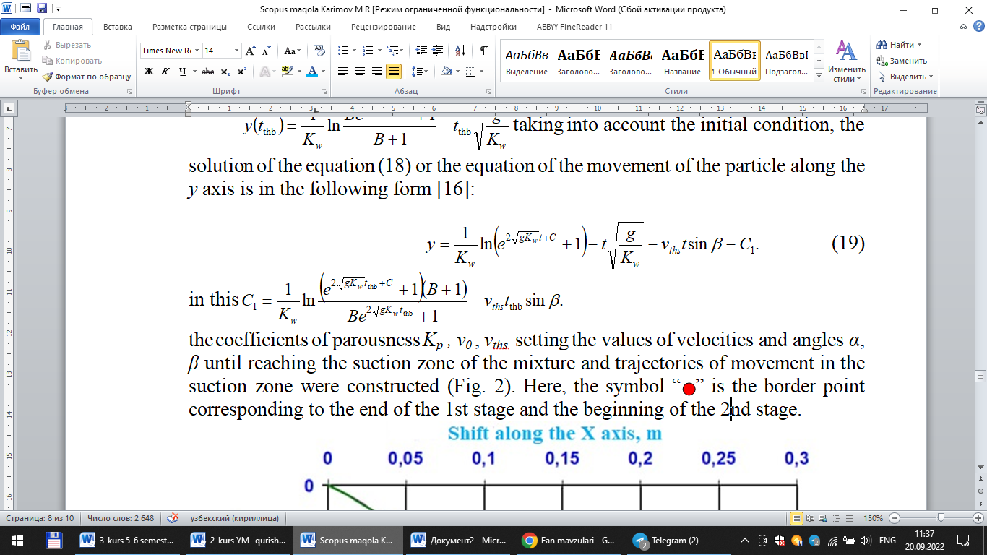is the border point corresponding to the end of the 1st stage and the beginning of the 2nd stage.
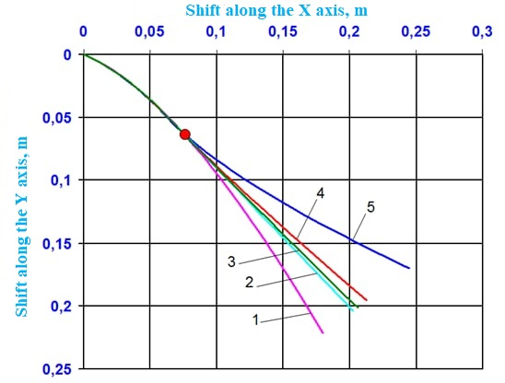
FIGURE 3. Movement trajectories of the seed and its impurities from the feeder until it reaches the absorption area and in the absorption area. 1 – seed; 2 – stem piece; 3 – seed basket; 4 – white seed;5 – light mixtures.
CONCLUSIONS
Based on the theoretical studies of the investigated type of working element of temporary irrigation dam compactors, the following main conclusions can be drawn:
With a soil loosening coefficient equal to one during the cutting of temporary irrigation channels, analytical relationships have been derived between the volume of soil removed by the trenching machine and the volume of soil placed in the dam ridge.
Dependencies have been obtained whereby, given the soil cutting depth by the trenching machine, knowing the soil’s natural slope angle and the soil loosening coefficient, it is possible to calculate the main dimensions of the temporary irrigation dam, and from them-the overall dimensions of the dam compactor being developed.
The conditions for compaction have been defined-compaction without sloughing is achieved when the angle formed between the velocity vector of the compacting surface movement and the vector of normal pressure is less than the soil’s external friction angle, which completely eliminates bulging. This condition is met when using a rolling working element.
References
- K. Stanford, G. L. Wallins, B. M. Lees, and H. H. Mundel, “Title not specified,” Canadian Journal of Animal Science 81(2), 289–292 (2001).
- J. W. Bergman, N. R. Riveland, C. R. Flynn, D. M. Wichman, and G. R. Carlson, “Title not specified,” Crop Science 41(5), 1640 (2001).
- Yo. Karimov and M. Karimov, “Study of physical and mechanical properties of safflower seed,” in Problems of Implementation of Innovative Ideas, Technologies and Projects, Proceedings of the Republican Scientific and Technical Conference (Jizzakh, 2014), pp. 326–329.
- K. Astanakulov and M. Karimov, “Physico-mechanical properties of sunflower seeds,” in The Country that Amir Temur Prospered, Proceedings of the Republican Scientific-Practical Conference (Book Economy and Service KCK, May 20–21, 2016), pp. 29–30.
- K. Astanakulov, “Determination of physico-mechanical and weeding properties of soybean and its grain,” Agro Ilm (Special Issue), 53–54 (2018).
- I. E. Kozhukhovsky, Grain Cleaning Machines (Mashinostroenie, Moscow, 1974), 200 p. (in Russian).
- K. D. Astanakulov, M. R. Karimov, O. Sh. Ochildiev, and Yo. Z. Karimov, Grain Cleaning Machine, Uzbekistan Patent No. FAP 01127 (Official Notice, No. 9, 2016).
- K. D. Astanakulov, M. R. Karimov, O. Sh. Ochildiev, Yo. Z. Karimov, and A. Dj. Kurbanov, Grain Cleaning Machine, Uzbekistan Patent No. FAP 01209 (Official Notice, No. 7, 2017).
- A. A. Imandar and D. S. Suresh, “Title not specified,” International Food Research Journal 21(6), 2083–2083 (2014).
- Z. Krzysiak, “Title not specified,” Transactions of the ASABE 60(5), 1751–1758 (2017).
- O. Toshbekov, M. Urozov, F. Sultonova, S. Raximqulova, Z. Mustanova, and G. Xulkaliyeva, “Analysis of the thermal conductivity of nonwoven fabrics made from silkworm cocoons and their influence on ambient temperature,” AIP Conference Proceedings 3331, 050005 (2025). https://doi.org/10.1063/5.0306845
- J. Paliwal, D. Jayas, N. Visen, and N. White, “Title not specified,” Applied Engineering in Agriculture 20(2), 245–248 (2004).
- X. P. Li, J. L. Zhang, and J. J. Tao, “Title not specified,” Applied Engineering in Agriculture 35(2), 193–201 (2019).
- C. Lee, “Agricultural mechanization in Asia, Africa and Latin America,” Agricultural Mechanization in Asia, Africa and Latin America 42(4), 41–47 (2011).
- C. Lee, “Agricultural mechanization in Asia, Africa and Latin America,” Agricultural Mechanization in Asia, Africa and Latin America 42(4), 48–53 (2011).
- O. Toshbekov, M. Urozov, S. Yermatov, and M. Khamraeva, “Efficient and economical energy use technology in the processing of domestic coarse wool fiber,” E3S Web of Conferences 461, 01068 (2023). https://doi.org/10.1051/e3sconf/202346101068
- K. Jumaniyozov, M. Urozov, O. Toshbekov, M. Salimova, K. Raximova, and B. Khursandova, “Enhancement of energy-efficient cleaning equipment,” AIP Conference Proceedings 3331, 050007 (2025). https://doi.org/10.1063/5.0307149
- F. Sultonova, O. Toshbekov, M. Urozov, N. Boymurova, Z. Mustanova, and I. Boltaeva, “Enhancing and evaluating the characteristics of specialized workwear for employees in the electric power supply sector,” AIP Conference Proceedings 3331, 050006 (2025). https://doi.org/10.1063/5.0306350
- A. I. Kobzar, Applied Mathematical Statistics for Engineers and Scientists (Fizmatlit, Moscow, 2006), 816 p. (in Russian).
- E. Kamke, Reference Book on Ordinary Differential Equations (Nauka, Moscow, 1971), 576 p. (in Russian).
- I. I. Lyashko, A. K. Boyarchuk, Ya. G. Gai, and G. P. Golovach, Reference Manual for Mathematical Analysis: Introduction to Analysis, Derivative, Integral (Higher Education School, Kyiv, 1984), 456 p. (in Russian).
- A. U. Abdukholikov and M. R. Karimov, “Working out and implementation of the safflower cleaning machine,” in Problems and Solutions of Cargo and Passenger Transportation in the South of the Republic, Proceedings of the Republican Scientific and Scientific-Technical Conference (Termiz State University of Engineering and Agro-Technology, October 25–26, 2024), pp. 314–318.
- N. Safarov, R. Yangiboev, H. Bo‘riyev, B. Karshiev, O. Gulboyev, F. Narzullayev, and A. Qurbonov, “Study of the influence of main factors on the mass and density of saw fiber separator raw material,” AIP Conference Proceedings 3268, 020033 (2025). https://doi.org/10.1063/5.0257374
- Mahmutkhonov S., Baizhonova L., Mustayev R., Tashmatova S. Dynamic analysis of voltage-ampere characteristics and harmonic distortions in electric arc furnaces. // AIP Conference Proceedings. 3331(1), 2025. pp. 070023, 1–5. https://doi.org/10.1063/5.0305745.
- Bobojanov M., Mahmutkhonov S. Influence of the consumer to power quality at the point of connection // E3S Web of Conferences 384. 2023. РР, 01041, 1-5. https://doi.org/10.1051/e3sconf/202338401041.
- Reymov K.M., Makhmuthonov S.K., Turmanova G., Uzaqbaev Q. Optimization of electric networks modes under conditions of partial uncertainty of initial information // E3S Web of Conferences 289, 07023 (2021). -2021, pp: 1-4, https://doi.org/10.1051/e3sconf/202128907023.
- Alimov, U.K., Reimov, A.M., Namazov, Sh.S., Beglov, B.M. The insoluble part of phosphorus fertilizers, obtained by processing of phosphorites of central kyzylkum with partially ammoniated extraction phosphoric acid. Russian Journal of Applied Chemistry. Russ J Appl Chem (2010) 83(3): 545–552. https://doi.org/10.1134/S107042721030328
- Reymov, A.M., Namazov, S.S., Beglov, B.M. Effect of phosphate additives on physical-chemical properties of ammonium nitrate. Journal of Chemical Technology and Metallurgy 2013 48(4), 391-395. http://dl.uctm.edu/journal/
- Urishev, B., Fakhriddin Nosirov, and N. Ruzikulova. 2023. “Hydraulic Energy Storage of Wind Power Plants.” E3S Web of Conferences, 383. https://doi.org/10.1051/e3sconf/202338304052
- Urishev, B., S. Eshev, Fakhriddin Nosirov, and U. Kuvatov. 2024. “A Device for Reducing the Siltation of the Front Chamber of the Pumping Station in Irrigation Systems.” E3S Web of Conferences, 274. https://doi.org/10.1051/e3sconf/202127403001
- Turabdjanov, S., Sh. Dungboyev, Fakhriddin Nosirov, A. Juraev, and I. Karabaev. 2021. “Application of a Two-Axle Synchronous Generator Excitations in Small Hydropower Engineering and Wind Power Plants.” AIP Conference Proceedings. https://doi.org/10.1063/5.0130649
- L.Jing, J.Guo, T.Feng, L.Han, Z.Zhou and M.Melikuziev, "Research on Energy Optimization Scheduling Methods for Systems with Multiple Microgrids in Urban Areas," 2024 IEEE 4th International Conference on Digital Twins and Parallel Intelligence (DTPI), Wuhan, China, 2024, pp. 706-711, https://ieeexplore.ieee.org/abstract/document/10778839
- Baratov, B.N., Umarov, F.Y., Toshov, Z.H. Tricone drill bit performance evaluation. Gornyi Zhurnal, Moscow, 2021. - № 12. - PP. 60-63. DOI:10.17580/gzh.2021.12.11.
- Toshov, J.B., Toshov, B.R., Baratov, B.N., Haqberdiyev, A.L. Designing new generation drill bits with optimal axial eccentricity | Вопросы проектирования буровых долот нового поколения с оптимальным межосевым эксцентриситетом // Mining Informational and Analytical Bulletin, 2022, (9). - PP. 133–142. DOI: 10.25018/0236_1493_2022_9_0_133
- Toshov J., Makhmudov A., Kurbonov O., Arzikulov G., Makhmudova G. Development and Substantiation of Energy-Saving Methods for Controlling the Modes of Operation of Centrifugal Pumping Units in Complicated Operating Conditions. Proceedings of the 11th International Conference on Applied Innovations in IT, (ICAIIT), November 2023, Koethen, Germany. – РР. 161-165.
- J.B. Toshov, K.T. Sherov, B.N. Absadykov, R.U. Djuraev, M.R. Sikhimbayev, Efficiency of drilling wells with air purge based on the use of a vortex tube. NEWS of the National Academy of Sciences of the Republic of Kazakhstan “Series of geology and technical sciences”. – Almaty, Volume 4, Number 460 (2023), 225–235. https://doi.org/10.32014/2023.2518-170X.331
Toshov J., Toshov B., Bainazov U., Elemonov M. Application of Cycle-Flow Technology in Coal Mines. Proceedings of the 11th International Conference on Applied Innovations in IT, (ICAIIT), March 2023, Koethen, Germany. – РР. 279-284.
- Usmanov, E., Kholikhmatov, B., Rikhsitillaev, B., Nimatov, K. Device for reducing asymmetry // E3s Web of Conferences 461. 2023. PP, 01052, 1-5. https://doi.org/10.1051/e3sconf/202346101052
- Toshov B., Toshov J., Akhmedova L., Baratov B. The new design scheme of drilling rock cutting tools, working in rotation mode pairs. E3S Web of Conferences 383, 04069 (2023) TT21C-2023 https://doi.org/10.1051/e3sconf/202338304069
- J.B. Toshev, M.B. Norkulov, A.A. Urazimbetova and L.G. Toshniyozov. Optimization of scheme of placing cutting structures on the cone drill bit. E3S Web of Conf., Volume 402, 10039 (2023), International Scientific Siberian Transport Forum - TransSiberia 2023, https://doi.org/10.1051/e3sconf/202340210039
- Toshov J., Baratov B., Sherov K., Mussayev M., Baymirzaev B., Esirkepov A., Ismailov G., Abdugaliyeva G., Burieva J. Ways to Optimize the Kinetic Parameters of Tricone Drill Bits. Material and Mechanical Engineering Technology, №1, 2024, 35-45. https://doi.org/10.52209/2706-977X_2024_1_35
- K.T. Sherov, N.Zh. Karsakova, B.N. Absadykov, J.B. Toshov, M.R. Sikhimbayev, Studying the effect of the boring bar amplitude-frequency characteristics on the accuracy of machining a large-sized part. NEWS of the National Academy of Sciences of the Republic of Kazakhstan “SERIES OF GEOLOGY AND TECHNICAL SCIENCES”. – Almaty, Volume 2, Number 464 (2024), 217–227. https://doi.org/10.32014/2024.2518-170X.405
- J. Toshov, L. Atakulov, G. Arzikulov, U. Baynazov, Modeling of optimal operating conditions of cyclic-flow technologies with a belt conveyor at coal mine under the "ANSYS" program. AIP Conf. Proc. 3152, 020006 (2024) / III International Scientific and Technical Conference “Actual issues of Power supply systems” (ICAIPSS2023), 7–8 September 2023, Tashkent, Uzbekistan. https://doi.org/10.1063/5.0218904
- Kholikhmatov B.B., Samiev Sh.S., Erejepov M.T., Nematov L.A. Modelling of laboratory work in the science "Fundamentals of power supply" using an educational simulator based on a programmed logic controller // E3S Web of Conferences 384. 2023. РР, 01032, 1-3. https://doi.org/10.1051/e3sconf/202338401032
- Rakhimov F, Rakhimov F, Samiev Sh, Abdukhalilov D. Justification of Technical and Economic Effectiveness of Application of 20 kV Voltage in Overhead Electric Networks //AIP Conf. Proc. 3152, 030023 (2024). https://doi.org/10.1063/5.0218921
- Taslimov A, Mo'minov V, Samiev Sh, Abdukhalilov D. Issues of Optimization of Electrical Network Parameters Medium Voltage //AIP Conf. Proc. 3331, 020007 (2025). https://doi.org/10.1063/5.0305781
- Toshbekov, O., Urazov, M., Yermatov, S., & Khamraeva, M. 2023). Yeffisient and yesonomisal yenergy use teshnology in the prosessing of domestis soarse wool fiber. In Ye3S Web of Sonferenses (Vol. 461, p. 01068). https://doi.org/10.1051/e3sconf/202346101068
- Jumaniyozov, K., Urozov, M., Toshbekov, O., Salimova, M., Raximova, K., & Khursandova, B. (2025, November). Enhancement of energy-efficient cleaning equipment. In American Institute of Physics Conference Series (Vol. 3331, No. 1, p. 050007). https://doi.org/10.1063/5.0307149
- Sultonova, F., Toshbekov, O., Urozov, M., Boymurova, N., Mustanova, Z., & Boltaeva, I. (2025, November). Enhancing and evaluating the characteristics of specialized workwear for employees in the electric power supply sector. In American Institute of Physics Conference Series (Vol. 3331, No. 1, p. 050006). https://doi.org/10.1063/5.0306350

