Improving the quality of feed by optimizing the structural and kinematic parameters of a straw crushing machine
Karimov Rustam¹, Abobakr Muratov ^{1, a)}, Komilov Azamjon¹, Boymatov Utkirbek¹, Khudaikulova Saida², Safarov Feruz³
¹ Termez State University of Engineering and Agrotechnologies, Termez, Uzbekistan.
²Termez State Pedagogical Institute, Termez, Uzbekistan.
³Denov Institute of Entrepreneurship and Pedagogy, Denov, Uzbekistan.
^{a)} Corresponding author: abubakr.muratov@mail.ru
Abstract. The article presents theoretical and experimental research results on the parameters of a semi-conical straw shredder. During operation, the straw is fed to the knife through a chute and guide. The incoming straw is cut by a counter-knife and then shredded within the body or shredding chamber with the help of the knife and counter-knives. The flat rotor knife captures the straw entering the shredding chamber, directs it toward the counter-knife, and it is cut between them. During shredding, the straw undergoes bending, tearing, and cutting. The shredded straw moves toward the outlet funnel under the influence of the airflow generated by the rotation of the flat rotor knife, exiting and forming a pile. The study examines the rotation frequency of the shredding drum, the diameters of the drum, the shape of the knives, the number of knives on the flat disk of the drum, the inclination angle of the cutting edge, the sharpness angle, and both theoretical and experimental results of the shredding drum. The results of the study contribute to increasing the nutritional value of straw, reducing losses, and ensuring energy efficiency in the feed preparation process.
INTRODUCTION
Straw is one of the most widespread agricultural by-products and plays a significant role as feed in livestock production. However, its rigid structure and low digestibility limit its nutritional value for animals, making mechanical processing-such as grinding or chopping-essential to improve its digestibility and uniformity. Mini-grinders are widely used in small and medium-sized farms because they are energy-efficient, effective, and adaptable to different types of straw. The operational efficiency of a mini-grinder is directly influenced by its structural and technological parameters, including drum diameter, rotational speed, number and length of blades, and blade inclination angle. Previous studies often focused on individual parameters, while a comprehensive approach considering all factors simultaneously is necessary. The aim of this study is to determine the optimal parameters for improving straw grinding efficiency and to develop a new mini-grinder design, which will enhance feed quality and promote resource-efficient practices in livestock farming.
EXPERIMENTAL RESEARCH
The quality of feed prepared from straw can be improved by optimizing the grinding process, i.e., cutting straw in feed preparation machines. This enhancement leads to better nutritional properties of the straw, reduces losses, and conserves material resources. To ensure improved quality of straw from cereal crops, we developed a shredder with a conical working element featuring a backward-inclined blade [1, 4, 6-40].
According to researchers, the material is primarily destroyed by the cutting edge of the blade, while the bevel surfaces of the edge perform a secondary, sometimes even detrimental, role by pushing apart the cut straw. At the same time, some studies have demonstrated the significant role of the bevel in the process of cutting straw with a knife, which makes this process similar to wood cutting using a chisel.
To date, drum-type and hammer-type impact-abrasive shredders have been studied. However, the blade inclination angle of the working element in a straw shredder performing an oblique cutting action has not yet been investigated.
As is known, the cutting speed of the knife is necessary, and consequently the power, to ensure sliding cutting at the moment of cutting cereal crop stems [2, 7, 8]. Since the sliding of straw along the blade at the moment of cutting is largely determined by the angle ($β$) of the knife blade relative to the radius of the working element, let us consider the dependence of the cutting process on the value of this angle (Fig. 1).

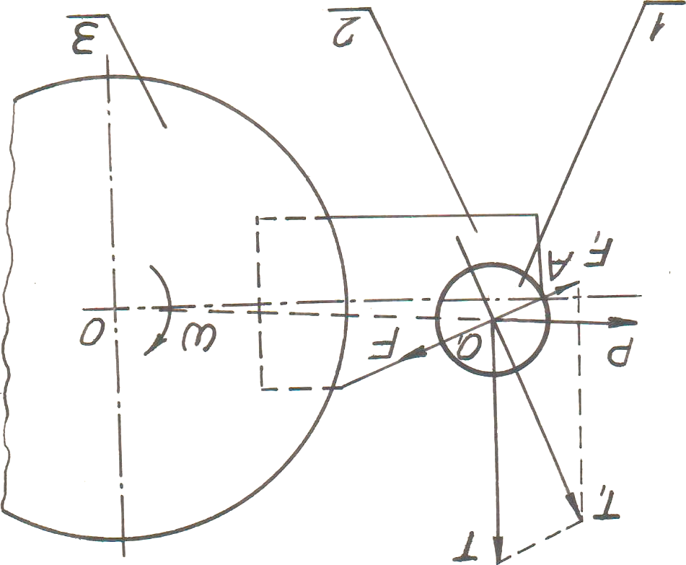
FIGURE 1. Diagram for determining the inclination angle of the knife blade of the working element. 1 – straw, 2 – knife, 3 – rotor.

The straw is subjected to centrifugal force:
$P=\frac{m*V^{2}}{R}$ (1)
where: $m$– mass of the cut part of the straw, reduced to the cutting plane, g; $V-$tangential (circumferential) speed of the straw in the cutting plane, m/s; $R-$distance from the straw axis to the axis of rotation of the working organ, m.
Using the cone theorem, from $∆ОО_{1}А$ we find:
$R=\sqrt{R_{p}+\frac{d_{cм}^{2}}{4}*\cos^{2}∝_{н}-R_{p}*d_{cm}*cos∝_{н}*сosβ}$ (2)
where: $R_{p}-$ rotor radius, mm; $d_{cм}$- diameter of the straw, m; $∝_{н}-$ angle of straw feed, degrees.
After transformation, we obtain
$P=\frac{m*V^{2}}{\sqrt{R_{p}+\frac{d_{cm}^{2}}{4}*\cos^{2}∝_{н}-R_{p}*d_{cm}*cos∝_{н}*сosβ}}$. (3)
And so, the inertia force
$T=ma$, (4)
where $a$ is the tangential component of the straw’s acceleration in the cutting plane, m/s².
According to the accepted assumption
$a=\frac{V}{∆t}$ (5)
At the same time, the sliding of the straw along the knife blade is resisted by the force of friction.
$F=f*N$, (6)
where f-is the coefficient of friction of the straw on the blade, and N- is the normal pressure of the straw on the blades, in newtons (N).
Since at high peripheral speeds of the knife the bending of the straw is small, its elastic resistance is also negligible, and we will not take it into account [3, 9, 10].
Then, according to the above assumption, we determine the condition for the straw to slide along the knife. In this case, the sum of the projections of all forces responsible for cutting the straw must be greater than the friction force [11, 12, 13]. For a blade with a backward inclination, this condition is expressed by an inequality.
$\frac{mV}{∆t}*sinβ+\frac{2mV^{2}}{\sqrt{4R_{p}^{2}+d_{cм}^{2}*\cos^{2}∝_{н}-4R_{p}*d_{cм}*cos∝_{н}*соsβ}}>f(\frac{mV}{∆t}*cosβ-\frac{2mV^{2}}{\sqrt{4R_{p}^{2}+d_{cм}^{2}*\cos^{2}∝_{н }-4R_{p}*d_{cm}*cos∝_{н }*сosβ}}$ (7)
After the transformations, we obtain:
$\frac{1}{4}*d_{cм}^{2}*\cos^{2}∝_{н}-R_{p}*d_{cm}*cosβ*cos∝_{н}$+$R_{p}^{2}-∆t^{2}*V^{2}*ctg(β-V)<0$ (8)
We denote $x_{1}$=$∆tV-$the displacement of the straw during the cutting process, in mm.
Then, solving inequality (8) with respect to $β$, we obtain:
$β<-arcctg\frac{\sqrt{d_{cм}^{2}*\cos^{2}∝_{н}-4R_{p}*d_{cм}*coβ*cos∝_{н }+4R_{p}^{2}}}{2X_{1}}$ (9)
Expression (9) defines the dependence of the blade inclination angle ($β$) of the working organ knife of the straw chopper on other factors during the straw cutting process [4]. Calculations show that for $R_{p}$=0,13...0,19 m, $X_{1}$= 0,5...2 mm, $φ=$24...${30}^{0}$, $∝_{н}=0…{20}^{0},$ $d_{cм}=$3...7 mm the inclination angle of the chopper knife blade lies within $β$ =0...${38}^{0}$.
Based on the theoretical research, a straw chopper with a semi-conical working organ was developed (Fig. 2).
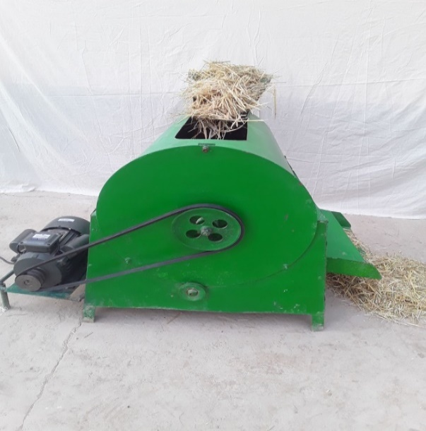
FIGURE 2. Straw chopper with a semi-conical working organ
RESEARCH RESULTS
From this, the rotation frequency of the chopping drum, the drum diameter, and other parameters were studied. The results of the experimental research showed that increasing the rotation frequency of the chopping drum from 500 rad/min to 900 rad/min, with intervals of 100 rad/min, affects the quality of straw chopping (Table 1).
The following parameters were adopted: diameter of the chopping drum – 550 mm; number of knives on the disk – 3; knife length – 100 mm; knife blade tilt angle – 38°; and knife sharpness angle.
According to zootechnical requirements, the fractions of chopped straw should be as follows: straw length up to 30 mm – 10%, straw length 30–50 mm – 80%, and straw length over 50 mm – 10%.
When the rotation frequency of the chopping drum was increased to 800 rad/min, the fraction of straw up to 30 mm increased by 1.8%, then decreased to 0.7%. For straw of 30–50 mm, the chopping quality increased by 3.3% and later decreased to 0.6%. For straw longer than 50 mm, the chopping quality decreased by 4% and then increased to 0.4%.
TABLE 1. The effect of the quality of shredding straw on the frequency of rotation of the shredding drum
Chopped straw fraction | Rotational speed of the grinding drum, rad/min
Chopped straw fraction | 500 | 600 | 700 | 800 | 900
Length of straw up to 30 mm (%) | 6,3 | 6,7 | 7,1 | 8,1 | 7,4
Length of straw 30–50 mm (%) | 82,4 | 83,2 | 84,5 | 85,7 | 85,1
Length of straw over 50 mm (%) | 7,8 | 6,5 | 5,2 | 3,8 | 4,2

Thus, the optimal rotational speed of the grinding drum is 800 rad/min. It can be seen that with an increase in the drum diameter from 400 mm to 600 mm with an interval of 50 mm, the quality of straw grinding changes (Table 2).
At this, the adopted rotational speed of the grinding drum is 800 rad/min. For a drum diameter of 500 mm and straw length up to 30 mm, the grinding quality of straw decreased by 0.6%, then increased up to 1.2%. Also, for a drum diameter of 550 mm and straw length of 30–50 mm, the grinding quality increased up to 5.3%, then decreased by 1.2%. Additionally, for a drum diameter of 600 mm and straw length over 50 mm, the grinding quality decreased by 2.9%.

TABLE 2. The dependence of the quality of shredding straw on the diameter of the shredding drum
Chopped straw fraction | Diameter of the grinding drum, mm
Chopped straw fraction | 400 | 450 | 500 | 550 | 600
Length of straw up to 30 mm (%) | 7,5 | 7,2 | 6,9 | 7,3 | 8,1
Length of straw 30–50 mm (%) | 78,5 | 80,3 | 82,3 | 83,8 | 81,3
Length of straw over 50 mm (%) | 7,5 | 7,1 | 6,4 | 4,9 | 4,6

Thus, the optimal diameter of the grinding drum is 550 mm. It can be seen that as the diameter of the grinding drum increases from 400 mm to 600 mm in increments of 50 mm, the quality of straw grinding changes (Table 3). For these tests, the rotational speed of the grinding drum was set at 800 rad/min. With a drum diameter of 500 mm and straw length of 30 mm, the grinding quality initially decreased by 0.6% and then increased to 1.2%. With a drum diameter of 550 mm and straw length of 30–50 mm, the grinding quality increased up to 5.3% and then decreased by 1.2%. With a drum diameter of 600 mm and straw length greater than 50 mm, the grinding quality decreased by 2.9%.

TABLE 3. The dependence of the quality of shredding straw on the diameter of the shredding drum.
Chopped straw fraction | Diameter of the grinding drum, mm
Chopped straw fraction | 400 | 450 | 500 | 550 | 600
Length of straw up to 30 mm (%) | 7,5 | 7,2 | 6,9 | 7,3 | 8,1
Length of straw 30–50 mm (%) | 78,5 | 80,3 | 82,3 | 83,8 | 81,3
Length of straw over 50 mm (%) | 7,5 | 7,1 | 6,4 | 4,9 | 4,6

Thus, the optimal diameter of the grinding drum is 550 mm. It can be seen that with an increase in the number of blades on the disk from 2 to 6 with an interval of 1 blade, the quality of straw grinding changes (Table 4).
When the number of blades on the disk is 6 and the straw length is 30 mm, the quality of straw grinding decreased by 2.4%. Similarly, when the number of blades on the disk is 5 and the straw length is 30–50 mm, the quality of grinding increased by 3.0%, then decreased to 0.3%. When the number of blades on the disk is 6 and the straw length is greater than 50 mm, the grinding quality increased up to 2.6%.
TABLE 4. Dependence of straw grinding quality on the number of blades on the disks
Chopped straw fraction | Number of knives on the discs, pcs
Chopped straw fraction | 2 | 3 | 4 | 5 | 6
Length of straw up to 30 mm (%) | 4,1 | 3,6 | 3,1 | 1,9 | 1,7
Length of straw 30–50 mm (%) | 79,2 | 80,4 | 81,2 | 82,2 | 81,9
Length of straw over 50 mm (%) | 2,3 | 2,7 | 3,8 | 4,1 | 4,9

Thus, the optimal number of knives on the disks is 6. It can be seen that as the knife length increases from 70 mm to 110 mm in 10 mm increments, the quality of straw shredding changes (Table 5).

TABLE 5. Dependence of straw chopping quality on knife length
Chopped straw fraction | Knife length, mm
Chopped straw fraction | 70 | 80 | 90 | 100 | 110
Length of straw up to 30 mm (%) | 2,4 | 2,9 | 3,4 | 3,9 | 3,5
Length of straw 30–50 mm (%) | 71,4 | 74,6 | 77,1 | 79,6 | 78,4
Length of straw over 50 mm (%) | 2,7 | 3,4 | 4,1 | 4,8 | 5,3

In addition, experimental variants of knife length and a flat rotating rotor have been developed (Fig. 3).
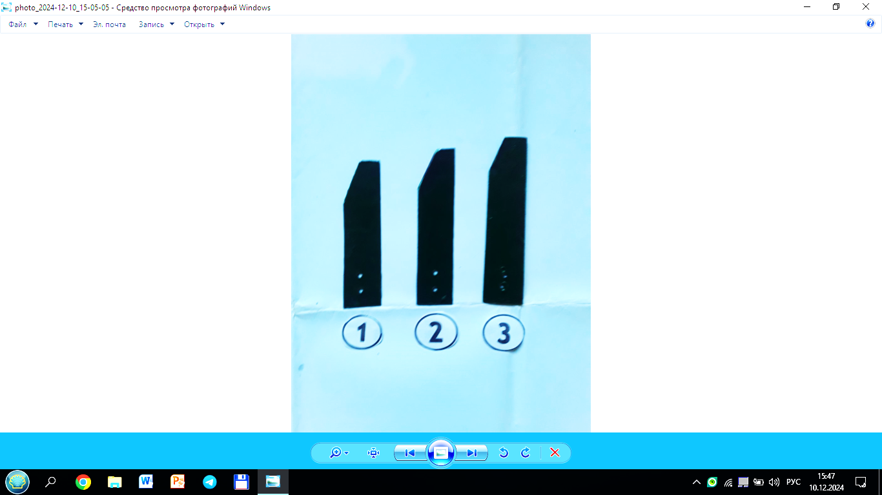 | 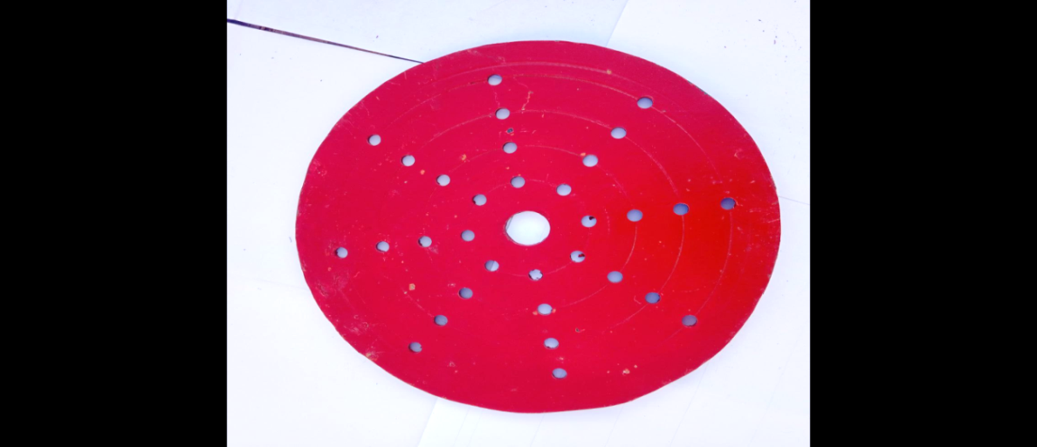
a) | b)
FIGURE 3. The main parts of a straw chopper. a) knife lengths (1) 160 mm; 2) 170 mm; 3) 180 mm); b) flat rotating rotor

The knife length of 100 mm and straw length up to 30 mm increased the chopping quality of the straw by 1.5%, then decreased by 0.4%. For straw length of 30–50 mm, the chopping quality increased by 8.2% and then decreased to 1.2%. With a knife length of 110 mm and straw length over 50 mm, the chopping quality increased up to 2.6%.
Thus, the optimal knife length is 100 mm. Next, the following design parameters were adopted: knife blade angle – 35°, spacing between the flat rotating rotors – 45–55 mm, and diameter of the flat rotating rotor – 230 mm.
CONCLUSIONS
This study focused on improving the quality of feed from cereal straw by optimizing the chopping process. A new type of straw chopper with a conical working element and a backward-angled knife was developed. It was found that the optimal knife inclination angle (β) ranges from 0° to 38°, and that the drum diameter, rotational speed, number of knives, and knife length significantly affect the quality of straw chopping.
Experimental results showed that the optimal technological parameters are: drum diameter – 550 mm, rotational speed – 800 rad/min, number of knives – 6, and knife length – 100 mm. These parameters allow more than 80% of straw to be chopped into the 30–50 mm fraction, which meets zootechnical requirements for feed preparation.
The study demonstrated that the new chopper design reduces energy consumption, minimizes losses, and increases efficiency in feed preparation. Moreover, controlling the straw fraction and knife parameters helps maintain the nutritional value of the feed at a high level.
REFERENCES
- Rustam R. Karimov, Ilkhom E. Abdullaev, Shavkat S. Ishmuratov, and Ryziboy D. Ergashev. Researching the work of mini – grinder for rough fodder. International Journal of Advanced Research in Science. Engineering and technology. Vol. 6, Issue 4, April 2019.- pp 8658-8662.
- Krasikov, D. Y. (2004). Enhancement of the performance of a mobile straw-chopper-spreader from windrows by improving its working units [Doctoral dissertation abstract, Cand. Tech. Sci., Specialty 05.20.01: Technology and Tools of Agricultural Mechanization, Kirov]. 16 pp.
- Karimov, R. R., Kholmurodov, M. Kh., Toshpulotov, T. M., & Avazov, Zh. D. (2011). Investigation of the blade inclination angle of the working element of a mini-grinder for rough fodder. Reports of the Academy of Sciences of the Republic of Uzbekistan, (5), 51–53.
- Karimov, R. R., Turaev, B. B., Tulaganov, A. A., & Avazov, Zh. D. (2010). Determination of cutting force for stem fodder. Problems of Mechanics, (4), 42–44.
- Smirnov, N. N. (2002). Justification of parameters and operating modes of a technical device for picking up and grinding straw from windrows [Doctoral dissertation abstract, Technology and Means of Agriculture]. Moscow, Russia. 22 pp.
- Makhnev, E. L. (2000). Improvement of the design and optimization of parameters of the hammer straw grinder-spreader from windrows [Doctoral dissertation]. Kirov, Russia. 202 pp.
- Trubilin, E. I. (1996). Mechanics-technological justification and development of energy-saving technology for using straw as fertilizer [Doctoral dissertation abstract, Doctor of Technical Sciences]. Zernograd, Russia. 52 pp.
- Voloshin, N. I., & Maslov, G. G. (n.d.). Apparatus for grinding and transporting straw. Retrieved from https://findpatent.ru/patent/209/2093009
- Sokolov, N. V., Kryazhevskikh, V. L., & Efremov, Yu. A. (1999). Straw pick-up and grinder. Information Sheet, No. 74-99, Kirov, 3 pp.
- Smirnov, N. N. (2000). Trailed straw grinder from windrows. Information Sheet, No. 21-00, Yoshkar-Ola, 3 pp.
- Muratov, A., & Kuziev, A. (2025, February). Improving the efficiency of cargo delivery by automobile vehicles. In AIP Conference Proceedings (Vol. 3268, No. 1, p. 050017). AIP Publishing LLC. https://doi.org/10.1063/5.0258347
- Antamoshkin, O. A., Tsyganko, E. N., Astanakulov, K. D., Akhmadaliev, Sh. Sh., & Muratov, A. Kh. (2025). Prospects of underground gasification for coal mine stock improvement. Ugol, 1194(6), 114–118. https://www.ugolinfo.ru/artpdf/RU2506114.pdf
- Kuziev, A., Muratov, A., Suyunov, O., Mardonov, S., & Samatova, B. (2025, February). Clark-Wright algorithm in routing small-batch cargo transportation. In AIP Conference Proceedings (Vol. 3268, No. 1, p. 050016). AIP Publishing LLC. https://doi.org/10.1063/5.0258390
- Jumaniyozov, K., Urozov, M., Toshbekov, O., Salimova, M., Raximova, K., & Khursandova, B. (2025, November). Enhancement of energy-efficient cleaning equipment. In American Institute of Physics Conference Series (Vol. 3331, No. 1, p. 050007). https://doi.org/10.1063/5.0307149
- Sultonova, F., Toshbekov, O., Urozov, M., Boymurova, N., Mustanova, Z., & Boltaeva, I. (2025, November). Enhancing and evaluating the characteristics of specialized workwear for employees in the electric power supply sector. In American Institute of Physics Conference Series (Vol. 3331, No. 1, p. 050006). https://doi.org/10.1063/5.0306350
- Safarov, N., Yangiboev, R., Bo‘riyev, H., Karshiev, B., Gulboyev, O., Narzullayev, F., & Qurbonov, A. (2025, February). Study of the influence of main factors on the mass and density of saw fiber separator raw material. In AIP Conference Proceedings (Vol. 3268, No. 1, p. 020033). AIP Publishing LLC. https://doi.org/10.1063/5.0257374
- Mahmutkhonov S., Baizhonova L., Mustayev R., Tashmatova S. Dynamic analysis of voltage-ampere characteristics and harmonic distortions in electric arc furnaces. // AIP Conference Proceedings. 3331(1), 2025. pp. 070023, 1–5. https://doi.org/10.1063/5.0305745.
- Bobojanov M., Mahmutkhonov S. Influence of the consumer to power quality at the point of connection // E3S Web of Conferences 384. 2023. РР, 01041, 1-5. https://doi.org/10.1051/e3sconf/202338401041.
- Reymov K.M., Makhmuthonov S.K., Turmanova G., Uzaqbaev Q. Optimization of electric networks modes under conditions of partial uncertainty of initial information // E3S Web of Conferences 289, 07023 (2021). -2021, pp: 1-4, https://doi.org/10.1051/e3sconf/202128907023.
- Alimov, U.K., Reimov, A.M., Namazov, Sh.S., Beglov, B.M. The insoluble part of phosphorus fertilizers, obtained by processing of phosphorites of central kyzylkum with partially ammoniated extraction phosphoric acid. Russian Journal of Applied Chemistry. Russ J Appl Chem (2010) 83(3): 545–552. https://doi.org/10.1134/S107042721030328
- Urishev, B., Fakhriddin Nosirov, and N. Ruzikulova. 2023. “Hydraulic Energy Storage of Wind Power Plants.” E3S Web of Conferences, 383. https://doi.org/10.1051/e3sconf/202338304052
- Urishev, B., S. Eshev, Fakhriddin Nosirov, and U. Kuvatov. 2024. “A Device for Reducing the Siltation of the Front Chamber of the Pumping Station in Irrigation Systems.” E3S Web of Conferences, 274. https://doi.org/10.1051/e3sconf/202127403001
- Turabdjanov, S., Sh. Dungboyev, Fakhriddin Nosirov, A. Juraev, and I. Karabaev. 2021. “Application of a Two-Axle Synchronous Generator Excitations in Small Hydropower Engineering and Wind Power Plants.” AIP Conference Proceedings. https://doi.org/10.1063/5.0130649
- L.Jing, J.Guo, T.Feng, L.Han, Z.Zhou and M.Melikuziev, "Research on Energy Optimization Scheduling Methods for Systems with Multiple Microgrids in Urban Areas," 2024 IEEE 4th International Conference on Digital Twins and Parallel Intelligence (DTPI), Wuhan, China, 2024, pp. 706-711, https://ieeexplore.ieee.org/abstract/document/10778839
- Baratov, B.N., Umarov, F.Y., Toshov, Z.H. Tricone drill bit performance evaluation. Gornyi Zhurnal, Moscow, 2021. - № 12. - PP. 60-63. DOI:10.17580/gzh.2021.12.11.
- Toshov, J.B., Toshov, B.R., Baratov, B.N., Haqberdiyev, A.L. Designing new generation drill bits with optimal axial eccentricity | Вопросы проектирования буровых долот нового поколения с оптимальным межосевым эксцентриситетом // Mining Informational and Analytical Bulletin, 2022, (9). - PP. 133–142. DOI: 10.25018/0236_1493_2022_9_0_133
- Toshov J., Makhmudov A., Kurbonov O., Arzikulov G., Makhmudova G. Development and Substantiation of Energy-Saving Methods for Controlling the Modes of Operation of Centrifugal Pumping Units in Complicated Operating Conditions. Proceedings of the 11th International Conference on Applied Innovations in IT, (ICAIIT), November 2023, Koethen, Germany. – РР. 161-165.
- J.B. Toshov, K.T. Sherov, B.N. Absadykov, R.U. Djuraev, M.R. Sikhimbayev, Efficiency of drilling wells with air purge based on the use of a vortex tube. NEWS of the National Academy of Sciences of the Republic of Kazakhstan “Series of geology and technical sciences”. – Almaty, Volume 4, Number 460 (2023), 225–235. https://doi.org/10.32014/2023.2518-170X.331
Toshov J., Toshov B., Bainazov U., Elemonov M. Application of Cycle-Flow Technology in Coal Mines. Proceedings of the 11th International Conference on Applied Innovations in IT, (ICAIIT), March 2023, Koethen, Germany. – РР. 279-284.
- Usmanov, E., Kholikhmatov, B., Rikhsitillaev, B., Nimatov, K. Device for reducing asymmetry // E3s Web of Conferences 461. 2023. PP, 01052, 1-5. https://doi.org/10.1051/e3sconf/202346101052
- Toshov B., Toshov J., Akhmedova L., Baratov B. The new design scheme of drilling rock cutting tools, working in rotation mode pairs. E3S Web of Conferences 383, 04069 (2023) TT21C-2023 https://doi.org/10.1051/e3sconf/202338304069
- J.B. Toshev, M.B. Norkulov, A.A. Urazimbetova and L.G. Toshniyozov. Optimization of scheme of placing cutting structures on the cone drill bit. E3S Web of Conf., Volume 402, 10039 (2023), International Scientific Siberian Transport Forum - TransSiberia 2023, https://doi.org/10.1051/e3sconf/202340210039
- Toshov J., Baratov B., Sherov K., Mussayev M., Baymirzaev B., Esirkepov A., Ismailov G., Abdugaliyeva G., Burieva J. Ways to Optimize the Kinetic Parameters of Tricone Drill Bits. Material and Mechanical Engineering Technology, №1, 2024, 35-45. https://doi.org/10.52209/2706-977X_2024_1_35
- K.T. Sherov, N.Zh. Karsakova, B.N. Absadykov, J.B. Toshov, M.R. Sikhimbayev, Studying the effect of the boring bar amplitude-frequency characteristics on the accuracy of machining a large-sized part. NEWS of the National Academy of Sciences of the Republic of Kazakhstan “SERIES OF GEOLOGY AND TECHNICAL SCIENCES”. – Almaty, Volume 2, Number 464 (2024), 217–227. https://doi.org/10.32014/2024.2518-170X.405
- J. Toshov, L. Atakulov, G. Arzikulov, U. Baynazov, Modeling of optimal operating conditions of cyclic-flow technologies with a belt conveyor at coal mine under the "ANSYS" program. AIP Conf. Proc. 3152, 020006 (2024) / III International Scientific and Technical Conference “Actual issues of Power supply systems” (ICAIPSS2023), 7–8 September 2023, Tashkent, Uzbekistan. https://doi.org/10.1063/5.0218904
- Kholikhmatov B.B., Samiev Sh.S., Erejepov M.T., Nematov L.A. Modelling of laboratory work in the science "Fundamentals of power supply" using an educational simulator based on a programmed logic controller // E3S Web of Conferences 384. 2023. РР, 01032, 1-3. https://doi.org/10.1051/e3sconf/202338401032
- Rakhimov F, Rakhimov F, Samiev Sh, Abdukhalilov D. Justification of Technical and Economic Effectiveness of Application of 20 kV Voltage in Overhead Electric Networks //AIP Conf. Proc. 3152, 030023 (2024). https://doi.org/10.1063/5.0218921
- Taslimov A, Mo'minov V, Samiev Sh, Abdukhalilov D. Issues of Optimization of Electrical Network Parameters Medium Voltage //AIP Conf. Proc. 3331, 020007 (2025). https://doi.org/10.1063/5.0305781
- Toshbekov, O., Urazov, M., Yermatov, S., & Khamraeva, M. 2023). Yeffisient and yesonomisal yenergy use teshnology in the prosessing of domestis soarse wool fiber. In Ye3S Web of Sonferenses (Vol. 461, p. 01068). https://doi.org/10.1051/e3sconf/202346101068
- Jumaniyozov, K., Urozov, M., Toshbekov, O., Salimova, M., Raximova, K., & Khursandova, B. (2025, November). Enhancement of energy-efficient cleaning equipment. In American Institute of Physics Conference Series (Vol. 3331, No. 1, p. 050007). https://doi.org/10.1063/5.0307149
- Sultonova, F., Toshbekov, O., Urozov, M., Boymurova, N., Mustanova, Z., & Boltaeva, I. (2025, November). Enhancing and evaluating the characteristics of specialized workwear for employees in the electric power supply sector. In American Institute of Physics Conference Series (Vol. 3331, No. 1, p. 050006). https://doi.org/10.1063/5.0306350

