Increasing the productivity of breeds sex-marked in the egg stage as a result of selection
Otabek Oripov ^{1,a)}, Ulug‘bek Akilov¹, Murodjon Bobomuradov², Abduvahob Buriyev², Alimardon Turakulov²
¹ Silk Industry Research Institute. Tashkent, Uzbekistan.
²Termez State University of Engineering and Agrotechnologies, Termez, Uzbekistan
^{a)}Corresponding author: o.o.oripov1985@gmail.com
Abstract. In order to create 100% pure hybrids with full heterosis demonstration in silkworm breeds sex-marked in the egg stage, the process of breed selection and preparation of silkworm eggs has been simplified. The eggs of sex-marked breeds have a high viability, this indicator is from 89.9% to 96.1%, the larva viability is also high, this indicator is from 77.0% to 93.0%. The weight of cocoons of these breeds ranges from 1.43 to 1.69 g, percent cocoon shell is from 19.8% to 23.9%, they belong to the medium cocoon group. Selection of silkworm breeds marked by sex at all stages of development was carried out employing methods used in selection and breeding, as well as on movement activity. In order to improve the quality indicators of the breeds used for this purpose, selection work was carried out on the size of egg layings, eggs hatchability, larvae viability, average weight of one cocoon, weight of the cocoon shell and percent cocoon shell. As a result, new breeding systems of sex-marked breeds at the egg stage were developed that are capable of competing with existing zoned breeds.
INTRODUCTION
When hybridizing silkworms, the use of sex-marked strains at the egg stage results in the creation of 100% pure hybrids. Accordingly, eggs from sex-marked breeds are valuable and provide great benefit to silkworm production companies[1]. Sex-marked breeds and their eggs guarantee demonstration of high heterosis in viability and percent cocoon shell, and their production does not require a lot of investment[2]. Many scientific achievements in the silk industry of Uzbekistan are of global significance. Namely, significant progress has been achieved in cloning the silkworm[3], and methods have been developed for genetic modification[4], meiotic and amyotic parthenogenesis[5], androgenesis arising from two fathers was carried out[6], autotetraploids were obtained, methods for creating heterogeneous polyploidy were found[7,8], issues of using and enhancing heterosis were resolved, and genetic mechanisms of sex ratio regulation were studied[9.10], ways to obtain homozygous lines were found[11], correlations of many reproductive, productive, and technological indicators of the silkworm were studied[12], and the genetic basis for the movement of silkworm was studied[13].
The aim of the study is to increase the productivity of breeds marked by sex at the egg stage as a result of selection.
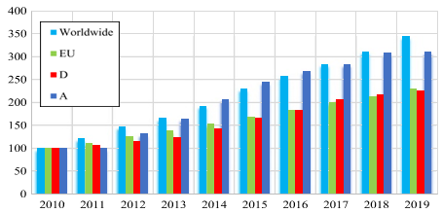
FIGURE 1. The graph of the development of installed wind energy(GW) since 2010(Indicators from left to right:Worldwide, EU, Germany, America)
EXPERIMENTAL RESEARCH
Materials and Methods. From the breeds of the world collection of the Research Institute of Sericulture, 5 breeds of silkworm with translocation of W₂W₂, W₃W₃, W₅W₅ genes on sex W-chromosome, were selected for research. According to the genetic modification of these breeds, depending on the color of the eggs, they are divided into male (light colored) and female (dark colored) sexes. These are breeds C-5, C-10, C-12, C-13, C-14. Larvae of sex-marked species are white, some are masked and half-shaped. The cocoons of the species are small with medium granularity, white in color, of various shapes - elongated-cylindrical, oval, narrowed waist or straight. Selection work with sex-marked breeds at the egg stage was carried out on the basis of the “Basic Methodological Guide to Selection Work of Silkworms”.
At the egg stage, families were separated and sorted due to low reproductive capacity, incorrect sex ratio and low egg hatchability. To grow the second-instar larvae, 110 male and 110 female (darkish, whitish) eggs were selected from each family, they were bred together, counted and 200 (in 3 replicates) were taken from the hybrids intended for laboratory testing. Families with very low percent cocoon shell, cocoon and shell weight were separated and removed. The analysis of cocoons of each breed was carried out separately for males and females. Based on family analysis, cocoons with large shells, possessing by high percent cocoon shell, and corresponding to cocoon breeds in shape and granularity were selected for the preparation of the initial egg laying material. Along with traditional methods used to further improvement of silkworms productivity, in our research we also used a new selection method based on motor activity. Based on this method, the most active moths are selected at the beginning of the silkworm eggs hatching and when the moths emerge from the cocoons.
RESEARCH RESULTS
Each egg laying of sex-marked breeds was analyzed: the number of normal gray and unfertilized yellow eggs, seed weight and 1 egg mass were calculated. The data obtained in spring of 2024 were processed using biometric statistics methods. Reproductive indicators of breeds are presented in Table 1.

TABLE 1. Reproductive indicators of eggs of the studied breeds (average for 2024)
№ | Breeds | Number of normal eggs, pcs. |  | Mass of normal eggs, mg |  | Weight of one egg, mg
№ | Breeds | ±с | С_{v} | ±С | С_{v} | ±С | C_{v}
1 | С-5 | 561±9,1 | 11,5 | 289±5,8 | 14,2 | 0,515±0,005 | 7,4
2 | С-10 | 525±8,4 | 11,1 | 260±5,1 | 13,4 | 0,491±0,007 | 9,6
3 | С-12 | 495±8,4 | 9,2 | 221±5,1 | 12,3 | 0,447±0,005 | 6,5
4 | С-13 | 469±6,0 | 8,2 | 237±3,7 | 9,7 | 0,506±0,005 | 5,9
5 | С-14 | 560±6,5 | 10,8 | 285±5,3 | 11,9 | 0,510±0,05 | 6,4
6 | Silkworm 1 (control) | 600±6,6 | 10,7 | 318±7,0 | 11,0 | 0,530±0,003 | 4,1
According to the data in Table 1, among the breeds marked by sex, the highest indicator for the number of eggs in a laying is in the breeds C-5 (561 pcs), the smallest is in C-13 (469 pcs), in terms of the weight of normal eggs the highest is in C-5 (289 mg), the smallest is in C-13 (237 mg), which is slightly smaller than the control breed Ipakchi 1 (620 pcs, 318 mg). However, since these differences are very small, in general it can be assumed that the reproductive indexes of sex-marked breeds is at the level of the control variant. Variability coefficients of reproductive properties were observed. They have from 18.2 to 11.5% according to normal eggs number, from 9.7 to 14.2% normal egg weight, and from 5.9 to 9.6% per egg weight, which testifies the success of the selection work carried out in this study.
In addition, the coefficients of variation of reproductive characteristics of breeds marked by sex at the egg stage show that the breeds genetic variability is not yet exhausted, and if selection and breeding are continued, the indicators and stabilization of reproductive characteristics can be further improved. Changes in selection characteristics largely depend on the intensity of selection and the magnitude of the selection differential. These indicators are presented in Table 2.

TABLE 2. Selection intensity and selection differential of the studied breeds (average for 2024)
№ | Breeds | Number of families, pcs. |  | Selection intensity,% | Number of eggs, pcs. |  | S
№ | Breeds | Total, pcs. | Selected for incubation, pcs. | Selection intensity,% | Total, pcs. | Selected for incubation, pcs. | S
1 | С-5 | 50 | 32 | 64,0 | 561 | 595 | 54
2 | С-10 | 49 | 28 | 57,1 | 525 | 563 | 38
3 | С-12 | 29 | 23 | 79,3 | 495 | 512 | 17
4 | С-13 | 39 | 22 | 56,4 | 469 | 493 | 24
5 | С-14 | 86 | 34 | 39,5 | 560 | 615 | 55
6 | Silkworm 1 (сontrol) | 30 | 20 | 66,7 | 600 | 630 | 30

From Table 2 it can be seen that family selection was carried out based on the reproductive indicators of each breed. Initially, the best egg layings from each of the existing breeds were selected for incubation. Then, from all incubated layings, families with a good hatching rate were selected. The selection differential for the number of eggs in a laying is different in all breeds, and for some of them this figure is significantly higher. For example, breed C-14 has 55, breed C-10 has 38, and breed C-5 has 34. In sex-marked breeds, the number of eggs ranges from 469 to 561, which is typical for these breeds. Diagram 1 is given to clearly demonstrate the intensity of selection of sex-marked breeding families based on the number of eggs.
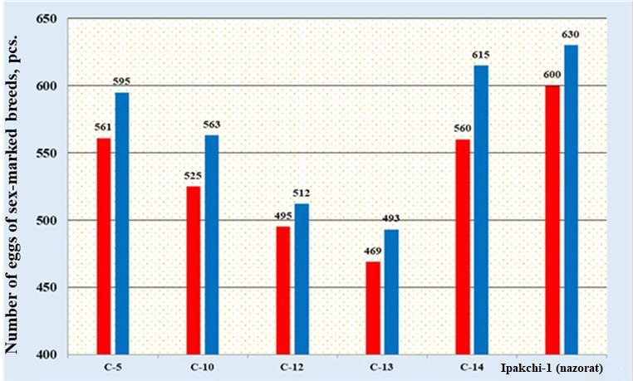
FIGURE-1. Number of eggs in a laying of sex-marked breeds (average for 2024)
- total number of eggs in the laying, pcs.
- number of eggs in the selected laying, pcs.
Diagram 1 shows that families with the maximum number of eggs in the laying at this stage of breeding work were selected for incubation: C-5 - 595 eggs, C-10 - 563 eggs, C-12 - 512 eggs, C-13 - 493 eggs, C-14 - 615 eggs.
Selective breeding was carried out by hatching eggs of breeds marked by sex at the egg stage.
Table 3 presents the egg hatching rates of the studied breeds.

TABLE 3. Hatchability of eggs of the studied breeds (average for 2024)
№ | Breeds | Hatchability, %
№ | Breeds | Incubated |  | Selected for breeding |  | S
№ | Breeds | n | ±S | n | ±S | S
1 | С-5 | 32 | 96,0±0,2 | 20 | 96,5±0,2 | 0,5
2 | С-10 | 28 | 95,5±0,3 | 18 | 96,1±0,2 | 0,6
3 | С-12 | 23 | 96,9±0,1 | 22 | 97,0±0,1 | 0,1
4 | С-13 | 22 | 96,8±0,2 | 21 | 96,9±0,2 | 0,1
5 | С-14 | 34 | 95,5±0,3 | 25 | 96,0±0,3 | 0,5
6 | Ipakchi 1 (control) | 20 | 96,0±04 | 15 | 98,0±0,3 | 2,0

As can be seen from Table 3, eggs with the highest hatching rate were selected for rearing, that is, the intensity of selection by the hatchability percent of breeding systems is quite high. For example, the selection differential (c) in breed C-5 is 0.5%, in breed C-10 - 0.6%, in breed C-12 - 0.1%, in breed C-13 - 0.1%, in breed C-14 - 0.5%. According to the data provided, the percentage of eggs hatchability of experimental breeds marked by sex is at the level of the control variant (the hatchability in the control variant is 96.0%). In the experiments, high egg hatching rates were 97.0% for C-12 breed and 96.9% for C-13 breed. The lowest rate was observed in C-14 breed and amounted to 96.0%. However, these hatching rates are considered to be significantly higher, since it is known that the hatchability of silkworm eggs depends not only on the genotype of the breed, but also on the conditions in which the silkworm is kept. Families of sex-marked breeds with the best egg hatchability were selected for breeding and were reared in spring season of 2024. If a strict selection method is carried out at all stages of silkworm development (egg, larva, pupa, moth), the indicators can change for the better. For example, during the period of egg aestivation, the selection of the best egg layings was carried out according to the following indicators: the number of normal eggs in the laying, the weight of the oviposition, mass of one egg and the sex ratio of 1:1, according to the eggs hatchability. The best families of the breeds in terms of egg production were bred in spring of 2023-2024. Their biological indicators are presented in Table 4.

TABLE 4. Biological indicators of the studied breeds (average for 2024)
Table – 4. Biological indicators of the studied breeds (average for 2024)
№ | Breeds |  |  |  | Larvae viability,  % |  |  |  | Cocoon mass, g. |  |  |  | Mass of cocoon shell, mg. |  |  |  | Percent cocoon shell %
№ |  |  |  |  | ±С |  | С_{в} |  | ±С |  | С_{в} |  | ±С |  | С_{в} |  | ±С |  | С_{в}
1 | С-5 | total | 32 | 94,6±0,32 |  | 1,84 |  | 1,46±0,001 |  | 3,88 |  | 309±3,90 |  | 6,82 |  | 21,3±0,2 |  | 5,70
1 | С-5 | selected | 15 | 95,1±0,45 |  | 1,81 |  | 1,45±0,02 |  | 4,49 |  | 317±4,10 |  | 5,05 |  | 21,8±0,29 |  | 5,18
2 | С-10 | total | 28 | 95,1±0,45 |  | 2,47 |  | 1,48±0,01 |  | 3,63 |  | 311±2,30 |  | 3,85 |  | 21,0±0,20 |  | 5,03
2 | С-10 | selected | 15 | 95,8±0,32 |  | 1,28 |  | 1,47±0,01 |  | 3,89 |  | 316±2,74 |  | 3,35 |  | 21,5±0,25 |  | 4,00
3 | С-12 | total | 23 | 96,0±0,49 |  | 2,26 |  | 1,50±0,02 |  | 1,23 |  | 315±4,20 |  | 5,97 |  | 21,0±0,27 |  | 5,70
3 | С-12 | selected | 14 | 95,8±0,54 |  | 2,11 |  | 1,49±0,03 |  | 6,73 |  | 320±5,33 |  | 6,22 |  | 21,5±0,23 |  | 4,05
4 | С-13 | total | 22 | 95,0±0,40 |  | 2,16 |  | 1,50±0,01 |  | 2,64 |  | 333±3,50 |  | 5,32 |  | 22,2±0,27 |  | 6,28
4 | С-13 | selected | 15 | 95,6±0,60 |  | 2,42 |  | 1,49±0,01 |  | 2,63 |  | 343±3,34 |  | 3,76 |  | 23,0±0,28 |  | 4,76
5 | С-14 | total | 34 | 95,5±0,40 |  | 2,42 |  | 1,55±0,01 |  | 4,48 |  | 349±1,1 |  | 1,82 |  | 22,6±0,18 |  | 4,74
5 | С-14 | selected | 15 | 96,6±0,37 |  | 1,50 |  | 1,55±0,02 |  | 4,49 |  | 351±1,35 |  | 1,48 |  | 22,7±0,28 |  | 1,86
6 | Silkworm (сontrol) | average | 20 | 94,8±0,8 |  | 3,0 |  | 1,55±0,03 |  | 4,40 |  | 347±5,00 |  | 5,00 |  | 22,4±0,80 |  | 5,90

Table 4 shows that the viability of all studied silkworms in 2024 was very high and ranged from 94.6% to 96.0%. It should be noted that the viability of the breeds C-5, C-10, C-12, C-13, C-14, sex-marked during the egg period was high, while the viability of unmarked Ipakchi 1 caterpillars made 94.8%. Diagram 2 below is provided to clearly show how the viability of larvae of sex-marked breeds changes under the influence of selection.
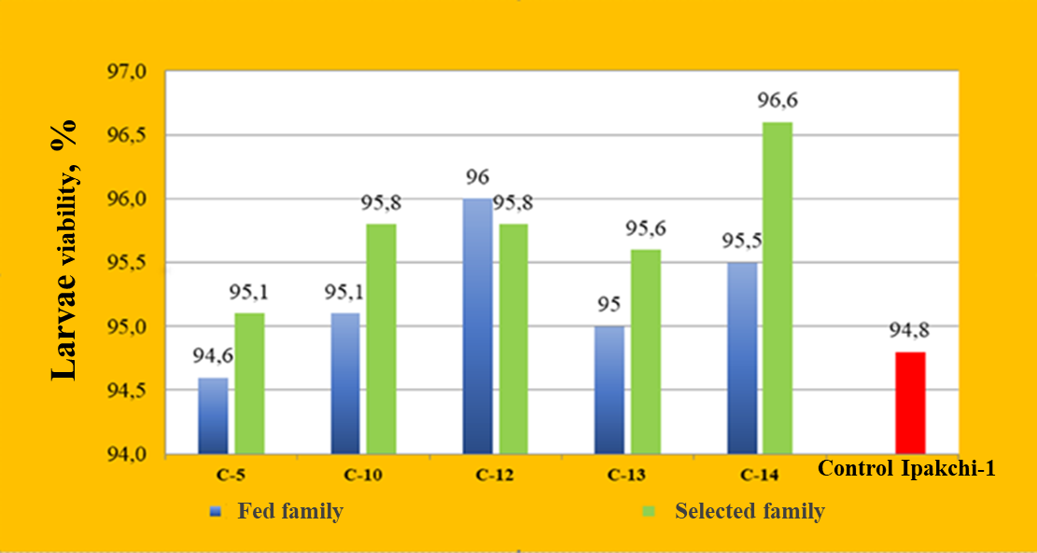
FIGURE 2. Viability of silkworm breeds C-5, C-10, C-12, C-13, C-14.

From diagram 2 it can be seen that almost all breeds, except C-5, have a viability of 94.6–96.0%, which is higher than the control of 94.8%. Based on the results of the selection carried out, families of breeds with 95.0-96.6% viability were given the opportunity to be used in breeding work. Sex-marked breeds differ from usual breeds in that they have chromosomal changes in their genomes. Therefore, these breeds are more sensitive to any changes in life conditions. As known from many studies in good climatic conditions, breeds marked by sex have the same level of biological characteristics as the usual material, but in unstable conditions, genetically modified material behaves somewhat worse. From 1.81 to 2.47 shows the variability of such an indicator as the larvae viability, and indicates the possibility of further selection based on this trait. Relatively smaller but very high Cv have adaptively important features such as a cocoon, silk shell and egg mass. Variability of percent cocoon shell is a less important trait from an adaptive point of view; on the contrary, it is characterized by the lowest. According to data silk productivity negatively correlates with the larvae viability and reproductive characteristics. But long-term, targeted and intensive selection work can lead to changes in existing relationships between traits. This means that given enough time, high percent cocoon shell can be achieved while maintaining maximum viabile and reproductive characteristics[15,16-46]. There is a statistically significant positive correlation (r=+0.24-+0.53) between the average weight of one cocoon, silk shell and egg laying mass, since these characteristics determine the proportionality of the organism, and a change in one leads to a change in another characteristic. On the contrary, the indices of organs functional activity (silkiness, egg production and frequency of complete parthenogenesis) change independently of each other and of cocoon mass. Of the five breeds studied, the highest silk content was observed in C-14 (22.6%) and C-13 (22.2%) (Table 4). During breeding, 10-12 families, having the best indicators of larval viability and percent cocoon shell, were selected from 25-30 families of each breed. From each selected family, 20-30 cocoons were visually selected based on shape and granularity. All selected cocoons were weighed individually. The cocoons with the best percent cocoon shell were left. As an example, the biological indicators of the selected families and cocoons are presented in Table 5.
According to the data analysis of Table 5, for example, in C-5 breed with percent cocoon shell of 20.8%, a family with percent cocoon shell of 21.3% was left for offspring, and cocoons with percent cocoon shell of 21.8% were included for papillonage. Families reared in C-14 breed had percent cocoon shell of 22.6%, and purebred families - 22.7%, eggs were obtained from cocoon moths, with percent cocoon shell of 23.3%. Similar selection work was carried out on the breeds C-10, C-12, C-13 (Table 5), where the selection intensity was quite high. According to Table 5, the highest viability rate in 2023-2024 was observed in C-12 breed (96.0%), the lowest rate was observed in C-5 strain (94.6%). The highest intensity of selection for caterpillar viability was observed in C-14 breed, which ranged from 95.5% to 96.6%. It is known that the greatest phenotypic correlation exists between larvae viability and eggs hatchability. Strain C-14 (349-351 mg) had the highest shell mass, and breed C-10 (311-316 mg) had the lowest. Since there is a direct correlation between the degree of percent cocoon shell and the mass of the shell, the greater the mass of the shell, the higher the percent cocoon shell.

TABLE – 5. Biological indicators of cocoons of families selected for obtaining offspring and studied breeds (on average for 2024)
Breeds |  | Larvae viability, % | Average weight |  | Percent cocoon shell, %
 |  | Larvae viability, % | Cocoon, g | Shell, mg | Percent cocoon shell, %
С-5 | Reared family | 94,6 | 1,46 | 309 | 21,3
С-5 | Purebred family | 95,1 | 1,45 | 317 | 21,8
С-5 | Purebred cocoon | - | 1,45 | 318 | 21,9
С-10 | Reared family | 95,1 | 1,48 | 311 | 21,0
С-10 | Purebred family | 95,8 | 1,47 | 316 | 21,5
С-10 | Purebred cocoon | - | 1,47 | 325 | 22,1
С-12 | Reared family | 96,0 | 1,50 | 315 | 21,0
С-12 | Purebred family | 96,0 | 1,49 | 320 | 21,5
С-12 | Purebred cocoon | - | 1,50 | 359 | 23,9
С-13 | Reared | 95,0 | 1,49 | 333 | 22,2
С-13 | Purebred family | 95,6 | 1,50 | 343 | 23,0
С-13 | Purebred cocoon | - | 1,50 | 368 | 24,5
С-14 | Reared family | 95,5 | 1,55 | 349 | 22,6
С-14 | Purebred family | 96,6 | 1,55 | 357 | 22,7
С-14 | Purebred cocoon | - | 1,55 | 361 | 23,3
Silkworm (control) | Reared family | 94,8 | 1,50 | 339 | 22,6
Silkworm (control) | Purebred family | 95,2 | 1,50 | 341 | 22,7
Silkworm (control) | Purebred cocoon | - | 1,50 | 345 | 23,0

The same situation was observed in our experiments – the highest percent cocoon shell rate was observed in C-13 and C-14 breeds, which amounted to 24.5% and 23.3%, respectively (Table 5). A total of 3,390 cocoons of all breeds were analyzed separately. Of these, 1880 were approved for the production of breeding seeds, i.e. 55.5% of cocoons with the best percent cocoon shell rate. This selection intensity allows for a slight increase in the percent cocoon shell of some breeds (Table 6).

TABLE – 6. Selection differentials for percent cocoon shell in breeds with a sex-marked component (2024)
№ | Breeds | Number of cocoons, pcs. |  | Percent cocoon shell, %
№ | Breeds | total | selected | total | selected | S
1 | С-5 | 597 | 323 | 20,8 | 21,9 | 1,1
2 | С-10 | 564 | 293 | 21,0 | 22,1 | 1,1
3 | С-12 | 391 | 193 | 22,5 | 23,9 | 1,4
4 | С-13 | 906 | 484 | 23,1 | 24,5 | 1,4
5 | С-14 | 990 | 587 | 22,2 | 23,3 | 1,1
6 | Silkworm 1 (сontrol) | 220 | 112 | 23,8 | 24,2 | 0,4

To date, the achieved results in increasing the productivity indicators of the silkworm are practically at the same level as the indicators in the catalogue of “Genetic Fund of Silkworms World Collection of Uzbekistan”. The change in the percent cocoon shell after selection of the best families is shown in Figure -3.
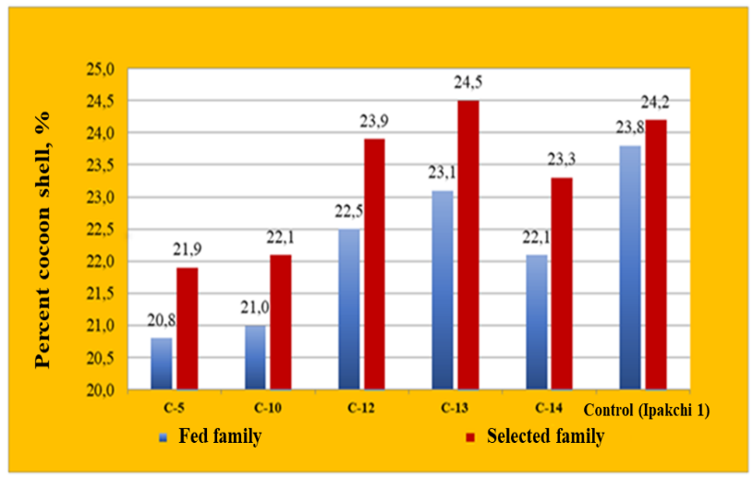
FIGURE 3. Percent cocoon shell of all families of selected breeds C-5, C-10, C-12, C-13, C-14.

It is known that the occurrence of silkworm indicators depends on the combined effect of environmental conditions and genetic factors. Global changes in climate conditions throughout the world, including in Uzbekistan, have a negative impact on the process of reproduction and rearing of silkworms. This certainly affect the condition of the silkworms and prevent them from realizing their genetic potential. Taking into account the importance of the problem of moths non-emergence from cocoons, in our research we observed and recorded similar cases in the studied breeds. For this purpose, 100 cocoon samples were taken from each cocoon mixture (of each breed). After the moths emerged, unperforated cocoons, i.e. cocoons with non-emerged moths, were collected and counted (Figure 4 and Table 7).
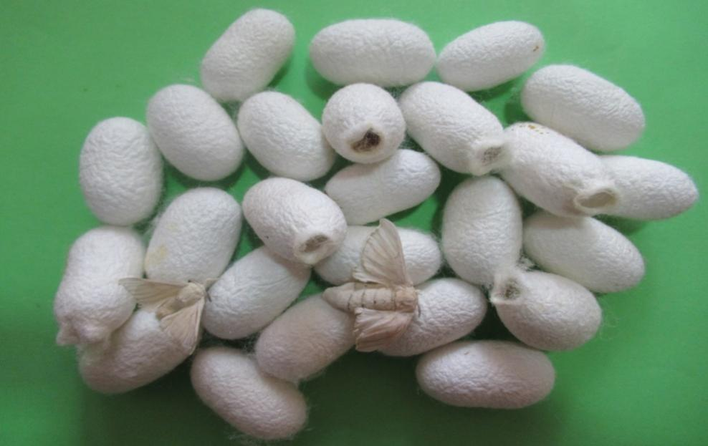
FIGURE 4. The emergence of moths from cocoons of sex-marked breeds.

TABLE 7. Number of moths that did not emerge from cocoons of sex-marked breeds (average for 2024)
№ | Breeds | Number of cocoons, pcs. |  | Non-emerged moths, %
№ | Breeds | Checked | Non-emerged moths | Non-emerged moths, %
1 | С-5 | 103 | 12 | 11,7
2 | С-10 | 102 | 14 | 13,7
3 | С-12 | 100 | 12 | 12,0
4 | С-13 | 100 | 11 | 11,0
5 | С-14 | 105 | 18 | 17,1
6 | Silkworm 1 (control) | 100 | 7 | 7,0

According to the obtained results, the proportion of moths that did not emerge from cocoons in sex-marked breeds varies and averages from 11.0% to 18.1% in 2024. The highest percentage of non-emerged moths was in C-14 breed - 17.1%, and the lowest was in C-13 strain- 11.0%. In the control variant “Ipakchi 1” breed, this indicator was comparatively low and amounted to only 7.0%. According to 2023 indicators, the moth non-emergence rate was 11.0-17.1%. This situation can be explained by the fact that genetic changes in the genomes of sex-marked breeds negatively affect on the metabolism of silkworms. It is possible that this condition, i.e. moths’ non-emergence, is due to the high level of percent cocoon shell in breeds. Because according to the data in table 6 in 2023-2024, the highest percent cocoon shell was observed in C-14 breed (23.3%). In the same breeds, the degree of moths non-appearance is also high, in C-14 (18.2%). According to some data (report of the Research Institute of Sericulture 2012, project KXA-9-028), the degree of moths’ emergence from cocoons depends on the cocoon caliber. According to other researchers, the problem of moths non-emergence is associated with changes in temperature during the cocoon mounting, improper placement of cocoons on shelves, and low concentration of the liquid produced by moths to pierce the cocoon shell. Despite this, the problem of moths non-emergence from cocoons of sex-marked breeds has not yet been studied. Since this problem is one of the tasks that needs to be solved, this and future projects are expected to study this issue.
CONCLUSIONS
Among the breeds marked by sex, the following breeds were identified: C-5 W₂W₂, C-10 W₃W₃, C-12 W₅W₅, C-13 W₃W₃, which occupy a high place in terms of larvae viability, cocoon weight and percent cocoon shell.
Work has been carried out to create systems with high reproductive and biological indicators based on silkworm breeds marked by sex, at present, they have the following indicators: caterpillar viability - 94.6-96.0%, cocoon weight - 1.46-1.55 g, percent cocoon shell - 21.0-22.6%.
The percentage of moths non-emergence from the cocoons of sex-marked breeds at the egg stage was determined and amounts to 11.0-17.1%.
REFERENCES
- Larkina, E.A. Use of partinogenetic clones for mulberry silkworm in genetic study. Biserica, Padna, Italia, 3 (2013), 15–316.
- Larkina, E.A., Mirzakhodjaev, B.A., Mirzakhodjaev, A., Daniyarov, U.T., Radzhabov, I.B. The Use of Parthenogenetic Clones to Create Highly Heterogeneous Hybrids of the Silkworm (Bombyx Mori L.). Asian Research Journal of Agriculture, 15(4), 227–237 (2022). https://doi.org/10.9734/arja/2022/v15i4373.
- Zabelina, V. Technology of silkworm cloning. Current Opinion in Biotechnology, 22, 53 (2011).https://www.researchgate.net/publication/251623609_Technology_of_silkworm_cloning.
- Zabelina, V. Silkworm parthenogenesis phenotypic intraclonal variability. BACSA International Conference, Bucharest, Romania (2011), 11–15.
- Sabhat, A., Farooq, M., Sofi, A.M., Malik, M.A. Heritability, genetic advance and correlation analysis of some reproductive traits in silkworm, Bombyx mori L. Journal of Experimental Zoology, 12, 307–310 (2009).
- Nomozov, A.K., Beknazarov, Kh.S., Geldiev, Y.A., Babamurodov, B.E., Muzaffarova, N.Sh., Yuldashova, S.G. Synthesis of PFG brand corrosion inhibitor and its quantum chemical calculation results. Chemical Problems, 3(23), 297–309 (2025). https://doi.org/10.32737/2221-8688-2025-3-297-309
- Durdibaeva, R., Beknazarov, K., Nomozov, A., Demir, M., Berdimurodov, E. Exploring protective mechanisms with triazine ring and hydroxyethyl groups: experimental and theoretical insights. Kuwait Journal of Science, 52 (2024). https://doi.org/10.1016/j.kjs.2024.100341.
- Nomozov, A.K., Eshkaraev, S.Ch., Jumaeva, Z.E., Todjiev, J.N., Eshkoraev, S.S., Umirqulova, F.A. Experimental and Theoretical Studies of Salsola oppositifolia Extract as a Novel Eco-Friendly Corrosion Inhibitor for Carbon Steel in 3% NaCl. International Journal of Engineering Trends and Technology, 72, 312–320 (2024). https://doi.org/10.14445/22315381/IJETT-V72I9P126.
- Nomozov, A., Khodjamkulov, S., Misirov, Z., Umurzakova, S., Buranova, D., Nurova, Z., Soatov, S. Antibacterial evaluation, and prediction of the ability of Salsola oppositifolia extract. Journal of Chemistry Letters, 6(3), 203–211 (2025). https://doi.org/10.22034/jchemlett.2025.546568.1348
- Ibragimov, A.J., Ortikov, E.A. Mapping of distribution of the species of Iris in Kuhitang botanical-geographical region (Uzbekistan). Iranian Journal of Botany, 30(2), 145–154 (2024).
- Uralov, R.A., Ibragimov, A.Zh. Transformation of adventive species into the flora of lower Surkhan. The Way of Science International Scientific Journal, №7 (125), 18–21 (2024).
- 12 Toshbekov, O., Urozov, M., Sultonova, F., Raximqulova, S., Mustanova, Z., & Xulkaliyeva, G. (2025, November). Analysis of the thermal conductivity of nonwoven fabrics made from silkworm cocoons and their influence on ambient temperature. In AIP Conference Proceedings (Vol. 3331, No. 1, p. 050005). AIP Publishing https://doi.org/10.1063/5.0306845
- Akram, J. Ibragimov. Findings to the flora of Russia and adjacent countries: New national and regional vascular plant records, 5. Botanica Pacifica: A Journal of Plant Science and Conservation, 13(1), 67–92 (2024).
- Nomozov A, Beknazarov Kh.S, Normurodov B.A, Misirov Z.Kh, Yuldashova S.G, Mukimova G.J, Nabiev D.A, Jumaeva Z. Inhibition potential of Salsola oppositifolia extract as a green corrosion inhibitor of mild steel in an acidic solution. Int. J. Corros. Scale Inhib. 2025;14(3):1103–1115. https://doi.org/10.17675/2305-6894-2025-14-3-5.
- Misirov, Z. K., and K. S. Beknazarov. "Synthesis and application of corrosion inhibitor for hydrogen sulfide corrosion of steel. Indian Journal of Chemical Technology, vol. 32, no. 3, 2023, pp. 101–109. https://doi.org/10.56042/ijct.v32i3.7278.
- Tojibaev, K.Sh., Yusupov, Z., Sennikov, A.N., Ibragimov, A., Ortikov, E., Asatulloev, T. Iris anvarbekii (Iridaceae), a new species of I. subg. Scorpiris from the southern Pamir-Alay in Uzbekistan. Nordic Journal of Botany, 2025, https://doi.org/10.1002/njb.04860.
- Minkayeva, A.A., Azilbek, L., Amzeyeva, U., Karunakaran, T., Liu, X., Shang, X., Muzaffarova, N., Jenis, J. Comparative investigation of Rheum tataricum and Rheum palmatum. International Journal of Biology and Chemistry, 2025; 18(1):127–137.
- Toshbekov, O., Urazov, M., Yermatov, S., & Khamraeva, M. 2023). Yeffisient and yesonomisal yenergy use teshnology in the prosessing of domestis soarse wool fiber. In Ye3S Web of Sonferenses (Vol. 461, p. 01068). https://doi.org/10.1051/e3sconf/202346101068
- Jumaniyozov, K., Urozov, M., Toshbekov, O., Salimova, M., Raximova, K., & Khursandova, B. (2025, November). Enhancement of energy-efficient cleaning equipment. In American Institute of Physics Conference Series (Vol. 3331, No. 1, p. 050007). https://doi.org/10.1063/5.0307149
- Sultonova, F., Toshbekov, O., Urozov, M., Boymurova, N., Mustanova, Z., & Boltaeva, I. (2025, November). Enhancing and evaluating the characteristics of specialized workwear for employees in the electric power supply sector. In American Institute of Physics Conference Series (Vol. 3331, No. 1, p. 050006). https://doi.org/10.1063/5.0306350
- Safarov, N., Yangiboev, R., Bo‘riyev, H., Karshiev, B., Gulboyev, O., Narzullayev, F., & Qurbonov, A. (2025, February). Study of the influence of main factors on the mass and density of saw fiber separator raw material. In AIP Conference Proceedings (Vol. 3268, No. 1, p. 020033). AIP Publishing LLC. https://doi.org/10.1063/5.0257374
- Mahmutkhonov S., Baizhonova L., Mustayev R., Tashmatova S. Dynamic analysis of voltage-ampere characteristics and harmonic distortions in electric arc furnaces. // AIP Conference Proceedings. 3331(1), 2025. pp. 070023, 1–5. https://doi.org/10.1063/5.0305745.
- Bobojanov M., Mahmutkhonov S. Influence of the consumer to power quality at the point of connection // E3S Web of Conferences 384. 2023. РР, 01041, 1-5. https://doi.org/10.1051/e3sconf/202338401041.
- Reymov K.M., Makhmuthonov S.K., Turmanova G., Uzaqbaev Q. Optimization of electric networks modes under conditions of partial uncertainty of initial information // E3S Web of Conferences 289, 07023 (2021). -2021, pp: 1-4, https://doi.org/10.1051/e3sconf/202128907023.
- Alimov, U.K., Reimov, A.M., Namazov, Sh.S., Beglov, B.M. The insoluble part of phosphorus fertilizers, obtained by processing of phosphorites of central kyzylkum with partially ammoniated extraction phosphoric acid. Russian Journal of Applied Chemistry. Russ J Appl Chem (2010) 83(3): 545–552. https://doi.org/10.1134/S107042721030328
- Reymov, A.M., Namazov, S.S., Beglov, B.M. Effect of phosphate additives on physical-chemical properties of ammonium nitrate. Journal of Chemical Technology and Metallurgy 2013 48(4), 391-395. http://dl.uctm.edu/journal/
- Urishev, B., Fakhriddin Nosirov, and N. Ruzikulova. 2023. “Hydraulic Energy Storage of Wind Power Plants.” E3S Web of Conferences, 383. https://doi.org/10.1051/e3sconf/202338304052
- Urishev, B., S. Eshev, Fakhriddin Nosirov, and U. Kuvatov. 2024. “A Device for Reducing the Siltation of the Front Chamber of the Pumping Station in Irrigation Systems.” E3S Web of Conferences, 274. https://doi.org/10.1051/e3sconf/202127403001
- Turabdjanov, S., Sh. Dungboyev, Fakhriddin Nosirov, A. Juraev, and I. Karabaev. 2021. “Application of a Two-Axle Synchronous Generator Excitations in Small Hydropower Engineering and Wind Power Plants.” AIP Conference Proceedings. https://doi.org/10.1063/5.0130649
- L.Jing, J.Guo, T.Feng, L.Han, Z.Zhou and M.Melikuziev, "Research on Energy Optimization Scheduling Methods for Systems with Multiple Microgrids in Urban Areas," 2024 IEEE 4th International Conference on Digital Twins and Parallel Intelligence (DTPI), Wuhan, China, 2024, pp. 706-711, https://ieeexplore.ieee.org/abstract/document/10778839
- Baratov, B.N., Umarov, F.Y., Toshov, Z.H. Tricone drill bit performance evaluation. Gornyi Zhurnal, Moscow, 2021. - № 12. - PP. 60-63. DOI:10.17580/gzh.2021.12.11.
- Toshov, J.B., Toshov, B.R., Baratov, B.N., Haqberdiyev, A.L. Designing new generation drill bits with optimal axial eccentricity | Вопросы проектирования буровых долот нового поколения с оптимальным межосевым эксцентриситетом // Mining Informational and Analytical Bulletin, 2022, (9). - PP. 133–142. DOI: 10.25018/0236_1493_2022_9_0_133
- Toshov J., Makhmudov A., Kurbonov O., Arzikulov G., Makhmudova G. Development and Substantiation of Energy-Saving Methods for Controlling the Modes of Operation of Centrifugal Pumping Units in Complicated Operating Conditions. Proceedings of the 11th International Conference on Applied Innovations in IT, (ICAIIT), November 2023, Koethen, Germany. – РР. 161-165.
- J.B. Toshov, K.T. Sherov, B.N. Absadykov, R.U. Djuraev, M.R. Sikhimbayev, Efficiency of drilling wells with air purge based on the use of a vortex tube. NEWS of the National Academy of Sciences of the Republic of Kazakhstan “Series of geology and technical sciences”. – Almaty, Volume 4, Number 460 (2023), 225–235. https://doi.org/10.32014/2023.2518-170X.331
Toshov J., Toshov B., Bainazov U., Elemonov M. Application of Cycle-Flow Technology in Coal Mines. Proceedings of the 11th International Conference on Applied Innovations in IT, (ICAIIT), March 2023, Koethen, Germany. – РР. 279-284.
- Usmanov, E., Kholikhmatov, B., Rikhsitillaev, B., Nimatov, K. Device for reducing asymmetry // E3s Web of Conferences 461. 2023. PP, 01052, 1-5. https://doi.org/10.1051/e3sconf/202346101052
- Toshov B., Toshov J., Akhmedova L., Baratov B. The new design scheme of drilling rock cutting tools, working in rotation mode pairs. E3S Web of Conferences 383, 04069 (2023) TT21C-2023 https://doi.org/10.1051/e3sconf/202338304069
- J.B. Toshev, M.B. Norkulov, A.A. Urazimbetova and L.G. Toshniyozov. Optimization of scheme of placing cutting structures on the cone drill bit. E3S Web of Conf., Volume 402, 10039 (2023), International Scientific Siberian Transport Forum - TransSiberia 2023, https://doi.org/10.1051/e3sconf/202340210039
- Toshov J., Baratov B., Sherov K., Mussayev M., Baymirzaev B., Esirkepov A., Ismailov G., Abdugaliyeva G., Burieva J. Ways to Optimize the Kinetic Parameters of Tricone Drill Bits. Material and Mechanical Engineering Technology, №1, 2024, 35-45. https://doi.org/10.52209/2706-977X_2024_1_35
- K.T. Sherov, N.Zh. Karsakova, B.N. Absadykov, J.B. Toshov, M.R. Sikhimbayev, Studying the effect of the boring bar amplitude-frequency characteristics on the accuracy of machining a large-sized part. NEWS of the National Academy of Sciences of the Republic of Kazakhstan “SERIES OF GEOLOGY AND TECHNICAL SCIENCES”. – Almaty, Volume 2, Number 464 (2024), 217–227. https://doi.org/10.32014/2024.2518-170X.405
- J. Toshov, L. Atakulov, G. Arzikulov, U. Baynazov, Modeling of optimal operating conditions of cyclic-flow technologies with a belt conveyor at coal mine under the "ANSYS" program. AIP Conf. Proc. 3152, 020006 (2024) / III International Scientific and Technical Conference “Actual issues of Power supply systems” (ICAIPSS2023), 7–8 September 2023, Tashkent, Uzbekistan. https://doi.org/10.1063/5.0218904
- Kholikhmatov B.B., Samiev Sh.S., Erejepov M.T., Nematov L.A. Modelling of laboratory work in the science "Fundamentals of power supply" using an educational simulator based on a programmed logic controller // E3S Web of Conferences 384. 2023. РР, 01032, 1-3. https://doi.org/10.1051/e3sconf/202338401032
- Rakhimov F, Rakhimov F, Samiev Sh, Abdukhalilov D. Justification of Technical and Economic Effectiveness of Application of 20 kV Voltage in Overhead Electric Networks //AIP Conf. Proc. 3152, 030023 (2024). https://doi.org/10.1063/5.0218921
- Taslimov A, Mo'minov V, Samiev Sh, Abdukhalilov D. Issues of Optimization of Electrical Network Parameters Medium Voltage //AIP Conf. Proc. 3331, 020007 (2025). https://doi.org/10.1063/5.0305781
- Toshbekov, O., Urazov, M., Yermatov, S., & Khamraeva, M. 2023). Yeffisient and yesonomisal yenergy use teshnology in the prosessing of domestis soarse wool fiber. In Ye3S Web of Sonferenses (Vol. 461, p. 01068). https://doi.org/10.1051/e3sconf/202346101068
- Jumaniyozov, K., Urozov, M., Toshbekov, O., Salimova, M., Raximova, K., & Khursandova, B. (2025, November). Enhancement of energy-efficient cleaning equipment. In American Institute of Physics Conference Series (Vol. 3331, No. 1, p. 050007). https://doi.org/10.1063/5.0307149
- Sultonova, F., Toshbekov, O., Urozov, M., Boymurova, N., Mustanova, Z., & Boltaeva, I. (2025, November). Enhancing and evaluating the characteristics of specialized workwear for employees in the electric power supply sector. In American Institute of Physics Conference Series (Vol. 3331, No. 1, p. 050006). https://doi.org/10.1063/5.0306350

