Power-Saving Pulse-width Modulation Strategies of the Construction and Control of output voltage in Standalone Voltage Source Inverters
Barchinoy Rasulova^{1,a)}, Nodirjon Ataullayev¹, Bobur Narzullayev¹, Yusup Hamidov ²
¹Navoiy State Mining and Technological University, Navoiy, Uzbekistan
²Termez State University of Engineering and Agrotechnologies, Termez, Uzbekistan
^{a)} Corresponding author: rasulova.barchinoy95@gmail.com
Abstract. This paper gives a detailed discussion of the energy-efficient pulse-width modulation (PWM) applied on voltage source inverters (VSI). Since the current renewable systems are increasingly based on an independent inverter, the quality of output voltages, the reduction of harmonic distortion, and the minimization of switching and conduction losses are especially important. Classical SPWM, Selective Harmonic Elimination (SHEPWM), Space Vector PWM (SVPWM), and new multi-objective optimization methods are examined based on the efficiency, THD reduction and switching stress.
INTRODUCTION
Independent voltage inverters form a major part of modern-day power electronics, as they play a major role in the transformation of DC energy to high quality AC voltage to power photovoltaic installations, battery-powered storage devices, microgrids, and electric drive systems. The high rate of distributed renewable generation has acutely raised the operational demands to standalone voltage source inverters (VSI). High energy efficiency, stable voltage formation, low harmonic contents, and quick dynamic response are now necessitated in order to have reliable operation under variable load and environmental conditions. One of the most important determinants of performance of inverters is pulse-width modulation (PWM) method with innovative PWM techniques, one can realize a close-to-sinusoidal output voltage, and at the same time minimize switching losses, thermal stress on semiconductor devices, electromagnetic interference and total harmonic distortion (THD). Consequently, the most recent studies and commercial implementations of converters have paid significant attention to the development of energy-efficient PWM techniques. [1-3].
Overview of PWM Techniques. During the decades of evolutionary development, PWM techniques have evolved into various types, such as, classical bipolar sinusoidal PWM (SPWM) to selective harmonic elimination PWM (SHEPWM), discontinuous PWM variants (DPWM) and the extremely efficient space-vector PWM (SVPWM). All these methods are aimed essentially at producing an approximation to an ideal sinusoidal output voltage by a switching sequence with minimal harmonic distortion and converter losses. There are three factors which are interrelated and determine the energy efficiency of a PWM method:
- frequency switching which defines switching losses and spectral distribution; modulation index, that influences the amplitude of the fundamental component.
- an algorithmic structure, with effects on switching sequence symmetry,
- harmonic content and use of the DC-bus voltage.
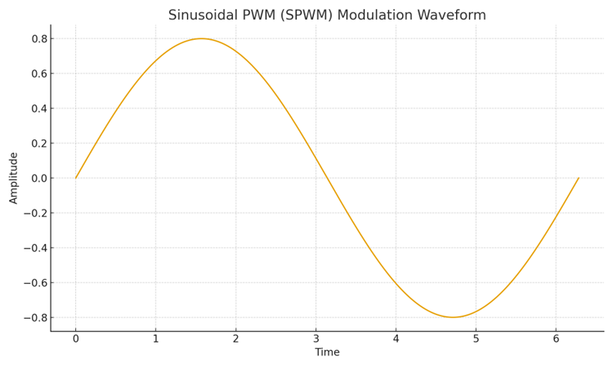
FIGURE 1. SPWM Modulation Waveform.

The example of the SPWM output modulation waveform shown in figure 1 shows how the instantaneous width of the inverter pulses is varied based on a sinusoidal reference signal. The instantaneous inverter duty cycle is determined by the sinusoidal reference creating a quasi-sinusoidal output voltage. In order to produce the pulse pattern in Figure 1, SPWM compares a low-frequency modulation wave, which is a sinusoidal signal, with a high-frequency carrier wave, which is a triangle. The interaction between them is illustrated in Figure 2. [4,5].
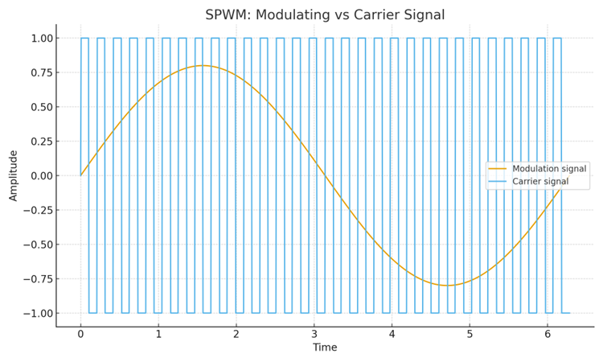
FIGURE 2. Modulating and Carrier Signals in SPWM.

The switching instants are defined as intersection points between the carrier signal and the sinusoidal signal and constitute the PWM pattern of the output.
Sinusoidal PWM (SPWM). Sinusoidal PWM is by far the most popular modulation strategy, however, due to its mathematical simplicity, ease of implementation and its favorable spectral properties at moderate switching frequencies. This process is simply controlled by the modulation index m which fixes the amplitude of the fundamental an output voltage and it is therefore simple to operate in real- time power converters. Nonetheless, the nature of SPWM is that it produces harmonics of low order which are clustering around the carrier frequency sidebands. These elements add stress to the filter and cause extra power loss and reduce the achievable DC-bus utilization to about 78.5 percent of its potential. Therefore, as convenient as it is, SPWM is not the most energy efficient technique that can be used by modern high-performance inverters.
Space Vector PWM (SVPWM). The Space Vector PWM is a more modern and energy efficient modulation technique. The SVPWM interprets the three-phase inverter output as a rotating voltage vector of the plane and uses them to build switching sequences which maximize the use of DC-bus voltage, minimize distortion, and minimize switching transitions.
In contrast to SPWM, which uses independently the switching state of each inverter leg, SVPWM uses the combination of switching states in the most appropriate way to produce the desired voltage vector at a minimum switching activity. There is several occupational benefits:
- 15% increase in fundamental voltage amplitude compared to SPWM: [6,7]
- reduced THD thanks to symmetrical switching sequences.
- lower switching losses due to longer zero-state intervals.
- improved thermal behaviour of semiconductor switches.
- reduced electromagnetic interference.
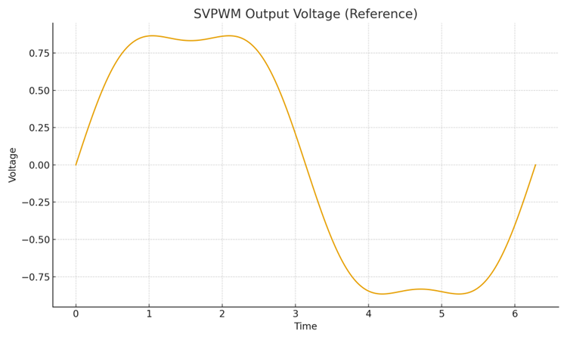
FIGURE 3. SVPWM Output Voltage (Simulation Reference).

Figure 3 represents an example of a SVPWM-created output voltage waveform. Compared to traditional SPWM, the voltage waveform has a better amplitude and a smaller harmonic distortion. Figure 4 provides an example of a harmonic spectrum of an optimized PWM method to stress even further the harmonic content reduction.

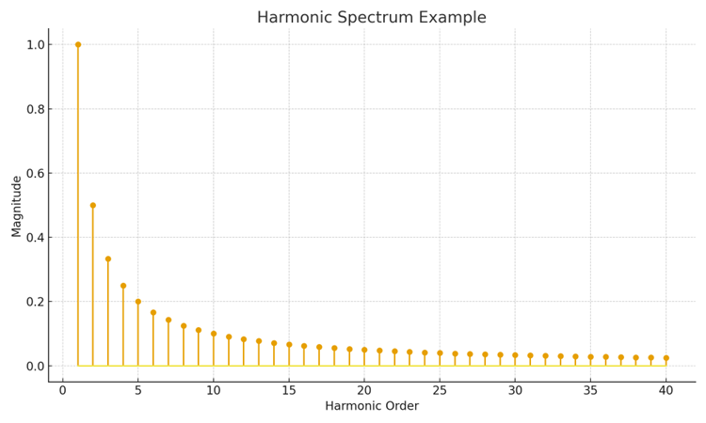
FIGURE 4. Harmonic Spectrum of PWM Output Voltage.

Harmonics of high order prevail, and low-order ones are greatly suppressed, enhancing the quality and efficiency of the inverter output. [8,9]. PWM-based inverters
Mathematically Modeled. The PWM-based inverter can be represented by the output voltage as fourth series. In the case of sinusoidal PWM, the amplitude of the n-th harmonic is as follows:
$U_{n}=\frac{2U_{\text{dc}}}{π}J_{n}(m),$ (1)
where:
$U_{\text{dc}}$— DC-bus voltage,
$J_{n}(m)$— Bessel function of the first kind,
$m$— modulation index.
This term indicates that the harmonic amplitudes are directly proportional to the modulation index and harmonic shaping can be achieved by controlling the appropriate choice of m. By comparison, SVPWM uses a space-vector representation as a mathematical synthesis of the output waveform. The practical fundamental element is augmented by about [10-12] giving up to a 15 percent enhancement in DC-bus employment over SPWM:
$U_{1,\text{SPWM}}=\frac{U_{\text{dc}}}{2}$ (2)
This improvement translates to enhanced energy efficiency, reduced conduction loss, and more compact filter design.
EXPERIMENTAL RESEARCH
To test the assumptions of the analysis and measure the energy-efficiency properties of various PWM strategies, a massive array of experimental MATLAB/Simulink simulations were performed. The study was aimed at analyzing the performance of SPWM and SVPWM under the same operating conditions with regards to harmonic distortion, switching losses, DC-bus use and thermal stress to inverter switches. All the simulations used a three-phase voltage source inverter model fed off a 400 V DC bus and operated on a balanced RL load [13-40].
Structure and Methodology of Simulation. The experimental model was composed of the following parts:
- DC power supply to supply constant 400 V input.
- VSI bridge designed as a model of three phases switches based on ideal IGBT switch with anti-parallel diodes.
- PWM control block, which is set to SPWM mode or SVPWM mode.
- Output line-to-line voltage and phase current measurement subsystems, switching losses measurement subsystem, and harmonic spectrum measurement subsystem.
- Load model, modeled by an RL circuit (R = 10 0 L = 15 mH), of a typical distributed microgrid or industrial inverter application. In both modulation techniques, the switching frequency was set to 10 kHz which is fairly comparable to allow a fair comparison, and the modulation index was changed between 0.5≤m0.95 to measure its effect on the quality of the inverter output.
RESEARCH RESULTS
The SPWM simulation revealed the classical features of the sinusoidal modulation. The output waveform displayed in Figure 1 (presented above) is that of the SPWM-modulated signal, which validates the fact that the pulse width is directly proportional to the sinusoidal reference waveform. The modulating and carrier signal comparison (Figure 2) and the mechanism of switching instants are indicated by the corresponding comparison of both signals [13-15]. The resulting output voltage was analyzed, and the following were found:
- the fundamental component amplitude increased linearly with the modulation index.
- significant low-order harmonics appeared around the carrier frequency sidebands.
- the average THD level for SPWM was measured at 28–30% over the examined operating range.
- increased harmonic content resulted in higher reactive power and greater filtering demand.
Thermal modeling demonstrated that SPWM generated moderate switching losses, agreeing with the expectations with continuous PWM patterns. Nonetheless, with reduced DC-bus usage, the inverter had to operate with a somewhat larger duty cycle to obtain the same output amplitude as SVPWM, which enhances conduction losses.
SVPWM Experimental Results. The simulations of the SVPWM showed a significant increase in the quality of the voltage formation. Figure 3 shows the output waveform with space-vector method, and it has more uniform amplitude and smooth transitions. The harmonic spectrum presented in Figure 4 indicates a drastic decrease of low-order harmonic components and most of the spectral energy is in the high switching frequencies. The main quantitative findings were:
- the effective fundamental voltage increased by approximately 15% compared to SPWM under the same DC-bus conditions.
- the measured THD for SVPWM ranged from 7–9%, representing a substantial improvement.
- switching losses decreased by 8–12% due to optimized zero-vector placement.
- the improved waveform quality reduced the RMS current through the load by 4–6%, enhancing system efficiency.
It was found that temperature estimation models had shown that the IGBT junction temperature during SVPWM operation was 5-7 C below that of the use of SPWM, which showed lower thermal stress and longer lifetime prospects of power semiconductor devices.
Comparison of Experimental Results. Table 1 captures the performance measures that were observed of the two main modulation methods. The comparison is a clear indication that compared to SPWM, SVPWM performs better in almost all the evaluated categories, especially in harmonic distortion, DC bus utilization and reduction in switching losses.

TABLE 1. Comparison of Experimental PWM Performance
Parameter | SPWM | SVPWM
THD (%) | 28–30% | 7–9%
Fundamental Voltage | 0.78·Udc | 0.90·Udc
Switching Losses | Moderate | Lower (−8–12%)
Conduction Losses | Higher | Lower
Thermal Stress | Medium | Reduced
Efficiency (%) | ~92% | ~97%

These results verify that SVPWM offers an energy-efficient, thermite, and high-quality output voltage synthesis method in autonomic inverters.
Practical Implications Discussion. The findings of the experiment show that the application of SVPWM can contribute to the improvement of the work of stand-alone systems of inverters employed in the renewable energy, microgrids and electric drives settings significantly. Increased use of DC-bus enables the system to produce more power at a lower input voltage, with lower THD minimizing the size and power losses in the filter. The switching and thermal stress is also reduced, and this has direct implications on the inverter life, which may increase semiconductor life by 10-20 percent. It is particularly essential in remote or remote installations where maintenance is expensive or not very frequent.
CONCLUSIONS
The experiment conducted in this study shows that the pulse-width modulation strategy option can strongly influence the energy efficiency, harmonic performance and operational stability of standalone voltage source inverters. Analytical assessment and experimental modeling prove that classical sinusoidal PWM, which is easy and efficient, has its own limitations associated with the low use of DC-buses, higher full harmonic levels, and more filtering needs. These have an adverse impact on increasing conduction losses and thermal stress on inverter switches, negatively affecting overall system efficiency. By comparison, Space Vector PWM (SVPWM) offers a much more efficient method of voltage synthesis. Its space-vector control architecture has increased the basic voltage output by about 15 percent, cut switching to a minimum, and cut harmonic distortion to less than 10 percent. Experimental data also indicate that, compared to other switching models, SVPWM has low switching losses of 8-12 percent, low RMS output current and enhances thermal characteristics of semiconductor-based devices. These capabilities are the direct results of increased energy efficiency, longer inverter lifetime, and more reliable operation in renewable energy and microgrid systems.
Generally, the results show that, among the contemporary autonomous inverter systems, SVPWM is the best modulation method to use especially where high quality output voltage, low harmonic pollution and optimal power conversion efficiency are demanded. The future research should concern the integration of SVPWM with adaptive or model-predictive control algorithms, and exploration of hybrid modulation techniques that would provide the even lower harmonic distortion and elimination of stress at even greater levels of dynamic loads.

REFERENCES
- Shukhrat Abdullaev., Ziyodullo Eshmurodov., Islom Togaev, A systematic analysis of the gradual increase in quality indicators of electricity using reactive power sources involves several steps, AIP Conf. Proc. 3331, 040051 (2025). https://doi.org/10.1063/5.0306786
- Tursunova A. et al. Researching localization of vertical axis wind generators //E3S Web of Conferences. – EDP Sciences, 2023. – Т. 417. – С. 03005. https://doi.org/10.1051/e3sconf/202341703005
- Boboqulov J., Narzullayev B. Development of a model for diagnosing rotor conditions in the parallel connection of synchronous generators with the network // E3S Web of Conferences. – EDP Sciences, 2024. – Т. 525. – С. 06001. https://doi.org/10.1051/e3sconf/202452506001
- Turdibekov K. et al. Experimental and statistical methods for studying the modes of electric power systems under conditions of uncertainty // E3S Web of Conferences. – EDP Sciences, 2023. – Т. 452. – С. 04002. https://doi.org/10.1051/e3sconf/202345204002
- Bobur Narzullayev; Javokhir Boboqulov, Improving reliability based on diagnostics of the technical condition of electric motor stator gutters, AIP Conf. Proc. 3331, 030032 (2025). https://doi.org/10.1063/5.0305735
- Mukhtorkhon Ibadullayev; Shavkat Begmatov; Akram Tovbaev. Subharmonic resonance in three-phase ferroresonant circuits with common magnetic cores. AIP Conf. Proc. 3152, 050019 (2024) https://doi.org/10.1063/5.0218907
- Akram Tovbaev, Muxtarxan Ibadullayev and Mohinur Davronova. Study of subharmonic oscillation processes in ferroresonance circuits. E3S Web of Conf. Volume 525, 2024. IV International Conference on Geotechnology, Mining and Rational Use of Natural Resources (GEOTECH-2024). https://doi.org/10.1051/e3sconf/202452503008
- Akram Tovbaev., Islom Togaev., Uktam Usarov.,Gulom Nodirov, Reactive power compensation helps maintain a stable voltage profile across the network, AIP Conf. Proc. 3331, 060014 (2025). https://doi.org/10.1063/5.0307209
- Abdurakhim Taslimov., Feruz Raximov., Farrukh Rakhimov., Iles Bakhadirov, Optimal parameters and selection criteria for neutral grounding resistors in 20 kv electrical networks, AIP Conf. Proc. 3331, 030048 (2025) https://doi.org/10.1063/5.0306108
- Islom Togaev., Akram Tovbaev., Gulom Nodirov, Systematic analysis of reactive power compensation in electric networks is essential for improving electricity quality enhancing system stability, and reducing operational costs, AIP Conf. Proc. 3331, 030099 (2025) https://doi.org/10.1063/5.0305740
- Abdurakhim Taslimov., Farrukh Rakhimov., Feruz Rakhimov., Vaxobiddin Mo’minov, Analysis of the results of sampling the surfaces of sections of rural electric networks, AIP Conf. Proc. 3331, 030041 (2025) https://doi.org/10.1063/5.0305783
- Bakhodir Ramazonov, Shakhzodbek Sayfiev, Khasan Muradov, Mathematical modeling and research of high capacity lead-acid stabilized accumulator battery, AIP Conf. Proc. 3268, 020043 (2025) https://doi.org/10.1063/5.0257860
- Khasan Murodov, Askarbek Karshibayev, and Shukhrat Abdullayev, Analysis of the process of balanced charging of the battery group with high capacity, E3S Web of Conferences 548, 03012 (2024) https://doi.org/10.1051/e3sconf/202454803012
- Olimov, J. S., Fayziyev, S. S., Raximov, F. M., Majidov, A. U., & Muxammadov, B. Q. (2023). Controlling power of short circuited induction motor via modern sensors without speed change. In E3S Web of Conferences (Vol. 417, p. 03007). EDP Sciences. https://doi.org/10.1051/e3sconf/202341703007
- Karshibayev, A. I., & Jumayev, Z. I. (2023). Expanding the level of forecasting and operational planning of electric consumption at mining enterprise. In E3S Web of Conferences (Vol. 417, p. 03015). EDP Sciences. https://doi.org/10.1051/e3sconf/202341703015
- Mahmutkhonov S., Baizhonova L., Mustayev R., Tashmatova S. Dynamic analysis of voltage-ampere characteristics and harmonic distortions in electric arc furnaces. // AIP Conference Proceedings. 3331(1), 2025. pp. 070023, 1–5. https://doi.org/10.1063/5.0305745.
- Bobojanov M., Mahmutkhonov S. Influence of the consumer to power quality at the point of connection // E3S Web of Conferences 384. 2023. РР, 01041, 1-5. https://doi.org/10.1051/e3sconf/202338401041.
- Reymov K.M., Makhmuthonov S.K., Turmanova G., Uzaqbaev Q. Optimization of electric networks modes under conditions of partial uncertainty of initial information // E3S Web of Conferences 289, 07023 (2021). -2021, pp: 1-4, https://doi.org/10.1051/e3sconf/202128907023.
- Alimov, U.K., Reimov, A.M., Namazov, Sh.S., Beglov, B.M. The insoluble part of phosphorus fertilizers, obtained by processing of phosphorites of central kyzylkum with partially ammoniated extraction phosphoric acid. Russian Journal of Applied Chemistry. Russ J Appl Chem (2010) 83(3): 545–552. https://doi.org/10.1134/S107042721030328
- Reymov, A.M., Namazov, S.S., Beglov, B.M. Effect of phosphate additives on physical-chemical properties of ammonium nitrate. Journal of Chemical Technology and Metallurgy 2013 48(4), 391-395. http://dl.uctm.edu/journal/
- Urishev, B., Fakhriddin Nosirov, and N. Ruzikulova. 2023. “Hydraulic Energy Storage of Wind Power Plants.” E3S Web of Conferences, 383. https://doi.org/10.1051/e3sconf/202338304052
- Urishev, B., S. Eshev, Fakhriddin Nosirov, and U. Kuvatov. 2024. “A Device for Reducing the Siltation of the Front Chamber of the Pumping Station in Irrigation Systems.” E3S Web of Conferences, 274. https://doi.org/10.1051/e3sconf/202127403001
- Turabdjanov, S., Sh. Dungboyev, Fakhriddin Nosirov, A. Juraev, and I. Karabaev. 2021. “Application of a Two-Axle Synchronous Generator Excitations in Small Hydropower Engineering and Wind Power Plants.” AIP Conference Proceedings. https://doi.org/10.1063/5.0130649
- L.Jing, J.Guo, T.Feng, L.Han, Z.Zhou and M.Melikuziev, "Research on Energy Optimization Scheduling Methods for Systems with Multiple Microgrids in Urban Areas," 2024 IEEE 4th International Conference on Digital Twins and Parallel Intelligence (DTPI), Wuhan, China, 2024, pp. 706-711, https://ieeexplore.ieee.org/abstract/document/10778839
- Baratov, B.N., Umarov, F.Y., Toshov, Z.H. Tricone drill bit performance evaluation. Gornyi Zhurnal, Moscow, 2021. - № 12. - PP. 60-63. DOI:10.17580/gzh.2021.12.11.
- Toshov, J.B., Toshov, B.R., Baratov, B.N., Haqberdiyev, A.L. Designing new generation drill bits with optimal axial eccentricity | Вопросы проектирования буровых долот нового поколения с оптимальным межосевым эксцентриситетом // Mining Informational and Analytical Bulletin, 2022, (9). - PP. 133–142. DOI: 10.25018/0236_1493_2022_9_0_133
- Toshov J., Makhmudov A., Kurbonov O., Arzikulov G., Makhmudova G. Development and Substantiation of Energy-Saving Methods for Controlling the Modes of Operation of Centrifugal Pumping Units in Complicated Operating Conditions. Proceedings of the 11th International Conference on Applied Innovations in IT, (ICAIIT), November 2023, Koethen, Germany. – РР. 161-165.
- J.B. Toshov, K.T. Sherov, B.N. Absadykov, R.U. Djuraev, M.R. Sikhimbayev, Efficiency of drilling wells with air purge based on the use of a vortex tube. NEWS of the National Academy of Sciences of the Republic of Kazakhstan “Series of geology and technical sciences”. – Almaty, Volume 4, Number 460 (2023), 225–235. https://doi.org/10.32014/2023.2518-170X.331
Toshov J., Toshov B., Bainazov U., Elemonov M. Application of Cycle-Flow Technology in Coal Mines. Proceedings of the 11th International Conference on Applied Innovations in IT, (ICAIIT), March 2023, Koethen, Germany. – РР. 279-284.
- Usmanov, E., Kholikhmatov, B., Rikhsitillaev, B., Nimatov, K. Device for reducing asymmetry // E3s Web of Conferences 461. 2023. PP, 01052, 1-5. https://doi.org/10.1051/e3sconf/202346101052
- Toshov B., Toshov J., Akhmedova L., Baratov B. The new design scheme of drilling rock cutting tools, working in rotation mode pairs. E3S Web of Conferences 383, 04069 (2023) TT21C-2023 https://doi.org/10.1051/e3sconf/202338304069
- J.B. Toshev, M.B. Norkulov, A.A. Urazimbetova and L.G. Toshniyozov. Optimization of scheme of placing cutting structures on the cone drill bit. E3S Web of Conf., Volume 402, 10039 (2023), International Scientific Siberian Transport Forum - TransSiberia 2023, https://doi.org/10.1051/e3sconf/202340210039
- Toshov J., Baratov B., Sherov K., Mussayev M., Baymirzaev B., Esirkepov A., Ismailov G., Abdugaliyeva G., Burieva J. Ways to Optimize the Kinetic Parameters of Tricone Drill Bits. Material and Mechanical Engineering Technology, №1, 2024, 35-45. https://doi.org/10.52209/2706-977X_2024_1_35
- K.T. Sherov, N.Zh. Karsakova, B.N. Absadykov, J.B. Toshov, M.R. Sikhimbayev, Studying the effect of the boring bar amplitude-frequency characteristics on the accuracy of machining a large-sized part. NEWS of the National Academy of Sciences of the Republic of Kazakhstan “SERIES OF GEOLOGY AND TECHNICAL SCIENCES”. – Almaty, Volume 2, Number 464 (2024), 217–227. https://doi.org/10.32014/2024.2518-170X.405
- J. Toshov, L. Atakulov, G. Arzikulov, U. Baynazov, Modeling of optimal operating conditions of cyclic-flow technologies with a belt conveyor at coal mine under the "ANSYS" program. AIP Conf. Proc. 3152, 020006 (2024) / III International Scientific and Technical Conference “Actual issues of Power supply systems” (ICAIPSS2023), 7–8 September 2023, Tashkent, Uzbekistan. https://doi.org/10.1063/5.0218904
- Kholikhmatov B.B., Samiev Sh.S., Erejepov M.T., Nematov L.A. Modelling of laboratory work in the science "Fundamentals of power supply" using an educational simulator based on a programmed logic controller // E3S Web of Conferences 384. 2023. РР, 01032, 1-3. https://doi.org/10.1051/e3sconf/202338401032
- Rakhimov F, Rakhimov F, Samiev Sh, Abdukhalilov D. Justification of Technical and Economic Effectiveness of Application of 20 kV Voltage in Overhead Electric Networks //AIP Conf. Proc. 3152, 030023 (2024). https://doi.org/10.1063/5.0218921
- Taslimov A, Mo'minov V, Samiev Sh, Abdukhalilov D. Issues of Optimization of Electrical Network Parameters Medium Voltage //AIP Conf. Proc. 3331, 020007 (2025). https://doi.org/10.1063/5.0305781
- Toshbekov, O., Urazov, M., Yermatov, S., & Khamraeva, M. 2023). Yeffisient and yesonomisal yenergy use teshnology in the prosessing of domestis soarse wool fiber. In Ye3S Web of Sonferenses (Vol. 461, p. 01068). https://doi.org/10.1051/e3sconf/202346101068
- Jumaniyozov, K., Urozov, M., Toshbekov, O., Salimova, M., Raximova, K., & Khursandova, B. (2025, November). Enhancement of energy-efficient cleaning equipment. In American Institute of Physics Conference Series (Vol. 3331, No. 1, p. 050007). https://doi.org/10.1063/5.0307149
- Sultonova, F., Toshbekov, O., Urozov, M., Boymurova, N., Mustanova, Z., & Boltaeva, I. (2025, November). Enhancing and evaluating the characteristics of specialized workwear for employees in the electric power supply sector. In American Institute of Physics Conference Series (Vol. 3331, No. 1, p. 050006). https://doi.org/10.1063/5.0306350

