Evaluation of Emergency Control Schemes in the Northwestern Region of Uzbekistan’s Power System Considering the Integration of New Generating Capacities
Shohrukh Samiev ^{1, 2,} ^{a)}, Kamola Rizaeva ¹, Kamola Rizaeva ², Jahongir Esanov ¹
Tashkent state technical university named after Islam Karimov, Tashkent, Uzbekistan
²Renaissance University, Tashkent, Uzbekistan
^{a)} Corresponding author: shohrux.samiyev@mail.ru
Abstract. This paper investigates the applicability and significance of emergency control automation in the northwestern region of the power system of the Republic of Uzbekistan in the context of integrating prospective power plants into the grid. The study focuses on maintaining power balance and ensuring system stability under both steady-state and disturbed operating conditions. The operating modes of generating units are analyzed for present-day and future scenarios, considering variations in load demand and power flow distribution resulting from the commissioning of new generating capacities. Transient stability assessments of power plant generators are performed under critical disturbance conditions to evaluate dynamic system behavior. As an effective emergency control measure, impulse turbine unloading is employed to preserve synchronism and enhance system stability margins. The results demonstrate that properly coordinated emergency control automation significantly improves the reliability and operational security of the northwestern power system, enabling stable integration of new generating units without compromising system performance.
INTRODUCTION
One of the main trends in the development of modern electric power systems is the formation of large-scale interconnected power systems, which enables a reduction in electricity generation costs while improving the economic efficiency and reliability of power supply to consumers [5,6]. The integration of power systems allows for optimal utilization of generation resources, enhanced operational flexibility, and improved resilience against large-scale disturbances.
As an illustrative example, the Unified Power System of the Republic of Uzbekistan represents one of the largest centrally controlled power systems in Central Asia. Due to its unique position within the Central Asian Power System (CAPS), Uzbekistan’s power system plays a key role both in terms Hof installed generation capacity and overall electricity consumption. In addition, the 500 kV and 220 kV transmission networks of Uzbekistan are extensively utilized to facilitate power transit between interconnected power systems that form part of CAPS.
Given these conditions, the deployment of emergency control automation (ECA) devices at power facilities has, in most cases, been aimed at ensuring the reliable and secure operation of the Central Asian Power System as a whole. This applies not only to individual ECA devices and integrated emergency control schemes installed at generation and transmission facilities, but also to the active involvement of power system elements in coordinated emergency control actions. Furthermore, special attention has been paid to the organization of reliable communication channels for transmitting emergency control signals between system operators and controlled facilities.
The high degree of centralization in the management of the national power sector has enabled domestic power engineers to develop a solid theoretical foundation and successfully implement emergency control automation systems designed to prevent the propagation of cascading failures within the power system [4,5]. These systems play a crucial role in maintaining system integrity under severe disturbance conditions by limiting the spread of avariy, preserving system stability, and ensuring rapid restoration of normal operating conditions.
In the context of ongoing power system expansion and the integration of new generating capacities, the role of emergency control automation becomes increasingly significant. The growing complexity of operating conditions, higher power transfer levels, and tighter stability margins necessitate continuous improvement and adaptation of emergency control strategies to ensure secure and reliable power system operation.

EXPERIMENTAL RESEARCH
Forecast assessments indicate that electricity consumption in the Republic of Uzbekistan will increase at an average annual rate of approximately 6–7% over the period up to 2030. According to projected data, total national electricity consumption is expected to reach 120.8 billion kWh by 2030, representing a 1.9-fold increase compared to 2018 levels. At the same time, residential electricity demand is forecasted to amount to 21.9 billion kWh, corresponding to a 1.8-fold increase, while electricity consumption by economic sectors is projected to reach 85.0 billion kWh, reflecting a 2.2-fold growth relative to 2018 [1].
To prevent a potential shortage of generation capacity under rapidly growing demand, large-scale measures have already been initiated to increase installed generation capacity through the deployment of new flexible thermal power plants, including gas engine-based thermal power stations, as well as wind and solar power plants. In accordance with the Decree of the President of the Republic of Uzbekistan “On Approval of the Investment Program of the Republic of Uzbekistan for 2022–2026 and the Introduction of New Approaches and Mechanisms for Investment Project Management”, it is planned to increase installed generation capacity by approximately 7,300 MW during the period from 2022 to 2026 through the commissioning of new power plants.
Within this framework, power plants with a total capacity of 274 MW, including a 174 MW thermal power plant (ODASH TPP located near the Khorezm substation) and a 100 MW wind power plant (Karauzyak WPP), are planned to be constructed in the Northwestern power system node. In addition, the Concept for Ensuring Electricity Supply in the Republic of Uzbekistan for 2020 – 2030 outlines a set of strategic objectives aimed at integrating new generating capacities and enhancing the reliability of power supply in the Northwestern energy node. These objectives also address the growing electricity demand of newly commissioned industrial facilities in the Republic of Karakalpakstan and the Navoi region through the construction of major transmission infrastructure, including:
a) A 220 kV overhead transmission line designed with a 500 kV corridor, with a total length of 177 km from Navoi Thermal Power Plant to the Besopan switching point, with subsequent upgrading to 500 kV;
b) A 500/220 kV Muruntau substation equipped with two autotransformers rated at 501 MVA each;
c) A 500 kV Sarymay substation with two autotransformers rated at 501 MVA each;
d) A 500 kV overhead transmission line with a length of 226 km connecting Sarymay and Muruntau substations;
e) A 500 kV overhead transmission line with a length of 255 km connecting Sarymay and Karakul substations[1].
The commissioning of new generating capacities and high-voltage transmission lines leads to significant changes in both the magnitude and direction of power flows within the transmission network. Consequently, this necessitates a comprehensive revision and adaptation of emergency control automation schemes from the standpoint of maintaining steady-state and transient stability of operating conditions. In this paper, the emergency control automation of the Northwestern power system node is analyzed considering the integration of the aforementioned power plants and transmission facilities. The analysis is carried out using the DigSILENT PowerFactory software package, which enables detailed steady-state and dynamic simulations of power system behavior.
At present, virtually all types of emergency control automation devices are installed and operational at power system facilities across the Republic of Uzbekistan. In this study, the role, functionality, and impact of emergency control automation are examined using the Northwestern part of the power system as a representative case for future operating conditions associated with the commissioning of planned infrastructure projects.
The primary objective of emergency control automation is to prevent further aggravation of post-disturbance operating conditions and to ensure the fastest possible transition of the power system to a normal, long-term permissible operating state. Emergency control devices can be implemented based on either a post-fault or a pre-fault principle. In the post-fault approach, the severity of a disturbance is assessed after its occurrence, followed by the calculation and execution of appropriate control actions to prevent the escalation of аварий processes.
Depending on the nature and severity of disturbances, emergency control automation systems typically employ a range of control actions, including impulse turbine unloading, generator tripping, load shedding, control of reactive power compensation devices, switching of shunt reactors, and controlled system separation into asynchronously operating areas, among others [2,3,4]. The coordinated application of these measures plays a crucial role in preserving system stability and preventing cascading outages under severe operating conditions.

RESEARCH RESULTS
In the Northwestern power system node, the main generating sources are the Takhiatash Thermal Power Plant (TPP) with an installed capacity of 880 MW and the Tuyamuyun Hydropower Plant (HPP), which can supply up to 150 MW under maximum water discharge conditions. The largest load centers of the region are connected to the Khorezm substation, the Beruniy substation, and the Takhiatash TPP.
Under normal operating conditions, Takhiatash TPP supplies power to the power system through 220 kV overhead transmission lines L-1-X-2, L-1-X-1, and L-B-X, with a total power output of up to 640 MW. This value is limited by static stability constraints. In the event of maintenance or outage of any of the transmission lines, the maximum permissible power output is reduced to 540 MW, which reflects the reduced transmission capability and tighter stability margins of the network.
At the first stage of the Karauzyak Wind Power Plant (WPP) project, an installed capacity of 100 MW is planned, with the connection scheme implemented through a loop-in/loop-out arrangement on the 220 kV transmission line L-1-X-1. This connection approach ensures integration of the wind generation into the existing network while minimizing additional infrastructure requirements and maintaining acceptable operating conditions [5].
A preliminary structural scheme of the Northwestern power system node after the commissioning of the Karauzyak WPP and the ODASH Thermal Power Plant is shown in Fig. 1. Power evacuation from the ODASH TPP is carried out through two transmission lines (Fig. 1) connected to the Khorezm substation, forming a reliable power evacuation scheme that satisfies power system stability requirements. Such a configuration enhances operational flexibility and improves the overall reliability of power supply in the Northwestern region, particularly under contingency and high-load conditions.
The integration of new generating sources within this node significantly alters power flow distribution and affects stability limits, thereby increasing the importance of coordinated emergency control automation to ensure secure and stable system operation.

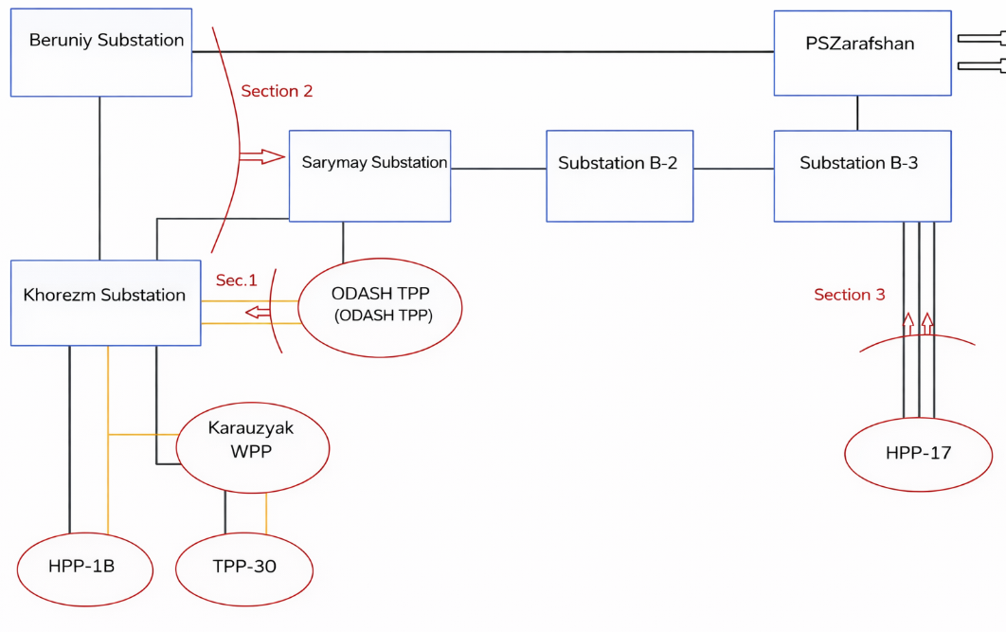
FIGURE 1. Structural diagram of the Northwestern power system node with the commissioning of the ODASH Thermal Power Plant and the Karauzyak Wind Power Plant

ТАBLE 1. Controlled sections
№ | Section Composition | Positive Power Flow Direction
1 | L-ODASH-Х-1, L-ODASH-Х-2. | From ODASH TPP busbars toward Khorezm Substation
2 | L-V-1-X, L-C-X-2. | From Khorezm Substation busbars toward Zarafshan Substation
3 | L-17-D, L-Besopan, L-17-A. | From Navoi TPP busbars toward NMMC

The power flow distribution after the commissioning of the ODASH Thermal Power Plant is presented in Tab 2. Under normal operating conditions of the Northwestern zone, based on actual load measurements recorded in December 2021, the generation output of the ODASH TPP amounts to 175 MW. In order to ensure acceptable normal operating conditions of the power system node, the generation level at the Takhiatash TPP is correspondingly reduced to 515 MW [10-34].
An operating condition corresponding to system loading increase indicates that an overload occurs on the 220 kV overhead transmission line L-1-X-2 when the generation output of the Takhiatash TPP reaches 815 MW. This overload reflects the limitation of the existing transmission network under high generation scenarios and highlights the sensitivity of power flow distribution to changes in generation dispatch within the Northwestern node.
The obtained results emphasize the necessity of coordinated generation control and the application of emergency control automation measures to prevent violations of thermal and stability limits of transmission lines under stressed operating conditions.

ТАBLE 2. Transmission Line Loadings and Power Flows under Normal and Stressed Operating Conditions with the Commissioning of the ODASH Thermal Power Plant.
Transmission Line | With ODASH TPP at 515 MW Generation of Takhiatash TPP |  | With ODASH TPP at 815 MW Generation of Takhiatash TPP
Transmission Line | Line Loading (%) | Power Flow (МW) | Line Loading (%) | Power Flow (МW)
L-1-X-2 | 58,65 | 141,6 | 99,7 | 234,3
L-1-Х-1 | 35,46 | 110,7 | 59,67 | 180,2
L-B-Х | 10,2 | 14,35 | 19,66 | -44,46
L-Beruniy | 45,4 | -135,7 | 68,55 | -194,76
L-V-1-X | 15,4 | 67,95 | 39,70 | 168,42
Л-С-Х-2 | 18,3 | 49,95 | 52,42 | 151,95

After the commissioning of the Karauzyak Wind Power Plant, no significant changes in power flow distribution are observed compared to the initial operating condition (Table 3). However, under stressed operating conditions, an overload of the 220 kV overhead transmission line L-1-X-2 begins to occur when the generation output of the Takhiatash Thermal Power Plant reaches 770 MW.

ТАBLE 3. Transmission Line Loadings and Power Flows under Normal and Stressed Operating Conditions with the Integration of the ODASH Thermal Power Plant and the Karauzyak Wind Power Plant.
Transmission Line | With ODASH TPP and Karauzyak WPP at 515 MW Generation of Takhiatash TPP |  | With ODASH TPP and Karauzyak WPP at 770 MW Generation of Takhiatash TPP
Transmission Line | Line Loading (%) | Power Flow (MW) | Line Loading (%) | Power Flow (МW)
L-1-X-2 | 53,56 | 131,49 | 100,31 | 234.24
L-B-Х | 12,21 | 20,85 | 19,21 | -44,22
L-Beruniy | 42,33 | -129,24 | 68,97 | -194,49
L-V-1-X | 18,03 | 82,95 | 46,06 | 194,04
L-X-Karauzyak | 47,23 | -149,1 | 76,52 | -220,47
L-Т-Karauzyak | 18,44 | -57,63 | 46,23 | -134,31
L-C-Х-2 | 21,48 | 64,71 | 61,21 | 177,63
At the next stage, to analyze the dynamic stability of the power system node, a three-phase short circuit is applied on the 220 kV overhead transmission line L–Sarymay in close proximity to the busbars of the Sarymay substation. The calculation results illustrating the variation of rotor angles of the generators at the Takhiatash Thermal Power Plant, Navoi Thermal Power Plant, and Tuyamuyun Hydropower Plant are presented below in the form of graphical plots.

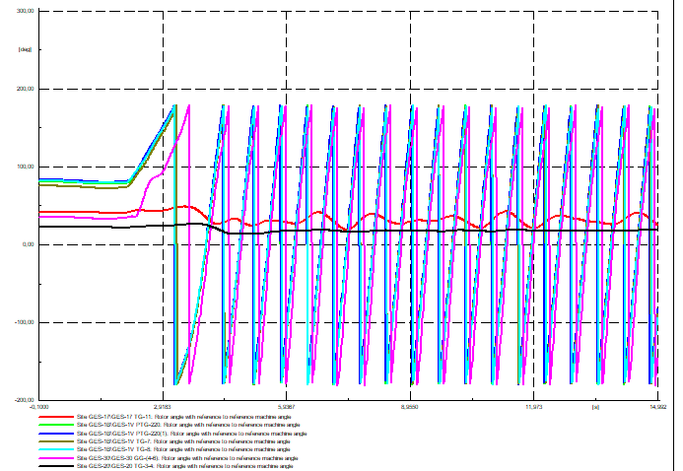
FIGURE 2. Rotor Angle Variation of Generators without Emergency Control Action.

As can be seen from the graphical results, an asynchronous operation is observed on the side of the Northwestern power system node. To preserve system stability under such conditions, an immediate reduction of generation in the Northwestern node is required. This can be achieved by applying one of the available emergency control actions aimed at reducing generation output.
In power system disturbances, particularly during short-circuit faults on transmission lines, an effective method for improving the dynamic stability of generators is short-term impulse turbine unloading followed by a gradual restoration of load according to either stepwise or exponential characteristics [4,8]. This control action allows the acceleration of generator rotors to be limited during the fault period and facilitates resynchronization after fault clearing.
Following the impulse unloading of the turbine of unit GT-1 at the Takhiatash Thermal Power Plant, the total generated power of the station is reduced by 185 MW. After the application of the emergency control automation, system stability is maintained, and damping is observed in the rotor angle oscillations of all generators within the studied power plants (Fig. 3).
At the same time, the resulting power deficit in the NMMC area is compensated by an increase in generation at the Navoi Thermal Power Plant. The post-disturbance power flow distribution is presented in Table 3, confirming the effectiveness of the applied emergency control measures in maintaining stable and secure system operation.
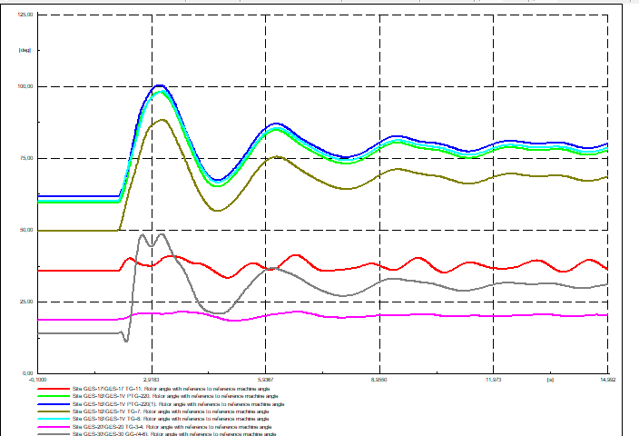

FIGURE 3. Rotor Angle Variation of Generators with Emergency Control Action.

ТАBLE 3. Post-Disturbance Transmission Line Loadings and Power Flows
Transmission Line | Line Loading (%) | ower Flow (MW)
L-1-X-2 | 60,52 | 149,04
L-B-Х | 10,01 | 9,06
L-V-1-X | 22,40 | 103,14
L-Beruni | 46,14 | -140,97
L-X- Karauzyak | 51,54 | -162,21
L-Т- Karauzyak | 22,65 | -71,37
L-С-Х-2 | 27,73 | 85,38

The stability analysis demonstrates that impulse turbine unloading satisfies the conditions required to maintain dynamic stability and is therefore recommended for implementation as a control action in the turbines of the Takhiatash Thermal Power Plant. An unloading impulse with a duration of 0.1–0.2 s, followed by a gradual increase in power output according to an exponential law, ensures rapid movement of turbine servomotors at their maximum speed. This significantly enhances the stability of the turbogenerator during the first and subsequent oscillation cycles. By adjusting the duration of the impulse, the magnitude of turbine unloading can be effectively regulated [7,8].
Based on the results obtained from the performed calculations and simulations, the following conclusions and recommendations are made:
- For the current operating conditions of the Northwestern power system node, the application of impulse turbine unloading as a control action ensures a smooth transition through emergency processes, prevents the development of cascading failures, and does not require additional capital investments.
- The most effective long-term solution for ensuring reliable and stable operation not only of the Northwestern node but also of the entire power system of the Republic of Uzbekistan is the acceleration of projects related to the construction of 500 kV transmission lines from the Sarymay substation to the Karakul substation and from the Sarymay substation to the Muruntau substation. In particular, the commissioning of these projects will strengthen interconnections between different parts of the power system and will further contribute to the formation of a closed 500 kV ring network, thereby improving system stability margins and operational reliability.
CONCLUSIONS
This study analyzes the impact of integrating new generating capacities, including the ODASH Thermal Power Plant and the Karauzyak Wind Power Plant, on the operating conditions and stability of the Northwestern power system node of the Republic of Uzbekistan. The results show that the commissioning of these power plants significantly affects power flow distribution in the 220 kV transmission network and reduces stability margins under stressed operating conditions, particularly at high generation levels of the Takhiatash Thermal Power Plant.
Steady-state power flow analysis indicates that while normal operating conditions remain acceptable, stressed scenarios lead to overloads of critical transmission lines, highlighting the need for coordinated generation dispatch and effective emergency control measures. Dynamic simulations under severe three-phase short-circuit disturbances demonstrate that, without emergency control actions, the system may experience loss of synchronism within the Northwestern node.
The performed transient stability analysis confirms that impulse turbine unloading is an effective emergency control measure for preserving rotor angle stability. A short-duration unloading impulse of 0.1–0.2 s followed by gradual power restoration ensures sufficient damping of electromechanical oscillations and maintains system synchronism during fault conditions. This control action can be implemented using existing turbine control systems and does not require additional capital investments.
In addition to operational measures, the study emphasizes the importance of strengthening the transmission network. The accelerated construction of 500 kV transmission lines connecting the Sarymay substation with the Karakul and Muruntau substations is identified as a key long-term solution for improving system reliability, enhancing interregional connectivity, and forming a robust 500 kV ring network.
Overall, the results demonstrate that a coordinated combination of emergency control automation and targeted network development is essential for ensuring stable and reliable operation of the Northwestern power system node under current and future operating conditions.
REFERENCES
- Oncept for Providing the Republic of Uzbekistan with Electric Power for the Period 2020–2030, Tashkent, Uzbekistan, 2020.
- Ya. D. Barkan and L. A. Orekhov, Automation of Power Systems. Moscow, Russia: Vysshaya Shkola, 2005.
- A. G. Phadke and J. S. Thorp, Synchronized Phasor Measurements and Their Applications. New York, NY, USA: Springer, 2008.
- IEEE PES Task Force, System Integrity Protection Schemes. IEEE, 2010.
- Y. Xue and X. Yu, “Smart grid: A cyber–physical system perspective,” IEEE Proceedings, vol. 104, no. 5, pp. 1058–1070, 2016.
- A. G. Phadke and J. S. Thorp, “Applications of synchrophasor measurements in power systems,” IEEE Transactions on Smart Grid, vol. 9, no. 2, pp. 196–204, 2018.
- J. Machowski, J. Bialek, and J. Bumby, Power System Dynamics: Stability and Control, 3rd ed., Wiley-IEEE Press, 2020.
- A. Ulbig, T. S. Borsche, and G. Andersson, “Impact of low rotational inertia on power system stability,” IEEE Transactions on Power Systems, vol. 30, no. 2, pp. 657–665, 2015.
- Rakhimov F, Rakhimov F, Samiev Sh, Abdukhalilov D. Justification of Technical and Economic Effectiveness of Application of 20 kV Voltage in Overhead Electric Networks //AIP Conf. Proc. 3152, 030023 (2024). https://doi.org/10.1063/5.0218921
- Taslimov A, Mo'minov V, Samiev Sh, Abdukhalilov D. Issues of Optimization of Electrical Network Parameters Medium Voltage //AIP Conf. Proc. 3331, 020007 (2025). https://doi.org/10.1063/5.0305781
- Mahmutkhonov S., Baizhonova L., Mustayev R., Tashmatova S. Dynamic analysis of voltage-ampere characteristics and harmonic distortions in electric arc furnaces. // AIP Conference Proceedings. 3331(1), 2025. pp. 070023, 1–5. https://doi.org/10.1063/5.0305745.
- Bobojanov M., Mahmutkhonov S. Influence of the consumer to power quality at the point of connection // E3S Web of Conferences 384. 2023. РР, 01041, 1-5. https://doi.org/10.1051/e3sconf/202338401041.
- Reymov K.M., Makhmuthonov S.K., Turmanova G., Uzaqbaev Q. Optimization of electric networks modes under conditions of partial uncertainty of initial information // E3S Web of Conferences 289, 07023 (2021). -2021, pp: 1-4, https://doi.org/10.1051/e3sconf/202128907023.
- Alimov, U.K., Reimov, A.M., Namazov, Sh.S., Beglov, B.M. The insoluble part of phosphorus fertilizers, obtained by processing of phosphorites of central kyzylkum with partially ammoniated extraction phosphoric acid. Russian Journal of Applied Chemistry. Russ J Appl Chem (2010) 83(3): 545–552. https://doi.org/10.1134/S107042721030328
- Reymov, A.M., Namazov, S.S., Beglov, B.M. Effect of phosphate additives on physical-chemical properties of ammonium nitrate. Journal of Chemical Technology and Metallurgy 2013 48(4), 391-395. http://dl.uctm.edu/journal/
- Urishev, B., Fakhriddin Nosirov, and N. Ruzikulova. 2023. “Hydraulic Energy Storage of Wind Power Plants.” E3S Web of Conferences, 383. https://doi.org/10.1051/e3sconf/202338304052
- Urishev, B., S. Eshev, Fakhriddin Nosirov, and U. Kuvatov. 2024. “A Device for Reducing the Siltation of the Front Chamber of the Pumping Station in Irrigation Systems.” E3S Web of Conferences, 274. https://doi.org/10.1051/e3sconf/202127403001
- Turabdjanov, S., Sh. Dungboyev, Fakhriddin Nosirov, A. Juraev, and I. Karabaev. 2021. “Application of a Two-Axle Synchronous Generator Excitations in Small Hydropower Engineering and Wind Power Plants.” AIP Conference Proceedings. https://doi.org/10.1063/5.0130649
- L.Jing, J.Guo, T.Feng, L.Han, Z.Zhou and M.Melikuziev, "Research on Energy Optimization Scheduling Methods for Systems with Multiple Microgrids in Urban Areas," 2024 IEEE 4th International Conference on Digital Twins and Parallel Intelligence (DTPI), Wuhan, China, 2024, pp. 706-711, https://ieeexplore.ieee.org/abstract/document/10778839
- Baratov, B.N., Umarov, F.Y., Toshov, Z.H. Tricone drill bit performance evaluation. Gornyi Zhurnal, Moscow, 2021. - № 12. - PP. 60-63. DOI:10.17580/gzh.2021.12.11.
- Toshov, J.B., Toshov, B.R., Baratov, B.N., Haqberdiyev, A.L. Designing new generation drill bits with optimal axial eccentricity | Вопросы проектирования буровых долот нового поколения с оптимальным межосевым эксцентриситетом // Mining Informational and Analytical Bulletin, 2022, (9). - PP. 133–142. DOI: 10.25018/0236_1493_2022_9_0_133
- Toshov J., Makhmudov A., Kurbonov O., Arzikulov G., Makhmudova G. Development and Substantiation of Energy-Saving Methods for Controlling the Modes of Operation of Centrifugal Pumping Units in Complicated Operating Conditions. Proceedings of the 11th International Conference on Applied Innovations in IT, (ICAIIT), November 2023, Koethen, Germany. – РР. 161-165.
- J.B. Toshov, K.T. Sherov, B.N. Absadykov, R.U. Djuraev, M.R. Sikhimbayev, Efficiency of drilling wells with air purge based on the use of a vortex tube. NEWS of the National Academy of Sciences of the Republic of Kazakhstan “Series of geology and technical sciences”. – Almaty, Volume 4, Number 460 (2023), 225–235. https://doi.org/10.32014/2023.2518-170X.331
Toshov J., Toshov B., Bainazov U., Elemonov M. Application of Cycle-Flow Technology in Coal Mines. Proceedings of the 11th International Conference on Applied Innovations in IT, (ICAIIT), March 2023, Koethen, Germany. – РР. 279-284.
- Usmanov, E., Kholikhmatov, B., Rikhsitillaev, B., Nimatov, K. Device for reducing asymmetry // E3s Web of Conferences 461. 2023. PP, 01052, 1-5. https://doi.org/10.1051/e3sconf/202346101052
- Toshov B., Toshov J., Akhmedova L., Baratov B. The new design scheme of drilling rock cutting tools, working in rotation mode pairs. E3S Web of Conferences 383, 04069 (2023) TT21C-2023 https://doi.org/10.1051/e3sconf/202338304069
- J.B. Toshev, M.B. Norkulov, A.A. Urazimbetova and L.G. Toshniyozov. Optimization of scheme of placing cutting structures on the cone drill bit. E3S Web of Conf., Volume 402, 10039 (2023), International Scientific Siberian Transport Forum - TransSiberia 2023, https://doi.org/10.1051/e3sconf/202340210039
- Toshov J., Baratov B., Sherov K., Mussayev M., Baymirzaev B., Esirkepov A., Ismailov G., Abdugaliyeva G., Burieva J. Ways to Optimize the Kinetic Parameters of Tricone Drill Bits. Material and Mechanical Engineering Technology, №1, 2024, 35-45. https://doi.org/10.52209/2706-977X_2024_1_35
- K.T. Sherov, N.Zh. Karsakova, B.N. Absadykov, J.B. Toshov, M.R. Sikhimbayev, Studying the effect of the boring bar amplitude-frequency characteristics on the accuracy of machining a large-sized part. NEWS of the National Academy of Sciences of the Republic of Kazakhstan “SERIES OF GEOLOGY AND TECHNICAL SCIENCES”. – Almaty, Volume 2, Number 464 (2024), 217–227. https://doi.org/10.32014/2024.2518-170X.405
- J. Toshov, L. Atakulov, G. Arzikulov, U. Baynazov, Modeling of optimal operating conditions of cyclic-flow technologies with a belt conveyor at coal mine under the "ANSYS" program. AIP Conf. Proc. 3152, 020006 (2024) / III International Scientific and Technical Conference “Actual issues of Power supply systems” (ICAIPSS2023), 7–8 September 2023, Tashkent, Uzbekistan. https://doi.org/10.1063/5.0218904
- Kholikhmatov B.B., Samiev Sh.S., Erejepov M.T., Nematov L.A. Modelling of laboratory work in the science "Fundamentals of power supply" using an educational simulator based on a programmed logic controller // E3S Web of Conferences 384. 2023. РР, 01032, 1-3. https://doi.org/10.1051/e3sconf/202338401032
- Rakhimov F, Rakhimov F, Samiev Sh, Abdukhalilov D. Justification of Technical and Economic Effectiveness of Application of 20 kV Voltage in Overhead Electric Networks //AIP Conf. Proc. 3152, 030023 (2024). https://doi.org/10.1063/5.0218921
- Toshbekov, O., Urazov, M., Yermatov, S., & Khamraeva, M. 2023). Yeffisient and yesonomisal yenergy use teshnology in the prosessing of domestis soarse wool fiber. In Ye3S Web of Sonferenses (Vol. 461, p. 01068). https://doi.org/10.1051/e3sconf/202346101068
- Jumaniyozov, K., Urozov, M., Toshbekov, O., Salimova, M., Raximova, K., & Khursandova, B. (2025, November). Enhancement of energy-efficient cleaning equipment. In American Institute of Physics Conference Series (Vol. 3331, No. 1, p. 050007). https://doi.org/10.1063/5.0307149
- Sultonova, F., Toshbekov, O., Urozov, M., Boymurova, N., Mustanova, Z., & Boltaeva, I. (2025, November). Enhancing and evaluating the characteristics of specialized workwear for employees in the electric power supply sector. In American Institute of Physics Conference Series (Vol. 3331, No. 1, p. 050006). https://doi.org/10.1063/5.0306350

