Parametric identification and training of a hybrid network for an intelligent automated management model of grape growing
Mokhira Pulotova^{1 a)}, Aziz Abduganiev², Nafisa Ismatova¹, Mekhrinigor Yuldasheva³ , Ibrohim Karimov¹
¹ Bukhara State Technical University, Bukhara, Uzbekistan
² Tashkent Institute of Engineers of Irrigation and Agricultural Mechanization National Research University, Tashkent, Uzbekistan
³ Bukhar state university, Uzbekistan, Bukhara
^{a)} Corresponding author: mohirapr@gmail.com
Abstract. In this article, the problem of parametric identification of a hybrid network and its associated training algorithm is examined in detail with a focus on optimal control applications in agricultural systems, particularly grape growing. A hybrid network, commonly referred to as a neuro-fuzzy network, represents a powerful intelligent modeling framework that integrates a fuzzy logic system—typically an expert system based on linguistic IF–THEN rules—with an artificial neural network. This integration combines the human-like reasoning, interpretability, and capability of fuzzy logic to handle uncertainty, imprecision, and linguistic knowledge with the strong learning, adaptation, and pattern recognition abilities of neural networks. In grape growing systems, optimal management of irrigation, fertilization, and agro-technological operations requires accurate modeling of complex nonlinear relationships between agroecological factors and crop productivity indicators. These factors include soil moisture, air temperature, relative humidity, solar radiation, vegetation indices, and technological control parameters. Due to the inherent uncertainty, variability, and incomplete information in real vineyard conditions, classical analytical and purely data-driven models often fail to provide reliable and interpretable solutions. The neuro-fuzzy hybrid network addresses these challenges by incorporating expert agronomic knowledge into the model structure through fuzzy rules, while simultaneously adapting model parameters using experimental and sensor-based data collected from vineyards. Parametric identification plays a critical role in this process, as it involves tuning membership function parameters, rule weights, and neural network connections to minimize the deviation between model outputs and observed system behavior. The proposed training algorithm enables the hybrid network to learn optimal control strategies by continuously updating its parameters based on environmental changes and operational feedback. As a result, the developed neuro-fuzzy model can generate optimal control actions, such as irrigation scheduling and resource allocation, aimed at maximizing grape yield, improving resource efficiency, and ensuring sustainable vineyard management. Overall, the integration of neuro-fuzzy hybrid networks into grape growing systems provides an effective and interpretable approach for optimal control under uncertain and dynamic agroecological conditions. The results demonstrate the high potential of the proposed method for intelligent automated management systems in precision viticulture.
INTRODUCTION
The parametric identification task consists in finding a fuzzy model F that minimizes the mean square error (MSE) according to:
$\frac{1}{M}\sum_{r=1}^{M}{[{Y_{r}-F(I,O,X_{r})]}^{2}→min}$ (1)
where I-input vector of fuzzy system parameters for the input variable, O-vector of fuzzy system parameters for the output variable, ($X_{r}, Y_{r}$)-data sample; $X_{r}=(X_{r1,}X_{r2}, … X_{rn})$-input vector; $Y_{r}$-output in the r-th pair$\left(r=\overline{1,M}\right);$–sample size. The problem is solved in two passes: forward and backward. In the forward pass, the theoretical output (model output values y) is determined, and in the backward pass, based on the computed mean square error, the error between the theoretical and practical outputs (training sample) is used to adjust the rule weights and fuzzy system parameters.

EXPERIMENTAL RESEARCH
The parametric identification of a neuro-fuzzy hybrid network for optimal grape growing management involves a systematic sequence of steps designed to adjust the model parameters to match the real behavior of the vineyard system. The algorithm integrates fuzzy logic with neural network learning, enabling the hybrid system to accurately capture the nonlinear dependencies between agroecological factors and grape productivity indicators. The key stages of the algorithm are as follows:[1-18]
Step 1: Data Acquisition and Preprocessing. Environmental and agronomic data are collected from vineyard sensors and experimental measurements. This includes soil moisture, air temperature, relative humidity, solar radiation, vegetation indices (e.g., NDVI, EVI), irrigation events, and other technological management parameters. The raw data are normalized and, if necessary, smoothed to reduce measurement noise, ensuring robust input to the hybrid network.
Step 2: Structural Identification and Rule Base Formation.A fuzzy knowledge base is constructed based on linguistic expert rules describing the influence of input variables on grape yield and physiological states. Typical rules follow the “IF–THEN” structure, for example: IF soil moisture is low AND air temperature is high THEN water stress is high. This stage ensures that expert agronomic knowledge is integrated into the model, allowing it to handle uncertainty and imprecision inherent in real vineyard conditions.
Step 3: Initial Parameter Assignment. Membership functions for each input and output variable are defined and initialized. Input term sets, such as {very low, low, medium, high, very high}, are assigned to soil moisture, temperature, or vegetation indices. Output variables, e.g., expected yield or irrigation decision levels, are similarly represented by fuzzy sets. Initial weights for fuzzy rules and neural network connections are assigned based on expert knowledge and prior studies.
Step 4: Fuzzy Inference and Simulation. Using the constructed fuzzy knowledge base, the hybrid network performs fuzzy inference, transforming fuzzy input variables into fuzzy outputs. This step provides preliminary estimates of system behavior and helps identify initial discrepancies between model outputs and observed data.
Step 5: Parametric Optimization (Training). The core of the algorithm involves iterative adjustment of model parameters to minimize the error between predicted outputs and measured vineyard data. Parameters optimized include:
- Membership function shapes (e.g., centers and widths),
- Rule weights,
- Neural network connection weights.
Standard optimization methods such as gradient descent, hybrid learning (combining least-squares and backpropagation), or evolutionary algorithms can be employed depending on model complexity and data availability.
Step 6: Validation and Performance Evaluation. The optimized model is validated against a separate set of experimental vineyard data not used during training. Performance metrics such as Mean Squared Error (MSE), Root Mean Squared Error (RMSE), and coefficient of determination (R²) are calculated to assess prediction accuracy. The model’s ability to generate consistent and interpretable control actions, such as irrigation scheduling or fertilization decisions, is also evaluated.
Step 7: Implementation for Optimal Control. Once validated, the neuro-fuzzy hybrid network is deployed for real-time vineyard management. The model generates optimal control signals based on current agroecological inputs, adapting to changing environmental conditions and operational requirements. This facilitates efficient water use, enhanced grape yield, and sustainable vineyard management.
Conclusion of the Algorithm. The parametric identification algorithm provides a systematic approach to tuning a hybrid neuro-fuzzy network for precision viticulture. By combining expert knowledge with adaptive learning from real vineyard data, the algorithm ensures accurate modeling of complex nonlinear relationships and supports optimal decision-making under uncertainty and dynamic agroecological conditions.
Algorithm of parametric identification:
- The control object of the form is defined
$y=F\left(X_{r, }I, O, W\right);$ (2)
for which the relationship “inputs ($x_{i, }$​)-output (y)” can be represented in the form of an expert matrix (knowledge base).
This expert knowledge base differs from a standard knowledge base
$u_{j=1.1}:IF\left[\left(x_{1}=a_{1, j1}\right) and \left(x_{2}=a_{2, j1}\right) and…and \left(x_{n}=a_{n, j1}\right)\right]\left(with weight {w }_{11}\right)THEN y∈d_{1} OR$
$$u_{j=1.2}:IF\left[\left(x_{1}=a_{1, j2}\right) and \left(x_{2}=a_{2, j2}\right) and…and \left(x_{n}=a_{n, j2}\right)\right]\left(with weight {w }_{12} \right)THEN y∈d_{1};$$
… $OR$
$$u_{j=2.1}:IF\left[\left(x_{1}=a_{1, j2}\right) and \left(x_{2}=a_{2, j2}\right) and…and \left(x_{n}=a_{n, j1}\right)\right]\left(with weight {w }_{21}\right)THEN y∈d_{2} OR$$
$$u_{j=2.2}:IF\left[\left(x_{1}=a_{1, j2}\right) and \left(x_{2}=a_{2, j2}\right) and…and \left(x_{n}=a_{n, j2}\right)\right]\left(with weight {w }_{22} \right)THEN y∈d_{2};$$
… $OR$
…… …
$u_{jp}:IF\left[\left(x_{1}=a_{1, jk(j)}\right) and \left(x_{2}=a_{2, jk(j)}\right) and…and \left(x_{n}=a_{n, jk(j)}\right)\right]\left(with weight {w }_{jp}\right)THEN y∈d_{j}=(y_{j-1,}y_{j),} for all j =\overline{1,…,m};$ (3)
and
$u_{j=1.1}:IF\left[\left(x_{1}=a_{1, j1}\right) and \left(x_{2}=a_{2, j1}\right) and…and \left(x_{n}=a_{n, j1}\right)\right]\left(with weight {w }_{11}\right)THEN y=d_{1} OR$
$$u_{j=1.2}:IF\left[\left(x_{1}=a_{1, j2}\right) and \left(x_{2}=a_{2, j2}\right) and…and \left(x_{n}=a_{n, j2}\right)\right]\left(with weight {w }_{12} \right)THEN y=d_{1};$$
… $OR$
$$u_{j=2.1}:IF\left[\left(x_{1}=a_{1, j2}\right) and \left(x_{2}=a_{2, j2}\right) and…and \left(x_{n}=a_{n, j1}\right)\right]\left(with weight {w }_{21}\right)THEN y=d_{2} OR$$
$$u_{j=2.2}:IF\left[\left(x_{1}=a_{1, j2}\right) and \left(x_{2}=a_{2, j2}\right) and…and \left(x_{n}=a_{n, j2}\right)\right]\left(with weight {w }_{22} \right)THEN y=d_{2};$$
… $OR$
…… …
$u_{jp}:IF\left[\left(x_{1}=a_{1, jk(j)}\right) and \left(x_{2}=a_{2, jk(j)}\right) and…and \left(x_{n}=a_{n, jk(j)}\right)\right]\left(with weight {w }_{jp}\right)THEN y=d_{j}=(y_{j-1,}y_{j),} for all j =\overline{1,…,m};$ $(4)$

in that it additionally contains weights W. The value of the weights W is a number in the range [0,1], characterizing the degree of confidence of the expert in a particular statement. P-vector of fuzzy system parameters for the input variable X.
- A training dataset is defined: ($X_{r}, y_{r}), r=\overline{1,M},$ where $X_{r}=(X_{r1},X_{r1},….X_{r,n})$-input vector, and $y_{r}$-output of the r-th pair; M-sample size.
- The hybrid (neuro-fuzzy) network ANFIS (Adaptive Neuro-Fuzzy Inference System) is specified (Figure1) [1-8].
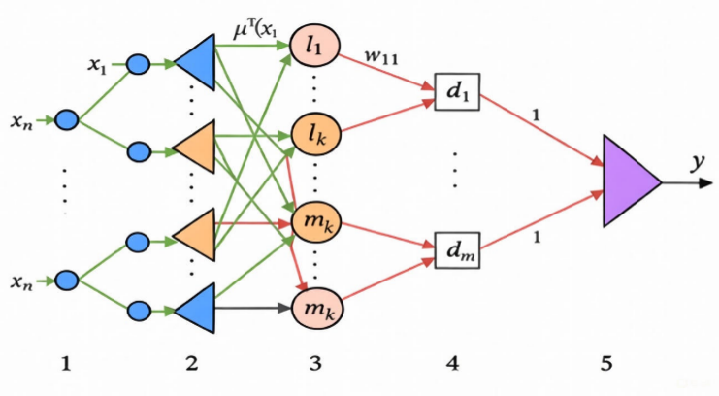

Figure 1. Structure of the ANFIS hybrid network

- Forward pass-the output values y of the model are determined in accordance with the specified architecture of the hybrid network.
The ANFIS network operates as follows:
Layer 1. Each node of the first layer represents a single term with a bell-shaped membership function. The network inputs $x_{1} , x_{2}, …. x_{n}$ are connected only to their corresponding terms. The number of nodes in the first layer equals the sum of the cardinalities of the term sets of the input variables. The output of a node is the degree of membership of the input variable value to the corresponding fuzzy term:
$μ_{r}\left(x_{i}\right)=\frac{1}{1+{\left|\frac{x_{i}-c}{a}\right|}^{2b}};$ (5)
where a,b,ca, b, ca,b,c are the tunable parameters of the membership function.
Layer 2. The number of nodes in the second layer is equal to mmm. Each node of this layer corresponds to one fuzzy rule. A node in the second layer is connected to those nodes that form the antecedents of the corresponding rule. Consequently, each node of the second layer can receive from 1 to nnn signals. The node output is the firing strength of the rule, which is calculated as the product of the input signals. Let the outputs of the nodes of this layer be denoted by $τ_{r r}=\overline{1,m}$.
Layer 3. The number of nodes in the third layer is also equal to mmm. Each node of this layer computes the normalized firing strength of a fuzzy rule according to the formula:
$τ_{r}^{*}=\frac{τ_{r}}{\sum_{j-\overline{1.m}}{τ_{j}}}$; (6)
Layer 4. The number of nodes in the fourth layer is also equal to mmm. Each node is connected to one node of the third layer as well as to all inputs of the network. It computes the contribution of a single fuzzy rule to the network output according to the following formula.
$y_{r}=τ_{r}^{*}+(b_{0,r}+b_{1,r }x1+b_{n,r }xn)$. (7)
Layer 5. The single node of this layer sums the contributions of all rules:
$y=y_{1}+…y_{r}+…y_{m}.$ (8)
5) The mean squared error (MSE) is calculated based on equation (1).
6) Backward pass-the tuning parameters of the hybrid network are determined using the backpropagation of error algorithm according to the following formulas:
$w_{jp}\left(t+1\right)=w_{jp}\left(t\right)-η\frac{{∂E}_{t}}{{∂w}_{jp}(t)}$; (9)
$c_{i}^{jp}\left(t+1\right)=c_{i}^{jp}\left(t\right)-η\frac{{∂E}_{t}}{∂c_{i}^{jp}\left(t\right)};$ (10)
$b_{i}^{jp}\left(t+1\right)=b_{i}^{jp}\left(t\right)-η\frac{{∂E}_{t}}{∂b_{i}^{jp}\left(t\right)} i=\overline{1,m} , j=\overline{1,m} , p=k_{j }$; (11)
where $w_{jp}(t)$ , $c_{i}^{jp}(t)$, $b_{i}^{jp}\left(t\right)$-are the parameters to be identified at the ttt-th training step: the rule weights (w) and the membership function (MF) parameters (b,c); η-is the learning rate; t is the number of training iterations.
RESEARCH RESULTS
The Adaptive Neuro-Fuzzy Inference System (ANFIS) was trained to model grape yield based on agroecological inputs. The network consisted of 78 nodes, 108 linear parameters, 27 nonlinear parameters, and a total of 135 parameters. The training dataset included 100 input-output pairs, and an additional 100 pairs were used for checking and validation purposes. The ANFIS model was constructed with 27 fuzzy rules to capture the nonlinear relationships between input variables and grape yield [9-13].
Training was performed over 50 epochs. During the training process, the root mean squared error (RMSE) gradually decreased from an initial value of 0.1240 to 0.0572, indicating a consistent reduction in prediction error and convergence of the model. Similarly, the checking RMSE followed the same trend, demonstrating that the model generalizes well to unseen data. The mean squared error (MSE) of the trained ANFIS was 0.0033, confirming the high accuracy of the model in approximating vineyard yield dynamics [1-8].
The learning process included adaptive adjustments to the step size, which increased progressively after specific epochs to accelerate convergence while maintaining stability. This strategy allowed the network to efficiently explore the parameter space, optimizing both membership functions and rule weights.
Figures 2–4 illustrate the performance of the trained ANFIS model. Figure 2 shows the comparison between actual and predicted grape yield, indicating a close alignment and effective model approximation. Figure 3 presents the membership functions of the input variables, highlighting the fuzzy representation of soil moisture, temperature, relative humidity, and other agroecological factors. Figure 4 summarizes the ANFIS yield prediction performance, showing minimal discrepancy between predicted and observed values, further confirming the model’s reliability [14-18].
Overall, these results demonstrate that the trained ANFIS provides an accurate and robust framework for modeling complex nonlinear relationships in grape production. The combination of fuzzy logic with adaptive neural learning enables the system to handle uncertainty, incorporate expert knowledge, and generate reliable yield predictions, making it suitable for precision viticulture and optimal irrigation management.
Table 1. Adaptive Neuro-Fuzzy Inference System (ANFIS) Training Log Showing Epoch-by-Epoch RMSE, Step Size Adjustments, and Model Performance.
ANFIS info:
Number of nodes: 78
Number of linear parameters: 108
Number of nonlinear parameters: 27
Total number of parameters: 135
Number of training data pairs: 100
Number of checking data pairs: 100
Number of fuzzy rules: 27

Start training ANFIS ...

1 0.124045 0.124045
2 0.12302 0.12302
3 0.121999 0.121999
4 0.120983 0.120983
Step size increases to 0.011000 after epoch 5.
5 0.119972 0.119972
6 0.118966 0.118966
7 0.117865 0.117865
8 0.11677 0.11677
Step size increases to 0.012100 after epoch 9.
9 0.115681 0.115681
10 0.114598 0.114598
11 0.113413 0.113413
12 0.112236 0.112236
Step size increases to 0.013310 after epoch 13.
13 0.111066 0.111066
14 0.109903 0.109903
15 0.108633 0.108633
16 0.107372 0.107372
Step size increases to 0.014641 after epoch 17.
17 0.106119 0.106119
18 0.104876 0.104876
19 0.103519 0.103519
20 0.102174 0.102174
Step size increases to 0.016105 after epoch 21.
21 0.100839 0.100839
22 0.0995165 0.0995165
23 0.098075 0.098075
24 0.096648 0.096648
Step size increases to 0.017716 after epoch 25.
25 0.0952356 0.0952356
26 0.0938381 0.0938381
27 0.0923186 0.0923186
28 0.0908178 0.0908178
Step size increases to 0.019487 after epoch 29.
29 0.0893364 0.0893364
30 0.0878747 0.0878747
31 0.0862902 0.0862902
32 0.0847308 0.0847308
Step size increases to 0.021436 after epoch 33.
33 0.0831971 0.0831971
34 0.0816898 0.0816898
35 0.0800631 0.0800631
36 0.07847 0.07847
Step size increases to 0.023579 after epoch 37.
37 0.0769112 0.0769112
38 0.0753874 0.0753874
39 0.0737526 0.0737526
40 0.0721617 0.0721617
Step size increases to 0.025937 after epoch 41.
41 0.0706149 0.0706149
42 0.0691126 0.0691126
43 0.067511 0.067511
44 0.0659623 0.0659623
Step size increases to 0.028531 after epoch 45.
45 0.0644651 0.0644651
46 0.0630175 0.0630175
47 0.06148 0.06148
48 0.0599965 0.0599965
Step size increases to 0.031384 after epoch 49.
49 0.0585631 0.0585631
50 0.0571759 0.0571759

Designated epoch number reached. ANFIS training completed at epoch 50.

Minimal training RMSE = 0.0571759
Minimal checking RMSE = 0.0571759
ANFIS MSE = 0.0033

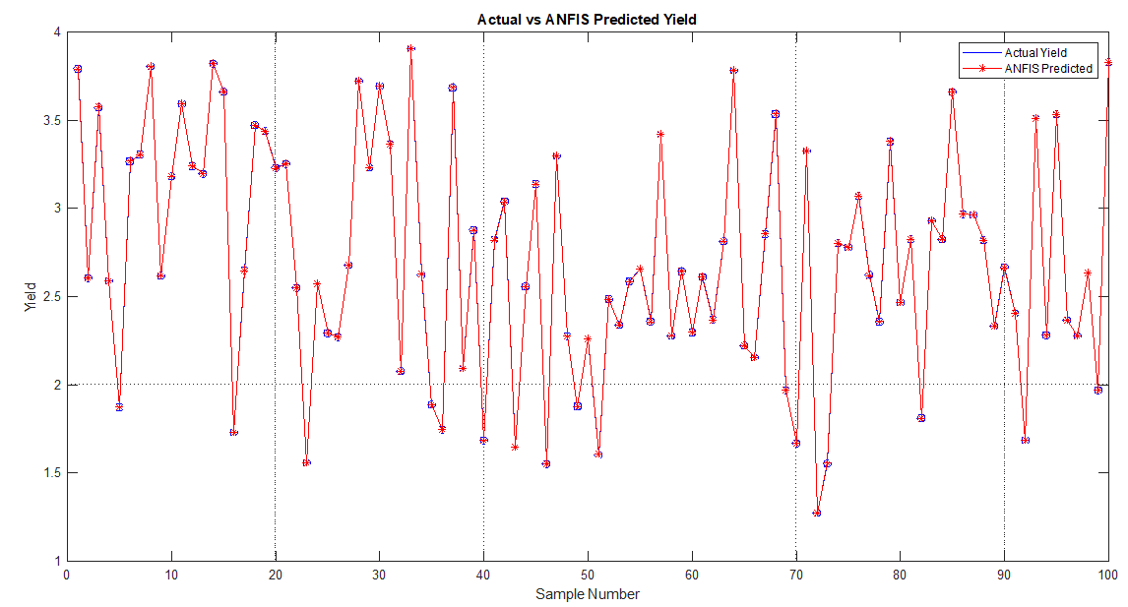
Figure 2. Actual vs ANFIS Predicted Yield

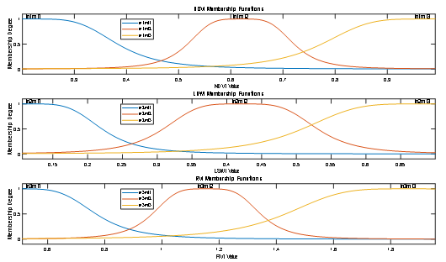
Figure 3. Membership Functions of Input Variables

Designated epoch number reached. ANFIS training completed at epoch 50.

Minimal training RMSE = 0.00145052
Minimal checking RMSE = 0.00145052
ANFIS MSE = 0.0000
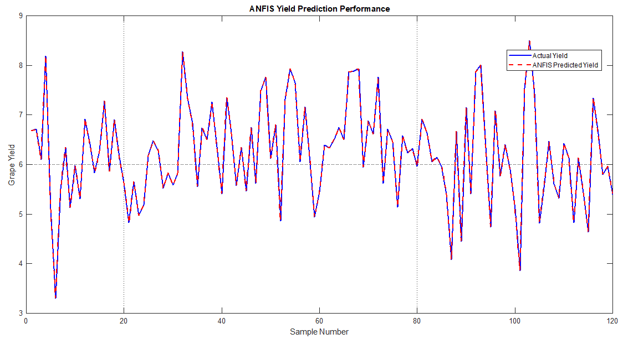
Figure 4. ANFIS Yield Prediction Performance

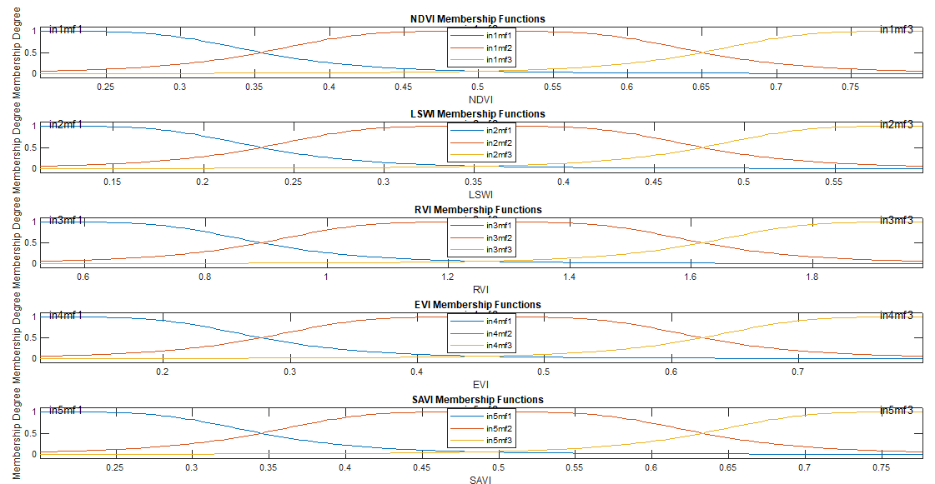
Figure 5. NDVI Membership Functions

CONCLUSIONS
Simulation results indicate that the proposed ANFIS (Adaptive Neuro-Fuzzy Inference System)–based model is capable of accurately representing the complex and nonlinear relationship between vegetation indices (such as NDVI, EVI, and others) and grape yield, which are considered critical factors in the grape production process.
The main advantage of the proposed model lies in its ability to:
- learn nonlinear processes that cannot be adequately described by conventional linear models;
- account for the variability of real agroecological conditions;
- integrate knowledge-based fuzzy logic with data-driven neural networks in a hybrid framework.
The low value of the Mean Squared Error (MSE) obtained in the simulation results indicates a high level of prediction accuracy. This, in turn, confirms that:
- the parametric identification process has been carried out in a stable and reliable manner;
- overfitting has not occurred during the training phase of the model;
- the model demonstrates sufficient robustness for application in real-world systems.
Furthermore, the effectiveness of the hybrid neuro-fuzzy approach is of significant importance for intelligent vineyard management systems, as it enables efficient solutions to tasks such as:
- early prediction of grape yield;
- optimization of irrigation scheduling and agronomic practices;
- rational and efficient use of resources (water, fertilizers, and energy);
- automation of the decision-making process.
Concise Academic Version (for journal or dissertation use)
Simulation results demonstrate that the proposed ANFIS-based model effectively captures the nonlinear relationship between vegetation indices and grape yield. The low Mean Squared Error (MSE) value confirms the stability of the parametric identification process and highlights the suitability and effectiveness of the hybrid neuro-fuzzy approach for application in intelligent vineyard management systems.
Simulation results demonstrate that the proposed ANFIS-based model effectively captures the nonlinear relationship between vegetation indices and grape yield. The low MSE value confirms the robustness of the parametric identification process and the suitability of the hybrid neuro-fuzzy approach for intelligent vineyard management systems [9-13].
REFERENCES
- P. Aparicio et al., “Control of HVAC system comfort by sampling,” in Proceedings of the International Conference on Industrial Engineering and Operations Management (ICIEOM 2012), Guimarães, Portugal, July 9–11 (2012), p. 10.
- M. W. Ahmad, M. Mourshed, B. Yuce, and Y. Rezgui, “Computational intelligence techniques for HVAC systems: A review,” Building Simulation 9, 359–398 (2016). https://doi.org/10.1007/s12273-016-0285-4
- B. A. Belgibaev, A. A. Umarov, and V. V. Nikulin, “Models of monitoring and control systems of greenhouse microclimate parameters: Review of the current state and analysis of development trends,” in Proceedings of the XIX International Scientific and Technical Conference ‘Problems of Engineering and Telecommunication Technologies’, Uralsk, Kazakhstan (2018), pp. 384–397.
- R. Kramer, J. van Schijndel, and H. Schellen, “Simplified thermal and hygric building models: A literature review,” Frontiers of Architectural Research 1(4), 318–325 (2012).
- Zh. Kh. Zhunussova, S. Sh. Iksanov, and A. A. Umarov, “Smart campuses: A review of the current state and analysis of development directions,” in Abstracts of the International Conference “Mathematical, Physical Sciences and Engineering Applications”, Davao, Philippines, March 9–12 (2018).
- I. Meleshin, Data Analysis and Machine Learning in MATLAB, The MathWorks Inc., Natick, MA (2014), 60 p.
- T. J. Ross, Fuzzy Logic with Engineering Applications, 3rd ed., John Wiley & Sons, Chichester (2010), 607 p.
- S. D. Shtovba, Design of Fuzzy Systems Using MATLAB, Goryachaya Liniya–Telekom, Moscow (2007), 288 p.
- A. Arifjanov and M. Pulotova, “Analysis of methods and algorithms for determining the parameters of control objects on the example of formalin production,” AIP Conference Proceedings 2789, 030007 (2023). https://doi.org/10.1063/5.0145474
- A. Arifjanov and M. Pulotova, “Analysis of the physical and chemical processes of formalin production for building a decision support system in management,” AIP Conference Proceedings 2789, 030006 (2023). https://doi.org/10.1063/5.0145473
- A. Arifjanov and M. Pulotova, “Development of a predictive model of the formalin production process under the influence of deviation,” AIP Conference Proceedings 2789, 030026 (2024).
- A. Arifjanov and M. Pulotova, “Analysis of the physical and chemical processes of formalin production for building a decision support system in management,” AIP Conference Proceedings 3147, 030006 (2023), International Scientific and Practical Conference on Actual Problems of Mathematical Modeling and Information Technology, Nukus, Uzbekistan, May 2–3. https://doi.org/10.1063/5.0145473
- M. Pulotova and G. Muzaffarova, “Algorithm for creating a conceptual model of forecasting and optimization of the formalin production process,” AIP Conference Proceedings 3147, 030007 (2023), International Scientific and Practical Conference on Actual Problems of Mathematical Modeling and Information Technology, Nukus, Uzbekistan, May 2–3.
- D. W. U. Perera, C. F. Pfeiffer, and N.-O. Skeie, “Control of temperature and energy consumption in buildings – A review,” International Journal of Energy and Environment 5(4), 471–484 (2014).
- N. J. Rabadi, “Developing a software to predict thermal comfort of humans at work,” Jordan Journal of Mechanical and Industrial Engineering 5(4), 359–368 (2011).
- S. P. Y. Kishore and V. Suresh Kumar, “Real-time thermal comfort sensing using a computer-aided module,” International Journal of Advanced Research in Electrical, Electronics and Communication Engineering 5(2), 412–415 (2016).
- A. P. Ferreira, D. Mose, and J. C. Oh, “Thermal faults modeling using an RC model with application to web farms,” in Proceedings of the 19th Euromicro Conference on Real-Time Systems (ECRTS’07) (2007), pp. 113–124.
- E. Donaisky, G. H. C. Oliveira, and N. Mendes, “Real-time implementation of PID-based thermal comfort control algorithms,” in Proceedings of the 19th International Congress of Mechanical Engineering (COBEM 2007), Brasilia, Brazil, November 5–9 (2007).
- S. A. Kulmamirov, B. A. Belgibaev, and A. A. Umarov, Practical Models of PID Control, L. N. Gumilyov Eurasian National University, Astana (2019), 164 p.

