Experimental Studies of a Device for Crushing and Packaging Plant Residues
Djapbar Alijanov ¹, Abdulla Tulaev², Ikrom Djurayev^{3, a)}
¹National Research University Tashkent Institute of Irrigation and Agriculture Mechanization Engineers, Tashkent, Uzbekistan
²Samarkand State University of Veterinary Medicine, Animal Science and Agricultural Technology, Samarkand, Uzbekistan
³ Termez State University of Engineering and Agrotechnologies, Termez, Uzbekistan
^{a)} Corresponding author: ikromdjuraev53@gmail.com
Abstract. The paper presents the design, technological and kinematic diagrams of the device for crushing and packaging the remains of agricultural plants, the device and the operating principle, with the aim of verifying theoretical research and determining the factors influencing the process of crushing and packaging the remains of plant crops. As well as the results of experimental studies conducted in laboratory conditions to optimize the parameters and operating modes of the installation.
INTRODUCTION
Agricultural harvesting takes place in the fall. However, it's common knowledge that harvesting leaves crop residues (stems, tops, leaves, husks, weeds, etc.) in the fields. These residues can be effectively used as livestock feed, as they contain a certain amount of proteins, fats, carbohydrates, minerals, and vitamins. Unfortunately, in some regions, they are not collected in a timely manner and are burned.
To determine the possibility of using plant residues as livestock feed, their nutritional value and yield from fields were studied [1]. Analysis of the results of this work shows that the nutritional value of plant residues can be used as feed, and the yield per unit area can represent a significant feed reserve.
Specialized machines and devices exist for short-term collection of crop residues [2-8]. The main disadvantages of existing stationary machines are their high metal and energy consumption, as well as the labor-intensive nature of their use in the field.
With this in mind, scientists from the Samarkand State University of Veterinary Medicine, Animal Husbandry, and Agricultural Technology have developed a machine for processing and packaging plant residues in the field [9].
MATERIALS AND METHODS
To test theoretical research and identify factors influencing the process of crushing and packaging agricultural waste, developed design and technological scheme, a model of a device for crushing and packaging plant waste was manufactured, capable of operating both in laboratory and field conditions (Fig. 1, a).
Based on the design and process diagram of the device and the developed working drawings, a prototype device was manufactured at JSC BMKB AGROMASH. The packaging portion of the device is shown in Figure 1, b.
It closely approximates the real process and allows for experimental study of the interaction of the working parts with the forage. The device is mounted on the tractor's suspension and is driven by the tractor's power take-off shaft. The kinematic diagram of the device is shown in Figure 2. The number of revolutions of the feed conveyor changes by replacing the sprockets, and the number of revolutions of the grinding device and the dosing auger changes by replacing the pulleys.
The laboratory setup, in turn, ensures the registration of forces and moments arising on the shaft of the opposing knives and the grinding device. To comprehensively study the process of cutting stems with moving chopping knives during operation of the chopper, as well as internal and external influences, the laboratory setup was equipped with special sensors measuring forces and moments. During the experiments, it was possible to output data obtained from the grinding device directly to a computer in real time using control and measuring instruments.
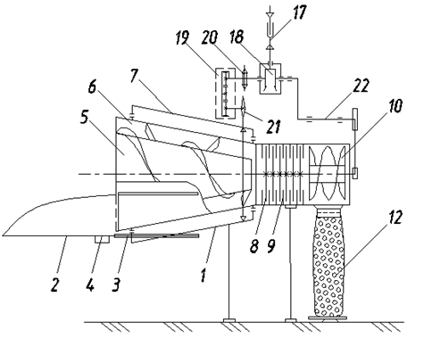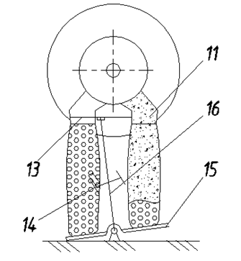
a) b)
FIGURE 1. Diagram of a device for crushing. a) packaging plant residues; b) packaging part.

The natural version of the laboratory setup consists of 1-frame; 2-chute; 3-track for movement of the chute; 4-separator; 5-stationary and 6-rotating conical screw feeder; 7, 8-cutting knives; 9-double-sided counter-shear plates; 10-screw feeder for receiving crushed materials and transferring them to bag containers; 11-two-way unloading path; 12-container bag; 13-lid; 14-folding adjustment weight; 15-mass dispenser; 16-dispenser tip; 17-cardan transmission with drive from tractor power take-off shaft; 18-bevel and 19-cylindrical gearboxes; 20-clutch, 21-chain drive; 22-roller drive.

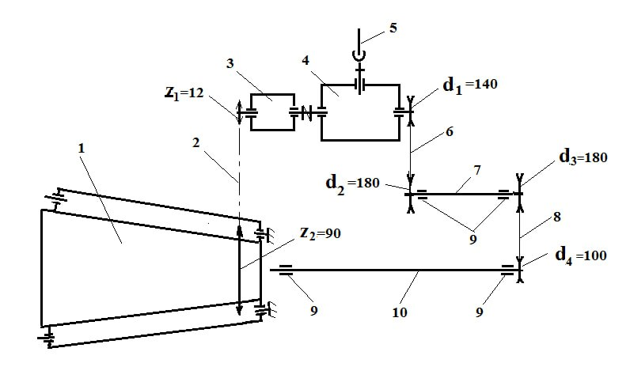
FIGURE 2. Kinematic diagram of a device for crushing and packaging plant residues: 1-feed conveyor; 2-chain transmission; 3-small gearbox; 4-large gearbox; 5-tractor power take-off shaft; 6-belt transmission; 7-intermediate shaft; 8-belt transmission; 9-ball bearings; 10-shaft of the chopping apparatus and auger dispenser.
To determine the optimal joint values of the parameters and modes investigated in theoretical studies and single-factor experiments of the developed plant residue shredder, multi-factor experiments were conducted [10-13].
RESULTS AND DISCUSSION
Based on the results of theoretical studies and single-factor experiments, factors, their designations, ranges of change and levels influencing the operation of the disc grinding apparatus were determined (Table 1). Since the process is influenced by 3 main factors, the Hartley-3 design based on a minimum of 2^{k-r} constant replicas (Table 2) was adopted for conducting multifactorial experiments. The Hartley-3 design is somewhat more economical than the orthogonal central composition (OCC) design and the rototable central composition (RCC) design, allowing for higher accuracy with fewer experiments.
When conducting multifactorial experiments, the torque on the gearbox shaft and the cutting length of plant stems were taken as evaluation criteria.

TABLE 1. Main factors and their levels of variation
Name of factors | Unit of measurement | Factors
Name of factors | Unit of measurement | Coded value | Variation interval | Levels of variation of factors
 |  |  |  | Lower (-1) | Main (0) | Upper(+1)
Rotational speed of the disk blade, n | rpm | Х1 | 100 | 400 | 500 | 600
Number of fixed and movable blades, z | things | X2 | 2 | 6 | 8 | 10
Amount of product transferred into the working chamber, W | t/h | X3 | 0,2 | 0,4 | 0,6 | 0,8

In order to reduce the influence of changes in the physical and mechanical properties of the raw material over time and the number of revolutions of the grinding apparatus on the process, the sequence of experiments was randomized using a table of random numbers [11].

TABLE 2. Plan for conducting multifactorial experiments
№ | Х 1 | X2 | X3 | № | Х 1 | X2 | X3
1 | -1 | -1 | +1 | 7 | 0 | -1 | 0
2 | +1 | -1 | -1 | 8 | 0 | +1 | 0
3 | -1 | +1 | -1 | 9 | 0 | 0 | -1
4 | +1 | +1 | +1 | 10 | 0 | 0 | +1
5 | -1 | 0 | 0 | 11 | 0 | 0 | 0
6 | +1 | 0 | 0

According to the experimental design, each experiment was conducted in triplicate. The data obtained as a result of the experimental studies (Table 3) were processed on a computer using optimization programs [10-13].

TABLE 3. Results of the multifactorial experiment
Length of chopped stem parts, cm |  |  | Driller torque, N m
1 | 2 | 3 | 1 | 2 | 3
8.44 | 8.51 | 8.41 | 69.1 | 70.3 | 68.6
6.64 | 6.70 | 6.63 | 90.1 | 91,5 | 89.2
6.36 | 6.44 | 6.30 | 82.1 | 83.2 | 81.8
4.06 | 4.13 | 4.03 | 109.5 | 110.8 | 108.7
9.14 | 9.21 | 9.11 | 92.7 | 93,8 | 92.4
8.04 | 8.09 | 8.04 | 119.3 | 120,5 | 118.7
7.56 | 7.64 | 7.51 | 114.1 | 115.0 | 114.0
5.96 | 6.02 | 5.94 | 147.1 | 148.2 | 146.6
7.30 | 7.37 | 7.26 | 98.0 | 99.1 | 97.7
5.60 | 5.66 | 5.59 | 125.0 | 126.3 | 124.3
7.74 | 7.80 | 7.72 | 94.8 | 96.0 | 94.2

In this case, to test the hypothesis of homogeneity of variance with the same number of repeated experiments, Cochran's test was used, and the significance of the regression coefficients was determined using Student's t-test at a significance level of 0.05. The adequacy of the process model was tested using Fisher's exact test.
The experimental results were processed in the prescribed manner, and the following regression equations were obtained, which adequately reflect the evaluation criteria:
Cut length of chopped stems, cm:
$Y_{1}$Y₁=+6,4563-0,8481X₁ -1,0410X₂ +0,6507X₃ +0,0000 $X_{1}^{2}$-0,1246X₁ X ₂+0,1751X₁ X₃ +0,2665 $X_{2}^{2}$+0,1251X₂ X₃+ +0,3132 $X_{3}^{2}$ (1)
Torque, Nm:
$Y_{2}$=+109,8473+13,4695X₁ +10,2103X₂ +15,3155X₃ +1,8690 $X_{1}^{2}$+1,5948X₁ + X₂+1,4000X₁ X₃ -4,6458 +2,1021 $X_{2}^{2}$X₂ X₃ -3,8492 $X_{3}^{2}$ (2)
Analysis of regression equations (1) and (2) and the graphical dependencies constructed on their basis (Figures 3 and 4) shows that all factors have a significant impact on the evaluation criteria of the grinding process.
With increasing rotary blade speed (factor X₁), a sharp decrease in the first evaluation criterion Y₁—the particle size of the ground product—is observed. Increasing the rotational speed of the moving blades leads to a natural reduction in particle size, which is explained by the increased frequency of contact between the cutting elements and the material. When feeding material W₁ = 0.4 t/h and W₂ = 0.6 t/h, the size indicators of the crushed product are close to optimal values and meet zootechnical requirements (range 4–6 cm). When the feed rate increases to W₃ = 0.8 t/h, the particle sizes increase significantly and go beyond the established standards, which indicates a decrease in the efficiency of the grinding process.
As the rotary blade speed X₁ increases, an increase in the second evaluation criterion Y₂—the torque on the rotary blade shaft—is also observed. Initially, the torque increases gradually, then more rapidly. This is due to the increased number of knife impacts on the material and, consequently, increased cutting resistance. It has also been established that the magnitude of the torque depends on the amount of material fed into the working chamber.
With an increase in the number of moving and fixed knives (factor X₂), the size of the crushed product (Y₁) initially decreases sharply and then stabilizes. For feeding modes W₁ and W₂, the quality of grinding satisfies zootechnical requirements, whereas with W₃ the length of particles exceeds the permissible limit, which causes difficulties when packaging the product and requires additional grinding before feeding to animals. Increasing the number of knives (factor X₂) also leads to an increase in torque (Y₂), which is explained by the increased number of knife impacts on the material. Subsequently, as the process stabilizes, a gradual decrease and leveling of the torque value is observed. Moreover, the shape of the curves constructed for different feed modes (W₁, W₂, W₃) differs, which indicates the dependence of the torque on the feed rate - as it increases, the number of impacts and, accordingly, the torque increases.
The influence of the main factors on the evaluation criteria of the process (1) and (2) regression equations Y₁ The criterion is within 5-8 cm, Y₂ Having derived the conditions for the minimum value of the criterion, the following values of the factors were determined to ensure that these conditions are met (Table 4).

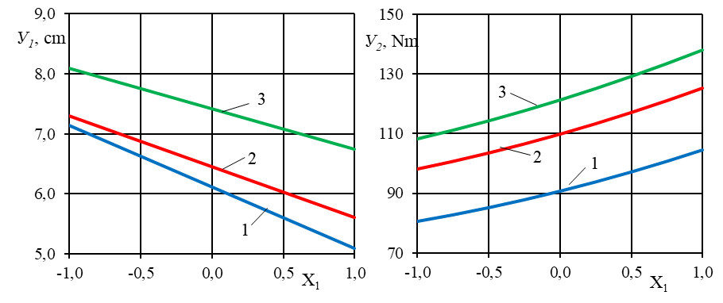
a) b)
FIGURE 3. Criteria Y₁ (a), Y₂ (b) depending on factor X₁ change graphs:

1 – W₁ = 0,4 t/h; 2 – W₂ = 0,6 t/h; 3 – W₃ = 0,8 t/h.

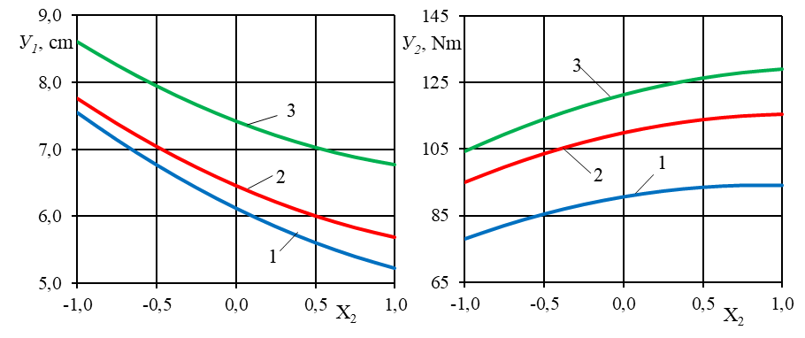
- b)
FIGURE 4. Criteria Y₁ (a), Y₂ (b) depending on factor X₁ change graphs:

1 – W₁ = 0,4 t/h; 2 – W₂ = 0,6 t/h; 3 – W₃ = 0,8 t/h.

The solution of regression equations (1) and (2) under the conditions that the U₁ criterion is in the range of 5–8 cm, and the U₂ criterion takes on minimum values, made it possible to determine the optimal values of the factors that ensure the fulfillment of these conditions (Table 4).
TABLE 4. Optimal values of the feed mixture
X₃ |  | Х₁ |  | X₂
Code | Real | Code | Real | Code | Real
1.0 | 0,80 | -0,9227 | 407.7 | 0,1229 | 6.25
0.0 | 0,60 | -0,8570 | 414.3 | -0,6864 | 4.63
-1.0 | 0,40 | -0,4992 | 450.1 | 0,7426 | 7.49

To ensure the required grinding quality with minimal energy consumption, the feed rate into the working chamber should be in the range of 0.4–0.8 t/h. The optimal speed of the moving blade shaft is 407.7–450 rpm, and the number of blades is 4.63–7.43. Given the need for a whole number of blades, 6 is chosen.
After repeated optimization for a feed rate of 0.4–0.8 t/h, refined parameters were obtained (Table 5). Thus, with a number of knives of 6 and a material feed rate of 0.4–0.8 t/h, the optimal rotational speed of the knife shaft should be 413.8–456 rpm.
TABLE 5. Optimal values of the feed mixture
№ | Name of indicators | Factor values
№ | Name of indicators | X₁, rpm | Х₂, pcs. | X₃, t/h
1 | Coded | -0,4373 | 0.0 | 1.0
2 | Valid | 456.3 | 6.0 | 0, 6
3 | Rounded | 450 | 6.0 | 0, 6

With these factor values, the particle length of the crushed stems was 6.00–7.01 cm, and the torque was 81.67–115.16 N m.
CONCLUSIONS
Experimental studies conducted on the developed device for crushing and packaging plant residues confirmed its reliability in performing the specified technological process. The device's performance meets established technical requirements.
Based on experimental data, it is recommended to use 6 movable and 6 fixed knives and a rotation speed of 450 rpm for the movable knives.
Based on the results of multifactorial studies, it was established that at a rotation speed of the moving knives of 413.8–456 rpm, With a number of knives of 4–7 and a material feed of 0.4–0.6 t/h, the torque on the shaft of the moving knives is 81.67–115.16 N m, and the length of the particles of the crushed product is in the range of 6.00–7.01 cm, which meets the technological and zootechnical requirements.
REFERENCES
- Alijanov D., Musurmanov A.T., Tulaev A.A. Analysis of technical means for grinding plant waste and their classification/ Bulletin of Agricultural Science of Uzbekistan. 2 (20/2) 2025. Tashkent. – P. 140-142.
- D. Alijanov, Sh. Abdurokhmonov, Kh. Ismaylov ICECAE 2020 IOP Conf. Series: Earth and Environmental Science 614 (2020). https://doi.org/10.1088/1755-1315/614/1/012110
- D Alijanov, Sh Abdurokhmonov, Sh Turayev, A Begjanov, J Ogalikov Some results of experimental study of a multi-faced rotary crusher Aip Conference Proceedings Open source preview, 2025, 3286(1), 050004 https://doi.org/10.1063/5.0279332
- Alijanov D., Abdurokhmonov Sh., Umirov N., Ismaylov Kh., Ogalikov J. Justification of the basic parameters of the rotary soil subsoiler Iop Conference Series Earth and Environmental ScienceOpen source preview, 2024, 1420(1), 012026. https://doi.org/ 10.1088/1755-1315/1420/1/012026
- D.Аlijanov, Sh. Abdurokhmonov Yo. Jumatov, A. Bozorboyev IOP Conf. Series: Materials Science and Engineering 883 (2020) 012155 https://doi.org/10.1088/1757-899X/883/1/012155
- Ball M A, Shaver R D, Jirovec A G, Shinners K J and Coors J G 2000 Article in Journal of Dairy Science 6(83) 1264-73.
- Momin M A, Wempe P A, Grift T E and Hansen A C 2017 Transactions of the ASABE 5(60) 1551-60
- Savinykh P A Isupov A Yu Ivanov I I 2019 Results of the centrifugal-rotor grain grinder research. Bulletin of the NIIEI No 8 (99) pp 18-33
- Tulaev A.A., Musurmanov A.T., Alijanov D. Device for crushing and packaging plant waste / Journal of Agriculture and Water Management of Uzbekistan. No. 11, 2023. Tashkent. - Pages 52-54.
- Kobzar A.I. Practical Mathematical Statistics / For engineers and scientists. Moscow: Fizmatlit. 2006. - 816 p.
- Augambaev M., Ivanov A.Z., Terekhov Yu.I. Fundamentals of Planning a Research Experiment. - Tashkent: Uqituvchi, 1993. – 336 p.
- Vedenyapin V.V. General Methodology of Experimental Research and Processing of Experimental Data. - Moscow: Kolos. 1973. -199 p.
- Dospekhov B.A. Methodology of Field Experiment. - Moscow: Kolos. 1973. – 335 p.
14. S. Makhmutkhanov, Y. Ochilov, H. Nurov, and S. Kurbonazarov, “Increasing the environmental cleanness of industrial enterprises,” in AIP Conference Proceedings, AIP Publishing, 2024, p. 060012. Accessed: Oct. 06, 2025. [Online]. Available: https://doi.org/10.1063/5.0219213
15. A. Nomozov, Kh.S. Beknazarov, B.A. Normurodov, Z.Kh. Misirov, S.G. Yuldashova, G.J. Mukimova, D.A. Nabiev, Z. Jumaeva. Inhibition potential of Salsola oppositifolia extract as a green corrosion inhibitor of mild steel in an acidic solution. Int. J. Corros. Scale Inhib., 14(3) (2025) 1103–1115. https://doi.org/10.17675/2305-6894-2025-14-3-5

