Obtain of oligomeric corrosion inhibitors based on polycaprolactam with urea adduct (PUA-1) and melamine adduct (PUM-1)
Charoskhon Rustamova^{1,a)}, Hasan Beknazarov¹, Sakhomiddin Khodjamkulov², Bakhodir Shamayev², Makhliyo Ganibekova³
¹ Termiz state university, Termiz, Uzbekistan
²Termez State University of Engineering and Agrotechnologies. Termez, Uzbekistan.
³Angren University, Angren, Uzbekistan.
^{a)} Corresponding author: charosxonr@gmail.com
Abstract. In this article, study of the syntheses an oligomer-type corrosion inhibitors based on polycaprolactam, urea, melamine and orthophosphoric acid were reacted in a different mass ratio at a temperature of 391 К. Oligomer corrosion inhibitors such as polycaprolactam with urea adduct (PUA-1) and melamine adduct (PUM-1) were synthesized as a result of the reaction of 113 kg of polycaprolactam, 400 l of acetic acid, gradually add 158 kg of adduct of urea and phosphoric acid and at a temperature of 391 K. The structure of the obtained corrosion inhibitors was studied and analyzed by methods such as IR-spectroscopic, and its composition elemental analysis. The inhibition efficiency of these two types of PUA-1 and PUM-1 brand corrosion inhibitors was determined using gravimetric and electrochemical methods in water, acidic (HCl and H₂SO₄), and saline (NaCl=3%) environments. In addition, the factors affecting the inhibition efficiency, such as the pH of the solution, the duration of time, and the concentration of the inhibitor, were also studied. Also, the protection mechanism of corrosion inhibitors on the steel surface was studied and analyzed by scanning electron microscopy and atom force microscopy methods.
INTRODUCTION
Protection of metals against corrosion in various corrosive environments [1–3]. A corrosion inhibitor is a compound that is added in low concentrations to a corrosive solution to reduce and/or minimize the corrosion rate [4-6]. If we talk about the economic damage of this corrosion process, as an example, we can cite the following figures, for example: according to the results of international research conducted by NACE (IMPACT 2016), the annual economic damage of the corrosion process worldwide is 2.5 trillion US. It is concluded that, if we analyze this figure in each country section, it is about 3.4% of the average gross domestic product (GDP) of each country[9]. The results of many years of scientific research carried out by world scientists show that the environment should be taken into account when choosing corrosion inhibitors, and that the use of compounds containing nitrogen and sulfur and substances based on them is more effective for acidic environments[10]. In addition, such as aldehydes, thioaldehydes, including various alkaloids, such as papaverine, strychnine, quinine, and nicotine, have been proven to be highly effective corrosion inhibitors and meet the requirements for corrosion inhibitors. Many researchers show that the use of corrosion inhibitors based on benzoates, nitrites, and inhibitors based on them, as well as chromates and phosphates, have a high inhibition efficiency for alkaline and acidic solutions[11,12]. An anti-corrosion additive is proposed, which is a mixture of orthophosphoric acid, water and a tertiary amine. It has been shown that the synthesized new anti-corrosion composition based on nitrogen- and phosphorus-containing organic compounds, which provides a high protective effect under conditions of sulfide corrosion of steel, amounting to Z = 53.0-80 at low dosages, 9%[13].

EXPERIMENTAL RESEARCH
The main goal of this study of the obtaining corrosion inhibitors based on polycaprolactam, urea, melamine and orthophosphoric acid and determining their inhibition efficiency by gravimetric and electrochemical methods in different corrosion environments. It consists of studying and analyzing the inhibition mechanism of the obtained corrosion inhibitors on the steel surface in environments with and without an inhibitor.
Materials. The experiments were carried out with samples of carbon steel grade St30 and steel samples of this brand were purchased from "Uzbekistan Metallurgical Combinat" JSC. Water (cooling water in the cooling system of "Mubarak gas processing" and "Shurtan gas processing" plants) was used as a corrosion medium (water composition and properties are as follows: total hardness 6.3 mg-eq/l, total alkalinity 2.08 mg-eq/l, 6.3 mg-eq/l, total alkalinity 2.08 mg-eq/l, Ca²⁺-4.2 mg-eq/l, Mg²⁺- mg-eq/l, HCO⁻₃-2.00 mg-eq/l, CO₃²-0.08 mg-eq/l). Other chemical reagents: polycaprolactam, urea, orthophosphoric acid, and melamine were purchased "chemically pure" from “Merit Chemicals” company.
Methods. Polarization curves analysis. The corrosion-inhibiting properties of an aqueous dispersion of the studied corrosion inhibitor (PUA-1 and PUM-1), both with and without additives, were studied by the potentiostatic method on a PI-50-1.1 tool with a PR-8 program, by recording polarization curves on steel electrodes in different corrosion media aqueous, acidic and saline media.
IR analysis. The composition of the inhibitors was investigated using IR-spectra and elemental analysis with Shimadzu IR Tracer-100.
SEM analysis. Surface morphology and microstructure studies of the samples were carried out using a scanning electron microscope SEM - EVO MA 10 (Carl Zeiss, made in Germany).
Obtaining of oligomeric corrosion inhibitors. For the synthesis of an oligomeric corrosion inhibitor based on secondary polycaprolactam by acidolysis with acetic acid and a urea adduct at a temperature of 391 K. Various technological parameters of the method for obtaining the interaction of polycaprolactam with a urea adduct were studied. Based on this research, an optimal process for obtaining the corrosion inhibitors polycaprolactam with a urea adduct has been developed. 113 kg of polycaprolactam, 400 l of acetic acid are loaded into a reactor with a volume of 10 m³, equipped with a refrigerator and a stirrer, 158 kg of urea adduct with phosphoric acid are gradually poured and boiled with stirring at the boiling point of acetic acid 391 K for 1.0 hour. Then the excess acetic acid is distilled off and 264 kg of an oily, light yellow product, highly soluble in water, is obtained. Density 1.3 g/cm³. Optimal conditions for obtaining urea adduct with phosphoric acid: 40 kg of urea and 80 kg of phosphoric acid are loaded into the reactor, the reaction mixture is stirred for 10-12 minutes and a clear syrupy liquid is obtained [14]
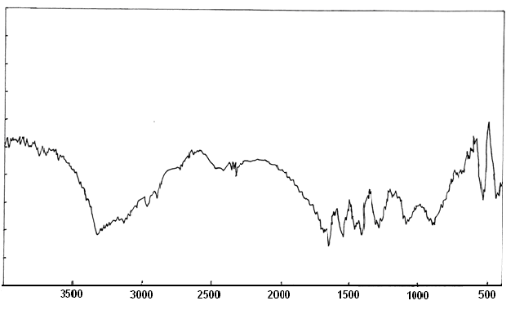
FIGURE 1. IR spectra of an oligomeric corrosion inhibitor based on polycaprolactam and urea adduct.

The IR spectrum of the resulting compound contains bands in the region of 3290 and 3330 cm⁻¹, corresponding to free hydroxyl groups, the appearance of a band at 3140 and inflection at 3260 cm⁻¹ indicates the presence of a bound NH group, and in the region of 2980 and 2900 we observe allowed resonances of the –CH– and –CH₂– groups. Amide structures are characterized by the presence in the IR spectra of bands of primary and secondary amides, respectively, in the region of 1480 and 1550 cm⁻¹. C=O groups in the region of 1650 cm⁻¹, in the bands of 1550 cm⁻¹ - NH and CN groups. However, from the data obtained, it can be said that acetic acid significantly affects the synthesis and yield of the product. When using a small amount of solvent - acetic acid - the yield of the product decreases sharply[15,16]. The resulting product of the interaction of polycaprolactam with a urea adduct has the following characteristics: a viscous liquid of light yellow or brown color, non-volatile, content of the main component 97.4%, impurities 2.6%.
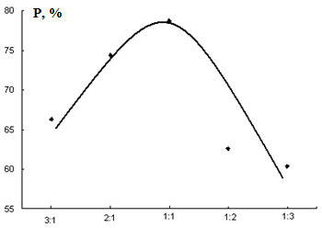
FIGURE 2. Dependence of oligomer yield on ratio starting materials. T= 391 K. Time 1.5 hours.
The use of a constant approximate ratio of reagents leads to a decrease in the proportion of polymer, and if the ratio of reagents is violated, the yield of the oligomer decreases and, in connection with this, a decrease in molecular weight (viscosity) is observed from 0.12 to 0.05 dl/g.
TABLE 1. Influence of the ratio of reagents on the composition of the product (T = 391 K, τ = 1.5 hour)
PC+Ad U | Yield, % | η_{пр} 0.5 aq. solution. dl/g | Elemental analysis
PC+Ad U | Yield, % | η_{пр} 0.5 aq. solution. dl/g | Nitrogen |  | Phosphorus
PC+Ad U | Yield, % | η_{пр} 0.5 aq. solution. dl/g | Calculated | Found | Calculated | Found
1:3 | 60,4 | 0,05 | 14,9 | 14,7 | 11,29 | 11,12
1:2 | 62,6 | 0,07 | 14,9 | 14,9 | 11,29 | 10,96
1:1 | 78,7 | 0,12 | 14,9 |  | 11,29 | 11,27
2:1 | 74,4 | 0,10 | 14,9 | 15,04 | 11,29 | 10,97
3:1 | 66,3 | 0,09 | 14,9 | 14,3 | 11,29 | 10,83
Note*- PC- polycaprolactam; Ad- adduct; U-uren
To obtain a higher molecular weight, the reagents should obviously be taken in equimolar ratios (Table 2).
The study of the dependence of the polymer yield on the ratio of the initial reagents is extreme, with the maximum yield corresponding to a 1:1 ratio (Figure 3).
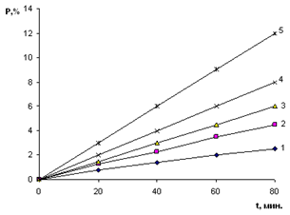
1 — 1:3; 2 — 1:2; 3:1; 4 — 2:1; 5 — 1:1.
FIGURE 3. Kinetic dependence of polycondensation in the system polycaprolactam: urea adduct in acetic acid. (T =391 K)

A study of the kinetic dependence of the reaction rate, determined by the rate of consumption of the urea adduct on the ratio of the initial reagents, showed that the kinetic dependence of the formation of the oligomeric product is characterized by a decrease in the slope in the event of a violation of equimolar (FIGURE 3). The optimal conditions for the synthesis of the condensation product of polycaprolactam with the melamine adduct were carried out at a temperature of 118°C, i.e. at the boiling point of acetic acid. First, 113 kg of polycaprolactam, and 500 l of acetic acid are loaded into a reactor with a volume of 10 m³, equipped with a refrigerator and a stirrer, and 252 kg of melamine adduct with phosphoric acid is gradually poured and boiled with stirring at the boiling point of acetic acid 391 K for 2.0 hours. Then the excess acetic acid is distilled off and 356 kg of an oily light yellow product, highly soluble in water, is obtained. Density 1.3 g/cm³[17,18].
Preparation of melamine adduct with phosphoric acid: 126 kg of melamine and 160 kg of phosphoric acid are loaded into the reactor, the reaction mixture is stirred for 15-30 minutes and a clear syrupy liquid is obtained.
The resulting substance has the following characteristics: viscous liquid of light yellow or brown color, non-volatile, main component content 99.5%, impurities 0.5%.
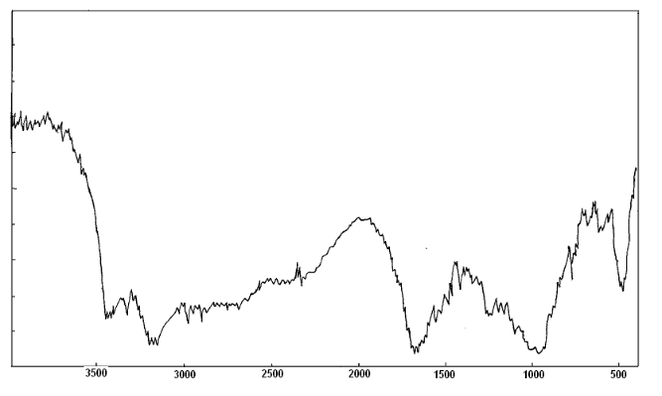
FIGURE 4. IR spectra of an oligomeric corrosion inhibitor based on polycaprolactam and melamine adduct

The IR spectrum of the resulting compound contains absorption bands at 3450 and 3330 cm⁻¹, corresponding to free hydroxyl groups, and, accordingly, –NH in the region of 3150, 3200 and 1550 cm⁻¹, C=O in the region of 1650 and 1680 cm⁻¹, the region 960 and 970 contains P=O and P–O–C. The data obtained showed that if the reagent ratio of 2:1 is violated, the yield of the oligomer decreases and, in connection with this, a decrease in molecular weight (viscosity) is observed from 0.1 to 0.08 dl/g, We also studied the effect of the solvent on the product yield. When using a solvent in small quantities, a decrease in the yield of the product is observed, and, in connection with this, the molecular weight decreases. The identified features are probably associated with shielding of the active groups of biradicals during the reaction.

TABLE 2. The influence of the ratio of reagents on the composition of the product(T = 391 K, τ = 2 hours)
PC+Ad Melamin | Yield, % | η_{пр} 0.5 aq. solution. dl/g | Elemental analysis
PC+Ad Melamin | Yield, % | η_{пр} 0.5 aq. solution. dl/g | Nitrogen |  | Nitrogen
PC+Ad Melamin | Yield, % | η_{пр} 0.5 aq. solution. dl/g | Calculated | Calculated | Calculated | Calculated
1:3 | 63,6 | 0,08 | 28,8 | 28,4 | 8,91 | 8,87
1:2 | 67,2 | 0,07 | 28,8 | 28,3 | 8,91 | 9,08
1:1 | 73,5 | 0,1 | 28,8 | 27,6 | 8,91 | 9,1
2:1 | 77,9 | 0,09 | 28,8 | 28,91 | 8,91 | 8,89
3:1 | 71,4 | 0,08 | 28,8 | 28,5 | 8,91 | 8,65

TABLE 2 shows the results of the interaction of polycaprolactam with the melamine adduct in different ratios. At a molar ratio = 2:1, the yield of the oligomer increases and at the same time the molecular weight of the product increases.

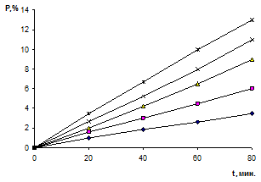
1—2:1; 2—1:1; 3—3:1; 4—1:2; 5—1:3
FIGURE 5. Kinetic dependence of polycondensation in the system polycaprolactam: melamine adduct in acetic acid. (T =391 K)

A study of the kinetics of the dependence of the reaction rate, determined by the rate of consumption of the melamine adduct on the ratio of the initial reagents, showed that the kinetic dependence of the formation of the oligomeric product is characterized by a decrease in the slope in the case of violation of the 2:1 equimolarity (Figure 5 and 6.).
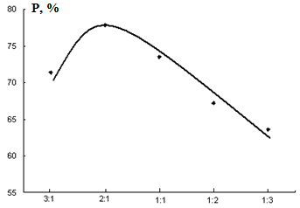
FIGURE 6. Dependence of oligomer yield on ratio starting materials. T= 391 K. Time 1.5 hours.
RESEARCH RESULTS
The rate of general corrosion was determined from metal samples in the form of plates made of steel grade St3 measuring 40×12×2 mm with a surface finish of V 6. Each value of the corrosion rate was calculated based on the test results of at least 9 control steel samples. The corrosion rate was calculated using the formula:
$ρ=\frac{∆A}{S·T}$ (1)

where p is the corrosion rate, g/(m² h);
A is the mass loss of the metal sample during the study, g;
S - sample surface area, m2;
T - test duration, hours.
The protective effect of inhibitory compounds was calculated using the formula:
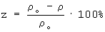 (2)
where z is the protective action, %;
ρ₀- rate of general corrosion without inhibitor, g/(m² h);
ρ - rate of general corrosion with inhibitor, g/(m² h).
The test results and their evaluation are shown in Table 3 a and b.

TABLE 3a. Comparative assessments of the protective properties of oligomeric corrosion inhibitors at pH=6
Inhibitor | Concentration, mg/l | Protective effectiveness against general corrosion, %, with mineralization, mg/l
Inhibitor | Concentration, mg/l | 30 | 100 | 270
1 | 2 | 3 | 4 | 5
PUA-1 | 250 | 88 | 86 | 82
PUA-1 | 150 | 85 | 82 | 78
PUA-1 | 50 | 75 | 72 | 70
PUM-1 | 250 | 92 | 92 | 90
PUM-1 | 150 | 90 | 90 | 88
PUM-1 | 50 | 82 | 80 | 78
PUM-1 | 50 | 98 | 94 | 93

TABLE 3b. Comparative assessments of the protective properties of oligomeric corrosion inhibitors at pH=3
Inhibitor | Concentration, mg/l | Protective effectiveness against general corrosion, %, with mineralization, mg/l
Inhibitor | Concentration, mg/l | 30 | 100 | 270
PUA-1 | 250 | 83 | 82 | 80
PUA-1 | 150 | 80 | 80 | 76
PUA-1 | 50 | 72 | 70 | 68
PUM-1 | 250 | 90 | 90 | 88
PUM-1 | 150 | 87 | 85 | 84
PUM-1 | 50 | 78 | 76 | 70

Table 3 shows data on the aftereffect of inhibitors.
The protective effect of the corrosion inhibitor does not exceed 15-25% over the entire range of varied test parameters.
From Table 4 it follows that the addition of a corrosion inhibitor increases the effectiveness of inhibitory compounds. Corrosion inhibitors, along with dispersing properties, already exhibit solvent properties - leading to a decrease in the concentration of the active component.
TABLE 4. Comparative assessments of the protective properties of oligomeric corrosion inhibitors in aggressive environments
Inhibitor | Efficiency of the aftereffect of inhibitors,%, during exposure to an aggressive environment, hour.
Inhibitor | 6 | 24 | 96 | 120 | 240
1 | 2 | 3 | 4 | 5 | 6
рН=6
PUA-1 | 96 | 90 | 82 | 76 | 62
PUM-1 | 98 | 90 | 86 | 78 | 75
рН=3
PUA-1 | 94 | 90 | 80 | 72 | 58
PUM-1 | 96 | 88 | 82 | 76 | 70

The difference in the protective effect of inhibitors between Tables 3 a, b and 4 with the same exposure duration is explained by different conditions for the formation of protective films: in the first case, the film is formed from an aggressive environment, and in the second - mechanically, which gives a slight increase in the protective effect. This is clearly seen in the examples of samples PUA-1 and PUM-1.
Oligomeric corrosion inhibitors at C_{inh} concentrations <20 mg/l somewhat stimulate corrosion in H₂SO₄ solutions at room temperature. However, with increasing concentration they become inhibitors, and the molecular weight provides a higher degree of protection of steel from corrosion than PUA-1 and PUM-1. At elevated t = 80°C, the differences in the anti-corrosion properties of oligomers are more pronounced. PUM-1 provides Z ≈ 90% at C > 10 mg/l, for PUA-1 even at C = 135 mg/l Z < 353 K. All oligomers slow down not only the anodic, but also the cathodic reaction, i.e. are mixed type corrosion inhibitors.
Oligomeric corrosion inhibitors are substances that protect metal surfaces from corrosion. The mechanism of the anti-corrosion effect of oligomeric corrosion inhibitors on metals, primarily steel, is to create a very thin film on the metal surface that protects the metal from corrosion.
SEM and AFM Analysis. The steel surface was examined in three different states: before corrosion, after corrosion, and after corrosion inhibition, using a scanning electron microscope (SEM-EVO MA 10, Zeiss, Germany). Specifically, the morphological characteristics of carbon steel samples at various concentrations were extensively analyzed using SEM imaging techniques.

 | 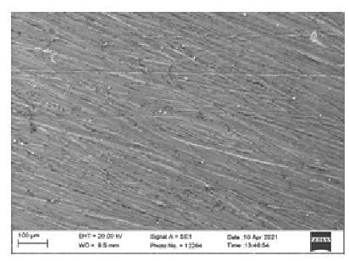 | 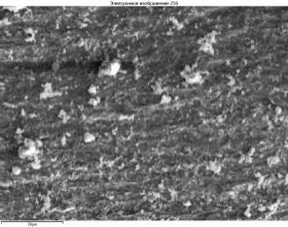
FIGURE 7. The original photograph of the steel sample. | FIGURE 8. SEM image of a steel sample | FIGURE 9. SEM image of a steel sample after inhibition

Based on Figure 7, the initial steel sample underwent meticulous cleaning using various grades of sandpaper and was subsequently washed with acetone. Microphotographs of the untreated steel sample were captured using a scanning electron microscope in an uninhibited environment (Figure 7) and in an inhibited environment (Figure 9).

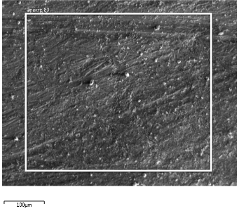 | 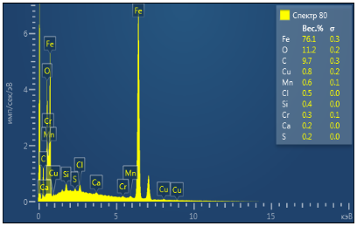 | 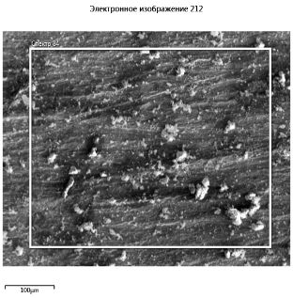 | 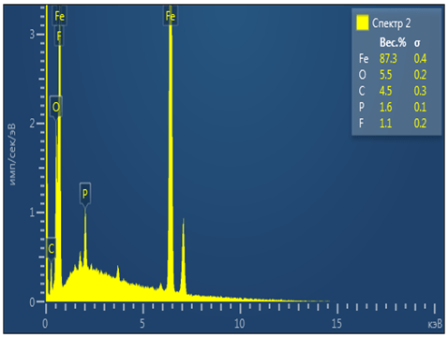
a) | b) | a) | b)
FIGURE 10. Scanning electron microscopy (SEM) and elemental analysis were conducted on an inhibited St20 steel sample treated with the PUM-1 inhibitor. a) SEM image of the PUM-1 inhibitor b) elemental analysis were conducted on an inhibited St20 PUM-1 inhibitor |  | FIGURE 11. SEM imaging and elemental analysis were performed on an inhibited St30 steel sample treated with the PUA-1 inhibitor. a) SEM image of the PUA-1 inhibitor b) elemental analysis were conducted on an inhibited St20 PUA-1 inhibitor

Figure 10. illustrates the SEM imaging and elemental analysis of corrosion inhibited by the PUA-1 inhibitor brand. The images demonstrate the adsorption of the inhibitor on the steel surface and its protective role against aggressive environments. In Figure 11, the elemental analysis reveals that the iron content in the annealed steel sample was 87.3%, indicating effective protection by the inhibitor. The scanning was performed at a nano-micro scale, utilizing high-precision instrumentation to study inhibitor effects on corrosion formation and prevention at metal/alloy interfaces[26,27].

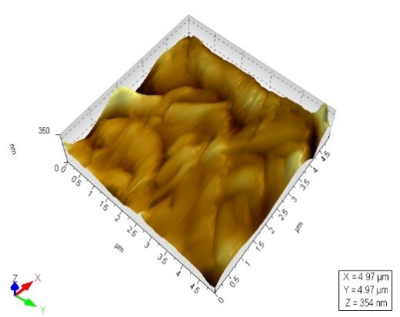 | 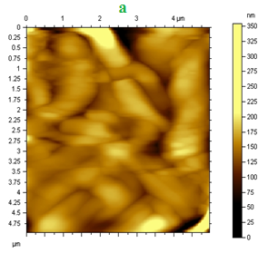
a) | b)
FIGURE 12. A photomicrograph displaying the surface morphology of an St20 steel sample in a 3% NaCl saline solution, acquired using an atomic force microscope (AFM). a) general two-dimensional surface topography of the steel sample; b) magnified view of the same area, showing finer surface features, local roughness, and micro-scale corrosion-related irregularities;

Figure 12. illustrates that the surface of the initial carbon steel sample is nearly flat and devoid of any signs of corrosion damage
. | 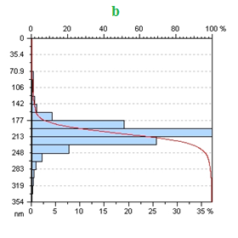
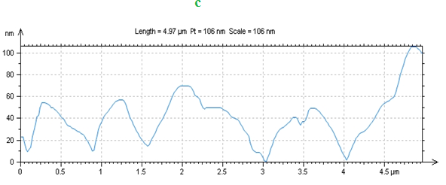
FIGURE 13. Topographical analysis of the steel surface. (a) 2D surface topography over a 4.5 × 4.5 μm scan area; (b) height profile showing convex peaks (~350 nm) and depressions (~135 nm); (c) 3D surface morphology with wave-like structures reaching ~106 nm and surface coverage ranging from ~30% to 100%.

The carbon steel surface was examined at a size of 4.5x4.5 μm, revealing convex peaks measuring approximately 350 nm and depressions measuring 135 nm (Figure 13). These surface features were visually striking, with wave-like structures reaching a height of 106 nm (Figure 13). The analysis also identified various concave and convex dimensions on the steel surface, along with areas exhibiting coverage ranging from a minimum of 30% to 100%
Protection of steel against corrosion with oligomeric inhibitors. In general, two main factors influencing the anticorrosion properties of oligomers can be distinguished: the ability to form complexes and molecular weight. Due to the fact that anionic polymers with a lower molecular weight have the best protective ability in relation to low-carbon steel, various oligomers deserve attention, which are often not only more accessible for practical use, but also safe for the environment. Particles of the oligomer itself and its complexes with iron cations are adsorbed on the metal surface and slow down the anodic dissolution of the metal. The tendency to complex formation in solution has been studied and the high dispersing ability of oligomers, on the contrary, can negatively affect the corrosion resistance of iron in their solutions, since this facilitates the removal of metal corrosion products from its surface. This feature of the compounds considered allows them to be used as detergents and anti-scale compounds, and their combined use gives them anti-corrosion properties.
CONCLUSIONS
In present research, synthesis of the new oligomer-type of corrosion inhibitor based on polycaprolactam, urea, melamine and orthophosphoric acid also its various properties were studied. The new oligomer-type of corrosion inhibitors were synthesized and its structure was confirmed by the IR spectroscopy. The inhibition efficiency of both obtained corrosion inhibitors was studied by gravimetric and electrochemical methods in various aggressive environments. According to the results of the research, it was 97.8% for PUM-1 at a concentration of 400 mg/l in an aqueous medium, and 96.7% at a concentration of 100 mg/l for NaCl=3%. These corrosion inhibitors have been found to perform best in environments with a pH between 3 and 6. The surface morphology of this modification was studied by scanning electron microscopy and atom force microscopy methods.
REFERENCES
- M. Lagrenée, B. Mernari, M. Bouanis, M. Traisnel and F. Bentiss. Study of the mechanism and inhibiting efficiency of 3,5-bis(4-methylthiophenyl)-4H-1,2,4-triazole on mild steel corrosion in acidic media. Corros. Sci., 2002; 44(3): 573–588. https://doi.org/10.1016/S0010-938X(01)00075-0.
- N.K. Gupta, M.A. Quraishi, C. Verma and A.K. Mukherjee. Green Schiff's bases as corrosion inhibitors for mild steel in 1 M HCl solution: experimental and theoretical approach, RSC Adv. 2016; (6): 102076–102087. https://doi.org/10.1039/C6RA22116E.
- Ostanov Uktam Yuldashovich, Beknazarov Khasan Soibnazarovich and Dzhalilov Abdulakhat Turopovich. Study By Differential Thermal Analysis and Thermogravimetric Analysis of the Heat Stability of Polyethylene Stabilised With Gossypol Derivatives,” Inter Polymer Sci. and Tech. 2011; 38(9): 25–27. https://doi.org/10.1177/0307174X1103800906.
- Kai. Wan, P. Feng, B. Hou and Y. Li, Enhanced corrosion inhibition properties of carboxymethyl hydroxypropyl chitosan for mild steel in 1.0 M HCl solution, RSC Adv., 2016; (6): 77515–77524. https://doi.org/10.1039/C6RA12975G.
- Nurilloev Zafar, Beknazarov Khasan, Nomozov Abror, "Production of Corrosion Inhibitors Based on Crotonaldehyde and Their Inhibitory Properties," Int. J. of Eng. Trends and Tech. 2022; 70(8): 423-434, https://doi.org/10.14445/22315381/IJETT-V70I8P243.
- Narzullaev A.X, Beknazarov X.S, Jalilov A.T and Rajabova M.F, “Studying the Efficiency of Corrosion Inhibitor IKTSF-1, IR-DEA, IR-DAR-20 in 1m HCl,” Inter. J. of Advan. Sci. and Tech. 2019; 28, (15): 113–122. http://sersc.org/journals/index.php/IJAST/article/view/1555.
- Beknazarov K.S and Dzhalilov A.T, “The Synthesis of Oligomeric Derivatives of Gossypol and the Study of their Antioxidative Properties. Inter. Poly. Sci. and Tech. 2016; 43(3): 25–30. https://doi.org/10.1177/0307174X160430030.
- Y.G. Avdeev, Protection of metals in phosphoric acid solutions by corrosion inhibitors. Review. Int. J. Corr. Scale Inhib, 2019; 8(4): 760–798. https://doi.org/10.17675/2305-6894-2019-8-4-1.
- B. E. Amitha Rani, Bharathibai J. Basu. Green Inhibitors for Corrosion Protection of Metals and Alloys: An Overview. Inter.J. of Corr. 2012; 1687-9325. https://doi.org/10.1155/2012/380217.
- Faizullina S.R., Kalistratova T.A., Builova E.A., Galieva D.R., Mazitova A.K. Synthesys of N-acylated derivatives of some triazines // Baskirskii khimicheski zhurnal. – 2012. Vol. 19, № 3, pp. 92 - 94.
- Shaymardanova M A, Mirzakulov Kh Ch, Melikulova G, Khodjamkulov S Z, Nomozov A K, Shaymardanova Kh.S. Study of process of obtaining monopotassium phosphate based on monosodium phosphate and potassium chloride. Chemical Problems. 2023; 3 (21): 279-293. https://doi.org/10.32737/2221-8688-2023-3-279-293.
- Nomozov A K, Beknazarov Kh S, Khodjamkulov S Z, Misirov Z Kh. Salsola Oppositifolia acid extract as a green corrosion inhibitor for carbon steel. Indian J Chem Tech. 2023; 30(6): 872-877. https://doi.org/10.56042/ijct.v30i6.6553.
- Beknazarov Khasan Soibnazarovich., Dzhalilov Abdulakhat Turopovich., Ostanov Uktam Yuldashovich., Erkaev, A.M. The inhibition of the corrosion of carbon steel by oligomeric corrosion inhibitors in different media. Int. Poly. Sci. and Tech. 2015; 42(4): 33–37.
- Beknazarov Kh.S., Dzhalilov Abdulakhat Turopovich.. Protection of steel from corrosion by oligomeric inhibitors and their compositions. Chem and Chem Tech. 2015; 1: 50-52.
- Beknazarov K.S and Dzhalilov A.T. The Synthesis of Oligomeric Derivatives of Gossypol and the Study of their Antioxidative Properties. Inter. Poly. Sci. and Tech. 2016; 43(3): 25–30. https://doi.org/10.1177/0307174X160430030
- Turaev Kh, Shavkatova D, Amanova N, Shadhar M.H, Berdimurodov E, Bektenov N, et al. Application of Sulfur-2,4-dinitrophenylhydrazine as Modifier for Producing an Advantageous Concrete. Baghdad Sci J. 2023; 20(6(Suppl)): 2414. https://bsj.uobaghdad.edu.iq/index.php/BSJ/article/view/9038.
- Turaev Kh.Kh., Eshankulov Kh.N., Umbarov I.A., Kasimov Sh.A., Nomozov A.K., Nabiev D.A "Studying of Properties of Bitumen Modified based on Secondary Polymer Wastes Containing Zinc. Inter J. of Engin. Trends and Tech. 2023; 71(9): 248-255, 2023. Crossref, https://doi.org/10.14445/22315381/IJETT-V71I9P222
- Y. Qiang, S. Zhang, Q. Xiang, B. Tan, W. Li, S. Chen and L. Guo. Halogeno-substituted indazoles against copper corrosion in industrial pickling process: a combined electrochemical, morphological and theoretical approach. RSC Adv. 2018; 8: 38860–38871. https://doi.org/10.1039/C8RA08238C.
- J.A. Selvi, A. Arthanareeswari, T. Pushpamalini, S. Rajendran and T. Vignesh, Effectiveness of Vinca rosea leaf extract as corrosion inhibitor for mild steel in 1 N HCl medium investigated by adsorption and electrochemical studies, Int. J. Corros. Scale Inhb., 2020; 9(4): 1429–1443. https://doi.org/10.17675/2305-6894-2020-9-4-15.
- A.S. Fouda, A.S. Abd El-Maksoud, M.Sh. Zoromba and A.R. Ibrahim, Corrosion Inhibition and thermodynamic activation parameters of Myrtus communis extract on mild steel in sulfamic and medium, Int. J. Corros. Scale Inhib. 2017; 6(4): 428–448. https://doi.org/10.17675/2305-6894-2017-6-4-4
- A. Ghames, T. Douadi, S. Issaadi, L. Sibous, K.I. Alaoui, M. Taleb and S. Chafaa, Theoretical and Experimental Studies of Adsorption Characteristics of Newly Synthesized Schiff Bases and their Evaluation as Corrosion Inhibitors for Mild Steel in 1 M HCl, Int. J. Electrochem. Sci., 2017; 12: 4867–4897. https://doi.org/10.20964/2017.06.92
- Y.G. Avdeev, Protection of metals in phosphoric acid solutions by corrosion inhibitors. Review, Int. J. Corros. Scale Inhib., 2019; 8(4): 760–798. https://doi.org/10.17675/2305-6894-2019-8-4-1
- Normurodov BA, Misirov Z.Kh, Yuldashova SG, Mukimova G.J, Nabiev D.A, Jumaeva Z. Inhibition potential of Salsola oppositifolia extract as a green corrosion inhibitor of mild steel in an acidic solution. Int J Corros Scale Inhib. 2025;14(3):1103–1115. https://doi.org/10.17675/2305-6894-2025-14-3-5.
- Beknazarov Kh, Khodjamkulov S, Misirov Z, Yuldashova S. Synthesis of Corrosion Inhibitors Based on (Thio)Urea, Orthophosphoric Acid and Formaldehyde and Their Inhibition Efficiency. Baghdad Sci.J. 2024; 22(4). https://doi.org/10.21123/bsj.2024.10590.
- Misirov, Z. K., and K. S. Beknazarov. Synthesis and application of corrosion inhibitor for hydrogen sulfide corrosion of steel. Indian Journal of Chemical Technology, vol. 32, no. 3, 2023, pp. 101–109. https://doi.org/10.56042/ijct.v32i3.7278.
- Kh.S. Beknazarov, Y.A. Geldiev, B.E. Babamurodov,N.Sh. Muzaffarova, S.G. Yuldashova. Synthesis of PFG brand corrosion inhibitor and its quantum chemical calculation results. Chemical problems 2025 no. 3 (23). p 297-309. https://doi.org/10.32737/2221-8688-2025-3-297-309..
- Muratov B.A, Turaev Kh. Kh, Umbarov I.A, Kasimov Sh.A, Nomozov A.K, "Studying of Complexes of Zn(II) and Co(II) with Acyclovir (2-amino-9-((2-hydroxyethoxy)methyl)-1,9- dihydro-6H-purine-6-OH),"Int. J of Eng. Trends and Tech. 2024; 72(1): 202-208. https://doi.org/10.14445/22315381/IJETT-V72I1P120.
- Jumaniyozov, K., Urozov, M., Toshbekov, O., Salimova, M., Raximova, K., & Khursandova, B. (2025, November). Enhancement of energy-efficient cleaning equipment. In American Institute of Physics Conference Series (Vol. 3331, No. 1, p. 050007). https://doi.org/10.1063/5.0307149
- Sultonova, F., Toshbekov, O., Urozov, M., Boymurova, N., Mustanova, Z., & Boltaeva, I. (2025, November). Enhancing and evaluating the characteristics of specialized workwear for employees in the electric power supply sector. In American Institute of Physics Conference Series (Vol. 3331, No. 1, p. 050006). https://doi.org/10.1063/5.0306350

