Influence of hydrated lime-modified bitumen on the strength of asphalt mixtures
Baxrom Tovboev ^{a)}, Sadikov Ibragim, Buriyev Shuxrat, Isakova Gulkhan
Tashkent state transport university, Tashkent, Uzbekistan
^{a)} Corresponding author: tovboyevbaxrom5@gmail.com
Abstract. This article presents the preparation of asphalt mixtures using bitumen modified with hydrated lime (HL) in amounts of 4.8%, 5.0%, and 5.2%, based on local raw materials with the addition of mineral powders derived from three types of shale, dolomite, and limestone at a content of 5%. Technologies aimed at improving the physical and mechanical properties and durability of asphalt concrete were developed. As a result, the density, strength, and longevity of fine-grained dense hot asphalt concrete mixtures of Type A containing three types of mineral powders were enhanced. The modified mixtures demonstrated reduced water absorption, increased strength, and improved road performance characteristics.
INTRODUCTION
An analysis of the global experience in highway construction and maintenance within our republic has shown that pavement deformation and deterioration are greatly influenced by non-compliance with operational requirements and untimely maintenance. One of the key scientific challenges today is the search for materials capable of resisting slippage, cracking, and plastic deformation under high air temperatures.
From this perspective, the construction of highways that meet international standards is currently considered a matter of national importance. Based on the above conclusions, the improvement of asphalt concrete road construction processes, enhancement of the transport and operational performance of roads, better maintenance practices, and the development of scientific foundations for the efficient use of roads are among the most relevant and pressing tasks in ensuring safe and comfortable vehicle movement across the country.
In road construction, bitumen is used as the main binding material to ensure pavement quality and extend its service life. In particular, the durability of road pavements under the influence of water, temperature, and traffic loads is closely related to the physico-chemical properties of bitumen.
In recent years, considerable attention has been devoted to modifying bitumen to improve its resistance to various defects such as increased traffic loads, axle pressure, moisture damage, deformation, and aging under different climatic conditions-especially under low rheological performance at high temperatures [1, 2, 3]. Hydrated lime (HL) can be used as a filler or additive to modify bituminous binders with the aim of improving their various properties as well as the characteristics of hot asphalt mixtures [3, 4, 5].
The main objective of this study is to experimentally investigate the effect of bitumen modified with hydrated lime on the physical and mechanical properties of dense hot asphalt concrete mixtures.
MATERIALS AND METHODS
Materials. In this research, a technology was developed for producing shale, dolomite, and limestone mineral powders based on locally available raw materials such as dolomite crushed stone and sand. Bitumen modified with hydrated lime (HL) was used, obtained from the stone-crushing plant of the Nurli Tulkin holding company located in the Jizzakh region. The study also focused on improving the physical and mechanical properties and durability of asphalt concrete.

RESULTS AND DISCUSSION
Hydrated lime was added to bitumen grade 50/70 in quantities of 1%, 1.5%, and 2%, and their physical and mechanical properties were tested under laboratory conditions. The obtained results are presented in Table 1.
As seen from the data, bitumen modified with hydrated lime shows a significant improvement in durability and hardness compared to the control bitumen. It also enhances the plastic and elastic properties and increases resistance to brittleness, ensuring long-term and reliable performance under cold climate conditions. Moreover, it does not have any negative impact on the aging process; on the contrary, it maintains stable properties that remain well below the standard limits.
TABLE 1. Physical and mechanical indicators of bitumen grade 50/70 with the addition of HLs in the amount of 1%, 1.5% and 2%
Names of Indicators | Requirement according to GOST 33133-2014 | 50/70 Bitumen | Content of Hydrated Lime, %
Names of Indicators | Requirement according to GOST 33133-2014 | 50/70 Bitumen | 1,0 | 1,5 | 2,0
Needle penetration depth at 25°C, 0.1 mm | 51-70 | 69 | 62,6 | 59,5 | 51,6
Softening point temperature at 25°C, not less than | 51 | 50,6 | 54,8 | 55,7 | 56,9
Ductility at 25°C, cm, not less than | 60 | 105 | 69,5 | 56,5 | 49
Bitumen brittleness temperature, °C, not more than | -16 | -16,6 | -17,5 | -17,9 | -18,6
Penetration index | According to GOST 22245: from -1.0 to +1.0 | -0,26 | 0,49 | 0,58 | 0,47
Change in sample mass after aging, %, not more than | 0,6 | 0,3 | 0,3 | 0,32 | 0,36
Change in softening point temperature after aging, °C, not more than | 7 | 4 | 2,1 | 2,5 | 2,5
Needle penetration depth after aging, mm | - | 57,1 | 47,8 | 46,2 | 45
Ductility after aging, cm | - | 68,5 | 36,5 | 32,1 | 29,5
Brittleness temperature after aging, °C, not more than | -13 | -18,4 | -19,8 | -19,5 | -19,1

One of the main differences in the preparation of fine-grained dense hot asphalt concrete mixtures and coarse-grained porous hot asphalt concrete mixtures lies in the composition of the mineral powder used in dense asphalt concrete. In other words, mineral powders added to the asphalt mixture increase its density, water impermeability, water resistance, and binding activity, while improving the viscosity of the mineral portion of the mixture and enhancing its overall strength [6, 7].
In this study, shale, dolomite, and limestone mineral powders used in the preparation of fine-grained dense hot asphalt concrete mixtures were obtained by crushing natural rock materials. According to GOST 16557-2005 “Mineral Powder for Asphalt Concrete and Organomineral Mixtures”, the powder should pass through a sieve with a particle size of 0.71 mm. The volume of the bitumen sample mixed with mineral powder was 2.5, and the porosity at a moisture content of not less than 35% was 1.0% [8].
Laboratory tests of mineral powders obtained from shale rocks in the Samarkand region and from dolomite and limestone rocks in the Jizzakh region were carried out in accordance with GOST 16557-2005 “Mineral Powder for Asphalt Concrete and Organomineral Mixtures” and compared with the standard requirements. The test results are presented in Table 2.

ТАBLE 2. Results of laboratory tests of mineral powders
№ | Names of indicators | Unit of Measurement | Value of Indicators
№ | Names of indicators | Unit of Measurement | Standard Value | Shale Mineral Powder | Dolomite Mineral Powder | Limestone Mineral Powder | Compliance with Regulatory Document
1 | Natural moisture content | % | 0-1.0 | 0.8 | 0.7 | 0.8 | -
2 | Grain size, mm | 1.25 | Not less than 100 | 99.6 | 99.7 | 99.8 | Complies
2 | Grain size, mm | 0.315 | Not less than 90 | 91.7 | 91.5 | 91.9 | Complies
2 | Grain size, mm | 0.071 | Not less than 80 | 81.2 | 81.1 | 81.4 | Complies
3 | Density | g/sm³ | Not standardized | 2.6 | 2.6 | 2.56 | -
4 | Porosity, not less than | % | 30 | 28.9 | 29.1 | 29.2 | Complies

The products of all three types of mineral powders (MP-1) fully comply with the requirements of the standard GOST 16557-2005 “Mineral Powder for Asphalt Concrete and Organomineral Mixtures” [9].
Mineral powders obtained from shale, dolomite, and limestone rocks are ground into a fine powder. The mineral powder derived from these rocks, which meets the granulometric composition requirements specified in Table 1 of GOST 16557-2005, increases the average density of the mixture by filling the small voids between the fine-grained hot asphalt concrete mixture, coarse aggregates, and fine sand filler. This improves the adhesion of the mineral part to the bitumen due to the high degree of surface bonding of the mineral powders derived from natural rocks [10].
The strength and durability of highways depend on the physical and mechanical properties of the mixture and the technologies used during laying [11]. The mineral powders produced by crushing natural rocks from the Jizzakh and Samarkand regions were added to fine-grained dense hot asphalt concrete mixtures of Type A. Samples were prepared according to the testing methods outlined in GOST 12801-98 “Materials Based on Organic Binders for Road and Airfield Construction” [12], and their physical and mechanical properties were tested in accordance with the technical requirements of GOST 9128-2013 “Asphalt Concrete, Polymer Asphalt Concrete, and Asphalt-Polymer Concrete Mixtures for Highways and Airfields” [13].
The composition of the Type A hot asphalt concrete mixture was selected according to Table 3 of GOST 9128-2013 “Asphalt Concrete, Polymer Asphalt Concrete, and Asphalt-Polymer Concrete Mixtures for Highways and Airfields” [13].

ТABLE 3. Granulometric composition required by the standard document:
Grade I dense hot asphalt concrete of Type A | Grain size, mm, less than
Grade I dense hot asphalt concrete of Type A | 20 | 15 | 10 | 5 | 2.5 | 1.25 | 0.63 | 0.315 | 0.16 | 0.071
Grade I dense hot asphalt concrete of Type A | 90-100 | 75-100 | 62-100 | 40-50 | 28-38 | 20-28 | 14-20 | 10-16 | 6-12 | 4-10
Bitumen content, % | 4.5-6.0

For the preparation of the selected fine-grained dense hot asphalt concrete mixture of Type A, dolomite crushed stone produced at the stone-crushing plant of the Nurli Tulkin holding company located in the Jizzakh region was used. The bitumen, modified with hydrated lime, was applied in amounts of 4.8%, 5.0%, and 5.2%, while shale, dolomite, and limestone mineral powders were added in a proportion of 5.0%.
The physical and mechanical properties of these mixtures were studied under laboratory conditions. The selected compositions are presented in Table 4.

ТABLE 4. Composition prepared from dolomite crushed stone and sand produced at the stone-crushing plant of the Nurli Tulkin holding company
№ | Name of Material | Percentage of inert material | Selected composition (by bitumen content)
№ | Name of Material | Percentage of inert material | 1 | 2 | 3
1 | Crushed stone (10-20 mm) | 17,00 | 16,18 | 16,15 | 16,12
2 | Crushed stone (5-10 mm) | 33,00 | 31,42 | 31,35 | 31,28
3 | Crushed sand (0-5 mm) | 45,00 | 42,84 | 42,75 | 42,66
4 | Mineral powder (0-0.315 mm) | 5,00 | 4,76 | 4,75 | 4,74
5 | Bitumen, % |  | 4,8 | 5,0 | 5,2

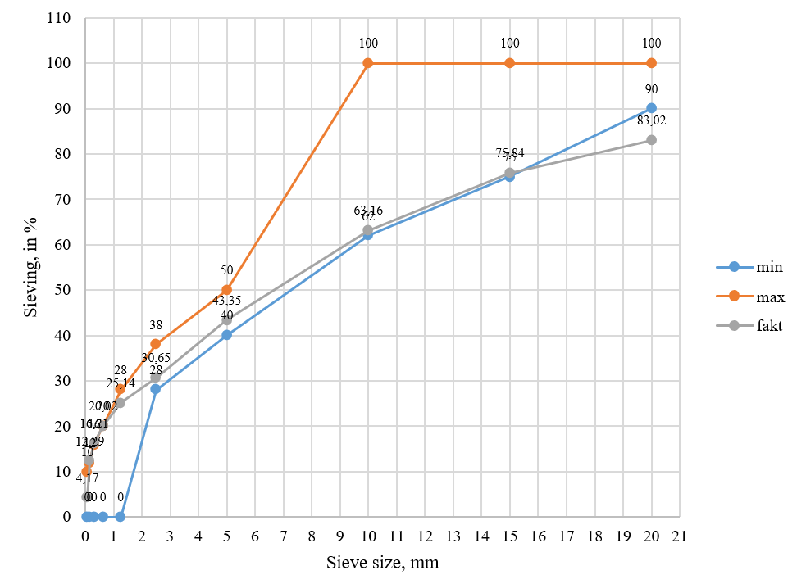
FIGURE 1. The results of the analysis based on the data from Table 4 are presented in the following graph

The physical and mechanical properties of fine-grained hot dense asphalt concrete mixtures of type A with the addition of hydrated lime to dolomite crushed stone in the amount of 1.0%, 1.5% and 2.0% of modified bitumen in the amount of 4.8%, 5.0%, 5.2% were compared with the results of tests of mineral powders isolated from shales, dolomites and limestone rocks based on the requirements of T.U. GOST 9128-2013 "Asphalt concrete, polymer asphalt concrete, asphalt concrete, polymer asphalt concrete mixtures for roads and airfields." [13] the results of the asphalt mixture with the addition of modified bitumen in the amount of 4.8% are presented in the 5th table, the results of the asphalt mixture with the addition of modified bitumen in the amount of 5.0% are presented in the 6th table, the results of the asphalt mixture with the addition of modified bitumen in the amount of 5.2% are presented in the 7th table.

ТАBLE 5. Physical and mechanical properties of mixtures with dolomite crushed stone containing 1.0%, 1.5%, and 2.0% hydrated lime and 4.8% modified bitumen
Indicators | Requirement according to GOST 9128-2013 | Dolomite MP | 1,0 % | 1,5 % | 2,0 % | Shale MP | 1,0 % | 1,5 % | 2,0 % | Limestone MP | 1,0 % | 1,5 % | 2,0 %
Density, g/sm³ | - | 2,37 | 2,38 | 2,38 | 2,37 | 2,38 | 2,4 | 2,39 | 2,37 | 2,36 | 2,39 | 2,38 | 2,37
Water absorption, % | 1,5-5 | 3,65 | 2,85 | 2,97 | 3,28 | 3,72 | 3,15 | 3,26 | 3,56 | 3,62 | 3,35 | 3,28 | 3,59
Water resistance, not less than | 0,9 | 0,99 | 0,98 | 0,97 | 0,99 | 0,97 | 0,95 | 0,97 | 0,99 | 0,96 | 0,93 | 0,94 | 0,96
Swelling, % | - | 0,3 | 0,2 | 0,2 | 0,2 | 0,2 | 0,1 | 0,2 | 0,2 | 0,2 | 0,2 | 0,2 | 0,3
Compressive strength at 20°C, MPa | 2,5 | 3,68 | 4,25 | 4,18 | 3,94 | 3,9 | 4,37 | 4,26 | 3,98 | 3,75 | 4,1 | 4,05 | 3,81
Compressive strength at 50°C, MPa | 1,1 | 1,3 | 1,96 | 1,83 | 1,2 | 1,4 | 2,43 | 2,41 | 1,52 | 1,69 | 1,98 | 1,88 | 1,29
Compressive strength at 60°C, MPa | - | 0,9 | 1,21 | 1,16 | 0,68 | 1,12 | 1,4 | 1,32 | 1,17 | 0,85 | 1,13 | 1,05 | 0,62
Compressive strength at 70°C, MPa | - | 0,6 | 0,9 | 0,85 | 0,58 | 0,7 | 0,96 | 0,88 | 0,72 | 0,62 | 0,86 | 0,78 | 0,6
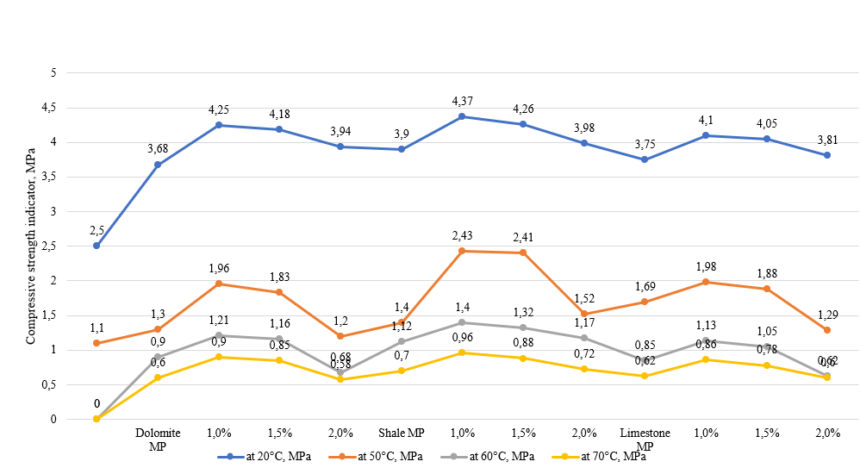
FIGURE 2. Graph of compressive strength of mixtures containing 4.8% modified bitumen

ТАBLE 6. Physical and mechanical properties of mixtures with dolomite crushed stone containing 1.0%, 1.5%, and 2.0% hydrated lime and 5.0% modified bitumen
Indicators | Requirement according to GOST 9128-2013 | Dolomite MP | 1,0 % | 1,5 % | 2,0 % | Shale MP | 1,0 % | 1,5 % | 2,0 % | Limestone MP | 1,0 % | 1,5 % | 2,0 %
Density, g/sm³ | - | 2,38 | 2,39 | 2,39 | 2,38 | 2,39 | 2,4 | 2,39 | 2,38 | 2,37 | 2,38 | 2,38 | 2,38
Water absorption, % | 1,5-5 | 3,5 | 2,44 | 2,67 | 3,15 | 3,57 | 2,85 | 2,82 | 3,2 | 3,54 | 2,51 | 2,59 | 3,35
Water resistance, not less than | 0,9 | 0,99 | 0,98 | 0,98 | 0,99 | 0,95 | 0,94 | 0,95 | 1 | 0,97 | 0,95 | 0,96 | 0,97
Swelling, % | - | 0,3 | 0,2 | 0,2 | 0,2 | 0,2 | 0,1 | 0,2 | 0,2 | 0,3 | 0,2 | 0,2 | 0,3
Compressive strength at 20°C, MPa | 2,5 | 3,75 | 4,56 | 4,39 | 4,1 | 4 | 4,54 | 4,42 | 4,1 | 3,94 | 4,29 | 4,16 | 3,89
Compressive strength at 50°C, MPa | 1,1 | 1,95 | 2,59 | 2,45 | 2,15 | 2,26 | 2,71 | 2,68 | 2,25 | 1,82 | 2,32 | 2,1 | 1,76
Compressive strength at 60°C, MPa | - | 1,32 | 1,68 | 1,62 | 1,41 | 1,65 | 1,85 | 1,72 | 1,56 | 1,26 | 1,55 | 1,52 | 1,49
Compressive strength at 70°C, MPa | - | 0,9 | 1,26 | 1,12 | 0,96 | 0,96 | 1,45 | 1,22 | 0,8 | 0,8 | 0,94 | 0,85 | 0,78

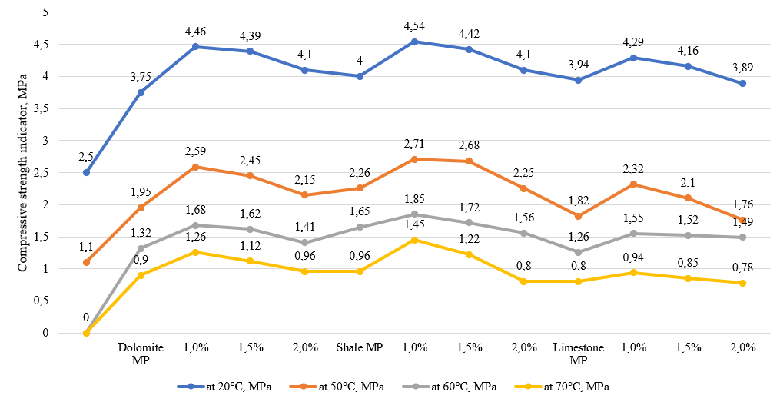
FIGURE 3. Graph of compressive strength of mixtures produced with 5.0% modified bitumen

ТАBLE 7. Physical and mechanical properties of mixtures with dolomite crushed stone containing 1.0%, 1.5%, and 2.0% hydrated lime and 5.2% modified bitumen
Indicators | Requirement according to GOST 9128-2013 | Dolomite MP | 1,0 % | 1,5 % | 2,0 % | Shale MP | 1,0 % | 1,5 % | 2,0 % | Limestone MP | 1,0 % | 1,5 % | 2,0 %
Density, g/sm³ | - | 2,38 | 2,39 | 2,38 | 2,38 | 2,38 | 2,39 | 2,39 | 2,38 | 2,37 | 2,39 | 2,39 | 2,38
Water absorption, % | 1,5-5 | 3,46 | 2,42 | 2,68 | 3,15 | 3,46 | 2,87 | 2,95 | 3,28 | 3,45 | 2,56 | 2,75 | 2,96
Water resistance, not less than | 0,9 | 1,02 | 0,97 | 0,96 | 0,96 | 1 | 0,98 | 0,99 | 0,99 | 1,05 | 0,93 | 0,98 | 1,1
Swelling, % | - | 0,32 | 0,28 | 0,2 | 0,2 | 0,26 | 0,31 | 0,38 | 0,1 | 0,4 | 0,26 | 0,32 | 0,4
Compressive strength at 20°C, MPa | 2,5 | 3,63 | 4,15 | 4,05 | 3,82 | 3,85 | 4,42 | 4,26 | 3,96 | 3,78 | 4,1 | 3,95 | 3,85
Compressive strength at 50°C, MPa | 1,1 | 1,84 | 2,35 | 2,24 | 2,07 | 2 | 2,59 | 2,51 | 2,34 | 1,65 | 2,15 | 1,96 | 1,73
Compressive strength at 60°C, MPa | - | 1,3 | 1,56 | 1,51 | 1,28 | 1,56 | 1,74 | 1,62 | 1,32 | 1,1 | 1,34 | 1,22 | 0,91
Compressive strength at 70°C, MPa | - | 0,85 | 0,91 | 0,9 | 0,75 | 0,86 | 0,94 | 0,88 | 0,81 | 0,72 | 0,85 | 0,78 | 0,65

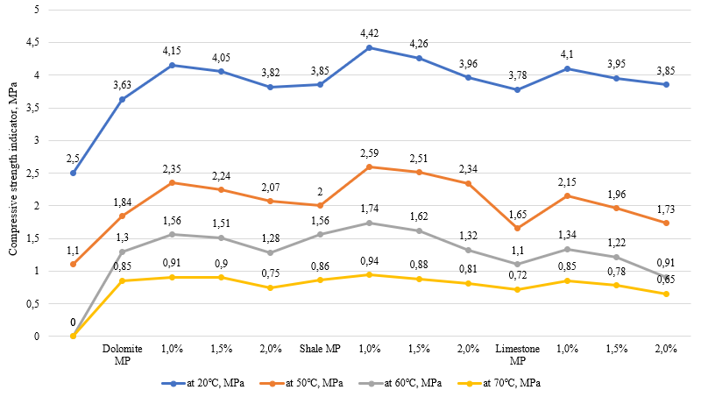
FIGURE 4. Graph of compressive strength of mixtures containing 5.2% modified bitumen
As can be seen from the table and graph, the fine-grained dense hot asphalt concrete mixtures of Type A containing modified bitumen at concentrations of 4.8%, 5.0%, and 5.2% with 5% mineral powders derived from shale, dolomite, and limestone exhibit differences in their physical and mechanical properties. The indicators of water resistance, permeability, compressive strength, and average density of the samples with 5.0% modified bitumen are significantly higher compared to those with 4.8% and 5.2% content.
CONCLUSIONS
The addition of mineral powder derived from dolomite, shale, and limestone rocks, combined with modified bitumen, into fine-grained dense hot asphalt concrete increases the mixture’s density, binder activity, and viscosity in relation to the mineral component. Incorporating mineral powder from natural rocks into the fine-grained dense hot asphalt concrete used in the upper pavement layer improves its water resistance, impermeability, and strength [3, 6, 10].
In Uzbekistan, during the summer months when the air temperature reaches 45–50°C, the surface temperature of asphalt pavements can rise to 65-70°C. According to the standard GOST 9128-2013 “Asphalt Concrete, Polymer Asphalt Concrete, and Asphalt-Polymer Concrete Mixtures for Highways and Airfields,” the compressive strength requirements are specified for 0°C, 20°C, and 50°C [13].
Thus, laboratory tests show that the compressive strength results of samples made from fine-grained dense hot asphalt concrete mixtures of Type A, prepared with mineral powders from dolomite and shale rocks and bitumen modified with hydrated lime, exceed the standard requirements at temperatures of 60°C and 70°C compared to the normative values set for 50°C.
Therefore, it can be concluded that bitumen modified with hydrated lime and combined with mineral powders from dolomite and shale rocks significantly improves the high-temperature strength and durability of asphalt concrete mixtures.
REFERENCES
1. Sengoz, B. & Isikyakar, G. (2008). Evaluation of the properties and microstructure of SBS and EVA polymer modified bitumen. Construction and Building Materials, 22(9), 1897–1905. https://doi.org/10.1016/j.conbuildmat.2007.07.013
2. Bala, N., Napiah, M., & Kamaruddin, I. (2018). Effect of nano silica particles on polypropylene polymer modified asphalt mixture performance. Case Studies in Construction Materials, 8, 447–454. https://doi.org/10.1016/j.cscm.2018.03.011
3. Sadikov, I.S., & Tovboyev, B.Kh. (2025). Additives for asphalt concrete mixtures: A literature review. Problems of Architecture and Construction (Scientific and Technical Journal), Samarkand, No. 2.
4. Al-Khateeb, G.G., & Al-Akhras, N.M. (2011). Properties of Portland cement-modified asphalt binder using Superpave tests. Construction and Building Materials, 25(2), 926–932. https://doi.org/10.1016/j.conbuildmat.2010.06.091
5. Bala, N., Kamaruddin, I., & Napiah, M. (2017). The influence of polymer on rheological and thermo-oxidative aging properties of modified bitumen binders. Jurnal Teknologi, 79(6), 69–73. https://doi.org/10.11113/jt.v79.10180
6. Sadikov, I.S., & Tovboyev, B.Kh. (2025). The effect of hydrated lime on road bitumen. Proceedings of the International Scientific-Practical Conference “Current Issues and Prospects in Chemistry and Chemical Technology,” Jizzakh, pp. 602–605.
7. Morev, A.A., Ilyasov, V.N., Ilyasov, S.V., Ilyasov, V.S., Mrakin, A.N., & Selivanov, A.A. (2016). Prospects for the use of shale and shale processing products in road construction. International Journal of Applied and Fundamental Research, (3–4), 529–532.
8. Radovskiy, B.S. (2003). Problems of Mechanical Properties of Road-Building Materials and Road Pavements. Moscow: Transport.
9. GOST 16557-2005. Mineral Powder for Asphalt Concrete and Organomineral Mixtures. Technical Conditions.
10. Buriyev, Sh., Davranov, Sh., Kuchkarov, Y., & Saydakberova, I. (2021). The effect of shale mineral powder on the strength of asphalt concrete. E3S Web of Conferences, 264, 02052. https://doi.org/10.1051/e3sconf/202126402052
11. Ladygina, B.I. (1987). Strength and Durability of Asphalt Concrete. Minsk: Science and Technology.
12. GOST 12801-98. Materials Based on Organic Binders for Road and Airfield Construction. Testing Methods.
13. GOST 9128-2013. Mixtures of Asphalt Concrete, Polymer Asphalt Concrete, and Asphalt-Polymer Concrete for Highways and Airfields. Technical Specifications.
14. Jumaniyozov, K., Urozov, M., Toshbekov, O., Salimova, M., Raximova, K., & Khursandova, B. (2025, November). Enhancement of energy-efficient cleaning equipment. In American Institute of Physics Conference Series (Vol. 3331, No. 1, p. 050007). https://doi.org/10.1063/5.0307149
15. Sultonova, F., Toshbekov, O., Urozov, M., Boymurova, N., Mustanova, Z., & Boltaeva, I. (2025, November). Enhancing and evaluating the characteristics of specialized workwear for employees in the electric power supply sector. In American Institute of Physics Conference Series (Vol. 3331, No. 1, p. 050006). https://doi.org/10.1063/5.0306350
16. Safarov, N., Yangiboev, R., Bo‘riyev, H., Karshiev, B., Gulboyev, O., Narzullayev, F., & Qurbonov, A. (2025, February). Study of the influence of main factors on the mass and density of saw fiber separator raw material. In AIP Conference Proceedings (Vol. 3268, No. 1, p. 020033). AIP Publishing LLC. https://doi.org/10.1063/5.0257374

