Control of excitation of synchronous motors of pumping stations based on neural networks
Obid Nurmatov ª, Flora Makhmaraimova, Dildora Obidjonova
Tashkent state technical university named after Islam Karimov, Tashkent, Uzbekistan
^{a)} Corresponding author: obidjon444@mail.ru
Abstract. Large pumping stations incorporating synchronous motors with powers reaching several tens of megawatts can be used as reactive power compensators in electrical systems and minimize energy losses in networks. The method described in the article can be used in systems for automatic control of the excitation of large synchronous motors.
INTRODUCTION
The practice of operating electrical systems (ES) shows that if they include large pumping stations equipped with powerful synchronous motors (SM), they are taken into account as a constant load. At the same time, taking into account the regime properties of large SDs will improve the operating conditions of the ES, reduce losses in the system and increase its controllability. It all depends on the rational use of automatic excitation control (AEC) of the engine.
It is known [1] that in the case of a lack of reactive power in the electrical system, there may be a loss of operation stability not only of the engine itself, but of the entire load node. AEC changes the amount of reactive power output by the engine according to a certain law, depending on the size and nature of the load, as well as on the mode of the supply network, and maintains the voltage values at the SM connection point [4].
The paper describes a method for automatic control of the excitation current of a synchronous electric motor in post-emergency modes of the power system. The essence of the method lies in the fact that in the post-emergency modes of the power system, the value of cosφ of the motor, the current value of its load angle are measured and the value of cosφ is maintained at a level of about 1.0 by changing the setting value of the excitation current control loop in the appropriate direction according to the voltage deviation of the stator circuit, carried out according to proportional-differential law. The disadvantage of this approach is that in order to limit the maximum allowable value of the rotor current, the temperature of its winding is continuously monitored by indirectly measuring the active resistance of the winding [1,2].

EXPERIMENTAL RESEARCH
A device is described that contains voltage and current meters of the stator of a synchronous motor, an angle φ meter, a rotor current meter, an amplifier, and a phase-pulse device. The disadvantages of this method include insufficiently effective damping of oscillations that occur with changes in the load and mains voltage, as well as insufficient static stability of the motor [3,4].
A model of a fuzzy controller is presented, the output of which is connected to the input of a PID controller that performs fuzzy control in order to minimize energy losses in the electrical network. Here, the disadvantage is the selected control parameter in the form of a deviation of the rotor speed of the synchronous motor, which cannot sufficiently minimize energy losses without controlling the level of reactive power in the load node [5,6].
The essence of the proposed control approach is illustrated in Figure 1, depicting a functional diagram of a synchronous motor powered by the network, implementing the proposed excitation control approach.

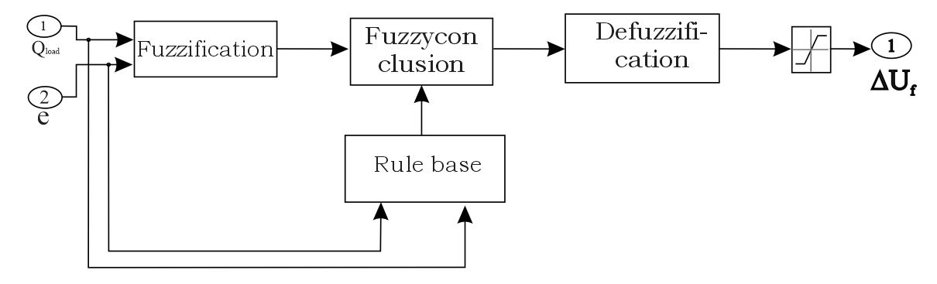
FIGURE 1. Fuzzy Logic Controller Structure

The objective of the proposed approach is to maintain the maximum value of cosφ of the load node in order to minimize energy losses in the network. The task is achieved by the fact that stabilization signals for the deviation of cosφ and reactive power in the load node are introduced into the system for controlling the excitation of a synchronous motor, which is a controller based on fuzzy logic [7,8,9].

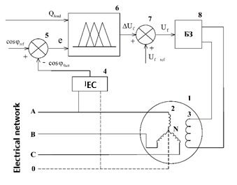
FIGURE 2. Functional diagram of excitation control of a synchronous motor of a pumping station

The excitation control circuit of a synchronous motor (Fig. 2) contains a synchronous motor 1 connected to a three-phase electrical network, a measuring part 4 (IC) connected to one of the phase terminals of the stator winding 2 and neutral N of the synchronous motor 1, while the outputs of the measuring part 4 (IC) are the inputs of the adder 5, which in turn is connected to the fuzzy logic controller 6, the output of which is connected to the adder 7, the output of which is connected to the protection unit 8 (BZ) connected to the excitation winding 3 of the synchronous motor [10,11,12]
RESEARCH RESULTS
The excitation control of a synchronous motor is implemented as follows.
The measuring part 4 (IC) connected to the output of the stator winding 2 and neutral N of the synchronous motor 1 is designed to measure and convert the control parameter - cosφ. The signal of the measured cosφ_{fact} is fed to the input of the adder 5, in which it is compared with the specified setting cosφ_{ref} and an error signal e=cosφ_{ref} – cosφ_{fact} is generated, which, together with the signal of the pre-measured value of the reactive power Q_{load} consumed in the node, is fed to the input of the fuzzy logic controller 6. The fuzzy controller logic 6 is a non-linear control system that uses accurate input variables in the form of an error signal e and reactive power consumption in the node Q_{load} and, in accordance with the rule base, generates a control variable in the form of a signal for changing the excitation voltage ΔU_{f}. The output signal ΔU_{f} from the fuzzy logic controller 6 is fed to the input of the adder 7, where it is added to the excitation voltage setting ΔU_{f}_ref and forms the output signal Uf, which is fed to the input of the protection unit 8 (BZ), designed to limit the increased voltage and overload current supplied to the excitation winding 3 synchronous motors 1 [13,14,15,16].
Figure 2 shows the membership functions of the input parameters - changes in cosφ in the form of an error signal e (Fig. 2, a) and the level of reactive power consumption in the Qload node (Fig. 2, b), as well as the output parameter - excitation voltage Uf (Fig. .2, c).

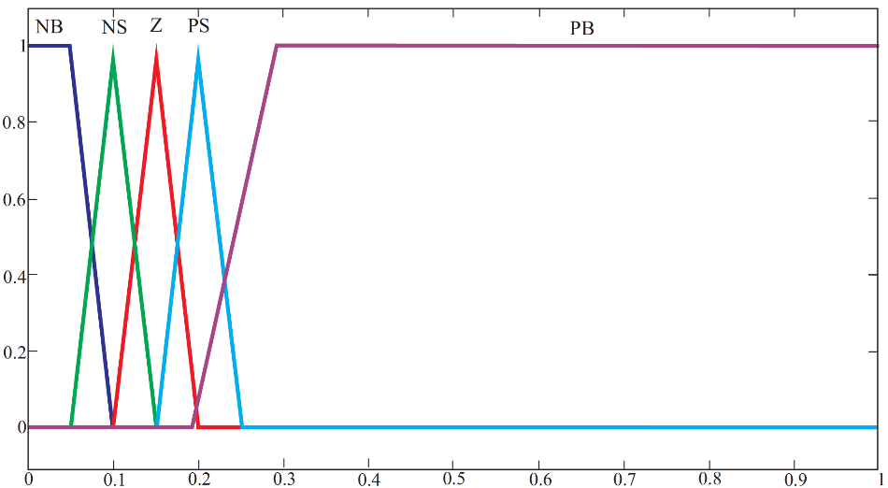
e (error signal of cosφ deviation from the setpoint)
a)

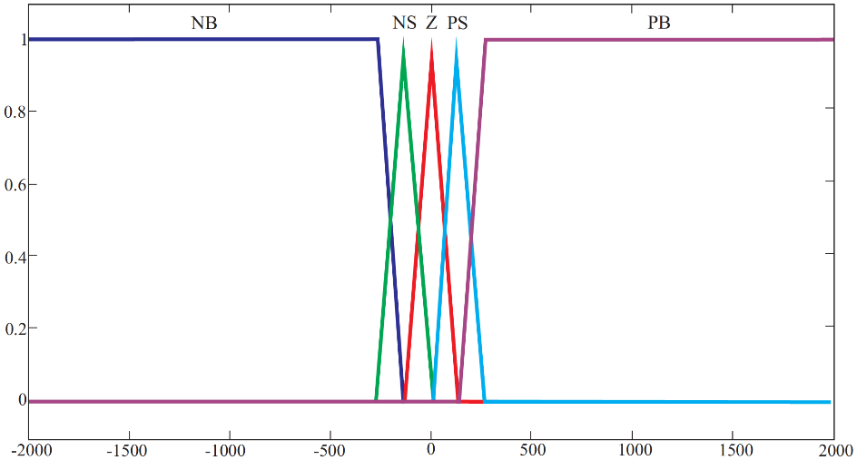
Qload (value of reactive power consumed in the load node)
b)

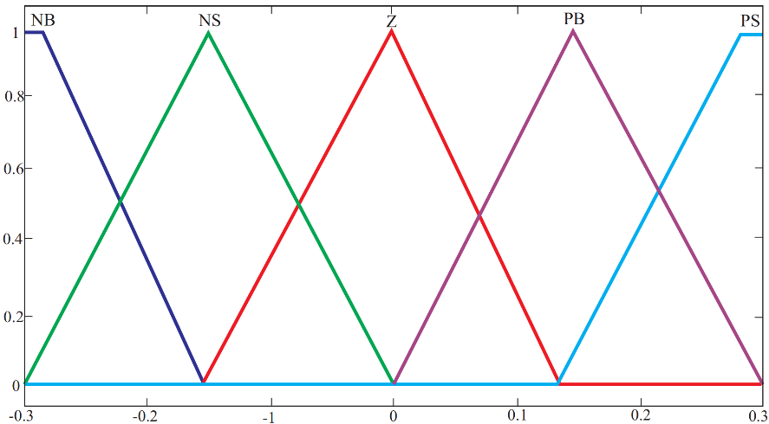
Uf (excitation voltage change)
s)
Fig. 2. Membership functions of input and output parameters

The fuzzy controller functions based on the rule base shown in Table 1, where the following notations are used: NB (negative large), NS (negative small), Z (zero), PS (positive small), and PB (positive large).

TABLE 1. Parameters of synchronous generators.
Error signal (e) | The value of reactive power consumption in the load node (Qload)
Error signal (e) | NB | NS | Z | PS | PB
NB | NB | NB | NB | NS | Z
NS | NB | NB | NS | Z | PS
Z | NB | NS | Z | PS | PB
PS | NS | Z | PS | PB | PB
PB | Z | PS | PB | PB | PB

As an example of the implementation of the proposed method for controlling the excitation of synchronous motors of pumping stations using the Matlab software package from The MathWorks Inc, the circuit shown in Fig. 1 was simulated. Synchronous motor parameters: rated active power 800 kW; nominal power factor 0.85; rated voltage 10 kV; nominal number of revolutions 1000; starting current ratio 7; Efficiency - 0.94.
We will simulate the connection of a large asynchronous load to the connection node of a synchronous motor at the 2nd second of the simulation. The cosφ setpoint of the fuzzy controller is set to 0.85.
Figures 3 and 5 show graphs of the transient change in cosφ in the load node, torque and voltage of the synchronous motor. The curve of change in the moment of a synchronous machine under external disturbance indicates the preservation of stable synchronous operation of the motor [18,19,20]

FIGURE 3. Changing torque and voltage synchronous

Thus, a synchronous motor equipped with a fuzzy controller as an AEC system is able to maintain cosφ by controlling the level of reactive power in the node. The described approach to controlling the excitation of synchronous motors of pumping stations ensures that the maximum value of cosφ is maintained in order to minimize energy losses in the network when the load changes in the connected node. Large pumping stations incorporating synchronous motors with power reaching several tens of megawatts can be used as reactive power compensators for load nodes to ensure minimization of energy losses in networks.
CONCLUSIONS
Thus, a synchronous motor equipped with a fuzzy controller as an AEC system is able to maintain cosφ by controlling the level of reactive power in the node. The described approach to controlling the excitation of synchronous motors of pumping stations ensures that the maximum value of cosφ is maintained in order to minimize energy losses in the network when the load changes in the connected node. Large pumping stations incorporating synchronous motors with power reaching several tens of megawatts can be used as reactive power compensators for load nodes to ensure minimization of energy losses in networks.

REFERENCES
- Allaev K.R., Khoxlov V.A., Sitdikov R.A., Transient processes of pumping stations/Pod red. prof. M.M. Muxammadiev. - «Fan va texnologiya». –T. 2012, 226 s.
- Tashilin V.A. Analysis and selection of stabilization parameters of excitation control devices using identification methods: Avtoref. dis. kan. tex. nauk. – Ye.: 2018. – 24 s.
- Abramovich B.N., Kruglыy A.A. Excitation, regulation and stability of synchronous motors. - L. : Energoatomizdat : Leningr. otd-nie, 1983. - 128 s.
- Nurmatov O., Nosirov F., Shamsutdinov K., Obidjonova D.Research on control systems for automatic excitation regulation utilizing fuzzy logic methodology. AIP Conference Proceedings AIP Conf. Proc. 3331, 040081 (2025) https://doi.org/10.1063/5.0306119
- Nurmatov O., Makhmudov T.: Pulatov N. Сontrol of the excitation system of synchronous motors pumping stations //AIP Conference Proceedings, 3152, 040008 (2024) https://doi.org/10.1063/5.0218781
- Jing Shi, Ying Xu, Meng Liao, Shuqiang Guo, Yuanyuan Li, Li Ren, Rongyu Su, Shujian Li, Xiao Zhou, Yuejin Tang Integrated design method for superconducting magnetic energy storage considering the high frequency pulse width modulation pulse voltage on magnet Applied Energy, Volume 248, 2019, pp. 1-17
- Allayev K.R., Nurmatov O., Makhmudov T. Influence of automatic excitation regulators on modes of hydropower plants//6th International Conference on Electromechanics and Robotics “Zavalishin’s Readings”, ERZR 2021. https://www.scopus.com/record/display.uri?eid=2-s2.0-85115186020&origin=resultslist#metrics
- Makhmudov T., Nurmatov O. Modernization of automatic excitation control systems of generators in Syrdarya TPP//6th International Conference on Electromechanics and Robotics “Zavalishin’s Readings”, ERZR 2021. https://www.scopus.com/record/display.uri?eid=2-s2.0-85115188474&origin=resultslist
- Allaev K., Makhmudov T.: Research of small oscillations of electrical power systems using the technology of embedding systems. Electrical Engineering 102(1), 309–319 (2020). https://doi.org/10.1007/s00202-019-00876-9
- Felipe M. Pimenta, Arcilan T. Assireu Simulating reservoir storage for a wind-hydro hydrid system Renewable Energy, Volume 76, 2015, pp. 757-767
- Allayev K. Nurmatov O., Makhmaraimovа Calculastion experimental studies of transition processes in electricity systems with account of hydroenergy installations. Journal of Critical Reviews ISSN- 2394-5125 VOL 7, ISSUE 13, 2020 http:// www.jcreview.com/index.php?iid=2020-7-13.000&&jid=197&lng=
- JuanI. Pérez Díaz, M. Chazarra, J. García González, G. Cavazzini, A. Stoppato Trends and challenges in the operation of pumped-storage hydropower plants Renewable and Sustainable Energy Reviews, Volume 44, 2015, pp. 767-784
- Nurmatov O. Large pumping stations as regulators of power systems modes. Rudenko International Conference “Methodological problems in reliability study of large energy systems” (RSES 2020), E3S Web of Conferences 216, 01098(2020) https://doi.org/10.1051/e3sconf/202021601098
- Urishev B., Nosirov F., Nurmatov O., Amirov Sh.,Urishova D. Local energy system based on thermal, photovoltaic, hydroelectric stations and energy storage system AIP Conf. Proc. 3331, 070015 (2025) https://doi.org/10.1063/5.0306446
- Makhmudov T.: Nurmatov O., Ramatov A.N., Site Selection for Solar Photovoltaic Power Plants Using GIS and Remote Sensing Techniques//AIP Conference Proceedings, 3152, 060002 (2024) https://doi.org/10.1063/5.0218779
- Ghosh A., Sanyal S., Das A., Sanyal A.: Automatic Electronic Excitation Control in a Modern Alternator, In: Chattopadhyay S., Roy T., Sengupta S., Berger-Vachon C. (eds) Modelling and Simulation in Science, Technology and Engineering Mathematics. Advances in Intelligent Systems and Computing 749. Springer, Cham, 397-406 (2018). https://doi.org/10.1007/978-3-319-74808-5_33
- Abbas Ali Salimi, Ali Karimi, Yousef Noorizadeh Simultaneous operation of wind and pumped storage hydropower plants in a linearized security-constrained unit commitment model for high wind energy penetration Journal of Energy Storage, Volume 22, 2019, pp. 318-330
- Wejia Yang, Jiandong Yang, Wei Zeng, Renbo Tang, Liangyu Hou, Anting Ma, Zhigao Zhao, Yumin Peng Experimental investigation of theoretical stability regions for ultra-low frequency oscillations of hydropower generating systems Energy, Volume 186, 2019, Article 1158
- Rismukhamedov D., Shamsutdinov K., Magdiev K., Peysenov M., Nurmatov O. Construction of pole-switchable windings for two-speed motors of mechanisms with a stress operating modeAIP Conference Proceedings AIP Conf. Proc. 3331, 040059 (2025) https://doi.org/10.1063/5.0305963
- Chiniforoosh S., Jatskevich J., Yazdani A., Sood V., Dinavahi V., Martinez J.A., Ramirez A.: Definitions and Applications of Dynamic Average Models for Analysis of Power Systems. IEEE Transactions on Power Delivery 25 (4), 2655-2669 (2010). https://doi.org/10.1109/TPWRD.2010.2043859

