Development of an electrode motion control device for electric arc steelmaking furnaces
Ikromjon Rakhmonov ^{1,2}, Makhzuna Korjobova ^{1, a)} Kıdırbay Baymuratov ³, Javokhir Boboqulov ⁴
¹ Tashkent state technical university named after Islam Karimov, Tashkent, Uzbekistan
² Termez State University of Engineering and Agrotechnology, Termez, Uzbekistan
³Karakalpak State University named after Berdakh, Nukus, Uzbekistan
⁴Navoi State University of Mining and Technologies, Navoiy, Uzbekistan
^{a)} Corresponding author: mahzunaqorjobova@gmail.com
Abstract. This article analyzes the process of electrode motion regulation in electric arc steelmaking furnaces. The limitations of existing regulation methods under conditions of sharp variations in arc current and voltage are identified. To address these challenges, an electrode motion regulation and control device, EHRK-2024, based on fuzzy logic, has been developed. The proposed device enables accurate and stable real-time control of electrode motion by directly measuring the arc current in the short network of the furnace. Comparative analysis results demonstrate that the device exhibits higher sensitivity, lower production cost, and improved energy efficiency compared to conventional PLC-based solutions currently used in industrial practice.
INTRODUCTION
In electric arc steelmaking furnaces (EAFs), the process of melting the primary charge is directly dependent on electrode motion regulation systems. The operating mode of the furnace is largely determined by the characteristics of power regulators responsible for stabilizing the electric arc and ensuring high-speed vertical movement of heavy electrodes. However, the steelmaking process in EAFs is a multistage, nonlinear, and highly complex technological process. Due to its nonlinear nature, the electrical parameters of the arc such as current and voltage can vary sharply over short time intervals, which significantly complicates the task of maintaining optimal electrode motion and stable arc length [1, 2].
In practical applications, electrode motion regulation is typically performed using power regulators based on arc current and voltage signals measured on the primary side of a special furnace transformer through measuring transformers. Nevertheless, the arc current in the short network between the furnace transformer and the electrodes is highly variable, often ranging from approximately 17 kA to 41 kA. This variability leads to considerable measurement inaccuracies when arc state parameters are evaluated indirectly, thereby reducing the ability of conventional control systems to respond rapidly and accurately to abrupt changes in arc conditions. Previous studies indicate that arc current fluctuations frequently exceed 4–7 kA, further complicating reliable regulation.
The high dynamic variability of arc current poses a serious challenge for conventional electrode regulation devices and control systems. Most existing regulators are unable to precisely control electrode motion speed and maintain arc length within narrow optimal limits under unstable melting conditions. As a result, sharp fluctuations in arc current and voltage occur, leading to electrode breakage, electrode damage, and unplanned interruptions in the technological process. These disturbances ultimately increase the specific electrical energy consumption per ton of steel produced and reduce overall energy efficiency [3, 4].
Under these conditions, there is a clear need to develop advanced electrode motion regulation and control devices that can operate reliably in nonlinear and rapidly changing environments. The integration of intelligent control approaches capable of simultaneously regulating electrode motion, arc current, and arc voltage in a coordinated manner is essential for improving arc stability, reducing electrode wear, minimizing energy losses, and enhancing the efficiency and reliability of electric arc steelmaking processes.

EXPERIMENTAL RESEARCH
Experimental investigations conducted on electric arc steelmaking furnaces indicate that electrode motion control is typically implemented without explicitly accounting for electrode movement speed [5]. Instead, electrodes are moved upward or downward through mechanical actuators primarily in response to changes in arc current. In certain operating conditions, a decrease in arc current triggers downward electrode movement in an attempt to restore the current level. However, when a non-conductive slag layer forms on the surface of the primary charge, such control actions may cause direct contact between the electrode and the charge material, resulting in electrode breakage [6]. This, in turn, leads to electrode damage and a sudden increase in arc current within a short time interval.
These limitations highlight the necessity of developing advanced control approaches that consider not only arc current and voltage, but also electrode motion dynamics, particularly electrode movement speed. The implementation of such intelligent regulation methods is essential for improving arc stability, reducing electrode consumption, and enhancing the overall energy efficiency and reliability of electric arc furnace operations.
The regulation device operates based on the values obtained from current and voltage measuring transformers installed on the high-voltage side of a special furnace transformer [7]. However, if the electrode lifting speed commanded by the controller is not ensured with sufficient accuracy, an increase in arc current may occur, leading to damage to the furnace walls, emergency shutdowns of the furnace, and excessive upward movement of the electrodes beyond the calculated distance. As a consequence, the efficiency of intensive melting of the charge by the electric arc decreases, energy losses increase, and overall energy efficiency deteriorates.
Therefore, the main objective of this study is to implement a comprehensive electrode motion regulation device and control system for electric arc steelmaking furnaces, aimed at stabilizing arc current and voltage within narrow operating ranges [10, 11]. This approach enables faster and higher-quality melting of the charge material, while reducing the negative impact of rapid changes in arc state parameters on electrode breakage. To achieve this objective, an electrode motion regulation and control device (it is called “EHRK-2024”) for EAFs was developed. The external view of the proposed device is shown in Figure 1, where compact high-power components are employed to ensure reliable and efficient operation.
FIGURE 1. External view of the EHRK-2024 device
As shown in Figure 1, the proposed EHRK-2024 device for regulating and controlling electrode motion in electric arc steelmaking furnaces (EAFs) was developed to control the speed and direction of electrode movement based on the input values of arc current and arc voltage, ensuring that the arc length is maintained within optimal limits. To facilitate installation in an electric arc steelmaking shop and integration with existing furnace equipment, the device is equipped with a four-terminal connection block (1). In addition, a USB port is located on the side of the device (2), which enables integration with the electrode motion control system through the internal controller and allows configuration, monitoring, and data exchange. The device also includes a dedicated power supply unit connected to the electrical network for its own operational needs (3), as well as a status indicator (4).
The proposed EHRK-2024 device provides a 10% increase in operational lifetime and enables regulation of arc current within the 2–3 kA range. Owing to the selection of components with 1,7 times higher sensitivity to changes in arc voltage and, most importantly, due to localization of the device, its production cost is reduced by up to 45% compared to existing analogues. Furthermore, the implementation of a modern fuzzy-logic-based control system ensures precise and reliable regulation of electrode motion, resulting in high operational efficiency (see Figure 2).
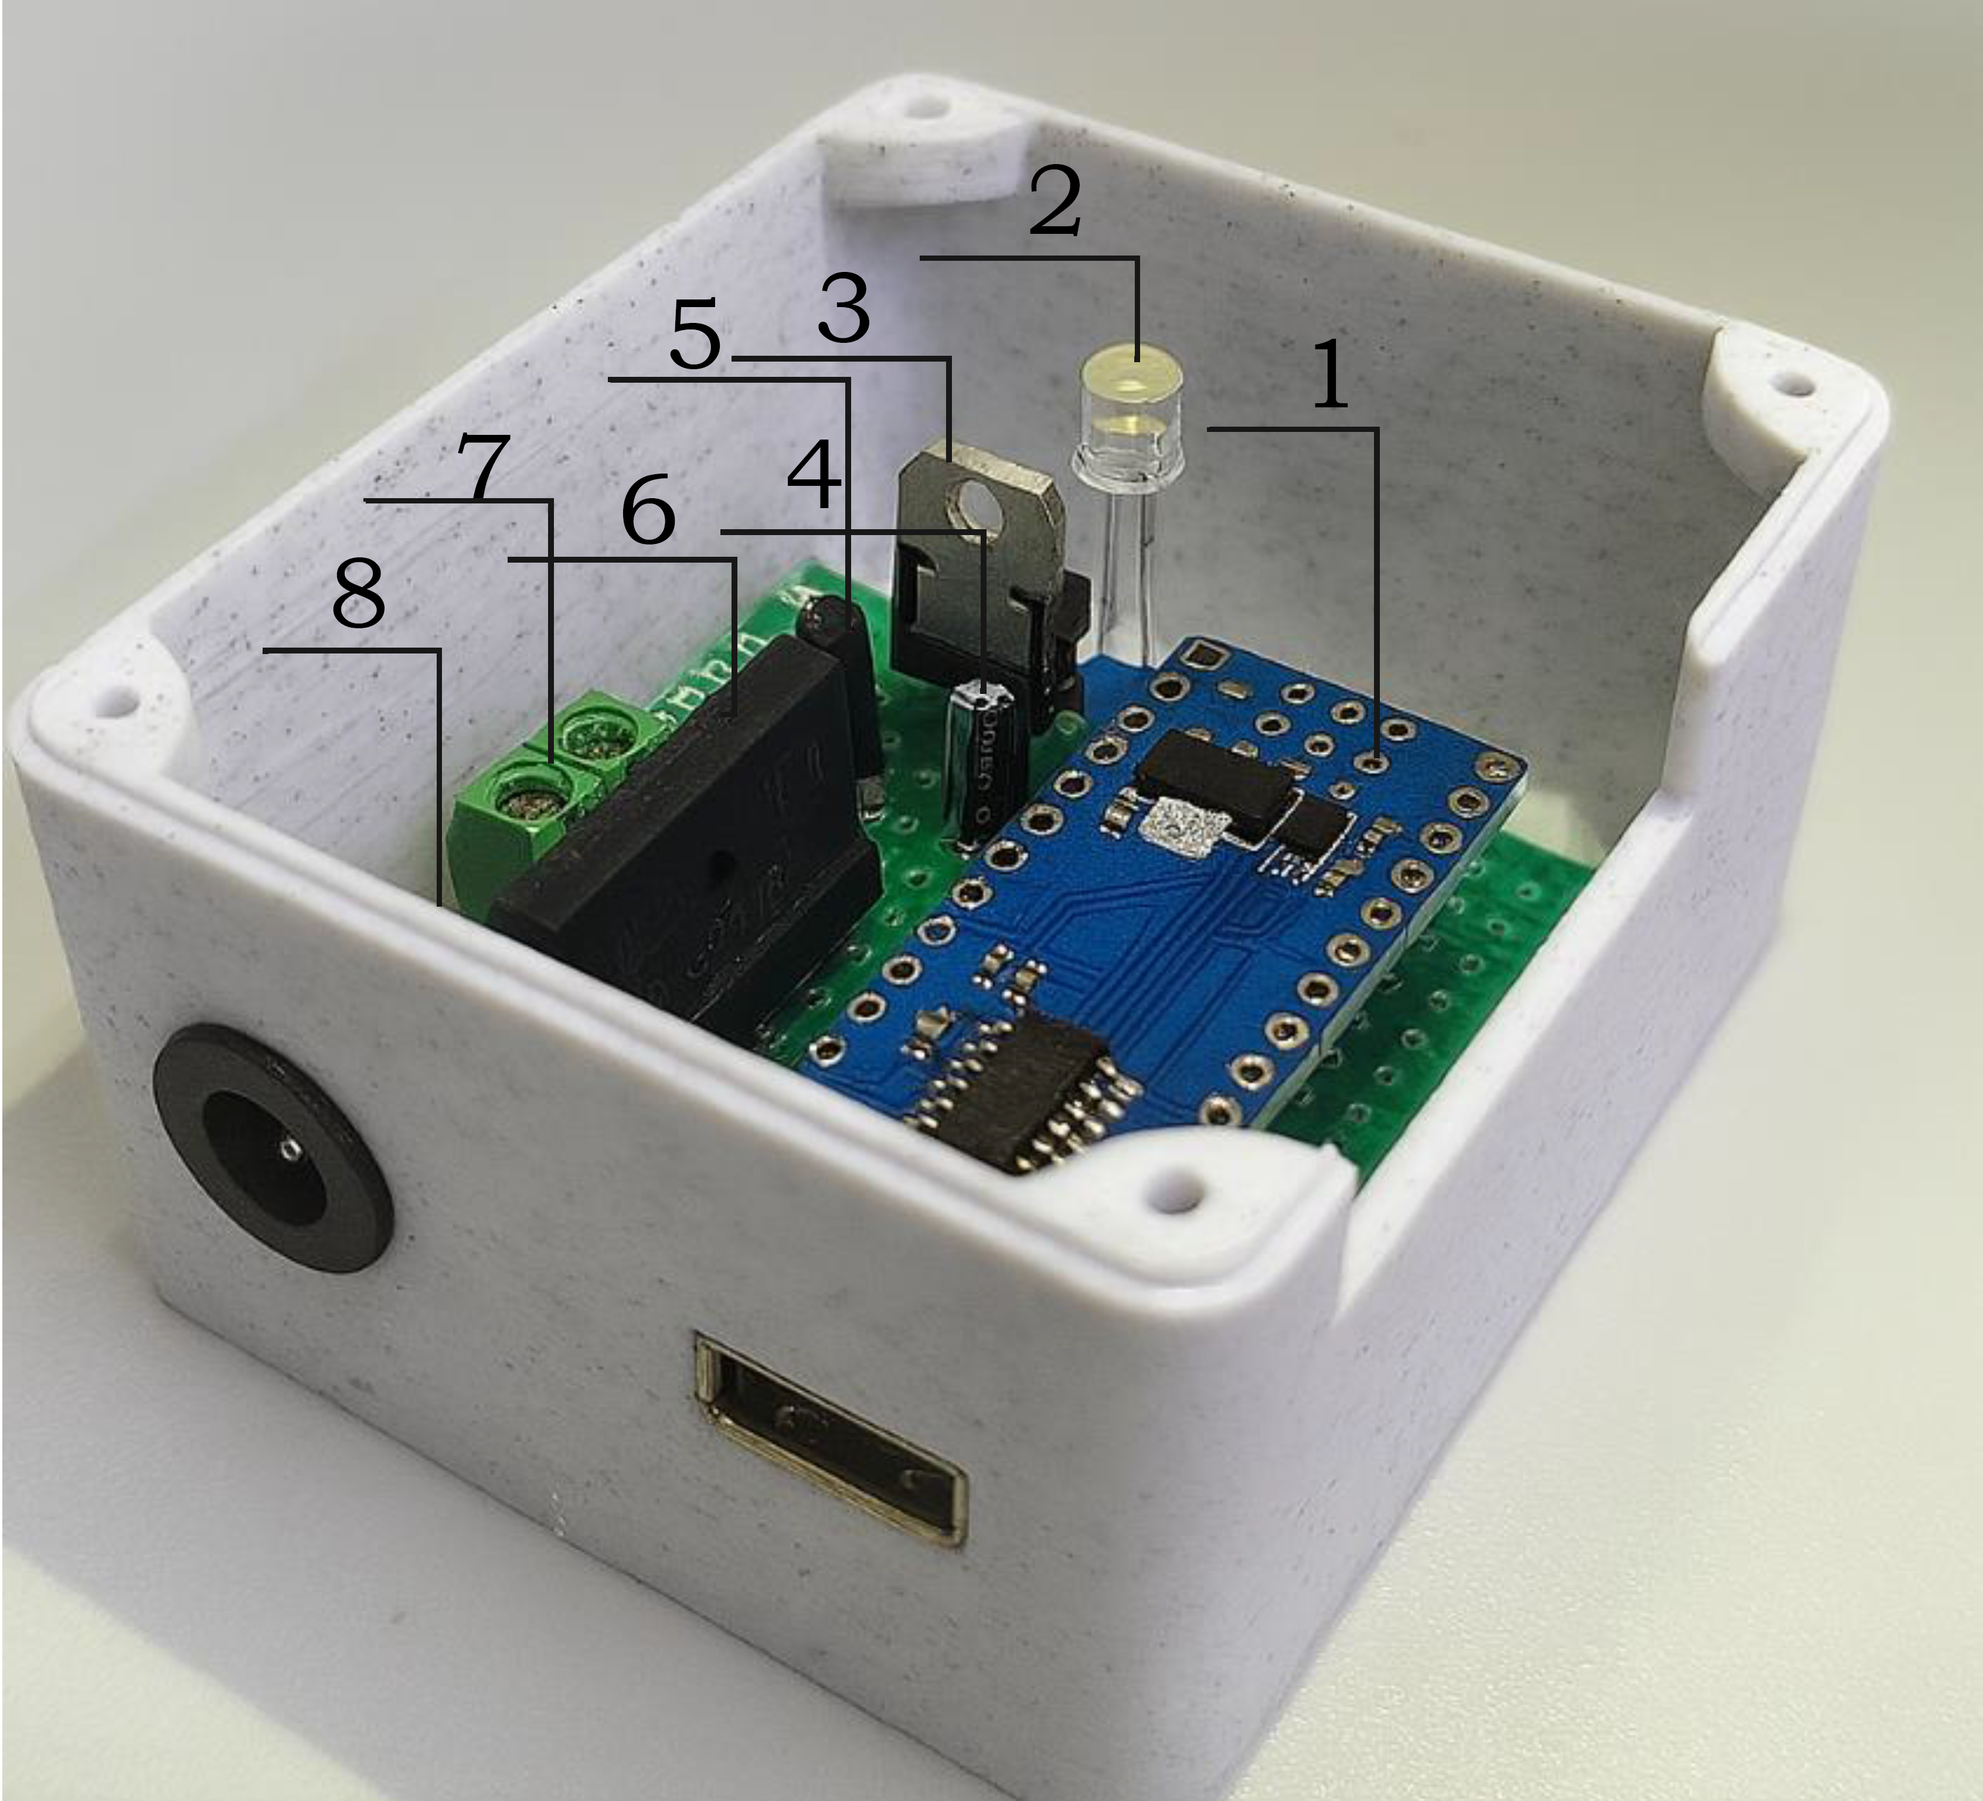
FIGURE 2. Internal structure of the EHRK-2024 device
In addition, the proposed EHRK-2024 device complies with the requirements of GOST 22261-94 from the standpoint of metrological standardization [8]. The automatic electrode motion control system also meets the requirements of GOST 26.001-80 [9].
RESEARCH RESULTS
Based on the conducted scientific research, it has been established that, in current industrial practice, electrode motion regulation in electric arc steelmaking furnaces (EAFs) is mainly implemented using electrohydraulic power regulators and electromechanical power regulators. In these systems, auxiliary control devices such as Siemens S7, Mitsubishi Q, and Delta PLC controllers are widely employed to regulate and control electrode motion in EAFs. These controllers process arc current and voltage signals and generate control commands for electrode lifting or lowering mechanisms.
However, despite their widespread use, the existing regulation methods exhibit a number of limitations, particularly under conditions of rapid and nonlinear variations in arc current and voltage. In electrohydraulic regulation systems, delays associated with hydraulic response and fluid dynamics often reduce control accuracy, while electromechanical systems may suffer from limited responsiveness and insufficient adaptability to rapidly changing arc conditions [12, 13, 14]. As a result, maintaining optimal arc length and stable melting conditions becomes challenging, especially during the initial stages of primary charge melting.
In the present study, the proposed electrode motion regulation and control method was subjected to a comparative analysis against these conventional approaches. Using available scientific literature and practical operational data, two widely applied regulation and controllling methods – Delta PLC, Mitsibushi Q and EHRK-2024 – were compared with the proposed intelligent regulation method. The comparison focused on key performance indicators such as response speed, regulation accuracy, adaptability to arc parameter fluctuations, reliability, and impact on electrode wear and energy consumption.
The results of this comparative analysis made it possible to identify the advantages and limitations of each approach. In particular, the proposed method demonstrated improved sensitivity to rapid changes in arc current and voltage, enhanced precision in controlling electrode motion speed, and greater stability in maintaining optimal arc length. At the same time, potential implementation challenges and operational constraints of the proposed system were also identified. The summarized results of this comparative evaluation are presented in Table 1, which provides a structured overview of the performance characteristics of the analyzed regulation methods.

TABLE 1. Comparative analysis of electrode motion regulation and control methods in EAFs
Performance indicators | Delta PLC | Mitsubishi Q | EHRK-2024
Power supply | 24 V DC inside cabinet; external 230/400 V AC | 24 V DC, 3–10 W (module-dependent) | 24 V DC (accepts 12–28 V DC), ≤ 3 W
Rated frequency | 50–60 Hz | 50-60 Hz | 50 Hz
Analog input | 4–20 mA/0–10 V (with inductive/Rogowski interfaces) | 4–20 mA/0–10 V | ±10 V via Transreactor and analog devices
Analog output | ±10 V/4–20 mA | ±10 V or 4–20 mA, $I_{out}$ 5–20 mA | ±10 V or 4–20 mA
Control function | PLC integration; servo-valve control via ±10 V | PLC with analog modules; servo-valve control ±10 V | Servo-valve control via ±10 V based on Fuzzy logic
Control algorithm | 5…20 ms, adaptive model-based | 10–20 ms (PID) with filters | 10 ms (100 Hz) Fuzzy logic (Mamdani), remote-capable
Operating temperature | 0$÷$+50 °C (depending on IP enclosure) | −20$÷$+60 °C | −25$÷$+50 °C
Power factor (cos φ) | 0,85-0,99 | 0,85-0,95 | 0,85-0,95
Permissible relative humidity at nominal temperature, % | 95 | 96 | 90
Weight, kg | 0,45 | 0,75 | 0,35
Dimensions, mm | 130х90х60 | 98х27х90 | 70х60х60
Service life, years | 10-15 | 15-20 | 20
Cost, million UZS | 70 | 100 | 45
The analysis of the proposed electrode motion regulation and control device demonstrates that the system exhibits a high degree of adaptability to the dynamic and nonlinear characteristics of the electric arc steelmaking process. The compact structural design of the device, its relatively low production and implementation cost, and its ability to accurately and stably regulate the arc current within a 2–3 kA range using fuzzy logic–based control clearly indicate its advantages over existing conventional analog systems currently used in industrial practice.
One of the key advantages of the proposed device is its capability to regulate electrode motion in real time based directly on the arc current parameters measured in the short network of the electric arc furnace. This approach significantly reduces measurement errors associated with current and voltage transformers installed on the primary side of the furnace transformer. As a result, the response speed of the control system to technological disturbances is increased, and the accuracy of electrode motion control is substantially improved.
In addition, the device is equipped with a controller integrated with a modern artificial intelligence–based Mamdani-type fuzzy decision-making system, which enables comprehensive, fast, and precise control of electrode motion. This control strategy ensures optimal adaptation of electrode movement under abrupt variations in arc current and voltage, maintains the arc length within an optimal operating range, and effectively reduces the risk of electrode mechanical damage and breakage.
CONCLUSIONS
In conclusion, one of the primary objectives of the present study—ensuring the effective operation sequence of an electrode motion regulation and control device for electric arc steelmaking—has been successfully achieved. The proposed control scheme enables stable regulation of arc current and voltage within narrow operating ranges, thereby reducing electrode breakage, preventing technological interruptions, and enhancing both the intensity and energy efficiency of the steelmaking process under normal operating conditions.
As a result of the conducted research, the following outcomes were achieved:
1. An electrode motion regulation device was developed based on a Fuzzy logic control system integrated with a transreactor, opto-relay/thyristor power switching units, and PLC/Arduino platforms. As a result, stable maintenance of the arc current within narrow ranges under optimal arc length conditions was achieved, along with fast and stepwise regulation of electrode speed and direction. This approach reduced operating conditions that lead to electrode breakage and enabled an increase in the overall intensity of the technological process.
2. The installation points and interface architecture of the EHRK-2024 device within the electric power supply system of an electric arc steelmaking shop were designed, and a comparative analysis was performed against existing solutions based on Delta PLC and Mitsubishi Q platforms. The results demonstrated the advantages of the proposed device, including a compact design and lower cost (approximately 45% reduction in production cost), extended service life (approximately 10% increase), about 1,7-times higher sensitivity to arc voltage variations, and the ability to accurately regulate arc current within a 2–3 kA range.
REFERENCES
- Nikolaev, A.A., Kornilov, G.P., Tulupov, P.G., Povelitsa, E.V. Analysis of various configurations of automatic control systems for electrode movement in electric arc steelmaking furnaces and ladle furnace units // Bulletin of the Magnitogorsk State Technical University named after G.I. Nosov, 2015, No. 3.
- Panoiu M., Panoiu C., Ghiormez L. Modeling of the Electric Arc Behavior of the Electric Arc Furnace // Advances in Intelligent Systems and Computing. – 2013. – Vol. 195. – P. 261.
- Rakhmonov, I.U., Korjobova, M.F., Usmanov, E.G., Ushakov, V.Ya. Power regulation device for an electric arc steelmaking furnace // Patent for Invention, Federal Service for Intellectual Property (Rospatent), Russian Federation, 2025, No. 2845265.
- Rakhmonov I.U., Korjobova M.F., Ktaybekov M.K. Power regulation issues in electric arc furnaces (EAFs) // Научно-методический журнал. - 2024. - №4 (80).
- Rakhmonov I.U., Korjobova M.F., Kholixmatov B.B., Uzakov N.Ch. Challenges in Electrode Usage in the Steelmaking Process // E3S Web of Conferences, 461, 01090 (2023) DOI: https://doi.org/10.1051/e3sconf/202346101090
- Rakhmonov I.U., Korjobova M.F. Analysis of Existing Methods for Regulating and Controlling Electrode Movement in the Steelmaking Process // Scientific and technical journal of Problems of Energy and Sources Saving, 2024, no. 4, pp. 17-23. https://doi.org/10.5281/zenodo.16932889
- GOST 22261-94. Information processing systems. Terms and definitions // Moscow: Standards Publishing House, 1995, 23 p.
- GOST 26.001-80. Unified system of instrumentation standards. General provisions // Moscow: Standards Publishing House, 1980, 15 p.
- Rakhmonov, I.U., Korjobova, M.F. Device for regulating electrode movement in electric arc steelmaking // Innovative Technologies, Scientific and Technical Journal, 2025, Vol. 58, No. 2, ISSN 2181-4732.
- Rakhmonov, I.U., Korjobova, M.F. Improving energy efficiency of electric arc steelmaking furnaces by reducing electrode breakage // In: Proceedings of the IV International Scientific and Technical Conference “Actual Problems of Power Supply Systems”, TSTU–KSU, 2024.
- Rakhmonov, I.U., Korjobova, M.F., Ushakov, V.Ya., Khoshimov, F.A. Mathematical modeling of electrode motion control in an electric arc furnace based on fuzzy logic // Bulletin of the Tomsk Polytechnic University. Geo Assets Engineering, 2025, Vol. 336, No. 9, pp. 212–226. https://doi.org/10.18799/24131830/2025/9/5150
- Rakhmonov, I.U., Korjobova, M.F. Improving the intensity of the steelmaking technological process based on fuzzy logic // Digital Technologies in Industry, 2025, Vol. 3, No. 3, DOI: 10.70769/3030-3214.SRT.3.3.2025.7
- Rakhmonov I.U., Korjobova M.F., Kholikhmatov B.B., Bazarbaeva A.X. The Mathematical Model of the Controlling Steel Smelting Process // Science and Education in Karakalpakstan. 2024 №4/1 pp. 107-112.
- Rakhmonov I.U., Korjobova M.F., Kholikhmatov B.B., Nimatov K.B./ The role of digitalization in improving energy efficiency in steel smelting in Uzbekistan // AIP Conference Proceedings. 2025. Vol. 3331. № 060009. https://doi.org/10.1063/5.0305889

