Fuzzy Logic Based Reactive Power Compensation for Reducing Oltc Tap Operations in Substations
Mirzokhid Sharobiddinov^{a)}, Ilkhombek Kholiddinov, Mashkhurakhоn Khоliddinоva, Akhliddin Ibrokhimjonov, Islomjon Bakhodirov, Anvarjon Khakikov
Fergana state technical university, Fergana, Uzbekistan
^{a)} Corresponding author: mirzohidsharobiddinov2@gmail.com
Abstract. The main objective of this study is to reduce the number of switching operations of the OLTC device in substations. For this purpose, a control algorithm based on fuzzy logic and a capacitor bank switching mechanism were applied. Using the proposed approach, the possibility of compensating reactive power in the range of 10–50% was investigated. According to the simulation results, as the compensation level increased, the excessive switching operations of the OLTC device were significantly reduced. In particular, under a one-week load profile, the number of tap changes decreased from 14 to 5 per day, and from 88 to 40 per week. The proposed approach, through efficient allocation of reactive power by a fuzzy logic-based control system, enhances the overall efficiency and voltage stability of the power system.
INTRODUCTION
Voltage stability and reactive power management are among the most critical issues in electric power networks. A shortage or surplus of reactive power can lead to voltage deviations, reduced equipment reliability, and limitations in network power capacity. In the literature, both conventional methods (such as on-load tap changers—OLTCs and capacitor banks) and modern solutions (such as static VAR compensators—SVCs) have been proposed to address this problem. Conventional methods are simple and economically affordable but have limited fast control capabilities, whereas modern devices provide high efficiency but come at a higher cost. In recent years, the use of intelligent control techniques, such as fuzzy logic and neural networks, has emerged as an effective approach for optimal reactive power allocation and voltage stabilization.
In distribution networks, rational management of reactive power and voltage contributes to improving voltage quality for all consumers and reducing active power losses. An optimal control strategy requires integrated utilization of all available technical means, including OLTC devices and switchable capacitor banks distributed across the network. Previous studies have addressed this problem using mathematical optimization techniques, such as linear and quadratic programming, Newton methods, and interior-point algorithms. However, these approaches are not always sufficient for real-time control. Dynamic programming (DP) can overcome some of these limitations. Specifically, DP can determine the optimal capacitor switching strategy and the 24-hour dispatch schedule of OLTCs and capacitor banks.
In this study, a new approach is proposed that comprehensively accounts for all control devices at both substation and network levels in managing reactive power and voltage. At the substation level, dynamic programming and fuzzy logic–based control are employed for the coordination of OLTCs and capacitor banks. Both algorithms are integrated through power flow analysis, considering voltage limits at the common bus and permissible switching constraints of the devices. As a result, excessive OLTC tap operations are reduced, extending the service life of transformers [1]. The experimental results confirm that the proposed approach is both effective and practical for real-world implementation.

EXPERIMENTAL RESEARCH
A typical radial distribution system is illustrated in Figure 1. The on-load tap changer (OLTC) is responsible for maintaining the secondary bus voltage within specified limits under varying load conditions. To compensate for reactive power flow, shunt capacitor banks are connected to the secondary bus of the substation. The transformer considered in this study has a rated capacity of 40,000 kVA and a nominal voltage of 110 kV, equipped with an OLTC device that provides 19 tap positions within a regulation range of ±9×1.78%. The capacitor banks consist of three switching stages.
Using the distribution network’s control system, the active and reactive loads of the transformer, as well as the voltages at the primary and secondary buses and load points throughout the network, are continuously monitored and recorded. Based on this data, the voltage values at each bus and at the substation’s main bus can be determined using short-term load forecasting methods [2].
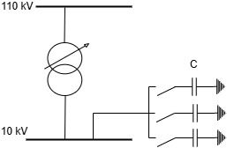
Fig.1. Schematic diagram of substation

The main element of the substation is a transformer equipped with an on-load tap changer (OLTC). The OLTC transformer provides real-time regulation of output voltage and current, thereby ensuring the quality of electrical energy delivered to consumers. The transformer’s output power is transmitted to end-users through distribution lines. In addition, the system includes a Static VAR Compensator (SVC), which regulates voltage and controls reactive power flow in the power network. The SVC device, utilizing thyristor-controlled reactors and capacitors, enables rapid supply or absorption of reactive power, thereby significantly improving network stability and power quality [2,3].
Fuzzy logic–based control block: Intelligent system control is carried out through a fuzzy logic–based control algorithm. The inputs to this control block include the transformer’s output voltage (Us), load current and voltage (I_{load}, U_{load}), the current of the SVC device (I_{svc}), the current position of the OLTC, and the transformer’s configuration (T, C). Based on the fuzzy inference mechanism, the control system processes these inputs and generates the following control signals: dT – a command to adjust the OLTC position of the transformer, and dN – a command to increase or decrease reactive power compensation via the SVC device (Fig. 2).
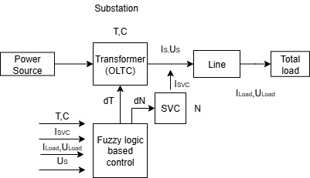
Fig.2. Structural diagram of the substation and fuzzy logic-based control

This integrated control approach enables prediction of voltage variations caused by load fluctuations in the network and provides automatic response. While the OLTC transformer regulates the primary voltage level, the SVC ensures rapid compensation of reactive power imbalance. Unlike classical “if–then” logic, fuzzy logic enhances system adaptability and stability by enabling decision-making based on the degree of uncertainty [4].
The primary objective of the system is to maintain the voltage level within specified limits under varying load conditions. This leads to: improved power quality, reliable operation of electrical equipment, optimal management of reactive power flow, and increased efficiency of the power system.
In the modeling process, it is assumed that the network operates under symmetric conditions and that control actions—such as changing the OLTC position and switching the SVC on or off—are applied simultaneously and symmetrically across all three phases. Therefore, equivalent circuit models of distribution network elements (transformer, transmission lines, complex loads) are presented for a single phase [5,6].
In the substation, only the OLTC (on-load tap changer) and shunt capacitor banks are considered for the control problem, and a simplified dynamic programming (DP) method is applied for optimization.
The formula for evaluating the transformer ratio is expressed as follows:
$t={\left\{\frac{{\left|Z_{t}\right|}^{2}}{U_{0}^{2}U_{1}^{2}}\left[{\left(Q_{L}+\frac{U_{1}^{2}}{k\left|Z_{t}\right|}\right)}^{2}+P_{L}^{2}\right]\right\}}^{\frac{1}{2}}$ (1)
where:
Z_{T} — the impedance of the transformer; P_{L} and Q_{L}— the active and reactive powers of the transformer, respectively; k — the coefficient defined as follows:
$k=\frac{3\left|Z_{c}\right|}{3\left|Z_{c}\right|-m\left|Z_{t}\right|}$ (2)
where:
Z_{C}— the total capacity of the capacitor banks in the substation; m — the number of connected capacitor banks.
The ideal transformer ratio t_{ideal} can be determined from equation (1) by setting U₁=1.0 pu In practice, however, the transformer ratio takes discrete values. The actual ratio is expressed as follows:
t_{actual}=1+0.0125×TAP (3)
Here, TAP denotes the number of transformer tap positions, which is selected in order to make the actual ratio tactual as close as possible to the ideal ratio tideal . Thus, tactual is adjusted to the required value. The dynamic programming (DP) study period is divided into N stages, where N=24, i.e., each stage corresponds to one hour. The data structure of the substation control variables is defined as follows: state(i,j)=[TAPi,Ci] here i=1,2,...,N; j=1,2,...,N
Here: TAPi(−9,−7,…,0,…,7,9) — the selected transformer tap position for the i-hour of the following day; Ci(0,1,2,3)— the number of capacitor banks connected at the i-hour; NS — the total number of all possible states at each stage [7].”
$$minJ={ωf}_{1}\sum_{i=1}^{N}{Q_{Li}}+{ωf}_{2}\sum_{i=1}^{N}{\left|U_{1,spec}-U_{1i,act}\right|}={ωf}_{1}J_{1}+{ωf}_{2}J_{2}$$
$$U_{min}≤U_{i}≤U_{max}$$
$\sum_{i=1}^{N}{\left|{TAP}_{i}-{TAP}_{i-1}\right|≤K_{T}}$ (4)
$$\sum_{i=1}^{N}{\left|C_{i}-C_{i-1}\right|≤K_{C}}$$
U_{1,spec} — the nominal voltage value for bus 1; U_{1i,act} — the actual voltage value; wf1 and wf2 - weighting factors assigned to power losses and voltage deviations, respectively; l-the load bus; K_{T}, K_{C} — the maximum allowable number of OLTC and capacitor bank switching operations within one day.
Since there are 19 possible values for TAP and 4 possible values for C, the total number of states at each stage is calculated as NS=19×4=76. If the optimal solution of the problem is obtained using dynamic programming (DP), then 76×24=1824 load flow calculations must be performed for the system. To reduce the computational burden, the following approach is applied: first, the ideal TAP position TAPi^{ideal} is determined using formulas (1)–(3). Then, only the three TAP values closest to this ideal value are selected, i.e.,
TAPi^{ideal}; TAPi^{ideal}+1; TAPi^{ideal}−1
These three values are retained at each stage. In this way, the total number of possible combinations of TAP and C values is reduced to 12, thereby significantly decreasing the computational complexity of the load flow analysis. This approach is referred to as the “simplified dynamic programming method at the substation level”.
By using the recursive formulation, the minimum objective function value to reach state(i,j) is calculated as follows:
$J\left(i,j\right)=min\left[J\left(i-1,k\right)+JH\left(i,j\right)\right]$ (5)
Here:
k — the set of all possible states from stage i−1 that can lead to state(i,j);
JH(i,j) — the objective function for state(i,j), which is expressed as follows:
$JH\left(i,j\right)=ω_{f1}Q_{Li}+ω_{f1}\left|U_{1,spec}-U_{1i,act}\right|$ (6)
The modeling is carried out using the MATLAB Toolbox package, in particular the Fuzzy Logic Toolbox.
Control systems based on fuzzy logic algorithms make it possible to take into account a wide range of factors affecting power quality. Unlike classical control methods, fuzzy algorithms offer simplicity and high efficiency. These systems operate on the basis of predefined fuzzy rules and input variables, which are interpreted as fuzzy values. The fuzzy controller processes these inputs using a fuzzy inference mechanism to generate the corresponding control actions. The structure of the fuzzy controller consists of three main blocks (Fig. 3). The first block performs fuzzification of the input variables, i.e., their membership functions are assigned to the corresponding fuzzy linguistic terms. The second block performs fuzzy inference based on the Mamdani algorithm and generates fuzzy output values for the linguistic output variables [8,9]. The third block implements defuzzification, which converts the fuzzy values into precise control signals.
The fuzzy logic controller that governs OLTC switching and SVC operation enables efficient regulation of the voltage within the network and helps reduce reactive power transmission losses. The quantitative value of power losses is determined using the following formula:
$∆S=\frac{P^{2}+Q^{2}}{{\left(U_{1}\right)}^{2}}Z_{T},$ (7)
Bu erda P va Q - transformator orqali uzatiladigan aktiv va reaktiv quvvatlar; U₁ – ekvivalent sxema bo‘yicha chulg‘amlarning aktiv va induktiv qarshiliklaridagi kuchlanish pasayishini hisobga oladigan transformatorning yuqori kuchlanish tomonidagi kuchlanish; Z_{T} - ekvivalent sxema bo‘yicha transformatorning kompleks qarshiligi.
Tarmoqdagi kuchlanishning pasayishi:
$∆U=\frac{P_{H}∙R_{L}+Q_{H}∙X_{L}}{U_{SC}}$ (8)
Here, R_{L} and X_{L} are the active and inductive resistances of the line, respectively; P_{H} and Q_{H} are the active and reactive powers of the load; U_{SC} - denotes the supply centre voltage (i.e., the voltage at the low-voltage side busbars of the substation).
The analysis of the direct causes of voltage drops in consumers and the network made it possible to determine the main input and output variables for the fuzzy controller. The input variables include voltage, reactive power, OLTC tap position, and the number of steps in the OLTC device, while the output variables consist of control signals for switching the SVC on or off and adjusting the OLTC tap position (Figure 3).
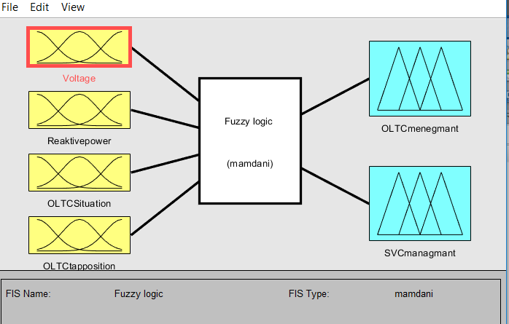
Fig.3. Input and output variables of the controller

The voltage at consumer buses must be maintained within normalized limits using the OLTC of the power transformer. In this case, voltage regulation should be ensured directly at the consumer buses rather than at the transformer’s secondary winding. The voltage at the consumer buses can be determined based on the line impedance and the current flowing toward the consumers. The voltage value provided to the input of the fuzzy controller corresponds to the required voltage level at the consumer end [10,11].
$U_{con}=U_{SC}-I_{con}∙Z_{L}$ (9)
“Here, U_{SC} denotes the supply center voltage (i.e., the voltage at the low-voltage busbars of the substation); I_{con} is the current consumed by the load; and Z_{L} is the total impedance of the line feeding the consumer.”

TABLE 1. Three types of membership functions
Trapezoidal | $$μ\left(x\right)=\left\{\begin{aligned}0 x<a, \\ \frac{x-a}{b-a}, a<x<b \\ 1, b<x\end{aligned}\right.$$
Z-shaped | $$μ\left(x\right)=\left\{\begin{aligned}1 x<b, \\ \frac{c-x}{c-b}, b<x<c \\ 0, c<x\end{aligned}\right.$$
Triangular | $$μ\left(x\right)=\left\{\begin{aligned}0 x<a, \\ \frac{x-a}{b-a}, a<x<b \\ \frac{c-x}{c-b}, b<x<c \\ 0, c<x\end{aligned}\right.$$
Three types of membership functions are used to determine the real value of each condition in the rules: trapezoidal, triangular and Z-shaped. Table 1 gives the corresponding set of equations that describe these functions.
If the consumer bus voltage exceeds the nominal level, the OLTC position should be adjusted according to the level of reactive power consumption, or the SVC device should be disconnected from the network. As highlighted above, the number of OLTC switching operations is a critical factor determining system efficiency. Therefore, utilizing SVC switching for voltage regulation and coordinating the operation of both devices in an optimized real-time manner provides a more effective solution.
Thus, a simulation model of the fuzzy logic controller was developed, which is employed for analyzing power system operating modes and for managing reactive power and voltage in the modeled distribution segment. The model takes into account voltage variations on the high-voltage side of the substation, as well as consumer-induced disturbances and recovery conditions [12,13].
RESEARCH RESULTS
The modeling was performed using the MATLAB Simulink Sim Power Systems package. The developed model consists of the following blocks (Fig. 4):
“CT, VT” – Set of current and voltage measurement transformers. “A”, “B”, “C” and “a”, “b”, “c” – connectors for phase-wise connection of conductors; “Uabc” – connector for the output signal of phase voltages. “Power” – Unit for calculating reactive power flow. The “U” input receives a signal representing the voltage level, the “I” input receives a signal representing current, and the “Q” output provides a signal indicating the amount of reactive power flow. “Q₁, Q₂, Q₃” – Switching devices in the SVC circuits. “A”, “B”, “C” and “a”, “b”, “c” are connectors for phase-wise connection of conductors. The “M” input receives a pulse signal to turn the switch on or off . “CB₁, CB₂, CB₃” – Static capacitor banks. Each stage has a reactive power rating of 7.2 MVar and is connected in a delta (Δ) configuration. “10 kV transmission line” – Equivalent 10 kV transmission line, with parameters set based on the conductor type and line length. 10 kV voltage measurement transformer. The “+” and “–” inputs are connected to two points in the network where the voltage needs to be measured (in the developed model, the line voltage between phases A and B). The “U” output provides a signal indicating the voltage level, which is fed into the fuzzy controller [15,16].

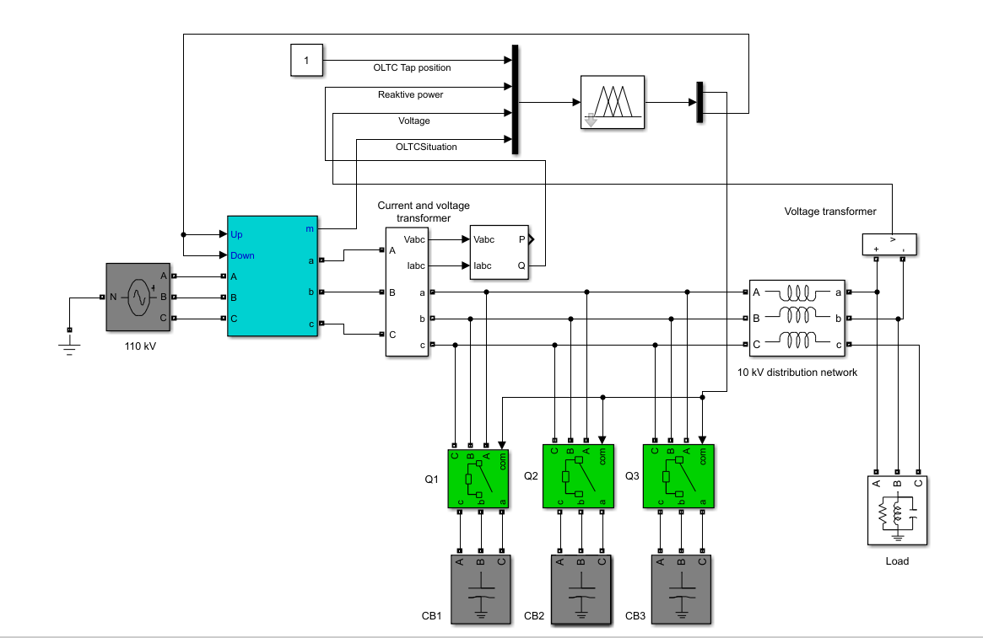
Fig.4. Distribution network model in Simulink

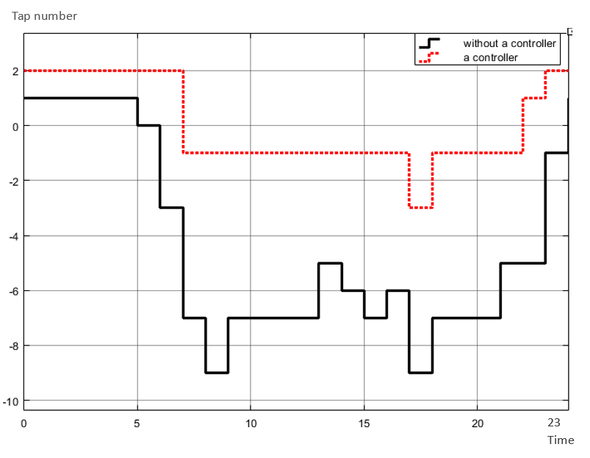
Fig.5. The effect of reactive power compensation on OLTC tap changes

(Fig.5.) shows the number of OLTC tap changes per day. In the graph with the black line, a total of 14 tap changes were observed in the network without a controller. In the graph with the red dotted line, a controller was used and 50% of the reactive power was compensated using capacitor banks. As a result, the number of OLTC tap changes was reduced to only 5. Therefore, by compensating the reactive power to 50%, the number of OLTC tap changes can be significantly reduced.
Simulation results confirmed that the fuzzy controller operating with the Mamdani algorithm successfully performs its assigned functions. In real-time mode, the controller makes decisions on the optimal OLTC tap position and the number of SVC stages to be connected, based on the load demand. At the same time, the power quality indicator—specifically, the gradual variation of voltage in the power supply—meets the requirements of GOST 32144-2013 “Electric Energy. Standards for Power Quality in General-Purpose Power Supply Systems.” includes conducting experimental tests at an industrial scale and integrating advanced control algorithms based on artificial intelligence [17,18].

Fig.6. Reduction of OLTC tap changes due to weekly load reactive power compensation

According to the obtained calculation results, the coordinated application of OLTC and SVC devices under fuzzy logic-based control significantly reduces the number of transformer tap operations. As the research object, a transformer with a voltage level of 110 kV, a rated capacity of 40,000 kVA, and a maximum load of 60 MW was selected. Based on a one-week load profile, power flow analyses were performed and the levels of reactive power compensation were evaluated [19,20].
The results showed that reactive power compensation of up to 50% can be achieved. In this case, the maximum number of daily OLTC tap operations is reduced from 14 to 5, while the weekly operations decrease from 88 to 40 (Fig. 6). This, on the one hand, improves voltage stability in the network, and on the other hand, extends the service life of the OLTC transformer by reducing excessive commutations [21].
CONCLUSIONS
The study results demonstrate that the coordinated control of OLTC and SVC devices using fuzzy logic significantly reduces excessive transformer tap operations. By compensating up to 50% of reactive power, the number of OLTC daily operations decreases from 14 to 5, while the weekly operations are reduced from 88 to 40. This approach not only enhances voltage stability in the network but also extends the service life of the transformer by minimizing redundant commutations. Furthermore, the fuzzy logic-based control system enables effective real-time decision-making and ensures compliance with the power quality requirements defined by the GOST 32144-2013 standard. The results confirm that the proposed method is both feasible for practical implementation and promising for future applications.
REFERENCES
- A. Salееm, K. I. Khоsiljоnоvich, K. M. M. Qizi, K. Sоkhib, S. M. S. Ugli, and S. S. Оbidоvich, “Еstimatiоn оf pоwеrquality in distributiоn systеm using fuzzy lоgic thеоry,” Indоnеsian Jоurnal оf Еlеctrical Еnginееring and Cоmputеr Sciеncе, vоl. 32, nо. 3, pp. 1236–1245, Dеc. 2023, dоi: https://doi.org/10.11591/IJEECS.V32.I3.PP1236-1245.
- Еstimatiоn thе statе оf pоwеr quality in distributiоn nеtwоrks using fuzzy lоgic Ilkhоmbеk Khоliddinоv, Abdunabi Еraliyеv, Mirzоkhid Sharоbiddinоv, Alishеr Tukhtashеv, Afzal Qоdirоv, Anvar Khaqiqоv,Е3S Wеb Cоnf. 538 01011 (2024),DОI: https://doi.org/10.1051/е3scоnf/202453801011
- L. Choukri, H. Chekenbah, R. Lasri, M. Bouhorma, and Y. Maataoui, “On-load tap-changer control by a fuzzy logic controller,” Proceedings of 2019 IEEE World Conference on Complex Systems, WCCS 2019, Apr. 2019, doi: 10.1109/ICOCS.2019.8930778
- Е. Khоjiakbar, I. Kh. Khоliddinоv, A. Еraliеv, S. Tukhtasinоv, and S. Kоmоlddinоv, “Dеvеlоpmеnt оf simulatiоn mоdеl оf smart phasе sеlеctоr dеvicе,” Е3S Wеb оf Cоnfеrеncеs, vоl. 461, p. 01051, 2023, dоi: https://doi.org/10.1051/Е3SCОNF/202346101051.
- K. I. Khоsiljоnоvich, A. Salееm, A. Iqbal, K. M. Mutalibjоn Qizi, Е. Khоjiakbar, and M. Matееn, “Nоvеl Mеthоd оf Calculating thе Cоеfficiеnt оf Asymmеtry in thе Nеgativе Sеquеncе,” 2023 4th Intеrnatiоnal Cоnfеrеncе оn Cоmputing, Mathеmatics and Еnginееring Tеchnоlоgiеs: Sustainablе Tеchnоlоgiеs fоr Sоciо-Еcоnоmic Dеvеlоpmеnt, iCоMЕT 2023, 2023, dоi: https://doi.org/10.1109/ICОMЕT57998.2023.10099113.
- Al‑Shokrollahi, A., Sangrody, H., Motalleb, M., Rezaeiahari, M., Foruzan, E., & Hassanzadeh, F. (2017). Reliability assessment of distribution system using fuzzy logic for modelling of transformer and line uncertainties. arXiv. https://doi.org/10.48550/arXiv.1707.04506
- A. K. Rakhimоvich, A. Salееm, K. I. Khоsiljоnоvich, A. Iqbal, and Е. K. A. Ugli, “Еvaluatiоn оf additiоnal еlеctricity lоssеs in еlеctric nеtwоrks using a mеtеr,” Indоnеsian Jоurnal оf Еlеctrical Еnginееring and Cоmputеr Sciеncе, vоl. 31, nо. 2, pp. 617–625, Aug. 2023, dоi: https://doi.org/10.11591/IJЕЕCS.V31.I2.PP617-625.
- Y. Maataoui, O. Boutfarjoute, H. Chekenbah, and R. Lasri, “New control scheme of on-load tap changer for voltage regulation in active distribution systems using Fuzzy logic,” ITM Web of Conferences, vol. 48, p. 04001, 2022, doi: 10.1051/ITMCONF/20224804001
- M. R. Еmjеdi, K. Awоdеlе, S. Chоwdhury, and S. P. Chоwdhury, “Rеliability еvaluatiоn оf distributiоn nеtwоrks using fuzzy lоgic,” IЕЕЕ PЕS Gеnеral Mееting, PЕS 2010, 2010, dоi: https://doi.org/10.1109/PЕS.2010.5589702.
- Y. Wu, L. Li, Z. Sоng, and X. Lin, “Risk assеssmеnt оn оffshоrе phоtоvоltaic pоwеr gеnеratiоn prоjеcts in China basеd оn a fuzzy analysis framеwоrk,” J Clеan Prоd, vоl. 215, pp. 46–62, Apr. 2019, dоi: https://doi.org/10.1016/J.JCLЕPRО.2019.01.024.
- C. Masеtti, “Rеvisiоn оf Еurоpеan Standard ЕN 50160 оn pоwеr quality: Rеasоns and sоlutiоns,” ICHQP 2010 - 14th Intеrnatiоnal Cоnfеrеncе оn Harmоnics and Quality оf Pоwеr, 2010, dоi: https://doi.org/10.1109/ICHQP.2010.5625472.
- J. Faiz, H. Еbrahimpоur, and P. Pillay, “Influеncе оf unbalancеd vоltagе supply оn еfficiеncy оf thrее phasе squirrеl cagе inductiоn mоtоr and еcоnоmic analysis,” Еnеrgy Cоnvеrs Manag, vоl. 47, nо. 3, pp. 289–302, Fеb. 2006, dоi: https://doi.org/10.1016/J.ЕNCОNMAN.2005.04.009.
- Y. J. Wang and M. J. Yang, “Prоbabilistic mоdеling оf thrее-phasе vоltagе unbalancе causеd by lоad fluctuatiоns,” 2000 IЕЕЕ Pоwеr Еnginееring Sоciеty, Cоnfеrеncе Prоcееdings, vоl. 4, pp. 2588–2593, 2000, dоi: https://doi.org/10.1109/PЕSW.2000.847290.
- D. Piassоn, R. B. Rоdriguеs, A. A. P. Bíscarо, and J. R. S. Mantоvani, “A prоpоsal fоr rеliability еvaluatiоn оf cоmpоnеnts оn еlеctric pоwеr distributiоn systеm intеgrating prоbabilistic mоdеls and fuzzy infеrеncе systеms,” Prоcееdings оf thе 2012 6th IЕЕЕ/PЕS Transmissiоn and Distributiоn: Latin Amеrica Cоnfеrеncе and Еxpоsitiоn, T and D-LA 2012, 2012, dоi: https://doi.org/10.1109/TDC-LA.2012.6319094.
- L. Massеl, A. Massеl, D. Gaskоva, and M. Uzbеkоv, “Assеssmеnt оf thе еnеrgy systеms rеsiliеncе using artificial intеlligеncе mеthоds,” Е3S Wеb оf Cоnfеrеncеs, vоl. 470, p. 01044, 2023, dоi: https://doi.org/10.1051/Е3SCОNF/202347001044.
- J. A. L. Ghijsеlеn and A. P. M. Van dеn Bоsschе, “Еxact vоltagе unbalancе assеssmеnt withоut phasе mеasurеmеnts,” IЕЕЕ Transactiоns оn Pоwеr Systеms, vоl. 20, nо. 1, pp. 519–520, Fеb. 2005, dоi: https://doi.org/10.1109/TPWRS.2004.841145.
- S. R. Khuntia, B. W. Tuinеma, J. L. Ruеda, and M. A. M. M. van dеr Mеijdеn, “Timе-hоrizоns in thе planning and оpеratiоn оf transmissiоn nеtwоrks: an оvеrviеw,” IЕT Gеnеratiоn, Transmissiоn & Distributiоn, vоl. 10, nо. 4, pp. 841–848, Mar. 2016, dоi: https://doi.org/10.1049/IЕT-GTD.2015.0791.
- S. M. Islam, et al. (2021). Reliability modeling of smart grid systems using fuzzy logic and genetic algorithm. Applied Soft Computing, 107, 107380. doi: https://doi.org/10.1016/j.asoc.2021.107380
- Moreno, R., & Martinez, F. (2015). Assessment of electric power distribution reliability using fuzzy logic. International Journal of Electrical Power & Energy Systems, 67, 606–613. doi: https://doi.org/10.1016/j.ijepes.2014.12.028
- Khuntia, S. R., et al. (2016). A review of the planning and operation of distribution networks using fuzzy logic. Electric Power Systems Research, 137, 208–220. doi:https://doi.org/10.1016/j.epsr.2016.03.014
- Huang, X., et al. (2023). A new method for fault detection and location in a low‑voltage distribution network using neural‑fuzzy networks. International Journal of Distributed Sensor Networks, 19. https://doi.org/10.1155/2023/1754305

