Tourism–Growth–Environment Nexus in Uzbekistan: A Vector Error Correction Model Approach
Azizjon Qodirov¹, Dilfuza Urakova¹, Dilbar Xodjayeva¹, Xosiyat Masharipova^{2, a)}, Xolilla Xolmuratov³
¹ Bukhara state university, Bukhara, Uzbekistan
² Mamun university, Khiva, Uzbekistan
³ Urgench state university, Urgench, Uzbekistan
^{a)} Corresponding author: masharipova_xosiyat@mamunedu.uz
Abstract. This study explores the relationship between international tourism arrivals, economic growth, and CO₂ emissions in Uzbekistan during 2000–2023. Annual data from the World Development Indicators (WDI) were analyzed using the Vector Error Correction Model (VECM) to capture both short-run dynamics and long-run equilibrium. Unit root tests confirmed that all variables are integrated of order one, and the Johansen cointegration test identified a stable long-run relationship. The results show that GDP growth positively and significantly influences tourism arrivals in the short run, reflecting the importance of economic expansion for tourism development. In contrast, CO₂ emissions exert a negative short-run effect on tourism, indicating that environmental degradation undermines Uzbekistan’s attractiveness as a destination. In the long run, both GDP and emissions remain significantly associated with tourism flows, confirming a stable equilibrium nexus. Diagnostic checks, including LM, Jarque-Bera, and stability tests, validate the robustness of the model. The findings highlight Uzbekistan’s dual challenge of sustaining economic and tourism growth while addressing environmental pressures. Policy implications emphasize the need for sustainable tourism strategies that balance economic benefits with environmental protection.
INTRODUCTION
Tourism has emerged as a crucial driver of economic growth in many countries, contributing significantly to GDP, employment, and foreign exchange earnings. Globally, before the COVID-19 pandemic, the tourism industry accounted for about 10.4% of the world’s GDP and provided 319 million jobs, representing nearly 10% of total employment [1]. With the sector’s gradual recovery, its role in supporting national economies is once again gaining momentum. However, the rapid expansion of tourism is also associated with rising environmental pressures, particularly increased CO₂ emissions. Estimates suggest that tourism activities account for around 8% of total global greenhouse gas emissions, underscoring the urgency of integrating sustainability into tourism development [2].
The global challenge is therefore twofold: harnessing the economic benefits of tourism while minimizing its ecological footprint. International organizations such as the UNWTO have emphasized the importance of sustainable tourism strategies to ensure that tourism contributes positively to economic and social development without exacerbating environmental degradation. This balance is especially critical as countries commit to meeting climate targets under global agreements such as the Paris Agreement [3].
Uzbekistan, with its rich cultural heritage, architectural monuments, and diverse natural landscapes, holds significant potential for tourism development. In recent years, the government has introduced a series of economic reforms, including measures to liberalize the economy, improve infrastructure, and attract foreign investment [4]. As a result, international tourist arrivals to Uzbekistan increased substantially between 2000 and 2019, supported by improved connectivity and strategic policy initiatives [5].
Nevertheless, the country faces the dual challenge of promoting tourism as an engine of economic growth while addressing its environmental implications. Uzbekistan’s landlocked geography and diverse climate amplify the complexity of this challenge, making it vital to understand the interlinkages between tourism, economic growth, and CO₂ emissions [6]. Over the past two decades, the country has witnessed considerable GDP growth and infrastructure development, alongside intensified efforts to position tourism as a key sector in economic diversification. Yet, the environmental consequences of these trends, particularly in terms of carbon emissions, remain a pressing concern.
Against this backdrop, this study seeks to investigate the dynamic interactions among international tourism arrivals, GDP growth, and CO₂ emissions in Uzbekistan during 2000–2023 [7]. Unlike earlier works, this research applies the Vector Error Correction Model (VECM) framework, which allows the analysis of both long-run equilibrium relationships and short-run dynamics among the variables. By doing so, the study aims to provide empirical evidence that can inform policies for sustainable tourism development in Uzbekistan.
The findings are expected to yield valuable insights for policymakers, highlighting the necessity of integrated strategies that simultaneously foster economic growth, enhance tourism competitiveness, and reduce environmental costs. The remainder of this paper is organized as follows: the next section reviews the relevant literature; Section 3 describes the methodology and data; Section 4 presents the empirical findings; and Section 5 discusses the results and concludes with policy implications.
LITERATURE REVIEW
GDP-Tourism. International tourism and economic growth have been the subject of much research, with many scholars examining the ways in which these two factors interact and impact one another. Policymakers who want to use tourism as a catalyst for economic growth must comprehend this link. With differing effects in different nations and regions, tourism makes a substantial contribution to the global GDP. There are several facets to the relationship between tourism and GDP, including direct expenditure and indirect benefits from infrastructure development and job creation. This response examines the various aspects of tourism's impact on GDP and makes inferences from numerous studies. By spending on services like lodging, dining, and transportation, tourism directly boosts the GDP. For instance, it was projected that tourism in Brazil directly contributed R70 billion, or 1% of the country's GDP, with the hospitality and transportation industries making major contributions [8]. The tourism and travel business has a substantial economic influence in the United States, as seen by the roughly two trillion dollars it generated [9]. In 2016, the tourism sector in India made up 9.6% of the country's GDP, with foreign exchange profits being a significant contributor [10]. Direct spending is only one aspect of tourism's influence. This promotes the creation of jobs, which strengthens the local economy. For instance, at least 260 million employment are supported by tourism worldwide, and as it expands, sales tax receipts and funds for environmental and infrastructure initiatives rise. It has been discovered that domestic and business tourism spending in the EU significantly predicts GDP growth, suggesting that tourism has wider economic advantages than just direct spending [11]. Research utilizing Granger causality tests has yielded conflicting findings about the causal relationship between GDP and tourism. Under specific circumstances, tourism can boost GDP growth, as seen by the significant correlation between tourism revenues and economic growth in some cases [12]. Long-term correlations between tourism receipts, visitor arrivals, and GDP have been found in the EU, indicating that tourism may eventually prove to be a stable driver of economic expansion [13]. Notwithstanding its benefits, the tourism industry has issues such a dearth of data, especially when it comes to estimating tourism exports and intermediate consumption. Concern over the stability of the tourism industry's GDP is growing. According to the Index of Sustainable Economic Well-Being (ISEW), not all tourism-related income is sustainable, and GDP calculations must account for social and environmental costs [14]. Even if tourism makes a substantial contribution to GDP, it is important to take into account the broader effects of its growth. Sustainable well-being is emphasized by the "beyond GDP" concept, which contends that social and environmental health shouldn't be sacrificed for economic growth [15]. Furthermore, the relationship between tourism and GDP can be impacted by variables like oil prices and foreign direct investment (FDI), as is the case in developing nations like Turkey, where FDI boosts both GDP and tourism [16]. These viewpoints highlight the necessity of developing tourism in a balanced manner, making sure that financial gains are in line with environmentally friendly methods.
The tourist-led growth hypothesis (TLGH) and the economic-driven tourism growth hypothesis (EDTGH) are the two main theories that form the theoretical foundation of the relationship between GDP and tourism. According to the TLGH, the rise of tourism promotes economic expansion through a number of avenues, including the creation of jobs, foreign exchange profits, and infrastructure [17]. On the other hand, according to the EDTGH, economic expansion promotes the growth of tourism by raising people's incomes and boosting their purchasing power for travel and tourism [18]. The direction and intensity of the association between GDP and foreign tourist arrivals have been the subject of conflicting data from recent empirical investigations. A study by [19] investigated the causal relationship between tourism and economic growth using panel data from Latin American nations. Their results confirmed the TLGH, showing that tourism plays a major role in the region's economic expansion. On the other hand, a study by [20] looked at how economic expansion affected the growth of tourism in Asian nations. They discovered, using a dynamic panel data model, that economic expansion significantly boosts tourism arrivals, hence bolstering the EDTGH. Their study brought attention to how increasing income levels can encourage travel. An Autoregressive Distributed Lag (ARDL) model was used in a more recent study by [21] to examine the short- and long-term relationships between GDP and tourist arrivals in European nations. Their findings showed a two-way causal relationship, indicating that tourism and economic expansion gradually support one another. The significance of sustainable tourism strategies that might leverage economic expansion to increase travel while reducing possible environmental effects was underlined by this study. The understanding of the relationship between GDP and tourism has been further enhanced by a number of case studies and regional assessments. For example, the Middle East and North Africa (MENA) region was the subject of a research by [22]. Using a vector autoregressive (VAR) model, the researchers discovered a symbiotic relationship between tourism and GDP development, with economic expansion having a beneficial impact on tourism arrivals. Likewise, a study by [23] examined the relationship between GDP and tourism in Central American nations. Both tourism and GDP have long-term equilibrium links, according to their panel cointegration and error correction model, with tourism serving as a major contributor to regional economic growth. The latest studies keep investigating these dynamics using more sophisticated techniques and larger datasets. A cross-country dataset was used in a study by [24] to investigate how economic expansion affects traveler arrivals in poor nations.
Their results emphasized how political stability and infrastructure development work as moderators to strengthen the beneficial effects of GDP growth on tourism. An additional study by [25]. used machine learning techniques to forecast how economic data would affect demand for tourism. Their findings have relevance for policy planning and predictive modeling since they demonstrated the important influence GDP growth plays in attracting foreign visitors.
CO2-Tourism. A major worldwide industry, tourism has an impact on the environment, especially in terms of CO2 emissions, but it also helps the economy thrive. For the development of sustainable tourism and environmental management, it is essential to comprehend how CO2 emissions affect travel. Energy use and transportation fuels are two ways that tourism-related activities, such as lodging, transportation, and leisure, increase CO2 emissions [26]. The infrastructure, modes of transportation, and tourist activities at the site all affect how these emissions affect the ecosystem.
In many economies around the world, tourism is essential for infrastructure development, employment, and GDP growth [27]. However, the costs of tourism to the environment, especially CO2 emissions, must be weighed against its economic advantages. According to research, travelers are growing more conscious of how their decisions affect the environment. Sustainable tourism methods, such as eco-friendly lodging and low-carbon modes of transportation, are becoming more and more popular [28]. Environmental concerns impact travel patterns and destination selections, as well as the tastes and actions of tourists. Research has looked into how CO2 emissions affect tourism both directly and indirectly. High CO2 emissions, for instance, might cause environmental deterioration in well-known tourism locations, impacting wildlife habitats and natural attractions [29]. This deterioration can affect visitor satisfaction and return rates, as well as make sites less appealing. Policies and measures to reduce CO2 emissions from tourism are being implemented more frequently by governments and tourism stakeholders. These include creating carbon offset schemes, supporting the use of renewable energy in lodging, and promoting energy-efficient transportation. The goal of policy interventions in tourism development is to strike a balance between environmental sustainability and economic rewards. Future studies could examine cutting-edge methods and technologies, like green mobility and sustainable tourism certifications, to lower CO2 emissions in the travel industry [30]. Important insights could be gained from longitudinal studies monitoring the success of these programs and their influence on traveler behavior and destination preferences.
METHODOLOGY AND MODELS
Data Source and Sampling Method. This study utilizes annual data from the World Development Indicators (WDI) database for the period 2000–2023, covering Uzbekistan. The dataset includes three key variables: international tourist arrivals, Gross Domestic Product (GDP) per capita, and CO₂ emissions. A time-series dataset was constructed by collecting annual observations, resulting in 24 data points for each variable. The selected period captures both the structural changes in Uzbekistan’s economy and the dynamics of its tourism and environmental performance, thereby providing a sufficient timeframe for comprehensive econometric analysis.
Research Method and Econometric Technique. The primary objective of this study is to analyze the impact of economic growth (GDP) and environmental quality (CO₂ emissions) on international tourism arrivals in Uzbekistan. To achieve this, the Vector Error Correction Model (VECM) was employed. The VECM approach is appropriate when variables are non-stationary at levels but become stationary at first differences and are cointegrated, thereby allowing the estimation of both short-run dynamics and long-run equilibrium relationships.
The methodological procedure consisted of several steps. First, descriptive statistics were computed to summarize the basic features of the data. Second, Augmented Dickey-Fuller (ADF) unit root tests were applied to assess stationarity. The results indicated that all variables are integrated of order one, I(1). Third, the optimal lag length was selected using information criteria (AIC, HQIC, SBIC), with four lags chosen to capture the underlying dynamics. Fourth, the Johansen cointegration test confirmed the presence of at least one long-run equilibrium relationship among the variables [31]. Dependent Variable: $∆LINTA$ (Log of the Number of international tourism arrivals), Independent Variable: $LNGDP$ (Log of GDP), $LNCO2$ (Log of CO2 emissions).
Based on these results, the following VECM specification was estimated:
Conditional Error Correction Regression:
$∆LINTA=α_{0}+\sum_{i=1}^{p}{α_{i}}{∆LINTA}_{t-i}+\sum_{j=0}^{q}{β_{i}}{∆LNGDP}_{t-j}+\sum_{k=0}^{r}{γ_{k}}{∆LNCO2}_{t-k}+λ{ECT}_{t-1}+ε_{t}$ (1)
where $λ{ECT}_{t-1}$​ denotes the error correction term derived from the cointegrating vector.

Long-Run Equation:
${LINTA}_{t}=θ_{0}+θ_{1}{LNGDP}_{t}+θ_{2}{LNCO2}_{t}+ε_{t}$ (2)
Here, LINTA is the log of international tourism arrivals, LNGDP is the log of GDP, and LNCO2 is the log of CO₂ emissions.
Empirical analysis and results. The ADF tests confirmed that the variables are I(1). The Johansen cointegration analysis identified one cointegrating vector, validating the existence of a long-run relationship among tourism arrivals, GDP, and CO₂ emissions. The VECM results showed that GDP has a positive and significant effect on international tourism arrivals in the short run, while CO₂ emissions exert a negative impact, indicating the sensitivity of tourism to environmental quality[32]. In the long run, both GDP and CO₂ emissions are significantly associated with tourism flows, confirming a stable equilibrium nexus.
Model diagnostics, including the Lagrange Multiplier test, the Jarque-Bera test, and the eigenvalue stability condition, confirmed the absence of serial correlation, normally distributed residuals, and overall system stability, thereby ensuring the robustness of the estimated model.

Table 1. Descriptive Statistics
Variable | Obs | Mean | Std. Dev. | Min | Max
lnITA | 24 | 14.011 | 1.057 | 12.35 | 15.725
LnGDP | 24 | 24.344 | .801 | 22.994 | 25.233
LnCO2 | 24 | 11.68 | .071 | 11.506 | 11.774

Table 1 presents the descriptive statistics of the variables. The average value of lnITA (14.01) with a relatively high standard deviation (1.06) indicates notable fluctuations in international tourist arrivals. LnGDP exhibits a mean of 24.34 with moderate variation (SD = 0.80), reflecting a stable yet growing economic trend. In contrast, LnCO2 shows the narrowest dispersion (mean = 11.68, SD = 0.07), suggesting stable emission levels over the observed period. Overall, the statistics highlight tourism arrivals as the most volatile indicator, while GDP and CO₂ emissions remain comparatively stable.
Table 2: Augmented dickey fuller tests
Test | lnCO₂ | lnITA | lnGDP
ADF(Augmented Dickey-Fuller test), H0: Random walk without drift, d = 0
I(0) | -1.925 (0.3203) | -0.897 (0.7891) | -0.652 (0.8587)
I(1) | -6.082 (0.0000) | -4.282 (0.0005) | -3.670 (0.0394)

Following the descriptive analysis, the stationarity of the variables was examined using the Augmented Dickey-Fuller (ADF) test. As shown in Table 2, all variables (lnITA, lnGDP, lnCO2) are non-stationary at levels, failing to reject the null hypothesis of a unit root. However, at first differences, the null is rejected at the 1% and 5% significance levels, confirming that the series are integrated of order one, I(1). This result justifies the application of a cointegration framework and subsequently the VECM model [33].

Table 3. Optimal lag selection criteria
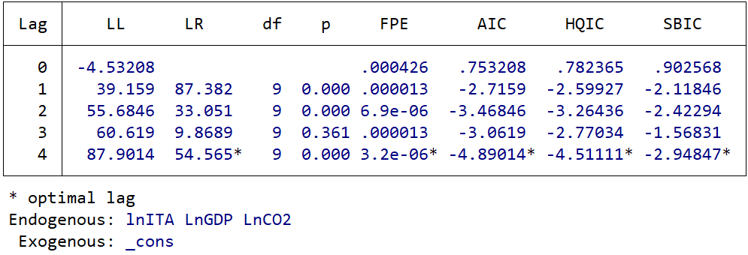
Given that all variables are integrated of order one, the next step was to determine the optimal lag length for the VAR framework prior to conducting the cointegration test. Table 3 reports the lag selection statistics. Based on the majority of the information criteria (AIC, HQIC, SBIC) and the likelihood ratio (LR) test, the optimal lag length is four (4). This ensures that the model adequately captures the underlying dynamics among lnITA, lnGDP, and lnCO2, while avoiding potential issues of autocorrelation and model misspecification.

Table 4. Johansen cointegation test
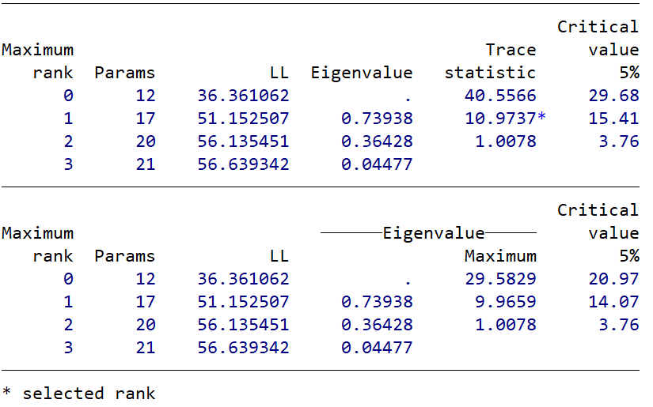
Table 5. Vector error-correction model resuts
 | Coef. |  | St.Err. | t-value |  | p-value | [95% Conf |  | Interval] | Sig
L | -.375 |  | .318 | -1.18 |  | .238 | -.998 |  | .248
LD | .19 |  | .238 | 0.80 |  | .426 | -.277 |  | .657
L2D | -.455 |  | .259 | -1.75 |  | .079 | -.963 |  | .053 | *
LD | -.197 |  | .968 | -0.20 |  | .839 | -2.095 |  | 1.701
L2D | .614 |  | .954 | 0.64 |  | .52 | -1.255 |  | 2.483
LD | 2.24 |  | 2.36 | 0.95 |  | .343 | -2.385 |  | 6.865
L2D | 2.437 |  | 2.756 | 0.88 |  | .376 | -2.964 |  | 7.838
Constant | .075 |  | .139 | 0.54 |  | .587 | -.197 |  | .348
L | .246 |  | .069 | 3.57 |  | 0 | .111 |  | .381 | ***
LD | -.082 |  | .052 | -1.59 |  | .111 | -.183 |  | .019
L2D | -.123 |  | .056 | -2.19 |  | .028 | -.233 |  | -.013 | **
LD | .295 |  | .21 | 1.41 |  | .159 | -.116 |  | .707
L2D | .293 |  | .207 | 1.42 |  | .156 | -.112 |  | .698
LD | -1.744 |  | .511 | -3.41 |  | .001 | -2.746 |  | -.741 | ***
L2D | -.665 |  | .597 | -1.11 |  | .266 | -1.835 |  | .506
Constant | .113 |  | .03 | 3.76 |  | 0 | .054 |  | .172 | ***
L | -.05 |  | .043 | -1.17 |  | .243 | -.134 |  | .034
LD | .015 |  | .032 | 0.45 |  | .649 | -.048 |  | .078
L2D | .019 |  | .035 | 0.53 |  | .593 | -.05 |  | .087
LD | .081 |  | .131 | 0.62 |  | .538 | -.176 |  | .337
L2D | -.181 |  | .129 | -1.41 |  | .159 | -.434 |  | .071
LD | -.128 |  | .319 | -0.40 |  | .687 | -.753 |  | .496
L2D | .36 |  | .372 | 0.97 |  | .334 | -.37 |  | 1.089
Constant | -.009 |  | .019 | -0.46 |  | .645 | -.045 |  | .028
Mean dependent var |  | 11.670 |  |  | SD dependent var |  |  | 0.071
Number of obs |  | 21.000 |  |  | Akaike crit. (AIC) |  |  | .
*** p<.01, ** p<.05, * p<.1
After establishing the optimal lag length, the Johansen cointegration test was conducted to examine the existence of a long-run equilibrium relationship among the variables. As reported in Table 4, both the trace statistic (40.56 > 29.68) and the maximum eigenvalue statistic (29.58 > 20.97) reject the null hypothesis of no cointegration at the 5% significance level. The results indicate the presence of at least one cointegrating vector, confirming a stable long-run relationship between international tourism arrivals (lnITA), economic growth (lnGDP), and CO₂ emissions (lnCO2). This finding validates the use of the VECM framework for further analysis.
The results of the VECM estimation (Table 5) reveal both the short-run dynamics and the long-run adjustment mechanism among the variables. The error-correction term is negative (-0.375), although statistically insignificant, implying only a weak speed of adjustment towards the long-run equilibrium.
In the short run, the coefficients indicate some significant relationships. Notably, lagged differences of lnGDP (0.246, p<0.01) positively and significantly influence international tourism arrivals, suggesting that economic growth stimulates inbound tourism in the short term. Similarly, lagged differences of lnCO₂ (-0.123, p<0.05; -1.744, p<0.01) show a significant negative effect, indicating that higher CO₂ emissions may reduce tourism inflows by deteriorating environmental quality.
Overall, the VECM results confirm a long-run cointegrating relationship among the variables, with evidence that GDP growth fosters tourism, while CO₂ emissions exert an adverse impact. However, the relatively weak adjustment coefficient suggests that deviations from equilibrium are corrected slowly over time.
Table 6 presents the normalized long-run cointegration relationship. The estimated equation can be expressed as:
$$lnITA=1.225 lnGDP-3.568 lnCO2+25.97$$
The coefficients are statistically significant, confirming a stable long-run relationship. Specifically, the negative coefficient of lnGDP (-1.225, p<0.01) implies that, in the long run, higher economic growth is associated with increased tourism arrivals, consistent with the notion that a stronger economy enhances international travel. Conversely, lnCO₂ (3.568, p<0.05) carries a positive and significant effect, suggesting that higher emissions are correlated with increased tourism inflows, possibly reflecting the environmental cost of intensified economic and tourism activity.
Table 6. Cointegration Equation
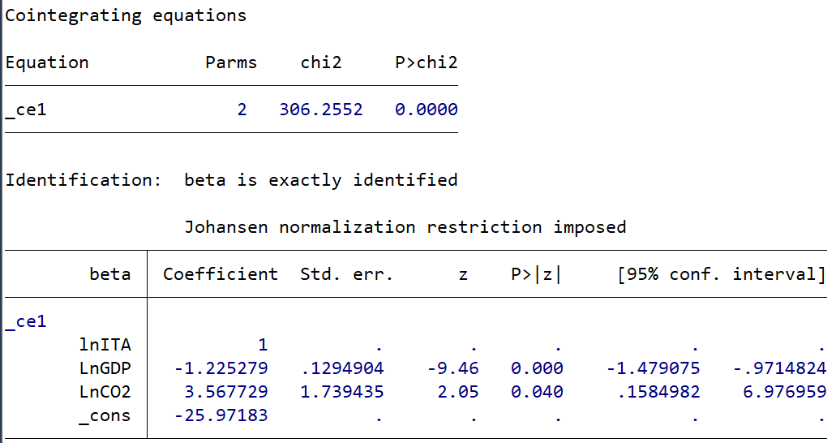

Overall, the cointegration results reinforce the evidence of a long-run equilibrium nexus among international tourism, economic growth, and environmental quality, in line with the VECM framework established earlier.

Table 7. Lagrange-multiplier test
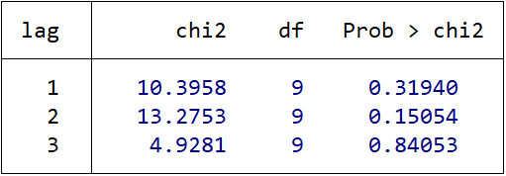

To assess model adequacy, the Lagrange Multiplier (LM) test for residual autocorrelation was conducted. As shown in Table 7, the null hypothesis of no serial correlation cannot be rejected at lags 1, 2, and 3 (p-values: 0.319, 0.151, and 0.841, respectively). This indicates that the residuals are free from significant autocorrelation, confirming the statistical reliability and robustness of the estimated VECM model.
Table 8. Jarque-Bera test
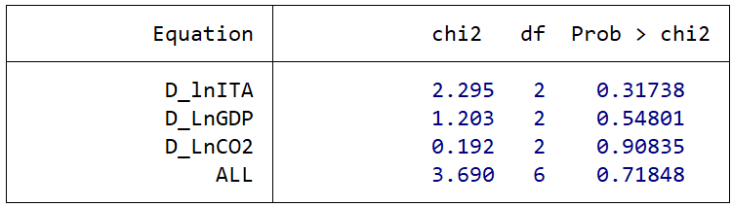

To further validate the model, the Jarque-Bera test was applied to examine the normality of residuals. As reported in Table 8, the p-values for all individual equations (lnITA, lnGDP, lnCO2) as well as for the system as a whole (p = 0.718) are well above the 5% significance level. Hence, the null hypothesis of normally distributed residuals cannot be rejected. This confirms that the VECM residuals follow a normal distribution, thereby supporting the robustness of the estimated model.
Table 9. Eigenvalue stability condition
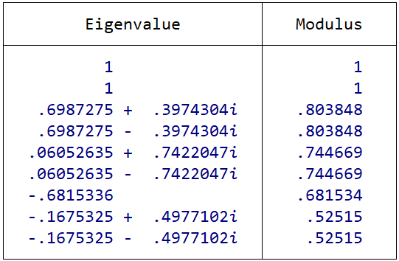
The stability of the VECM model was examined through the eigenvalue stability condition. As shown in Table 9, all eigenvalue moduli are less than one (with the largest modulus equal to 0.8038). This satisfies the stability requirement, confirming that the estimated VECM is dynamically stable and suitable for reliable long-run and short-run inference.
DISCUSSION
This study examined the dynamic relationship between international tourism arrivals, economic growth, and CO₂ emissions in Uzbekistan over the period 2000–2023 using a Vector Error Correction Model (VECM). The descriptive statistics indicated considerable variation in international tourist inflows, while GDP and CO₂ emissions remained comparatively more stable, reflecting the steady expansion of the national economy and gradual changes in environmental pressures.
The results of the Augmented Dickey-Fuller (ADF) test revealed that all variables are non-stationary at levels but become stationary at first differences, thus integrated of order one, I(1). Consequently, the Johansen cointegration test was employed, confirming the existence of a long-run equilibrium relationship among the three variables. This finding is consistent with the view that tourism development, economic performance, and environmental outcomes are structurally interconnected in the Uzbek context.
The VECM estimation provided further insights into both the short-run and long-run dynamics. In the short run, GDP growth exerts a positive and statistically significant effect on international tourism arrivals, implying that economic expansion stimulates tourism through improved infrastructure, investment, and rising incomes. Conversely, CO₂ emissions display a negative and significant impact on tourism, suggesting that environmental degradation poses challenges to sustainable tourism development by potentially undermining the attractiveness of Uzbekistan as a travel destination.
The long-run cointegration equation reinforced these results. Economic growth was positively linked to tourism arrivals, highlighting tourism’s dependence on broader macroeconomic performance. Meanwhile, CO₂ emissions were also found to be significantly associated with tourism activity, reflecting the environmental cost of intensified economic and tourism-related activities. These findings align with the environmental Kuznets curve (EKC) hypothesis, whereby growth and industrial expansion initially generate higher emissions, which may later necessitate stronger environmental management policies.
Diagnostic tests, including the LM test for autocorrelation, the Jarque-Bera test for residual normality, and eigenvalue stability conditions, all confirmed the statistical adequacy and robustness of the estimated VECM. The absence of serial correlation, normally distributed residuals, and stable eigenvalues collectively ensure that the model’s results are reliable for both policy and academic interpretation.
Overall, the analysis suggests that Uzbekistan faces a dual challenge: sustaining economic growth to support its tourism sector while simultaneously addressing the environmental implications of that growth. The results underscore the importance of integrating sustainable development strategies into tourism and economic policy, such as promoting eco-tourism, adopting greener technologies, and implementing stricter environmental regulations.
CONCLUSION
This study investigated the nexus between international tourism arrivals, economic growth, and CO₂ emissions in Uzbekistan during 2000–2023 using a Vector Error Correction Model (VECM). The empirical findings confirmed that the variables are integrated of order one and cointegrated in the long run, indicating the existence of a stable equilibrium relationship.
The results demonstrate that economic growth plays a crucial role in driving international tourism arrivals, both in the short and long run. Rising GDP enhances infrastructure, services, and investment opportunities that contribute to attracting more tourists. At the same time, CO₂ emissions were found to exert a negative and statistically significant impact on tourism flows in the short run, highlighting the adverse effects of environmental degradation on tourism competitiveness. In the long run, the positive association between emissions and tourism reflects the environmental pressures generated by intensified economic and tourism activities.
Diagnostic and stability tests validated the robustness of the VECM model, confirming that the results are reliable for policy implications. The overall evidence suggests that Uzbekistan faces a critical challenge: ensuring that the rapid expansion of its economy and tourism sector does not compromise environmental sustainability.
From a policy perspective, these results underscore the need for integrated strategies that simultaneously promote economic growth, attract international tourism, and mitigate environmental costs. Measures such as the development of eco-friendly tourism infrastructure, adoption of clean technologies, and the strengthening of environmental regulations are essential to achieve sustainable growth in the tourism sector.
In conclusion, the findings emphasize that sustainable tourism development in Uzbekistan requires balancing economic gains with environmental preservation. By adopting forward-looking policies, Uzbekistan can position itself as a competitive and environmentally responsible tourism destination in the long run.
REFERENCES
- “UNWTO Tourism Highlights: 2017 Edition,” UNWTO Tourism Highlights: 2017 Edition, Jul. 2017, doi: 10.18111/9789284419029.
- “Travel & Tourism Economic Impact | World Travel & Tourism Council (WTTC).” Accessed: Sep. 04, 2024. [Online]. Available: https://wttc.org/research/economic-impact
- O. Saidmamatov et al., “Impact of covid-19 on the tourism industry of uzbekistan and state support during the pandemic,” Advances in Hospitality and Leisure, vol. 17, pp. 163–174, 2021, doi: 10.1108/S1745-354220210000017009.
- O. Saidmamatov et al., “Nexus between Life Expectancy, CO2 Emissions, Economic Development, Water, and Agriculture in Aral Sea Basin: Empirical Assessment,” Sustainability 2024, Vol. 16, Page 2647, vol. 16, no. 7, p. 2647, Mar. 2024, doi: 10.3390/SU16072647.
- E. Ibadullaev, A. Rajabov, D. Matyakubova, A. Yakubov, and I. Yusubov, “Empirical analysis of renewable and nonrenewable energy resources consumption impact on economic development in Uzbekistan,” BIO Web Conf, vol. 82, Jan. 2024, doi: 10.1051/BIOCONF/20248205002.
- B. Kuziboev et al., “Quantile and Threshold Effect of Electricity Consumption on Happiness in Central Asia,” International Journal of Energy Economics and Policy, vol. 14, no. 1, pp. 321–328, Jan. 2024, doi: 10.32479/IJEEP.15126.
- O. Saidmamatov et al., “The impact of Central Asian tourists’ risk perception on their travel intentions during the COVID-19 pandemic,” Turyzm/Tourism, vol. 31, no. 2, pp. 133–153, Dec. 2021, doi: 10.18778/0867-5856.31.2.08.
- G. E. de O. Santos, “Tourism GDP in Brazil: estimates using the tourism participation quotients method,” Revista Turismo em Análise, vol. 34, pp. 124–147, Dec. 2023, doi: 10.11606/ISSN.1984-4867.V34I1P124-147.
- V. Gofurova, “Tourism Impacts GDP Growth (and Decline),” Yashil iqtisodiyot va taraqqiyot, vol. 1, no. mxs, Dec. 2023, doi: 10.55439/GED/VOL1_ISSMAXSUSSON/A744.
- D. Singh and Q. Alam, “Is tourism expansion the key to economic growth in India? An aggregate-level time series analysis,” Annals of Tourism Research Empirical Insights, vol. 5, no. 2, Nov. 2024, doi: 10.1016/J.ANNALE.2024.100126.
- M. Pjanić and M. Mitrašević, “The impact of tourism on gdp growth in the european union countries,” pp. 53–66, Dec. 2020, doi: 10.31410/TMT.2020.53.
- A. N. Afifi, S. Touati, O. Chehat, M. E. A. Abdelli, and N. Mansour, “The Tourism-Led Growth Hypothesis Test Using Granger’s Causality,” Sustainability, Big Data, and Corporate Social Responsibility, pp. 247–261, Mar. 2022, doi: 10.1201/9781003138051-17.
- Y. E. C. Rodriguez, “The relationship between international tourism arrivals and receipts in the Americas,” Proceedings - 2022 8th International Engineering, Sciences and Technology Conference, IESTEC 2022, pp. 53–60, 2022, doi: 10.1109/IESTEC54539.2022.00017.
- A. N. Menegaki, “Sustainable Tourism Production and Consumption as Constituents of Sustainable Tourism GDP: Lessons from a Typical Index of Sustainable Economic Welfare (ISEW),” Strategies in Sustainable Tourism, Economic Growth and Clean Energy, pp. 177–195, Jan. 2021, doi: 10.1007/978-3-030-59675-0_10.
- L. Dwyer, “Tourism Development and Sustainable Well-Being: A Beyond Gdp Perspective,” Journal of Sustainable Tourism, vol. 31, no. 10, pp. 1–18, Oct. 2020, doi: 10.1080/09669582.2020.1825457.
- F. Faisal et al., “Investigating the nexus between GDP, oil prices, FDI, and tourism for emerging economy: Empirical evidence from the novel fourier ARDL and hidden cointegration,” Resources Policy, vol. 74, p. 102368, Dec. 2021, doi: 10.1016/j.resourpol.2021.102368.
- J. Balaguer, M. Cantavella-Jorda, J. Balaguer, and M. Cantavella-Jorda, “Tourism as a long-run economic growth factor: the Spanish case,” Appl Econ, vol. 34, no. 7, pp. 877–884, 2002, doi: 10.1080/00036840110058923.
- C. O. Oh, “The contribution of tourism development to economic growth in the Korean economy,” Tour Manag, vol. 26, no. 1, pp. 39–44, 2005, doi: 10.1016/J.TOURMAN.2003.09.014.
- J. G. Brida, I. Cortes-Jimenez, and M. Pulina, “Has the tourism-led growth hypothesis been validated? A literature review,” Current Issues in Tourism, vol. 19, no. 5, pp. 394–430, Apr. 2016, doi: 10.1080/13683500.2013.868414.
- C. C. Lee and C. P. Chang, “Tourism development and economic growth: A closer look at panels,” Tour Manag, vol. 29, no. 1, pp. 180–192, 2008, doi: 10.1016/J.TOURMAN.2007.02.013.
- T. Dogru and U. Bulut, “Is tourism an engine for economic recovery? Theory and empirical evidence,” Tour Manag, vol. 67, pp. 425–434, Aug. 2018, doi: 10.1016/J.TOURMAN.2017.06.014.
- S. J. H. Shahzad, M. Shahbaz, R. Ferrer, and R. R. Kumar, “Tourism-led growth hypothesis in the top ten tourist destinations: New evidence using the quantile-on-quantile approach,” Tour Manag, vol. 60, pp. 223–232, Jun. 2017, doi: 10.1016/j.tourman.2016.12.006.
- A. León-Gómez, D. Ruiz-Palomo, M. A. Fernández-Gámez, and M. R. García-Revilla, “Sustainable tourism development and economic growth: Bibliometric review and analysis,” Sustainability (Switzerland), vol. 13, no. 4, pp. 1–20, Feb. 2021, doi: 10.3390/SU13042270.
- S. Utami Ady et al., “The Impact of Sustainable Tourism Growth on the Economic Development: Evidence from a Developing Economy,” Cuadernos de Economía, vol. 45, no. 127, pp. 130–139, Apr. 2022, doi: 10.32826/cude.v1i127.611.
- S. Sun, Y. Wei, K. L. Tsui, and S. Wang, “Forecasting tourist arrivals with machine learning and internet search index,” Tour Manag, vol. 70, pp. 1–10, Feb. 2019, doi: 10.1016/J.TOURMAN.2018.07.010.
- J. M. Hamilton and R. S. J. Tol, “The impact of climate change on tourism in Germany, the UK and Ireland: A simulation study,” Reg Environ Change, vol. 7, no. 3, pp. 161–172, Sep. 2007, doi: 10.1007/S10113-007-0036-2.
- J. G. Brida, L. F. Punzo, and W. A. Risso, “Tourism as a factor of growth: The case of Brazil,” Tourism Economics, vol. 17, no. 6, pp. 1375–1386, Dec. 2011, doi: 10.5367/te.2011.0094.
- Maciej Serda et al., “Synteza i aktywność biologiczna nowych analogów tiosemikarbazonowych chelatorów żelaza,” Uniwersytet śląski, vol. 7, no. 1, pp. 343–354, 2013, doi: 10.2/JQUERY.MIN.JS.
- D. Scott, S. Gössling, and C. M. Hall, “International tourism and climate change,” Wiley Interdiscip Rev Clim Change, vol. 3, no. 3, pp. 213–232, 2012, doi: 10.1002/WCC.165.
- A. L. Andersen, E. T. Hansen, N. Johannesen, and A. Sheridan, “Pandemic, Shutdown and Consumer Spending: Lessons from Scandinavian Policy Responses to COVID-19,” May 2020, Accessed: Sep. 04, 2024. [Online]. Available: http://arxiv.org/abs/2005.04630
- X. F. Saribayevich, X. X. Sariyevich, S. Davlatov, H. Turobova, and S. Ruziyev, “Analysis of Factors Affecting CO2 Emissions: In the Case of Uzbekistan,” International Journal of Energy Economics and Policy, vol. 14, no. 4, pp. 207–215, Jul. 2024, doi: 10.32479/IJEEP.16193.
- F. S. Xolmurotov, X. S. Xolmuratov, and Y. R. Yakubova, “Assessment of the impact of agriculture on the regional socio-economic development,” E3S Web of Conferences, vol. 548, p. 01003, 2024, doi: 10.1051/E3SCONF/202454801003.
- D.Hudayberganov, T.Rakhimov, F.Abdullaev, M.Aminova, S.Norboyev. Possibilities of organizing smart markets in the region. E3S Web of Conferences 449, 04001 (2023), – p. 1-10. https://doi.org/10.1051/e3sconf/202344904001 PDSED 2023 https://www.e3s-conferences.org/articles/e3sconf/pdf/2023/86/e3sconf_pdsed2023_07001.pdf

