Improvement of Methods of Fire-Technical Expertise at Industrial Facilities
Gulnora Gulomova^{1, a)}, Bakhtiyor Baymirzaev ¹, Rayhon Mudarisova ²,
Surayyo Abdullayeva ³

¹ Tashkent state technical university named after Islam Karimov, Tashkent, Uzbekistan
² Uzbek State University of World Languages, Tashkent, Uzbekistan
³ Tashkent University of Information Technologies named after Muhammad al-Khorazmi Tashkent, Uzbekistan
^{a)} Corresponding author: gulomovagulnora433@gmail.com
Abstract. In the process of transition to a free market economy in the republic, the damage caused by fires at industrial facilities is also enormous, which has a significant impact on the development of industrial facilities. When determining the causes of explosions and fires in our republic, it is necessary to carry out comprehensive measures for the scientific and practical development of expert institutions, increasing the efficiency of experts, saving resources, and ensuring their safety. The article describes the uniqueness of industrial facilities, the complex process of detecting fires that have occurred there, the role of fire-technical experts in detecting the causes of fires, the goals and objectives of conducting fire-technical examinations, the work performed by experts and the purpose of fire-technical examinations in emergency situations related to fires at industrial facilities, the organization and conduct of examinations, the use of field scientific and instrumental methods in conducting fire-technical examinations and the possibility of increasing the efficiency of experts through the digitalization of instrumental methods. Also, in order to determine the efficiency coefficient during the fire-technical examination of this developed hardware and software complex "Fire-technical examination", mathematical calculations are made, the results of which are presented in tabular form. The conducted studies, the developed software and hardware complex, the efficiency of the specialists involved in determining the causes of fires that occurred at facilities, using mathematical calculations during instrumental field studies are scientifically substantiated.
INTRODUCTION
In the world in more than 190 countries there are about 7-8 million fires annually, which can occur, early detection and suppression of fires is a pressing problem.
Over the past 20 years, there have been more than 7,300 different emergencies worldwide, including explosions and fires, and the fact that they have killed more than 1 million people and caused economic damage of 2.97 trillion US dollars shows that further improvement in this area is one of the urgent tasks [1]. In this regard, conducting research on the prevention, elimination and establishment of causes of fires is becoming one of the most pressing issues of our time. At present, the use of high-quality and modern technologies, technical means, devices is considered important in protecting the lives and property of people in accidents, disasters and natural disasters that threaten human life.
Despite the fact that systematic measures are being implemented in the field of fire safety, unpleasant events related to fires occur in the everyday life of the population and in the activities of business entities. In 2023, more than 10 thousand fires occurred in our republic, in which about 80 people died, more than 170 people were injured to varying degrees, and the amount of material damage caused by fires amounted to more than 270 billion soums.
More than 50% of fires occurred at industrial facilities and business entities [2].
Today, information and analytical support is provided to technical experts in determining the causes of explosions and fires, and research work is being conducted aimed at developing new scientific and technical solutions for digital technologies and technical means for the industry. In this regard, special attention is paid to the On organizational measures for further improvement of the activities of emergency structures quality of work and saving of forces and resources during the fire-technical examination in emergency situations related to explosions and fires, safe work of employees at the scene of the incident and conducting field research methods.
When determining the causes of explosions and fires in our republic, it is necessary to carry out comprehensive measures for the scientific and practical development of expert institutions, increasing the efficiency of experts, saving resources, and ensuring their safety.
Based on the tasks set by our state, it is important to take measures to promptly identify and eliminate emergency situations caused by fires, identify their origin, causes and consequences and prevent similar situations in the future, as well as radically increase the effectiveness of the organization of preventive work.
This study to a certain extent serves the implementation of the tasks defined in the Decrees of the President of the Republic of Uzbekistan №PD-5706 “ On the introduction of a qualitatively new system of prevention and elimination of emergency situations and ensuring fire safety in the Republic of Uzbekistan ” from April 10, 2019, №PD-6256 «On measures to improve the forensic system in the Republic of Uzbekistan» from July 5, 2021, as well as the Resolutions of the Cabinet of Ministers № -4276 “On organizational measures for further improvement of the activities of emergency structures” from April 10, 2019, № 649 “On approval of fire safety rules” from October 20, 2020 and other regulatory legal acts related to this activity [3-6].
Objectives and tasks of the study on conducting fire-technical examination at industrial facilities
The aim of the work is to improve the methods of field research of fire-technical expertise and to determine the causes of fires, as well as to increase the efficiency of experts.
The objectives of the study are: analysis of violations of fire safety requirements, identifying those admitted in the project, and proposing a solution to eliminate them; study of improving the quality and efficiency of work of employees of the state fire control and examination bodies of the Ministry of Emergency Situations conducting investigations of emergency situations; improvement of field research methods in fire-technical examination of emergency situations related to fires; determination of the practical effectiveness of the use of an automated software package in the process of examination in connection with emergency situations related to fires.

EXPERIMENTAL RESEARCH
The basis of the system of methods used in forensic examinations are: the method of materialistic dialectics - a general method of cognition; general scientific methods on the basis of which the expert's work is built (methods of observation, measurement, description, comparison, modeling, logical and mathematical methods), and special methods of individual sciences, developed for the purpose of the most effective study of objects of the corresponding scientific field.
In addition, other methods are used that are not related to those listed above. These are general expert methods (used or can be used when conducting almost any type of expert research) and specific expert methods (used in the study of objects of only a certain type of examination, intended only for it and, as a rule, presuppose the use of one or another equipment, device or instrument complex, in many cases forming a single whole with a computer) [7].
According to the nature of the information obtained about the object under study, general expert methods are divided into:
a) Methods of morphological analysis: optical and electron microscopy; ultrasonic and X-ray flaw detection.
b) Methods of composition analysis: 1) elemental (organic elemental, X-ray spectral, emission spectral, laser micro-spectral, etc.); 2) molecular (chemical methods: qualitative chemical semi-microanalysis and microanalysis, quantitative chemical analysis; physicochemical methods: coulometric analysis, molecular spectroscopy in the ultraviolet, infrared and visible regions, molecular fluorescence spectroscopy, gas chromatography, gas-liquid, pyrolytic gas-liquid, gas absorption, liquid column and planar; thin layer); 3) phase (X-ray structural phase analysis, metallography; thermal analysis methods - gravimetric thermal analysis, thermographic and differential thermal analysis, colorimetry).
c) Methods of crystal structure analysis: X-ray structural analysis; metallographic analysis; fractographic analysis.
d) Methods for studying various properties of substances and materials: magnetic (permeability, susceptibility, saturation); magnetic method for measuring coercive force; hardness, microhardness; electrical properties (specific electrical resistance); thermal properties (phase transformation temperatures, thermal EMF, thermal conductivity, coefficient of volumetric expansion).
Special (private expert) methods of fire-technical examination (FTE) include: methods for identifying focal signs of fire on materials exposed to thermal impact (wood, chipboard, polymeric materials, concrete, brick, metals and alloys, cement-based building mortars, paint and varnish coatings, natural building materials); methods for experimentally studying the fire hazardous properties of materials and substances (temperature and concentration limits of ignition, the ability to ignite under the influence of certain ignition sources or when mixed with other substances under specific conditions, etc.); methods for testing electrical products for fire hazard under emergency operating conditions (cable products, electrical protection devices, heating devices, switching devices, etc.).
These methods are used individually and in combination to solve expert problems related to establishing the location of a fire source and the mechanism of initial combustion, as well as the dynamics of fire spread. In order for the application of these methods to be orderly and could be implemented by experts with different practical experience, methods for solving specific expert problems are developed on their basis, primarily typical ones, most frequently encountered in practice. [7].
The main method of fire-technical examination at industrial facilities is compliance with design and technical documentation, non-violation of fire safety rules, determination of the origin and causes of the fire, comparison with the requirements of the instructions.
Methods of inspection of the scene of the incident by experts, in order to establish the cause of the fire, the degree of thermal damage to their sources (epicenter/center), inorganic materials, electrical conductors and other products, zones of thermal damage by measuring the zones of residual temperature in structures that have been in an emergency fire hazardous state for a long time, studies were conducted on the direction of the spread of an emergency situation during inspection of the fire scene, traces of combustion, tactics for conducting an examination during a fire zone, determining the cause of the emergency and the possibility of prompt exchange of information.
The main stages of fire-technical expertise: preparation, execution of documents and development of organizational solutions based on the results of the expertise. One of the most basic and important stages of determining the cause of a fire is the inspection of the fire site. It would be wrong to draw a conclusion about the cause of the fire without inspecting the place where the fire occurred. The conducted research shows that industrial facilities are characterized by the fact that they are not similar to each other. In such cases, it has been established that in order to establish the origin of a fire that occurred at these facilities, the expert must in any case be given the opportunity to inspect the scene of the incident. It turned out that in the absence of the necessary conditions for inspecting the fire site at the facility and establishing the cause of the fire, the expert has little chance of establishing the cause of the fire. The stages of inspecting the fire site are shown in Figure 1 [8].

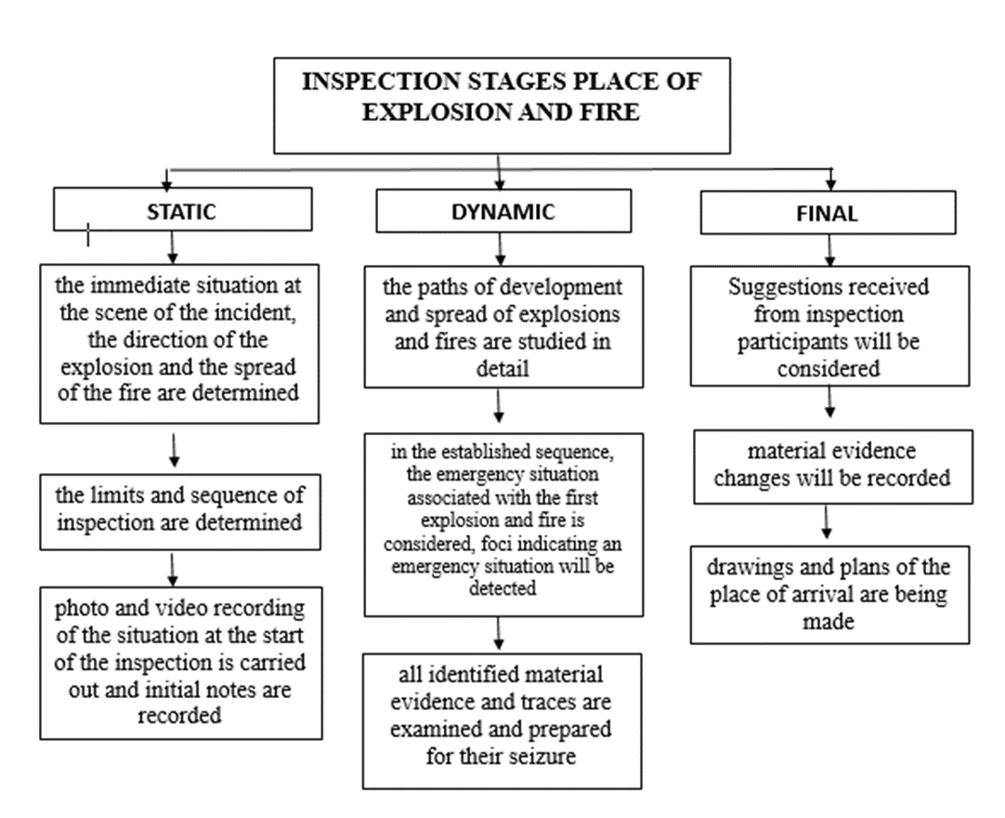
FIGURE 1. Stages of crime scene inspection

After a fire, inspection work is carried out within 10 days from the moment the state fire supervision inspector receives a notification or statement about an emergency. The determination of the efficiency determination coefficient during inspection and decision-making at the initial stage F of an explosion and fire emergency has been achieved.
$F_{ec}∈\left(x_{1,}x_{2,}x_{3}…x_{n}{;y}_{1,}y_{2,}y_{3}…y_{n};z_{1},z_{2,}z_{3}…z_{n}\right)$(1)

Where, $F_{ec}$ − efficiency coefficient of the state fire supervision officer during the investigation of the emergency scene;
$x_{1,}x_{2,}x_{3}$,…- conditions for performing operations that are known in advance and cannot be changed;
$y_{1,}y_{2}{,y}_{3}$ … - determining and performing the type of examination and research that should be ordered to determine unknown conditions or factors;
$z_{1},z_{2,}z_{3}$…- decisions that the inspector must determine.
If the conditions are known $y_{1,}y_{2,}y_{3}$ …,then you can find a solution in advance $F_{ek}$, at the same time, the efficiency of their work would increase several times, and $z_{1},z_{2,}z_{3}$ … will be as effective as possible. But $y_{1,}y_{2,}y_{3}$ …- may be known as an unknown or probability when investigating a situation, that is $F_{ec}$ - number is unknown for any solution due to the efficiency factor that depends on them. The actions specified in this set are based on the correct implementation of the final solution by the inspectors. For their successful completion, the appointment of a fire-technical examination is required. During the study, the dependence of specific conditions and factors of the dynamics of hazardous factors of an explosion and fire emergency situation was revealed, as well as the uncertainty of the origin of individual events, based on the fact that the conclusion of the results of the inspection during the technical inspection is carried out under conditions of uncertainty. In order to make a reasonable conclusion before the expert, the first task is to find the source of the emergency situation. In order to establish the causes of a fire at a facility, a fire-technical expert prepares or requests:
- the place where the fire occurred is inspected in detail and a report is drawn up;
- a drawing of the place where the fire occurred is made;
- meteorological conditions are recorded, i.e. air temperature and humidity, precipitation, lightning, wind and other sudden changes in the weather;
- explanatory letters are received from witnesses, victims and perpetrators, participants in extinguishing the fire, persons responsible for fire safety and security of the premises;
- an expert opinion is received (electrician, chemist, etc.);
- The facility management is required to provide a departmental inspection certificate for the fire, a certificate on the amount of material damage caused by the fire, and other technical and operational documents (written instructions from the State Fire Supervision Service, Electrical Control and Industrial Inspection, test reports on the resistance of the protective sheath of electrical wires, operational documentation for fire-fighting automation, repair work carried out before the fire, etc.).
After completing the above-mentioned works, the expert is obliged to prepare an expert opinion by conducting the relevant laboratory studies. The expert opinion is drawn up in accordance with the purpose, so that it consists of three parts. that is: introduction; research; conclusion.
When drawing up an expert's report, the date and place of the examination, the order number, explaining to him his rights and obligations and the fact that he gave a knowingly incorrect report, disclosed the case materials, and also receiving a receipt that he will be held liable for refusing to give a report without good reason or refusing to do so.
In the research part of the expert's report on each issue submitted to the forensic expert, the course of the study and its results are set out, and a scientific explanation of the facts revealed is given. At the same time, the expert determines the types of research that must be carried out independently. Such types of research include instrumental field research, X-ray phase research, and may include metallographic research, research to identify combustion initiators. At the same time, the final (summary) part of the report is set out in the form of an answer to the questions posed to the forensic expert, and must be set out in clear, understandable language that does not allow for different interpretations. [9-10].
At industrial facilities, when conducting a fire-technical examination, the use of technical means occupies one of the leading places. The source of a fire is usually understood as the place where the combustion initially occurred (the place where the fire started). Establishing the location of the source is the most important and primary stage in the study by a fire-technical specialist, whether it is a fire-technical expert or an engineer of a fire-technical laboratory. Without establishing the source, work to identify the causes of the fire is usually doomed to long and ineffective searches.
Instrumental research methods that allow quantitative recording of changes in the structure and properties of a material as a result of the thermal impact of a fire make it possible to assess the desired degree of thermal damage to the material more accurately and more objectively. It is also valuable that instrumental methods and means are in many cases sensitive to such changes in the material that are not determined visually [11].
In principle, to solve the problem of determining the degree of thermal damage to a material using an instrumental method, it is necessary:
a) determine for it a test characteristic (a property of a substance, a parameter of a structure, a spectrum, etc.), which objectively reflects the degree of destruction of the material or its individual components under the influence of the fire temperature. This characteristic should change monotonously (either increase or decrease) with an increase in the temperature and duration of heating of the material in the range of change of these values ​​characteristic of a fire;
b) select an instrumental (or chemical) method that allows this test characteristic to be determined quantitatively (measured) and thus really differentiate materials that have been exposed to heat of varying intensity and duration. For example, in one of the first instrumental methods of fire forensics - ultrasonic flaw detection of concrete and reinforced concrete - such a test characteristic is the speed of ultrasound in the material. The more the concrete layer is destroyed by the heat of the fire, the lower the speed of ultrasound. This method of assessment is clearly better and more reliable than attempts to notice a change in the color shade of concrete or the formation of microcracks in it. [11].
The following special research devices are used in instrumental methods:
Wire Annealing Tester "TOP-01-EP" - study of cold-formed wire made of non-ferrous metals. Detects zones of thermal damage. The installation is designed to study objects made of aluminum or copper electrical wire. The essence of the study is to assess the depth of development of pre-recrystallization and recrystallization processes in unannealed wire products when heated during a fire. The degree of recrystallization of individual sections of wire located in different fire zones is determined by the method of determining the bending force. The measured parameter is the magnitude of the bending force F(H). With an increase in the heating temperature, the degree of recrystallization increases, and accordingly, the magnitude of the bending force during heating under isothermal conditions consistently decreases;
Multifunctional eddy current device MVP-2M-EP - expert tool for solving various problems of the eddy current (electromagnetic induction) testing method, depending on the converter connected to it. It is intended for use as: a magnetic induction ferritometer for measuring the content of the ferrite phase in products made of austenitic and pearlitic steels; a conductivity meter - for determining the specific electrical conductivity of various non-ferrous metals and their alloys; a thickness gauge - for measuring the thickness of protective and decorative coatings applied to conductive material.
The measurement objects can be any products, including large-sized ones with hard-to-reach measurement zones on flat and convex surfaces with a curvature radius of at least 5 mm, at various angles. The adjustable gain coefficient allows you to configure the device for working with different converters and monitoring different materials.
Analyzer of magnetic characteristics of steel products KIM-2M-EP - is designed to determine the hardness and mechanical properties of parts made of ferromagnetic materials in the presence of a correlation between the controlled and measured parameters, to determine the depth of hardening by high-frequency currents (HFC), to determine the places of development of material stresses and local places of structural damage, etc.
The study is conducted by measuring the demagnetization current of similar cold-formed products located in different zones of the fire site. The essence of the study is to assess the depth of development of pre-recrystallization and recrystallization processes in cold-formed steel products when heated during a fire. The degree of recrystallization is determined by a magnetic method.
Thermal imager TESTO 865- used to determine residual temperatures on massive structures made of inorganic materials (brick, concrete), in order to identify focal signs (designed to detect the localization of leaks or defects in enclosing structures) [12].
This instrumental field method is widely used in the field of fire-technical expertise, thanks to the results obtained with their help, the causes of many fires have been clarified. But along with convenience, these devices also have some disadvantages. For example, the results obtained from them are recorded on paper, and then tables and maps are created using computer technology. The expert will have to spend a lot of time to do these things.
In order to determine the cause of emergency situations associated with fire, at the first stage of the research, experimental studies were conducted to study the thermal residual temperature in heat-absorbing structures after a fire (see Table 1).

Table 1. Study of residual thermal temperature measurement in a wall
Points of research | 1 (⁰С) | 2 (⁰С) | 3 (⁰С) | 4 (⁰С) | 5 (⁰С) | 6 (⁰С) | 7 (⁰С)
1 | 113 | 118 | 162 | 198 | 157 | 142 | 131
2 | 220 | 237 | 258 | 240 | 242 | 221 | 210
3 | 220 | 180 | 210 | 200 | 217 | 250 | 280
4 | 100 | 150 | 290 | 291 | 120 | 140 | 145

Figure 2 shows a map created using the results obtained, and the map shows that a cone-shaped trace has formed starting from the place where the structure absorbs the most heat and ending at the place where it absorbs the least heat.
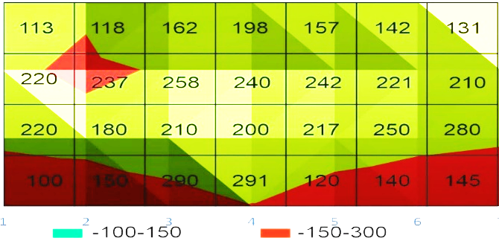
FIGURE 3. Formation of a cone-shaped trace from a heat-absorbing structure

RESEARCH RESULTS
Based on the conducted research, it was established that the most critically affected areas of heat-absorbing structures correspond to columns 3-5. At the second stage, the state of demagnetization of metal products prepared by the method of cold deformation of a homogeneous type was studied using a laboratory method (see Table 2).

TABLE 1. Results of research on self-tapping screws obtained by cold deformation method
№ | Set temperature (⁰С) | Steel products
№ | Set temperature (⁰С) | self-tapping screw  (6 cm) |  |  |  |  | Average arithmetic value | self-tapping screw  (4 cm) |  |  |  |  | Average arithmetic value
1 | 200⁰ С | 65 | 63 | 66 | 62 | 60 | 63 | 47 | 50 | 48 | 48 | 52 | 49
2 | 300⁰ С | 45 | 41 | 42 | 43 | 41 | 42 | 41 | 40 | 39 | 43 | 43 | 41
3 | 400⁰ С | 25 | 23 | 26 | 26 | 25 | 25 | 25 | 24 | 24 | 25 | 24 | 24
4 | 500⁰ С | 26 | 27 | 24 | 23 | 29 | 25 | 21 | 22 | 22 | 22 | 20 | 21
5 | 600⁰ С | 24 | 27 | 25 | 25 | 23 | 24 | 16 | 19 | 19 | 20 | 15 | 17
6 | 700⁰ С | 16 | 19 | 19 | 18 | 19 | 18 | 16 | 14 | 16 | 16 | 15 | 15
7 | 800⁰ С | 16 | 18 | 17 | 20 | 21 | 18 | 13 | 12 | 14 | 11 | 13 | 13

The results of the studies showed that the samples in the 7th row were critically damaged, and since the magnetization in these samples is at the highest level, it can be assumed that the fire started here.
At the third stage, the change in physical and mechanical properties as a result of thermal exposure to electrical conductors removed from the fire site, manufactured by the cold deformation method, was studied. According to this research method, the more heat electrical conductors are exposed to, the less strength and hardness they have and the greater their flexibility [12].

FIGURE 3. Results of studies conducted on the device “TOR-01-EP”
From the table and map presented in Figure 3, it is clear that as a result of thermal exposure, the strength and hardness of the electrical conductor designated by the letter D decreased, while its flexibility increased. However, as we have already mentioned above, as a result of these studies, it was found that the efficiency of the expert's work decreases due to the fact that the expert spends a lot of time preparing the conclusion of the forensic fire-technical examination. In order to improve the efficiency of experts in conducting expert studies of emergency situations associated with a fire, a software product has been developed in the form of a hardware and software complex based on a hierarchical system (see fig. 4)
This complex consists of three parts, including registration and analysis of fires, four devices (MVP-2M, TOP-01-EP, KIM-2M, Thermal imager), and also consists of departments for studying traces of punctures and drawing up a protocol at the site of the fire. Taking into account the fire-technical expertise in the hardware and software complex, which serves as a source of information on detecting fire sources, this useful model was implemented as a means of monitoring a multi-criteria device. Each functional subsystem of the control support system was implemented as separate software [13].

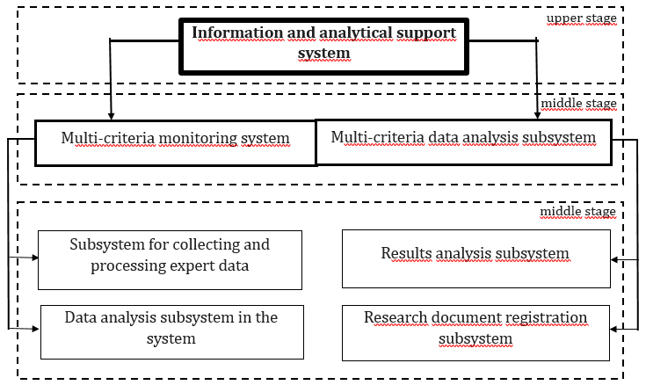
FIGURE 4. Hierarchical diagram of the hardware and software product

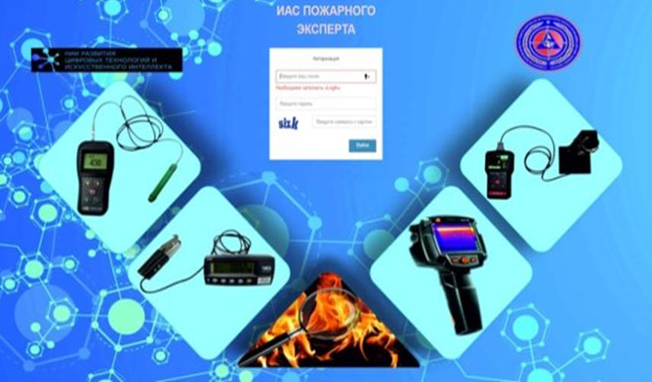
FIGURE 5. Automated program of the system of information and analytical support of experts

The convenience and usefulness of this hardware and software product is that it issues a protocol in electronic form, which is the basis of the expert's conclusion, using the input of results obtained from the above-mentioned devices of instrumental field research. The protocol will show the date of the fire, information about the expert, information about the research device used, a table of entered results and maps created based on the results.
By studying the effectiveness of the hardware and software complex developed to improve field research methods, it was found that the minimum result can be achieved using a stationary linear programming system of the following type, while it was proven that the use of the software product is effective when using field research methods when conducting a technical examination, the results of the study are presented in Table 3.

Table 3. Evaluation of instrumental methods of field research without hardware and software and express results of research with its help
№ | Research methods | Time spent on conducting the study  without  hardware and software complex  (minutes)  (per 1 object) | Time spent on conducting the study using the hardware and software complex (minutes) (per 1 object) | Time saved in  %
1 | Presentation of the results obtained at the research facility “KIM-2M” | 30 | 10 | 33
2 | Presentation of the results obtained at the research facility “TOP-01-EP” | 28 | 12 | 43
3 | Presentation of the results obtained at the research facility “Thermal Imager” | 35 | 15 | 42
4 | Presentation of the results obtained at the research facility “MVP-2M” | 30 | 10 | 33

Calculations performed using a hardware and software complex developed on the basis of a hierarchical system and the presented table showed that, from the point of view of reducing the time of field studies, the time spent on supporting management decisions using express assessment of the time of fire detection is from 33% to 43%. [13].

CONCLUSIONS
Based on the obtained results: for the formalization of instrumental field research in emergency situations related to explosion and fire, a software product called "Expert-information analytical support system" was developed based on a hierarchical system, with the help of these technologies, digitalization of storage, processing of expert research results, citation of used literature and preparation of documents was achieved.
It has been scientifically proven that the efficiency of such processes as fire registration, creation of an electronic database and a research report using an automated software package in improving the methods of field research of fire-technical expertise related to fires at industrial facilities, i.e. the formalization of the results obtained from the research device "KIM-2M", "MVP-2M" can increase to 33%, the formalization of the results obtained from the research installation "Teplovizor" up to 42%, the formalization of the results obtained from the research installation "TOP-01-EP" up to 43%.
REFERENCES
1. S.M. Djuraev, M.S. Saidov, N.D. Saidova. Problems in ensuring fire safety and the ways of eliminating them and the prospects of establishing a fire audit institute // Journal of Worldwide Cross-Disciplinary Research with. Fergana City of the Republic of Uzbekistan. ISSN 2347-6915 Vol.1 No. 1 (2024) Pp. 1-4
2. «On organizational measures for further improvement of the activities of emergency structures. Resolution of the President of the Republic of Uzbekistan dated April 10, 2019 No. UP-4276. URL: https://lex.uz/ru/docs/4326829
3. G.M. Gulomova, U.M. Turabekova. Problems of ensuring safety at open coal mines in the republic of Uzbekistan. Technical science and innovation №3 ISSN: 2181-0400, (2022)
4. G.M Gulomova, E.B Abduraxmonov, Adsorption energy of toluene vapors into an adsorbent obtained on the basis of local angrene coal. Harvard Educational and Scientific Review, (2021) https://www.journals.company/index.php/article/view/14
5. G.M.Gulomova, M.N.Musaev, Problems of Ensuring Safety at Open Pits in the Republic of Uzbekistan. JournalNX, 314-319, (2020) https://scholar.google.com/citations
6. D.Rakhmatova, M.Musaev, G.Gulomova, M.Aripkhadzhaeva, D.Nizamova, Development of safe products from local waste of oil and fat production E3S Web of Conferences, 371, (2023) https://scholar.google.com/citations
7. «On the introduction of a qualitatively new system for the prevention and elimination of emergency situations and ensuring fire safety in the Republic of Uzbekistan. Decree of the President of the Republic of Uzbekistan dated April 10, 2019 No. UP-5706. URL: https://lex.uz/docs/4320297.
8. G.M. Gulomova, О.Т. Тuxtamurodov and ofters. AIP Conference Proceedings, 224-230, (2023) https://zenodo.org/record/7985791
9. Suleimanov A.A., Kuldashev I.Kh., Aripkhodzhaeva M.B. Risk assessment when exposed to hazardous factors on categorized objects. Uzbekiston Republicasi Milliy Gvardiyasi Ҳarbiy-technician Instituteining Akhborotnomasi (Ilmiy-Amaliy Journal). 2019 yil, 2-dream. pp. 121-128.
10. Suleimanov A.A., Aripkhodzhaeva M.B. Technologies for ensuring the safety of buildings and structures, studying international and domestic experience on the example of the republic. Uzbekiston Respublikasi Milliy guards faoliyatini huquqiy ta’minlash: muammo va echimlar ilmiy makolalar tuplami. Tashkent, 2019.
11. Aripkhodzhaeva M.B., Suleimanov A.A. Drones for monitoring the operational situation in emergency situations. Far Eastern Spring 2019, international scientific and practical conference on environmental and safety issues, Komsomolsk-on-Amur. 2019, - S. 173-175. ISBN 978-5-7765-1406-7.
12. Suleimanov A.A. The activities of the consolidated headquarters created in case of extreme and emergency events. UzR Milliy Guard Harbiy Technician Institute Harbiy-Technician Institute Akhborotnomashi. - Tashkent, 2018, - p. 158-159.
13. Bodrova A.S., Bezdenezhnykh S.I. Prospects for the development and use of complexes with unmanned aerial vehicles: Conf. Kolomna, 2016. 274 p.
14. Organization of protection of the population and territories from emergency situations: a textbook. - 3rd ed., revised. and additional / V. A. Sednev, S. I. Voronov, I. A. Lisenko, E. I. Koshevaya, N. A. Savchenko, N. I. Sedikh.
15. Emergency situations of peacetime and wartime. Characteristics of emergency zones: methodological development / [compiled by V. A. Gorishny, V. B. Chernetsov, L. N. Borisenko]. - N. Novgorod, NSTU, 2006.
16. Forecasting emergency situations of a natural nature: B.A. Khramsov, T.G. Bolotskikh, A.M. Yurev. Methodical instructions. –Belgrod: Publishing house of BSTU im. V.G. Shukhova, 2006. - 25p.
17. Abdurakhmanova A.D. Emergencies and protection of the population: Textbook. TSTU. - Tashkent. 2020.- 203 p.
18. Madzhidov I.U., Ibragimov B.T., Suleymanov A.A. Composições modernas de isolação térmica para o aumento da resistência térmica das estruturas de concreto reforçadas Сiência, engenharia e tecnologia 4 de julho, SÃO PAULO, BRASIL 2019 Publicado por Science WA Ltd рр 78-86.
19. Levitt R.E., Kunz J.C. “Using Artificial Intelligence Techniques to Support Project Management.” Artificial Intelligence in Engineering Design, Analysis and Manufacturing. Vol. 1, No. 1 (2017). pp.3-24.
20. Vambol S.O., Kondratenko O.M., Mishchenko I.V., Koloskov V.Yu. (2018). Investigati-on of hydraulic jets during creation of ecological safety management system of high-risk objects: Monograph, Kharkiv, Publ. NUCD of Ukraine, 204 p. ISBN 978-617-7555-58-1.
21.Emergency situations of peacetime and wartime. Characteristics of emergency zones: methodological development / [compiled by V. A. Gorishny, V. B. Chernetsov, L. N. Borisenko]. - N. Novgorod, NSTU, 2006.
22. Forecasting emergency situations of a natural nature: B.A. Khramsov, T.G. Bolotskikh, A.M. Yurev. Methodical instructions. –Belgrod: Publishing house of BSTU im. V.G. Shukhova, 2006. - 25p.

