Parametric Optimization of the Magnetic System of an Electric Generator with an Integrated Magnetic Multiplier
Abdurahman Akhmedov, Sardorbek Khudoyberganov, Sayfulla Kayumov, Yelena Iksar, Sanjar Hakimov ^{a)}, Dilmurod Usmonov
Tashkent state transport university, Tashkent, Uzbekistan
^{a)} Corresponding author: sanjarhakimov3955@gmail.com
Abstract This paper presents the design and parametric optimization of a low-speed synchronous generator with an integrated magnetic multiplier. The study aims to reduce the size and mass of the generator while maintaining the required rated power output of 500 kW. A parametric mathematical model was developed using COMSOL Multiphysics® software, allowing variation of key parameters such as the number of stator and rotor poles, rotor diameters, and the thickness of permanent magnets. Optimization was performed based on achieving the target power output with minimal dimensions and material consumption. A 3D model of the generator was created in Compass 3D, and the manufacturability of the proposed design was analyzed. The results show that the new generator design can effectively replace conventional gearbox-driven systems in wind turbines without significant modifications to the nacelle structure. The proposed direct-drive generator reduces mechanical complexity, improves reliability, and provides efficient performance for renewable energy applications.
INTRODUCTION
The growing demand for renewable energy sources has significantly increased interest in the development of efficient and reliable wind power systems. Conventional wind turbines typically employ a gearbox to match the low rotational speed of the turbine blades with the higher rotational speed required by standard generators. However, gearboxes are known to be mechanically complex, prone to failures, and costly in terms of maintenance. These drawbacks have encouraged researchers and engineers to explore direct-drive solutions that eliminate the need for gearboxes while ensuring high efficiency and durability [1-3].
One of the promising approaches is the use of synchronous generators with integrated magnetic multipliers. Such generators enable the conversion of mechanical energy into electrical energy at low rotational speeds, reducing the overall size of the nacelle while maintaining the required output power [4-7]. Magnetic multipliers are advantageous because they minimize mechanical losses, enhance system reliability, and simplify the overall construction of the drive train.
Recent studies have shown that parametric optimization plays a critical role in achieving efficient designs of electrical machines. By systematically adjusting design variables such as the number of poles, rotor diameters, and permanent magnet dimensions, it is possible to improve both the power density and the torque performance of the machine. Simulation tools like COMSOL Multiphysics® provide a powerful platform for modeling, testing, and refining such systems under various operating conditions [8-12].
This research focuses on the design and optimization of a low-speed synchronous generator with an integrated magnetic multiplier. The primary objective is to achieve a rated output power of 500 kW while reducing the weight and volume of the generator. The optimized generator is then compared with a conventional gearbox–generator system in order to demonstrate its advantages for wind turbine applications [13-16]. The study further evaluates manufacturability and highlights the potential of the proposed design as a reliable alternative for renewable energy systems [17-19].

METHODOLOGY
Based on the analysis of existing publications, the main features of the new type of generator were identified, which allowed the development of its parametric mathematical model in COMSOL Multiphysics®. By repeatedly varying the number of poles on the stator and rotor, rotor diameters, and the thickness of permanent magnets, the design was optimized to achieve the specified output power of 500 kW while keeping the overall weight and size to a minimum [20-24]. For the improved configuration, a new winding connection scheme was selected (Figure 1).
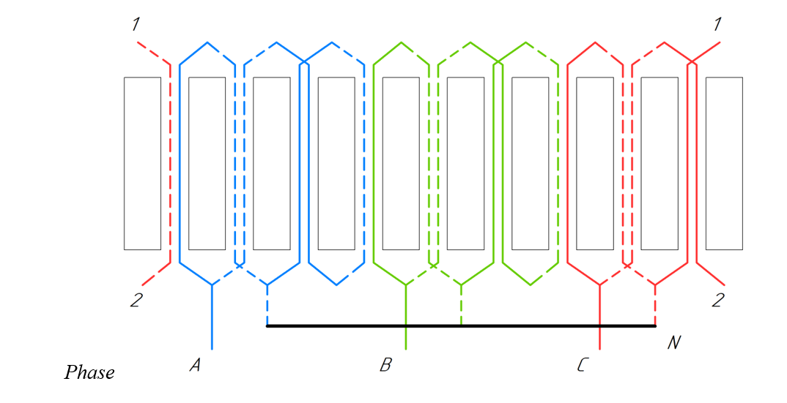
FIGURE 1. Generator winding diagram

The distribution of current density across the windings was then simulated (Figure 2), and the optimal parameters of the magnetic system were obtained. The results of the magnetic field calculations confirmed that the modified design can provide the required power characteristics (Figures 3–4). The main parameters of the optimized magnetic system are presented in Table 1.
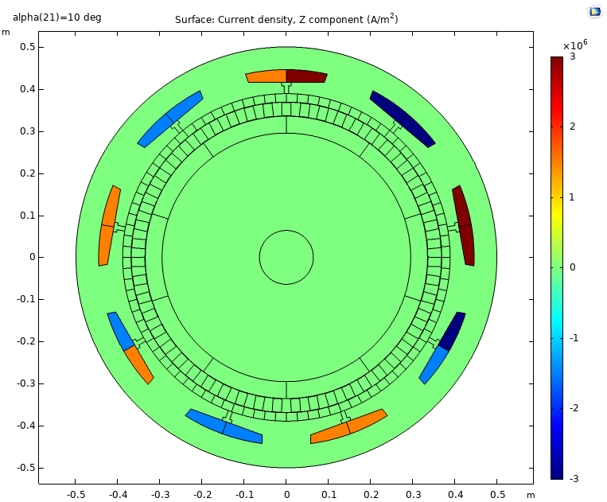
FIGURE 2. Distribution of current density across the windings of the machine model
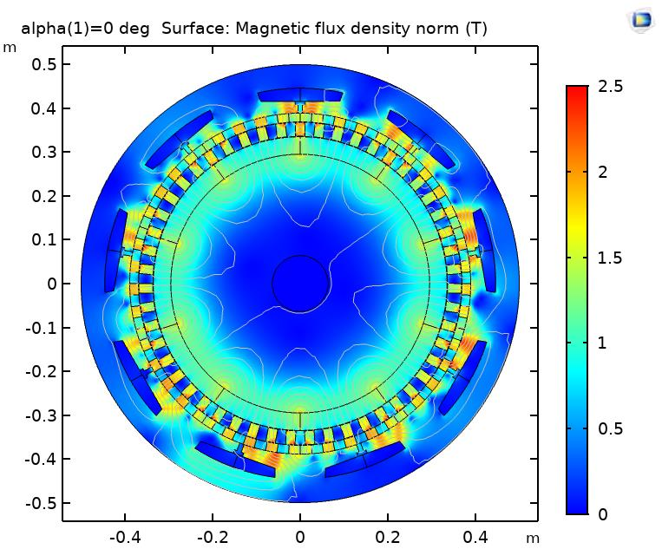 | 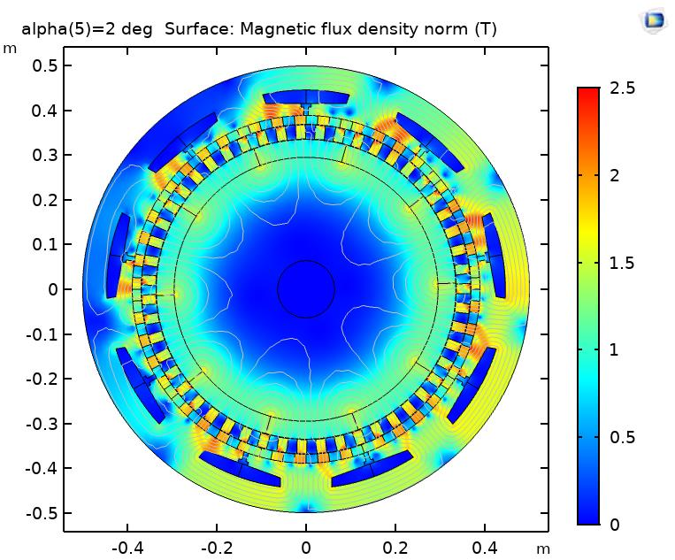
a) | b)
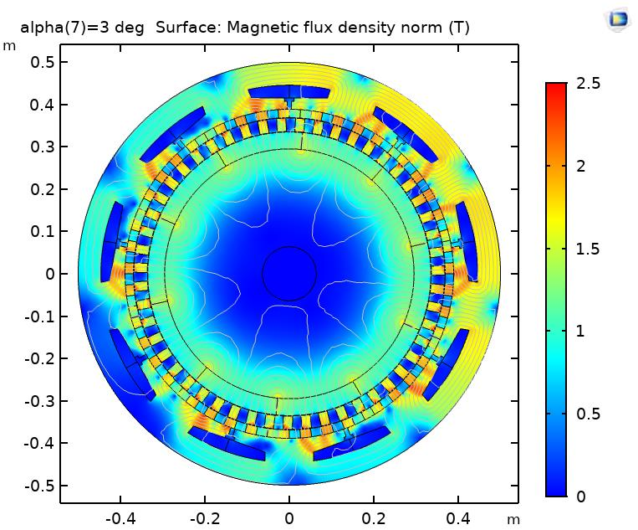 | 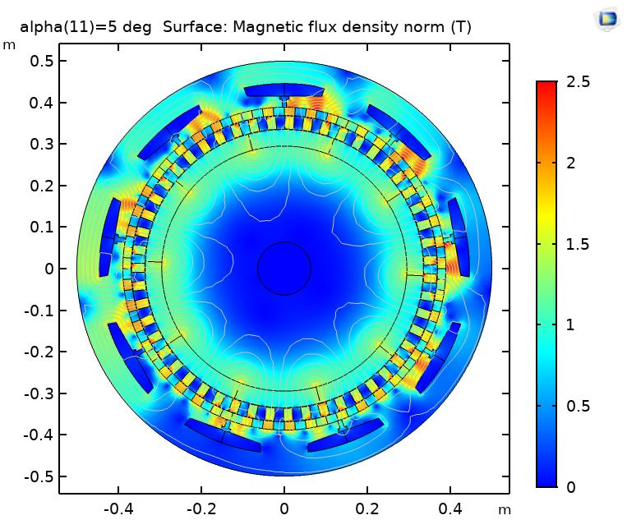
c) | d)
FIGURE 3. COMSOL Multiphysics® computer model – magnetic induction in the elements of the magnetic system (T) as a function of the rotor rotation angle α (degrees)
a) α = 0° – Initial position of the rotor, b) α = 2° – Early stage of rotor rotation, c) α = 3° – Intermediate rotation angle, d) α = 5° – Advanced rotor position

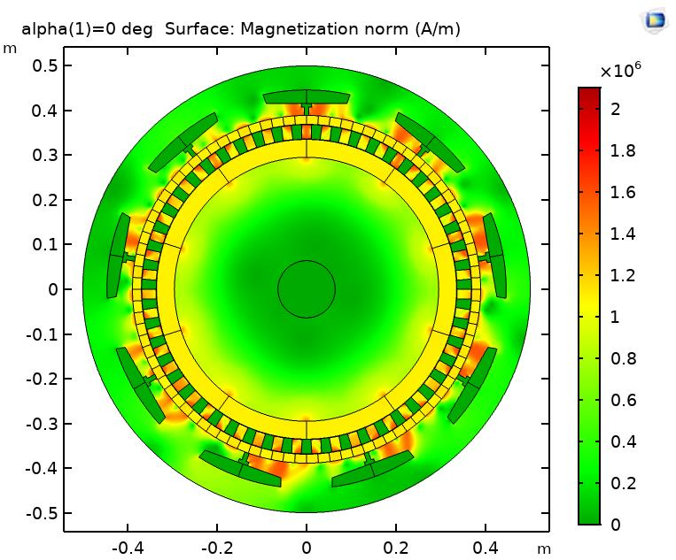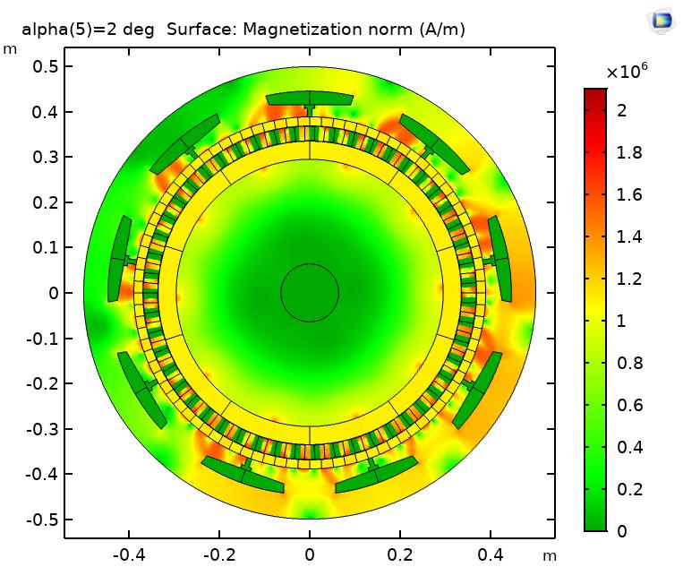
- b)
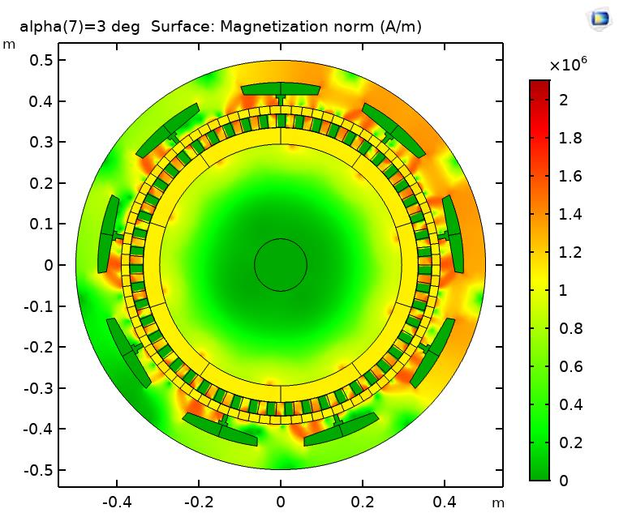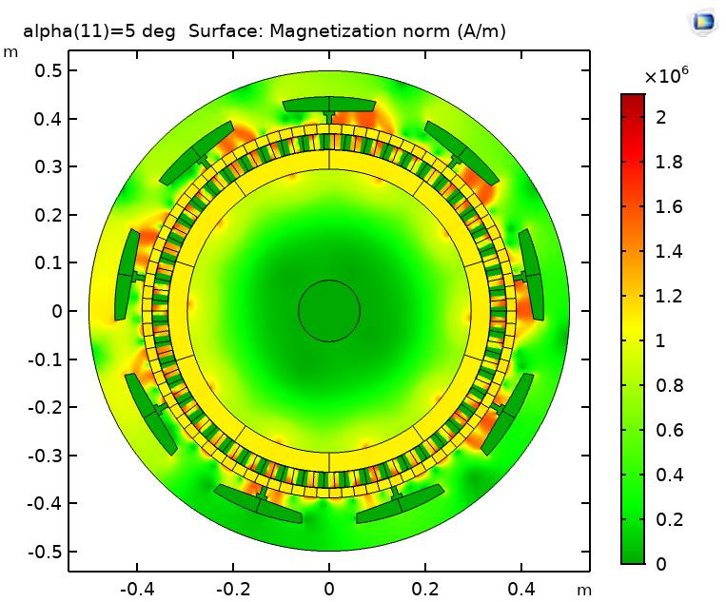
c) d)
FIGURE 4. COMSOL Multiphysics® computer model – magnetization (A/m) as a function of the rotor rotation angle α (degrees)
a) α = 0° – Initial rotor position, b) α = 2° – Beginning of rotor displacement, c) α = 3° – Transition phase of magnetic flux redistribution, d) α = 5° – Final stage of the transition
TABLE 1. Parameters of the mathematical computer model of the generator
Parameter | Value
Outer diameter of the generator stator, Dr | 1000 mm
Length of the generator, Lr | 1500 mm
Angular speed of the low-speed shaft, nr | 23 rpm
Maximum torque of the generator, Mmax2 | 224.4 kN·m
Specific torque per unit mass of magnets, Mnm | 157.2 N·m/kg
Specific torque per unit volume of the magnetic system, M* | 190.5 kN·m/m³
Maximum torque of the multiplier, M′ | 241.7 kN·m
Maximum power of the generator, PM | 540.5 kW
RMS value of current density in the stator slots, J | 2.12 A/mm²

The generator was developed as a synchronous electrical machine without excitation, incorporating permanent magnets on the inner rotor, multiple pole pairs on the stator, and a steel segment modulator. To ensure effective cooling, a fan was mounted on the unused high-speed rotor, functioning as an air-cooling system. The direction of magnetization of the permanent magnets is shown in Figure 5.
Based on the simulation results, a three-dimensional model of the generator was created in Compass 3D software. Both cross-sectional (Figure 6) and longitudinal (Figure 7) drawings were prepared to analyze the internal arrangement of the components. During manufacturability analysis, it was determined that most of the machine elements are standard and can be produced using conventional techniques. The only non-standard part is the magnetic modulator, but its production does not require any special equipment. The final external view of the designed model is presented in Figure 8.
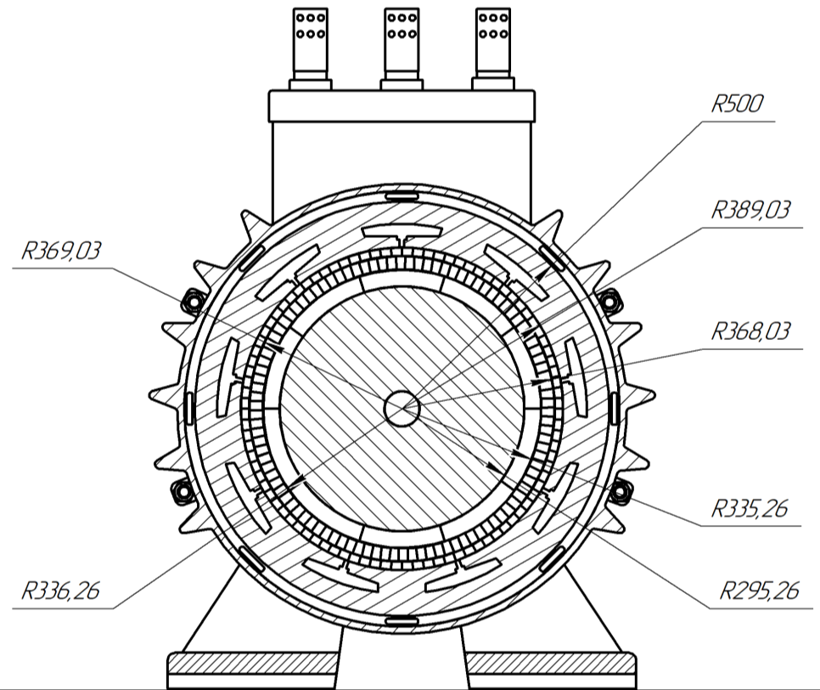 | 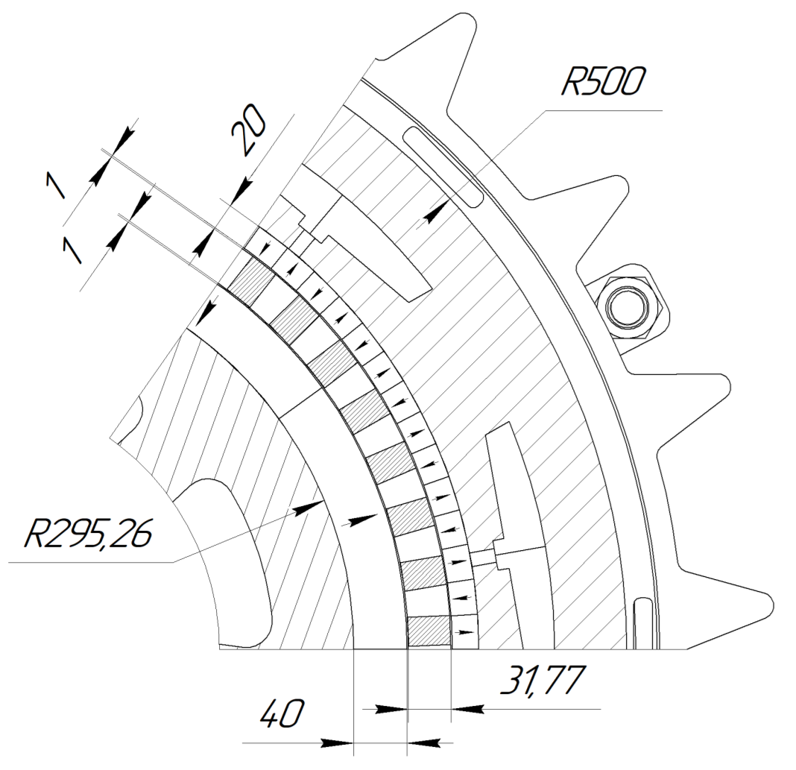
FIGURE 5. Drawing of the designed generator in cross section | FIGURE 6. Drawing of a fragment of the machine’s magnetic system
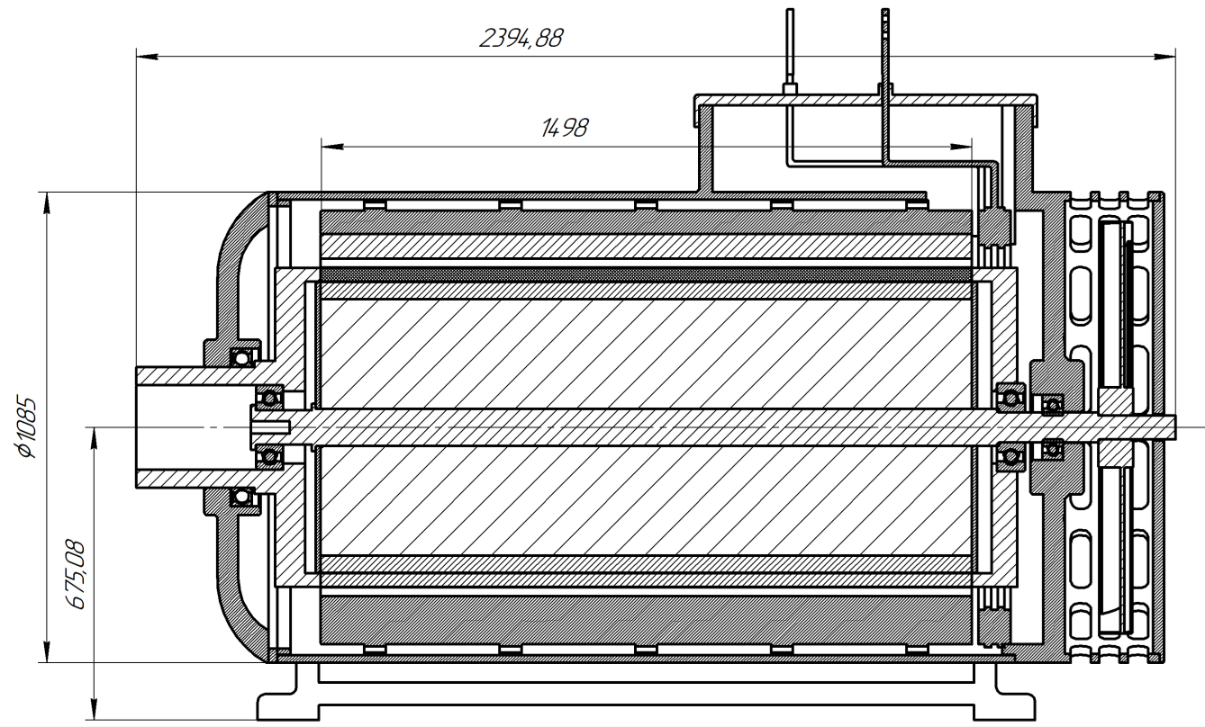 | 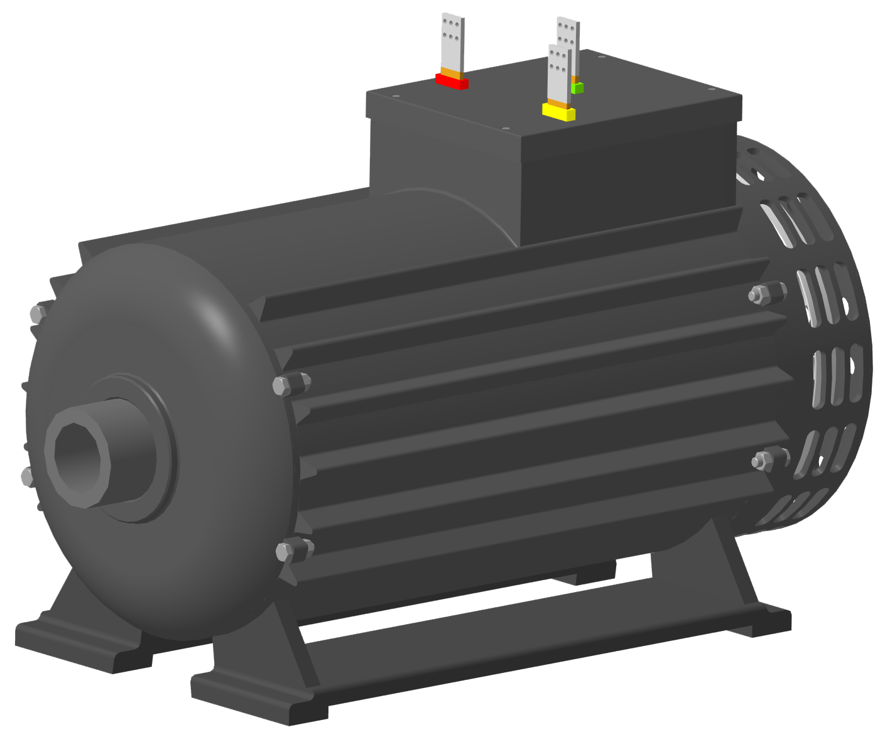
FIGURE 7. Drawing of the designed generator in longitudinal section | FIGURE 8. Final external view of the 3D model of the generator
DISCUSSION
The results of the parametric optimization carried out in COMSOL Multiphysics® demonstrate the effectiveness of the proposed low-speed synchronous generator with an integrated magnetic multiplier. The optimized parameters indicate that the generator is capable of delivering up to 540.5 kW, which exceeds the nominal design requirement of 500 kW. This margin ensures reliable operation under variable wind conditions and highlights the robustness of the design.
The analysis of electromagnetic behavior shows that the developed configuration maintains stable flux distribution and magnetization across the entire rotor rotation range. This confirms efficient utilization of the magnetic circuit, minimizing energy losses and ensuring high conversion efficiency. The chosen winding connection scheme further enhances performance by balancing current density within the stator slots, thereby reducing overheating risks and extending machine lifetime.
From a structural perspective, the generator design demonstrates clear manufacturability advantages. Most of the machine’s components are standard, which simplifies production and reduces overall cost. The only non-standard component is the magnetic modulator, but it can still be fabricated using conventional machining processes without requiring highly specialized equipment.
A comparative evaluation against a conventional gearbox–generator system shows that the new direct-drive solution reduces space requirements inside the nacelle, decreases mechanical complexity, and eliminates maintenance challenges typically associated with gearboxes. Despite its more compact design, the generator fully supports the rated power capacity, thereby offering both technical and economic benefits.
Overall, the findings confirm that the developed generator not only meets the required performance specifications but also enhances efficiency, reliability, and long-term maintainability. This demonstrates the high potential of integrated magnetic multiplier systems for application in medium-scale wind power plants, providing a practical and effective alternative to traditional gearbox-driven systems.
CONCLUSION
This study presented the design, modeling, and parametric optimization of a synchronous generator with an integrated magnetic multiplier intended for use in a 500 kW wind turbine system. Using COMSOL Multiphysics®, a mathematical model was developed, and key design parameters such as pole numbers, rotor diameters, and permanent magnet thickness were optimized. The simulation results demonstrated that the generator achieves a maximum power of 540.5 kW, exceeding the nominal requirement and ensuring stable operation under varying wind conditions.
A significant outcome of the work is the reduction in overall nacelle space requirements compared to traditional gearbox–generator systems. The designed generator eliminates the need for a mechanical gearbox, thereby reducing maintenance costs, mechanical complexity, and potential failure risks. Additionally, the analysis of the magnetic system confirmed efficient flux utilization and balanced current density distribution, which enhance both performance and durability.
From a manufacturability perspective, the majority of the generator’s components are based on standard industrial designs, with the exception of the modulator, which can still be produced without advanced equipment. This ensures that the proposed design can be implemented in practice without excessive production challenges.
In summary, the integration of the optimized low-speed generator into the T 600-48 wind turbine proves its viability as a replacement for conventional systems. The results highlight the potential of this approach for improving the efficiency, reliability, and cost-effectiveness of medium-scale wind power plants. Future work should focus on experimental validation of the proposed model and evaluation of its performance under real operational conditions.
REFERENCES
- Ackermann, T. (2005). Wind Power in Power Systems. John Wiley & Sons.
- Boldea, I., & Tutelea, L. N. (2010). Direct Drive Permanent Magnet Synchronous Generators for Wind Turbines: A Review. IEEE Transactions on Energy Conversion, 25(2), 389–399.
- Dubois, M. R. (2004). Optimized Permanent Magnet Generator Topologies for Direct-Drive Wind Turbines. PhD Thesis, Delft University of Technology.
- Hansen, A. D., & Hansen, L. H. (2007). Wind Turbine Concept Market Penetration. Wind Energy, 10(1), 81–97.
- Polinder, H., van der Pijl, F. F. A., de Vilder, G. J., & Tavner, P. J. (2006). Comparison of Direct-Drive and Geared Generator Concepts for Wind Turbines. IEEE Transactions on Energy Conversion, 21(3), 725–733.
- Zhu, Z. Q., & Howe, D. (2007). Electrical Machines and Drives for Renewable Energy Systems. Renewable and Sustainable Energy Reviews, 11(6), 1241–1259.
- F. Libert, J. Soulard Investigation on Pole-Slot Combinations for Permanent-Magnet Machines with Concentrated Windings
- Molokanov O., Dergachev P., Osipkin S., Kuznetsova E., Kurbatov P. A Novel Double-Rotor Planetary Magnetic Gear// IEEE TRANSACTIONS ON MAGNETICS, VOL. 54, NO. 11. 2018.
- Shan Peng, W. N. Fu, and S. L. Ho A Novel High Torque-Density Triple Permanent-Magnet-Excited Magnetic Gear // IEEE TRANSACTIONS ON MAGNETICS, VOL. 50, NO. 11. 2014.
- Molokanov O., Kurbatov P., Dergachev P., Alami A. Dynamic Model of Coaxial Magnetic Planetary Gear // 18th International Conference o Electrical Machines and Systems. 2015.
- Kühn P. Big Experience with Small Wind Turbines – 235 Small Wind Turbines and 15 Years of Operational Results // ISET. 2007.
- Burkhanov, S.D. Relationship of parameters that characterize the quality of live cocoons / Burkhanov, S.D., Mirsaatov, R.M., Khudoyberganov, S.B., Kadyrov, B.H. // IOP Conference Series: Earth and Environmental Sciencethis link is disabled, 2021, 677(4), 042032.
- Akhmedov, A. The influence of production conditions on the electrophysical parameters of piezoceramics for different applications / Akhmedov, A., Sauchuk, G., Yurkevich, N., Khudoyberganov, S., Bazarov, M., Karshiev, K. // E3S Web of Conferences, 2021, 264, 04020.
- Ravshanbek Mirsaatov and Sardorbek Khudoyberganov, "Development of a non-destructive method determination of the maturity of Mulberry cocoons", AIP Conference Proceedings 2432, 040018 (2022) https://doi.org/10.1063/5.0089646
- R. Mirsaatov, S. Khudoyberganov, A. Akhmedov; Uncertainty estimation in determination of Cocoons silkiness by thickness of their shell. AIP Conf. Proc.15 March 2023; 2612 (1): 050010. https://doi.org/10.1063/5.0114683
- Halina Sauchuk, Natallia Yurkevich, Abduraxman Akhmedov, Sardorbek Khudoyberganov, Sayfulla Kayumov and Ulmasbek Berdiyarov. Dielectric and microwave properties of ceramics of the Bi- Ti -O system. E3S Web of Conf., 401 (2023) 05076. DOI: https://doi.org/10.1051/e3sconf/202340105076
- Cumulative generation of electricity from the wind of passing vehicles and natural wind in the Bukhara region of the Republic of Uzbekistan / Abduraxmon Akhmedov and Sardorbek Khudoyberganov // E3S Web Conf., 461 (2023) 01073. https://doi.org/10.1051/e3sconf/202346101073
- Akhmedov AP, Khudoyberganov SB Generation of electricity with the help of wind and solar on the route of Tashkent overground metro trains. (2024) International Conference on Thermal Engineering, 1(1). https://www.scopus.com/inward/record.uri?eid=2-s2.0-85199166478&partnerID=40&md5=c545973449e66f14166b44089f170b20
- Sauchuk HK, Yurkevich NP, Akhmedov AP, Kolesnikov IK, Berdiyev UT, Khudoyberganov SB, Khakimov SH Physical and thermal properties of binary (Bi-Ti-O)-TiO2 UHF-ceramics (2024) International Conference on Thermal Engineering, 1 (1), https://www.scopus.com/inward/record.uri?eid=2-s2.0-85199155227&partnerID=40&md5=ccbd0010d5ffcfaa5e077619c15e6149
- S. F. Amirov, Sh.A. Sharapov, A.Kh. Sulliev, O.T. Boltaev. Biparametric resonant transformer sensor of large linear movements. AIP Conf. Proc. 26 December 2023; 2624 (1): 030007. DOI: 10.1063/5.0132847
- U. T. Berdiyev, U. N. Berdiyorov, U. B. Sulaymonov, L. U. Khalikova; Ways to improve the energy performance of asynchronous electric motors of rolling stock. AIP Conference Proceedings 15 March 2023; 2612 (1): 050017. https://doi.org/10.1063/5.0117784
- Methods of new technological developments of electric motors based on soft magnetic materials. U. T. Berdiev, I. K. Kolesnikov, M. N. Tuychieva, F. F. Khasanov and U. B. Sulaymonov. E3S Web of Conf., 401 (2023) 03038. DOI: https://doi.org/10.1051/e3sconf/202340103038
- Yusupov D.T., Muminov A.B., Nosirov A.I., Berdiev U.T., Kutbidinov O.M. Development of an algorithm of processes for cleaning power transformer oil in a circulatory way15th International Conference on Thermal Engineering: Theory and Applications, ICTEA 2024. No. 1, vol. 12024
- Yusupov D.T., Muxammadjonov, M. Sh., Berdiev U.T., Kutbidinov O.M., Abdurakhimov D.R. Development of the algorithm of additional cooling process for oil power transformers with onan cooling system 15th International Conference on Thermal Engineering: Theory and Applications, ICTEA 2024. No. 1, vol. 12024
- Kolesnikov, I.K., Abidova, G.S., Khakimov, S.H. (2024). The Choice of a Generalized Criterion for the Efficiency of an Automated Electric Drive of a Railway Rolling Stock. 12th World Conference “Intelligent System for Industrial Automation” (WCIS-2022). WCIS 2022. Lecture Notes in Networks and Systems, vol 912. Springer, Cham. https://doi.org/10.1007/978-3-031-53488-1_34.
- Kolesnikov, I.K., Abidova, G.Sh., Karshiyev, K.T., Hakimov, S.H. Development of a Mathematical Model to Determine the Basic Parameters of an Induction Motor. 2025, Advances in Science, Technology and Innovation, volume Part F764, pages 265 – 269. doi 10.1007/978-3-031-82210-0_44, https://www.scopus.com/inward/record.uri?eid=2-s2.0-105014249553&doi=10.1007%2f978-3-031-82210-0_44&partnerID=40&md5=854fe7e9ef8be355b24a6b3eda4cda26.

