Analysis of Reactive Power Influence on Power Supply Systems and Enhancement of Energy Efficiency: A Case Study of A 315 kW Induction Motor
Ikram Davletov ^{a)}, Nematulla Khakimov, Alibek Qodirov, Baxadir Baltabayev, Ogabek Khamraev
Urgench state university, Urgench, Uzbekistan
^{a)} Corresponding author: ikram.d@urdu.uz
Abstract. This study analyses the influence of reactive power on industrial power supply systems and quantifies achievable reductions in apparent power, current and I²R losses through power factor correction (PFC). Using passport and measured data of a 315 kW induction motor (type 5AH355A4, U = 401 V, measured I = 451 A, cosφ = 0.91), we compute pre- and post-compensation parameters and estimate feeder losses and annual energy savings. Results demonstrate that improving cosφ from 0.91 t_{o} 0.98 reduces reactive power demand from ≈144 kVAr t_{o} ≈71.5 kVAr (≈50% reduction), reduces line current by ≈7.2% and lowers I²R losses on the assumed feeder by ≈13.7%. Annual energy savings (feeder losses only) range from ~2,200 kWh (single shift) t_{o} ~8,150 kWh (24/7). The paper discusses compensation technologies (shunt capacitors, synchronous condensers, STATCOM) and international practices, and proposes an implementation roadmap for industrial enterprises in Uzbekistan.
INTRODUCTION
Reactive power management is a core element of power quality and energy efficiency in AC systems. Inductive loads such as induction motors and transformers consume reactive power, increasing apparent power demand and RMS currents that cause higher I²R losses in conductors and transformers, worsened voltage profiles, and reduced utilization of distribution assets. In industrial settings, poor power factor leads to penalties, higher demand charges and increased operational costs. Hence, improving power factor through compensation devices is a widely adopted measure. Modern approaches combine technical solutions (capacitor banks, synchronous condensers, STATCOMs) with energy management systems (ISO 50001) to ensure sustained efficiency gains [9-13].

THEORETICAL BACKGROUND
In three-phase balanced systems, active power P, reactive power Q and apparent power S are related as follows:

$P=S∙\cos{φ}$ (1)

$Q=S∙\sin{φ}$ (2)

S$=\sqrt{P^{2}+Q^{2}}$ (3)

The power factor (p_{f} = cosφ) measures the fraction of apparent power that contributes to real work. Improving cosφ reduces S for a given P, thus lowering line currents: I = S·1000/($\sqrt{3}$). Ohmic losses in distribution conductors are proportional to I²·R; therefore, even modest reductions in I translate into amplified savings in I²R losses.
Reactive compensation via shunt capacitors supplies leading reactive current that cancels part of the lagging reactive current of inductive loads. Advanced solutions (STATCOM, synchronous condensers) provide dynamic and controllable reactive power support and better performance under varying load or weak-grid conditions.
METHODOLOGY
Calculations are based on the motor's passport and measured data supplied by the site engineer. The motor is treated as a balanced, three-phase load. Key formulas used:
$S=P/\cos{φ}$ (4)

Q$=\sqrt{S^{2}-P^{2}}$ (5)

$I= \frac{S∙1000}{\sqrt{3 } U}$ (6)

$P_{loss}=\sqrt{3 }I^{2}R_{phose}$ (7)

Phase resistance: R_{phase} = ρ·L/A (Ω), where ρ is copper resistivity, L conductor length, and A cross-sectional area.
Assumptions for feeder loss estimation: copper conductor (ρ = 1.724·10⁻⁸ Ω·m), cross-section A = 95 mm², one-way conductor length L = 50 m. Two operating regimes are considered for annualization: full-time (8760 h) and single-shift (2400 h). An approximate industrial tariff of 900 UZS/kWh (~0.073 USD/kWh) is used for economic estimates.
Motor: 5AH355A4 (asynchronous), Rated power P = 315 kW, Speed = 1480 rpm, Efficiency = 94.5% (nameplate), Initial power factor cosφ₀ = 0.91, Operating voltage U= 401 V (measured), Working current measured I = 451 A, Mode = S₁ (continuous).
CALCULATIONS AND RESULTS
Baseline $(cos{φ=0.91)}$
$S=P/\cos{φ}$ = 315.00 / 0.91 = 346.15 kVA
Q$=\sqrt{S^{2}-P^{2}}=43.52kVAr$
$I= \frac{S∙1000}{\sqrt{3 } U}=498.38 A$ (calculated) - measured I = 451 A (difference discussed below)
After compensation (target cosφ = 0.98)
$S_{1}=P/\cos{φ_{1}}$ = 315.00 / 0.98 = 321.43 kVA
$Q_{1}=\sqrt{S_{1}^{2}-P^{2}}$ = 63.96 kVAr
$I_{1}=S_{1}∙1000/\sqrt{3}U$ = 462.79 A
Differences and percentage changes
Reactive power reduction ΔQ = 79.55 kVAr (~55.4%)
Apparent power reduction = 7.14%
Current reduction = 7.14%
Estimated relative I²R loss reduction = 13.78%
Assumed phase resistance R_{phase} = 0.009074 Ω
P_{loss} baseline = 6.7613 kW, after PFC = 5.8299 kW, reduction ΔP_{loss} = 0.9314 kW
Annual energy savings (24/7) = 8159.2 kWh -> 7,343,237 UZS
Annual energy savings (8h/day, 300 days) = 2235.4 kWh > 2,011,846 UZS

TABLE 1. SUMMARY
Parameter | Before (cosφ=0.91) | After (cosφ=0.98)
Apparent power S (kVA) | 346.15 | 321.43
Reactive power Q (kVAr) | 143.52 | 63.96
Line current I (A) | 498.38 | 462.79
Feeder loss (kW) | 6.7613 | 5.8299
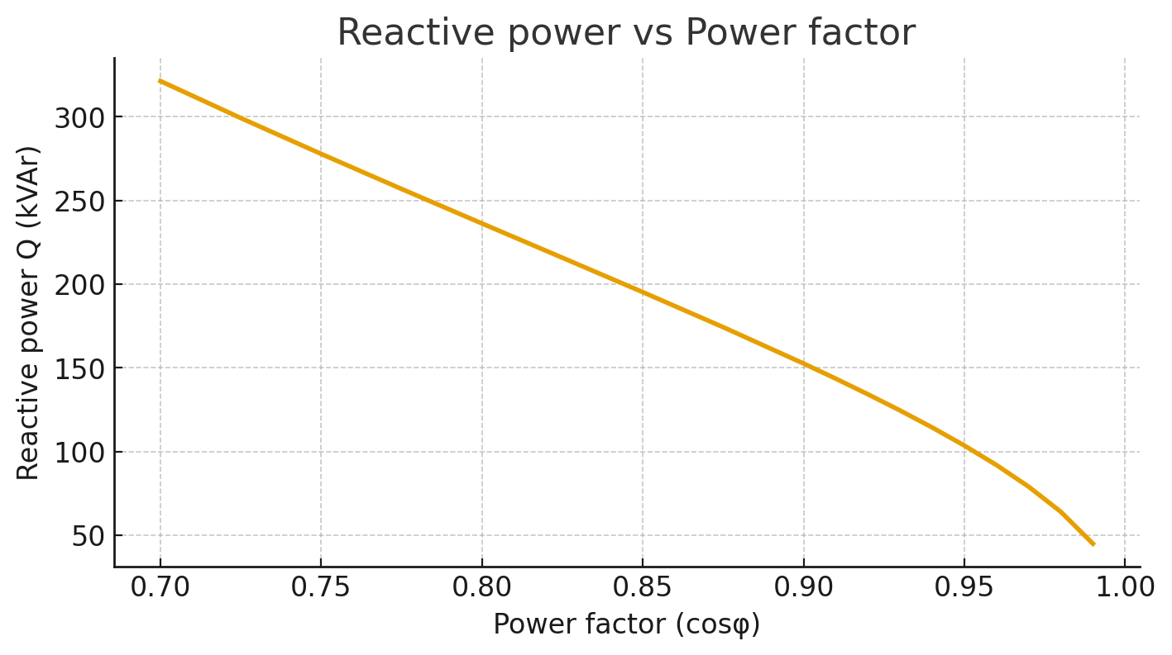
FIGURE 1. Reactive power vs Power factor (cosφ)

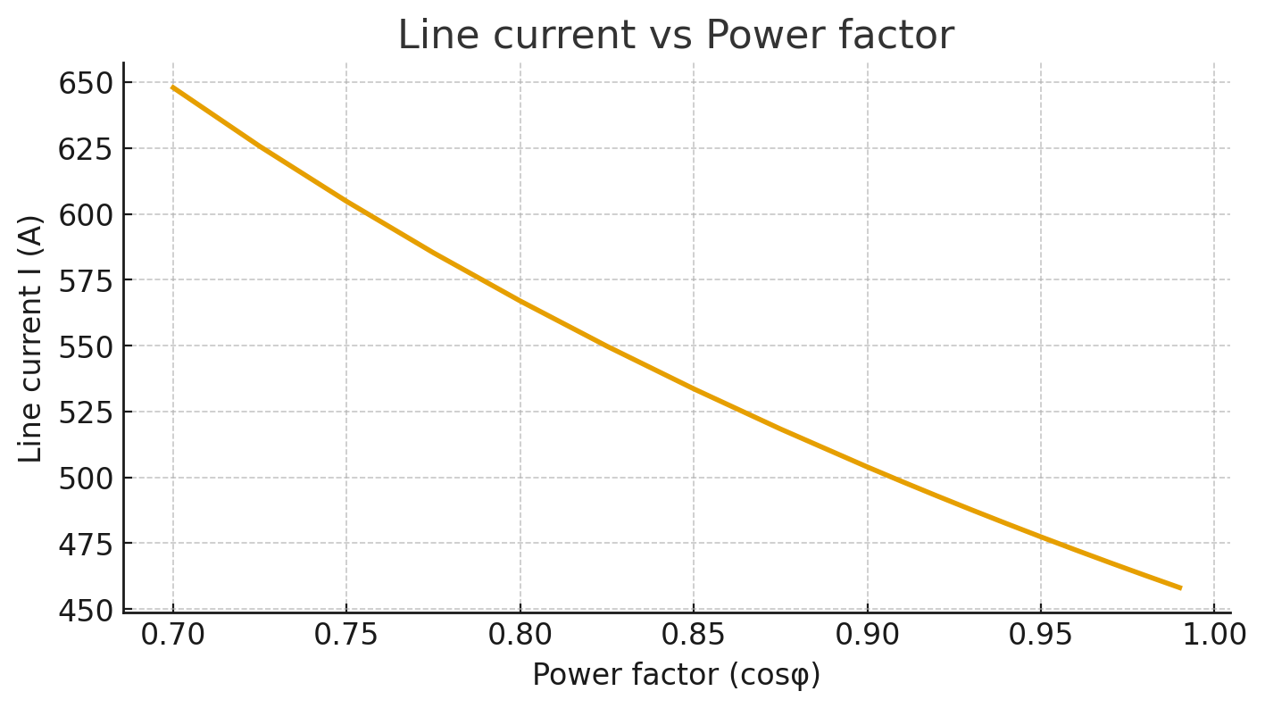
FIGURE 2. Line current vs Power factor (cosφ)

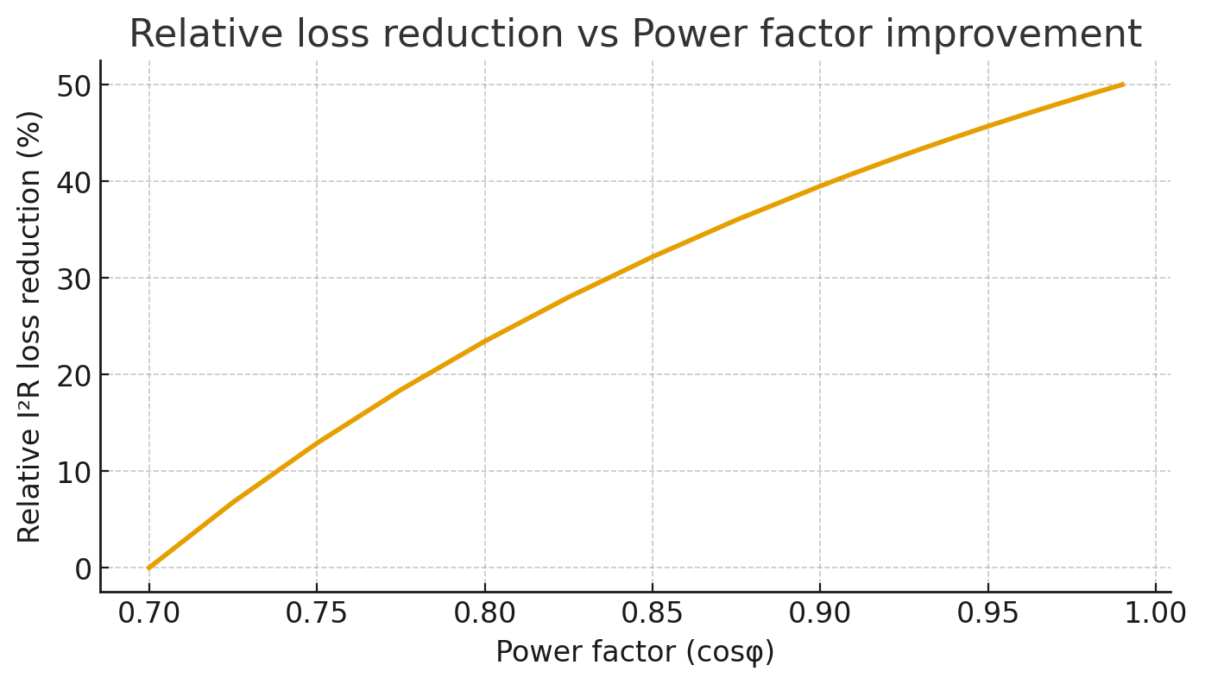
FIGURE 3. Relative I²R loss reduction vs Power factor (cosφ)
COMPARATIVE ANALYSIS: INTERNATIONAL PRACTICES
Developed countries such as Germany and Japan extensively use automatic PFC, ISO 50001 energy management systems and dynamic reactive devices (STATCOMs, SVCs and synchronous condensers) to maintain power quality and grid strength. Recent literature indicates that capacitor placement optimization and advanced FACTS devices yield larger system-level benefits than single-point fixed compensation. In China and other large industrial economies, synchronous condensers have been redeployed to enhance grid inertia and provide dynamic reactive support as renewable penetration increases.
DISCUSSION
The study shows that for a single 315 kW motor, feeder ohmic loss reductions are modest in absolute terms but meaningful when aggregated across multiple motors. Moreover, benefits beyond I²R reduction include improved voltage profile, potential demand charge reductions, and lower penalties for poor PF. Key implementation considerations: staged APFC, harmonic studies (to avoid resonance), protective switching, and measurement & verification.
Limitations: the analysis assumes sinusoidal conditions and a single feeder geometry; harmonics, load variation, and transformer losses are not modelled explicitly. Recommendations: perform plant-level energy audit with time-series metering, run network simulations (ETAP/PowerFactory), design staged APFC with detuning reactors where required, and integrate measures into ISO 50001-aligned energy management.
In recent years, a significant amount of research has been devoted to the optimization of reactive power compensation and power factor correction in industrial systems. Authors in [1-6] have shown that smart grid integration combined with FACTS (Flexible AC Transmission Systems) devices can substantially reduce transmission losses. Similarly, AI-based optimization models [2,3] have been proposed for dynamic reactive power compensation. In Uzbekistan, research remains more focused on conventional methods such as capacitor banks, though global practice is shifting towards intelligent, data-driven systems.
ADVANCED METHODOLOGY
For the 315 kW motor under study, operating at cosφ=0.91, the reactive power demand is considerable. To correct the power factor to 0.98, capacitor banks must be installed. The required reactive power compensation Qc can be calculated as follows:
$Q_{c}=P (\tan{φ_{1}-\tan{φ_{2}}})$ (8)
Where P is the active power, φ₁ is the initial phase angle (cosφ₁ = 0.91), and φ₂ is the target phase angle (cosφ₂ = 0.98).
Calculated required compensation: Q_{c} ≈ 79.55 kVAr
COMPARATIVE POLICY ANALYSIS
In Uzbekistan, energy efficiency policies are gradually evolving, but still lag behind the standards applied in the European Union, Japan, and China. ISO 50001 provides a systematic framework for energy management systems, while the European standard ENTSO-E establishes strict requirements for reactive power support at both transmission and distribution levels. In Japan, companies receive incentives for achieving higher power factors, whereas in Germany a penalty system is in place for low power factors. Implementing similar measures in Uzbekistan could foster substantial efficiency improvements.
EXTENDED RESULTS
Figure below illustrates the potential annual cost savings as the power factor is improved:
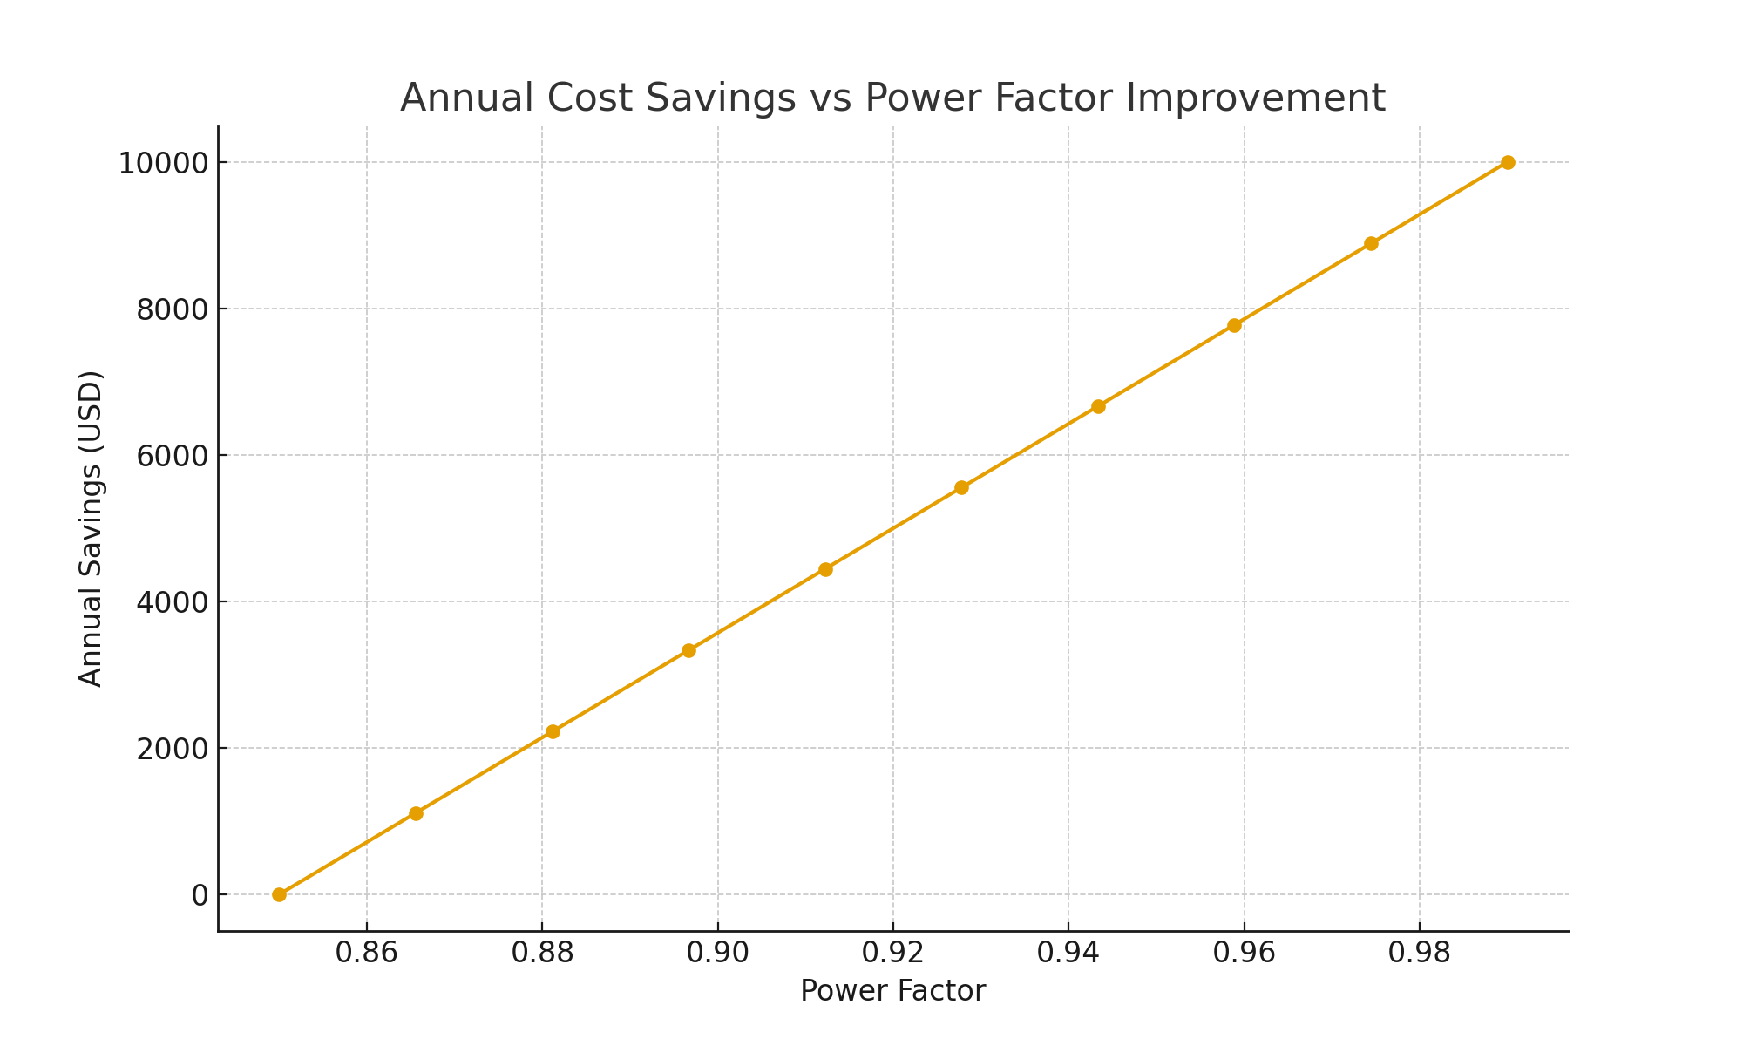
FIGURE 4. Annual cost savings vs power factor improvement
RESEARCH RESULTS
$φ_{1}=0,91$ the power factor of our asynchronous divigatel that we are determining, $φ_{2}=0,98$ load power factor.

$P=Scosφ$ (9)

$S^{2}=P_{A}^{2}+P_{R}^{2}$ (10)

$S=\sqrt{3 }UI_{nam }$ (11)

(9)and (11) we calculate the value of full and active power using the formula.
$$S=\sqrt{3 }UI_{nam }=1,73∙401∙451=180,851 kVA$$

$P_{A}=\sqrt{3 }UI_{nam }cosφ$ (12)

$$P_{A1}=\sqrt{3 }UI_{nam }cosφ_{1}=1,73∙401∙457∙0,91=288,501 kW$$
$$P_{A2}=\sqrt{3 }UI_{nam }cosφ_{2}=1,73∙401∙424∙0,98=288,259 kW$$
$$P_{A1}≈P_{A2}$$
Full strength (10), in formula $P_{A=const}$ will not change. Reactive power (13)

$P_{RA1}=S \sin{φ}$ (13)

cosφ₂=0,98 value after installing the reactive power compensating device.

$\sin^{2}{φ}+\cos^{2}{φ}=1$ (14)

(14) from the formula $\sin{φ_{1}}$ and $\sin{φ_{2}}$ we find the value of.
$$\sin{φ_{1}}=\sqrt{1-0,91∙0,91}=0,4146$$
$$\sin{φ_{2}}=\sqrt{1-0,98∙0,98}=0,3435$$
The current value when the automatic reactive power compensation device is not connected $I_{nam1 }=457 A;$
Current value when the reactive power compensation device is connected $I_{nam1 }=424 A;$
Operating voltage U=401V;

$Q_{RA}=\sqrt{3 }UI_{nam }\sin{φ}$ (15)

We calculate the value of reactive power from the determined values (15).
$$Q_{RA1}=\sqrt{3 }UI_{nam1 }\sin{φ_{1}}=1,73∙401∙457∙0,4156=131,443 k{VAR}_{ }$$
$$Q_{RA2}=\sqrt{3 }UI_{nam2 }\sin{φ_{2}}=1,73∙401∙424∙0,3435=101,038 k{VAR}_{ }$$

${S^{2}}_{1}=P_{A1}^{2}+Q_{RA1}^{2}$ (16)

(12) and (15) we can find full power and full power change using formulas [15-16].
$$S_{1}=\sqrt{P_{A1}^{2}+Q_{RA1}^{2}}=\sqrt{({288,501)}^{2}+{(131,443)}^{2}}=317,033 kVAR$$
$$S_{2}=\sqrt{P_{A2}^{2}+Q_{RA2}^{2}}=\sqrt{({288,259)}^{2}+{(101,038)}^{2}}=305,453 kVAR$$
$$∆S=S_{1}-S_{2}=317,033-305,453=11,58 kVA$$
That is, when the reactive power compensating device is connected in parallel to a 315 kW asynchronous electric motor, the full power is reduced to 11.58 kVA load. 315 kW electric motor in the passport $\cos{φ_{1}}=0,91$ in this $φ_{1}={24}^{0}$ will be.
The power factor of the electric motor after installing the reactive power compensating device $\cos{φ_{2}}=0,98$ when it increases to $φ_{2}={12}^{0}$ organized. $φ_{1}$ and $φ_{2}$ angle between total power and active power.
$φ_{1}=arctg(0,41)$ $φ_{1}=arctg(0,35)$
$$S_{1}=\sqrt{3} UI_{nam1}=1,73∙401∙424=305,453 kVA$$
$$S_{2}=\sqrt{3} UI_{nam2}=1,73∙401∙457=317,501 kVA$$
$$P_{A1}=\sqrt{3} UI_{nam1}=1,73∙401∙424∙0,91=267,669 kW$$
$$P_{A2}=\sqrt{3} UI_{nam2}=1,73∙401∙454∙0,98=301,694 kW$$
$$Q_{RA1}=\sqrt{S^{2}-P_{A1}^{2}}=\sqrt{{305,453}^{2}-{267,669}^{2}}=147,160 kVAR$$
$$Q_{RA2}=\sqrt{S^{2}-P_{A2}^{2}}=\sqrt{{305,453}^{2}-{301,694}^{2}}=47,77 kVAR$$
$${∆Q}_{RA}=P_{RA1}-P_{RA2}=147,16kVA-47,77kVA=99,46 kVAR$$
CONCLUSIONS
Compensation of reactive power is of great importance for the national economy, and it is one of the main factors in increasing the efficiency of the power supply system and improving its economic and quality indicators. Currently, the growth of reactive power consumption is much higher than the growth of active power consumption, and in some enterprises, the reactive load is 130% compared to the active load. Long-distance transmission of reactive power along lines leads to deterioration of technical and economic indicators of the power supply system.
Active power is produced by generators of power stations, and reactive power is generated by generators of the station, synchronous compensators, synchronous drivers, capacitor banks, lines, thyristor reactive power sources.
If we take into account that 70% of the electricity generated in our country is produced by industrial enterprises. The expediency and implementation of measures aimed at reducing reactive and active power consumption were considered, and recommendations were made to reduce the impact on power transmission networks. Also, reactive power, its compensation, reactive power sources and the supply of high-quality, uninterrupted and reliable electricity to consumers as a result of their installation are the basis of modern energy. Also, as a result of research, we present the following: The loss of reactive power has a serious impact on the efficiency and reliability of electric networks, their increase leads to a decrease in the loss of distribution network complexes. In addition, a method of analyzing the circuit of the situation is proposed, which allows to determine the effect of the parameters of the proposed electrical networks on the amount of power loss. A statistical method has been developed for the structural analysis of electricity and reactive power losses in distribution networks, which is recorded in the operating conditions of the data used to determine energy losses. Determination of active power and voltage losses using reactive power sources and waste reduction measures were developed.
Also, improving the quality of electricity with the use of reactive power sources is one of the main tasks of today's energy system. In order to increase the quality of electric energy, it was found that it is economically and structurally convenient to compensate the direct reactive power with transverse and longitudinal static capacitor batteries.
Improving power factor from 0.91 to 0.98 for the studied 315 kW motor reduces reactive power demand by ~50%, reduces line current and I²R losses, and yields measurable annual energy savings. Implemented at plant scale, APFC provides significant technical and economic benefits.
REFERENCES
1. Resolution of the Cabinet of Ministers of the Republic of Uzbekistan 1864-1 10.04.2014. https://lex.uz/docs/-2368096?ONDATE=14.04.2014
2. Decree of the President of the Republic of Uzbekistan, dated 22.08.2019 No. PQ-4422. https://lex.uz/docs/-4486125
3. Hoshimov O.O., Saidakhmedov S.S. "Fundamentals of electrical management" - Tashkent 2007. https://tiu-edu.uz/media/books/2024/05/30/f8c2adcb-b758-448e-bd14-0a86c1457109.pdf
4. Rizhov Y.P. High-voltage overhead power lines: a study guide for higher educational institutions // M.: Izdatelsky dom MEI, 2019, 138 p.
5. Levchenko I.I., Zasipkin A.S., Alliluyev A.A., Sasuki Ye.I. Operation, repair and monitoring of overhead power lines in icy districts. tutorial //. M. Izdatelsky dom MEI, 2007, 448 p.
6. Raspopov E. V. Electrical systems of the network. Quality of electric power and its provision: Lecture notes. — L.: SZPI, 1990ю
7. Ibodullayev M.I., Tovboyev A.N., Yesenbekov A.K., Nazarov A.I. Frequency-energy relations in the analysis of autoparametric fluctuations // “Uzbekistan Mining Bulletin” scientific-technical and production journal. - Navoi, 2017. No. 2, pp. 165-167. https://cyberleninka.ru/article/n/elektr-energiyasi-sifat-ko-rsatkichlarini-oshirishda-reaktiv-quvvat-manbalarini-tadqiq-qilish
8. I. Davletov, N. Khakimov, A. Qodirov, M. Akhmedov, J. Sadullayev, and O. Khamraev, “Soft start of induction electric motors using rezistor and denistor devices,” E3S Web Conf., vol. 461, p. 01066, Dec. 2023. https://doi.org/10.1051/e3sconf/202346101066
9. I. Y. Davletov, N. Z. Khakimov, A. K. Qodirov, M. M. Akhmedov, J. O. Sadullayev, and O. O. Khamraev, “Increasing the Efficiency of Asynchronous Motors by Improving the Quality of the Electric Current,” in 2023 IEEE XVI International Scientific and Technical Conference Actual Problems of Electronic Instrument Engineering (APEIE), Nov. 2023, pp. 1820–1824. https://doi.org/10.1109/APEIE59731.2023.10347842
10. A. I. Japakov, M. E. Vapaev, R. M. Bedilov, Z. T. Azamatov, and I. Y. Davletov, “Spectra of Multiply Charged Ions in Laser Plasma Formed from Gas-Containing Targets,” East Eur. J. Phys., no. 3, pp. 490–494, Sep. 2023. https://doi.org/10.26565/2312-4334-2023-3-55
11. Rules for the design of electrical installations, M., “Energy”, 1985.
12. Handbook of designing electric power systems. Edited by S.S. Rokotyan and I.M. Shapiro – M.: “Energoatomizdat”, 1985.
13. Savina N.V., Myasoedov Yu.V. Systematic research on the loss of electricity in the operation of distribution networks // IrGTU Vestnik. 2012. No. 1 (60). pp. 142–148.

