Energy Independence of Remote Communities: Barriers and Green Energy Solutions
Nurmammad Mammadov, Samira Akbarova ^{a)}
Azerbaijan University Architecture and Construction, Baku, Azerbaijan
^{a)} Corresponding author: samira.akbarova@azmiu.edu.az
Abstract. Energy supply to remote communities is a global challenge, exacerbated by complex logistics, high costs, and the environmental damage caused by fossil fuel use. The installation of centralised grids is often economically unfeasible. The aim of the study is to identify key technical and technological barriers to energy independence in remote communities and analyse the potential of green energy solutions, focusing on the experience of Azerbaijan. This study employs a comparative analytical method, including content analysis of scientific literature, expert assessments, statistical analysis, case studies, and scenario modelling. The study found that the main barriers include the instability of renewable energy generation, the high cost and complexity of energy storage systems, significant capital expenditures, and a shortage of local qualified personnel. The most effective solution is hybrid energy systems (solar + wind + small hydropower/bioenergy) integrated with modern storage systems (Li-ion, Na-ion) and intelligent control systems (Smart Grids). Case studies from Azerbaijan (Pirallahi Island, Nakhchivan Autonomous Republic, and Gobu village) confirm the feasibility and effectiveness of this approach. Energy independence for remote communities based on green energy is an achievable strategic goal. Key factors for success include government support, investment in savings technologies, digitalisation of management, and the development of local competencies.
INTRODUCTION
Providing energy to remote communities remains a key challenge in the modern world, especially for countries with complex terrain, diverse climates, and vast territories. Access to reliable energy has a direct impact on environmental sustainability, socioeconomic development, and the quality of life for the population [1,2]. Traditional energy supply methods offer only a temporary solution, accompanied by negative environmental impacts, complex fuel delivery logistics, and high operating costs [3,4]. Moreover, extending centralised grids to mountainous, island, and hard-to-reach areas is often economically unfeasible, making such communities particularly vulnerable. The development of renewable energy sources (RES) opens up new opportunities for remote, off-grid areas. Solar, wind, small hydropower, and bioenergy form the basis of "green" energy (GE), which reduces dependence on traditional energy resources and promotes sustainable development. The key advantages of GE are its environmental friendliness and flexible scalability to specific conditions [5,6]. However, the implementation of GE systems is associated with certain challenges: the need for energy storage, adaptation of equipment to the climate of the region in question, and overcoming institutional and financial barriers.
Climate change and the energy market crisis of recent decades have accelerated the development of GE technologies. More and more countries, including Azerbaijan, are adopting GE transition programs and developing GE and decarbonization roadmaps, increasing interest in local autonomous energy systems. The most effective solution for remote communities is a combination of various energy sources [7-9]. Hybrid systems combining solar panels, wind turbines, energy storage, and backup diesel generators have become the most widespread. Current trends in the GE industry include decreasing solar module costs, the development of battery technologies, and the digitalisation of energy systems. The use of GE technologies brings not only environmental benefits but also socioeconomic advantages: increased local employment, expanded access to education and healthcare, and poverty reduction. However, issues related to the scalability of small energy systems in challenging geographic and climatic conditions, their long-term economic sustainability, and their impact on the social structure of communities remain unresolved [10-12].
The study aims to identify key technical and technological barriers to energy independence in remote communities, analyze the potential of GE solutions, examine successful national examples, and identify prospects for the application of hybrid technologies. The scientific novelty lies in the comprehensive analysis of the use of GE systems in remote communities, with an emphasis on adaptation in the national and regional context.
MATERIALS AND METHODS
The study is based on a comparative analytical method, including an analysis of literary sources, technical reports and statistics on energy consumption in remote settlements, as well as international and local experience of Azerbaijan. Both quantitative and qualitative methods are used:
• content analysis of scientific publications in WoS and Scopus databases—identification of the main technical and technological barriers to the implementation of RES in remote settlements,
• comparative analysis of international cases (Russia, Uzbekistan, Tajikistan)—study of successful practices in the implementation of autonomous RES systems in various climatic and socio-economic conditions,
expert assessment—use of materials from specialized agencies (Alternative and Renewable Energy Agency of Azerbaijan, AZENERJI), the Ministry of Energy of Azerbaijan, as well as recommendations of international organizations (IRENА, UNDP, World Bank),
• statistical analysis—processing data on energy consumption, technology costs, economic efficiency, and greenhouse gas emission reduction,
• case studies—examination of examples of the implementation of solar, wind, and hybrid installations in remote areas of Azerbaijan, Russia, Uzbekistan, and Tajikistan, including their technical characteristics, operational indicators, and socio-economic impact,
• modelling of energy supply scenarios—use of forecast data and Computational models for assessing the scalability of green energy and its integration into autonomous energy systems.
The following criteria were applied to select research sources:
• focus on remote or isolated settlements not connected to the centralized grid;
• study of green energy technologies (solar, wind, hydro, biomass, geothermal, hybrid systems);
• identification of technical barriers and technological barriers to implementation;
• consideration of solutions for achieving energy independence;
• availability of practical implementation experience;
• quality of research—experiment, pilot project, observational study.
The research materials also include official reports of national and international energy agencies, IRENA and IEA databases, publications in peer-reviewed journals, as well as examples of green energy project implementation in mountainous, remote, and isolated areas. This approach ensures a comprehensive understanding of the problem and the identification of promising solutions. This study also has limitations: limited availability of local data on energy consumption and the operation of autonomous energy systems in Azerbaijan; the general nature of the results, which may vary depending on climatic and geographical conditions (e.g. mountainous areas require different solutions than coastal or island areas); insufficient coverage of institutional and social barriers (e.g. population perception of GE systems, local governance issues) [7,8].
RESULTS
Technical barriers to providing power to remote areas primarily relate to energy storage, system reliability, and high operating costs. The most promising solution is a combined approach—microgrids based on renewable energy sources with storage and backup systems (Table 1). Such hybrid models allow for: increased energy independence; reduced dependence on fossil fuels; and improved power supply reliability.

Table 1. Technical obstacles, technological barriers, and their potential solutions
 | Obstacles | Potential renewable energy solutions
1 | Lack of centralised infrastructure (power lines, fuel delivery) | Decentralized solar and wind turbines
2 | Lack of stable grids, difficult-to-reach regions | Modular microgrids with the ability to integrate renewable energy, Fig. 1
3 | Generation instability (depending on weather and season) | Hybrid systems (solar panels + wind turbines + bioenergy/small hydropower)
4 | Energy storage issues (expensive and limited batteries) | Modern batteries (Li-ion, Na-ion) + hydrogen fuel cells
5 | High cost and small scale | Modularity of renewable energy sources: the ability to gradually increase capacity without large initial investments
6 | Complexity of operation | Automated control systems (smart grids), remote monitoring systems
7 | Lack of qualified specialists | Remote monitoring, the need for on-site specialist training
8 | Low awareness of the benefits of renewable energy among local populations | Educational programs, demonstration projects, promoting local initiative and community participation
9 | Low reliability during outages | Backup hybrid solutions: renewable energy sources + batteries + a minimal diesel generator (for critical loads)
10 | Extreme geographic conditions (difficult climate, island settlements, high mountains) | Selection of sustainable technologies: wind generation in Arctic zones, small hydropower in the mountains, solar panels with overheating/freeze protection

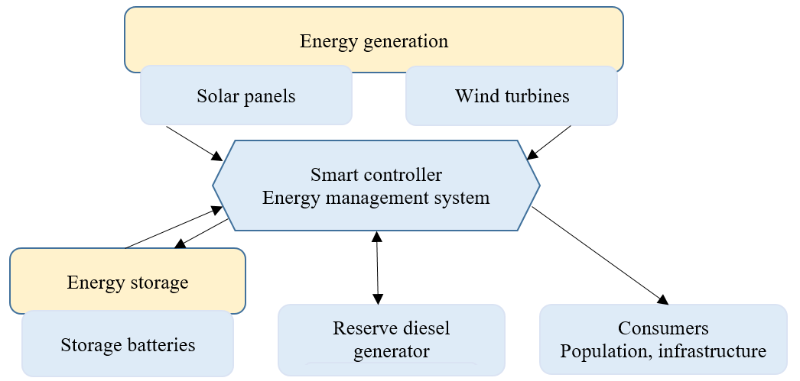
FIGURE 1. Conceptual diagram of a hybrid energy system

Fig. 1 shows a conceptual diagram of a hybrid energy system for a remote settlement. The diagram shows the structure of an autonomous microgrid [17-19]. Solar panels and wind turbines are the main sources of generation. Excess energy is sent to a storage system with batteries. A smart controller (Energy Management System) manages energy flows: it directs it for consumption by the population, charges batteries, or, in critical cases, activates a backup diesel generator [20]. This diagram clearly demonstrates the principle of a hybrid system that solves the problem of renewable energy instability. Potential solutions for ensuring energy independence in remote areas in Azerbaijan based on renewable energy [13-16]:
• Solar energy: High insolation over most of Azerbaijan makes it the primary resource for autonomous settlements;
• Wind energy: Coastal and mountainous regions have good wind potential, allowing for the use of hybrid solutions;
• Small hydropower plants and biomass: Promising in mountainous and agricultural areas;
• Storage systems: Development of battery technologies (lithium-ion batteries, renewable energy sources + hydrogen) ensures a stable energy supply;
• Hybrid models: A combination of solar panels, wind turbines, and batteries reduces vulnerability to seasonal and weather fluctuations.
Examples of successful implementation of renewable energy systems in Azerbaijan demonstrate the real possibility of achieving autonomous energy supply for remote settlements. Table 2 shows three of the most significant projects in Azerbaijan: Pirallahi Island, the Nakhchivan Autonomous Republic (an isolated region), and the highland village of Gobu. These projects confirm that even with infrastructural and institutional constraints, effective green solutions can be created, so Azerbaijan's experience can be scaled up to other regions of the Caucasus and Central Asia.

Table 2. The most significant green energy cases in Azerbaijan
Project Location | Technology | Energy Independence Impact
Pirallahi Island | Hybrid power plant: solar panels (300 kW) + wind turbines (200 kW) | Reducing dependence on the centralized grid, increasing supply reliability for a remote island
Nakhchivan Autonomous Republic | Solar power plants "Nakhchivan-1" (5 MW) and "Shahbuz" (20 MW) | This is a demonstration project designed to test technologies and provide energy to the island's local infrastructure.
Gobu highland village, Karadag District | Large solar power plant with a capacity of 230 MW | Providing electricity to an autonomous region with limited access to hydrocarbons; increasing the share of green energy
DISCUSSION
A comparison of global and Azerbaijani experience in ensuring energy independence in remote communities reveals the following general principles: efficiency is achieved through a combination of multiple energy sources; for remote communities, it is important to focus not only on large power plants but also on small, decentralized installations; and the issue of energy storage and accumulation remains key to the long-term sustainability of projects. Azerbaijan demonstrates that government support and the attraction of foreign investors (Masdar, ACWA Power, Nobel Energy) are accelerating the transition to green energy.
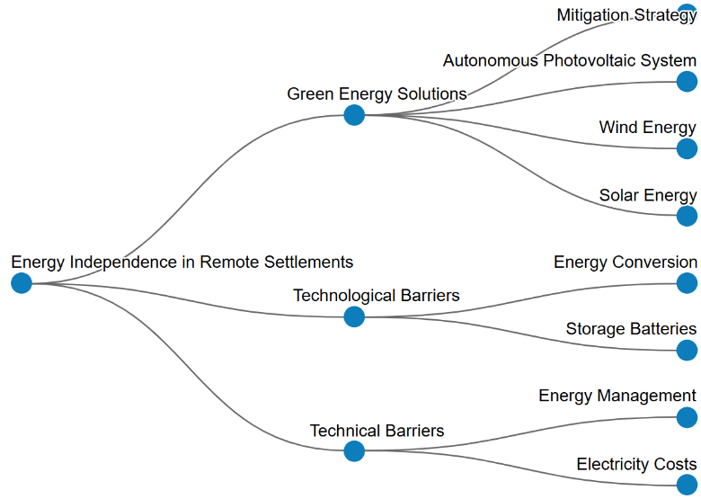
FIGURE 2. Conceptual map of the problem under study

According to Fig. 2, solutions based on solar, wind, and stand-alone photovoltaic systems are key strategies for achieving energy independence in remote regions. In the context of Azerbaijan, the high solar insolation potential and wind resources of the Caspian coast and mountainous regions allow these sources to be considered not simply as a supplement, but as a mitigation strategy for reducing dependence on traditional fuels. Hybrid systems, as demonstrated by the Pirallahi Island example, integrate these sources, providing a more stable and reliable power supply. The scalability of modular systems allows them to be used in both small communities (standalone photovoltaic plants) and larger ones (the Gobu project). Energy conversion and battery storage remain key technological hurdles. The intermittent nature of renewable energy generation (wind and solar) requires reliable storage systems. The development of lithium-ion, sodium-ion, and advanced hydrogen technologies (mentioned in Table 1) is critical to ensuring 24/7 power supply. Without efficient battery storage, hybrid systems will be forced to rely on backup diesel generators, which reduces environmental and economic benefits. At the operational level, technical hurdles include energy management and electricity costs:
- Energy management: renewable energy microgrids require intelligent systems capable of forecasting generation and consumption, balancing loads, and optimizing storage system operation. This is directly related to point 5 in Table 1—the need for automated control systems and remote monitoring due to a shortage of on-site specialists.
-Electricity Cost: although capital costs for renewable energy sources are declining, initial electricity costs can be high due to investments in battery storage and complex management. Long-term project sustainability (the economic sustainability of long-term operation, as mentioned in the Introduction) requires reducing initial costs through government subsidies, preferential lending, and technology scaling [9].
CONCLUSION
The problem of energy independence in remote communities remains a pressing one for many countries, and the transition to GE is becoming a strategic decision at the national level. This study goes beyond theoretical analysis and draws on specific examples from Azerbaijan—projects on Pirallahi Island, in the Nakhchivan Autonomous Republic, and in the village of Gobu—to demonstrate the practical feasibility of the proposed solutions. The country's experience demonstrates that energy independence for remote communities is achievable with the systematic implementation of RE: even in challenging geographic and climatic conditions, solar and wind projects can be successfully integrated. Hybrid energy systems and modern battery technologies represent the most promising areas for further development.
The study examines hybrid energy systems as a comprehensive solution combining generation, storage, and intelligent energy management. In the long term, this will reduce environmental impacts, increase energy security, and improve the quality of life. The analysis showed that autonomy based on renewable energy is a strategically achievable goal, despite existing obstacles:
1. Key barriers include the instability of renewable energy generation, the high cost of storage systems, the capital intensity of small-scale projects, operational complexity, and a shortage of qualified specialists.
2. Potential solutions include the efficiency of hybrid systems (solar and wind generation combined with small hydropower or bioenergy), supplemented by modern storage (Li-ion, Na-ion) and intelligent control systems (Smart Grids). These technologies act as a mitigation strategy, reducing dependence on centralized grids.
The experience of Azerbaijan demonstrates the high potential of renewable energy in the national context and confirms the feasibility of creating autonomous microgrids for isolated regions. The scientific novelty of this work lies in its comprehensive analysis of the technical and technological aspects of using renewable energy for remote settlements, with an emphasis on the modularity and adaptability of solutions to diverse climatic conditions. The practical significance is expressed in the recommendations:
• Prioritize hybridization and storage—the need for government incentives for investment in storage systems, which are critical for overcoming generation instability;
• Digitalization and training—implement remote monitoring and develop educational programs to train specialists on-site.
In the long term, the systematic implementation of renewable energy will not only reduce environmental impacts and improve energy security in remote areas, but will also become an important factor in socioeconomic development, contributing to improved quality of life in the most vulnerable regions of Azerbaijan. The study is unique in its detailed examination of national experience and its achievements, which can be scaled up to the Caucasus and Central Asia [21,22].
REFERENCES
1. N.Mammadov, S.Akbarova. Multi-disciplinary energy auditing of educational buildings in Azerbaijan: case study at a university campus, in Proceedings of the IFAC-Papers on-line, 51 (30), pp. 311-315, (2018), https://doi.org/ 10.1016/j.ifacol.2018.11.308
2. N.Mammadov, S.Akbarova, V.Rustamov. Evaluation of thermal energy production by solar panels for Karabakh "green" energy zone, Reliability: theory applications, 4 (70), pp. 200-206, (2022),
https://doi.org/10.24412/1932-2321-2022-470-200-206
3. W.Li, M.Han. J.M. Mapping renewable energy transition worldwide: gravity trajectory, contribution decomposition and income levels, Renewable energy, 206, pp. 1265-1274, (2023) https://doi.org/10.1016/j.renene.2023.02.119
4. N.Mammadov, S.Akbarova. Research areas on transition to renewable energy sources in bibliographic publications. BIO Web of Conferences, 151, 02007, (2025), https://doi.org/10.1051/bioconf/202515102007
5. D.Koncalovic, J.Nikolic, D.Aivkovic. Energy cooperatives and just transition in South e astern Europe, Energy, sustainable society, 13(1), (2023), http://doi.org/ 10.1186/s13705-023-00400-9
6. K.Dong, J.Zhao, F.Taghizadeh-Hesary. Toward China's green growth through boosting energy transition: the role of energy efficiency, Open J. Energy Efficiency, 16, 43, (2023), https://doi.org/10.1007/s12053-023-10123-7
7. K.Dong, S.Zeng, J.Wang, F.Taghizadeh-Hesary. How Justice Is Our Energy Future? Assessing the Impact of Green Finance on Energy Justice in China, Energy Exploration & Exploitation, 0(0), (2023), https://doi.org/10.1142/S2010495223500100
8. K.Abbasi, M.Shahbaz, J.Zhang, M.Irfan, R.Alvarado. Analyse the environmental sustainability factors of China: The role of fossil fuel energy and renewable energy, Renewable energy, 187, (2022), https://doi.org/10.1016/j.renene.2022.01.066
9. E.Dogan, M.Chishti, N.Alavijeh, P.Tzeremes. The roles of technology and Kyoto Protocol in energy transition towards COP26 targets: evidence from the novel GMM-PVAR approach for G-7 countries, Technol. Forecast. Soc. Change. 181, (2022)
10. T.
11. E.Dutta, T.Bouri, T.Rothovius, G.Uddin. Climate risk and green investments: new evidence, Energy, 265, (2023), https://doi.org/10.1016/j.energy.2022.126376
12. R.Jimenez, J.Cuadrado, R.Chandro. Foundations of onshore Wind turbines: current situation and trends, Construction reports, 76 (573), 6443, (2024), https://doi.org/10.3989/ic.6443
13. X.Ren, J.Li, F.He, B.Lucey. Impact of climate policy uncertainty on traditional energy and green markets: evidence from time-varying granger tests, Renewable and sustainable energy reviews, 173, pp. 114-220, (2024), https://doi.org/10.1016/j.rser.2022.113058
14. S.Akbarova, A.Zyhun. Design features of polypropylene heating mats and prospects their applying, In Proceedings of the 4th International Conference on Building Innovations, ICBI, 299, pp. 3-12, (2023)
15. Y.Avramenko, O.Yurin, S.Akbarova, A.Zyhun, I.Zadorozhnikova. Investigation of the moisture condition of the outer wall at the junction of the brick pilasters to the wall, In Proceedings of the 3rd International Conference on Building Innovations: ICBI, pp. 13-23, (2022)
16. G. Mammadova, S. Akbarova, Building certification methods applied in Azerbaijan, Urbanism Architecture Constructions, 15(3), (2024)
17. S.Akbarova, Y.Avramenko. Thermo-technical Issues of Ventilated Facades in Azerbaijan. In Proceedings of the 3rd International Conference on Building Innovations, pp. 35-42, (2022)
18. A.Mehmet, A.Samuel. Investigation of environmental Kuznets curve for ecological footprint: the role of energy and financial development, Science of the total environment, 650 (2), pp. 2483-2489, (2019), https://doi.org/10.1016/j.scitotenv.2018.10.017
19. N.Mammadov, S.Akbarova. New Methodology of Multi-Disciplinary Energy Auditing of Buildings in Azerbaijan in Proceedings of the International Symposium on Innovative Technologies in Engineering and Science, pp. 210-219, (2017)
20. S. Akbarova, Functional features of panel heating and priorities of its use, International Journal on Technical and Physical Problems of Engineering, 14(3), pp. 61–65, (2022)
21. L.Xiao, L.Pan, F.Maoyuan, M.Sarah, C.Lei, M.Bo, C.Jie, X.Kang, L.Weibo. Energy transition paradox: solar and wind growth can hinder decarbonization, Renewable and sustainable energy reviews, 192, pp.114-220, (2024), https://doi.org/10.1016/j.rser.2023.114220
22. G. Mammadova, S. Akbarova, Innovative construction technologies for smart villages: case study Karabakh, In book: Information Technologies and Their Applications (pp.18-31), (2024), http://doi.org10.1007/978-3-031-73420-5_2

