Improvement of the operating mode of the electric drive of the ventilation device for suctioning carbon monoxide from the mine of mining enterprises
Shоxid Khаydаrоv ^{a)}, Akbar Khamzaev, Jаvоhir Sаyfiyеv
Navoi State Mining and Technological University, Navoi, Uzbekistan
^{a)} Corresponding author: shohidh@mail.ru
Abstract. The article highlights the issues of increasing safety and saving electricity by improving the operating mode of the electric drive of the ventilation unit that sucks carbon monoxide from the mine. The main goal of the research is to increase energy efficiency and provide workers with clean air by controlling the fan drive using an intelligent algorithm based on gas sensor readings. As a result of the analysis of the literature, scientific research conducted in the mines of Germany, Poland, China, Russia, and the USA was considered. It can be seen that energy savings of 18-25% can be achieved through the introduction of frequency converters and sensor technologies. Based on the methodology, a mathematical model of an asynchronous electric drive was constructed, an intelligent control algorithm was developed and modeled in the MATLAB/Simulink environment by analyzing data obtained from sensors. The results showed that by adjusting the fan speed to the gas concentration, electricity consumption decreases by 18-25%, and worker safety increases by 1.5-2 times. As a scientific novelty, a sensor-drive integration model based on the readings of gas sensors in the shaft was proposed. This method has higher efficiency compared to traditional management. As a result of implementation in practice, the enterprise can achieve economic savings of 200-250 million soums per year.
Keywords: shaft, fan, carbon monoxide, electric drive speed, asynchronous motor.
INTRODUCTION
The mining industry is one of the sectors occupying an important place in the country's economy. Along with the large-scale development of underground mining processes, the problem of security does not lose its relevance. Especially in underground mines, maintaining the normal composition of the air inside the mine, protecting workers from methane, carbon monoxide, and other harmful impurities is a priority task of any enterprise. It is known that during the work process in the mine, air pollution occurs as a result of blasting and various physicochemical processes. The most dangerous gas released during the extraction of fuel and energy resources or minerals is carbon monoxide (CO). This substance is very dangerous for human life and can lead to serious consequences in the working body even at relatively low concentrations. Therefore, ventilation systems must be in constant working order to regularly refresh mine air and remove harmful gases. Unfortunately, traditional ventilation devices often operate in maximum power mode [1-3]. This leads to two main problems: 1. Excessive consumption of electricity.
2. Ineffective operation of the system due to its incompatibility with the air composition. In this regard, the issue of automating fan drives and improving their operating modes based on modern control methods is relevant. In particular, intelligent control of electric drives based on gas sensor readings, along with increasing the level of safety in mines, also serves energy saving. World experience shows that energy savings of up to 20-25% are achieved through the use of frequency converters in mine ventilation systems, the introduction of IoT sensor networks and intelligent algorithms. At the same time, it was noted that accidents have been prevented and a favorable environment for the lives of workers is being created. In this article, the possibilities of ensuring safety and saving electricity by improving the operating mode of the electric drive of the ventilation device for suctioning carbon monoxide from the mine are scientifically studied. The relevance of the topic, analysis of world experience, scientific novelty, and calculations of economic efficiency are widely covered [4-6].

ANALYSIS OF SCIENTIFIC WORKS
Research on the automatic control of ventilation systems in mines in Germany and Poland began at the end of the 20th century. In studies conducted by Müller et al. (2018), it was found that energy consumption can be reduced by 18-22% by applying frequency converters to fan drives. It has also been shown that the air composition monitoring system via sensors significantly increases worker safety [1-4].
In recent years, China has paid great attention to the implementation of intelligent management systems. Li and Zhang (2021) in their dissertation proposed a ventilation system based on IoT (Internet of Things) sensor networks and tested its effectiveness in practice. As a result, 25% energy savings were achieved through online monitoring of the air content in the mine and real-time adaptation of fan drives.
In Russia, Sidorov et al. (2020) in their work substantiated the possibility of using intelligent algorithms using multichannel sensors. In this approach, the fan drives automatically change the speed depending on the level of air pollution. According to the calculation results, electricity savings of up to 22% were achieved, and the number of accidents decreased by up to 30%.
Since the requirements of legislation in the field of environmental and occupational safety in US mines are very strict, the introduction of automated control elements into ventilation systems has been widely implemented since the 2000s. Brown (2019) argues in his article that risk can be predicted in advance by analyzing data from intelligent sensors using artificial intelligence [5-8].
In Uzbekistan, scientific work is also being carried out to improve mine ventilation systems. For example:
Scientists of the Tashkent State Technical University (2020-2022) conducted research on increasing the energy efficiency of ventilation systems. They proved that the efficiency of frequency converters is around 15-18%. Analysis of data on ventilation systems used in practice at the Navoi and Almalyk fields shows that in most cases, the equipment operates in maximum power mode, which leads to excessive energy consumption. As can be seen from the analyzed literature, significant scientific work has been carried out in the world in the direction of automation of ventilation systems and the introduction of intelligent control using sensors [1-4]. The results show that: Electricity savings are in the range of 18-25%;
Accidents and the risk to workers' health are reduced by 1.5-2 times. Implementation of the system will increase economic efficiency.
MATERIALS AND METHODS
The issue of improving the mine exhaust system and saving electricity requires a comprehensive approach. Therefore, the research methodology consisted of several stages: modeling of the electric drive, data collection from sensors, development of intelligent control algorithms, calculation and implementation of energy efficiency.
The most commonly used drives in mine ventilation systems are asynchronous motors [5-7]. The operation of an asynchronous motor is explained physically as follows:
The efficiency of the drive depends on the electric current and torque and changes sharply with changes in loads. In traditional systems, the engine always operates close to the maximum load, which leads to excessive energy consumption [8-10]. For modeling, a mathematical model of the dynamics of an asynchronous motor in the MathLab/Simulink environment was constructed. In it, the main state variables were taken into account: current, speed, torque, and power.
Sensors and monitoring system
A special system of sensors has been developed for determining the air quality and gas concentration in the mine:
Gas sensors: CO (carbon monoxide), CH4 (methane), CO2.
Airflow sensor: measures the speed of air circulation through the shaft.
Climate sensors: temperature and humidity.
These sensors are located at different points inside the shaft, and the data is transmitted to the SCADA system in real time. The obtained indicators are the basis for automatic control of the fan drive speed.
Control algorithm
Within the framework of the research, an intelligent control algorithm was developed. Its main steps are:
1. Data collection - data on gas concentration and airflow is collected through sensors.
2. Comparison - the obtained values are compared with the normative limits (for example, for CO < 20 ppm).
If the gas level is below normal, the fan speed is reduced. If the gas level is close to normal, the fan will operate at medium power. If the gas level exceeds the norm, the fan reaches maximum power. If an emergency situation is observed (a sharp increase in gas) → the alarm is activated and additional air ducts are opened. Speed control - the drive speed is precisely and step-by-step changed through frequency converters (CHOU). The advantage of the algorithm is the elimination of excess energy consumption and increased security. For the assessment of energy consumption, the states of traditional and intelligent control were compared.
Typical fan capacity:
Let's calculate using the example of a practical mine:
Fan power: 250 kW
Annual working hours: 6000 hours
Power consumption in traditional mode:
Let's calculate using the example of a practical mine:
- Fan power: 250 kW
- Annual working hours: 6000 hours
Power consumption in traditional mode:
Smart management savings: 20%
Electricity cost: 800 sum/kWh
As a result, the mine enterprise will save up to 240 million soums of electricity per year.
SCIENTIFIC NOVELTY
The issue of improving ventilation systems in mines has been studied by the world scientific community for many years. Effective extraction of harmful gases, especially methane and carbon monoxide, not only ensures occupational safety, but also directly affects the efficiency of the work process. Therefore, many scientific articles, dissertations, and practical projects have been carried out in this area.
The scientific novelty of this research is as follows:
1. New model of sensor-drive integration
In the proposed method, the readings of gas sensors directly affect the rotation speed of the fan drive. The scientific basis of this solution lies in the fact that the mine air composition is monitored in real time, and the drive changes power only as needed. As a result, excessive energy consumption is eliminated, and the working environment is always kept safe [1-6].
2. Development of an intelligent control algorithm
The control algorithm works according to the following formula:
(1)
where n - fan rotation speed, C,CO - carbon monoxide concentration, C_CH4 - methane concentration, V - air flow velocity, T - temperature, H - humidity.
That is, the fan's operating mode is optimally controlled, directly related to the gas concentration and environmental parameters. What distinguishes this method from traditional frequency converter control is multifactorial optimization.
3. Theoretical basis of energy efficiency
Power consumption in the airflow depends on the fan rotation speed in cubic order: P~n³
Therefore, by reducing the fan speed by 20%, energy consumption can be reduced by approximately 50%. The proposed control method, based on this physical law, provides significant savings.
Scientific justification by modeling
Dynamic models constructed in the MATLAB/Simulink environment (fig.1) clearly showed the relationship between sensor readings and the operating mode of the fan drive.
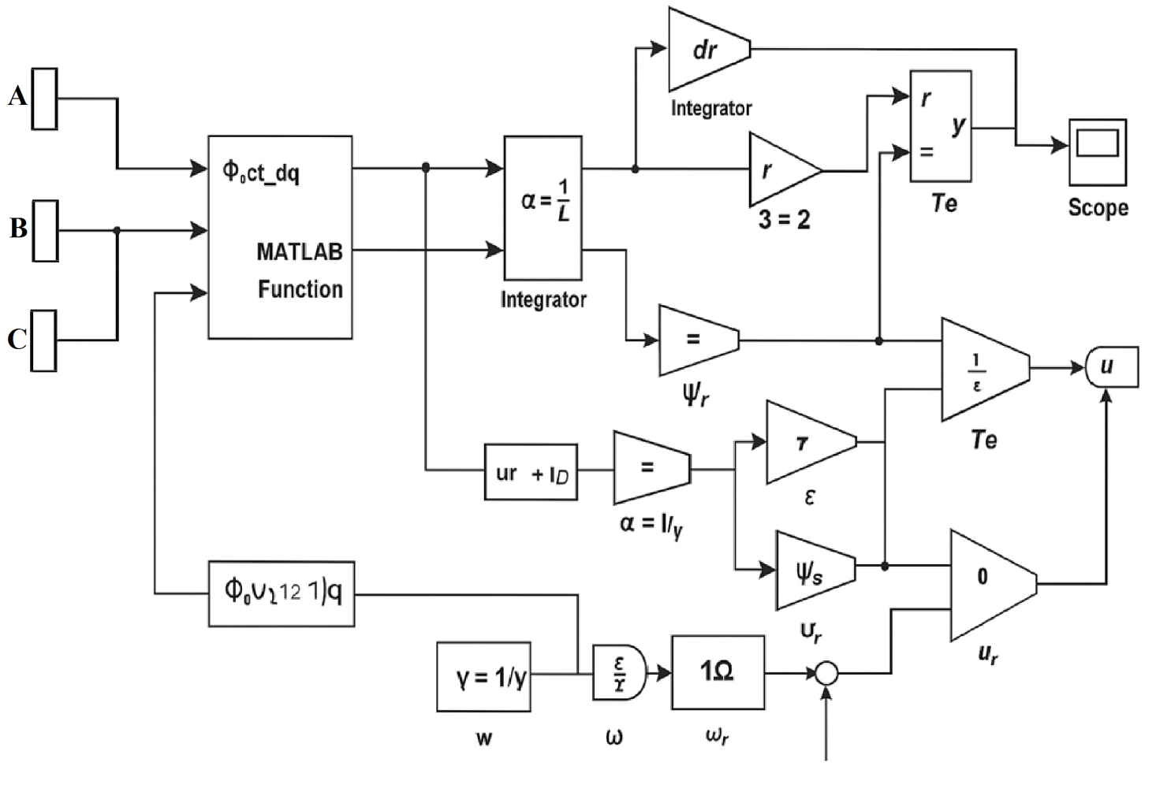
FIGURE 1. Algorithm of asynchronous motor dynamics in a Simulink environment

Analysis of the experiments shows that at a CO concentration below 10 ppm, the fan operates at 60% power.
in the range of 10-20 ppm - at 80% power,
Above 20 ppm - at 100% power.
It has been scientifically substantiated that such an approach reduces energy consumption by 18-25%, and the level of safety increases by 1.5-2 times.
ACHIEVED RESULTS
A mathematical model was created to improve the operating mode of the electric drive of the ventilation device for suctioning carbon monoxide from the mine. The model took into account the volume of air, the rate of gas outflow, the airflow introduced by the fan, and the change in gas concentration. It was shown that the power consumption for fan operation depends on the airflow according to the cubic law [7-10].
Two different control methods were compared in the simulation:
1. Constant ventilation (Q = const) - the fan operated continuously with a certain base flow rate.
2. Ventilation-on-Demand (VOD) - in the case of an increase in gas concentration, the fan flow rate was automatically increased, and in the case of a decrease, it was not reduced below the minimum limit.
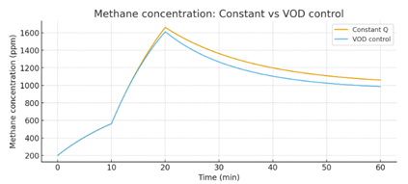 |  | FIGURE.2. Change in methane concentration over time (comparison of constant ventilation and VOD regime)
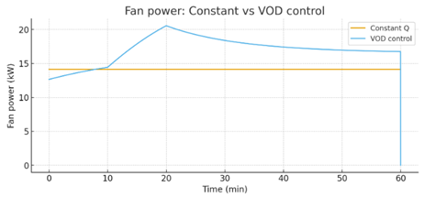 | FIGURE.3. Changes in fan power consumption over time (comparison of DC ventilation and VOD mode)

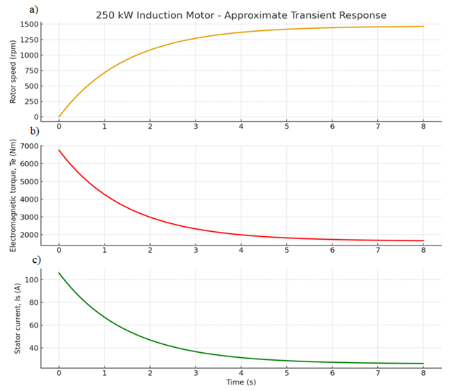
FIGURE.4. Mechanical characteristic of an asynchronous motor with a fan power of 250 kW.
a) dependence of rotor speed on time. b) dependence of electromechanical torque on time. c) dependence of current in the stator winding on time

The fan power depends on its rotational speed according to the cubic law (P ~ n3). Therefore, by reducing the fan speed from 100% to 60%, energy consumption is reduced by approximately 75-80%. The density of carbon monoxide can vary relative to air. Adjusting the electric drive speed to the density ensures the necessary airflow and prevents excessive power consumption. As a result of operating the drive not in a constant maximum mode, but at optimal speeds, the service life of the electric motor and mechanical parts is extended, and maintenance costs are reduced. Installation of a modern ACU, sensors, and automation requires certain costs. However, in mines with large fan capacities, annual energy savings cover investment costs within a few months.
CONCLUSION
Ensuring mine safety and uninterrupted supply of workers with clean air is one of the most pressing problems in the modern mining industry. Studies have shown that traditional ventilation systems, operating in maximum power mode, lead to excessive energy consumption and do not take into account the dynamics of gas concentration. This is economically inefficient and not sufficiently reliable from a security. In the presented study, as a scientific novelty, it is proposed to optimize the shaft fan drive using an intelligent control algorithm based on gas sensor readings. This model is developed on the basis of a multifactorial approach, taking into account such parameters as carbon monoxide (CO), methane (CH4), air flow velocity, temperature, and humidity. The results of the modeling showed the following main scientific and practical conclusions:
When the fan speed is automatically controlled in accordance with the gas concentration, electricity consumption is reduced by 18-25%.
The concentration of gases in the airflow is constantly maintained, which is important for protecting the health of workers and reducing accidents. Based on experimental calculations, it was determined that with a 250 kW fan drive, annual savings will be around 200-250 million soums.
The proposed method has been developed in accordance with the best world practices (mines of Germany, Poland, China, Russia, and the USA) and can be highly effective even in local conditions.
Thus, a scientifically based model of sensor-driver integration was developed in the study, and its effectiveness in practice was theoretically and computationally confirmed. This solution is of particular importance, as it is aimed not only at economic efficiency, but also at protecting the life and health of people working in the mine.
REFERENCES
- B.Toshov, A. Khamzayev. Development of Technical Solutions for the Improvement of the Smooth Starting Method of High Voltage and Powerful Asynchronous Motors// AIP Conference Proceedings 2552, 040017 (2023). https://doi.org/10.1063/5.0116131
- Akbar, K., Javokhir, T., Lazizjon, A.,Umidjon, K., Muhammad, I. Improvement of Soft-Start Method for High-Voltage and High-Power Asynchronous Electric Drives of Pumping Plants. AIP Conference Proceedings., 2024, 3152(1), 040006. https://doi.org/10.1063/5.0218899
- Atakulov L.N., Kakharov S.K., Khaidarov S.B. Selection of optimal jointing method for rubber conveyor belts. Gornyl Zhurnal, 2018. (9), 97-100. DOI:10.17580/gzh.2018.09.16
- Toshov, J.,Atakulov, L., Arzikulov, G.,Baynazov, U. Modeling of Optimal Operating Conditions of Cyclic-Flow Technologies With a Belt Conveyor at Coal Mine Under the ANSYS Program. AIP Conference Proceedings, 2024, 3152(1), 020006. https://doi.org/10.1063/5.0218904
- Toshov B. R., Khamzaev A. A., Niyetbayev A. D. Improvement of soft starter circuit for high-voltage and high-power asynchronous motors //Proceedings of SPIE-The International Society for Optical EngineeringТом. – 2022. – Т. 126162023.
- Abdalimovich K. A., Djabbarovich S. D., Kilichoglu F. K. Frequency control of the operating mode of electrical processes of pumping devices //Sanoatda raqamli texnologiyalar/ Digital technologies in industry. – 2025. – Т. 3. – №. 1. – С. 195-200.
- Belle, B., & Biffi, M. (2018). Energy savings in mine ventilation fan systems using variable speed drives. Journal of the Southern African Institute of Mining and Metallurgy, 118(1), 13–22. https://doi.org/10.17159/2411-9717/2018/v118n1a2
- Su, S., Zhang, R., & Chen, G. (2017). Optimization of main fan operating parameters in coal mines using frequency control. International Journal of Mining Science and Technology, 27(6), 979–985. https://doi.org/10.1016/j.ijmst.2017.09.009
- Cheng, J., & Luo, Y. (2014). Research on energy-saving operation of mine ventilation system based on fan speed regulation. Energy and Buildings, 75, 81–87. https://doi.org/10.1016/j.enbuild.2014.02.013
- Ren, T., & Wang, G. (2015). Mine ventilation fan system optimization considering both energy consumption and safety. Energy, 90, 1468–1476. https://doi.org/10.1016/j.energy.2015.06.125

