Analysis of designs and conditions of application of carbide drills for extreme operating conditions
Muhammadi Turonov ^{a)}, Talibjan Umarov, Andrey Jeltukhin
Tashkent State Technical University, Toshkent, Uzbekistan
^{a)} Corresponding author: turonovmuhammadi3@gmail.com
Abstract. In the famous article, the designs of high-performance drilling tools are developed for the conditions of the ministry of emergency Situations, a modernized portable drilling rig based on the RSM-1M rail drilling machine. Special attention is given to the analysis of the wear resistance of swell drills made of high-speed steel P6M5 (GOST 25524-82) and special feather carbide drills VK8 when drilling alloy steels and alloys for the conditions of the Ministry of Emergency Situations, Republic of Uzbekistan.
INTRODUCTION
The share of drilling operations in the total volume of mechanical processing reaches 30...40%. Therefore, the successful implementation of repair and rescue operations in emergency situations largely depends on the reliable execution of a number of drilling operations, which are mainly determined by the operational reliability of the axial tool used [1].
Carrying out drilling operations during processing of metal and concrete structures, in conditions close to field conditions, is characterized by the use of technological equipment with reduced rigidity, since in such conditions there is no possibility of using a stable stationary technological system [2-4]. Under such operating conditions, standard drills do not have a stable position that ensures a continuous cutting process, and the cutting edges of the tools chip long before the planned service life. It is important to take into account that concrete structures reinforced with metal belong to the class of difficult-to-process materials.
A summary of many years of experience in the operation of axial tools in extreme conditions shows that the greatest difficulties are associated with the processing of holes with a diameter of 20... 35 mm. Holes with a diameter of 20-35 mm are most widely used in machines and mechanisms of land vehicles, as well as in railway transport and in the connection of railway rails [5-7]. Therefore, this range of holes is the most common and usually requires the use of fairly expensive carbide tools and special equipment. When processing holes in this range, the cutting power, depending on the material being processed, reaches 1.5... 2.0 kW, and the specific cutting work is 15... 25 J/mm³. In stationary processing conditions, this requires fairly powerful and heavy equipment, which is unacceptable when working in emergency situations. In such conditions, portable equipment based on the RSM-1M model machines is usually used. However, this type of equipment has low technological rigidity [8]. For this reason, vibrations and transverse oscillations of the tool occur during drilling, and the processed holes have a pronounced facet and diameter difference. Therefore, the technological range of drilling tools is significantly limited by the economic feasibility of using the selected or developed drill design [9-11].
The analysis of cutting patterns that meet field operating conditions must be carried out under the following restrictions:
1.Performing a drilling operation with a reliability of no less than P = 0.95.
2.Technological adjustment should be carried out at low rigidity of the technological equipment.
3.The cutting part of the tool must ensure productive processing modes.
4.Operation of the tool without coolants.

METHODS
Within the above-mentioned limitations, first of all, the material of the cutting part of the drilling tool should be determined, provided that the design of the drill should have an increased degree of reliability. Experience in operating the tool in factory conditions shows that tool materials such as super hard (diamond, elbor, corundum), ceramic alloys - cermets find limited application in blade processing due to the strength properties of the materials being processed. Table 1 shows the physical and mechanical properties of some tool materials. Figure 1 shows the classification of tool materials according to their strength and hardness.

TABLE 1. Shows the physical and mechanical properties of some tool materials
Properties of materials | High speed steels | Hard alloys | Mineral ceramics | Salinity | Cubic boron nitride | Diamonds
Density g/sm³ | 8-9 | 8-15 | 3,6-4,0 | 3,4-3,8 | 3,5 | 3,5
Hardness H | 700-800 | 850-1400 | 1400-2000 | 900-3000 | 8000-9000 | 9000-10000
Compressive strength N/mm² | 2500-4000 | 3500-5900 | 1300-3000 | 3000 | 1500-2000 | 2000-6000
Bending strength N/mm² | 2000-6000 | 1000-3400 | 250-600 | 300-700 | 300 | 300-400
Heat resistance, deg. | 600-700 | 800-1000 | 1200 | - | 1400-1500 | 700-900
Coefficient of linear expansion, deg.⁻¹x10⁻⁶ | 9-12 | 3-7,5 | 2,5-9,0 | 2,75-3,0 | - | 1,5-1,9
Young's modulus N/mm² | 25-30 | 47-65 | 30-45 | - | - | 90-100

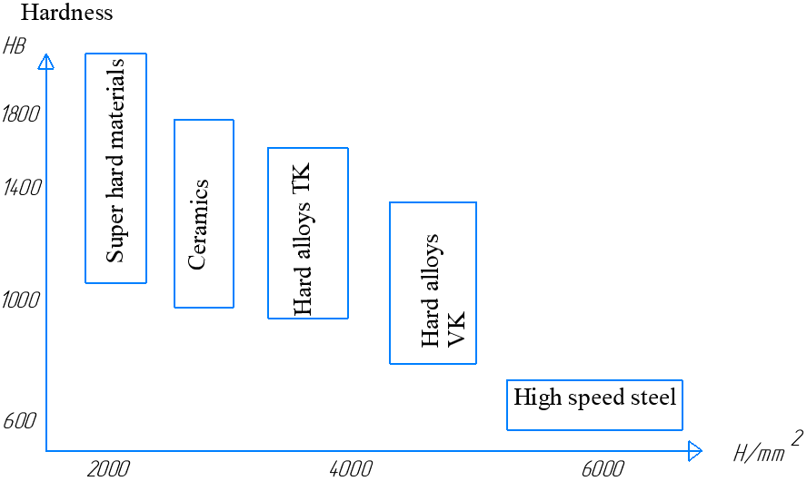
FIGURE 1. Classification of tool materials by their strength and hardness

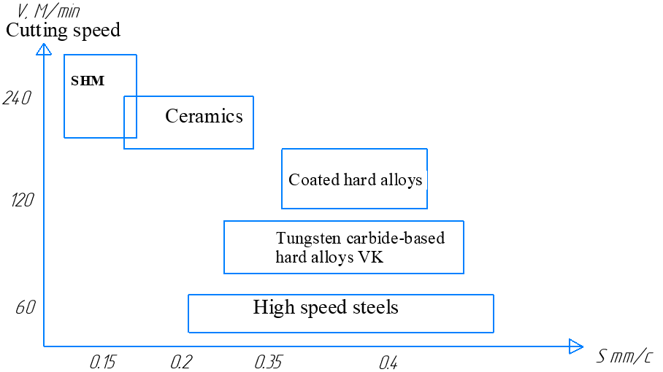
FIGURE 2. Comparative cutting modes for different tool materials

Figure 2 shows the areas of optimal cutting conditions for different groups of materials. Analysis of the physical and mechanical properties of the presented cutting materials shows that their applicability depends on the processing conditions and, in a number of cases, ensuring reliable technology lies beyond the characteristics of high-performance tools made from super hard materials. Within the framework of the limitations adopted in the work, the most suitable drills for the conditions of the Ministry of Emergency Situations are those made of hard alloys based on tungsten carbide. These are alloys of the VK6, VK8, VK8M (GOST 25524-82) series. With a sufficiently high hardness, they have sufficient strength to ensure productive modes of processing such materials as concrete, steel and rocks.
Effective technologies for processing holes in difficult-to-machine materials are based on the use of tools ranging from twist drills to BTA drills.
If we differentiate drills by the way they are directed in the hole being processed and the geometry of their cutting edges, they can be divided into two groups:
1.Deep-hole drills, which include single-ended gun-type drills, ejector drills, T-MAX and BTA type drills.
2.Drills for shallow holes (up to 3...4 diameters), which include twist drills, spade drills and drills with multi-faceted non-sharpen able inserts (multi-edged non-sharpening plate).
Given the accepted limitations of the technological operation of drilling holes in the range of 20...35 mm, the most reliable and productive are two drill designs. These are feather drills and drills with multi-edged non-sharpening plate. The type of drill is selected in direct operating conditions in relation to the material being processed and the length of the hole being processed.
RESULTS AND DISCUSSIONS
Analysis of cutting patterns and dynamic stability of spade drills. Theoretical studies of the stability of feather drills are based on the theory of stability of straight, cantilever-mounted round rods.
When rotating drills are in operation, they are loaded not only with a concentrated compressive force P, but also with a concentrated torque. The solution to the equation of equilibrium or motion can be obtained only when the external load is known. Therefore, let us consider the change in external load during loss of stability.
Fig. 1.3 schematically shows the loss of static stability of the technological system. When static stability is lost or there are small bending vibrations of the rod, the axial force maintains its direction, and the torque does not change in relation to the drill band. Thus, it can be assumed that the concentrated compressive cutting force P is constant, and the drill is affected by an additional part of the cutting moment, determined by the magnitude of the deviation of the drill axis.
This drilling model requires consideration of the dynamic stability of feather drills with guide elements. Therefore, in order to select the hole drilling schemes, we analyzed the schemes of loss of static and dynamic stability, and also calculated the critical force depending on the technological and geometric parameters of the drilling process.
The value of torques reduces the critical value of axial force comparatively little. Therefore, in calculations, a rod compressed by the main forces P applied to its end sections is considered.
Let us determine the critical force that determines the loss of drill stability. The calculation will consider the drilling process with drills with guide elements and without guide elements.
Due to some uncertainty in the conditions of fastening the spindle unit, it is advisable to consider the following calculation schemes shown in figure 4.
The static method of studying stability consists of finding those values of the compressive force at which the rod begins to bend.
When considering rigidity from the standpoint of loss of stability, we will use the method of comparing the coefficients of reduction of length “µ” known in the literature.
Flexibility of the rod under compressive force:
according to the table µ_{a} =1, µ_{b} =0,7, µ_{c} =0,7,
That's why
(1)
That is, the flexibility in the case without guides (Figure 4) is 1.4 times greater than with guides, i.e. the rigidity of the system with guides is 1.4 times greater.

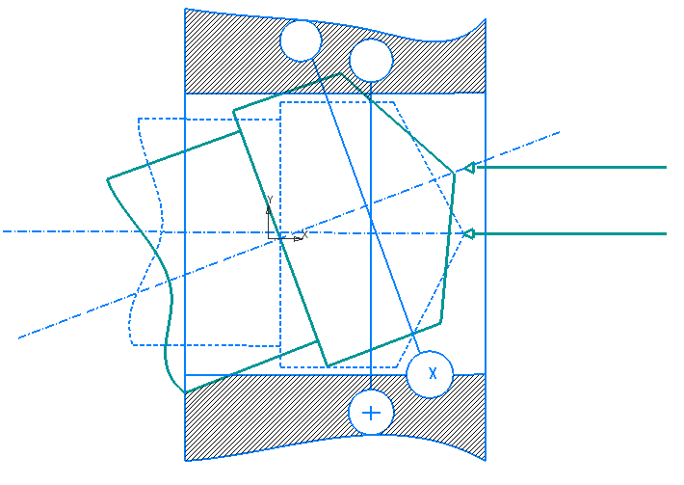
FIGURE 3. Diagram of loss of static stability of a drill.
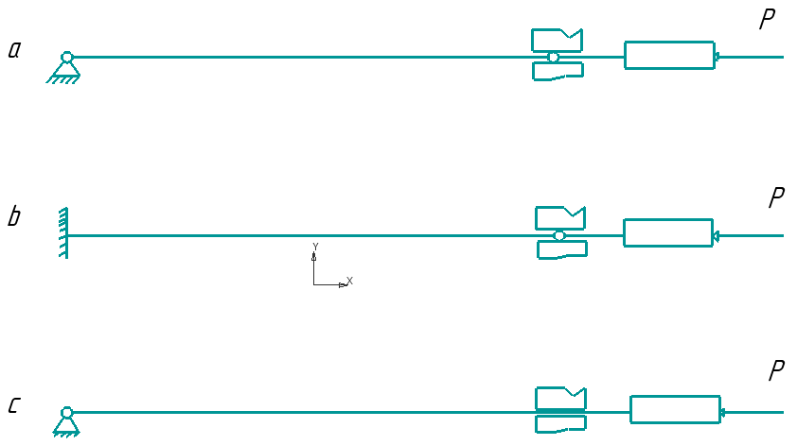
FIGURE 4. Calculation scheme of static stability of the drill.

a) One end is pivotally supported, the other is pivotally fixed;
b) One end is sealed, the other is pivotally fixed;
c) One end is pivotally supported, the other is placed in a fixed bushing.
Now we can proceed to the direct calculation of the critical force at which the loss of stability of elastic systems occurs. For the calculation we will use the well-known Euler formula:
$P_{kp}≐\frac{π^{2}EJ}{(μL)^{2}}$ (2)
where,
E - is the modulus of elasticity;
J - moment of inertia;
µ- length reduction coefficient;
L - rod length.
We find the critical force at which the drill body loses stability.
Since the ratio of the length of the chip groove to the total length of the tool extension is not large, we will not take it into account when calculating the polar moment of inertia.
Thus, for drills with a diameter of 32 mm

$J≐\frac{πd^{2}}{32}≐\frac{3.14·{d0,032}^{2}}{32}≐1.02·{10}^{-7}m^{4}$ (3)

$P_{kp}≐\frac{3.14·2.06·{10}^{11}·1.02·{10}^{-7}}{(1·0.2)^{2}}≐5.18·{10}^{7}H$ (4)

From the calculation of the critical force (4) it is clear that a force of 5,18*10⁷N is required to lose stability, since the maximum axial force during drilling, even with a drill with high wear, is of the order of 1.5*10⁴ N, so the drills considered in the work obviously have a margin of stability.
Therefore, the dynamic characteristics of the drilling machine allow us to estimate the loads acting in the drive system and select the design parameters of the machine and tool in order to minimize these loads within specified limits.
CONCLUSIONS
In conditions of low rigidity of the technological system, there is a significant loss of stability of the feather drills, which leads to a sharp decrease in their reliability. A new design of the feather drill has been developed at the Department of Mechanical Engineering Technology of TSTU (Author's Certificate No. 1832068). The design feature of the new feather drill is the presence of two supports located in the plane perpendicular to the cutting plane and removed from the cutting edges at some distance.
The above analysis of the dynamic stability of the new TSTU design spade drills allows us to draw the following conclusions:
1. With an increase in the tool rotation frequency, the value of the optimal drill gap must be increased
2. when processing stronger material, the value of the optimal gap must be reduced.
3. to optimize the gap between the additional support and machined surface of the hole, as well as to assess the rationality of the tool design, it is necessary to use calculation formulas (5)(varying the stability of the TSTU design spade drills with low rigidity of the process equipment.
(5)
REFERENCES
- T. Umarov, M. Z. Turonov, and Z. N. Muxiddinov, “Technological possibilities for increasing the reliability of drills with mechanical fastening of carbide plates,” in For Significant Contribution to the Development of Science: Commonwealth of Independent States (Astana, Kazakhstan).
- T. Umarov, M. Z. Turonov, and S. B. Normatov, “Ensuring efficiency in the use of carbide drills in machining machine parts,” Kompozitsionnye Materialy 2 (2023).
- S. Khasanov, U. Mardonov, and A. Ongboyev, “Influence of a magnetic field on HSS tool wear/life and the intensity of external machining environments in turning,” International Journal of Mechatronics and Applied Mechanics 16, 163–170 (2024). https://doi.org/10.17683/ijomam/issue16.19
- T. Umarov, M. Turonov, and Y. Meliboyev, “Influence of design and cutting conditions on the accuracy of the hole obtained by drills with multifaceted non-regrind-able inserts,” International Journal of Integrated Engineering 15(7), 157–165 (2023).
- U. Mardonov, O. Tuyboyov, K. Abdirakhmonov, and S. Tursunbaev, “Mathematical approach to the flank wear of high-speed steel turning tools in diverse external cutting environments,” International Journal of Mechatronics and Applied Mechanics 14, 19–26 (2023). https://doi.org/10.17683/ijomam/issue14.3
- S. Turonov, N. Turonov, U. Mardonov, B. Saydumarov, D. Kulmuradov, and M. Boltaeva, “Effects of germanium on hardness and microstructure of Al–Mg, Al–Cu, and Al–Mn system alloys,” International Journal of Mechatronics and Applied Mechanics 16, 179–184 (2024). https://doi.org/10.17683/ijomam/issue16.21
- J. Khamdamov, N. Kholikov, N. Saidov, B. Tursunov, D. Ergashev, K. Mamatov, A. Bakhromov, F. Abdullaeva, and A. Oripov, “Development of technology for obtaining thin-walled details from gray cast iron in sand–clay moulds,” International Journal of Mechatronics and Applied Mechanics 18, 199–209 (2024). https://doi.org/10.17683/ijomam/issue18.24
- M. Turonov, T. Umarov, S. Normatov, and D. Bekturov, “Wear resistance analysis of HSS drill bits P6M5 and special round carbide drill bits VK8 for drilling alloyed steels and alloys,” [Journal/Proceedings name not specified].
- U. Mardonov, M. Turonov, A. Jeltukhin, and Y. Meliboyev, “Difference between the effects of electromagnetic and magnetic fields on the viscosity coefficients of cutting fluids,” International Journal of Mechatronics and Applied Mechanics 10(1), 117–122 (2021). https://doi.org/10.17683/ijomam/issue10/v1.14
- A. Abdukarimov, A. Abdullajonov, S. Madaminov, A. Rozakhinov, and G. Achilov, “Graph-analytical study of a tooth-lever differential transmission mechanism,” AIP Conference Proceedings 2467, 020028 (2022). https://doi.org/10.1063/5.0092609
- N. Kholmirzaev, N. Turakhodjaev, N. Saidmakhamadov, J. Khasanov, A. Bektemirov, and N. Sadikova, “Effects of titanium content on the wear resistance of low-alloy steel alloys,” E3S Web of Conferences 525, 03003 (2024). https://doi.org/10.1051/e3sconf/202452503003

