Improvement of energy efficiency of pump devices based on renewable energy
Akbar Khamzaev^{1,a)}, Shоxid Khаydаrоv¹, Maftunjon Usmonov¹, Izzat Rakhmanov¹
¹Navoi State Mining and Technological University, Navoi, Uzbekistan
^{a)} Corresponding author: akbar-86-86@mail.ru
Abstract. In this work, modern directions for increasing the efficiency of pumping units widely used in geotechnological wells were studied in detail. In particular, the advantages of an integrated control system consisting of solar panels and frequency converters for the stable and economical operation of pumping units were analyzed. The analysis showed that the traditional direct start method generates large starting currents, resulting in excessive energy consumption and faster failure of the control elements. The use of a frequency converter significantly improves the technical and economic indicators of pumping units. In particular, a decrease in starting current by 3-4 times, a decrease in the heating level of the adapter by 25-30%, and a decrease in electricity consumption by 20-30% were observed. This not only ensures the long-term reliability of the unit, but also reduces maintenance costs. Also, the integration of solar panels with pumping units creates the possibility of efficient use of renewable energy sources. This situation is important not only from the point of view of increasing economic efficiency, but also from the point of view of reducing the harmful impact on the environment, that is, ensuring environmental sustainability. The research results show that this approach can serve as a promising solution for the implementation of energy-saving and stable pumping units in geotechnological wells.
INTRODUCTION
In geotechnological wells, in the process of extracting mineral raw materials, submersible pumping units play an important role. Such pumps are the main energy consumers for extracting groundwater, removing substances from the ground, and ensuring uninterrupted operation [1-6].
Currently, in many geotechnological wells, pumping units are commissioned using the traditional method - direct starting (DOL - Direct On Line). Although this method is distinguished by its simplicity and low cost, it has a number of drawbacks:
- high starting currents (Iput = (5÷7) *Inom) arise when the electric motor starts;
- voltage drop in the network and additional loads on electrical equipment;
- high energy consumption and a decrease in overall efficiency;
- dynamic loads increase in the pump unit and engine parts, which negatively affects long-term reliability [4,5]. Therefore, increasing the energy efficiency of pumping units used in geotechnological wells is a pressing issue. Today, one of the modern ways to solve this problem is the integration of frequency converters and solar panels.
Using a frequency converter creates the following possibilities [10]:
- smooth starting of the electric motor, reducing the starting current by 2-3 times;
- automatic control of the pump's rotation speed in accordance with the working schedule;
- reduction of energy consumption by 20-30%.
The use of solar panels allows the pumping unit in wells to be supplied with electricity from an independent and renewable source. This is important not only from an economic point of view, but also from the point of view of environmental sustainability [12-14].
Thus, this article compares the traditional starting mode of a submersible pumping unit used in geotechnological wells and the control method through solar panels and a frequency converter. On this basis, the possibilities of increasing energy efficiency are scientifically analyzed.
MATERIALS AND METHODS
To assess the effectiveness of the operation of submersible pumping units in geotechnological wells, two cases were considered [15-19]:
1. Traditional method - direct launch.
2. Modern method - commissioning integrated with a frequency converter and solar panels.
The nominal hydraulic power of the pumping unit is determined by the formula:
(1)
where:
ρ-liquid density, kg/m³;
g - acceleration due to gravity, 9.81 m/s²;
Q - flow rate through the pump, m³/s;
H-pump output, m.
The power required by the electric motor is calculated as follows:
(2)
where:
η_{p} - pump efficiency;
η_{el} - electric motor efficiency.
When the rotational speed of the pump unit changes, the following ratios apply:
, , (3)
This law shows the possibility of saving energy by controlling speed through a frequency converter. For example, when the rotation speed is reduced by 20%, power consumption decreases by about 50%.
In the case of a traditional direct start, a large starting current arises in the electric motor:
(4)
Here: I_{n} - nominal current of the electric motor.
When controlled through a frequency converter, the starting current does not exceed the nominal current by 1.5-2 times, which reduces the voltage drop in the network [17-18].
Daily energy consumption is calculated based on the pump's capacity and operating time as follows:
(5)
Here: t - pump operating time (hours per day).
When controlling with a frequency converter, energy consumption decreases by 20-30% depending on the specific operating schedule:
(6)
The power of solar panels for daily operation is determined by the formula:
(7)
where:
E_{d}-value corresponding to the daily energy requirement, kW·h;
N_{d}-average number of sunny hours per day;
η_{en} - inverter efficiency.
Currently, based on the scheme shown in Figure 1, the connection of pumps used in geotechnological wells to the network using magnetic starters is presented. In this case, the alternating three-phase current is fed to the magnetic starter 1, which is attached to the busbars 3 with connecting wires. The pump unit 6 is controlled by water level sensors 4 and 5 and a water pressure control relay 2 [14-17].
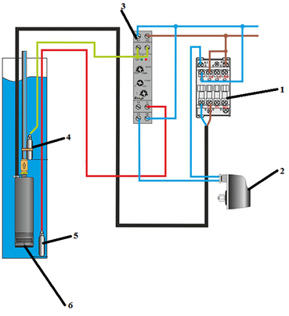
FIGURE 1. Direct pumping scheme:
1-magnetic starter, 2-pressure relay, 3-tires, 4,5-upper and lower level sensors, 6-pump
RESULTS
Currently, the demand for electricity is growing. Taking this into account, the scheme for starting pumps used in geotechnological wells using a frequency converter and providing electricity using solar panels is shown in Figure 2 below. This scheme has a number of advantages over the traditional direct ignition system: no electric shock during startup, reduced energy consumption, extended pump service life, and maintained stable pressure in the water supply system. At the same time, the use of solar panels as a renewable energy source increases the economic and environmental efficiency of the system.
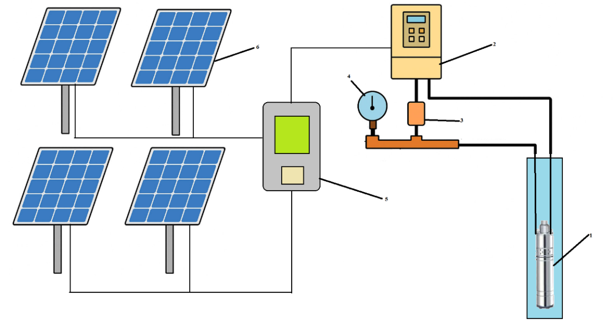
FIGURE 2. Diagram of starting a pump unit using a frequency converter and solar panels: 1-pump, 2-frequency converter, 3-pressure relay, 4-monometer, 5-inverter, 6-solar panels
As a result of practical calculations, the following technical and economic indicators were achieved.
Key indicators:
Pump power: P=20 kW
Working hours: t=10 hours/day
Electric motor efficiency: η_{el}=0.9
Pump efficiency: η_{p}=0.8
Daily energy consumption (in direct startup):
(8)
The pump operates at nominal power, the starting current is high, and losses are high.
Overall performance:
(9)
So, real energy consumption:
(10)
When starting with a frequency converter and solar panels, the starting current is reduced (3-4 times less), the speed is regulated, and there is no overload, energy savings are on average 25%.
Efficiency:
(11)
However, speed control reduces real energy consumption:
(12)
If a 25 kW solar panel is installed, it will produce 100 kWh per day. Of this, 50 kWh is accounted for by the network.
Comparison of parameters based on the results calculated above is presented in Table 1. The optimal operating mode is selected based on this schedule.

Table 1. Comparing the capabilities of startup methods
Indicators | In direct launch | Using a frequency converter and solar panels
Daily working hours (hours) | 10 | 10
Theoretical energy consumption (kWh) | 200 | 200
Actual energy consumption (kWh) | 278 | 150
Saving (%) | - | 46
Power from the network (kWh) | 278 | 50
Solar panel energy (kWh) | 0 | 100

Direct power consumption is 278 kWh/day, while with a frequency converter and solar panels, it is 150 kWh/day. Of this, 100 kWh/day is covered by the sun, that is, only 50 kWh/day is taken from the network.
The total energy saving is 46%, and the service life of the engine is also extended.
Based on the obtained results, the graphs of changes in the nominal parameters of the pump unit, i.e., the current, voltage, and temperature in the windings, are shown in Figures 3, 4, and 5 below.
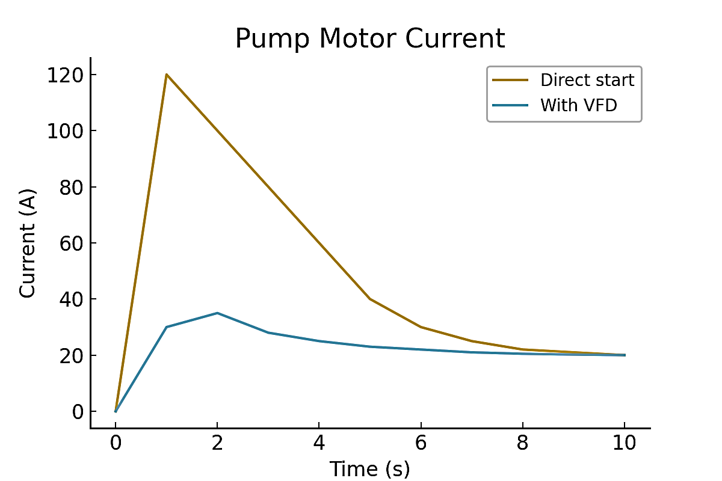 | 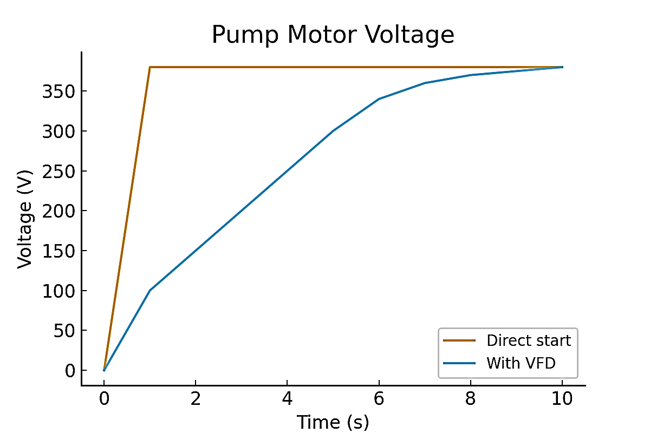
FIGURE 3. Graph of the dependence of the change in the current of the electric motor of the pump unit on time | FIGURE 4. Graph of the change in voltage of the electric motor of the pumping unit depending on time
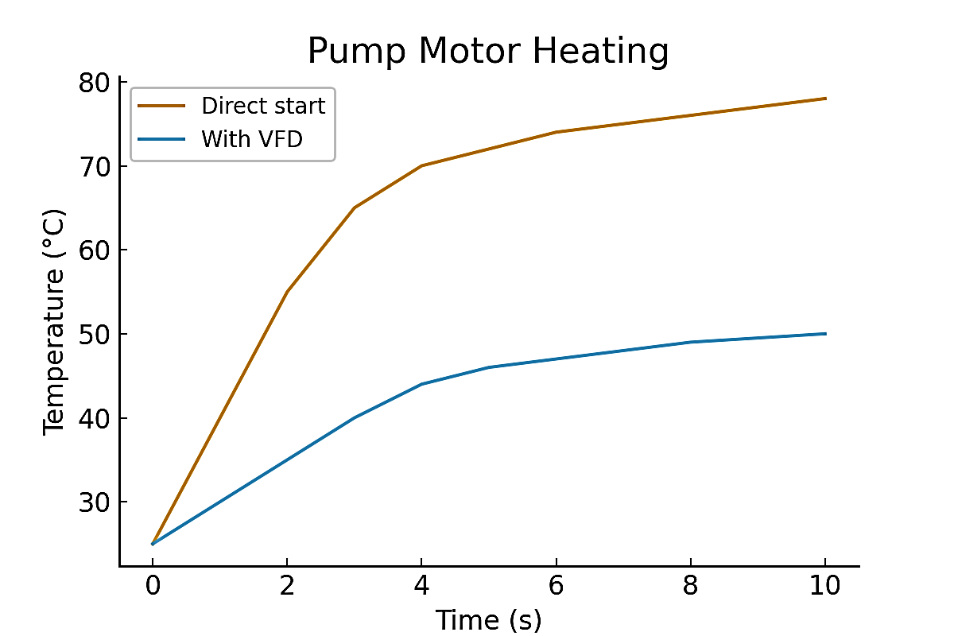 | FIGURE 5. Graph of the dependence of the temperature change in the windings of the electric motor of the pumping unit on time

CONCLUSION
Analysis of the operating modes of submersible pumping units used in geotechnological wells shows that in the traditional direct pusk (DOL) method, large pusk currents (5-7 times higher than the nominal value), voltage drop in the network, and excessive heat generation in the adapter windings are observed. This situation negatively affects the reliability and service life of the pumping unit in the long term, and also leads to an increase in electricity consumption.
The use of a frequency converter is an effective way to eliminate these shortcomings. In particular, in frequency control, the starting current is only 1.5-2 times higher than the nominal value, which prevents large current shocks and voltage drops. At the same time, the heating of the regulator decreases by 25-30%, dynamic loads are eliminated, and the reliability of the pumping unit increases. Most importantly, the pump's rotational speed is automatically controlled according to the hydraulic working schedule, which allows reducing energy consumption by an average of 20-30%.
When integrated with solar panels, the pumping unit receives electricity from a renewable source. Calculations showed that in this case, the pump's monthly energy consumption decreases by approximately 37% due to the energy received from the network. This ensures not only economic efficiency, but also environmental sustainability. At the same time, energy supply autonomy will increase, and the possibility of ensuring uninterrupted operation of geotechnological wells will be created.
In this way, it has been established that the commissioning of pumping units based on frequency converters and solar panels in geotechnological wells is not only technically and technologically optimal, but also economically and environmentally effective.
REFERENCES
- B.Toshov, A. Khamzayev. Development of Technical Solutions for the Improvement of the Smooth Starting Method of High Voltage and Powerful Asynchronous Motors// AIP Conference Proceedings 2552, 040017 (2023). https://doi.org/10.1063/5.0116131
- Akbar, K., Javokhir, T., Lazizjon, A.,Umidjon, K., Muhammad, I. Improvement of Soft-Start Method for High-Voltage and High-Power Asynchronous Electric Drives of Pumping Plants. AIP Conference Proceedings., 2024, 3152(1), 040006. https://doi.org/10.1063/5.0218899
- Mislibaev I.T., Makhmudov A.M., Makhmudov Sh.A. Theoretical generalisation of functioning modes and modelling of operational indicators of excavators. // Mining information-analytical bulletin. - 2021. №1. p. 102-110. DOI: 10.25018/0236-1493-2021-1-0-102-110
- Makhmudov Sh, Makhmudov A, Khudojberdiev L, Izzat Rakhmonov, “Criteria for assessing the performance of mining and transport equipment of mining enterprises,” Proc. SPIE 12986, Third International Scientific and Practical Symposium on Materials Science and Technology (MST-III 2023), 129860P (19 January 2024); doi: 10.1117/12.3017722
- Azamatovich, N., Abdullayev, S., Zhuraev, A., Turdiyev, S. Experimental study of improved constructions increasing the efficiency of ball mill protective coatings used in enrichment factories. E3S Web of Conferences., 2024, 525, 06006. https://doi.org/10.1051/e3sconf/202452506006
- Zhuraev, A.S., Turdiyev, S.A., Jurayev, S.T., Salimova, S.S.Q. Characteristics of packing gland seals in hydraulic systems of quarry excavators and results of comparative analysis of experimental tests Vibroengineering Procedi., 2024, 54, 252–257. doi:10.21595/vp.2024.24051 fatcat:3gn35vqqu5hnffb5bxj2jgm3pm
- Toshov, J. B., Rabatuly, M., Khaydarov, S., Kenetayeva, A. A., Khamzayev, A., Usmonov, M., & Zheldikbayeva, A. T. (2026). Methods for analysis and improvement of dynamic loads on the steel wire rope holding the boom of steel wire rope excavators. Kompleksnoe Ispolzovanie Mineralnogo Syra= Complex use of mineral resources, 339(4), 87-96. doi: 10.31643/2026/6445.43
- Ataqulov L.N., Haydarov Sh.B., Polvonov N.O. Impact forces on side and middle rollers. SPIE 12986, Third International Scientific and Practical Symposium on Materials Science and Technology (MST-III 2023), 129860Q (19 January 2024); doi: 10.1117/12.3017724
- Atakulov L.N., Kakharov S.K., Khaidarov S.B. Selection of optimal jointing method for rubber conveyor belts. Gornyl Zhurnal, 2018. (9), 97-100. DOI:10.17580/gzh.2018.09.16
- Toshov, J.,Atakulov, L., Arzikulov, G.,Baynazov, U. Modeling of Optimal Operating Conditions of Cyclic-Flow Technologies With a Belt Conveyor at Coal Mine Under the ANSYS Program. AIP Conference Proceedings, 2024, 3152(1), 020006. https://doi.org/10.1063/5.0218904
- Hieninger, T., Goppelt, F., & Schmidt-Vollus, R. (2019, October). Energetic Optimization and Saving Potential of Head-Controlled Identical Parallel Driven Centrifugal Pumps by On-Line Switch Point Detection. In 2019 8th International Conference on Systems and Control (ICSC) (pp. 200-205). IEEE.
- Djurayev R.U., Xatamova D.N., Pardayeva Sh. Increasing the operating efficiency of mining compressor installations on the basis of improving the cooling, lubrication and air suction system // International Scienentific SiberianTrasport Forum-TransSiberia. - 417, - 2023. https://doi.org/10.1051/e3sconf/202341703016
- Mahmudov A, Musurmanov E, Chorikulov A, Tukhtaev Sh. Justification of the development of the ventilation network and increasing the efficiency of ventilation equipment by controlling themovement of air flow. Third International Scientific and Practical Symposium on Materials Science and Technology (MST-III 2023), Proc. of SPIE Vol. 12986, 1298610. doi: 10.1117/12.3017914
- Ahonen, T., Pöyhönen, S., Siimesjärvi, J., & Tolvanen, J. (2019). Graphic determination of available energy-saving potential in a reservoir pumping application with variable-speed operation. Energy Efficiency, 12(5), 1041-1051.
- Ivanov, M.N. Control systems of mine pumps. (In Russian). - St. Petersburg: Nevsky, 2015.
- Khamzaev A. A., Mambetsheripova A., Arislanbek N. Thyristor-based control for high-power and high-voltage synchronous electric drives in ball mill operations/E3S Web Conf. Volume 498, 2024 //III International Conference on Actual Problems of the Energy Complex: Mining, Production, Transmission, Processing and Environmental Protection (ICAPE2024) DOI: https://doi. org/10.1051/e3sconf/202449801011.
- Toshov B. R., Khamzaev A. A., Niyetbayev A. D. Improvement of soft starter circuit for high-voltage and high-power asynchronous motors //Proceedings of SPIE-The International Society for Optical EngineeringТом. – 2022. – Т. 126162023.
- Abdalimovich K. A., Djabbarovich S. D., Kilichoglu F. K. Frequency control of the operating mode of electrical processes of pumping devices //Sanoatda raqamli texnologiyalar/ Digital technologies in industry. – 2025. – Т. 3. – №. 1. – С. 195-200.
- Hieninger, T., Goppelt, F., Schmidt-Vollus, R., & Schlücker, E. (2021). Energy-saving potential for centrifugal pump storage operation using optimized control schemes. Energy Efficiency, 14(2), 23.

