Improving the filter system of the cone compressor lubrication unit
Khusniddin Yuldoshov ^{a)}, Sarvar Ganiev, Shuhrat Raykhonov, Mamura Mirzayeva, Murodali Akberdiev, Abdurakhmon Sotiboldiev, Ibrohim Jabborov
Almalyk State Technical Institute, Almalyk, Uzbekistan
- Corresponding author: abduraxmon.sotiboldiyev@mail.ru
Abstract. This article analyzes ways to reduce the proportion of contaminant particles in compressor oil by improving the oil filters used in the lubrication system. The analysis is based on the results of an investigation into factors that reduce the operational efficiency of mining compressor equipment.
INTRODUCTION
In recent years, the growing volume of mineral extraction in our country has led to increased demands for the reliability and efficiency of mining machinery and equipment. In ensuring uninterrupted operation of mining compressor units, the lubrication system plays a crucial role.
Failures caused by the wear of moving and frictional mechanisms in mining compressor equipment often result in unexpected shutdowns. Therefore, special attention must be paid to the parameters and cleanliness of the oil used in lubricating the compressor’s moving mechanisms. Changes in the oil’s initial properties and contamination can accelerate the wear of these mechanisms, leading to a rise in emergency stoppages.
The presence of abrasive particles in the oil contributes to the degradation of the crosshead, its sliding surfaces, and the crosshead shaft, resulting in reduced dimensions and shortened service life.
Figure 1 presents the types of malfunctions and their photographic representations that occur due to changes in the initial parameters and contamination of the oil used to lubricate the movement mechanisms.

Figure 1. Malfunctions caused by contamination of the oil lubricating the movement mechanisms

All of the above-mentioned factors arise due to contamination of the oil in the lubrication system and changes in its initial parameters. The filters installed in the lubrication systems of compressor equipment do not always ensure the cleanliness of the circulating oil. In industrial enterprises, excessive wear of compressors and the poor quality of spare parts lead to the release of debris and contaminant particles during operation. Additionally, the filters used in the lubrication systems often do not meet the required standards. Based on these observations, it can be concluded that improving the filters in the compressor lubrication system and enhancing their performance can reduce unexpected equipment shutdowns and operational costs.
Currently, filters made of paper and cellulose-based materials are used in compressor lubrication systems. These types of filters cannot be regenerated and are designed for single-use only.
Specifically, for piston compressors, the replacement interval for oil filters is 2,500 engine hours. However, in practice, due to compressor aging, poor-quality and rapidly wearing spare parts, excessive overheating, and the ingress of contaminant particles from the external environment into the lubrication system, the service life of these filters is observed to decrease by 50–60%.
A new oil filter design has been developed based on a porous filter material that enables high-quality purification of circulating oil—specifically, the retention of abrasive metal particles as small as 0.5 microns—and allows the filter material to be regenerated and reused. The distinguishing feature of this newly developed filter compared to other porous filters is that the filter material is shaped as a cylinder with a permanent magnetic rod installed at its center. The filter material itself consists of two layers: the layer above the magnetic rod has pores sized 0.5–1.0 microns, while the second layer has pores sized 3–5 microns.
Oil filters installed in circulating lubrication systems must not obstruct oil flow. Therefore, filter materials with very small pore sizes are unsuitable, as clogging of these pores reduces the filter’s permeability, leading to oil shortages and overheating in the lubrication system.
The core concept of the proposed filter design is that during operation, the main volume of oil flows through the second layer of filter material with 3–5 micron pores. This layer does not significantly resist oil flow and retains particles larger than 3–5 microns. However, metal debris particles smaller than 1 micron are not retained by this layer. To capture these finer particles, the central permanent magnetic rod attracts them, and they are subsequently trapped in the first layer of filter material with 0.5–1.0 micron pores. This approach enables the retention of fine metal particles without compromising the filter’s permeability.
Figures 2 and 3 show the structural and general views of the proposed filter design.
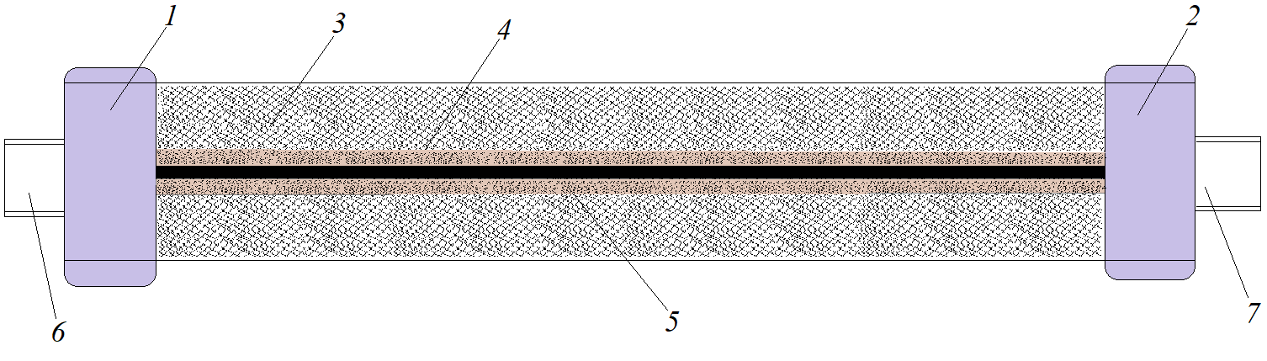
1,2 – Removable covers 3 – Filter material with pore size of 3–5 µm 4 – Filter material with pore size of 0.5–1.0 µm 5 – Permanent magnet 6,7 – Connection elements
Figure 2. Design of the magnetic oil filter

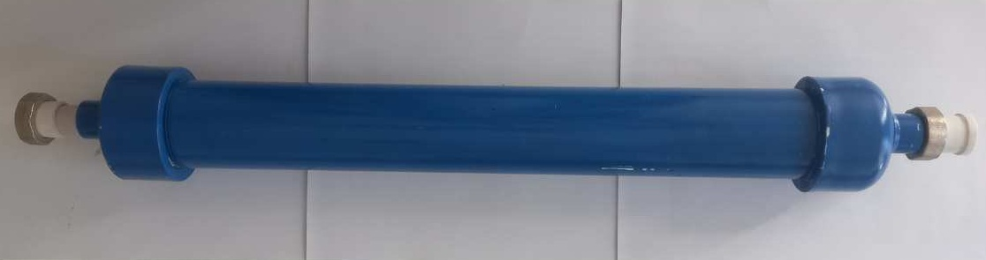
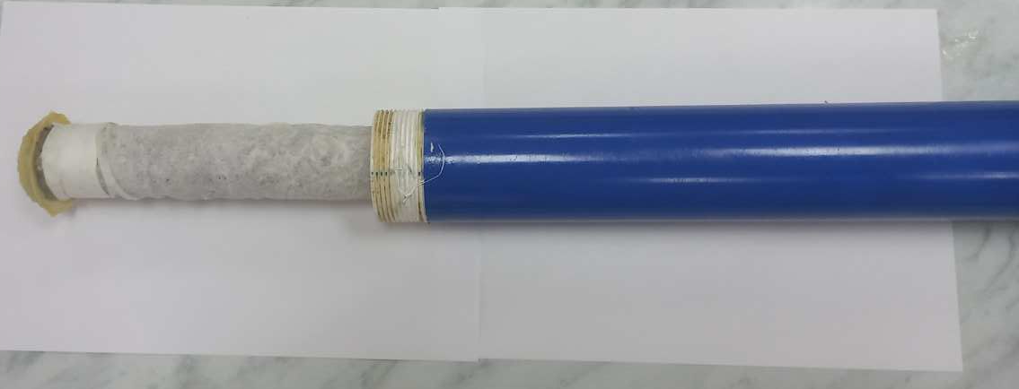
Figure 3. General view of the magnetic oil filter

In piston compressors, oil filters are replaced together with the oil during maintenance of the lubrication system. For example, if the oil’s service life is 2,500 engine hours, the oil filter is also replaced at the same interval. However, due to several factors, the actual effective service life of oil filters today does not exceed 1,500 engine hours. If the filter is not replaced in time, clogging may occur, leading to reduced oil circulation or damage to the integrity of the filter material due to continuous exposure to abrasive particles. As a result, oil purification becomes ineffective, increasing compressor operating costs and causing unexpected shutdowns.

The proposed filter is installed between the compressor manifold and the oil pump. Thanks to its easy removal and reinstallation features, it can be quickly and conveniently replaced during shift-change maintenance periods. The replaced filter can be cleaned (regenerated) and reused.

The cleaning process for the developed filter is as follows: the front cover (1) of the filter housing is removed, and the permanent magnetic rod (5) inside the filter material is taken out. Then the cover is hermetically sealed again, and a special cleaning solution is pumped in from the rear side of the filter against the direction of oil flow under high pressure. After thorough washing, the filter is dried using compressed air at a pressure of 3–3.5 atmospheres.

The efficiency and performance of the proposed filter are determined through experimental testing. Additionally, the filter must not obstruct the flow of circulating oil in the lubrication system. In piston compressor lubrication systems, the optimal oil flow velocity through the filter should be 0.12–0.15 m/s. A decrease below this range may lead to an increase in oil temperature.

EXPERIMENTAL RESEARCH
The movement of metallic particles within the oil passing through the developed magnetic filter was studied.
Due to the difference in fluid mass across the components of the magnetic filter, mechanical work is generated. This occurs as a result of the energy difference between the incoming fluid (energy E_{K1}) and the outgoing fluid (energy E_{K2}).

$E_{K1}=\frac{m_{T}×v_{1}^{2}}{2}$, J, (1)
$E_{K2}=\frac{m_{s}×v_{2}^{2}}{2} ,$ J, (2)
Where:
• $E_{K1}, E_{K2}$– Energies of the fluid entering and exiting the oil filter, measured in joules (J)
• $m_{T}$ – Total mass of the fluid, in kilograms (kg)
• $m_{s}$– Mass of the fluid exiting the filter, in kilograms (kg)
• $v_{1},v_{2 }$– Velocities of the fluid entering and exiting the filter, in meters per second (m/s)

Figure 4 illustrates the movement of a contaminant particle within the magnetic oil filter and the forces acting upon it.
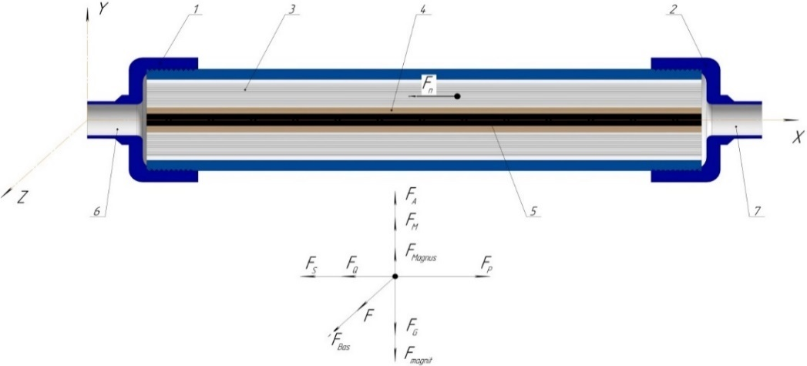
Figure 4. Movement of contaminant particles in the magnetic filter

Due to the magnetic element within the filter attracting iron and certain metallic particles suspended in the fluid, a mass of retained contaminants m_{con} is formed inside the magnetic filter. As a result, the mass of fluid entering the filter differs from the mass exiting it, i.e.:
$m_{con}{= m}_{T}-m_{s}$, kg, (3)
By combining the energy of all particles in the fluid into a single unified system, the difference in their energy represents the work performed on that system, which is calculated using the following formula:
${A_{1}=E}_{K2}-E_{K1},$ J, (4)
Where:
• A₁ – Work performed, in joules (J)
By substituting expressions (1) and (2) into equation (4), we obtain the following form:
$A_{1}$= $\frac{m_{s}×v_{2}^{2}}{2}$ - $\frac{m_{T}×v_{1}^{2}}{2}, J$, (5)
Due to the conditional difference between the energies of the fluid entering and exiting the filter, a mutual condition arises. based on $E_{K1}≥E_{K2}$ → - $A_{1 }$ this condition, the following arithmetic relationship is formed.
$A_{1}$=$\frac{m_{T}×v_{1}^{2}}{2}-\frac{m_{s}×v_{2}^{2}}{2} ,$J, (6)
Taking expression (3) into account, formula (6) takes the following form:
${ A }_{1}$=$\frac{m_{T}×v_{1}^{2}}{2}-\frac{m_{T}×v_{2}^{2}}{2}-\frac{m_{con}×v_{2}^{2}}{2}$, J, (7)
The work performed as the fluid passes through the filter is generated in the direction of the resultant force acting on the particle, namely:
${\begin{aligned} \\ A \end{aligned}}_{1}=\vec{F_{N}}×S$, J, (8)
Where: S – length of the filter, in meters (m)

By combining expressions (7) and (8), the following equation is obtained:
$\vec{F_{N}}×S=\frac{m_{T}×v_{1}^{2}}{2}-\frac{m_{T}×v_{2}^{2}}{2}-\frac{m_{con}×v_{2}^{2}}{2} , J,$ (9)
From the above expression, the mass of contaminant particles retained by the magnet can be determined using the following formula:
$m_{ex}=\frac{2×\vec{F_{N}}×S-m_{T}\text{(}v_{2}^{2}-v_{1}^{2})}{v_{2}^{2}} , kg,$ (10)
Let us now formulate the vector equation of the forces acting on the particles in the system:
$\vec{F_{N}}=m\frac{\vec{dv}}{dt}=\vec{F_{Q}}+\vec{F_{M}}+\vec{F_{G}}+\vec{F_{A}}+\vec{F_{mag}}+\vec{F_{S}}+\vec{F_{B}}+\vec{F_{P}}+\vec{F_{Mg}}$ , N, (11)
Where, $\vec{F_{Q}}$ – resistance force exerted by the filter medium on the particle, $\vec{F_{Q}}=\frac{C_{D×}ρ×S×v_{1}^{2}}{2}$, N;
$\vec{F_{M}}$ – Due to the angular velocity acquired by the particle, a centrifugal force acts upon it, $\vec{F_{M}}=ω^{2}×m×R$, N;
$\vec{F_{g}}$ – the gravitational force acting on a particle is expressed as $\vec{F_{g}}$=m$×g$, N;
$\vec{F_{A}}$ – Archimedes force acting on the particle, $\vec{F_{A}}=\frac{π×D_{P}^{2}}{6}×\left(ρ_{Z}-ρ_{S}\right)$, N;
$\vec{F_{mag}}$ – Magnus effect force acting on the particle, $\vec{F_{mag}}=\frac{π}{8}×ρ×C_{mag}×d_{p}×\left(v_{2}^{2}-v_{1}^{2}\right)$, N;
$\vec{F_{S}}$ – Saffman friction force acting on the particle, $\vec{F_{S}}=1,615×ρ×\sqrt{υ }×d_{p}^{2}×\left(v_{2}^{2}-v_{1}^{2}\right)×\frac{dv}{dR}$ , N;
$\vec{F_{B}}$ – Basset force acting on the particle$\vec{F_{B}}=\frac{3}{2}×d_{p}^{2}×\sqrt{π×ρ×μ}×\int_{0}^{t}{\frac{1}{\sqrt{t-τ}}}×\frac{d\left(v_{2}-v_{1}\right)}{dτ}×dτ$, N;
${\vec{F}}_{P}$ – pressure gradient force acting on the particle ${\vec{F}}_{P}=-\frac{m_{p}}{p}×∇\vec{P}$ , N;
$\vec{F_{Mg}}$ – magnetic force $\vec{F_{Mg}}=μ_{0}×α×V×\vec{H}×∇\vec{H},$ N.
By considering the particle as a material point, its motion—regardless of the moment in time—is influenced by both active and reactive forces. When the inertial force is added to these, the resulting system of forces becomes a system of equilibrium forces, meaning the point is in equilibrium at that instant.
This principle is based on D'Alembert's law for a material point, and the equation of the resultant forces acting on the point is constructed relative to the coordinate axes.
$\sum{F_{X}}=R_{X}$=$-F_{Q}-F_{S}+F_{P}$, N; (12)
$\sum{F_{Y}}=R_{Y}$=$F_{A}+F_{M}$+$F_{mag}-F_{G}-\vec{F_{MG}}, N;$ (13)
$\sum{F_{Z}}=R_{Z}$=$F_{B},$ N. (14)
Since these axes are mutually perpendicular, the resultant force acting on the particle along the X, Y, and Z directions can be determined:
$\sum{F}=R=\sqrt{R_{X}^{2}+R_{Y}^{2}+R_{Z}^{2}}$=
=$\sqrt{{\left(-F_{Q}-F_{S}+F_{P}\right)}^{2}+{\left(F_{A}+F_{M}+F_{mag}-F_{G}-\vec{F_{MG}}\right)}^{2}+{\left(F_{B}\right)}^{2}} , N.$ (15)
by combining expressions (10) and (15), the following equation is obtained:
$m_{ex}=\frac{2×\sqrt{{\left(-F_{Q}-F_{S}+F_{P}\right)}^{2}+{\left(F_{A}+F_{M}+F_{mag}-F_{G}-\vec{F_{MG}}\right)}^{2}+{\left(F_{B}\right)}^{2}}×S-m_{T}\text{(}v_{2}^{2}-v_{1}^{2})}{v_{2}^{2}}$, kg. (16)
The total mass of particles formed in the magnetic field depends on several parameters, such as the velocity and direction of the fluid, the mass of fluid entering the filter, the magnetic constant, the filter’s length and radius, the resistance force of the filter, as well as the particle’s diameter and average density. Expression (16) represents a general form for calculating the mass of particles formed in the magnetic field, but it does not characterize the factors influencing the particles retained by the magnet.
Taking the above into account, a set of theoretical expressions has been developed to determine the total mass of particles formed in the magnetic field under specific conditions, considering various influencing factors.
The mass of contaminant particles retained in a magnetic filter can be determined through several parameters and is calculated based on the time the fluid passes through the filter as follows:
$m_{con}=m_{T}\left(K_{T}-1\right)+\frac{2F_{n}t}{ϑ_{av}}$, kg, (17)
where:
m_{T} - total mass of fluid passing through the filter, kg;
K_{T} - velocity coefficient;
F_{n} - resultant force acting on the contaminant particle retained in the filter, N;
υ_{av} - velocity of the particle while passing through the filter, m/s;
t - time taken by the contaminant particle to pass through the filter, s.
The mass of the contaminant particle retained in the magnetic filter is determined through the magnetic length of the filter as follows:
$m_{con}=m_{T}\left(K_{T}-1\right)+\frac{2F_{n}∆l}{ϑ_{av}^{2}}$ , kg, (18)
where: Δl - magnetic length of the filter, m.
The mass of contaminant particles retained in the magnetic filter, based on the amount of fluid passing through, is determined as follows
$m_{con}=m_{T}\left(K_{T}-1\right)+\frac{2F_{n}V}{Qϑ_{av}}$, kg, (19)
where: Q - relative amount of fluid passing through the filter, m³/kg;
V - volume of fluid passing through the filter, (m³).
The mass of contaminant particles retained in the magnetic filter, based on the magnet’s diameter, is calculated as:
$m_{con}=m_{T}\left(K_{T}-1\right)+\frac{πF_{n}l\left(d_{k}^{2}-d_{m}^{2}\right)}{2Qϑ_{av}}$ , kg, (20)
where: d_{k}- inner diameter of the construction, mm;
d_{m}- diameter of the magnetic filter, mm.
The mass of contaminant particles retained in the magnetic filter, based on the fluid’s contamination level, is calculated as:
$m_{con}=m_{T}\left(K_{T}-1\right)+\frac{2F_{n}\left(1+G_{m}\right)V_{m}}{Qϑ_{av}}, kg,$ (21)
where: G_{m}- contamination level of the fluid, mg/kg.
Experimental tests were conducted to determine the efficiency of the developed magnetic oil filter.
RESEARCH RESULTS
Experimental tests were conducted in two stages. In the first stage, a standard porous filter material was tested (Figure 5). A 5-liter sample of KC-19 compressor oil, which had been in use for 2500 motor-hours and contained 880–900 mg/kg of metallic particles ranging in size from 0.5 to 25 microns, was passed through filters with porosity levels of 40%, 50%, 60%, and 70% under a pressure of 4 bar. The results of these experimental tests are presented graphically in Figures 6 and 7.
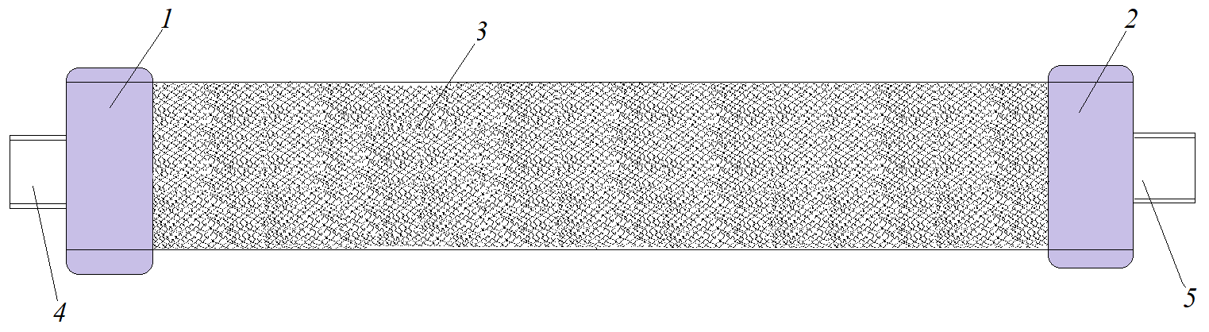
1,2 – removable caps; 3 – filter material with pore sizes of 3–5 microns; 4,5 – connecting components.
Figure 5. Porous oil filter

Figure 6. Relationship between the contamination level of oil filtered through a standard porous filter and the filter's porosity level

When experimental tests were conducted using porous oil filters with porosity levels of 40%, 50%, 60%, and 70%, it was observed that at 40% porosity, the contamination level of the oil was 330 mg/kg. With each 10% increase in porosity, the contamination level rose by approximately 20–30 mg/kg.
These results indicate that increasing the porosity of the filter tends to worsen the oil's contamination level by an average of 5–8%. Filters with 40–50% porosity demonstrate high purification efficiency. However, a secondary effect is that lower porosity reduces the flow rate of oil through the filter. Figure 6 illustrates the relationship between oil flow rate and filter porosity level.

Figure 7. Relationship between oil flow rate through a standard porous filter and the filter's porosity level

At porosity levels of 40–50%, the improved purification performance of the porous oil filter is attributed to the low number of pores and their limited interconnectivity. As a result, the pores effectively trap solid particles present in the oil. When oil enters the porous structure, it exits through rotational flow, while solid contaminants settle within the pores. This process also restricts the movement of smaller particles to some extent. However, over time, pore clogging occurs, reducing the filter’s permeability and rendering it ineffective.
In the second stage of the experimental tests, the proposed magnetic oil filter (see Figure 2) was evaluated. Tests were conducted using filters with porosity levels of 40%, 50%, 60%, and 70%, incorporating filter material with small pores arranged around the installed magnet. Trials were performed at material thicknesses of 5 mm, 10 mm, and 15 mm. The results of these tests are presented graphically in Figures 8 and 9.

Figure 8. Relationship between the contamination level of oil filtered through a magnetic filter and the filter's porosity level (with base filter porosity at 60%)

When the magnetic filter had a porosity level of 60%, and the filter material installed around the magnet had a thickness of 5 mm with 40% porosity, the concentration of contaminant particles in the filtered oil was measured at 252 mg/kg. As the porosity of the filter surrounding the magnet increased, a decrease in the oil’s contamination level was observed. Specifically, for every 10% increase in porosity, the contamination level dropped by approximately 14–18 mg/kg.
Additionally, increasing the thickness of the filter material around the magnet by 5 mm led to a reduction in contamination level by an average of 15–20 mg/kg.

Figure 9. Relationship between the contamination level of oil filtered through a magnetic filter and the filter's porosity level (with base filter porosity at 70%)

When the magnetic filter had a porosity level of 70%, and the filter material placed above the magnet had a thickness of 5 mm and porosity of 40%, the contamination level of the filtered oil was measured at 214 mg/kg. Similar to previous observations, increasing both the porosity and thickness of the magnet-top filter resulted in a reduction in oil contamination.
Experimental tests confirmed that installing a magnet within the porous filter significantly improves the retention of particles smaller than 1 micron, thereby reducing the overall contamination level in the oil. Higher porosity allows smaller particles to move more freely toward the magnet, while the filter material surrounding the magnet traps these particles and prevents them from passing through with the oil flow.
One of the key criteria in selecting or designing oil filters is their permeability. Any structural element added to a porous filter reduces the number of pores, which in turn decreases the oil’s flow rate through the filter. Incorporating a permanent magnetic rod into the porous filter introduces resistance to oil flow. During the experiments, the flow rates of oil through the magnetic filter were studied.
Figures 10 and 11 present graphical data showing the relationship between oil flow rate in the magnetic filter and the thickness and porosity of the filter material placed above the magnet.

Figure 10. Relationship between oil flow rate in a magnetic filter and the porosity level of the filter material above the magnet (with base filter porosity at 60%)

Figure 11. Relationship between oil flow rate in a magnetic filter and the porosity level of the filter material above the magnet (with base filter porosity at 70%)

As can be seen from the graphs above, installing a magnetic rod in the porous filter reduces the oil flow rate. In a conventional filter with 70% porosity, the oil flow rate is 75 mm/s, whereas in a magnetic filter with the same porosity and a 5 mm thick magnet-top filter, the flow rate is 50 mm/s. Additionally, the thickness and porosity of the magnet-top filter also affect the oil flow rate. The reduction in oil flow rate in the magnetic filter is compensated by an increase in purification efficiency.
As optimal parameters for the proposed magnetic filter, the following values were selected: the porosity of the porous filter is 70%, the thickness of the magnet-top filter is 10 mm, and its porosity is 70%. These parameters ensure maximum oil cleanliness and effective flow through the filter. Furthermore, the ability to retain particles smaller than 1 micron in the oil is achieved.
CONCLUSIONS
When comparing basic and magnetic filters, it was found that the proposed magnetic filter has an oil purification capability that is on average 40–50% better.
In addition, common faults in piston compressors were analyzed, and the following malfunctions were identified as causes of unexpected compressor shutdowns:
- Failure of the crosshead, i.e., malfunctions related to wear of the crosshead shaft, bearings, and slider surface due to oil contamination;
- Failure of the oil pump, i.e., malfunction of the reduction valve (typically the piston and spring fail), wear of the pump’s working surfaces (blade, spline, shafts), and erosion of the internal surfaces of the pump housing due to high oil contamination;
- Failure of the connecting rod and its components, i.e., wear of the connecting rod bearings and their babbitt linings;
- Reduced operational life of the oil filter;
- Reduced operational life of the oil.
The above-mentioned faults related to the structural components of the compressor arise due to a decrease in the service life of these parts, and the main reason for this decrease is the high contamination level of the circulating oil.
Research results show that using a magnetic filter in the compressor’s lubrication system allows for an increase in the service life of the crosshead by 20%, the oil pump by 30%, the connecting rod by 20%, and both the oil filter and the oil itself by up to 60%.

REFERENCES
- Djurayev R. U, Yuldoshov H. E. Calculation of the mass of contaminant particles retained in the magnetic filter of a piston compressor lubrication system. Intellectual Property Agency under the Ministry of Justice of the Republic of Uzbekistan & № DGU 21144. 17.12.2022.
- Djurayev R. U, Yuldoshov H. E. Investigation of malfunctions arising from contamination in the compressor lubrication system. Academy of Science and Innovation & RESEARCH FOCUS International Scientific Journal, Issue No. 2, 2022.
- H. E. Yuldoshov. Improvement of the compressor lubrication system filter. Education, science and innovative ideas in the world, No. 59, Part 14, December 2024, pp. 134–138.

