Assessment of Vehicle Flow Characteristics at Signalized Intersections: Case Study of Nukus
Dauletbay Jumabaev ^{1,2,a)}, Nursulıw Kenjebaeva¹, Kundiz Markabaeva¹, Kuralbay Bazarbaev¹, Sharibay Allanazarov¹
¹ Karakalpak state university named after Berdakh, Nukus, Karakalpakstan, Uzbekistan
² Tashkent state technical university named after Islam Karimov, Tashkent, Uzbekistan
^{a)} Corresponding author: jumabaevdawlet0115@gmail.com
Abstract. This study focuses on analyzing the intensity and structure of traffic flows at intersections within the city of Nukus. The research examined vehicle directions at designated observation points, together with the number and distribution of different transport types. A detailed analysis of traffic composition was carried out for the junction of Karakalpakstan Street and Uzbekistan Avenue. The results include graphical representations of changes in traffic composition during various hours of the day, as well as charts illustrating hourly fluctuations in the total traffic volume at the intersection.
INTRODUCTION
In response to the rising necessity for installing additional traffic lights in Nukus, stricter requirements are now being imposed on both the design quality of such installations and on the regulatory regimes that govern their functioning. One of the practical methods to enhance the organization of vehicle movement at controlled intersections is to refine the description of traffic flows, work out new schemes of vehicle maneuvering or improve existing ones, and assess the efficiency of the regulatory patterns used.
On February 16, 2023, the President of the Republic of Uzbekistan issued Decree No. 59 entitled “On measures to reform the public transport system” [1]. Based on this decree, a comprehensive roadmap was prepared with the aim of modernizing and improving the public transportation network of Nukus city.
In order to form a clear understanding of the traffic situation, the most important component is the availability of information that reflects the real characteristics of vehicle and pedestrian flows. The only reliable method of obtaining such information about the current state of road conditions is through natural observation and field studies.
The composition of traffic flows is generally expressed by the share of different categories of vehicles within the stream. This parameter plays a critical role in the performance of the roadway as a whole. For each movement direction, intensity indicators are considered separately. As a rule, traffic intensity is measured by the number of vehicles passing within a given period, irrespective of their type. In order to characterize road throughput more accurately, the actual volume is often converted into an equivalent number of passenger cars, taking into account the impact of heavy trucks, buses, or articulated road trains [4].
On extended urban road networks, it is more effective to study the intensity of movement not only along linear segments, but also directly at intersections, which act as transport nodes. Depending on the configuration of the intersection, observation teams are organized to register incoming flows according to vehicle type (passenger cars, heavy vehicles, buses, etc.) and direction of movement (turning right, going straight, turning left). This approach makes it possible to evaluate not only total traffic volume in each direction, but also the internal structure of the traffic flow at the node.
When estimating the load of intersections, the method of direct observation is applied most frequently. The number of observers required depends on the number of approaches: for a three-arm junction, three observers are needed; for a four-arm junction, four observers are assigned. In addition, the team should include specialists responsible for documenting the traffic light positions and taking photos and video footage of road signs, markings, signals, and their placement within the junction. Such records are necessary for preparing a reliable scheme of existing traffic patterns. Video materials also serve to verify vehicle movement phases and eliminate possible errors, avoiding repeated surveys. Moreover, it is advisable to appoint at least two additional persons whose task is to measure the speed of vehicles crossing the intersection [4].
In large cities of the Republic of Uzbekistan, the transport infrastructure is being improved, in particular, the development of urban passenger transport, as well as freight transport. 36-the goal of the development strategy for 2022-2026. The New Uzbekistan is aimed at "Developing a unified transport system in conjunction with all modes of transport, creating conditions for the possibility of daily trips on scheduled transport routes between major cities, in particular:
- improvement of the public transport system and development of its infrastructure in the city of Tashkent and the regions;
- increasing the attractiveness of intercity and suburban railway routes;
- development of the market of transport and logistics services and infrastructure, bringing the level of electrification of railway infrastructure to 60 percent and accelerated development of the highway network;
- expansion of "green corridors" and transit opportunities in the transport system for foreign trade, as well as an increase in the volume of transit cargo turnover to 15 million tons.

EXPERIMENTAL RESEARCH
When analyzing the service level of traffic flow at signalized intersections, the variation of intensity during peak hours must be considered. In practice, the most widespread approach to evaluate the quality of transport service relies on 15-minute peak intervals [5]. Consequently, if the traffic load at that time exceeds the overall roadway capacity, oversaturation occurs and may extend throughout the following hour.
Although the 15-minute segment is most frequently applied as the observation window, other durations can also be chosen. Vehicle arrival rates at intersections may be recorded for a longer interval, with subsequent adjustment by a specific correction coefficient, commonly known as the “peak factor” [5].
Method “a” assumes a study period equal to 15 minutes, i.e., T = 0.25 hours. Under this condition, the hourly peak intensity based on 15-minute intervals, or reduced peak load, can be determined using the following formula [3]:
$v_{p}=\frac{V}{PHF}$ (1)
where: Where $v_{p}$is the maximum vehicle arrival intensity on an approach (lane) of the regulated intersection, measured within a 15-minute interval, unit/hour;
- V represents the traffic volume recorded during the peak hour, unit/hour;
- PHF is the peak factor, which in the absence of direct data is taken as PHF = 0.92.
The main limitation of this approach lies in the fact that it accounts for only one 15-minute interval. In reality, queues at the studied intersection element may persist beyond this period, since the observed traffic intensity surpasses roadway capacity [3].
Method “C” requires surveying the entire observation period T (one hour), subdivided into successive 15-minute intervals. This approach allows consideration of residual queues carried over from one interval into the next. Accordingly, if demand exceeds capacity, a more precise estimation of delay at the studied intersection element can be obtained.
The calculation of hourly traffic intensity usually yields a maximum peak load that may only occur within a single 15-minute span. Thus, the resulting design values are often somewhat overestimated, leading to higher projected transport delays. Nevertheless, during the planning process, this technique provides the advantage of reflecting the maximum possible surge in demand throughout rush hour [3].
RESEARCH RESULTS
As a result of the study, both the intensity and structural composition of traffic flows were examined at the selected intersection. The data obtained for the intersection of Karakalpakstan–Guzar Street in Uzbekistan include: the distribution of vehicle types within the traffic stream, the timetable reflecting variations in traffic intensity over time, and the schedule showing temporal changes in flow composition. These findings are illustrated in Figures 1–3.
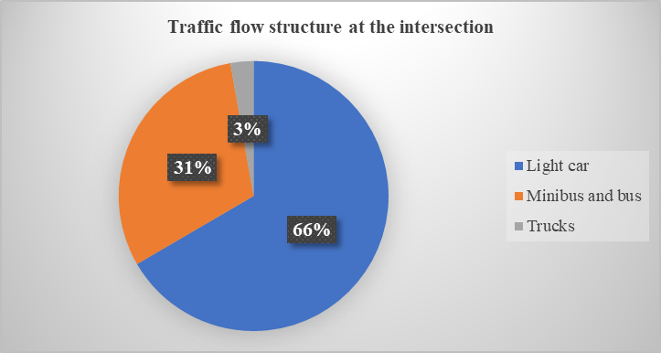
FIGURE 1. Structure of the traffic flow at the intersection of Karakalpakstan–Uzbek Guzar Street.

The analysis indicates that at this intersection, passenger cars account for 66% of the total flow, while trucks represent 3%. Buses together with minibuses make up the remaining 31% of traffic.

FIGURE 2. Graph showing variations in traffic flow by hourly intervals at the Karakalpakstan–Guzar Street intersection in Uzbekistan.
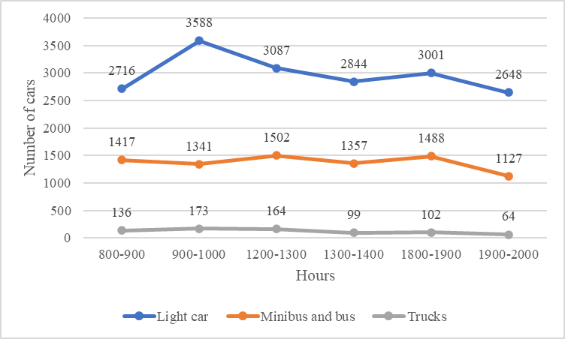
FIGURE 3. Hourly traffic flow schedule at the intersection of Karakalpakstan Street and the Uzbekistan road.

Two types of cartograms are used to represent the intensity of traffic flows: conditional and large-scale. These cartograms are created according to the number of vehicles moving in a particular direction, regardless of the number of lanes.
The conditional cartogram is prepared using the data from Table 1, expressed in natural (observed) vehicle units. An example of a conditional cartogram for the traffic intensity at the Karakalpakstan–Uzbek intersection is provided in Figure 4.
Meanwhile, the large-scale cartogram is constructed on the basis of the data from Table 2, recalculated into specific vehicle units. A large-scale cartogram reflecting the traffic flow intensity at the Karakalpakstan–Guzar intersection in Uzbekistan is illustrated in Figure 5.
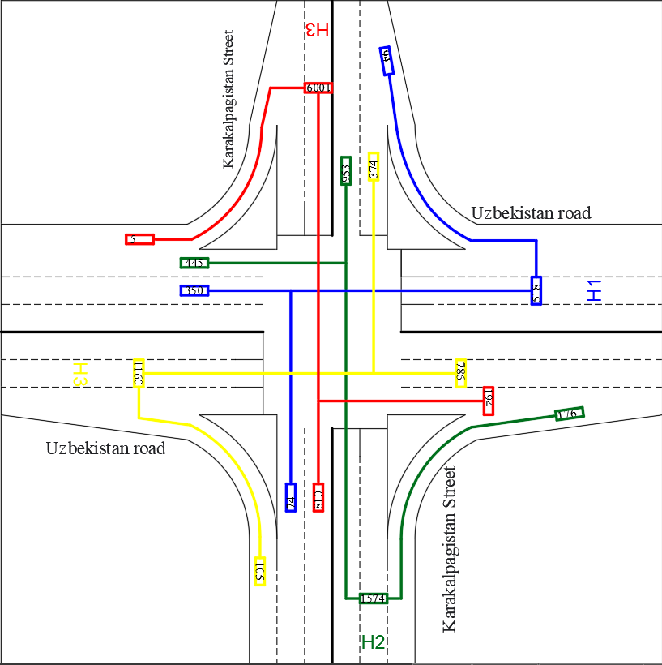
FIGURE 4. Conditional cartogram illustrating the intensity of traffic flows at the intersection of Karakalpakstan Street and the Uzbekistan road.
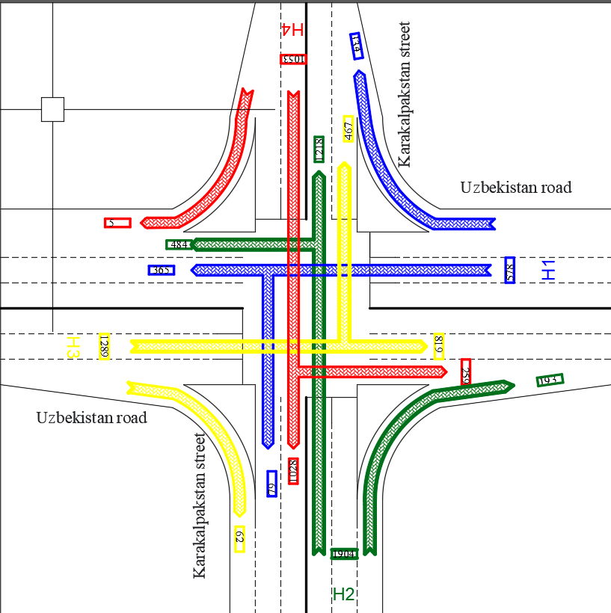
FIGURE 5. Scaled cartogram representing the traffic intensity at the intersection of Karakalpakstan Street and the Uzbekistan road.

CONCLUSION
In order to advance the industry, it is essential to study international practices for addressing the identified issues and to examine integrated strategies applied to transport infrastructure in large global cities [5].
The continued expansion of the highway system outside the city should include reconstruction of their dimensions and traffic sections in line with technical requirements and the forecasted traffic demand [6].
In preparing the city’s master plan for streets and roads, it is necessary to consider predictive data on the growth of motorization levels and the expected increase in the number of vehicles in correlation with economic indicators.
It is critical to comply with the SNK regulation 2.01.07-03, which emphasizes the principle of “infrastructure first, followed by construction.”
Residential areas should be developed in compact quarters, with block sides not exceeding 250 meters between street intersections.
New housing districts are recommended to consist of small-sized blocks, again with sides no longer than 250 meters between junctions [10].
For the city of Nukus, scientifically grounded schemes of long-term planning for the road and street network should be elaborated. On this basis, optimal passenger transport planning must be carried out, along with the development of transport hubs to strengthen connections with external transit routes, relying on established experience [9].
REFERENCES
- Resolution of the President of the Republic of Uzbekistan No. PK-60 "On measures to reform the public transport system".
- Almatov Mardon Isamitdinovich study of the intensity and composition of traffic flow at intersections near the city of Jizzakh and the share of public transport in it scientific article "Economics and Society" No.9(100) 2022.
- A.G. Levashev, A.Y. Mikhailov, I.M. Golovnykh Design of controlled intersections. Textbook - Irkutsk: Publishing house of IrSTU, 2007. - 208 p.
- Tolkov, A.V. Improving traffic at intersections: studies. manual for the implementation of the issue of qualifications. Works. Vladimir: Publishing House of the Volga, 2018. - 180 p.
- Highway Capacity Manual. // TRB, Washington, DC, 2000. - 1134 p.
- Asadulla Toshtemirovich Khotamov1, Dauletbay Maratovich Jumabaev, Fitrat Abdikhalil ugli Abdikhalilov. The main problems of the transport system of the city of nukus and recommendations for their elimination. E3S Web of Conferences 403, 07005 (2023) https://doi.org/10.1051/e3sconf/202340307005 ESCP-2023.
- Abrorbek Kutliev, Kuvvat Usmanov. Assessment and forecasting of traffic flow entering the historical city of khiva. Central asian journal of mathematical theory and computer sciences https://cajmtcs.centralasianstudies.org.
- Silyanov V.V., Lovanov E.M., Sitnikov Yu.M. et al. Traffic Capacity of Automobile Roads / Moscow: Transport, 1970. 152 pages.
- Khotamov A.T., Jumabaev D.M. "Main problems in the transport system of Nukus city and recommendations for their elimination," "Architecture, Construction and Design" scientific-practical journal, Issue 1, pp. 14-18, Tashkent 2023.
- Silyanov V.V., Lovanov E.M., Sitnikov Yu.M. et al. Traffic Capacity of Highways / Moscow: Transport, 1970. 152 pages.

