Experimental removal of the indicator diagram of a single-stage piston compressor at various speeds of rotation of the circulated walk
Madiyar Erejepov^{1, a)}, Salamat Saburov¹, Akmaral Keunimjayeva¹, Aysanem Abibullaeva²
¹ Karakalpak State University named after Berdakh, Nukus, Uzbekistan
²Nukus Branch of Tashkent university of information technologies named after Muhammad al-Khwarizmi, Nukus, Uzbekistan
³ Tashkent state technical university named after Islam Karimov, Tashkent, Uzbekistan
^{a)} Corresponding author: salamatsaburov7@gmail.com
Abstract. The work examines the results of experimental studies of the operation of a single-stage piston compressor at varying rotational speeds of the crankshaft. By taking indicator diagrams, the changes in the compression and filling parameters in the cylinder were assessed. The influence of rotational speed on the maximum pressure, the nature of the diagrams, mechanical losses, and energy efficiency were considered. The work is aimed at improving the accuracy of diagnostics and regulation of compressor operating modes in industrial conditions.
INTRODUCTION
Piston compressors are among the most common machines in pneumatic systems responsible for pumping and transporting air or gas. Their reliability and productivity depend on many factors: geometric parameters, thermodynamic conditions, as well as operating mode. In particular, the rotational speed of the crankshaft directly affects the filling, compression, and discharge process, which in turn determines the compressor's efficiency.
The indicator diagram, which represents the dependence of pressure on volume (or shaft rotation angle), is an important tool for analyzing the processes occurring in the cylinder. It is precisely by the shape and area of this diagram that one can judge the quality of filling, the completeness of compression, the presence of mechanical losses, and other important parameters.
The purpose of the study is to conduct an experiment to obtain indicator diagrams on a single-stage compressor at different rotational speeds and to assess their impact on the machine's operating parameters.
The operating principle of the piston compressor is based on the principle of periodic reduction of volume in the cylinder due to the reciprocating motion of the piston. During the movement process, the piston performs the following phases:
• intake: air intake when the intake valve opens;
• Compression: closing both valves and reducing volume;
• exhaust: opening of the exhaust valve when the specified pressure is reached.
Each of these phases is reflected in the indicator diagram as a separate section.
Indicator diagram: The indicator diagram is constructed in "pressure-volume" (p-V) coordinates (Fig.1) or "pressure-rotation angle" (p-θ) and represents a closed curve containing all information about the process. By the area of the diagram, it is possible to determine the indicator operation of the compressor. The diagram shape is sensitive to rotation frequency changes, leaks, valve condition, and other factors.
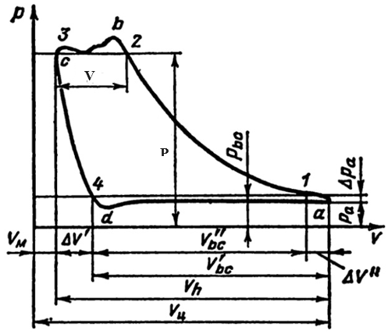
FIGURE 1. Theoretical indicator diagram of a single-stage piston compressor
The effect of rotation frequency: When rotations increase, the time allocated for each stroke decreases, which can lead to the following effects:
- Incomplete filling of the cylinder (reduction of air mass);
- Residual pressure increase;
- Disruption of valve tightness when quickly opening/closing;
- Increased vibrations and thermal load.

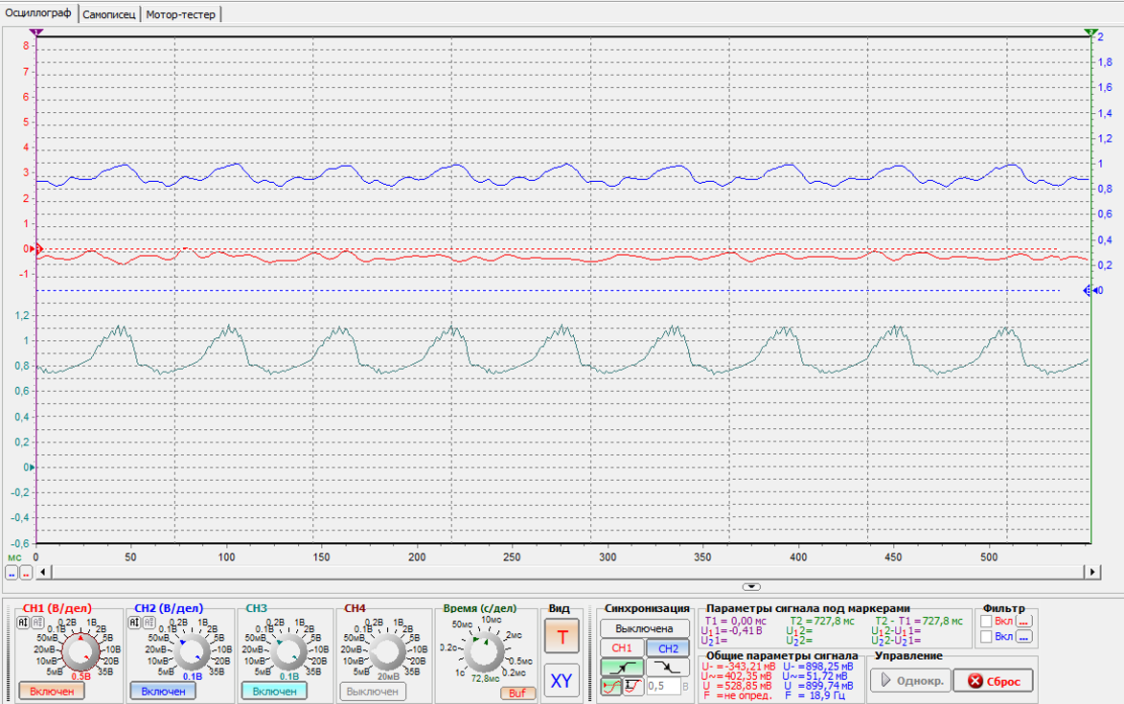
FIGURE 2. Dependence of pressure on the rotation angle of the crankshaft
EXPERIMENTAL RESULTS
1. After preserving the indicator diagram, find the pressure values P for each rotation angle of the crankshaft with a step of 10 degrees. The point where the pressure begins to decrease after reaching its maximum value is taken as zero degrees (see Figure 2).
2. Using the formula:
$V=V_{vr}+\frac{V_{k}}{2}(\left(1-cosθ\right)+\frac{λ}{4}\left(1-cos2θ\right))$ (1)
where θ - rotation angle of the crankshaft;
V_{k}- chamber volume (2 l.);
V_{vr}- harmful volume of the chamber (2 l.);
λ is the ratio of the crank radius to the length of the connecting rod (0.3). calculate the relative volume for each rotation angle of the crankshaft.
3. Knowing the volume and pressure for each point, plot the graph in P-V coordinates. An example is shown in Figure 4.
4. Compare the obtained graphs for different rotational frequencies of the piston compressor drive motor.
Example of resulting graph.

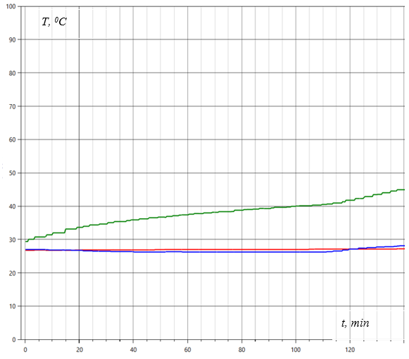
FIGURE 3. Dependence of pressure on the rotation angle of the crankshaft
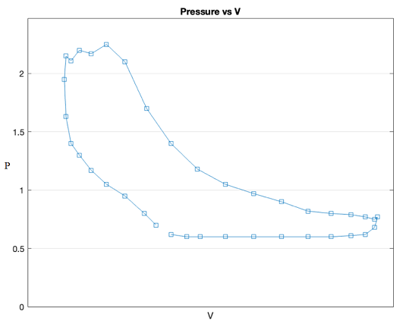
FIGURE 4. Experimental indicator diagram of a single-stage piston compressor
CONCLUSIONS
The experiment confirmed the sensitivity of the indicator diagram to changes in the compressor's rotational speed. Using the analysis of the diagrams, it was possible to determine:
Optimal operating mode parameters; P.
• Increase in losses with increasing frequency;
• The need to precisely adjust the valve mechanism at high speeds.
The maximum pressure value in the diagram corresponds to the maximum compression pressure achieved at the compression stage, and the minimum value corresponds to the pressure (or, more precisely, the vacuum) created in the cylinder during the gas.
It is important to note that the shape and characteristics of the indicator diagram can vary depending on many factors, including the type of compressor, its operating mode, the condition of the equipment, and the properties of the compressed gas. Practical analysis of indicator diagrams allows not only to assess the current efficiency of the compressor's operation but also to predict its further operation, determine optimal operating modes, and timely identify possible malfunctions.
The obtained results can be used in the development of automatic control and regulation systems for compressors in industrial installations.
REFERENCES
- A. N. Malyshev, Theory of reciprocating compressors (Mashinostroenie, Moscow, 2005).
- V. E. Gusev, Compressor machines and installations (Politekhnika, Saint Petersburg, 2010).
- V. V. Petrov, Automation of compressor stations (Ural Federal University, Yekaterinburg, 2019).
- ISO 1217:2009, Displacement compressors—Acceptance tests (International Organization for Standardization, Geneva, 2009).
- A. Vasilyev, “Indicator diagrams as diagnostic tools,” Journal of Mechanical Engineering (2020).
- S. Q. Mämbetov, Compressor machines and installations (Bilim, Almaty, 2018) (in Kazakh).
- A. A. Akhmetov, Analysis of reciprocating compressor operation (Mashina Zhasau, Tashkent, 2017) (in Uzbek).
- V. I. Kalashnikov, Diagnostics and adjustment of compressor units (Energoatomizdat, Moscow, 2004).
- I. B. Rakhmanov, Theory and calculation of compressor machines (University Press, Tashkent, 2016).
- A. L. Plotnikov, Dynamics and vibration of compressors (Nauka, Saint Petersburg, 2011).
- ANSI/ASHRAE Standard 41.1-2013: Standard methods for temperature measurement (ASHRAE, Atlanta, 2013).
- J. Lee and H. Kim, “Performance evaluation of reciprocating compressors at variable speeds,” International Journal of Thermal Sciences (2021).
- E. Q. Zhumabaev and N. S. Muratov, Fundamentals of heat engineering (Kazakh University, Almaty, 2019) (in Kazakh).
- A. A. Stepanov, “Indicator diagrams as a means of analyzing working processes,” Compressor Technology 4 (2018).
- A. M. Khusainov, Theory of high-pressure compressors (Fan, Tashkent, 2020).

