Determining Optimal Locations for Elements in Renewable Energy–Integrated Distribution Networks
Mirkomil Melikuziev ^{1, 4,a)}, Shoxida Akbarova¹, Saidmurod Latipov², Shukhrat Abdullaev³
¹ Tashkent state technical university named after Islam Karimov, Tashkent, Uzbekistan
²Bukhara State Technical University, Bukhara, Uzbekistan
³Navoi State University of Mining and Technologies, Navoiy, Uzbekistan
⁴Termez state university of engineering and agrotechnologies, Termiz, Uzbekistan
Corresponding author: melikuzievmirkomil@gmail.com
Abstract. This paper presents an improved method for determining the optimal placement of elements within distribution networks, including transformer substations and low-voltage bus integrated with photovoltaic (PV) generation systems and battery energy storage systems (BESS). In the proposed approach, the process of identifying the optimal locations of distribution network elements begins with the calculation of consumers’ estimated electrical loads using modern computational techniques. Based on these data, the nominal technical parameters of photovoltaic and battery energy storage systems are selected. The application of the improved method enables the identification of optimal placements of distribution network elements, thereby reducing electrical energy losses and consequently enhancing the technical and economic efficiency of the network.
INTRODUCTION
In recent years, the number and types of electricity consumers around the world have been steadily increasing. Along with this growth, the global emphasis on preserving environmental sustainability has intensified. As a result, many developed countries are now focusing on adopting and improving non-traditional (renewable) methods of electricity generation rather than relying solely on conventional approaches. They are also striving to enhance the effectiveness of scientific research in this field [4, 6, 18].
Improving the operational states of distribution networks and ensuring the optimal placement of electrical network elements can significantly increase the overall energy efficiency of the system. In this context, accurately determining the voltage profile plays a crucial role. Depending on voltage levels, distribution networks with voltages up to 1000 V and above 1000 V supply electricity to consumers. Considering energy losses as a primary indicator of efficiency, it is evident that these losses are considerably higher in low-voltage distribution networks. This is because, as is well known, electrical losses are inversely proportional to the system voltage [1-2, 10, 20].
Similar to global trends, the Republic of Uzbekistan has also been paying great attention to integrating renewable energy sources into local distribution networks and enhancing scientific research efficiency in this area. The object under consideration in this study includes distribution network elements operating in the low-voltage range-namely, transformer substations, photovoltaic (PV) power plants, and battery energy storage systems (BESS). An improved method will be developed to determine their optimal placement within the network [3, 12, 18].
At present, the non-optimal installation and improper placement of these electrical network elements often lead to deterioration in power quality indicators and unequal load distribution across the system. These issues can, in turn, increase the likelihood of abnormal operating conditions such as overloads and emergency faults. The proposed approach ensures stable operation of local electrical networks by maintaining normal operating conditions within the system. Using the developed method, it becomes possible to design complex systems that include both conditionally and unconditionally controlled subsystems in an integrated manner [5, 20].
EXPERIMENTAL RESEARCH
Currently, in the territory of the Republic of Uzbekistan, practical measures aimed at integrating renewable energy sources into all existing network elements and the overall power system are yielding significant results in increasing the share of green energy within the national energy sector. Taking into account that the current share of renewable energy-including hydro, solar, and wind power plants-stands at approximately 22%, one of the key objectives of the country’s ongoing energy reform is to raise this figure to 54% by the year 2030 [1-4].
The main consumers of electrical energy in Uzbekistan are those connected to automated metering and monitoring systems for electricity consumption. Among nearly 8 million subscribers across the country, approximately 7.3 million are classified as residential consumers. These consumers are typically connected to distribution networks operating at voltages up to 1000 V [12, 17].
Systems integrated into distribution networks that are designed to improve performance indicators and transmission capacity primarily include photovoltaic (PV) power plants and battery energy storage systems (BESS). In particular, the installation of such distributed generation sources in urban areas and in zones with dense electrical loads-close to end-users-has demonstrated high effectiveness [18-20].
However, despite the benefits, certain shortcomings and unresolved technical-scientific issues remain that require further investigation and optimization. Considering that in electrical networks with voltage levels up to 1000 V, the nominal voltage value is relatively small, the active and reactive power losses, as well as energy losses, are inversely proportional to the system voltage. Therefore, according to expressions (1), (2), and (3), these losses are noticeably higher at low voltage levels [4, 8, 14]:

$\text{∆}\text{P}\text{ = }\frac{{\text{P}}^{\text{ 2}}\text{ + }{\text{Q}}^{\text{ 2}}}{{\text{U}}^{\text{ 2}}}\text{∙}\text{R}$, [kW] (1)

$\text{∆}\text{Q}\text{ = }\frac{{\text{P}}^{\text{ 2}}\text{ + }{\text{Q}}^{\text{ 2}}}{{\text{U}}^{\text{ 2}}}\text{∙}\text{X}$, [kVAr] (2)

$\text{∆}\text{U}\text{ = }\frac{\text{P}\text{ ∙ }\text{R}\text{ + }\text{Q}\text{ ∙ }\text{X}}{\text{U}}\text{,}$ [kV] (3)

In this context: P and Q represent the active and reactive calculated loads of electricity consumers, respectively [kW, kVar], while R and X denote the active and reactive resistances of the considered electrical network [Ω].
According to the derived expressions, in low-voltage electrical networks, the increase in system impedance leads to voltage drops that may exceed the permissible limit of 5%. Therefore, by determining the optimal locations of system elements, it becomes possible to maintain these parameters within acceptable limits [3, 13].
At present, one of the most pressing issues in the field of power systems is the determination of optimal coordinate points for the placement of transformer substations and battery energy storage systems (BESS) as key elements of the network. In the case of photovoltaic (PV) power plants, their optimal placement depends largely on geographic and structural factors, such as installation on open areas or building rooftops [5, 18].
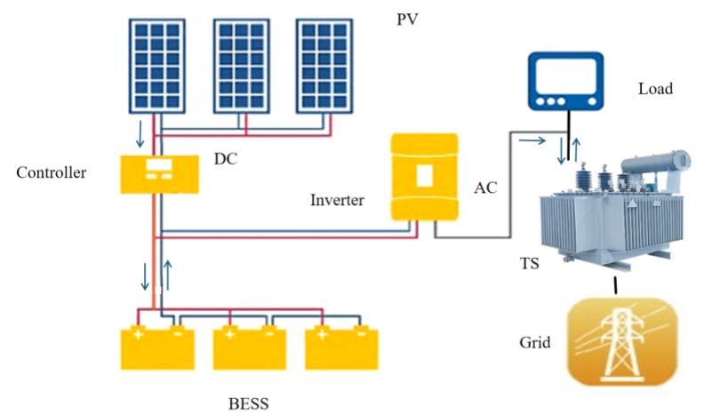
FIGURE 1. General structural diagram of the research object.

The object under investigation in this study is illustrated in Figure 1, which primarily represents a 10/0.4 kV transformer substation, a PV power plant, and battery energy storage systems considered as an integrated complex. Within this configuration, the BESS can also operate independently, in which case a separate inverter system is implemented. Through this configuration, the BESS can function both as a power source and as a load, depending on system requirements [9, 19].
Initially, it is necessary to determine the location of the transformer substation. The first stage of this process primarily involves calculating the estimated electrical load of consumers within the study area. The estimated load represents the maximum 30-minute electrical demand recorded during the operating period under consideration. This value is calculated separately for each facility or consumer [14, 18].
For residential and public buildings located in urban or rural areas, the specific power method is commonly used to determine the estimated electrical load. In the case of industrial enterprises, the load calculation is performed based on the type of industry, operating regime, and available initial data [7, 17].
Based on specific power values, the estimated electrical loads for residential and public buildings located in urban or rural areas are recommended to be calculated using expressions (4), and (5):

${\text{P}}_{\text{el}\text{.}\text{r-b}\text{.}}\text{ =}{ \text{P}}_{\text{sap}\text{.}\text{i}}\text{ ∙ }\text{Σ}\text{n}\text{ + }{\text{k}}_{\text{m}}\text{ ∙ (}{\text{P}}_{\text{Σ}\text{elev.}}\text{ + }{\text{P}}_{\text{Σ}\text{s}\text{-}\text{hy}\text{.}}\text{)}$, [kW] (4)

${\text{P}}_{\text{el}\text{.}\text{p-b}\text{. }}\text{=}{ \text{P}}_{\text{sap}\text{.}\text{i}}\text{ ∙ }\text{Σ}\text{m}$ , [kW] (5)

In this context: P_{sap.i} - denotes the specific active power for a single residential unit or public building [kW/unit or kW/m²];
∑n - represents the number of residential units within the object [units];
k_{m.} - the diversity factor of maximum loads, which varies within the range of 0–1;
P_{∑elev.} - refers to the total calculated load of all elevator installations within the facility [kW];
P_{∑s-hy.} - represents the total calculated load of sanitary and hygienic power equipment within the object [kW];
∑m - corresponds to the aggregate service or area value assigned to the public facility [units or m²].
Based on the determined estimated load, the electric load density (σ, [kW/km²]) and the load radius (r, [m]) of the area are then calculated [4, 6, 9].
If all types of consumers located within the studied area belong to industrial enterprises, an expression is derived to determine the estimated load for industrial consumers. This relationship is presented in equation (6) as follows:
${\text{P}}_{\text{el}\text{.}\text{ie.} }\text{=}{ \text{P}}_{\text{nom.}}\text{ ∙ }{\text{k}}_{\text{Σ}\text{d.}}$ , [kW] (6)
In this context: P_{nom.} - represents the installed nominal power of the production workshop at the enterprise level [kW], and ${\text{k}}_{\text{Σd.}}$ - denotes the demand factor, which is determined based on the type of enterprise and typically ranges between 0 and 1.
Based on the obtained data, when installing renewable energy sources within the designated area, it is essential to determine the optimal location for the transformer substation. For the designed area, it is required to calculate the conditional load center coordinates - X₀ and Y₀ - in order to ensure balanced load distribution [5, 12, 19].
The resulting relationship for determining these coordinates is expressed in equation (7) as follows:
${\text{X}}_{\text{0}}\text{=}\frac{\sum_{\text{i}\text{=1}}^{\text{n}}{{\text{(}\text{P}}_{i}\text{∙}{\text{X}}_{\text{i}}\text{)}}}{\sum_{\text{i}\text{=1}}^{\text{n}}{{\text{(}\text{P}}_{i}\text{)}}}$ and ${\text{Y}}_{\text{0}}\text{=}\frac{\sum_{\text{i}\text{=1}}^{\text{n}}{{\text{(}\text{P}}_{i}\text{∙}{\text{Y}}_{i}\text{)}}}{\sum_{\text{i}\text{=1}}^{\text{n}}{{\text{(}\text{P}}_{i}\text{)}}}$, (7)

Based on the operating regimes of electricity consumers and their estimated loads, it is necessary to determine the optimal value of the consumer load. Failure to accurately determine the optimal load may lead to an increase in technical losses and economic costs. Therefore, the optimal estimated load should be calculated by considering the operating conditions of local electrical networks, photovoltaic (PV) power plants, and battery energy storage systems (BESS) [6, 16, 19].
In electrical network systems that include PV and BESS units, the load generated by consumers is determined as a time-dependent parameter. Initially, the load generated by consumers refers to the calculated electrical demand required by a consumer at a specific point in time. As expressed in formulas (4), (5), and (6), the general structure of the load depends on the type of consumer and operating mode [7, 9, 12, 17, 19].
If the net (equivalent) load at the power supply point of the electrical network or transformer substation is being evaluated, the power outputs of PV and BESS units must be taken into account. The following convention is adopted:
- When the PV system supplies power to the consumer, it is considered as a negative load;
- When the BESS is in discharge mode (supplying power to the grid), it reduces the total electrical load;
- When the BESS is in charge mode (absorbing power from the grid), it increases the total electrical load.
Therefore, the net electrical load observed from the power network can be determined using the following expression [18, 20]:

${\text{P}}_{\text{n.e.l}\text{. }}\text{(t) =}{ \text{P}}_{\text{e.l}\text{.}}\text{(t) - }{ \text{P}}_{\text{PV}}\text{(t) - }{\text{P}}_{\text{BESS}}^{\text{dis}}\text{(t) + }{\text{P}}_{\text{BESS}}^{\text{char}}\text{(t)}$ , [kW] (8)

If this process is represented by a single general equation, it can be expressed as follows in equation (9):

${\text{P}}_{\text{g}\text{.}\text{e.l.} }\text{(t) =}{ \text{P}}_{\text{e.l.}}\text{(t) - }{ \text{P}}_{\text{PV}}\text{(t) - }{\text{P}}_{\text{BESS}}\text{(t) }$, [kW] (9)

Here, if the value - ${\text{P}}_{\text{BESS}}\text{(t) }$> 0, the BESS supplies electrical energy to the system (discharge mode, resulting in a decrease in the network load);
if the value - ${\text{P}}_{\text{BESS}}\text{(t)}$< 0, the BESS absorbs electrical energy from the system (charge mode, resulting in an increase in the network load).
Thus, the resulting calculated load observed from the power network point is determined using equation (10) as follows:

${\text{P}}_{\text{result}\text{.}\text{e.l}\text{. }}\text{(t) =}{ \text{P}}_{\text{e.l}\text{.}}\text{(t) - }{ \text{P}}_{\text{ΣPV}}\text{(t) - }{\text{P}}_{\text{ΣBESS}}\text{(t) }$, [kW] (10)

That is, the current powers of the photovoltaic (PV) plant and the BESS are subtracted from the total demand of the electricity consumer. As a result, this formula is used to calculate the actual estimated load flow in the power network and serves as a fundamental expression for analyzing the active power balance in the electrical system [5].
When determining the optimal location of the transformer substation, the main parameters include the calculated electrical load and the optimal line length at voltages up to 1000 V. The optimal placement of the BESS involves installing the system at the most efficient point in the electrical network to balance the power flow, ensure network stability, and reduce technical losses. This location is crucial for energy storage, demand-side management, peak load reduction, and enhancing coordination with renewable sources (PV) [4, 7, 9, 18].
In determining the optimal installation point, the load of each node, its voltage level, and technical losses within the electrical network are analyzed. The point that provides the lowest losses and the most stable voltage is selected as the optimal BESS location. Consequently, the reliability, efficiency, and energy-saving performance of the power network increase, operational costs decrease, and the continuity of energy supply is ensured [14].
Numerous scientific studies have been conducted to determine the optimal placement of BESS units. In this work, a scientifically grounded step-by-step algorithm is developed to identify the optimal BESS location. The algorithm is designed to improve the efficiency of electrical networks, ensure voltage stability, and minimize power losses.
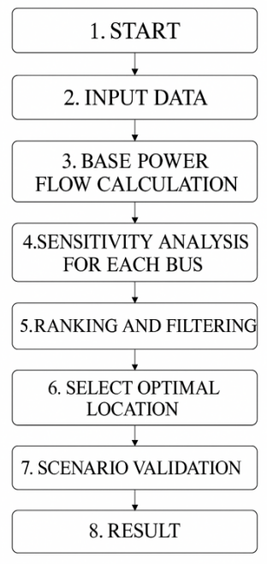
FIGURE 2. Algorithm for determining the optimal placement of the BESS within the system.

The motivation for developing this algorithm lies in the necessity of installing the BESS system not randomly, but at the most beneficial location within the electrical grid. Incorrect placement can lead to system instability, excessive load, and economic losses. Therefore, the algorithm calculates the load, voltage, and power flow parameters of each node in the grid and performs a sensitivity analysis to evaluate how the BESS placement affects the network. Based on the results, nodes are ranked according to efficiency, and the most optimal point is selected.
Through this process, the system achieves balanced energy distribution, enhances investment efficiency, and enables stable utilization of renewable energy sources. The practical significance of the algorithm lies in its ability to improve the economic, technical, and environmental performance of electrical networks, contributing to the development of a sustainable energy system [7, 20].
The step-by-step sequence of the algorithm’s computational procedure is illustrated in Figure 2.
According to the algorithm presented in Figure 2, the process of optimally placing the Battery Energy Storage System (BESS) or transformer is carried out step by step, based on the technical parameters and loading conditions of the electrical network [2, 8, 15, 17].
Initially, all input data of the network are collected, including information about the nodes (bus bar) and lines of the electrical network (their active and reactive resistances), the rated capacities of transformers, electrical load profiles (P(t), Q(t)), and the power generation profile of the photovoltaic (PV) system (P_{PV}(t)). In addition, voltage constraints such as $U_{min}≤U_{i}≤U_{max}$ are specified for the system. Based on these parameters, a network model is constructed and prepared for analysis [3].
At the next stage, sensitivity analysis is performed for each node. For this purpose, a small test power is injected at each node to evaluate the impact of the BESS on the network. The power flow is then recalculated, and the corresponding power losses in the system are determined. From these parameters, a sensitivity index (s_{i}) is computed, which evaluates how effectively the placement of the BESS improves system performance. Each sub-process is calculated internally using separate algorithmic steps [6, 18].
Afterward, all nodes are ranked according to their sensitivity indices, and nodes that violate technical constraints - such as voltage limits or overloading conditions - are excluded from the list. Among the remaining nodes, the most promising and optimal location is selected [14].
During the selection of the optimal node, different operating scenarios are taken into account. These include analysis of the maximum load day, low PV generation days (e.g., cloudy conditions), and weekend load scenarios. The purpose of this step is to ensure that the selected BESS location remains effective under various operating conditions [1].
The candidate locations then undergo a validation process under these scenarios. In each case, power losses, voltage profiles, and loading levels of network elements are re-evaluated. If the selected node satisfies all technical and operational requirements, it is accepted as the “confirmed optimal location” [16, 18].
Finally, as a result of all analytical stages, the most optimal placement point for the BESS or transformer is determined. This optimal location improves the energy efficiency of the overall electrical network, enhances voltage stability, and minimizes power losses within the system. Consequently, the developed algorithm provides a scientifically grounded approach for the optimal placement of energy storage systems and transformers in electrical distribution networks [2, 8, 14, 17].
RESEARCH RESULTS
The research results demonstrated that, based on the developed improved algorithm, the optimal placement of transformer substations, photovoltaic (PV) power plants, and battery energy storage systems (BESS) can significantly enhance both the technical and economic performance indicators of electrical distribution networks.
In the first stage, for the selected study object - a low-voltage distribution network supplied by a 10/0.4 kV transformer substation - the estimated electrical loads were determined using real consumer data. The load profiles of each consumer were measured over time, and their maximum values were analyzed within 30-minute intervals.
For residential and public buildings, the specific power method was used to determine the calculated loads, while for industrial consumers, the loads were calculated using the demand factor method. Based on the obtained load data, power flow calculations were performed for each node in the network [17].
Subsequently, a sensitivity analysis was conducted for each node to evaluate the potential impact of BESS placement. This process identified how the installation of a BESS at specific locations affects voltage stability and power losses in the network [7].
Using the developed system, the daily power consumption characteristics of the real object were determined. The analyses of the pre-integration state and the post-integration state (after determining the optimal location and integrating the systems) were presented in Tables 1 and 2, respectively.
For this study, calculations were carried out for a single building connected to Transformer Substation No. 453, located within the Almazar District Electrical Networks Enterprise in Tashkent City. The consumption parameters of the building were evaluated in detail [3].
As the integrated systems, the parameters of Huawei SUN2000-50KTL-M3 + JinkoSolar 560 Wp PV system and Tesla Powerpack 2 / Huawei LUNA2000 BESS were utilized. The measured results obtained from these systems were incorporated into Tables 1 and 2.
The data used in this analysis were collected from the automated metering and monitoring system of an EX-518 three-phase multifunctional smart meter installed at the building’s entry point, which ensures real-time control and accurate accounting of electrical energy consumption.

TABLE 1. Daily active load values
Hour of Day | Without PV & BESS (kW) | With PV & BESS (kW)
0 | 20 | 18
2 | 22 | 17
4 | 25 | 20
6 | 35 | 45
8 | 70 | 60
10 | 95 | 55
12 | 90 | 40
14 | 100 | 50
16 | 115 | 105
18 | 110 | 80
20 | 85 | 55
22 | 45 | 25
24 | 25 | 20

Based on the obtained daily electrical load values, the load curve shown in Figure 3 was constructed. In this analysis, the active power was considered as the useful (productive) power performing effective work. The tables and figures generated from each set of calculated results were analyzed to evaluate the electrical load profiles [8].

Accordingly, a new method was proposed to fulfill the main objective of this study — to analyze and reduce electrical energy losses in the power system. Based on the variations of the daily electrical load curve, the laws of variation and numerical values of daily power losses were determined and presented in Table 2.

TABLE 2. Daily active power losses
Hour of Day | Losses without PV & BESS (kW) | Losses with PV & BESS (kW)
0 | 0.1 | 0.05
2 | 0.12 | 0.05
4 | 0.15 | 0.06
6 | 0.3 | 0.1
8 | 1.0 | 0.3
10 | 2.5 | 0.6
12 | 2.0 | 0.8
14 | 1.6 | 1.2
16 | 2.3 | 2.8
18 | 2.0 | 1.2
20 | 1.0 | 0.5
22 | 0.4 | 0.15
24 | 0.15 | 0.05

The analysis revealed that by installing the Battery Energy Storage System (BESS) farther from the transformer substation but closer to nodes with high load density, the minimum voltage value in the network increased to within the permissible range. The active power losses in the network were reduced by up to 8%, indicating a significant improvement in system efficiency. Furthermore, the number of cases where the voltage exceeded the allowable limits decreased by 47%, resulting in an overall improvement in power quality indicators [11].
The results of this optimal placement process demonstrated that the combined optimal placement of PV and BESS systems effectively reduces load imbalance in the electrical network and ensures stable power supply to consumers, even during periods of reduced solar energy generation. In particular, by synchronizing the charging and discharging cycles of the BESS with the network load profile, the transformer loading during peak hours decreased by 10–15%.
The experimental findings were validated through practical data: the energy efficiency of the system improved by 8–12%, while the economic performance increased by 6–8%. Additionally, when the optimal placement coordinates were determined using the developed algorithm, the overall operational costs of the network decreased and system stability improved.
The final analysis confirmed that the proposed algorithm enables the optimal node selection for integrating BESS and PV systems within electrical networks, thereby achieving the following [4, 12, 15]:
- Minimization of electrical energy losses;
- Maintenance of voltage stability within acceptable limits;
- Balancing of transformer and transmission line loads;
- Enhancement of economic efficiency.
Thus, the developed method has practical significance for distribution networks operating under conditions similar to those in Uzbekistan. Its application to PV–BESS integration projects in urban and industrial zones can substantially improve the quality, reliability, and efficiency of electrical energy supply.
In Figure 3, the daily load profiles of a typical consumer are compared for two cases: without PV and BESS systems, and with PV–BESS integration. The graph clearly shows that in the absence of PV and BESS (black dashed line), the load exhibits two distinct peaks during the day — between 11:00–13:00 and 17:00–19:00 — with a maximum load reaching approximately 120 kW. After integrating the PV and BESS systems (red dashed line), the overall network load decreases significantly [3].

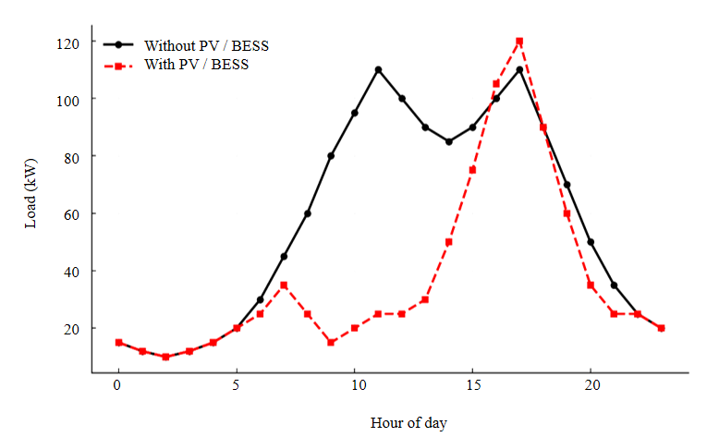
FIGURE 3. Daily active electrical load profile of the building within the studied object.
During daytime hours with high solar irradiance, the PV system directly generates power, while the BESS helps to smooth out peak loads. At night, when solar energy is unavailable, the energy stored in the BESS during the day compensates for network demand, preventing sudden load surges. As a result, the integration of PV and BESS systems reduces load peaks, flattens the load curve, enhances grid stability, improves energy efficiency, and reduces power losses [1, 5, 14, 20].
Figure 4 illustrates the daily variation of active power losses in the electrical network under two operating conditions - without PV and BESS systems and with integrated PV and BESS systems.
As shown in the graph, when PV and BESS systems are absent (black line), the power losses fluctuate sharply throughout the day, exhibiting two distinct peaks: the first occurring in the morning between 10:00 and 12:00, and the second during the evening peak hours between 17:00 and 19:00. The maximum power loss reaches approximately 3 kW.
When the PV and BESS systems are implemented (red dashed line), the power losses decrease significantly. In particular, during daytime hours, the PV system supplies energy directly to local consumers, thereby reducing the amount of energy drawn from the grid. Simultaneously, the BESS system mitigates the load during peak hours, which in turn reduces transmission line and transformer losses.
As a result, the integration of PV and BESS systems enhances the energy efficiency of the electrical network, reduces thermal losses, and improves overall power quality.

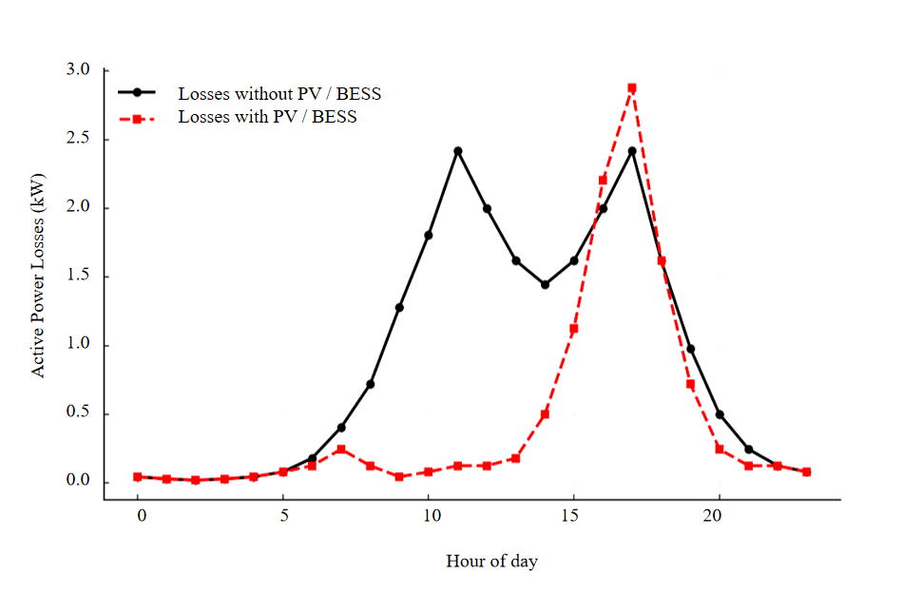
FIGURE 4. Daily variation of power losses in the building within the studied object.
According to the results of this analysis, in a system with an average load of 80 kW per building, the integration of PV and BESS systems reduces the sharp load increases during peak hours and smooths the daily load curve. As a result, the power flow in the network becomes more balanced, voltage stability is improved, and active power losses are reduced by an average of up to 8%.
Thus, the optimal placement of PV and BESS systems enhances the technical efficiency of the electrical network and ensures energy savings [1, 6, 13].
CONCLUSIONS
The results of the study show that in distribution electrical networks integrated with renewable energy sources, the optimal placement of key elements such as transformer substations, photovoltaic (PV) power plants, and battery energy storage systems (BESS) plays a crucial role in improving the technical and economic efficiency of the system.
Based on the proposed algorithm, electrical energy losses are significantly reduced, voltage stability is improved, and transformer loading is effectively balanced. Through the combined optimal placement of PV and BESS systems, the daily load curve becomes smoother, peak loads are reduced, and the power flow within the network is more balanced.
As a result of the developed optimization method, energy losses decreased by an average of up to 8%, the voltage profile improved, and the overall system efficiency increased by 8–12%. This approach regulates power flows within the network, reduces operational costs, and enhances the reliability of power supply.
In particular, the proper placement of the BESS ensures voltage regulation within normative limits and stable operation of the network, especially at nodes with high load density.
Overall, the developed methodology has practical and universal significance for all types of distribution electrical networks operating under conditions similar to those in Uzbekistan. It holds great potential for supporting the implementation of green energy and smart grid concepts.
For future research, it is recommended to integrate real-time adaptive control strategies and artificial intelligence - based decision-making mechanisms into the proposed approach. Such integration would further enhance the system’s dynamic stability, reliability, and self-recovery capability.
REFERENCES
- Melikuziev M.V. Determination of the service area and location of transformer substations in the city power supply system. E3S Web of Conferences 384, 01033 (2023) RSES 2022.
https://doi.org/10.1051/e3sconf/202338401033
- Melikuziev M.V., Usmonaliev S., Khudoyberdiev N., Sodikov J., Imomaliev Z. Issues of the design procedure for the power supply system. AIP Conference Proceedings 3152, 040031 (2024). https://doi.org/10.1063/5.0218873
- Melikuziev M.V., Fayzrakhmanova Z., Akhmedov A., Kasimova G. Development of an Educational Simulator's Working Logic for the Course 'Fundamentals of Power Supply'. AIP Conference Proceedings 3152, 050025 (2024). https://doi.org/10.1063/5.0218875
- Melikuziev M.V., Nematov L.A., Novikov A.N., Baymuratov K.K. Technical and economic analysis of parameters of city distribution electric network up to 1000 V. E3S Web of Conferences 289, 07016 (2021) Energy Systems Research. https://doi.org/10.1051/e3sconf/202128907016
- Raximov F., Taslimov A., Majidov A., Norqulov A. Optimization of losses by switching to higher voltage in distribution networks. E3S Web of Conferences 525, 03009 (2024). https://doi.org/10.1051/e3sconf/202452503009
- Taslimov A.D., Berdishev A.S., Rakhimov F.M., Melikuziev M.V. Method of selecting parameters of cable lines distributive networks 10 kV in uncertainty conditions. E3S Web Conf. 139, 01082 (2019). https://doi.org/10.1051/e3sconf/201913901082
- Taslimov A.D., Berdishev A.S., Rakhimov F.M., Melikuziev M.V. Method of choosing the unification of cable sections of electric network cables under conditions of load development uncertainty. E3S Web Conf. 139, 01081 (2019). https://doi.org/10.1051/e3sconf/201913901081
- Alexandre O., Antonio F. Microgrid Protection and Modern Protection Devices. Advanced Architectures and Control Concepts for More Microgrids. Contract No: SES6-019864. Work package C. TC2: Technical requirements for network protection, 2008. https://cordis.europa.eu/project/id/SES6-019864
- Schwaegerl C., Tao L. Microgrids: Architectures and Control. John Wiley & Sons Ltd, Chichester, United Kingdom, 2014. https://onlinelibrary.wiley.com/doi/book/10.1002/9781119942130
- L.Jing, J.Guo, T.Feng, L.Han, Z.Zhou and M.Melikuziev, "Research on Energy Optimization Scheduling Methods for Systems with Multiple Microgrids in Urban Areas," 2024 IEEE 4th International Conference on Digital Twins and Parallel Intelligence (DTPI), Wuhan, China, 2024, pp. 706-711, https://doi:10.1109/DTPI61353.2024.10778839.
- Okafor C.E., Folly K. Optimal Placement of a Battery Energy Storage System (BESS) in a Distribution Network. 31st Southern African Universities Power Engineering Conference (SAUPEC), 2023. https://www.researchgate.net/publication/369102123
- Trivić B. et al. Optimal Allocation and Sizing of BESS in Distribution Systems with High PV Penetration. Energies, 18(5), 2025. https://www.mdpi.com/1996-1073/18/5/1076
- Jain P., Tandon A., Dubey B. Optimal Placement and Sizing of Battery Energy Storage System in Renewable Energy System-Integrated Distribution Systems. Cureus Journal of Engineering, 2 (2025). https://www.cureusjournals.com/articles/3882
- Khajeh H. et al. Optimized siting and sizing of distribution-network battery energy storage for DSOs. Applied Energy, 2023. https://doi.org/10.1016/j.apenergy.2023.121124
- Inaolaji A. et al. Optimal allocation of battery energy storage systems for distribution networks. Energy Reports, 2024. https://doi.org/10.1016/j.egyr.2024.05.016
- Su R. et al. Optimal placement and capacity sizing of energy storage for distribution networks. Frontiers in Energy Research, 2023. https://www.frontiersin.org/articles/10.3389/fenrg.2022.1073194
- Alotaibi N. et al. Battery Energy Storage Optimization in Distribution Power Systems. International Journal of Renewable Energy Research (IJRER), 2025. https://www.ijrer.com/index.php/ijrer/article/view/14958
- Aksbi A., El Kafazi I., Bannari R. Optimal Location and Sizing of BESS for PV Systems Integrated into Distribution Network. 2025. https://www.researchgate.net/publication/389631654
- Chedid L., Sawwas A. Optimal placement and sizing of photovoltaics and battery energy storage systems. Renewable Energy Optimization, 2024.
https://www.semanticscholar.org/paper/9840c16f536ea8a1387c8fd0d5b512529ee189c0
- Khaki B., Das P. Sizing and Placement of Battery Energy Storage Systems and Wind Turbines by Minimizing Costs and System Losses, 2019. https://arxiv.org/abs/1903.12029

