Fuel-Free Power Generation Based on Turbo-Expander Units within the Uzbekistan Gas Transmission System
Abdurakhim Taslimov, Arsen Mukolyants ^{a)}, Irina Sotnikova, Dilbar Ergasheva, Jonibek Nizomov
Tashkent state technical university named after Islam Karimov, Tashkent, Uzbekistan
^{a)} Corresponding author: arsenm5675@gmail.com
Abstract. Thermodynamic analysis and optimization were conducted for fuel-free turbo-expander units (TEU) at gas distribution points utilizing heat pump units (HPU) for gas preheating. The research aims to enhance the energy efficiency of the TEU through a comprehensive assessment of the HPU's impact on the system's exergetic efficiency and the minimization of energy consumption for the compressor drive. A mathematical model was developed to account for the interrelationships between the TEU’s electrical power, gas flow rate, and preheating parameters. Comparative modeling of single-stage and two-stage TEUs was performed in combination with vapor-compression (using R134a and CO₂) and air-source heat pump units under varying ambient conditions. The efficiency criterion was defined as the share of electricity delivered to the external grid. The results established that two-stage TEUs with vapor-compression HPUs operating on CO₂ possess the highest thermodynamic efficiency, confirming the potential of CO₂ as an environmentally safe working fluid despite its high-pressure requirements. It was also shown that single-stage TEUs with air-source HPUs demonstrate a high share of electricity output to the grid. Furthermore, it was found that increasing the gas preheating temperature enhances the system's exergetic efficiency. A methodology is proposed for the accurate determination of nominal parameters and the annual power generation of TEUs. The results of this analysis provide a basis for selecting the optimal HPU type and working fluid when designing installations to ensure maximum performance and resource conservation.
INTRODUCTION
Energy conservation is one of the key directions for increasing the efficiency of energy systems. Despite the achieved level of technological development in electricity generation based on organic fuel, further improvement of technical-economic and environmental indicators requires the introduction of new technical solutions [1, 2]. In the context of growing energy consumption, this problem is especially relevant for Uzbekistan, which has significant potential of its own energy resources [3, 4]. Among the priority technologies in the republic's gas industry is the use of expander-generator units (EGUs), which convert the gas pressure drop into electrical energy during its throttling process [5-7].
The electricity generated by an expander-generator unit (EGU) depends on the mass flow rate of the gas and its parameters at the inlet and outlet of the gas distribution point (GDP). With an increase in gas temperature before the EGU, the exergy of heat supplied to the gas flow increases, which contributes to an increase in the exergetic efficiency of the unit.
Increasing the gas preheating temperature before a heat pump unit (HPU) can reduce the amount of electricity required to drive the compressor but may lead to a decrease in cold output for consumers [8-10]. Therefore, building a mathematical model of the unit requires comprehensive consideration of these factors for subsequent optimization of operating modes based on technical and economic efficiency criteria. Only then can the highest productivity and resource savings be achieved within the given unit.
Vapor compression units do indeed have thermodynamic advantages and can provide a higher coefficient of performance than air-source heat pump units (ASHP). Air-source heat pump units, in turn, can be attractive for operation in cases where it is not possible to use other heat transfer media or refrigerants (and in remote locations of gas distribution stations).
When selecting the optimal type of HPU for use in a EGU, various factors must be considered, such as requirements for efficiency and cost-effectiveness, operating conditions, availability of fuel and energy resources, environmental safety, and others. Moreover, the technical characteristics of the HPU directly affect the overall efficiency of the plant and the amount of auxiliary power consumption, including the energy consumption of compressor equipment.
When developing a mathematical model of a fuel-free plant based on vapor-compression or air-source HPUs, it is necessary to integrate the specific parameters of the pressure reduction node into the calculation algorithm, as well as to account for operational limitations and the system's functional boundary conditions. Furthermore, the goal of achieving efficient operation of such a plant can only be accomplished through a comprehensive analysis of the electricity and gas preheating requirements, the selection of the optimal type and operation of the HPU, and by choosing the most economical and efficient operating mode for all system components.
Performing calculations using different working fluids and various types of HPUs represents an important step in achieving maximum efficiency and cost-effectiveness of the plant. The choice of working fluid should be based on its thermodynamic properties, availability, environmental safety, and technological factors.
Choosing a vapor-compression HPU provides the possibility of achieving a higher coefficient of performance (COP) compared to using air-source refrigeration machines. At the same time, the selected working fluid must possess high efficiency and environmental safety. Based on the calculations performed, it was found that the use of refrigerant R134a (without subcooling the condensate) allows for achieving a higher coefficient of performance compared to using a refrigerant with subcooling.
The use of the promising refrigerant CO₂ could be more environmentally friendly and efficient for this plant. However, it should be taken into account that CO₂ requires higher pressures and temperatures for its operation, which may increase equipment costs.
The use of air-source HPUs can be attractive in cases where no other heat transfer media are available, and it must also be considered that there is no cost for its consumption (i.e., the air is free). Furthermore, the use of air-source HPUs can be important in environmentally sensitive zones.

EXPERIMENTAL RESEARCH
Based on the calculated data, a comparative thermodynamic analysis was conducted for the schemes of single-stage expander-generator units integrated with vapor-compression and air-source heat pump units [11]. The specific indicator of useful electricity supplied to the external grid was adopted as the key efficiency criterion.
Following the results of mathematical modeling, a comparison was made of the thermodynamic efficiency of configurations of single-stage DGUs with vapor-compression and air-source gas preheating. The efficiency of the considered schemes was evaluated based on the share of electricity delivered to the consumer minus the power consumed by the HPU compressors.
The calculations were performed under the condition of constant thermal power supplied to the gas flow and an ambient temperature range of 0… +20°C. Water and the air environment were considered as low-potential thermal resources, their thermophysical properties being correlated with the current climatic conditions. For the computations, the following initial characteristics were set: gas flow rate — 9.5 kg/s; operating pressures before and after expansion — 0.8–1.2 / 0.2 MPa. The heating intensity of the working fluid was established based on maintaining an isenthalpic process at the boundaries of the calculation cycle. The adiabatic efficiencies of the turbomachines (compressor and expander) were fixed at 0.85, while the electromechanical efficiency was set at 0.95 [12].
For air-source heat pump systems, temperature differentials of 5 and 10 °C were specified; for equipment with a vapor-compression cycle, similar temperature differences in the condenser and evaporator were set. The calculation results for a pressure drop of 1.0/0.2 MPa are presented in Table 1.
As can be seen from the diagram (Figure 1), an increase in the pressure and temperature of the gas mixture before the pressure reduction node requires a higher degree of gas preheating. This measure ensures the enthalpy balance at the inlet and outlet points of the technological pressure reduction complex.

TABLE 1. Share of useful electricity output of various heat pump units (at 1.0/0.2 MPa)
Name | HPU type | Environmental temperature, t_{en}°C
Name | HPU type | 0 | 5 | 10 | 15 | 20
Enthalpy of gas at inlet/outlet of the Expander-Generator Unit (EGU), h_{in} (h_{out}) kJ/kg | -- | 844,46 | 855,73 | 867,02 | 878,35 | 889,71
Gas temperature at inlet to the EGU, °C | -- | 92,94 | 99,83 | 106,71 | 113,60 | 120,47
Power generated by the EGU, N_{EGU} kW | -- | 2170,42 | 2212,73 | 2254,90 | 2297,06 | 2339,11
Gas temperature at outlet from the EGU, °C | -- | -4,23 | 0,93 | 6,07 | 11,22 | 16,35
Heat required for gas heating, Q1 kW | -- | 2301,68 | 2362,42 | 2422,95 | 2486,23 | 2550,25
Power consumed by the HPU compressor, N_{C}, kW | Vapor compression,  R134а,  Without subcooling | 1374,19 | 1542,44 | 1866,81 | 358,47 | 354,69
Efficient power of the unit, N_{efficiency}, kW | Vapor compression,  R134а,  Without subcooling | 796,23 | 670,29 | 388,09
Share of electricity supplied to the grid, α | Vapor compression,  R134а,  Without subcooling | 0,37 | 0,30 |  | - | -
 |  |  |  | 0,17 | - | -
Power consumed by the HPU compressor, N_{C}, kW | Vapor compression,  R134а,  With subcooling | 689,68 | 703,01 | 716,08 | 729,80 | 743,79
Efficient power of the unit, N_{efficiency}, kW | Vapor compression,  R134а,  With subcooling | 1480,75 | 1509,72 | 1538,82 | 1567,27 | 1595,32
Share of electricity supplied to the grid, α | Vapor compression,  R134а,  With subcooling | 0,68 | 0,68 | 0,68 | 0,68 | 0,68
Power consumed by the HPU compressor, N_{C}, kW | Vapor compression,  СО₂ | 628,13 | 667,91 | 713,42 | 768,21 | 836,34
Efficient power of the unit, N_{efficiency}, kW | Vapor compression,  СО₂ | 1542,29 | 1544,82 | 1541,48 | 1528,86 | 1502,76
Share of electricity supplied to the grid, α | Vapor compression,  СО₂ | 0,71 | 0,70 | 0,68 | 0,67 | 0,64
Power of the HPU compressor, N_{C}, kW | ASHPU | 2827,68 | 2896,80 | 2965,31 | 3037,47 | 3110,16
Power of HPU turbine N_{T},kW | ASHPU | 1454,91 | 1489,23 | 1525,48 | 1558,36 | 1594,11
Efficient power of the unit, N_{useful}, kW | ASHPU | 797,65 | 805,17 | 815,07 | 817,95 | 823,06
Share of electricity supplied to the grid, α | ASHPU | 0,37 | 0,36 | 0,36 | 0,36 | 0,35
In graphical form, the calculation results for other pressure intervals are presented in Figs. 1-4.
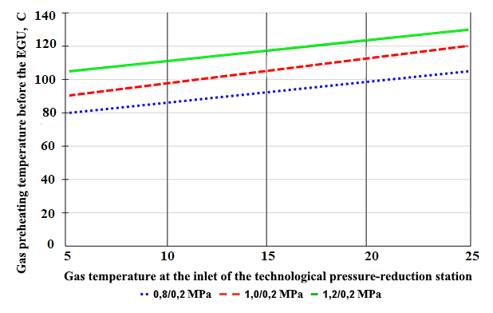
FIGURE 1. Dependence of the gas temperature at the inlet of the Gas Distribution Point (GDP) on the preheating intensity before the Expander-Generator Unit (EGU).

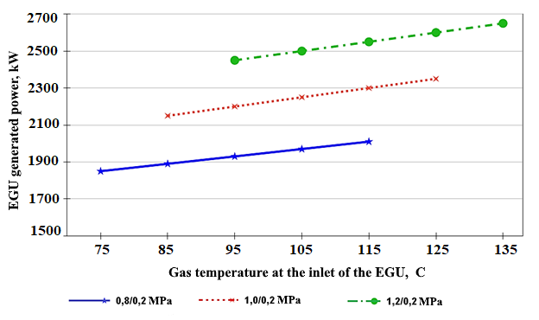
FIGURE 2. Dependence of DGU Power on Preheating Temperature and Pressure Drop

Fig. 2 demonstrates how the power generation by the Expander-Generator Unit (EGU) is influenced by the intensity of gas preheating and the magnitude of the pressure differential at the inlet to the expander unit.

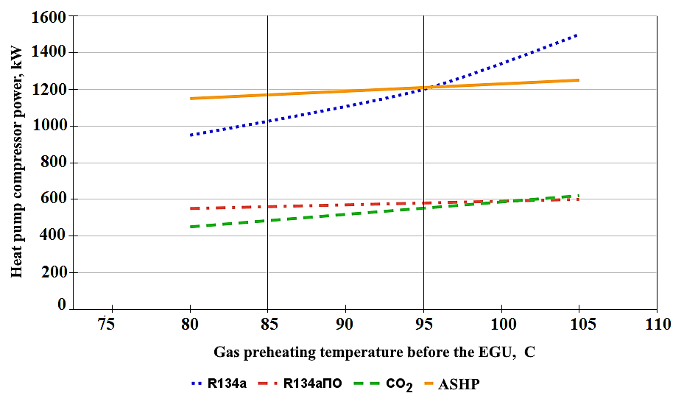

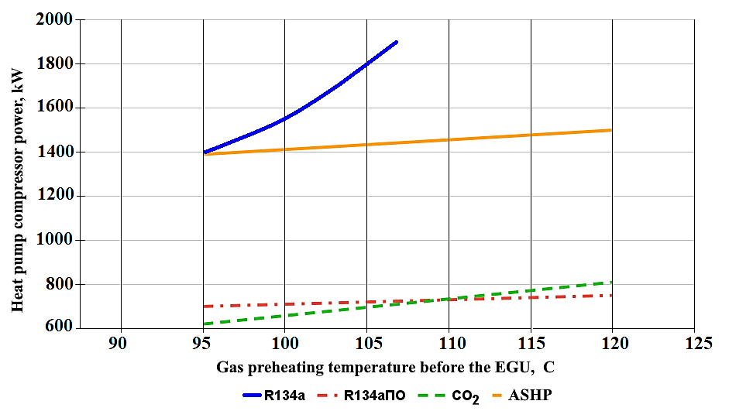
b)
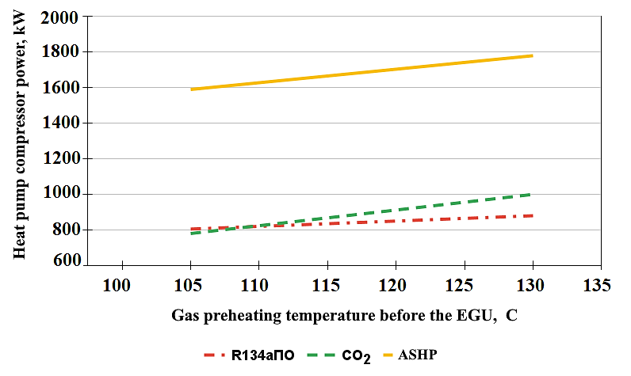
c)
FIGURE 3. Influence of gas preheating temperature before the EGU on compressor power consumption:
a) Power consumption of compressors in various HPUs versus gas preheating temperature; b) Energy consumption for various refrigerants versus gas preheating temperature; c) Compressor drive power versus gas preheating temperature

The study of the graphs presented in Fig. 3 led to several conclusions:
- For each of the considered heat pump unit models, an increase in compressor energy consumption was recorded in case of an increase in gas heating temperature.
- The most intensive growth in energy consumption was recorded for the HPU using refrigerant R134a (without condensate subcooling). It was established that at inlet pressures of 1.0–1.2 MPa and preheating temperatures above 107 °C, operation with this refrigerant is possible only via a transcritical cycle.
- The use of carbon dioxide (CO₂) minimizes the compressor drive's energy consumption within specific temperature corridors: 79–98 °C (at 0.8/0.2 MPa), 93–108 °C (at 1.0/0.2 MPa), and 104–115 °C (at 1.2/0.2 MPa). The nature of the change in the share of electricity fed into the common grid, depending on the gas heating in the EGU system, is presented in Fig. 4.

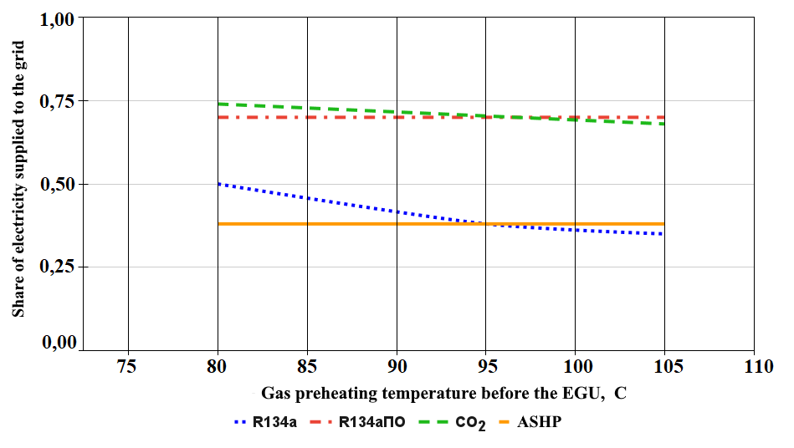
a)
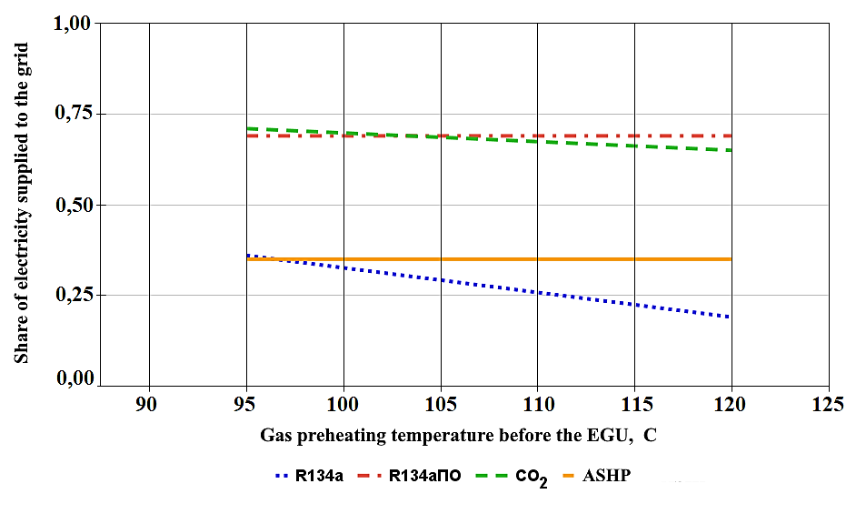
b)
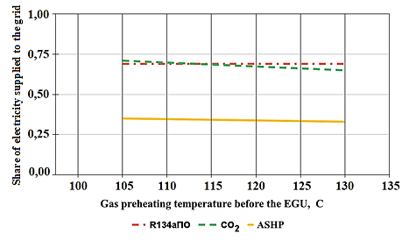
c)
FIGURE 4. Dependence of Useful Electricity Supply on the Gas Preheating Temperature before the EGU:
a) Share of electricity supplied to the grid versus gas preheating temperature; b) Share of electricity supplied to the grid versus gas preheating temperature interval; c) Share of electricity supplied to the grid versus refrigerant type.
RESEARCH RESULTS
An analysis of the graphical data (Fig. 4) and the results presented in Table 1 enabled the identification of the following patterns:
- It has been established that an increase in gas preheating temperature leads to a reduction in the share of useful electricity supplied. At the same time, CO₂-based systems demonstrate maximum efficiency within the following temperature intervals: 79–98 °C (at 0.8/0.2 MPa), 93–108 °C (at 1.0/0.2 MPa), and 104–115 °C (at 1.2/0.2 MPa).
- The amount of electrical energy supplied to the external grid is inversely proportional to the power consumed for the operation of the HPU's compressor unit.
- In schemes using agent R134a (which include subcooling of the working fluid), the points of maximum power generation shift towards higher temperature regimes: 98–106 °C, 108–121 °C, and 115–133 °C for the specified pressure drops.
- The minimum useful energy output was noted when using air-cycle HPUs. Furthermore, the impossibility of operating heat pump units on R134a without a subcooling system under certain conditions (specifically, at a pressure of 1.2/0.2 MPa) was established.
- Throughout the entire investigated pressure range, vapor-compression plants operating on carbon dioxide and R134a (with a subcooler) significantly outperform air-source HPUs and systems using R134a without condensate cooling in terms of energy efficiency.
CONCLUSIONS
The research confirms that the integration of turbo-expander units (TEU) with heat pump systems is a highly effective method for utilizing the pressure potential of natural gas in Uzbekistan. It was established that under equal operating conditions, single-stage TEUs possess greater energy potential than two-stage configurations when operating independently. However, when combined with vapor-compression energy converters, two-stage TEUs demonstrate superior performance by increasing the total electrical energy transferred to the external grid. Conversely, the implementation of air-source heat pumps (ASHPs) favors single-stage TEU modifications for achieving better indicators of useful electricity supply. Among all investigated configurations, the highest thermodynamic efficiency was demonstrated by plants equipped with vapor-compression HPUs using carbon dioxide (CO₂). Despite the high-pressure requirements of CO₂ systems, their environmental safety and efficiency make them a priority for industrial modernization.
The study identified that increasing gas preheating temperature generally enhances the system's exergetic efficiency but requires careful optimization of compressor energy consumption. Numerical modeling proved that the use of R134a with subcooling is necessary to avoid transcritical cycles at pressures above 1.0 MPa. The proposed mathematical model allows for the accurate determination of nominal parameters for TEU installations across various climatic zones. The findings provide a scientific basis for selecting the optimal working fluid and heat pump type depending on the specific pressure drop at gas distribution points. Economic analysis suggests that such fuel-free systems significantly reduce the carbon footprint of the gas transmission network.
The implementation of these technologies supports the national energy-saving strategy and the transition to sustainable industrial development in Uzbekistan. Future research should focus on the long-term reliability of TEU components under fluctuating gas flow rates. Additionally, the development of automated control systems for HPU-TEU complexes will further enhance their operational stability. In conclusion, the comprehensive optimization of preheating and expansion processes ensures maximum resource conservation and electricity generation without additional fuel consumption.
REFERENCES
- Mukolyants, A. A., Sotnikova, I. V., & Ergasheva, D. K. (2023). Analysis of the joint operation of the expander-generator unit and air heat pump. E3S Web of Conferences, 419, 01016. https://doi.org/10.1051/e3sconf/202341901016
- Mukolyants, A. A., Sotnikova, I. V., & Ergasheva, D. K. (2024). Investigation of a fuel-free power generating plant and evaluation of the effectiveness of its use. E3S Web of Conferences, 474, 01011. https://doi.org/10.1051/e3sconf/202447401011
- Ganiyeva, M. A., & Juraev, S. S. (2021). Innovative technologies for increasing the energy efficiency of gas transport systems in Uzbekistan. International Journal of Advanced Research in Science, Engineering and Technology, 8(3), 16890–16895.
- Safarov, O. A., & Toshov, J. B. (2023). Assessment of secondary energy resources utilization in the industrial sectors of Uzbekistan. Uzbek Journal of Oil and Gas, (4), 88–94.
- Klimenko, A. V., Agababov, V. S., Borisova, P. N., & Petin, S. N. (2017). Thermodynamic efficiency of using expander-generator units at stations of technological pressure reduction of transported natural gas. Thermophysics and Aeromechanics, 24(6), 933–940. https://doi.org/10.1134/S0869864317060129
- Buranov, M. D., Mukolyants, A. A., & Sotnikova, I. V. (2019). Generation of electrical energy at gas pipelines using a transported natural gas technological pressure drop. E3S Web of Conferences, 139, 01089. https://doi.org/10.1051/e3sconf/201913901089
- Golyashiv, A. N., & Bondarenko, V. L. (2019). Energy saving potential of turboexpanders at industrial gas pressure control points. Journal of Engineering Physics and Thermophysics, 92(4), 1012–1018. https://doi.org/10.1007/s10891-019-02014-z
- Zubarev, A. A., & Shcheglyaev, A. S. (2020). Optimization of heat recovery systems for natural gas preheating in turboexpander plants. Energy Reports, 6, 234–241. https://doi.org/10.1016/j.egyr.2020.08.045
- Lo Cascio, E., Perna, A., & Spazzafumo, G. (2018). Thermodynamic analysis of a turboexpander for electricity generation in a natural gas pressure reduction station. Energy Procedia, 148, 1114–1121. https://doi.org/10.1016/j.egypro.2018.08.026
- Heidari, M., & Hanafizadeh, P. (2016). Exergy analysis and optimization of a turboexpander in a natural gas pressure reduction station. Journal of Natural Gas Science and Engineering, 34, 1155–1165. https://doi.org/10.1016/j.jngse.2016.08.007
- Isakov, A. S., & Murodov, B. M. (2024). Application of adsorption drying systems for improving the reliability of gas distribution equipment. Journal of Physics: Conference Series, 2701, 012015. https://doi.org/10.1088/1742-6596/2701/1/012015
- Mukolyants, A. A., Sotnikova, I. V., Ergasheva, D. K., Shadibekova, F. T., & Taubaldiev, A. A. (2021). Heating of natural gas before expander-generator unit. Journal of Physics: Conference Series, 2094(5), 052049. https://doi.org/10.1088/1742-6596/2094/5/052049

