Intelligent GMDH-Based Model for Forecasting Electricity Losses in Distribution Networks
Xilola Nazirova ^{a)}, Abdumalik Badalov, Sumbula Jabborova
Tashkent state technical university named after Islam Karimov, Tashkent, Uzbekistan
^{a)} Corresponding author: hilolazahidjanovna1987@gmail.com
Abstract. Electricity losses in distribution networks, particularly in 0.4 kV grids, are influenced by numerous nonlinear factors and require more advanced forecasting approaches. This study proposes a model based on the Group Method of Data Handling (GMDH), which provides automatic structure selection and robustness to noisy and limited data. The obtained results demonstrate a low prediction error, confirming the applicability of GMDH for forecasting electricity losses under conditions of limited observability.
INTRODUCTION
Electricity losses in distribution networks represent one of the most complex and impactful challenges in modern power systems. With increasing loads, expanding electrification, and the progressive aging of infrastructure, low-voltage 0.4 kV networks have become the most vulnerable segment, where technical losses are influenced by a wide range of factors, including consumption patterns, weather conditions, load characteristics, and line conditions. The nonlinear and highly dynamic nature of these factors complicates the development of accurate forecasting models, which directly affects operational efficiency, maintenance planning, and cost reduction for power utilities[1].
Traditional statistical forecasting methods provide acceptable accuracy only when strict assumptions regarding data structure and volume are satisfied. However, real operational data from distribution networks are typically represented by short, noisy, incomplete time series with multiple gaps, which significantly limits the effectiveness of classical models and leads to reduced forecasting accuracy. This highlights the need for intelligent analytical techniques capable of identifying hidden nonlinear dependencies and ensuring stable performance under limited observability [2].
One of the promising tools for addressing these challenges is the Group Method of Data Handling (GMDH), which is based on the principles of model self-organization. Unlike conventional regression approaches, GMDH generates multiple intermediate functional relations, automatically selects optimal models using internal and external criteria, and captures complex interactions among input variables. This structural adaptability enhances resistance to overfitting and makes the method particularly suitable for forecasting problems characterized by uncertainty and incomplete information [3-8].
EXPERIMENTAL RESEARCH
The initial dataset consists of a time series of daily electricity losses in 0.4 kV distribution networks. The dataset covers an entire calendar year and reflects the typical dynamics of distribution grids, including alternating periods of high and low load, seasonal fluctuations, and variations associated with operating conditions of transformer substations and consumer behavior.[9].
A preliminary visual analysis of the time series (Figure 1) revealed pronounced nonlinearity, isolated anomalous deviations, and extended trend components. These characteristics indicate a complex data structure and highlight the need for intelligent forecasting methods capable of capturing hidden dependencies, adapting to non-stationarity, and ensuring robust estimates under limited observability.
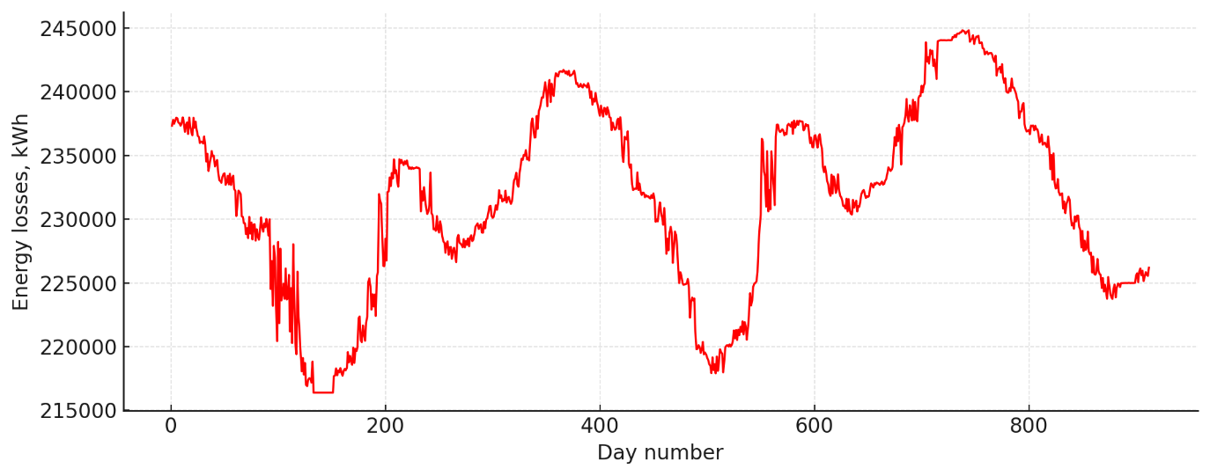
FIGURE 1. Original time series of daily electricity losses
At the preprocessing stage, the data were normalized and split into training (80%) and test (20%) subsets. This approach ensures an objective assessment of the model’s predictive accuracy and helps avoid overfitting when constructing the multi-layer GMDH structure.
The Group Method of Data Handling (GMDH) was applied to iteratively generate models of increasing complexity. At each layer, a set of polynomial partial descriptions was formed and subsequently filtered using internal quality criteria. At the next stage, the external criterion-the Mean Absolute Percentage Error (MAPE)-was employed to evaluate the predictive capability of the model.
Figure 2 illustrates the dependence of the MAPE value on the model layer index. The minimum error was obtained at the fourth layer, indicating an optimal balance between the number of model parameters and its generalization ability.
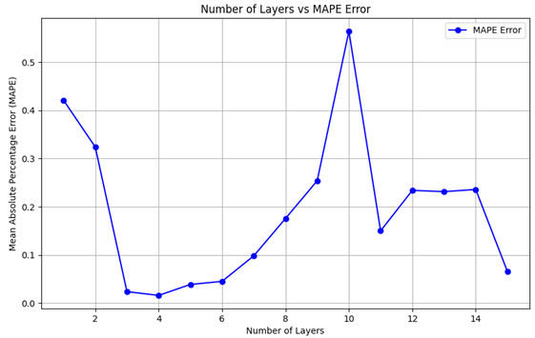
FIGURE 2. Determining the optimal layer of the multilayer GMDH model with minimal MAPE error
Thus, the experimental investigation made it possible to determine the optimal structure of the multilayer GMDH model and identify the layer that provides the minimum forecasting error. The results obtained at the preliminary analysis stage demonstrate the model’s potential to effectively reproduce the nonlinear dynamics of the time series and operate reliably under conditions of limited observability[11-15].
RESEARCH RESULTS
After identifying the optimal GMDH model layer, the predictive performance of the model was evaluated using an independent test dataset. The objective of this stage was to assess the model’s generalization capability and its robustness under irregular and noisy conditions typical for 0.4 kV distribution networks.
The application of the GMDH configuration corresponding to the minimum MAPE value demonstrated that the model accurately reproduces the dynamics of daily energy losses. Figure 3 presents a comparison between the actual and predicted values of the time series [16-18].
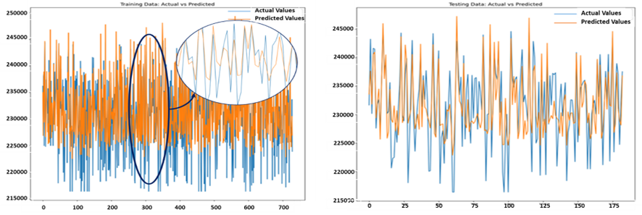
FIGURE 3. Comparison of actual and predicted daily electricity losses
As shown in the figure, the predicted values closely follow the behavior of the original series, confirming the high accuracy of approximation. The model successfully captures both short-term fluctuations and long-term trends without exhibiting significant deviations on individual segments [19-22].
A quantitative evaluation of the forecasting accuracy was also performed. The MAPE obtained on the test dataset matches the minimum value identified at the fourth layer of the model, confirming the correctness of the structural selection. The MAE and RMSE indicators also show stable performance, indicating the absence of overfitting.
Overall, the results confirm that the multilayer GMDH model exhibits strong predictive capability and effectively handles the task of modeling electricity losses under conditions of:
- limited observability,
- nonlinear behavior of the input data,
- presence of noise and anomalous points.
Thanks to its self-organizing mechanism, the model structure automatically adapts to the complexity of the data, ensuring stable and reliable forecasting performance.
CONCLUSIONS
In this study, a multilayer GMDH model was developed and applied to forecast daily electricity losses in a 0.4 kV distribution network. Analysis of a real 912-day time series demonstrated that the Group Method of Data Handling provides high forecasting accuracy under conditions of limited observability, nonlinear data behavior, and substantial measurement noise.
Experimental results showed that the optimal structure is achieved at the fourth layer of the multilayer GMDH model. On the independent test dataset, the model achieved a MAPE of 5.05%, which is considered an acceptable level of accuracy for forecasting electricity losses in distribution networks and aligns with engineering performance criteria. This value is consistent with the visual comparison of actual and predicted curves, where the model effectively reproduces both short-term fluctuations and long-term trends.
The model shows no signs of overfitting and maintains stable performance on previously unseen data. This confirms that the self-organizing structure and iterative selection mechanisms implemented in GMDH allow the model to adapt to the complexity of the data and accurately represent the nonlinear processes underlying energy losses in 0.4 kV distribution grids.
Overall, the multilayer GMDH model proves to be a promising tool for forecasting and analyzing electricity losses. The method can be practically applied by energy distribution companies for operational planning, technical loss assessment, and efficiency improvements in distribution network management.
REFERENCES
- Allayev K.R., Nazirova Kh.Z. Comparative assessment of electricity losses using ANN and GMDH methods // Problems of Energy and Resource Saving, 2024. pp. 1–10.
- Allayev K.R., Nazirova Kh.Z. Comparison of various forecasting methods of energy losses in distribution networks // Problems of Energy and Resource Saving, 2024. pp. 41–50.
- Nazirova Kh. Methods for determining static characteristics in industrial electrical networks // E3S Web of Conferences 384, 01046 (2023) https://doi.org/10.1051/e3sconf/202338401046 RSES. 2022
- Rasulov A.N, Nazirova Kh.Z, Badalov A.A., Saidova M. Study on graphs of electrical load and analysis of power consumption modes // E3S Web of Conferences 497, 01005 (2024) https://doi.org/10.1051/e3sconf/202449701005 ICECAE 2024
- Nazirova H.Z., Badalov A.A., Jo’rayev R.R. Comparative Analysis of the Calculation of Electricity Losses in 10-6-0.4 kV Distribution Networks // III International Scientific and Technical Conference "Actual Issues of Power Supply Systems (ICAIPSS1023) AIP Conf Proc. 3152, 030013-1-030013-6, https://doi.org/10.1063/5,0218854
- Madala H.R., Ivakhnenko A.G. Inductive Learning Algorithms for Complex Systems Modeling. CRC Press, Boca Raton, 1994. 365 p.
- Ivakhnenko A.G., Stepashko V.S. Noise Immunity of Modeling. Kiev: Naukova Dumka, 1985.
- Miller J.A., Ivakhnenko A.G. Selbstorganisation von Vorhersagemodellen. Berlin: VEB Verlag Technik, 1984.
- Ivakhnenko A.G., Yurachkovsky Yu.P. Modeling of Complex Systems after Experimental Data. Moscow: Radio i Svyaz, 1987.
- Ivakhnenko A.G. Continuity and Discreteness. Kiev: Naukova Dumka, 1990.
- Farlow S.J. (ed.). Self-Organizing Methods in Modeling. Marcel Dekker, New York — Basel, 1984.
- Tsado J., Usman A., Saka B., Ajagun A.S. Short-term electrical energy consumption forecasting using GMDH-type neural network // Journal of Electrical and Electronics Engineering. 2015. pp. 42–47.
- Xu H., Dong Y., Wu J., Zhao W. Application of GMDH to short-term load forecasting // Advances in Intelligent and Soft Computing. 2012. pp. 27–32.
- Hosseini S.A., Taheri B., Abyaneh H., Razavi F. Power swing detection by current signal modeling using the GMDH method // Protection and Control of Modern Power Systems. 2021. 6:15.
- Dubenko Yu.V., Dyshkant E.E. Forecasting of electricity losses in power networks using artificial intelligence tools // Technical Sciences, 2015.
- Shagidullin A.V., Gracheva E.I. Determination and forecasting of electricity losses in low-voltage networks using regression analysis // Actual Research Directions, 2014.
- Koltsov Yu.V. Forecasting electricity losses in distribution networks using neural networks // Butakov Conference, 2023.
- Mahmoud K. Machine learning-based methods for estimating energy losses in large-scale distribution systems with photovoltaics // IJIMAI, 2020.
- Blinov I. et al. Smart management of energy losses in distribution grids using deep neural networks // Energies, 2025.
- Chen Y. et al. Statistical and machine learning approaches for electrical power system losses // WIREs Data Mining, 2025.
- Tolun G. et al. Practical aspects of machine-learning-based active loss forecasting // IET Research Journal, 2024.
- Hong T., Dickey D.A. Energy Forecasting: Methods and Models // OTexts, 2020.

