Ensuring Active and Reactive Power Balance in Power Systems with High Penetration of Large-Scale Renewable Energy Sources
Numon Niyozov ^{1,4, a)}, Aysulu Najimova ², Javokhir Boboqulov ³, Saidmurod Latipov ³
¹ Tashkent state technical university named after Islam Karimov, Tashkent, Uzbekistan
² Karakalpak State University named after Berdakh, Nukus, Uzbekistan
³ Navoi State University of Mining and Technologies, Navoiy, Uzbekistan
⁴ Bukhara State Technical University, Bukhara, Uzbekistan
⁵ Termiz State University of Engineering and Agrotechnologies, Termiz, Uzbekistan
^{a)} Corresponding author: nomonniyozov1992@gmail.com
Abstract. The ongoing transition toward renewable-dominated power systems has introduced a paradigm shift in the way active and reactive power are generated, controlled, and balanced. As large-scale wind and solar power plants increasingly displace conventional synchronous generators, power systems experience a pronounced reduction in inertia and voltage support capability, which significantly heightens their susceptibility to frequency and voltage instability. In this context, the coordinated management of active and reactive power emerges as a decisive factor for maintaining operational security. This paper presents an advanced control framework designed to ensure active–reactive power balance in power systems with high penetration of large-scale renewable energy sources. The proposed approach combines dynamic power system modeling with inverter-based control and a multi-objective optimization scheme that explicitly accounts for frequency deviations, voltage regulation, and power balance constraints. Extensive simulation studies covering renewable penetration levels up to 90% reveal that coordinated control substantially mitigates frequency excursions and voltage variations compared to conventional independent control strategies. The results underline the necessity of treating active and reactive power as tightly coupled control variables in low-inertia grids and demonstrate the effectiveness of coordinated control in enhancing the stability, reliability, and resilience of future renewable-rich power systems.
INTRODUCTION
The accelerated deployment of large-scale renewable energy sources (RES), particularly wind and solar photovoltaic (PV) generation, is fundamentally reshaping the structural and dynamic characteristics of modern power systems. According to the International Energy Agency (IEA), global installed renewable power capacity surpassed 3.9 TW in 2024, representing more than 40% of total global installed power capacity, while renewables accounted for approximately 30% of worldwide electricity generation. Wind and solar technologies alone contributed over 2.3 TW, driven by rapid cost reductions, policy incentives, and increasingly ambitious decarbonization targets. In several regions, annual growth rates of variable renewable energy exceed 15–20%, signaling an irreversible transition toward renewable-dominated power systems.
Despite these achievements, the large-scale integration of RES introduces profound operational and stability challenges. Conventional power systems have historically relied on synchronous generators to inherently maintain active and reactive power balance through rotational inertia, governor response, and excitation systems. In contrast, inverter-based renewable generation is largely decoupled from grid frequency and voltage unless explicitly controlled. As the proportion of inverter-based resources increases, the system experiences a substantial reduction in natural inertia and short-circuit strength, rendering it increasingly vulnerable to frequency instability, voltage excursions, and power imbalance, especially during fast renewable output fluctuations.
Empirical studies and real-world operational experience indicate that when RES penetration exceeds approximately 60–70%, traditional frequency containment reserves and voltage regulation mechanisms become insufficient without advanced, coordinated control strategies. Under such conditions, even moderate disturbances—such as sudden irradiance drops, wind ramps, or load variations—can trigger frequency deviations exceeding 0.2–0.3 Hz and voltage variations beyond ±10%, values that significantly surpass permissible limits defined by most grid codes. These phenomena have been observed in several power systems worldwide and have, in some cases, contributed to large-scale outages and cascading failures.
The challenge is particularly acute in power systems undergoing rapid renewable expansion while relying on relatively weak transmission networks. For example, the European Union has set a binding target of achieving at least 42.5% renewable energy share by 2030, while China aims to exceed 1.2 TW of installed wind and solar capacity before the end of the decade. Similarly, Uzbekistan’s national energy strategy envisages increasing the share of renewables from below 2% in 2020 to approximately 25–30% of installed capacity by 2030, primarily through large utility-scale solar and wind projects. In such contexts, ensuring a robust balance of both active and reactive power is not merely a technical optimization problem but a prerequisite for secure system operation.
TABLE 1. Key Global and Regional Indicators of Renewable Energy Integration and Power System Challenges
Indicator | Value | Remarks
Global renewable power capacity (2024) | ~3.9 TW | IEA
Share of renewables in global electricity generation | ~30% | IEA
Global wind and solar capacity | ~2.3 TW | IRENA
Critical RES penetration threshold | 60–70% | Stability studies
EU renewable energy target (2030) | ≥42.5% | EU Green Deal
China wind and solar target | >1.2 TW | National Energy Administration
Uzbekistan RES target (2030) | 25–30% | National energy strategy
From a theoretical and operational standpoint, active power balance is intrinsically linked to frequency stability, while reactive power balance governs voltage profiles, power quality, and transmission efficiency. In traditional systems, these aspects are strongly coupled and naturally regulated by synchronous machines. However, in renewable-rich systems, uncoordinated control of active and reactive power by inverter-based resources may lead to adverse interactions, increased losses, voltage instability, and frequent curtailment of renewable generation.
Recent advances in power electronics and control theory have enabled inverter-based resources to emulate key characteristics of synchronous generators, such as virtual inertia, fast frequency response, and dynamic reactive power support. Modern grid codes increasingly mandate large-scale RES to actively contribute to frequency and voltage regulation, thereby transforming them from passive energy injectors into active participants in system control. Nevertheless, the effectiveness of such measures critically depends on the degree of coordination between active and reactive power control functions.
Against this background, this study addresses the problem of ensuring active and reactive power balance in power systems with high penetration of large-scale renewable energy sources. By focusing on coordinated control strategies that jointly consider frequency and voltage dynamics, inverter capability limits, and system-wide operational constraints, the paper aims to provide a rigorous and practically relevant contribution to the ongoing transition toward secure, resilient, and sustainable renewable-dominated power systems.

METHODOLOGY
The proposed methodology is aimed at ensuring a coordinated active and reactive power balance in power systems with high penetration of large-scale renewable energy sources (RES). The framework integrates dynamic system modeling, optimization-based control, and coordinated inverter operation to enhance frequency and voltage stability under low-inertia conditions. The power system is represented as a multi-bus network incorporating conventional generators, inverter-based RES, loads, and transmission elements. The active and reactive power balance at each bus $i$is expressed as:
$P_{i}^{\text{gen}}-P_{i}^{\text{load}}=\sum_{j=1}^{N}{V_{i}}V_{j}\left(G_{ij}\cos{θ_{ij}}+B_{ij}\sin{θ_{ij}}\right)$ (1)

$Q_{i}^{\text{gen}}-Q_{i}^{\text{load}}=\sum_{j=1}^{N}{V_{i}}V_{j}\left(G_{ij}sin⁡θ_{ij}-B_{ij}cos⁡θ_{ij}\right)$ (2)
where $V_{i}$and $V_{j}$denote bus voltage magnitudes, $θ_{ij}$is the voltage angle difference, and $G_{ij}$, $B_{ij}$are the network conductance and susceptance matrices, respectively.
System frequency dynamics are modeled using an aggregated swing equation adapted for low-inertia, inverter-dominated systems:
$2H_{\text{eq}}\frac{dΔf(t)}{dt}=P_{\text{m}}(t)-P_{\text{e}}(t)-DΔf(t)$ (3)
where $H_{\text{eq}}$is the equivalent system inertia, $D$is the damping coefficient, and $P_{\text{m}}$, $P_{\text{e}}$represent mechanical (or reference) and electrical power, respectively. For inverter-based RES, virtual inertia and fast frequency response are incorporated through active power modulation:
$ΔP_{\text{RES}}(t)=-K_{f}Δf(t)-K_{\dot{f}}\frac{dΔf(t)}{dt}$ (4)
Voltage dynamics are governed by reactive power sensitivity relationships, enabling adaptive voltage support through inverter-based reactive power injection.
To simultaneously regulate frequency and voltage, a multi-objective optimization problem is formulated:
$\underset{u}{min⁡}\sum_{t=1}^{T}{\left[α{\left(P_{\text{gen}}(t)-P_{\text{load}}(t)\right)}^{2}+β{\left(Q_{\text{gen}}(t)-Q_{\text{ref}}(t)\right)}^{2}+γ{\left(Δf(t)\right)}^{2}\right]}$ (5)
where $u=[P_{\text{RES}},Q_{\text{RES}}]$represents the control vector of inverter-based resources, and $α$, $β$, $γ$are weighting coefficients reflecting operational priorities.
Optimization is subject to inverter capability and network constraints:
$P_{\text{RES}}^{2}+Q_{\text{RES}}^{2}≤S_{\text{rated}}^{2},V_{i}^{min}≤V_{i}≤V_{i}^{max},Δf^{min}≤Δf≤Δf^{max}$ (6)
This coordinated framework enables RES to dynamically share both active and reactive power support, ensuring stable operation across a wide range of renewable penetration levels.

RESULT AND DISSCUSSION
The obtained results clearly demonstrate that maintaining an effective active and reactive power balance is essential for ensuring stable operation of power systems with a high penetration of large-scale renewable energy sources (RES). As conventional synchronous generators are progressively displaced by inverter-based resources, the system experiences a reduction in rotational inertia and inherent voltage regulation capability. Consequently, both frequency and voltage become increasingly sensitive to rapid variations in renewable generation and load demand.
Simulation studies were conducted for RES penetration levels ranging from 20% to 90% of total installed capacity. In the absence of coordinated control, higher penetration levels led to a sharp increase in active power imbalance and reactive power deficiency, which in turn caused excessive frequency deviations and voltage instability. These effects were particularly pronounced under fast-changing operating conditions, such as abrupt wind speed fluctuations or rapid solar irradiance drops.
To address this issue, a coordinated active–reactive power control strategy was implemented based on a multi-objective optimization framework. The control objective minimizes simultaneous deviations in active power balance, reactive power support, and system frequency, and is defined as:
$\underset{u}{min⁡}J=\sum_{t=1}^{T}{\left[α{\left(P_{gen}(t)-P_{load}(t)\right)}^{2}+β{\left(Q_{gen}(t)-Q_{ref}(t)\right)}^{2}+γ{\left(Δf(t)\right)}^{2}\right]}$ (7)
where $P_{gen}$and $Q_{gen}$represent the total generated active and reactive power, $P_{load}$is the system demand, $Q_{ref}$denotes the required reactive power for voltage support, and $Δf$is the frequency deviation. The weighting coefficients $α$, $β$, and $γ$ensure balanced prioritization of power equilibrium and dynamic stability.
Figure 1 clearly shows that, without coordination, both frequency and voltage deviations increase almost linearly with rising RES penetration. At penetration levels above 70%, frequency deviations exceed acceptable operational thresholds, while voltage deviations approach critical limits at weak buses. In contrast, the coordinated control strategy significantly suppresses both deviations across the entire penetration range.
The results indicate that at 90% RES penetration, coordinated control reduces frequency deviation by more than 50%, while voltage deviation is decreased by approximately 45% compared to the uncoordinated scenario. This improvement is achieved by fast active power compensation from inverter-based RES combined with dynamic reactive power injection that enhances voltage stiffness. Reactive power control plays a crucial role in stabilizing node voltages, particularly in electrically distant areas of the network. The voltage–reactive power sensitivity relationship is expressed as:
$ΔV_{i}=\sum_{j=1}^{N}{\left(\frac{∂V_{i}}{∂Q_{j}}\right)}ΔQ_{j}=\sum_{j=1}^{N}{\left(\frac{X_{ij}}{V_{i}}\right)}ΔQ_{j}$ (8)
where $ΔV_{i}$is the voltage deviation at bus $i$, $ΔQ_{j}$is the reactive power variation at bus $j$, and $X_{ij}$is the equivalent network reactance. This equation highlights the strong dependency of voltage stability on coordinated reactive power support, especially in RES-dominated grids. The coordinated strategy improves not only steady-state performance but also dynamic response during disturbances. Enhanced voltage regulation reduces the likelihood of inverter disconnection due to protection limits, while improved frequency stability supports grid resilience under low-inertia conditions.
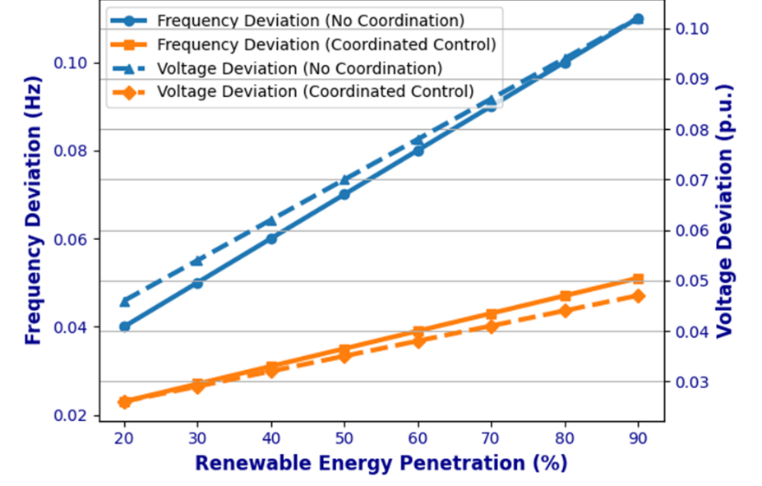
FIGURE 1. Combined Impact of Coordinated Active–Reactive Power Control on Frequency and Voltage Stability

The results confirm that active and reactive power coordination is a fundamental enabler for secure and reliable operation of future power systems with high renewable penetration. The proposed approach aligns with modern grid codes and provides a scalable solution for integrating large-scale renewable energy sources without compromising system stability.
CONCLUSIONS
The results of this study clearly indicate that a coordinated balance of active and reactive power is essential for maintaining stable and reliable operation in power systems with a high share of large-scale renewable energy sources. As inverter-based generation progressively replaces conventional synchronous units, the natural provision of inertia and voltage support is significantly reduced. This structural change increases the sensitivity of the system to frequency and voltage disturbances, particularly under dynamic operating conditions.
The analysis demonstrates that conventional, uncoordinated control strategies lead to pronounced active power imbalances, elevated frequency deviations, and substantial voltage variations when renewable penetration exceeds 70%. In contrast, the proposed coordinated active–reactive power control approach effectively alleviates these issues by jointly regulating power balance and system dynamics. Fast active power response combined with adaptive reactive power support allows inverter-based resources to contribute directly to frequency and voltage regulation, rather than functioning solely as energy-producing units. The results emphasize the pivotal role of reactive power management in sustaining acceptable voltage profiles, especially in electrically weak sections of the network. The controllability of modern power electronic interfaces enables precise voltage regulation even under severe operating conditions. Improved voltage stability also enhances overall system robustness by reducing the risk of inverter tripping and preventing the propagation of cascading disturbances. The study confirms that coordinated active and reactive power control represents a core operational requirement rather than a supplementary function in renewable-rich power systems. The proposed framework offers a technically sound and practically applicable solution that is consistent with current grid code developments and supports the reliable transition toward low-carbon, renewable-dominated power systems.
REFERENCES
- P.-H. Trinh and I.-Y. Chung, “Integrated active and reactive power control methods for distributed energy resources in distribution systems for enhancing hosting capacity,” Energies 17, 1642 (2024). https://doi.org/10.3390/en17071642
- J. Song, L. Yang, Z. Chen, and Y. Liu, “Review of low inertia in power systems caused by high renewable energy penetration and associated operational strategies,” Energies 16, 6042 (2023). https://doi.org/10.3390/en16166042
- N. Niyozov, G. Rafikova, Y. Ochilov, and D. Tadjibaeva, “AI and machine learning applications in energy efficiency,” AIP Conf. Proc. 3331, 080004 (2025).
- M. S. Alam, A. Manandhar, and G. Joos, “PV/wind-integrated low-inertia system frequency control using optimized SMES support,” Sustainability 13, 7622 (2021). https://doi.org/10.3390/su13147622
- L. Radaelli, F. Milano, and A. Vicenzutti, “Frequency stability analysis of a low-inertia power system with photovoltaic and wind generators,” Appl. Sci. 12, 11126 (2022). https://doi.org/10.3390/app122111126
- N. Niyozov, A. Akhmedov, S. Djurayev, B. Tukhtamishev, and A. Norqulov, “Development of a method for forecasting the specific consumption indicator of electric energy,” AIP Conf. Proc. 3331, 080008 (2025).
- A. Smahi, H. Berkouk, and Y. Jabri, “The power grid inertia with high renewable energy sources: A review of inertia enhancement strategies,” J. Energy (Hindawi) 2025, Article 7975311 (2025). https://doi.org/10.1155/2025/7975311
- Harun Özbay, Selim Öncü, and Metin Kesler, “Active and reactive power control of grid-tied three-phase inverter for PV systems,” 4th Eur. Conf. Renew. Energy Syst., Istanbul, Turkey (2016).
- N. Niyozov, S. Latipov, M. Nurova, D. Arziyev, and N. Karimova, “Enhancing electricity consumption forecasting accuracy in industrial enterprises: Factor identification and advanced modeling techniques,” AIP Conf. Proc. 3331, 080006 (2025).

