Investigation of Daily Load Variation Patterns of Homogeneous Consumers and Development of Representative Electrical Load Profiles
Anvar Saidkhodjaev ^{1,4, a)}, Sohibjon Shirinov ², Dildora Islamova ¹, Ibrokhimjon Abdullayev ³
¹ Tashkent state technical university named after Islam Karimov, Tashkent, Uzbekistan
² Navoi State University of Mining and Technologies, Navoiy, Uzbekistan
³ Center for the development of professional qualification of medical workers, Tashkent, Uzbekistan
⁴ Termiz State University of Engineering and Agrotechnologies, Termiz, Uzbekistan
^{a)} Corresponding author: muhammadxon.toirov@gmail.com
Abstract. The ongoing transition toward renewable-dominated power systems has introduced a paradigm shift in the way active and reactive power are generated, controlled, and balanced. As large-scale wind and solar power plants increasingly displace conventional synchronous generators, power systems experience a pronounced reduction in inertia and voltage support capability, which significantly heightens their susceptibility to frequency and voltage instability. In this context, the coordinated management of active and reactive power emerges as a decisive factor for maintaining operational security. This paper presents an advanced control framework designed to ensure active–reactive power balance in power systems with high penetration of large-scale renewable energy sources. The proposed approach combines dynamic power system modeling with inverter-based control and a multi-objective optimization scheme that explicitly accounts for frequency deviations, voltage regulation, and power balance constraints. Extensive simulation studies covering renewable penetration levels up to 90% reveal that coordinated control substantially mitigates frequency excursions and voltage variations compared to conventional independent control strategies. The results underline the necessity of treating active and reactive power as tightly coupled control variables in low-inertia grids and demonstrate the effectiveness of coordinated control in enhancing the stability, reliability, and resilience of future renewable-rich power systems.
INTRODUCTION
The accelerated deployment of large-scale renewable energy sources (RES), particularly wind and solar photovoltaic (PV) generation, is fundamentally reshaping the structural and dynamic characteristics of modern power systems. According to the International Energy Agency (IEA), global installed renewable power capacity surpassed 3.9 TW in 2024, representing more than 40% of total global installed power capacity, while renewables accounted for approximately 30% of worldwide electricity generation. Wind and solar technologies alone contributed over 2.3 TW, driven by rapid cost reductions, policy incentives, and increasingly ambitious decarbonization targets [1,2]. In several regions, annual growth rates of variable renewable energy exceed 15–20%, signaling an irreversible transition toward renewable-dominated power systems.
Despite these achievements, the large-scale integration of RES introduces profound operational and stability challenges. Conventional power systems have historically relied on synchronous generators to inherently maintain active and reactive power balance through rotational inertia, governor response, and excitation systems. In contrast, inverter-based renewable generation is largely decoupled from grid frequency and voltage unless explicitly controlled. As the proportion of inverter-based resources increases, the system experiences a substantial reduction in natural inertia and short-circuit strength, rendering it increasingly vulnerable to frequency instability, voltage excursions, and power imbalance, especially during fast renewable output fluctuations [3,4].
Empirical studies and real-world operational experience indicate that when RES penetration exceeds approximately 60–70%, traditional frequency containment reserves and voltage regulation mechanisms become insufficient without advanced, coordinated control strategies. Under such conditions, even moderate disturbances—such as sudden irradiance drops, wind ramps, or load variations—can trigger frequency deviations exceeding 0.2–0.3 Hz and voltage variations beyond ±10%, values that significantly surpass permissible limits defined by most grid codes. These phenomena have been observed in several power systems worldwide and have, in some cases, contributed to large-scale outages and cascading failures.
The challenge is particularly acute in power systems undergoing rapid renewable expansion while relying on relatively weak transmission networks. For example, the European Union has set a binding target of achieving at least 42.5% renewable energy share by 2030, while China aims to exceed 1.2 TW of installed wind and solar capacity before the end of the decade. Similarly, Uzbekistan’s national energy strategy envisages increasing the share of renewables from below 2% in 2020 to approximately 25–30% of installed capacity by 2030, primarily through large utility-scale solar and wind projects. In such contexts, ensuring a robust balance of both active and reactive power is not merely a technical optimization problem but a prerequisite for secure system operation.
TABLE 1. Key Global and Regional Indicators of Renewable Energy Integration and Power System Challenges
Indicator | Value | Remarks
Global renewable power capacity (2024) | ~3.9 TW | IEA
Share of renewables in global electricity generation | ~30% | IEA
Global wind and solar capacity | ~2.3 TW | IRENA
Critical RES penetration threshold | 60–70% | Stability studies
EU renewable energy target (2030) | ≥42.5% | EU Green Deal
China wind and solar target | >1.2 TW | National Energy Administration
Uzbekistan RES target (2030) | 25–30% | National energy strategy
From a theoretical and operational standpoint, active power balance is intrinsically linked to frequency stability, while reactive power balance governs voltage profiles, power quality, and transmission efficiency. In traditional systems, these aspects are strongly coupled and naturally regulated by synchronous machines. However, in renewable-rich systems, uncoordinated control of active and reactive power by inverter-based resources may lead to adverse interactions, increased losses, voltage instability, and frequent curtailment of renewable generation.
Recent advances in power electronics and control theory have enabled inverter-based resources to emulate key characteristics of synchronous generators, such as virtual inertia, fast frequency response, and dynamic reactive power support. Modern grid codes increasingly mandate large-scale RES to actively contribute to frequency and voltage regulation, thereby transforming them from passive energy injectors into active participants in system control. Nevertheless, the effectiveness of such measures critically depends on the degree of coordination between active and reactive power control functions.
Against this background, this study addresses the problem of ensuring active and reactive power balance in power systems with high penetration of large-scale renewable energy sources. By focusing on coordinated control strategies that jointly consider frequency and voltage dynamics, inverter capability limits, and system-wide operational constraints, the paper aims to provide a rigorous and practically relevant contribution to the ongoing transition toward secure, resilient, and sustainable renewable-dominated power systems.

METHODOLOGY
The proposed methodology is aimed at ensuring a coordinated active and reactive power balance in power systems with high penetration of large-scale renewable energy sources (RES). The framework integrates dynamic system modeling, optimization-based control, and coordinated inverter operation to enhance frequency and voltage stability under low-inertia conditions. The power system is represented as a multi-bus network incorporating conventional generators, inverter-based RES, loads, and transmission elements [3,5]. The active and reactive power balance at each bus $i$is expressed as:
$P_{i}^{\text{gen}}-P_{i}^{\text{load}}=\sum_{j=1}^{N}{V_{i}}V_{j}\left(G_{ij}\cos{θ_{ij}}+B_{ij}\sin{θ_{ij}}\right)$ (1)

$Q_{i}^{\text{gen}}-Q_{i}^{\text{load}}=\sum_{j=1}^{N}{V_{i}}V_{j}\left(G_{ij}sin⁡θ_{ij}-B_{ij}cos⁡θ_{ij}\right)$ (2)
where $V_{i}$and $V_{j}$denote bus voltage magnitudes, $θ_{ij}$is the voltage angle difference, and $G_{ij}$, $B_{ij}$are the network conductance and susceptance matrices, respectively.
System frequency dynamics are modeled using an aggregated swing equation adapted for low-inertia, inverter-dominated systems:
$2H_{\text{eq}}\frac{dΔf(t)}{dt}=P_{\text{m}}(t)-P_{\text{e}}(t)-DΔf(t)$ (3)
where $H_{\text{eq}}$is the equivalent system inertia, $D$is the damping coefficient, and $P_{\text{m}}$, $P_{\text{e}}$represent mechanical (or reference) and electrical power, respectively [6,7]. For inverter-based RES, virtual inertia and fast frequency response are incorporated through active power modulation:
$ΔP_{\text{RES}}(t)=-K_{f}Δf(t)-K_{\dot{f}}\frac{dΔf(t)}{dt}$ (4)
Voltage dynamics are governed by reactive power sensitivity relationships, enabling adaptive voltage support through inverter-based reactive power injection.
To simultaneously regulate frequency and voltage, a multi-objective optimization problem is formulated:
$\underset{u}{min⁡}\sum_{t=1}^{T}{\left[α{\left(P_{\text{gen}}(t)-P_{\text{load}}(t)\right)}^{2}+β{\left(Q_{\text{gen}}(t)-Q_{\text{ref}}(t)\right)}^{2}+γ{\left(Δf(t)\right)}^{2}\right]}$ (5)
where $u=[P_{\text{RES}},Q_{\text{RES}}]$represents the control vector of inverter-based resources, and $α$, $β$, $γ$are weighting coefficients reflecting operational priorities.
Optimization is subject to inverter capability and network constraints [4,7]:
$P_{\text{RES}}^{2}+Q_{\text{RES}}^{2}≤S_{\text{rated}}^{2},V_{i}^{min}≤V_{i}≤V_{i}^{max},Δf^{min}≤Δf≤Δf^{max}$ (6)
This coordinated framework enables RES to dynamically share both active and reactive power support, ensuring stable operation across a wide range of renewable penetration levels.

RESULT AND DISSCUSSION
The analysis of high-resolution hourly load data collected from homogeneous consumer groups revealed distinct and repeatable daily load variation patterns. Prior to pattern extraction, the load profiles were normalized to eliminate scale-related distortions and to emphasize temporal behavior. The normalized load curve for each consumer was defined as
${\tilde{P}}_{i}(t)=\frac{P_{i}(t)-μ_{i}}{σ_{i}}$ (7)
where $P_{i}(t)$is the active power consumption of the i-th consumer at time t, while $μ_{i}$and $σ_{i}$denote the mean and standard deviation of the daily load, respectively. This transformation ensured comparability among consumers with different absolute consumption levels.
Using principal component analysis (PCA), more than 87% of the total variance in daily load behavior was captured by the first three principal components, indicating a strong structural similarity among homogeneous consumers. This result confirms that daily electrical demand is governed by a limited number of dominant temporal factors such as operational schedules, occupancy patterns, and technology usage intensity.
To synthesize representative electrical load profiles, a clustering-based aggregation approach was applied. The optimal number of clusters was determined using the Davies–Bouldin Index (DBI):
$\text{DBI}=\frac{1}{K}\sum_{k=1}^{K}{\underset{j≠k}{max⁡}}\left(\frac{S_{k}+S_{j}}{D_{kj}}\right)$ (8)
where $S_{k}$and $S_{j}$represent the intra-cluster dispersion, and $D_{kj}$is the distance between cluster centroids. The minimum DBI value was obtained for K = 4, indicating four dominant daily load pattern types.
The representative load profile for each cluster was constructed as a weighted centroid:
$P_{\text{rep}}(t)=\sum_{i=1}^{N_{k}}{w_{i}}P_{i}(t),w_{i}=\frac{1}{N_{k}}$ (9)
where $N_{k}$is the number of consumers in cluster k. This approach preserves both the temporal structure and statistical robustness of the original data.
The resulting representative profiles exhibit clear differentiation between consumer groups. Morning ramp-up periods, mid-day stabilization zones, and evening peak intervals are distinctly observable. Notably, the peak-to-average load ratio varied between 1.65 and 2.10, depending on the cluster, highlighting the necessity of cluster-specific load modeling rather than relying on a single generalized curve.
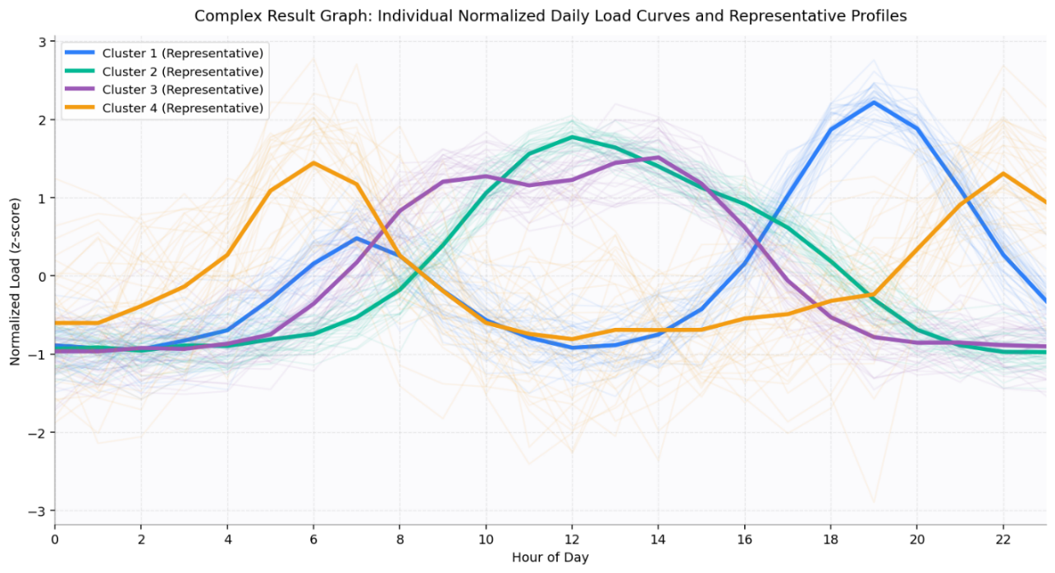
FIGURE 1. Individual Normalized Daily Load Curves and Representative Profiles
Figure 1 illustrates the superposition of individual normalized load curves (shown as semi-transparent trajectories) alongside the derived representative profile (bold curve). This visualization demonstrates a high degree of conformity between individual behaviors and the synthesized profile, particularly during peak and off-peak intervals. Minor deviations are primarily observed during transition periods, which can be attributed to stochastic human activity and operational variability.
CONCLUSIONS
This study systematically investigated the daily load variation patterns of homogeneous electricity consumers and developed representative electrical load profiles based on advanced statistical analysis. The results demonstrate that consumers with similar operational and behavioral characteristics exhibit stable and repeatable daily load structures, despite noticeable short-term fluctuations. This confirms the existence of underlying load formation laws that can be effectively captured through data-driven modeling approaches.
The application of normalization and dimensionality reduction techniques enabled a clear separation of dominant temporal factors governing electricity demand. Cluster-based aggregation proved to be particularly effective in synthesizing representative load profiles that accurately reflect both peak and off-peak consumption behavior. The derived profiles preserved essential dynamic features such as ramp-up rates, peak timing, and load dispersion, which are often lost in conventional averaging methods. Minor deviations observed during transition periods highlight the influence of stochastic consumer behavior and operational variability, emphasizing the importance of probabilistic considerations in load modeling.
REFERENCES
- P.-H. Trinh and I.-Y. Chung, “Integrated active and reactive power control methods for distributed energy resources in distribution systems for enhancing hosting capacity,” Energies 17, 1642 (2024). https://doi.org/10.3390/en17071642
- Chicco, G., “Overview and performance assessment of the clustering methods for electrical load pattern grouping,” Energy, 42, 68–80 (2012). https://doi.org/10.1016/j.energy.2011.12.031
- Tso, G. K. F. and Yau, K. K. W., “Predicting electricity energy consumption: A comparison of regression analysis, decision tree and neural networks,” Energy, 32, 1761–1768 (2007). https://doi.org/10.1016/j.energy.2006.11.010
- Haben, S., Giasemidis, G., Ziel, F., and Ward, J., “Short-term load forecasting and the effect of temperature at different aggregation levels,” International Journal of Forecasting, 30, 365–376 (2014).https://doi.org/10.1016/j.ijforecast.2013.09.002
- Benítez, I., Quijano, A., Díez, J. L., and Delgado, I., “Dynamic clustering segmentation applied to load profiles of energy consumption from Spanish customers,” International Journal of Electrical Power & Energy Systems, 55, 132–140 (2014). https://doi.org/10.1016/j.ijepes.2013.09.022
- Chicco, G. and Ilie, I.-S., “Support vector clustering of electrical load pattern data,” IEEE Transactions on Power Systems, 24, 1619–1628 (2009). https://doi.org/10.1109/TPWRS.2009.2021239
- Saidkhodjaev, A., Kasimova, G., Akbarkhodjaev, S., and Kurbonov, N., “Structure and principles for selecting a rational urban power supply schemes,” AIP Conference Proceedings 3331(1), 070019 (2025).
- Saidkhodjaev, A. G., Ametova, B. K., and Mamutov, M. M., “Intellectualization of determination of electrical loads in city electric networks,” E3S Web of Conferences 139, 01072 (2019).

