Rural power grid cable line optimal development research model
Abdurakhim Taslimov^{1, a)}, Farrukh Rakhimov², Feruz Raximov², Boʻstonbek Yuldashev³
¹Tashkent state technical university named after Islam Karimov, Tashkent, Uzbekistan
²Navoi State Universty of Mining and Texnologies, Navoi, Uzbekistan
³ Andijan State Technical Institute, Andijan, Uzbekistan
^{a)} Corresponding author: ataslimov@mail.ru
Abstract. The article developed a research model for the development of dynamic variable load rural power grid cable lines. On the basis of this model, during the accounting period under consideration, it is possible to choose a targeted scale of cross-sectional surfaces of rural power lines cable lines with a dynamically variable load.
INTRODUCTION
At the same time, according to the expert, the dynamics of rising prices for oil and petroleum products in the republic has not changed, which led to a decrease in demand for petroleum products. To optimize the parameters of these branches, it is necessary to compare them with the parameters of other branches [1-3].
Currently, increasing the permeability capacity of Rural Power Networks, the load of which is dynamically growing in the world and in our Republic, is becoming more and more complex. Optimization of the parameters of these networks, including the selection of the optimal option of transverse cross-sectional surfaces of conductors, is becoming more intensive. A model has been developed to optimize the selection of the initial cross-sectional surface of rural power lines of cable lines and to improve its permeability with increasing load, in accordance with existing conditions as well as with several possible conditions. At first, it will be necessary to build a cable network with a certain cross-sectional surface at the point corresponding to the accounting load of consumers, and later, if an increase in the load on the network is observed, it will be necessary to increase its conductivity. It is for consumers that the growth dynamics of the load in the studied period is known. N is cables with a specific cross-sectional surface [4-7].
In the initial step, it is considered to lay one cable with N cross-sectional surfaces or two parallel cables with the same cross-sectional surfaces, as well as lines with the same cross-sectional surfaces. If the cable line load increases during the accounting period, the following several options are compared each year. In addition to it, the option of pulling the second parallel cable is considered if the cable chosen to receive in the first place remains or not. Here, all cases of a cable network with a nominal cross-sectional surface N are studied [8,9].
Thus, a sufficient number of options for the selection of cross-sectional surfaces of rural power lines cable lines are studied. There will be several cases in this. In the first, the cable is selected depending on the load on the network and then a parallel cable is laid if the permissible value of the load reaches the maximum. In this option, the cost of initial capital funds will not be large, but the cost of waste and reconstruction of electricity on the line will come. In the latter, parallel cable lying is considered from the beginning of the accounting period. In this case, it will not be necessary to increase the conductivity of the transmission line later. However, at first a large cost will be needed, but the cost of electricity waste will be much less [10].

EXPERIMENTAL RESEARCH
Therefore, it is necessary to compare cable power lines with cable power lines. To optimize the mezzanine, it is necessary that it can be found in the form.
(1)
Where E_{m} – normative coefficient of capital funds; K_{t} – capital investments for Year t; E_{mk} – coefficient of non-payment of funds at different times; τ – the year of bringing capital funds-equal to all options; ΔU_{t} – inflation rate in t year.
Costs are brought to the year the cable line is connected to the network, i.e. τ=1 is taken to be. Using the dynamic programming method, it is possible to solve this issue, and this solution is optimal. Based on Dynamic Programming, we carry out the study as follows. P₀ has an initial load, and P_{t}=f(P₀,t) is legally assumed to be t=0 for the construction of cable lines at the beginning of the accounting period in the power supply of the growing consumer:
-N is one of the nominal, with a cable with a cross-sectional surface F_{i};
-N with cable with two denominations, cross-sectional surface F_{i} and F_{j};
In each subsequent t step (step equal to one year), the option of using this variant of the line (with one or two cables) and increasing the bandwidth of the transmission line by laying a cable parallel to each F_{j} cross-section surface of the cables is considered.
The variants studied are considered to be of order n. The number of levels N' corresponds to the row of selected standard cross-sectional surfaces and their possible combinations, and is set in a zero step (at time t=0). The cable line can be connected In N'=2N+∑^{N}_{n=1}(n-1) cases and in each t step and to a given St load. Alternatively, the status level may remain unchanged, or a higher level (Figure 1.) can change. This optimization model is such that at each stage, the most convenient option is selected when moving from one state to another. This optimization model is such that at each stage, the most convenient option is selected when moving from one state to another. This ensures that costs are minimal in this model. This minimum cost is reached in the next steps of optimization. The minimum cost level is determined at the end of the accounting period T, and the optimal option for the development of a cable line through the reverse path is determined.
We divide the annual costs into several parts:
$$\sum_{t=1}^{T}{ΔU_{t}}(1+E_{mk})^{1-t}=\sum_{t=1}^{T}{(U_{at}-U_{a(t-1)})(1+E_{mk})^{1-t}}+$$
$+\sum_{t=1}^{T}{(U_{et}-U_{e(t-1)})(1+E_{mk})^{1-t}}+\sum_{t=1}^{T}{(U_{It}-U_{I(t-1)})(1+E_{mk})^{1-t}}=$ (2)
Where U_{at}, U_{a(t-1)} – the depreciation costs of the cable line are t and t-1 years, respectively; U_{et}, U_{e(t-1)} – the operating costs of the cable line are for t and t-1 years, respectively; U_{It}, U_{I(t-1)} – the cost of covering the cable line's electricity wastes is t and t-1 years, respectively.
Developed and implemented, this optimization model takes into account the parallel operation of two lines. Therefore, in this model, considering its only active resistance in determining the cost at which rural power grids go to cover the lost power waste in cable lines would be incorrect from the scientific junket. Based on this above reasoning, it will also be necessary to take into account the reactive resistance in the optimization model. Taking into account the above, we write that the total costs with respect to the optimization model are.
$$Z=\sum_{t=1}^{T}{[(E_{m}+p_{a})(K_{t}-K_{t-1})+\frac{(F_{i}+F_{j})(1+x^{2}γ^{2}F_{i}F_{j})U_{is}}{[(F_{i}+F_{j})^{2}+4x^{2}γ^{2}F_{i}^{2}F_{j}^{2}]U_{n}^{2}γ\cos^{2}{ϕ}}}×$$
$×(P_{t}^{2}-P_{t-1}^{2})10^{-5}]l(1+E_{mk})^{1-t}$ (3)
Where p_{a} – normative coefficient of depreciation costs; K_{t-1} – t-1 year capital funding; P_{t} – active load in year t; P_{t-1} – active loading in t-1 year; x – cable reactive resistance; γ – specific cable conductivity; cosφ – power factor; F_{i}, F_{j} – i – as well as j – the cross-sectional surface of the cable; U_{is} – electricity waste costs; U_{n} – rated voltage, l – cable line length.
We carry out calculations of total costs in several stages. They will be as follows.
At first, the “zero” step considers laying one of all n rated cross-sectional surface wires on the standard scale, as well as two parallel cables with the same nominal cross-sectional surface, in order to deliver quality electricity to rural electricity consumers [11-15].

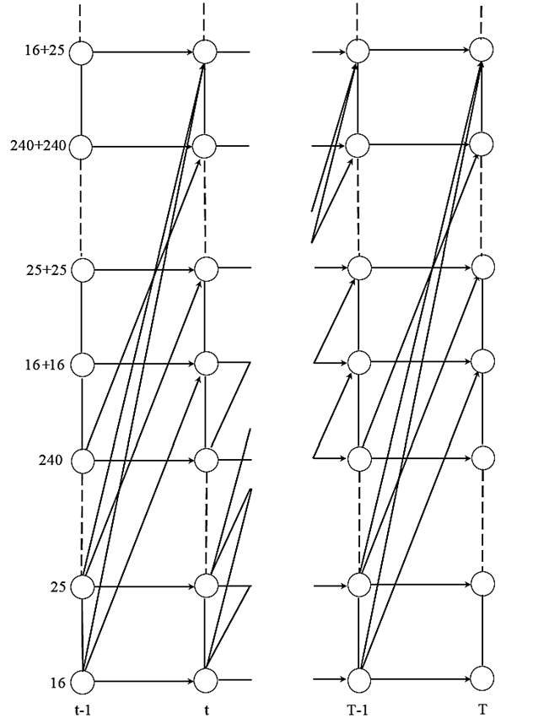
FIGURE 1. Outline of the optimization model.

After each t step, the cables are checked for the conductivity of the selected cross-sectional surfaces. The limiting conditions are that long-term allowable load current and allowable voltage waste are taken into account. A penalty function is applied if the cables on the cross-sectional surface under study do not meet the conditions of long-term allowable load currents or allowable voltage wastes (that is, a cost of several times greater than the total cost is added) [16-18].
RESEARCH RESULTS
In order to check the selected cross-sectional surfaces for long-term permissible load current, as well as to ensure that they are stable to possible changes in the future, as well as to increase reliability, the current in the cables is determined by the following expressions:
(4)
(5)
The calculated currents are comparable to the allowable current of the cross-sectional surface of these lines.
In order to check cross-sectional surfaces for the condition of permissible voltage loss, the voltage loss on the line under consideration is calculated at each step and compared with the one allowed. Voltage waste is calculated by the following expression:
(6)
An analysis of indicators that affect the optimal trend in the selection of cross-sectional surfaces of cables showed the following. Some of these indicators have a normalized value and do not change in the future (reactive resistance of cables and comparative conductivity of the conducting material) [18-20].
Another part of the indicators (loading, the number of maximum annual wastes, the cost of electricity waste, the amount of capital funds, etc.) can vary in a very wide range. It is therefore important to ensure the stability of the optimal development trend of cable lines while deviating from the average values of all factors that determine it during the study [21-24].
CONCLUSIONS
To assess the effect of all other factors on the established optimal tedency of the selection of cross-sectional surfaces of cables, their values were shifted twice as large or less than the accepted average values.
Determining the effect of limiting factors – long-term allowable current and voltage wastes-on the optimal trend is considered very important. As for long-term permissible currents, they are strictly regulated for a particular type of cable, while the value of the permissible voltage waste varies significantly depending on certain conditions. At the same time, it is also important to study the optimal trend without restrictions
REFERENCES
- A. Taslimov, F.Rakhimov, F.Rakhimov, V. Mo‘minov. Analysis of the results of sampling the surfaces of sections of rural electric networks. AIP Conf. Proc. 3331, 030041 (2025), 1-7. https://doi.org/10.1063/5.0305783
- Farrukh Rakhimov. Study of reliability indicators of cable lines in rural areas // E3S Web of Conferences 525, 03014 (2024). https://doi.org/10.1051/e3sconf/202452503014
- Freishteter V.P., Martianov A.C. The choice of an economically justified cross-section of wires and wires of cables of power transmission lines in the design // Oil industry. - 2011. - No. 4. - pp. 117-121.
- Makarenko D. E. Review and analysis of the technical condition of 6-10 kV agricultural cable lines // International Scientific Journal "INNOVATIVE SCIENCE". - 2017. - №03-1. – Pp. 68-70.
- Efentiev S.N., Zuev E.N. Economic current intervals of overhead line wire sections − yesterday, today, tomorrow // Electrical engineering, electric power industry, electrotechnical industry. - 2005. − No. 3. – pp. 43-48.
- Katrenko G.N. New approaches to the construction of distribution electric networks of 0.4-35 kV // Electric networks and systems. – 2013. - No. 5. - pp. 25-29.
- Bondarenko V.E., Cherkashina V.V., Cheremisin N.M. Formation of technical and economic models of overhead power transmission lines in conditions of market relations and their analysis by the criterion method // Technical electrodynamics. - 2010. - No. 6. – pp. 59-64.
- Khaziev D. N. Unified method of selecting sections of cable lines up to 1 kV // Electrics. 2002. - pp. 32-35.
- Leshchinskaya T.B. Application of multicriteria selection methods in optimizing power supply systems in rural areas. // Electricity, 2003. - No. 1. - pp. 14-12.
- Solopov R.V. Technical and economic laws in energy supply systems // VI-I inter. scientific. technol. conf. "Radio electronics, electrical engineering and power engineering". In 3 volumes of MEI. - Moscow, 2000. - pp. 1-6.
- Akram Tovbaev., Islom Togaev., Uktam Usarov.,Gulom Nodirov, Reactive power compensation helps maintain a stable voltage profile across the network, AIP Conf. Proc. 3331, 060014 (2025). https://doi.org/10.1063/5.0307209
- Shukhrat Abdullaev., Ziyodullo Eshmurodov., Islom Togaev, A systematic analysis of the gradual increase in quality indicators of electricity using reactive power sources involves several steps, AIP Conf. Proc. 3331, 040051 (2025). https://doi.org/10.1063/5.0306786
- Tatkeyeva G. et al. Experimental research of the developed method to determine the network insulation for ungrounded AC systems in laboratory conditions //2022 International Conference on Electrical, Computer and Energy Technologies (ICECET). – IEEE, 2022. – С. 1-4. 10.1109/ICECET55527.2022.9873012
- Ataullaev, A. O., & Sayidov, M. K. (2023). Investigation of multi loop linear magnetic circuits of electromagnetic flow converters with ring channels. In E3S Web of Conferences (Vol. 417, p. 03006). EDP Sciences. https://doi.org/10.1051/e3sconf/202341703006
- Eshmurodov, Z., & Abdullaev, S. (2024). Investigation of the methods of starting and braking in the “Frequency converter asynchronous motor” system. In E3S Web of Conferences (Vol. 548, p. 06013). EDP Sciences. https://doi.org/10.1051/e3sconf/202454806013
- Eshpulatov, N., Khalmuradov, T., Rakhimov, F., Abdurayimov, S., Khurramov, A., Ruziyeva, U., ... & Maftuna, I. (2023, March). Influence of the parameters of the impact of electrical impulses on the yield of juice from the pulp. In IOP Conference Series: Earth and Environmental Science (Vol. 1142, No. 1, p. 012006). IOP Publishing. DOI 10.1088/1755-1315/1142/1/012006
- Eshpulatov, N., Khalmuradov, T., Rakhimov, F., Abdurayimov, S., Khurramov, A., Mullajonov, I., & Vorisova, R. (2023, March). The influence of the impact of electrical impulses on the juice outputting of the pulp. In IOP Conference Series: Earth and Environmental Science (Vol. 1142, No. 1, p. 012017). IOP Publishing. DOI 10.1088/1755-1315/1142/1/012017
- Karshibayev, A. I., & Jumayev, Z. I. (2023). Expanding the level of forecasting and operational planning of electric consumption at mining enterprise. In E3S Web of Conferences (Vol. 417, p. 03015). EDP Sciences. https://doi.org/10.1051/e3sconf/202341703015
- Rakhimov, F., Rakhimov, F., Samiev, S., & Abdukhalilov, D. (2024, June). Justification of technical and economic effectiveness of application of 20 kV voltage in overhead electric networks. In AIP Conference Proceedings (Vol. 3152, No. 1, p. 030023). AIP Publishing LLC. https://doi.org/10.1063/5.0218921
- Islom Togaev., Akram Tovbaev., Gulom Nodirov, Systematic analysis of reactive power compensation in electric networks is essential for improving electricity quality enhancing system stability, and reducing operational costs, AIP Conf. Proc. 3331, 030099 (2025) https://doi.org/10.1063/5.0305740
- O.O. Zaripov, S.J. Nimatov, Y.M. Yeralieva, S.O. Zaripova, M.A. Zakirov, D.M. Nomozova, J.T. Akhmedov, Akram Tovbaev. Calculation of the nominal power and еlectrical еnergy of the hydro power plant on an еlectronic calculator. E3S Web Conf. Volume 486, 2024. IX International Conference on Advanced Agritechnologies, Environmental Engineering and Sustainable Development (AGRITECH-IX 2023). https://doi.org/10.1051/e3sconf/202448601027
- Akram Tovbaev, Muxtarxan Ibadullayev and Mohinur Davronova. Study of subharmonic oscillation processes in ferroresonance circuits. E3S Web of Conf. Volume 525, 2024. IV International Conference on Geotechnology, Mining and Rational Use of Natural Resources (GEOTECH-2024). https://doi.org/10.1051/e3sconf/202452503008
- Mukhtorkhon Ibadullayev; Shavkat Begmatov; Akram Tovbaev. Subharmonic resonance in three-phase ferroresonant circuits with common magnetic cores. AIP Conf. Proc. 3152, 050019 (2024) https://doi.org/10.1063/5.0218907
- Qarshibaev, A. I., Narzullaev, B. S., & Murodov, H. S. (2020, November). Models and methods of optimization of electricity consumption control in industrial enterprises. In Journal of Physics: Conference Series (Vol. 1679, No. 2, p. 022074). IOP Publishing. DOI 10.1088/1742-6596/1679/2/022074

