Thermo-mechanical optimization of expanded vermiculite lightweight cement composites using silica fume, polycarboxylate superplasticizer, and polypropylene fibers
Vladimir Soy¹, Jambul Turgaev², Nursultan Takhirjanov^{1, a)}, Batırbay Tolegenov²
¹ Tashkent state transport university, Tashkent, Uzbekistan
²Karakalpak state Institute of Engineering Economics, Karshi, Uzbekistan
^{a)} Corresponding author: taxirjanovnursultan@gmail.com
Abstract. Expanded vermiculite (EV) is an attractive lightweight aggregate for reducing density and thermal conductivity of cement-based composites; however, its layered porous structure increases water demand, porosity, and strength loss. This study develops and validates a combined modification strategy for EV lightweight cement composites based on (i) microstructural densification of the paste and interfacial transition zone using silica fume, (ii) controlled water reduction and particle dispersion using a polycarboxylate ether (PCE) superplasticizer, (iii) crack-bridging by polypropylene (PP) microfibers, and (iv) reduction of aggregate water uptake via surface treatment. Two experimental series were produced: an EV gradation series with a high water-to-cement ratio (w/c up to 1.15) and a reduced-w/c series (w/c about 0.52) with chemical and fiber modification. The EV gradation series showed a decrease in compressive strength from 12.81 to 5.71 MPa as bulk density decreased from 608 to 408 kg/m³, confirming the classic strength-porosity trade-off reported for vermiculite composites. The combined modification strategy enabled a high-performance lightweight composite with compressive strength about 32.6 MPa at 28 days, flexural strength about 8.56 MPa, density about 1680 kg/m³, and reduced thermal conductivity (about 0.42 W/mK) relative to the unmodified reference (about 0.52 W/mK). Microstructural interpretation indicates that silica fume and PCE improve packing and hydration products, while PP fibers stabilize microcracks and limit post-peak brittleness. The proposed approach offers a practical pathway to balance structural and thermal requirements in energy-efficient building components manufactured with EV.
INTRODUCTION
Reducing operational energy demand in buildings increasingly depends on envelope systems that integrate structural capacity with thermal insulation. Lightweight cement composites provide a route to lower heat transfer and dead load, but their performance is governed by porosity, interfacial bonding, and moisture transport, as also emphasized for durable lightweight concretes [21]. Expanded vermiculite is a naturally derived, exfoliated phyllosilicate aggregate with a lamellar morphology and high internal porosity. When used as a partial replacement of natural sand or as a lightweight aggregate, EV can significantly reduce bulk density and thermal conductivity; nevertheless, it typically increases water absorption and decreases mechanical strength because of its low intrinsic stiffness and the formation of a weak, porous interfacial transition zone (ITZ) [1–5].
Recent research shows that the mechanical penalty of EV can be mitigated by tailoring binder chemistry and microstructure. Silica fume is an ultrafine pozzolanic material that acts both as a microfiller and as a reactive silica source, refining pores and densifying the ITZ, which can improve strength and durability in cementitious systems [6,7]. Polycarboxylate ether superplasticizers can reduce mixing water and improve particle dispersion by steric and electrostatic mechanisms, enabling low w/c ratios and higher packing density without loss of workability [8–10]. At the mesoscale, polymer fibers (e.g., PP) can bridge cracks, increase energy absorption and flexural toughness, and limit shrinkage cracking, thereby improving serviceability of lightweight composites [11,12].
Complementary evidence is available for EV-based foam concretes and alternative binders: the joint use of expanded vermiculite and silica fume has been reported to improve the thermal performance of foam concretes [19], and vermiculite/geopolymer panels have demonstrated promising thermal insulation at low density [20]. These findings support the hypothesis that microstructural engineering can partially decouple the strength–insulation trade-off in EV systems.
Despite these advances, an integrated strategy that simultaneously addresses EV water absorption, paste rheology, microstructural densification, and crack control remains insufficiently reported, especially for design targets that combine low thermal conductivity with medium-to-high compressive strength. The present work contributes by (i) presenting a unified experimental program combining EV grading, chemical admixture optimization, fiber reinforcement, and aggregate surface treatment; (ii) discussing a performance-based optimization framework for the strength–insulation trade-off; and (iii) providing a set of mix-design recommendations that can be reproduced with commonly available materials.

EXPERIMENTAL RESEARCH
Ordinary Portland cement conforming to applicable standards was used as the primary binder. Expanded vermiculite with particle sizes covering fine-to-coarse fractions was employed as the lightweight aggregate. Natural quartz sand served as the dense reference aggregate in selected mixtures. Silica fume was introduced as a mineral admixture at a low mass fraction of the binder. A PCE-type high-range water-reducing admixture was used for workability control at reduced w/c ratios. Monofilament PP microfibers with a nominal length of 6–12 mm were used as crack-control reinforcement.
To limit rapid water uptake and stabilize effective w/c ratio, part of the EV was treated prior to mixing. A practical surface-treatment route was applied by impregnating EV with an alkaline silicate solution and drying to form a thin mineral coating. This approach follows the general concept of lightweight aggregate pre-coating to reduce absorption and improve the ITZ [13].
Two mixture series were produced. Series A investigated the influence of EV gradation and volumetric content at relatively high w/c ratios, reflecting typical EV mixtures without advanced rheology control. Series B applied combined modification (silica fume + PCE + PP fibers) at reduced w/c ratio, aiming at a balanced thermal–mechanical performance.
TABLE 1. Nominal batch proportions of the two base mixtures used for the experimental program
Mixture | Cement (g) | Sand (g) | Water (g) | EV (g) | PCE (g) | Silica fume (g)
A0 (reference) | 5000 | 11050 | 2640 | 0 | 20 | 50
A1 (EV-modified) | 4000 | 4416 | 3835 | 2720 | 50 | 50

TABLE 2. Conceptual design space for the combined modification series
Mixture | w/c | Silica fume (% of binder) | PCE (% of binder) | PP fiber (kg/m3) | Notes
B0 | 0.52 | 0 | 0 | 0 | Low w/c reference without modifiers
B1 | 0.52 | 5 | 0.5–1.0 | 0.6–1.2 | Combined modification

Dry constituents were first mixed to ensure uniform distribution of silica fume and fibers. Mixing water containing dissolved PCE was then introduced gradually while monitoring consistency. Prismatic specimens (40×40×160 mm) were prepared for flexural testing, and cubic specimens (e.g., 70.7 mm) were prepared for compressive strength evaluation. After casting, specimens were covered to limit moisture loss, demolded after 24 hours, and cured in a humid environment at approximately 20±2 °C until testing at 7 and 28 days.
Bulk density was determined from hardened specimens using mass and geometrical volume. Water absorption was measured after oven-drying and subsequent water immersion. Compressive strength was tested according to standard loading procedures for mortar/concrete specimens. Flexural strength was measured using a three-point bending configuration. Thermal conductivity was measured on plate specimens by a steady-state or transient method suitable for porous building materials [22]. Selected samples were examined by scanning electron microscopy to interpret the ITZ quality and pore morphology.
RESEARCH RESULTS AND DISCUSSION
The EV gradation series demonstrated a systematic reduction in strength with decreasing density. For mixtures with bulk densities of approximately 608, 508, and 408 kg/m3, the corresponding compressive strengths were about 12.81, 9.21, and 5.71 MPa, respectively, and the flexural strengths were about 6.64, 4.81, and 3.54 MPa. The observed trend aligns with published results reporting that EV increases porosity and water absorption and reduces mechanical resistance when used as sand replacement [1,3–5]. The corresponding water demand and strength trends are summarized in Figure 1 and Figure 2.
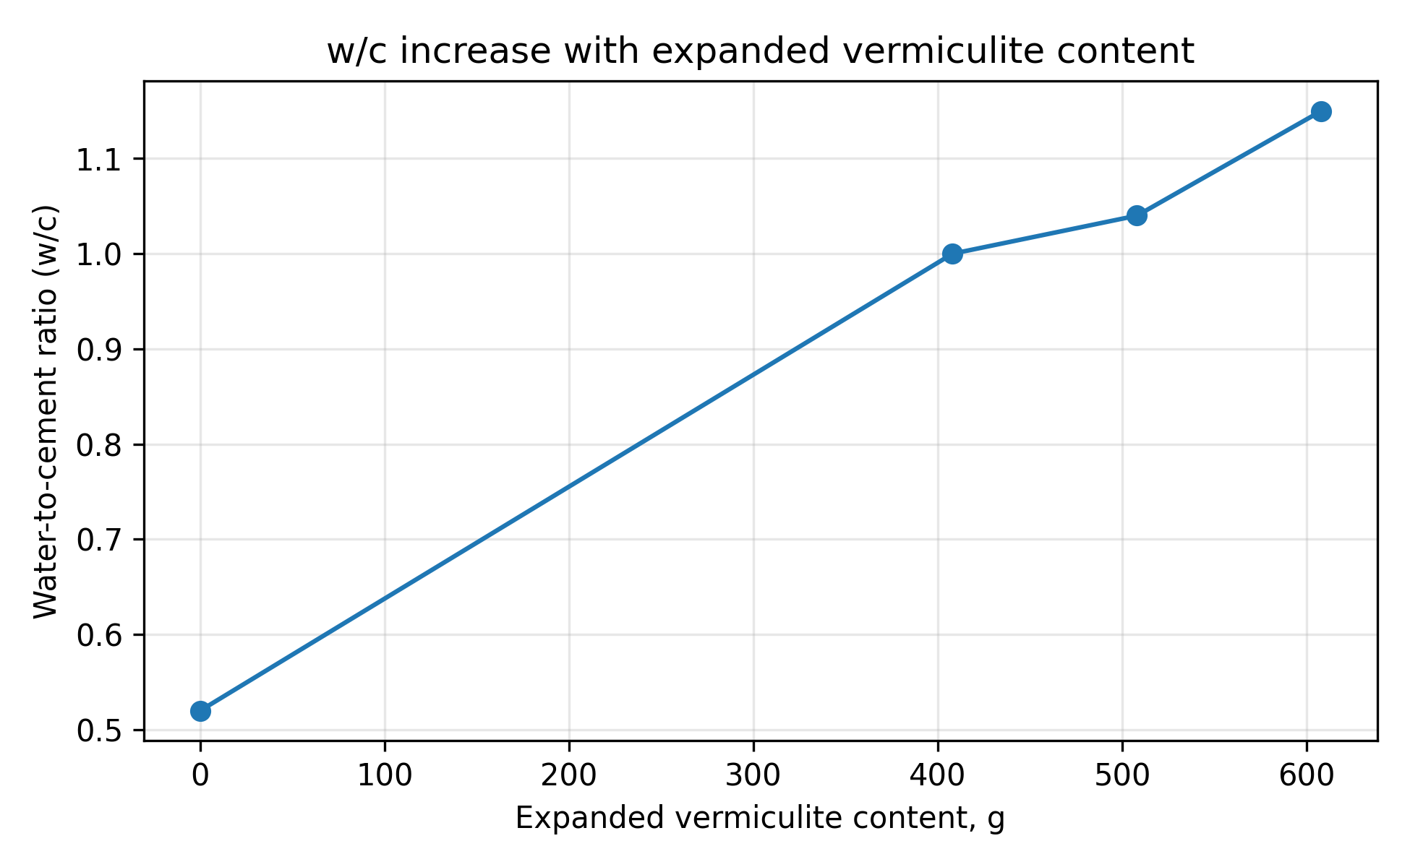
FIGURE 1. Water-to-cement ratio as a function of expanded vermiculite content.

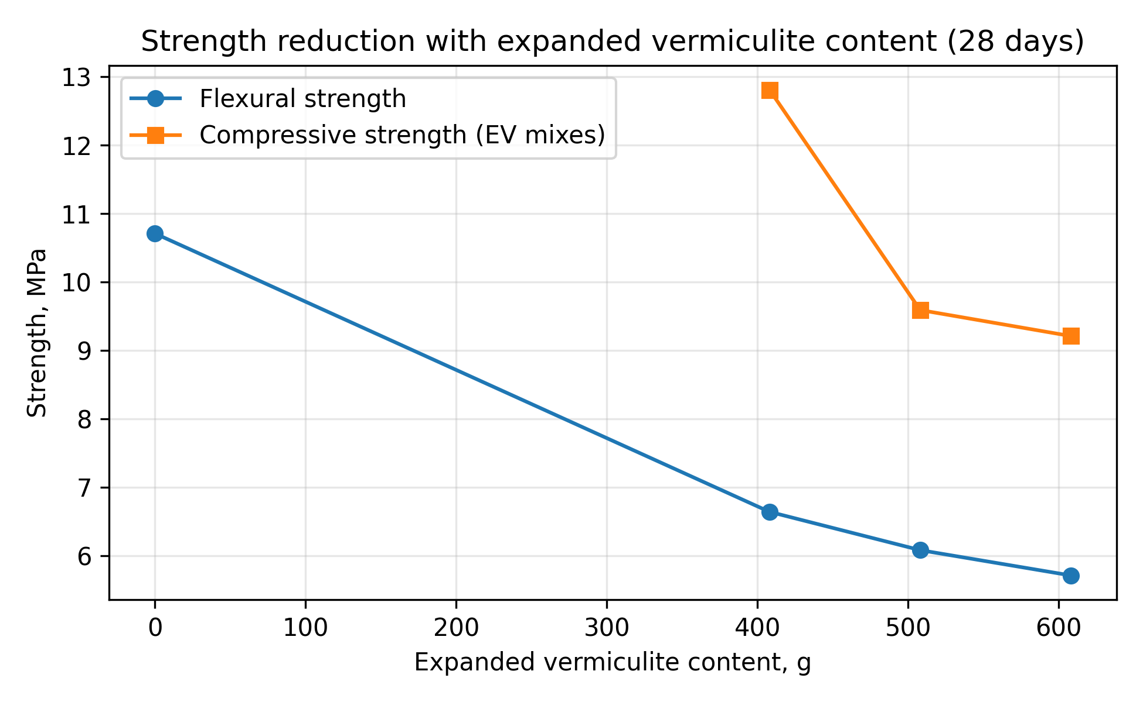
FIGURE 2. Flexural and compressive strength versus expanded vermiculite content (28 days).

Combined modification at reduced w/c ratio. Lowering the w/c ratio from approximately 1.15 to about 0.52 substantially improved the hardened performance, but required effective dispersion control. The PCE admixture provided the necessary workability at reduced mixing water, consistent with the dispersion and adsorption mechanisms described in the cement chemistry literature [8–10]. Silica fume further refined the paste microstructure via microfiller and pozzolanic effects, which is widely associated with a denser ITZ and reduced permeability [6,7]. Interactions between superplasticizers and silica fume can be preferential, affecting rheology and dispersion of highly fine systems [23,24].
In the modified compositions, a representative 28-day compressive strength of about 32.6 MPa was achieved at a density of about 1680 kg/m3, while flexural strength reached about 8.56 MPa. Water absorption was reduced from about 27% in the reference to about 23% after combined modification, indicating improved pore connectivity control and a more stable effective w/c ratio. Thermal conductivity decreased from about 0.52 W/mK in the reference to about 0.42 W/mK in the modified mixture, demonstrating that thermal insulation can be maintained while recovering strength through microstructural design. The influence of PCE dosage and fiber reinforcement on strength is summarized in Figure 3.
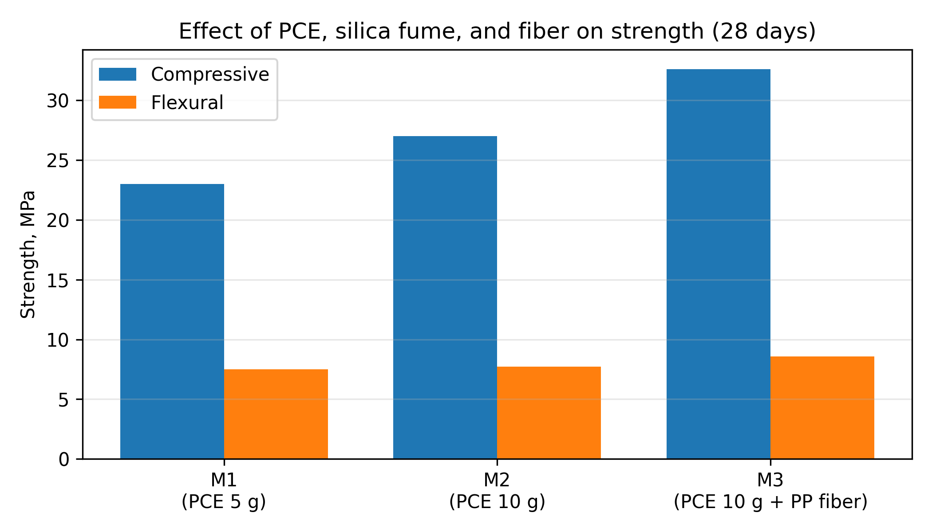
FIGURE 3. Effect of PCE dosage, silica fume, and polypropylene fiber on strength (28 days).

Microstructural interpretation. The microstructure of EV composites is governed by the layered particle morphology and the quality of the paste-aggregate bond. Untreated EV can act as a water sink during mixing, locally increasing porosity and producing a weak ITZ. Aggregate pre-coating and/or silicate-based surface treatments can reduce early water uptake and improve bond continuity, which is consistent with the general behavior of pre-coated lightweight aggregates [13].
Surface modification of expanded vermiculite is a complementary route to limit rapid water uptake and improve ITZ quality. Reported SEM-based indicators show a consistent reduction of characteristic pore scale from 15–25 μm (untreated) down to 3–5 μm for the combined treatment route (NaOH activation → sodium silicate coating → GKJ-11 hydrophobization), which is expected to enhance paste–aggregate continuity and reduce microcrack initiation sites (Figure 4).
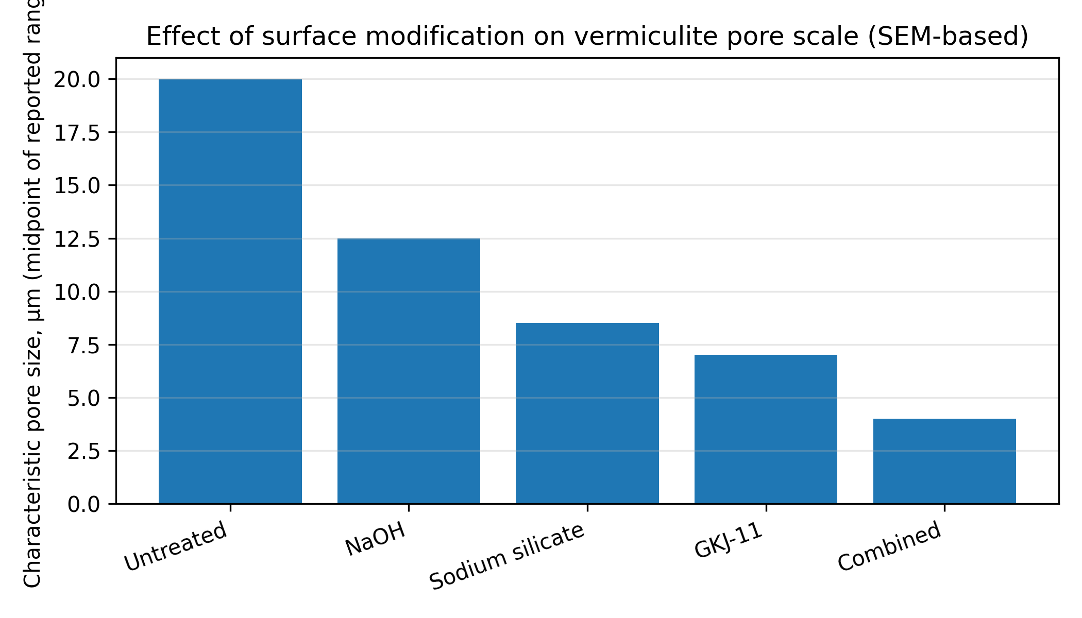
FIGURE 4. Effect of surface modification on vermiculite pore scale (midpoint of reported ranges).

SEM observations indicated that surface-treated EV exhibits a more continuous paste-aggregate contact zone and a reduced population of large interlayer voids. In samples with different treatment intensities, dominant pore sizes shifted from the fine range (about 3–5 μm) toward larger but less connected voids (about 15–25 μm), which can explain simultaneous reductions in capillary absorption and improvements in mechanical stability under load.
Performance-based optimization. For building components, it is convenient to compare mixtures using a combined performance index that balances strength and heat transfer. One simple index can be defined as PI = f_c,28 / k, where f_c,28 is the 28-day compressive strength (MPa) and k is thermal conductivity (W/mK). Using the representative results above, PI increased from about 27/0.52 ≈ 51.9 to about 32.6/0.42 ≈ 77.6, indicating a substantial improvement in strength per unit heat transfer.

CONCLUSIONS
Expanded vermiculite provides significant density reduction and improved thermal insulation in cement composites, but without modification it increases water demand and porosity, leading to strength loss. The EV gradation series confirmed a strong density-dependent strength reduction, with compressive strength decreasing from about 12.81 to 5.71 MPa as density decreased from 608 to 408 kg/m³.
A combined modification approach based on silica fume, PCE superplasticizer, PP microfibers, and EV surface treatment enabled a balanced lightweight composite with compressive strength about 32.6 MPa, flexural strength about 8.56 MPa, density about 1680 kg/m³, reduced water absorption, and lower thermal conductivity compared with the unmodified reference.
The results support the use of microstructural densification and rheology control as primary levers to recover strength in EV composites while preserving thermal benefits. Future work should broaden durability assessment (freeze–thaw, chloride ingress, carbonation) and quantify long-term moisture-dependent thermal conductivity for realistic service conditions.
REFERENCES
- P. C. Assis Neto, A. E. M. Paiva, and A. R. G. de Azevedo, “Expanded vermiculite: A short review about its production and use in cement-based composites,” Buildings 13(3), 823 (2023). https://doi.org/10.3390/buildings13030823
- R. Rashad, “Vermiculite as a construction material – A short guide for civil engineer,” Constr. Build. Mater. 125, 53–62 (2016). https://doi.org/10.1016/j.conbuildmat.2016.08.019
- H. Xu et al., “Effect of expanded vermiculite on the microstructure and properties of autoclaved aerated concrete,” Constr. Build. Mater. 440, 137226 (2024). https://doi.org/10.1016/j.conbuildmat.2024.137226
- F. Köksal, T. Nazlı, A. Benli, O. Gençel, and G. Kaplan, “The effects of cement type and expanded vermiculite powder on the thermo-mechanical characteristics and durability of lightweight mortars at high temperature and RSM modelling,” Case Stud. Constr. Mater. 15, e00709 (2021). https://doi.org/10.1016/j.cscm.2021.e00709
- F. Köksal, O. Gençel, and M. Kaya, “Combined effect of silica fume and expanded vermiculite on properties of lightweight mortars at ambient and elevated temperatures,” Constr. Build. Mater. 88, 175–187 (2015). https://doi.org/10.1016/j.conbuildmat.2015.04.021
- R. Siddique, “Utilization of silica fume in concrete: Review of hardened properties,” Resour. Conserv. Recycl. 55(11), 923–932 (2011). https://doi.org/10.1016/j.resconrec.2011.06.012
- M. I. Khan and A. Siddique, “Utilization of silica fume in concrete: Review of durability properties,” Resour. Conserv. Recycl. 57, 30–35 (2011). https://doi.org/10.1016/j.resconrec.2011.09.005
- L. Lei, T. Hirata, and J. Plank, “40 years of PCE superplasticizers – History, current state-of-the-art and an outlook,” Cem. Concr. Res. 157, 106826 (2022). https://doi.org/10.1016/j.cemconres.2022.106826
- Y. Fang et al., “Study on dispersion, adsorption, and hydration effects of polycarboxylate superplasticizers with different side chain structures in reference cement and belite cement,” Materials 16(11), 4168 (2023). https://doi.org/10.3390/ma16114168
- J. Plank and C. Hirsch, “Impact of zeta potential of early cement hydration phases on superplasticizer adsorption,” Cem. Concr. Res. 37(4), 537–542 (2007). https://doi.org/10.1016/j.cemconres.2007.01.008
- R. Banthia and R. Gupta, “Influence of polypropylene fiber geometry on plastic shrinkage cracking in concrete,” Cem. Concr. Res. 36(7), 1263–1267 (2006). https://doi.org/10.1016/j.cemconres.2006.01.010
- A. A. Jhatial et al., “Effect of polypropylene fibres on the thermal conductivity and mechanical properties of foamed concrete,” MATEC Web Conf. 150, 03008 (2018). https://doi.org/10.1051/matecconf/201815003008
- L. Domagała et al., “The properties of lightweight aggregates pre-coated with cementitious materials,” Materials 14(21), 6417 (2021). https://doi.org/10.3390/ma14216417
- K. H. Mo, H. J. Lee, M. Y. J. Liu, and T.-C. Ling, “Incorporation of expanded vermiculite lightweight aggregate in cement mortar,” Constr. Build. Mater. 179, 302–306 (2018). https://doi.org/10.1016/j.conbuildmat.2018.05.219
- S. Schackow et al., “Mechanical and thermal properties of lightweight concretes with vermiculite and EPS using air-entraining agent,” Constr. Build. Mater. 57, 190–197 (2014). https://doi.org/10.1016/j.conbuildmat.2014.02.009
- H. Shoukry et al., “Enhanced physical, mechanical and microstructural properties of lightweight vermiculite cement composites modified with nano metakaolin,” Constr. Build. Mater. 112, 276–283 (2016). https://doi.org/10.1016/j.conbuildmat.2016.02.209
- S. Koçyiğit et al., “The effect of natural resin on thermo-physical properties of expanded vermiculite–cement composites,” Int. J. Thermophys. 41, 128 (2020). https://doi.org/10.1007/s10765-020-02719-3
- X. Wang et al., “Properties and microstructure of an interfacial transition zone in cement composite: A review,” ACS Omega 9(6), 7075–7100 (2024). https://doi.org/10.1021/acsomega.3c08560
- F. Köksal, Y. Sahin, and O. Gençel, “Influence of expanded vermiculite powder and silica fume on properties of foam concretes,” Constr. Build. Mater. 257, 119547 (2020). https://doi.org/10.1016/j.conbuildmat.2020.119547
- V. Medri et al., “Production and characterization of lightweight vermiculite/geopolymer-based panels,” Mater. Des. 85, 266–274 (2015). https://doi.org/10.1016/j.matdes.2015.06.145
- C.-L. Hwang and M.-F. Hung, “Durability design and performance of self-consolidating lightweight concrete,” Constr. Build. Mater. 19(8), 619–626 (2005). https://doi.org/10.1016/j.conbuildmat.2005.01.003
- M. Stefanidou, M. Assael, K. Antoniadis, and G. Matziaroglou, “Thermal conductivity of building materials employed in the preservation of traditional structures,” Int. J. Thermophys. 31(4), 844–851 (2010). https://doi.org/10.1007/s10765-010-0750-8
- Q. Zhang et al., “Preferential adsorption of superplasticizer on cement/silica fume and its effect on rheological properties of UHPC,” Constr. Build. Mater. 359, 129519 (2022). https://doi.org/10.1016/j.conbuildmat.2022.129519
- A. Harichane et al., “Effectiveness of the use of polymers in high-performance concretes,” Polymers 15(18), 3730 (2023). https://doi.org/10.3390/polym15183730

